SEISWEBLOG
Installation and User Manual
Web Application • Desktop DataViewer2 • Data Import • QC • Reporting
Document version | 0.1 — Operational draft
Prepared | August 14, 2026
Target platform | Microsoft Windows 10/11, 64-bit
Application stack | Python 3.11, Django 5.2, PySide6, SQLite

Document status: This manual is ready for operational review. Exact installer and desktop-launcher filenames must be verified against the final release package before publication.

Document Control
Version | Date | Description | Status
0.1 | 2026-08-14 | Initial installation and operating manual | Review

Purpose
This manual explains how to install, configure, operate, maintain, and troubleshoot SeisWebLog. It covers both the Django web application and the PySide6 desktop application, including DataViewer2 and the principal seismic QC workflows.

Intended audience
- System administrators who install and maintain SeisWebLog.
- Survey managers, navigation QC personnel, ROV QC personnel, and source QC personnel.
- Project users who import, review, map, validate, and export survey data.

Conventions
Convention | Meaning
Menu › Command | A menu or ribbon command to select.
Code-style text | A command, file, folder, database table, or field name.
Note | Helpful operational information.
Warning | An action that may cause data loss or an incorrect result.

Contents
Right-click and select Update Field to build the table of contents.
Word instruction: After opening the document, press Ctrl+A and then F9 to update the table of contents and page-number fields.

1. Product Overview
SeisWebLog is a project-based QC and data-management system for marine seismic and OBN/OBS operations. It combines browser-based workflows with a Windows desktop mapping and QC application.

1.1 Main components
Component | Purpose
Web application | Project administration, imports, summaries, production monitoring, plots, reports, and exports.
DataViewer2 | Desktop mapping, layers, labels, Receiver QC, BlackBox tracks, measurements, and spatial review.
Project SQLite database | Stores project configuration and operational data. Each active project should use its designated database.
Media and report folders | Store uploaded source files, images, generated plots, and exported reports.

1.2 Principal modules
- Projects and Base Project — project metadata, coordinate system, preplots, masks, and shapes.
- ROV — DSR, Survey Manager, REC_DB, BlackBox, Receiver QC, OCR images, and receiver reporting.
- Source — SPS, sail-line solutions, shot tables, MFA reports, vessel assignments, and source QC.
- SVP — sound-velocity profile import, metadata, plots, and water-column review.
- Production Monitor — deployment, recovery, shooting, progress, and vessel summaries.

2. System Requirements
Item | Minimum / recommended
Operating system | Windows 10 or Windows 11, 64-bit
Processor | 4-core minimum; 8-core recommended for large QC datasets
Memory | 8 GB minimum; 16–32 GB recommended
Storage | 10 GB free minimum, plus project databases and uploaded data
Display | 1920 × 1080 recommended
Python | Python 3.11.x, 64-bit, for source-based installation
Browser | Current Microsoft Edge, Google Chrome, or Firefox
Network | Required for shared deployment and web-map tiles; local operation can use localhost

Coordinate systems: Confirm the project EPSG code before importing spatial data. A wrong EPSG code can place layers far outside the project area while leaving the source values unchanged.

3. Installation

3.1 Before installation
- Sign in with an administrator account. Use a Windows account permitted to install software and create application folders.
- Create a backup. If upgrading an existing installation, copy the application configuration, project SQLite databases, media, and exported reports to a separate location.
- Confirm the release package. Use only the approved SeisWebLog release ZIP or installer supplied for the project.
- Choose storage locations. Keep the program and project data separate. A typical arrangement is C:\SeisWebLog for the program and D:\SeisWebLogData for project data.

3.2 Install Python 3.11

Python 3.11 must be installed before downloading and configuring SeisWebLog.

Download and install the 64-bit version of Python 3.11.

Download Python 3.11.9 — Windows 64-bit installer

On the first installation screen, select:

Add python.exe to PATH

Complete the Python installation.

Open Command Prompt and verify the installed version:

py -3.11 --version

The command should display Python 3.11.x.

3.3 Download SeisWebLog

Download the current SeisWebLog ZIP archive:

Download SeisWebLog ZIP archive

The complete public repository is available here:

SeisWebLog2026_public repository

After downloading, locate the ZIP archive in the Windows Downloads folder.

3.4 Unpack SeisWebLog
- Create the following folder: SeisWebLog on C: or other drive (D,E, etc)
- Right-click the downloaded ZIP archive and select Extract All.
- Extract the archive contents into: C:\SeisWebLog
- The archive may create a nested folder named: SeisWebLog2026_public-main
- If this happens, open that folder and move all its contents directly into: C:\SeisWebLog
- Verify that manage.py and requirements.txt are located directly in the application folder:
C:\SeisWebLog\manage.py
C:\SeisWebLog\requirements.txt
- Remove block from the executable files. Right click *.bat files one by one in the folder and from drop down menu select properties and then tick on Unblock checkbox
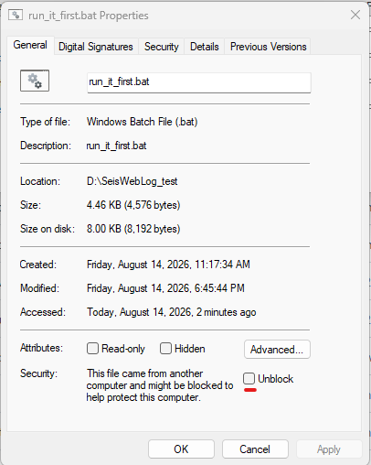
- Then launch run_it_first.bat
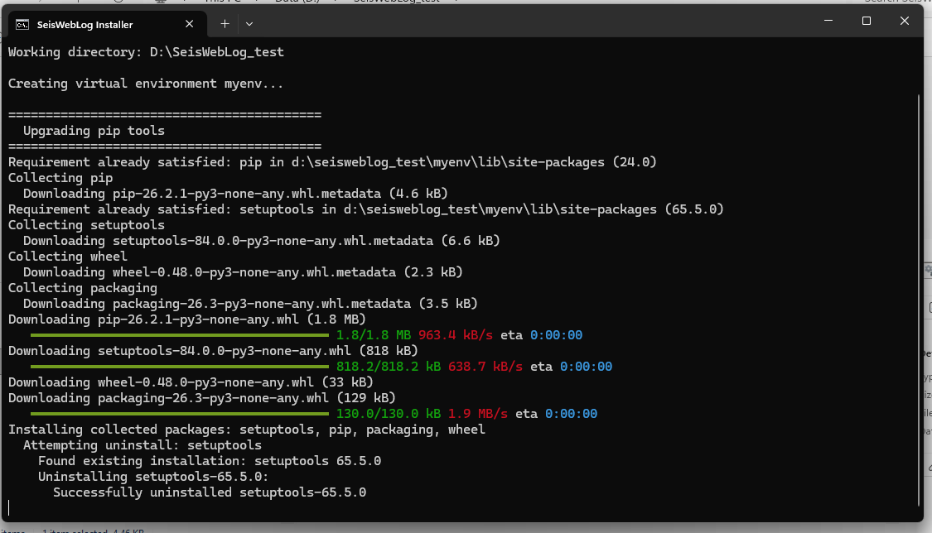

4. Start the program and creation of the First Project

4.1 Sign in and create users
To launch the server user has to run lrunlocal.bat file in program root folder. After that terminal window will be open and server start loading data. And start the server
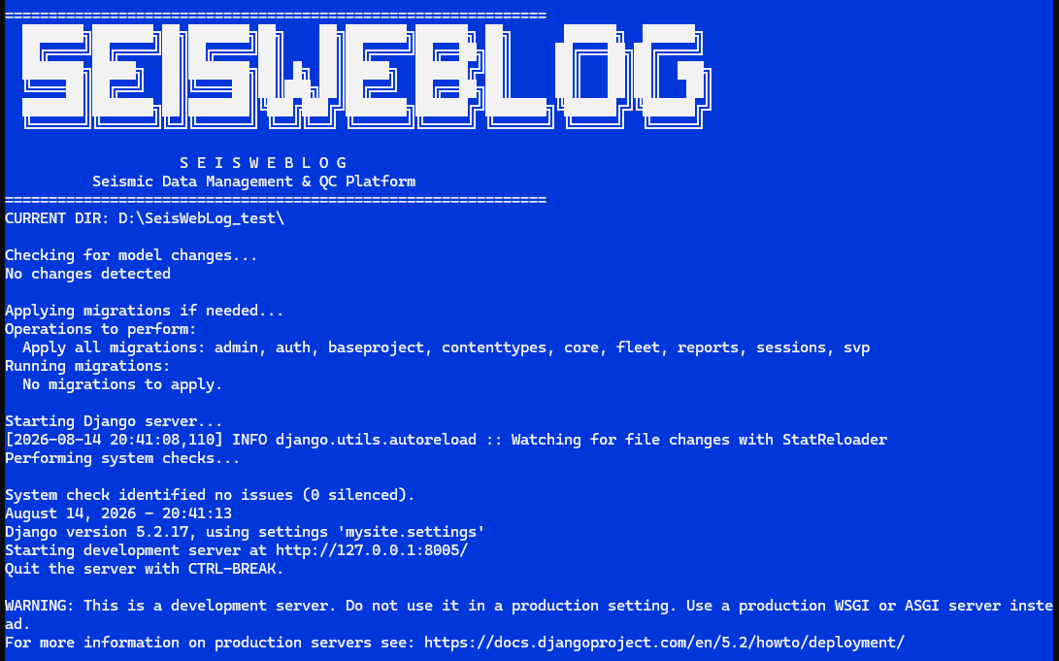
In any browser user has to type the following address http://127.0.0.1:8005/
And should see login window
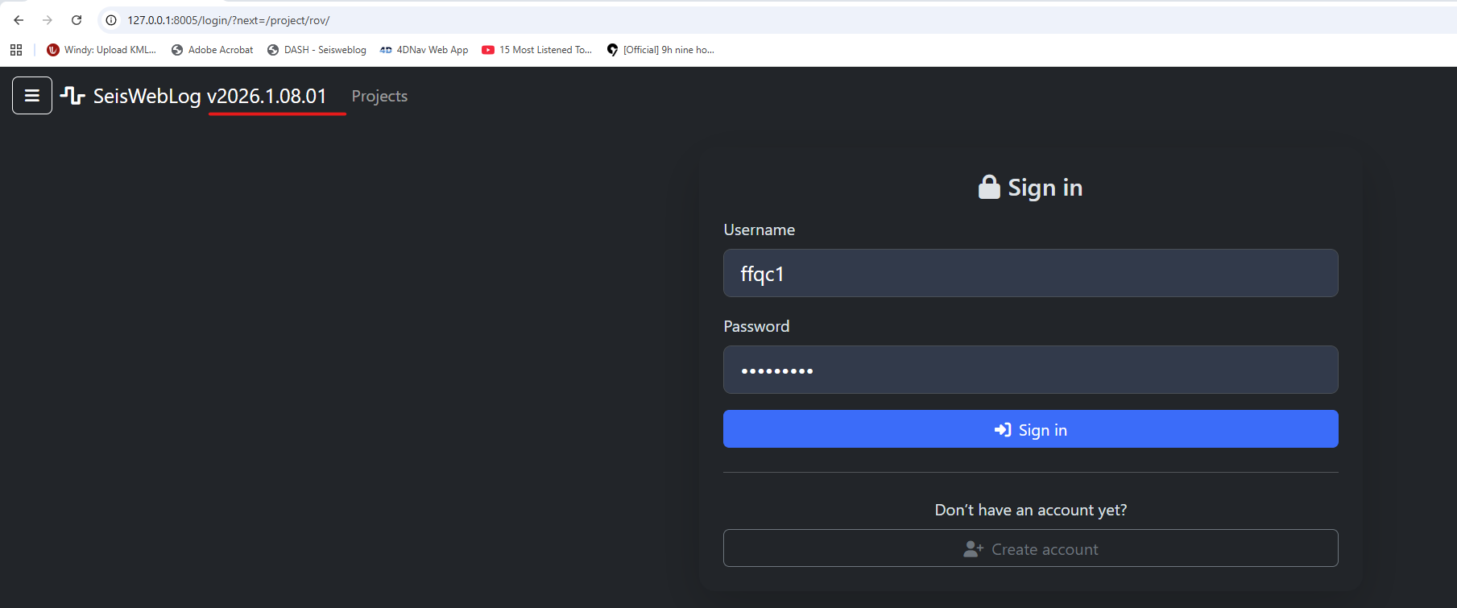
If it is first installation is necessary to create new user and password for that please click on Create account button
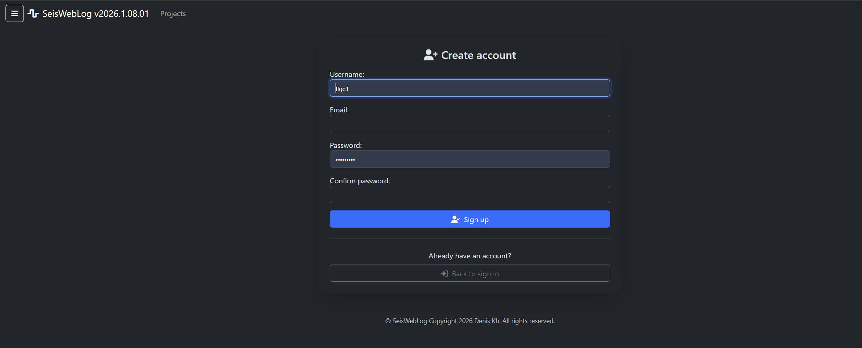 To create new user it is necessary to file the User form with name and passwords
After that you can see the new project window
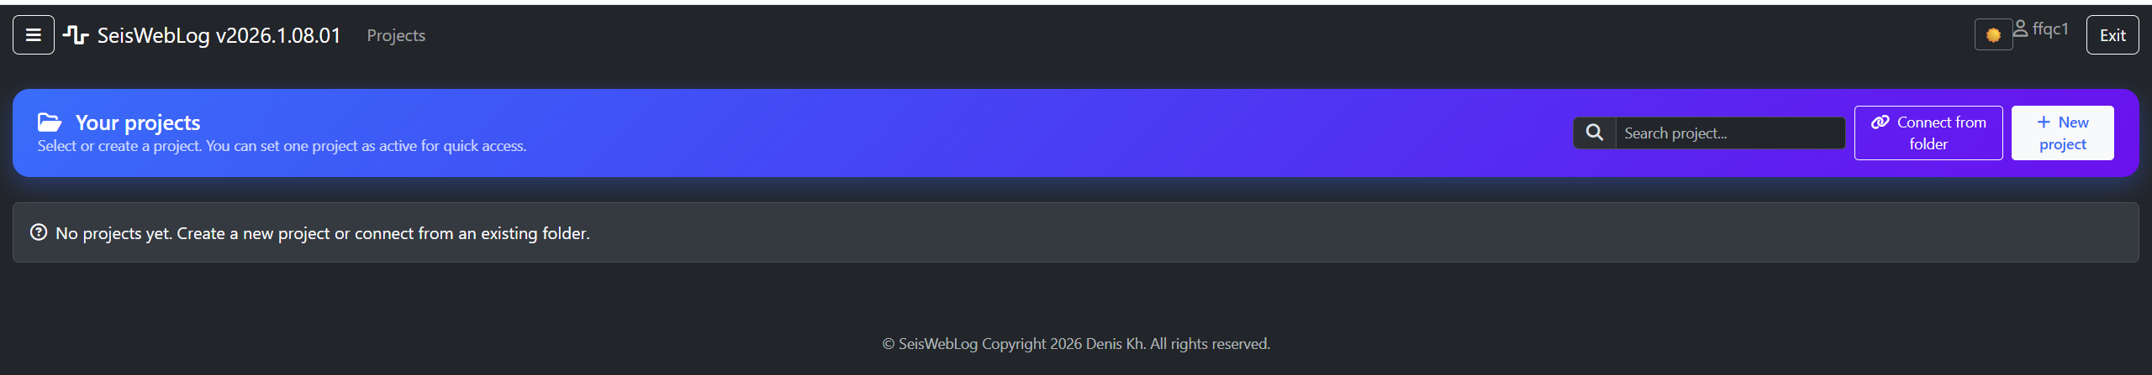
In order to create new project click on New project button then project setup page will show up
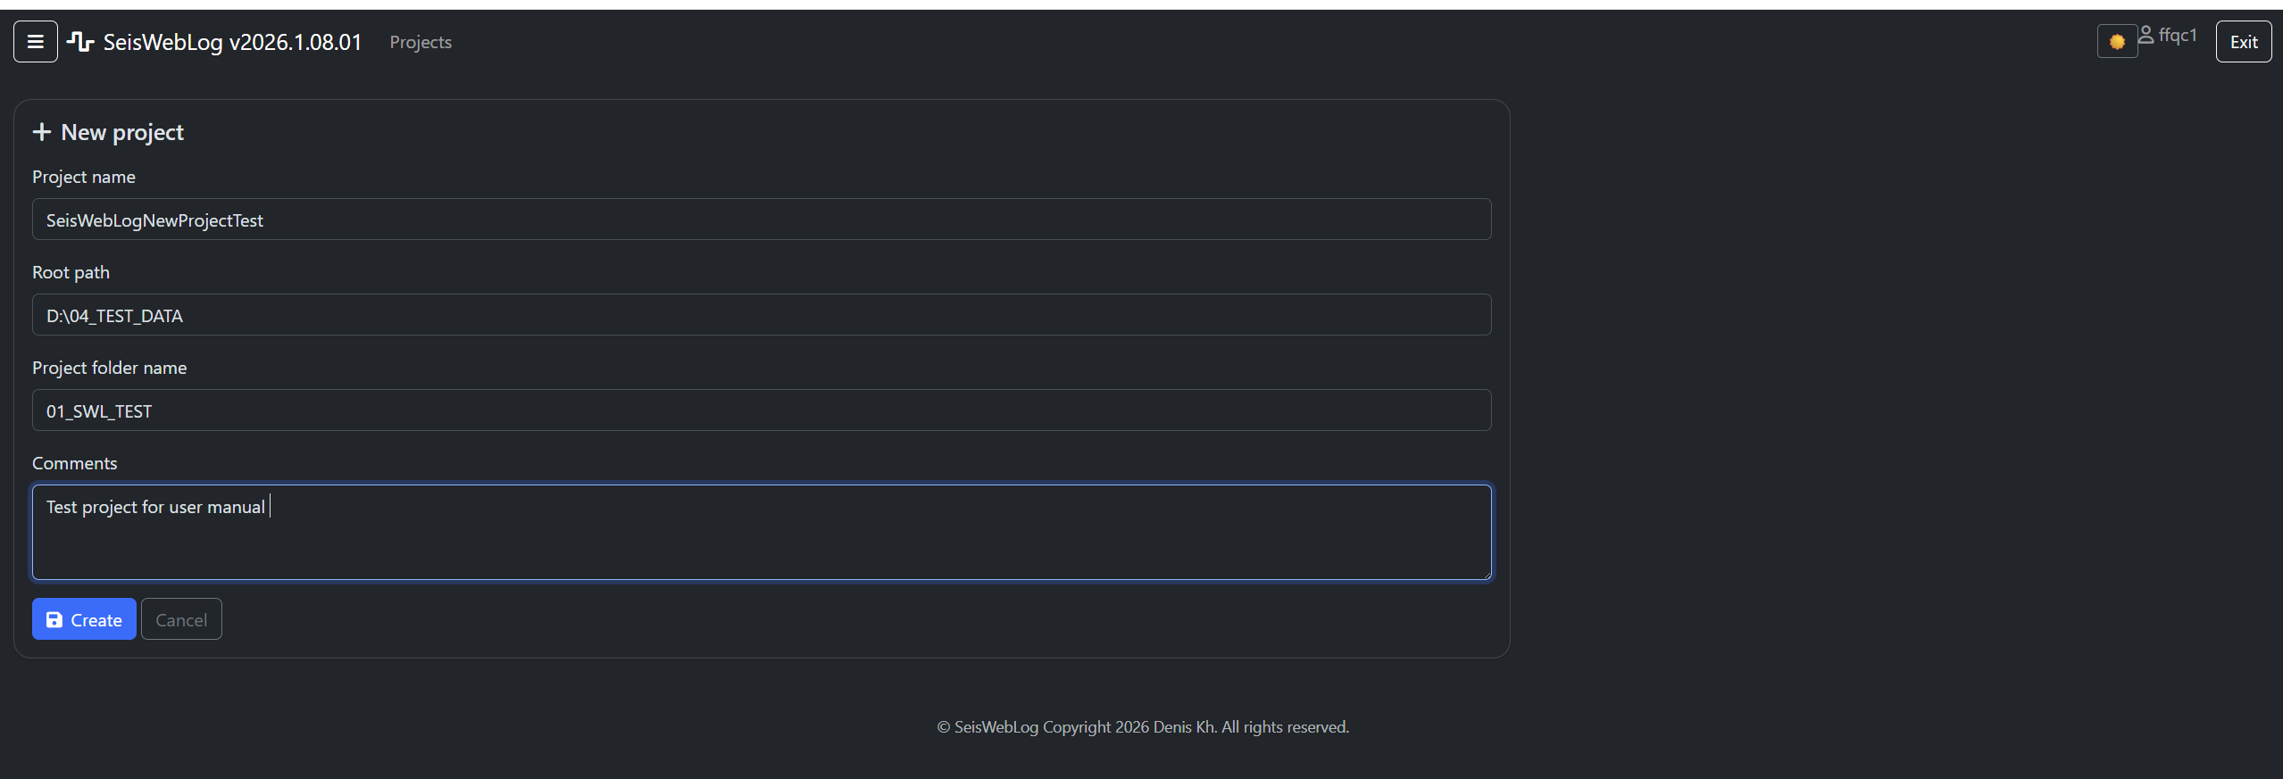
After fill all required fields press Create button at the bottom of the form and new project will be created
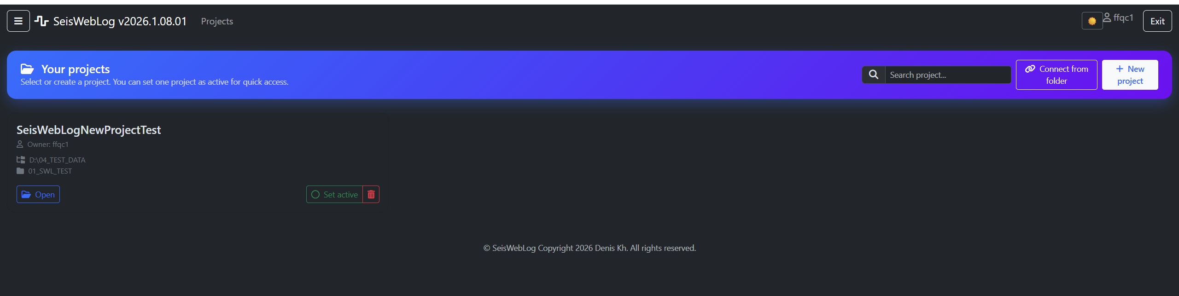
Then set it active by press the button
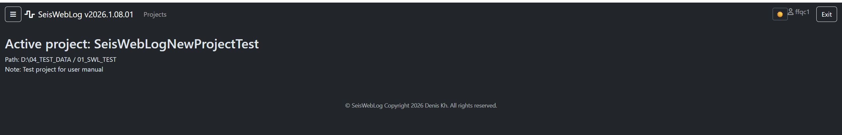
Sign in as administrator. Use the superuser or the administrator account created during installation.
Open user administration. Open the Django administration page or the application's user-management page.
After that click on sandwich button in top left corner of browser and open main program menu. There are some items started with numbers 1,2,3,4 it sequential steps to set up new project. User has to click on them 1 by 1
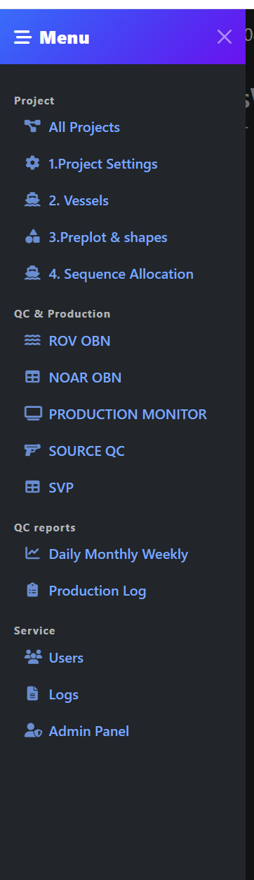

Start with 1.Project Settings.
And fill the requested forms. If on the moment of creating the project all parameters were not defined user can edit them in future
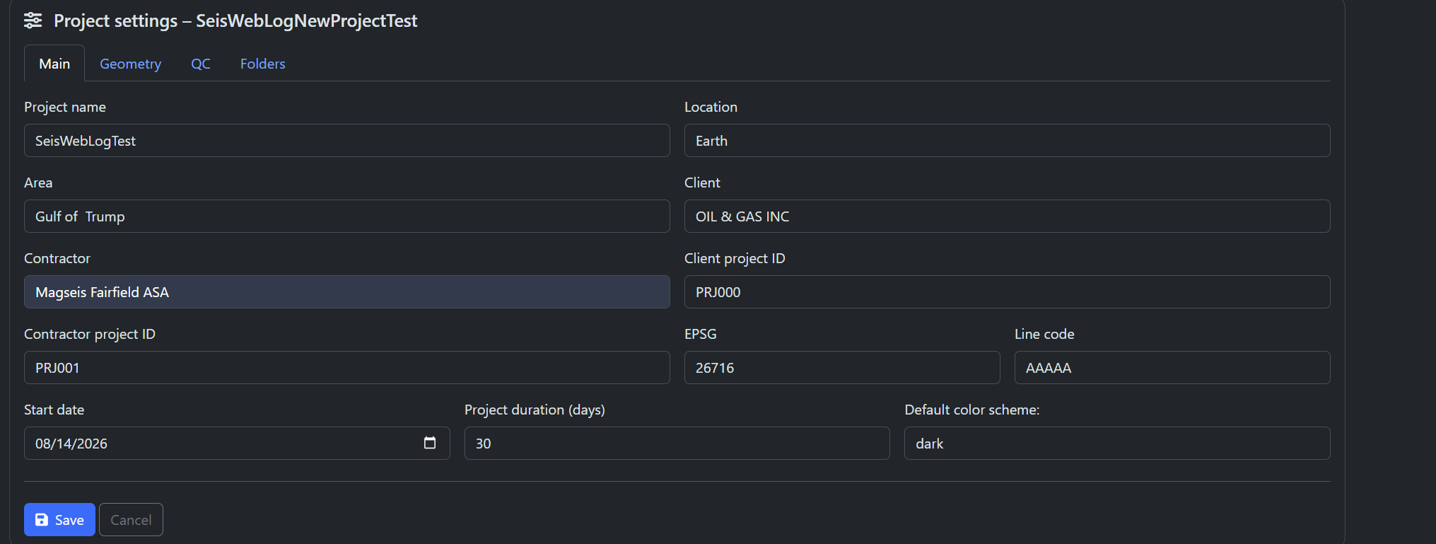
Very important to set up proper mask for receiver and source lines otherwise Preplot will be not properly uploaded
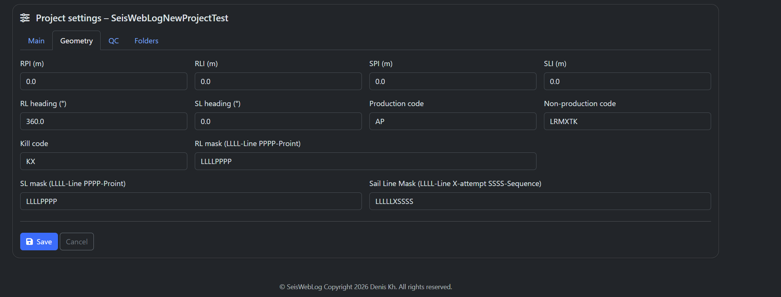
QC parameters will be used for cfurther QC receiver and source lines and can be edited later
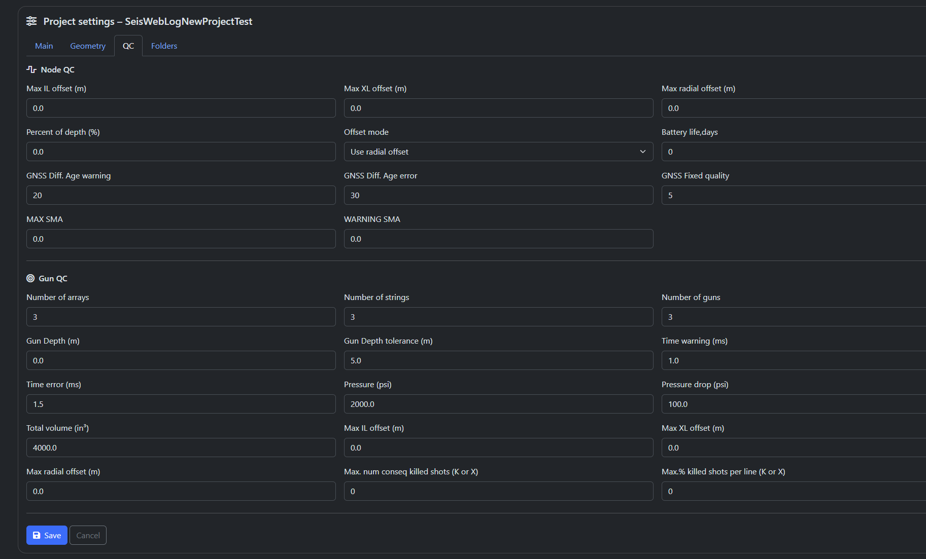
Folders tab is not realy in use.
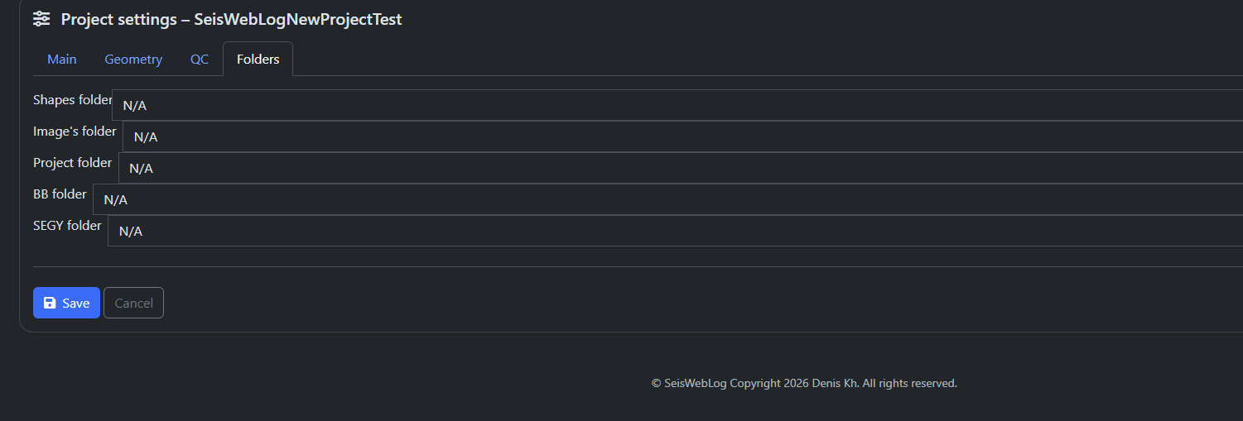
2.Vessels
On this page user can set up the vessels which will be used as company fleet. The vessel list contained almost all vessels which some when were utilized on the seismic project
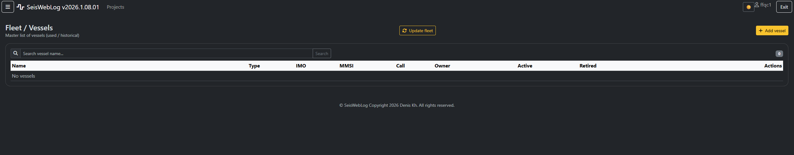
In order to upload list of the vessels click on update fleet button
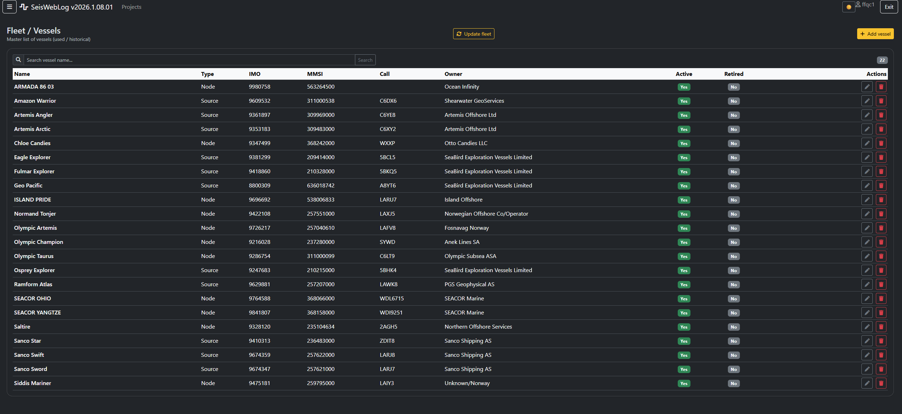 if your vessel not on the list click add vessel button and fill the form for new vessel
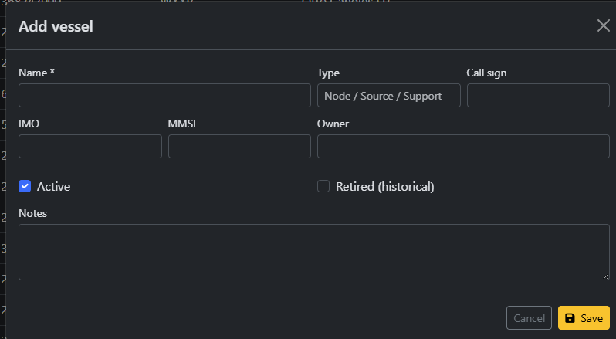
- Prpelot & Shapes

Create user accounts. Create an individual account for each operator; avoid shared accounts where auditability is required.
Assign permissions. Grant only the required view and edit permissions for projects and modules.
Test access. Sign in with a standard user account and confirm that restricted functions are not available.

4.2 Create a project
- Open Projects. Select the project-management page and choose Add Project.
- Enter metadata. Enter project name, location, area, client, contractor, project identifiers, and other required details.
- Set the coordinate reference system. Enter the correct EPSG code, for example EPSG:32615 when that is the approved project CRS.
- Set line masks. Configure the receiver-line and source-line masks in Project Geometry. Confirm line, point, attempt, and sequence positions before importing.
- Save the project. Save the record and verify that the associated database and folders are accessible.
- Activate the project. Set the new project as the active project in User Settings.
Active project: Always check the active project before importing, deleting, editing, or generating reports. SeisWebLog operations are project-specific.

4.3 Recommended initial import order
Order | Data | Reason
1 | Project metadata and geometry | Defines project identity, CRS, and parsing masks.
2 | RPPreplot and SPPreplot | Provides planned receiver and source positions.
3 | Project shapes | Adds boundaries, exclusions, infrastructure, and reference geometry.
4 | Fleet, vessels, purposes, and sequence assignments | Supports source and production attribution.
5 | Operational data | DSR, Survey Manager, REC_DB, SPS, SHOT_TABLE, BlackBox, MFA, and SVP.

5. Daily Operating Workflow
- Confirm the active project. Check the project name and coordinate system before opening files.
- Back up the database. Create a recoverable copy before a large import, schema update, merge, or delete operation.
- Receive and verify source files. Confirm filename, revision, date, vessel or ROV, line range, record count, and coordinate system.
- Import into the correct module. Use the preview and validation results before committing records.
- Review summaries and maps. Check counts, ranges, spatial position, timestamps, duplicates, and missing values.
- Run QC. Use module plots and DataViewer2 to investigate offsets, headings, tracks, depths, and progress.
- Export or report. Generate the required operational export or report and review it before distribution.
- Record issues. Document discrepancies, corrected files, excluded records, and the final accepted revision.

6. Preplots and Project Shapes

6.1 Import RPPreplot
- Open Base Project. Select the Receiver Preplot import function.
- Choose the approved file. Select the receiver preplot source and confirm its CRS and field mapping.
- Preview line and station parsing. Verify that the receiver-line mask produces the expected Line and Station values.
- Validate coordinates. Review easting, northing, first/last point, planned point count, and line bearing.
- Import. Commit the validated rows and review the receiver-line summary.

6.2 Import SPPreplot
- Open Source Preplot. Select the source preplot import function.
- Verify line mask and production definition. Confirm source-line parsing and the approved production point-code rules.
- Preview and import. Validate record counts and coordinates, then commit the source preplot.

6.3 Project shapes
- Open Project Shapes. Import the approved shapefile or GeoPackage layer.
- Confirm CRS. Assign or transform the source CRS to the project CRS when necessary.
- Set style. Choose line color, line width, fill color, fill state, and hatch where supported.
- Save and review. Confirm the shape aligns with preplot and operational data.

7. Receiver and ROV Data

7.1 DSR import and review
- Open the ROV module. Choose the DSR import page for the active project.
- Select the file and operation. Identify deployment or recovery data and the applicable solution.
- Map required fields. Verify Line, Station, Node, timestamps, primary/secondary coordinates, elevations, ROV, status, and solution.
- Preview validation. Check invalid timestamps, duplicate Line/Station/Node combinations, missing coordinates, and out-of-range positions.
- Import. Commit only after the preview agrees with the source file.
- Review line summaries. Check deployed/retrieved counts, first/last times, ROV statistics, offsets, sigmas, and station ranges.

7.2 Survey Manager data
- Open Survey Manager import. Choose deployment or recovery and select the received file.
- Verify identifiers. Confirm QR code, RFID, Line, Station, Remote Unit, coordinates, depth, day, and time.
- Merge carefully. When merging Survey Manager and DSR, confirm the matching keys and inspect unmatched records.
- Export. Choose line/station and timestamp ranges, then select deployment or recovery output.
- Review coordinates. If Always export Primary Deployment coordinates is enabled, confirm that this is the intended operational rule.
Merge safety: Never replace the production database with a newly created schema or blank table to solve an import error. Back up first and use migrations or targeted ALTER TABLE operations.

7.3 REC_DB first-break data
- Open REC_DB import. Select the approved processed receiver file.
- Verify preplot matching. Confirm that each record matches the correct RLPreplot foreign key.
- Review coordinates. Compare REC_X/REC_Y with preplot and, where applicable, RFIELD_X/RFIELD_Y.
- Import and review. Check processed counts in receiver-line summaries and use the REC_DB polar plots.

7.4 BlackBox data
- Select the BlackBox configuration. Choose the configuration matching the vessel and sensor mapping.
- Import one or more files. Confirm filenames, configuration, timestamps, and duplicate handling.
- Verify mapped sensors. Check vessel, GNSS1/GNSS2, ROV1/ROV2, TMS, depth sensors, DOP, NOS, DiffAge, FixQuality, and MRU fields as applicable.
- Run BlackBox QC. Review GNSS quality, vessel/ROV motion, heading/COG, tracks, depth, and time coverage.
- Add a BBOX track. In DataViewer2, choose Deployment, Recovery, or Both and add the track by receiver-line group or layer.
- Inspect headings. Click a track point to show vessel and ROV heading in the heading panel.

7.5 Receiver QC navigation
- Open Receiver QC. Choose the receiver line and load its stations.
- Select a station. Use the station list or click the station on the map.
- Move through stations. Use Previous and Next. The vertical cursor on synchronized QC plots should move to the selected event time.
- Review evidence. Check DSR coordinates, BlackBox track, headings, depth, timestamps, and OCR images for pre-deployment, deployment, or retrieval.
- Record the conclusion. Classify the issue and save comments or exported evidence according to project procedure.

8. Source Data

8.1 SPS source import
- Open Source › SPS Upload. Select one or more approved SPS files.
- Set import options. Choose SPS revision, vessel, solution/purpose, and any project-specific parsing options.
- Handle year correctly. Use Auto year by JDay only when the source file and project procedure support it; otherwise enter the correct year.
- Preview parsed data. Verify line, sequence, attempt, point, point code, fire code, coordinates, water depth, elevation, date, and time.
- Validate production codes. Confirm that Project Geometry production_code identifies the approved production fire codes.
- Import and review. Check sail-line totals, first/last points, time range, line length, production, non-production, kill, and purpose.

8.2 Shot table import
- Open Shot Table Upload. Select the approved shot table file.
- Choose year handling. Leave Auto year by JDay off unless automatic calculation is required and validated.
- Map fields. Verify nav line code, line, attempt, sequence, station, gun depth, water depth, shot coordinates, time, array/source ID, elevation, and post point code.
- Preview duplicates and errors. Resolve invalid required controls, missing values, and duplicate key combinations before import.
- Compare with SPS. Use the line-summary comparison to review count and attribute differences.

8.3 Vessel, purpose, and sequence assignment
- Maintain project fleet. Create or update vessels used on the project.
- Assign sequence ranges. Set first/last sequence, vessel, purpose, and comments.
- Review attribution. Confirm that sail lines and production summaries show the correct vessel and purpose.

8.4 MFA files and reports
- Open MFA import. Select the approved MFA PDF or supported source.
- Review file metadata. Confirm filename, version, UUID, line, sequence, attempt, vessel, total shots, first/last online shot, and times.
- Review pages. Verify page title, page number, shot range, rows, columns, and extracted values.
- Generate report. Select the required MFA records and choose Generate Report.
- Inspect the report. Confirm the front-page metadata, plots, tables, logos, line, sequence, attempt, and page order before issue.

9. SVP Data
- Prepare paired files. Where available, keep the instrument .000 file together with its matching .svp metadata file.
- Open SVP import. Select one or more file pairs or the supported generic CSV format.
- Confirm parser configuration. Verify delimiter, column mapping, units, header rules, and metadata keys.
- Review metadata. Confirm profile name, ROV, instrument model, coordinates, start date, and start time.
- Review the profile. Plot velocity, temperature, and salinity where present; inspect gaps, spikes, and unrealistic values.
- Import. Commit only validated profiles and retain the source files according to project procedure.
- Export or visualize. Use profile plots and supported 3D water-column views for comparison and reporting.

10. DataViewer2 Desktop

10.1 Mandatory layer groups
Group | Default layers
Survey Manager | SM Deployment; SM Recovery
Preplot | RPPreplot; SPPreplot (hidden by default)
DSR | Primary Deployment; Secondary Deployment; Primary Recovery; Secondary Recovery
REC_DB | Processed receiver positions
Project Shapes | Project boundaries and user-defined reference shapes

10.2 Basic navigation
- Open a project. Confirm the active project database and EPSG code.
- Control visibility. Use layer checkboxes; expand or collapse groups as needed.
- Pan and zoom. Use the mouse controls and zoom-to-layer or zoom-to-selection commands.
- Select features. Click a point or shape to inspect its attributes.
- Change theme. Use View › Day/Night where available.

10.3 User layers and styling
- Create a layer. Choose the data source and fields, then define the group and layer name.
- Choose symbols. Set point color, size, category field, line width, fill, or per-file color as applicable.
- Configure labels. Select label fields and define format, font size, offset, and zoom-dependent visibility.
- Save style. Save the layer and label configuration so it can be restored on the next project session.
- Organize layers. Create groups, drag layers between groups, multi-select, or delete user-defined layers.

10.4 Measurements and matching
- Choose a measurement tool. Select Distance, Area, Bearing, or Angle from the ribbon.
- Click map points. Add the required vertices and finish the measurement using the indicated command.
- Review units. Confirm that distance and area units match the project coordinate system.
- Match points. Use Match Points to compare preplot with DSR primary or recovery positions and review the connecting vectors.

10.5 3D view
- Choose the surface source. Select bathymetry from SPSolution or DSR.
- Set the parameter. Choose Water Depth, Radial Offset, or another supported surface attribute.
- Add overlays. Display receiver positions, heat maps, isolines, or other supported spatial layers.
- Inspect scale. Confirm horizontal and vertical scales before interpreting slopes or apparent relief.

11. QC Plots and Production Monitoring

11.1 Receiver QC plots
- Bullseye plots compare deployment and recovery positions with RPPreplot and REC_DB.
- Polar histograms show direction and magnitude of coordinate differences.
- Sigma, radial, range, and primary-to-secondary statistics support position-quality assessment.
- Speed and heading maps provide time-based vessel and ROV motion review.

11.2 Production monitor
- Open Production Monitor. Choose the active project and required view.
- Review receiver cells. Compare planned, deployed, and retrieved counts for each receiver line.
- Review source headers. Check assigned vessel, sequence, and completion status for each source line.
- Review colors. Interpret colors using the legend: preplot, deployed, completed, recovered, and partially recovered states.
- Review vessel summary. Separate Production, Production-Infill, Non-Production, Non-Production-Infill, Test, Kill, and Other metrics according to project definitions.
- Check forecasts. When available, review average speed and end-of-job projection using the approved calculation window.

11.3 Plot interpretation rule
Validation rule: A visually plausible chart is not proof that the underlying query is correct. Compare chart totals with database summaries and a known sample before operational release.

12. Reports and Exports
- Select the correct project and records. Verify project, vessel, ROV, line, station, sequence, attempt, and date range.
- Choose output settings. Select coordinate source, units, plot options, page range, and report template.
- Generate. Create the report or export in the required format.
- Open the result. Check page count, headers, logos, tables, plots, captions, and filename.
- Reconcile totals. Compare totals and ranges with the screen summary and source data.
- Issue the file. Move the reviewed result to the approved project folder and record its revision.
Data release: Do not distribute a generated report solely because generation completed without an error. Always perform a visual and numeric review.

13. Backup, Restore, and Updates

13.1 Backup
- Stop writes. Ask users to close import/edit operations and stop the local service if required.
- Identify the active database. Confirm the exact SQLite file used by the active project.
- Copy project data. Copy the SQLite database, project configuration, media/uploads, custom style JSON, and required exports.
- Label the backup. Include project name, date/time, application version, and reason.
- Verify. Open or integrity-check the copy and confirm its size is reasonable.

13.2 Restore
- Preserve the current state. Back up the current files before replacing anything.
- Stop SeisWebLog. Ensure no web or desktop process has the database open.
- Restore matching files. Restore the database together with compatible configuration and media.
- Start and verify. Open the project, check counts, and test representative records and reports.

13.3 Update
- Read release notes. Identify schema migrations, configuration changes, and dependency updates.
- Back up all affected projects. Make recoverable backups before the update.
- Install or replace program files. Use the approved installer or source-release procedure; do not overwrite project data.
- Update dependencies. For a source installation, activate the virtual environment and install the release requirements.
python -m pip install -r requirements.txt
- Apply migrations. Run the supplied migrations; do not rebuild populated tables manually.
python manage.py migrate
- Validate. Test login, imports, DataViewer2, summaries, plots, and reports before returning to production.

14. Troubleshooting
Symptom | Likely cause | Action
Login page does not open | Server stopped, wrong address, firewall, or port conflict | Check the server console and configured URL; confirm the service or runserver process is active.
ModuleNotFoundError | Virtual environment inactive or dependencies missing | Activate .venv and install the approved requirements file.
Database is locked | Another process is writing or a previous process did not exit | Close import tools and desktop windows; wait for writes to finish; restart only after confirming a backup.
Map layer is missing | Layer hidden, wrong group, filter, CRS, or empty query | Enable the layer, clear filters, zoom to layer, and verify EPSG and record count.
Imported dates are empty | Source format not recognized or field mapping incorrect | Inspect sample timestamps and parser mapping; normalize supported formats before import.
Invalid form control is not focusable | Hidden required field remains required | Update the form logic so disabled/hidden controls are not required; re-open the modal and validate.
Counts differ from source | Duplicate rules, production-code definition, filter, or purpose assignment | Compare preview counts, unique keys, fire codes, purpose mapping, and date/line filters.
Report layout is wrong | Template, font, page-break, or plot-size issue | Regenerate after checking template assets and review every rendered page.
DataViewer2 closes unexpectedly | Native graphics/library error, invalid geometry, or large layer | Record the traceback, isolate the layer, validate geometry, and retry with the approved environment.

14.1 Information to include in a support request
- SeisWebLog version and installation type.
- Windows version and Python version.
- Active project name and database path, with sensitive paths redacted if necessary.
- Module, page, and exact action being performed.
- Full traceback or browser-console message.
- A small sanitized sample file that reproduces the problem.
- Expected result and actual result.

15. Operational Safety Checklist
- Confirm active project before every import or edit.
- Confirm EPSG code and units before spatial review.
- Back up before migrations, schema changes, bulk corrections, or deletes.
- Preview imports and reconcile record counts.
- Do not count test, kill, or non-production points as preplot production unless the project definition explicitly requires it.
- Validate timestamp field selection: deployment TimeStamp versus recovery TimeStamp1.
- Review unmatched records after every merge.
- Check report totals and every page before issue.
- Retain the accepted source revision and document corrections.

Appendix A — Key Data Entities
Entity | Description
project_main / project_geometry | Project metadata, EPSG, masks, and production/non-production codes.
RLPreplot / RPPreplot | Receiver preplot lines and points.
DSR | Receiver deployment and recovery positions, timestamps, ROVs, status, and QC metrics.
REC_DB | Processed/first-break receiver positions.
SLSolution / SPSolution | Source sail-line summaries and source point solutions.
SHOT_TABLE | Shot table navigation, timing, gun depth, water depth, and coordinates.
BlackBox_Files / BlackBox | Imported navigation files and time-series vessel, GNSS, ROV, depth, DOP, and MRU data.
MFA_Files / MFA_Pages / MFA_Values | MFA source documents, pages, ranges, and extracted values.
SVP_Files / SVP_Profiles / SVP_Data | Sound-velocity files, profile metadata, and depth-dependent measurements.

Appendix B — Final Release Validation
Before publishing this manual as a controlled document, the release owner should verify the following values against the final SeisWebLog package:
- Installer filename, version, signing status, and supported Windows versions.
- Actual installation and project-data folders.
- Desktop/DataViewer2 launcher filename and command.
- Production web-server/service name, URL, port, TLS, and firewall requirements.
- Exact requirements file and Python patch version.
- Administrator and user-management navigation labels.
- Current menu, ribbon, modal, button, and report-template names.
- Company branding, support contact, document owner, and approval status.
Next revision: After validation against the final build, update this document to version 1.0 and add application screenshots for the principal installation, import, QC, and reporting procedures.

