FRS — Recycle Bin (Cloud module)
Functional Requirements Specification · Web3 Super App · User stories & acceptance criteria are embedded in section 5. This FRS stands alone; no BRD exists yet.

Document information
Document name | FRS — Recycle Bin (Cloud module)
Version | v0.8 (Draft)
Status | Draft — for review
Author (BA) | BA (assembled with AI assistant)
Related BRD | None — FRS stands alone
Created / Updated | 2026-07-16 (v0.8: File Restore fallback; item shows origin path + countdown; entry from home; retention 7 days; restore rename; filter chips; sort = soonest-to-expire; SC-06 folder confirm + SC-08 shared confirm; no open questions)

1. Overview & purpose
Recycle Bin is a data-safety feature of the Cloud module (the data-management module of the Web3 super app, comparable to Quark). When a user deletes a file or folder, it is moved to the Recycle Bin (soft delete) rather than removed immediately. Within a retention window the user can restore the item or delete it permanently; once the window elapses the item is purged automatically. Items held in the Recycle Bin do not consume the user's storage quota.
This document specifies the functional behaviour, user stories, acceptance criteria and screens for the feature. Membership (SVIP) recovery is out of scope. This is an enhancement of the current app, so existing components (delete confirmation, search) are reused as-is. Per-wallet scoping is inherited from the existing wallet-bound app; GDPR is not required for this release.

Definitions
Term | Meaning
Retention Window | The fixed period a deleted item is kept before automatic permanent purge — 7 days.
File Restore | The shared fallback folder in main Files where an item is placed when it is restored but its original path no longer exists.
hash | Existing search field carried over from the current app (file content hash).

2. Functional scope

In scope
- Soft-delete of files/folders into the Recycle Bin and their exclusion from storage quota.
- Restore to the original path, with a fallback location when the original path no longer exists.
- Permanent deletion of single items, multi-selected items, and 'Empty all', each behind a confirmation.
- Automatic purge at the end of the retention window.
- Browsing the bin: item list, empty state, folder browse; filter by type, sort, and search (by file name / hash / folder).
- Multi-select mode and per-item / bulk action sheets; the 'Recycle Bin Rules' help sheet.

Out of scope
- Membership (SVIP): the paid File Recovery service (180-day retention), its Privacy-Settings opt-out toggle, and all SVIP upsell surfaces.
- Retention-window extension (e.g., 'Extend to 30 days'), which was tied to membership.
- File encryption behaviour (explicitly excluded from this document).

Not covered in this release (inherited / not required)
- Web3 wallet-level behaviour of the bin (per-wallet scoping, account switch, seed-phrase recovery, offline, logout cleanup) — inherited from the existing wallet-bound app; no new behaviour is specified here.
- GDPR erasure handling — not required for this release (PO).

3. Actors / user roles
Actor | Description | Key permissions
User | Wallet-authenticated owner of the Cloud data; all bin data is scoped to their wallet. | View, restore, and permanently delete items in the Recycle Bin.
System | The application / back-end. | Automatically purges items whose retention window has elapsed.

4. Functional requirements
The 'how'. This FRS stands alone, so the 'Traces to (BR)' column is omitted.
ID | Functional requirement | Priority
FR-01 | The system moves a deleted file or folder to the Recycle Bin (soft delete) instead of removing it immediately. | Must
FR-02 | Items in the Recycle Bin are excluded from the user's cloud storage quota. | Must
FR-03 | The system permanently and automatically purges each item when its Retention Window (7 days) elapses. | Must
FR-04 | The system shows a persistent banner stating deleted items don't use storage and are auto-cleared after 7 days. | Must
FR-05 | The system restores a selected item to its original path. | Must
FR-06 | If the original path no longer exists, the system restores the item into the shared 'Files > File Restore' folder in main Files. | Must
FR-07 | The system permanently deletes a selected item. | Must
FR-08 | The system permanently deletes all items via 'Empty all' (header trash icon). | Must
FR-09 | Every permanent-delete action requires a confirmation dialog before execution: deleting a single folder (from the folder-detail screen) uses a dedicated dialog (SC-06); deleting a file / multi-selection / 'Empty all' uses the app's existing shared dialog (SC-08). | Must
FR-10 | The system lists deleted items with icon/thumbnail, name, delete time, original path and a days-remaining countdown (per the current app UI). | Must
FR-11 | The system filters the list with chips (single-select, default 'All'): 'All', 'Folders', 'Images', 'Videos', 'Audio', 'Documents', 'Others'. A file-type chip shows only files of that type and hides folders; 'Folders' shows only folders; 'All' shows everything. | Should
FR-12 | The system sorts the list, defaulting to days remaining — items closest to expiry (soonest to be permanently deleted) first; the user can change criterion and direction via a Sort settings sheet. | Should
FR-13 | The system lets the user search within the Recycle Bin by file name, hash and folder, reusing the current app's existing search as-is. | Must
FR-14 | When the bin has no items, the system shows an empty state labelled 'No deleted records yet'. | Must
FR-15 | The system enters multi-select mode when the user long-presses an item or taps the menu (⋮) beside the header trash icon. | Must
FR-16 | In multi-select mode the system shows the selected-item count and provides Select All and Close. | Must
FR-17 | In multi-select mode the system offers Restore and Delete via a bottom 'More' sheet. | Must
FR-18 | On tapping an item the system shows an 'Options' sheet offering Restore and Delete. | Must
FR-19 | The system lets the user open a deleted folder to browse its contents (breadcrumb, sort, empty state 'No file' / 'This folder is empty.'). | Should
FR-21 | The system shows a 'Recycle Bin Rules' bottom sheet (Restore Rules, Storage Usage) via the help (?) control. | Should

5. User stories & acceptance criteria

US-001 — Send deleted items to the Recycle Bin
Traces to: FR-01, FR-02 | Priority: Must
As a Cloud user, I want deleted files and folders to go to the Recycle Bin instead of disappearing, so that I can restore them if I delete something by mistake.
Acceptance criteria
ID | Given (context) | When (action) | Then (expected result)
AC-001.1 | A file or folder exists in Cloud | the user deletes it | the system moves it to the Recycle Bin and it no longer appears at its original location
AC-001.2 | An item has just been moved to the Recycle Bin | the user checks storage | the item's size is not counted against the storage quota
Edge cases / error flows to cover
- Offline behaviour follows the existing app (out of scope).
- Deleting a file automatically removes its Favorite — this is handled by the Favorite feature (Favorite stores references only); not specified further here.
Notes / open questions
- The Recycle Bin is entered from the home page. The delete action itself is triggered from the Cloud file browser (no wireframe provided).

US-002 — Browse deleted items
Traces to: FR-10, FR-14, FR-19 | Priority: Must
As a Cloud user, I want to see everything I've deleted in one place, so that I can find an item to restore or delete for good.
Acceptance criteria
ID | Given (context) | When (action) | Then (expected result)
AC-002.1 | The bin has items | the user opens the Recycle Bin | the system lists each item with icon/thumbnail, name, delete time, original path and a days-remaining countdown, sorted by days remaining — soonest to expire first
AC-002.2 | The bin has no items | the user opens the Recycle Bin | the system shows the empty state 'No deleted records yet'
AC-002.3 | A deleted folder with contents is in the list | the user opens it | the system shows its direct children under breadcrumb 'Recycle Bin / <folder>'
AC-002.4 | A deleted empty folder is in the list | the user opens it | the system shows the empty state 'No file' / 'This folder is empty.'
Edge cases / error flows to cover
- Very long file names / missing thumbnails — display handling to confirm.
Notes / open questions
- Item rows show the origin path + a days-remaining countdown (per the current UI).
- Folder detail is specified in SC-07.

US-003 — Find and sort deleted items
Traces to: FR-11, FR-12, FR-13 | Priority: Should
As a Cloud user, I want to filter, sort and search within the Recycle Bin, so that I can quickly find a specific item.
Acceptance criteria
ID | Given (context) | When (action) | Then (expected result)
AC-003.1 | The list has both folders and several file types | the user selects a file-type chip (e.g. 'Images') | the system shows only files of that type and hides folders
AC-003.2 | The user opens the Recycle Bin | the screen is shown (sort not changed) | the list is sorted by days remaining — items closest to expiry (soonest to be permanently deleted) first
AC-003.3 | The user has deleted items | the user searches by file name, hash or folder | the system returns matching items within the Recycle Bin
AC-003.4 | The list has folders | the user selects the 'Folders' chip | the system shows only folders
AC-003.5 | The list is shown | the user opens Sort settings and changes the criterion or direction | the list re-sorts accordingly
Edge cases / error flows to cover
- No results on search / filter follows the existing search's behaviour (reused as-is).
Notes / open questions
- Filter-chip labels should match the file-type vocabulary of the Files module (plural, consistent).
- Search reuses the current app's existing search (name / hash / folder), as-is.

US-004 — Restore a deleted item
Traces to: FR-05, FR-06 | Priority: Must
As a Cloud user, I want to restore a deleted item, so that I get my file or folder back.
Acceptance criteria
ID | Given (context) | When (action) | Then (expected result)
AC-004.1 | An item whose original path still exists | the user restores it | the system returns it to its original path and removes it from the bin
AC-004.2 | An item whose original path no longer exists | the user restores it | the system places it in 'Files > File Restore'
AC-004.3 | An item whose target path already contains a same-named item | the user restores it | the system restores it with ' (n)' appended to the name (n = next available number)
Edge cases / error flows to cover
- Restoring while offline follows the existing app (out of scope).
Notes / open questions
- The fallback target is the shared 'File Restore' folder (used for all restored files whose original path is gone).

US-005 — Permanently delete an item or empty the bin
Traces to: FR-07, FR-08, FR-09 | Priority: Must
As a Cloud user, I want to permanently delete items or empty the whole bin, so that I can clear files I definitely no longer need.
Acceptance criteria
ID | Given (context) | When (action) | Then (expected result)
AC-005.1 | A single item is selected | the user chooses Delete and confirms | the system permanently deletes the item and it can no longer be recovered
AC-005.2 | The bin has items | the user taps 'Empty all' (header trash) and confirms | the system permanently deletes every item in the bin
AC-005.3 | A permanent-delete action is triggered | the user sees the confirmation dialog and cancels | no item is deleted
Edge cases / error flows to cover
- Emptying / deleting while offline follows the existing app (out of scope).
Notes / open questions
- There are two confirmation dialogs: (1) a folder-only delete confirm — opened only from the folder-detail screen (SC-06); (2) the app's existing shared dialog for deleting a file / multi-selection / 'Empty all' (SC-08).

US-006 — Act on several items at once
Traces to: FR-15, FR-16, FR-17, FR-18 | Priority: Must
As a Cloud user, I want to select several deleted items and restore or delete them at once, so that I don't have to do it one by one.
Acceptance criteria
ID | Given (context) | When (action) | Then (expected result)
AC-006.1 | The list is shown | the user long-presses an item or taps the menu beside the trash icon | the system enters multi-select mode, showing the selected count, Select All and Close
AC-006.2 | Multi-select mode has selected items | the user opens the 'More' sheet and chooses Restore or Delete | the action applies to all selected items (Delete requires confirmation)
AC-006.3 | The list is shown | the user taps a single item | the system shows the 'Options' sheet with Restore and Delete
Edge cases / error flows to cover
- Select All then deselect one item — the count updates correctly.
- Bulk restore when some items have lost their original path — a mix of original path + 'File Restore' (see US-004).
Notes / open questions
- The multi-select header shows the selected-item count (per the wireframe).

US-007 — Understand retention and storage rules
Traces to: FR-03, FR-04, FR-21 | Priority: Should
As a Cloud user, I want to understand how long deleted items are kept and whether they use storage, so that I know when to act before I lose them.
Acceptance criteria
ID | Given (context) | When (action) | Then (expected result)
AC-007.1 | The Recycle Bin screen is shown | the screen is opened | the system shows a banner stating items don't use storage and are auto-cleared after 7 days
AC-007.2 | An item has been in the bin for its full Retention Window | the window elapses | the system permanently purges the item automatically
AC-007.3 | The Recycle Bin screen is shown | the user taps the help (?) control | the system shows the 'Recycle Bin Rules' sheet with Restore Rules and Storage Usage
Edge cases / error flows to cover
- Retention boundary (exactly at expiry) — purge timing to confirm.
Notes / open questions
- Retention Window = 7 days (decided).
- A per-item countdown (days remaining) is shown, per the current UI.

6. Business rules
ID | Rule | Applies to FR
BRule-01 | Deleted items are excluded from the user's storage quota. | FR-02
BRule-02 | Retention Window = 7 days. On expiry the item is permanently purged and cannot be recovered. | FR-03
BRule-03 | Restore target is the item's original path; if it no longer exists, the fallback is the shared 'Files > File Restore' folder. | FR-05, FR-06
BRule-05 | Permanent deletion (single, multi-select, empty all) is irreversible and always requires explicit confirmation. | FR-07, FR-08, FR-09
BRule-06 | Membership (SVIP) file recovery (180-day) and retention extension are out of scope for this release. | —
BRule-07 | On restore, if a same-named item already exists at the target path, the system appends ' (n)' to the restored item's name (n = next available number). | FR-05

7. Main user flow
7.1 is the clean linear path (restore). Branches & errors are keyed by step in 7.2; the flowchart shows both.

7.0 Entry / precondition
Trigger: the user opens the Recycle Bin from the home page. Precondition: the user is authenticated (wallet) and the bin may contain zero or more previously deleted items.

7.1 Main flow
Step | Actor | Action | System response
1 | User | Opens the Recycle Bin | Shows the deleted-items list, sorted by days remaining (soonest to expire first)
2 | User | Taps an item (or long-presses to multi-select) | Shows the action sheet (Options / More) with Restore and Delete
3 | User | Taps Restore | Restores the item to its original path, removes it from the bin, and returns to the updated list

7.2 Alternate & error flows
Keyed by main-flow step.
At step | Condition | Behavior | Resume / terminate
1 | Bin is empty | Show empty state 'No deleted records yet' | terminate
2 | User long-presses / selects several items | Enter multi-select (count, Select All); actions apply to all selected | resume → 3
3 | Restore: original path no longer exists | Restore into the shared 'Files > File Restore' folder | resume (done)
3 | User taps Delete instead of Restore | Show confirmation dialog; on Confirm purge permanently, on Cancel keep item | Confirm → done · Cancel → resume 2
any | Retention window elapses | System auto-purges the item (background); it disappears from the bin | terminate
any | Offline | Delete / restore / empty follow the existing app's offline behaviour (out of scope for this enhancement) | resume
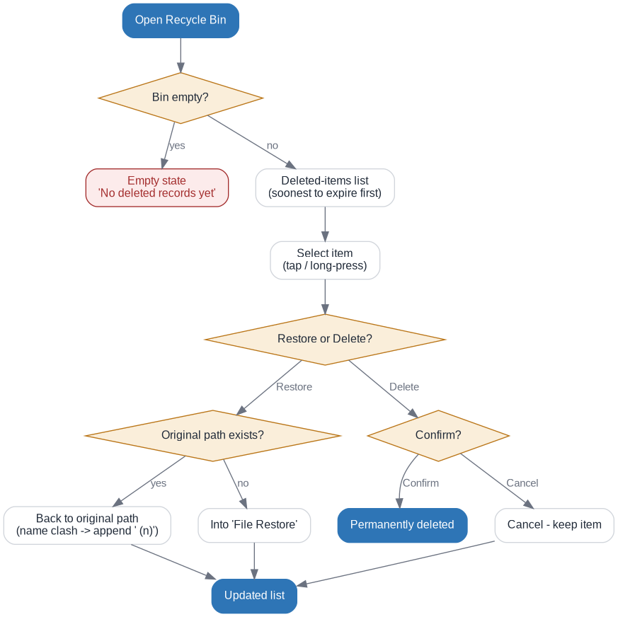

7.3 Postcondition
The selected item is either back in Files (restored to its original path or to the shared 'File Restore' folder) or permanently removed. Storage quota is unaffected by items remaining in the bin.

8. Screen specification
Screens below are the target (wireframe) design. Red-numbered items map to the tables; only feature-relevant items are numbered.

SC-01 — Recycle Bin — Item list
Purpose: The main screen listing deleted items; the entry point for filter, sort, search, restore and delete.
Related to: US-002, US-003, US-006, US-007, FR-10, FR-11, FR-12, FR-15, FR-21
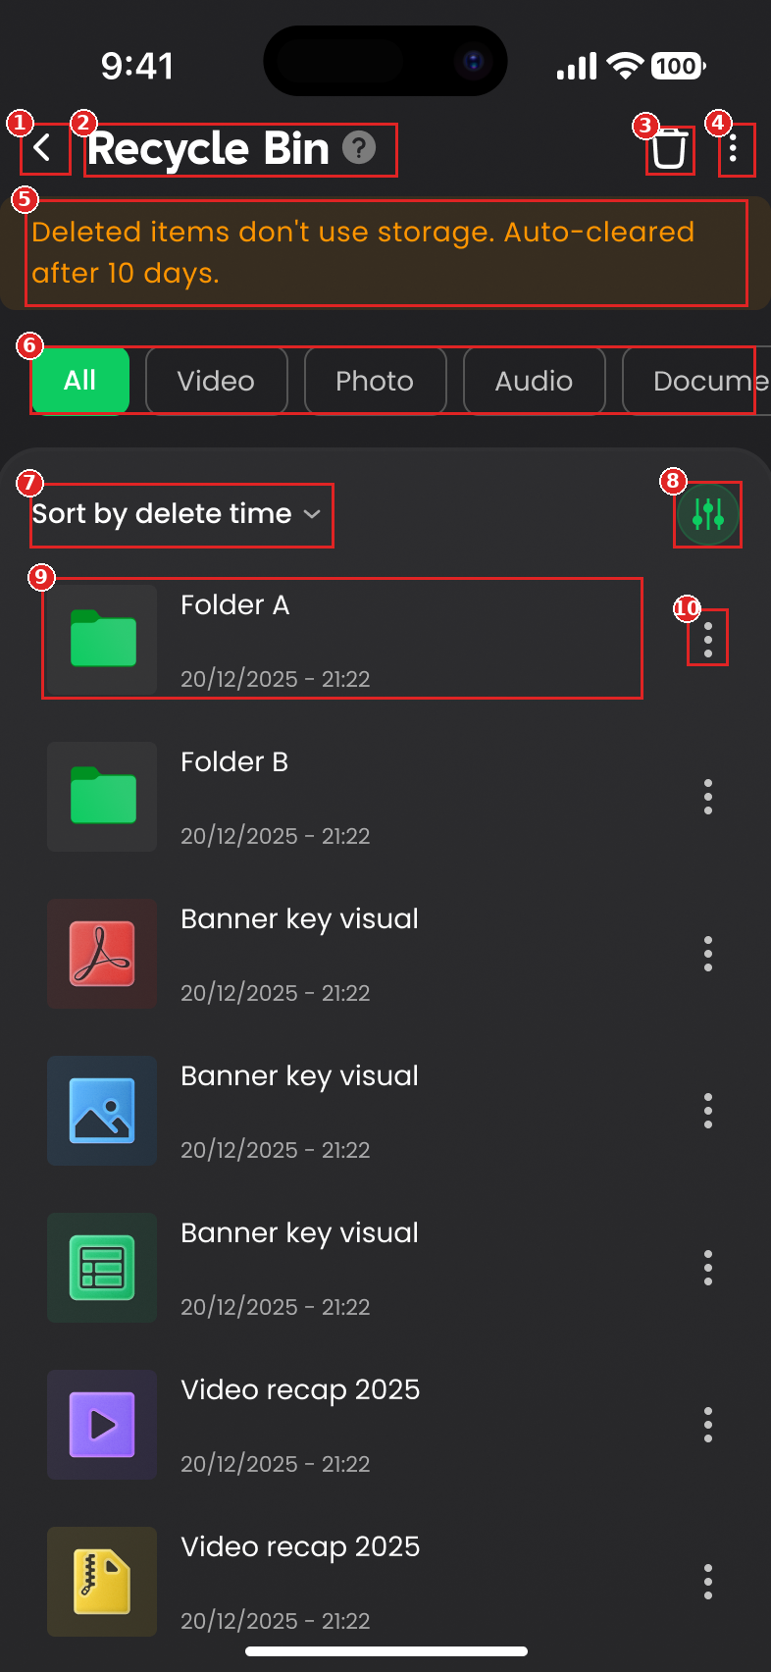
No. | Item name | Type | Description / behavior | Validation | Maps to
① | Back | Button | Returns to the previous screen | — | —
② | Title + Help (?) | Label + Button | Screen title; (?) opens the Rules sheet | — | FR-21
③ | Empty all | Button (trash) | Permanently deletes all items (with confirmation) | Disabled/hidden when the bin is empty; confirmation required | FR-08
④ | Multi-select menu (⋮) | Button | Enters multi-select mode | — | FR-15
⑤ | Retention / storage banner | Banner | States items don't use storage and are auto-cleared after 7 days | — | FR-04
⑥ | Filter chips | Chips | Filter: 'All', 'Folders', 'Images', 'Videos', 'Audio', 'Documents', 'Others' | Single-select; default 'All'; file-type chips hide folders | FR-11
⑦ | Sort control | Control | Shows current sort; opens Sort settings | Default: days remaining, soonest to expire first | FR-12
⑧ | Filter settings | Button | Opens the Filter settings sheet | — | FR-11
⑨ | Item row | List item | Shows icon/thumbnail, name, delete time, original path and a days-remaining countdown | — | FR-10
⑩ | Item action (⋮ / tap) | Button | Opens the Options sheet (Restore, Delete) | — | FR-18
Screen notes
- Search (name / hash / folder, FR-13) reuses the current app's existing search; the dark wireframe doesn't draw it.
- The dark wireframe banner reads '10 days'; the decided retention is 7 days — banner copy must read 7 days.
- The wireframe shows a 'delete time' sort; the decided default is days remaining (soonest to expire first) — sort copy to update.

SC-02 — Recycle Bin — Empty state
Purpose: Shown when the bin has no items.
Related to: US-002, FR-14, FR-04
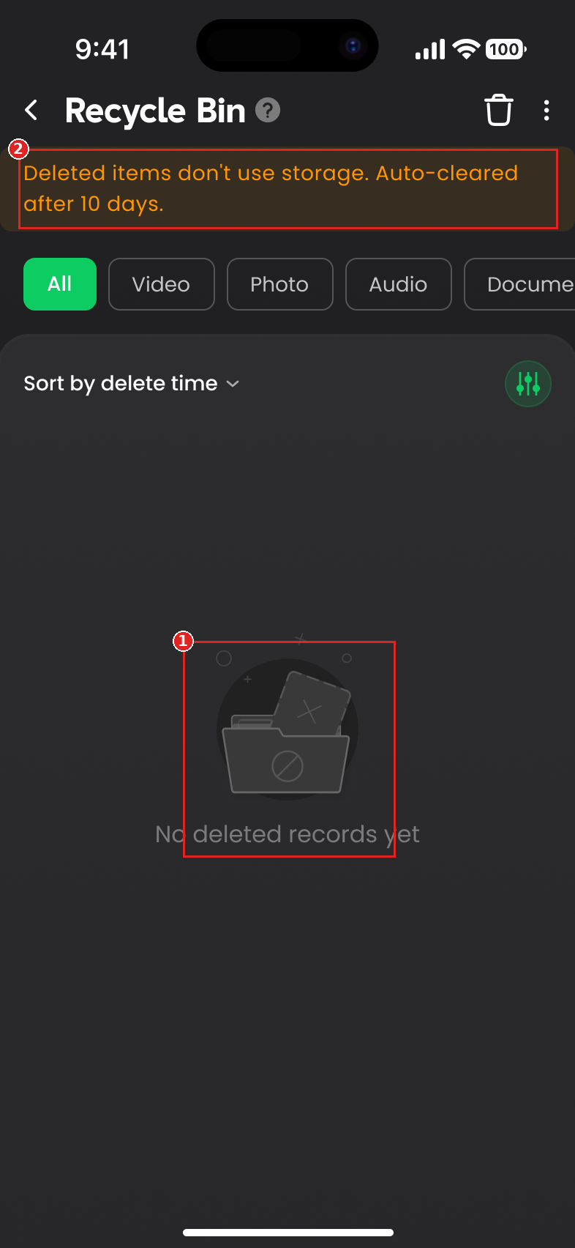
No. | Item name | Type | Description / behavior | Validation | Maps to
① | Empty state | Illustration + Label | Shows 'No deleted records yet' | Shown only when the bin is empty | FR-14
② | Retention / storage banner | Banner | Retention / storage info remains visible in the empty state | — | FR-04
Screen notes
- Confirm the banner remains visible in the empty state.
- 'Empty all' (header trash) should be disabled/hidden when the bin is empty.

SC-03 — Recycle Bin — Multi-select mode
Purpose: Select items in bulk to Restore or Delete.
Related to: US-006, FR-15, FR-16
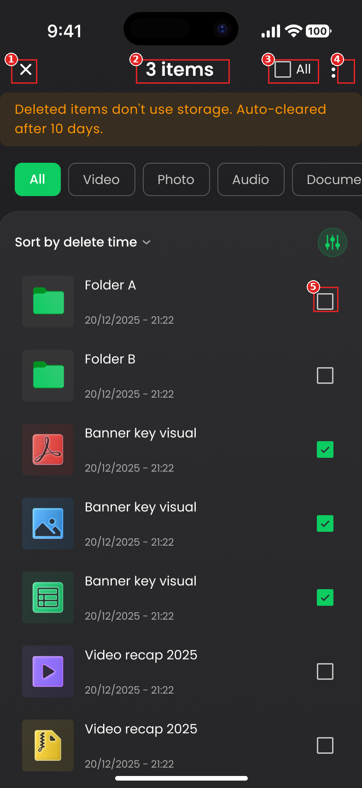
No. | Item name | Type | Description / behavior | Validation | Maps to
① | Close / exit | Button (×) | Exits multi-select back to the list | — | FR-15
② | Selected count | Label | Shows the number of selected items | — | FR-16
③ | Select All | Control | Selects / deselects all items | — | FR-16
④ | Header menu (⋮) | Button | Additional actions | — | FR-15
⑤ | Row checkbox | Checkbox | Selects / deselects an item | — | FR-16
Screen notes
- Bulk Restore / Delete are in the 'More' sheet (see SC-05).

SC-04 — Recycle Bin Rules — bottom sheet
Purpose: Explains the bin's rules; opened via the help (?) control.
Related to: US-007, FR-21, FR-05, FR-06, FR-02
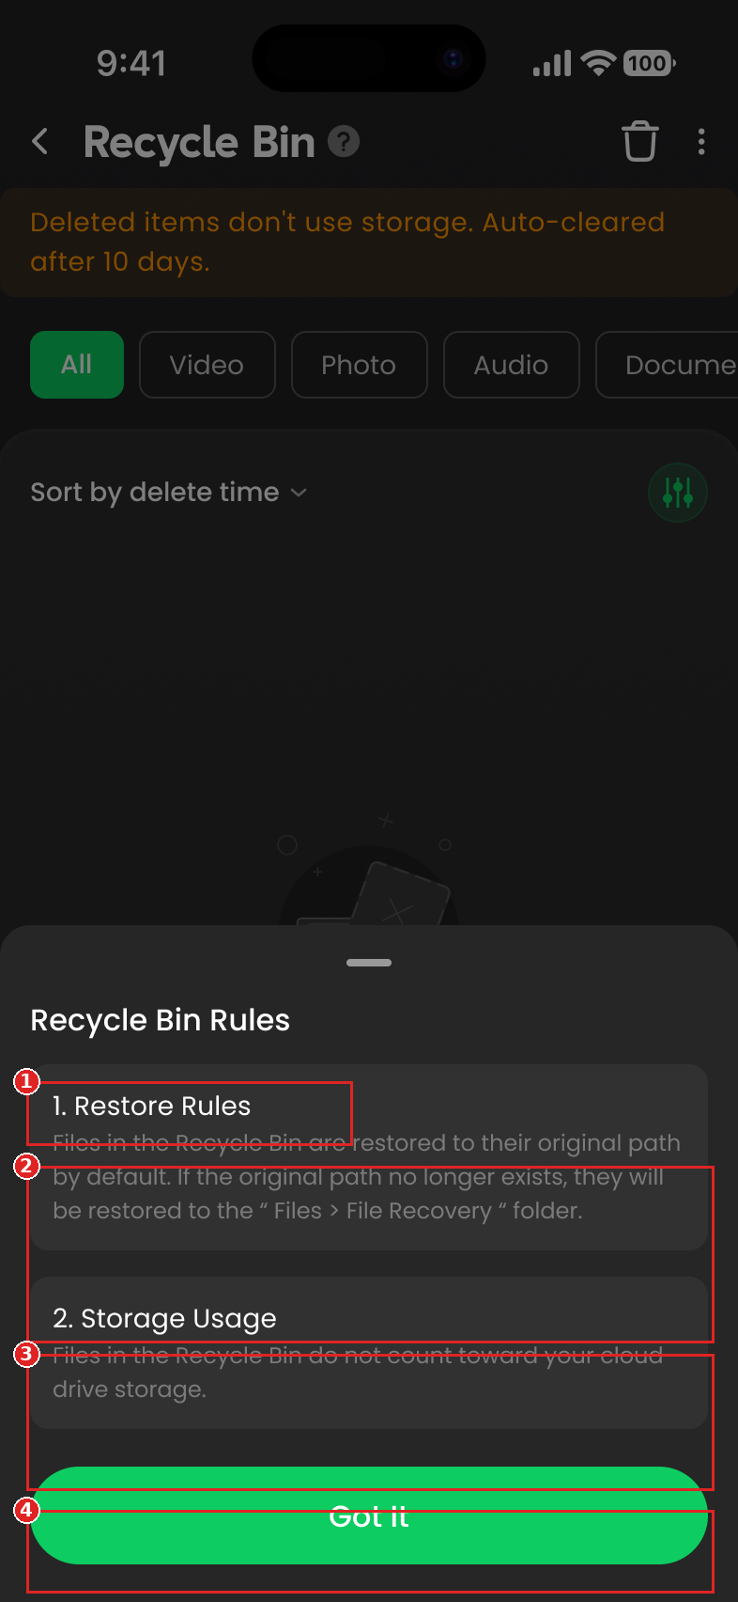
No. | Item name | Type | Description / behavior | Validation | Maps to
① | Sheet title | Label | 'Recycle Bin Rules' | — | FR-21
② | Restore Rules | Info card | Restore to original path; fallback to the shared 'Files > File Restore' folder | — | FR-05, FR-06
③ | Storage Usage | Info card | Items don't count against storage | — | FR-02
④ | Got It | Button | Closes the sheet | — | FR-21
Screen notes
- The membership 'File Recovery' rule has been removed (VIP out of scope).

SC-05 — Item action sheet (More / Options)
Purpose: Actions on selected item(s); 'More' in multi-select, 'Options' for a single item.
Related to: US-004, US-005, US-006, FR-17, FR-18
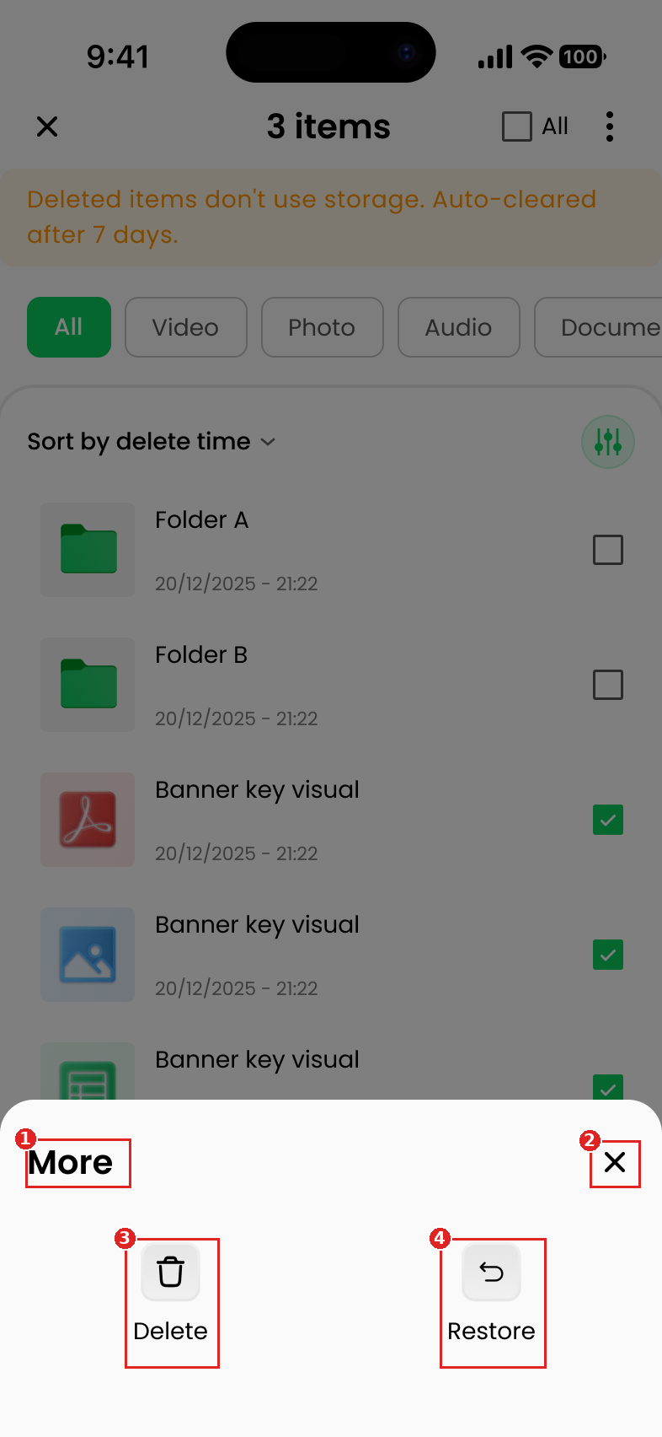
No. | Item name | Type | Description / behavior | Validation | Maps to
① | Sheet title | Label | 'More' (multi-select) / 'Options' (single item) | — | FR-17, FR-18
② | Close | Button | Closes the sheet | — | —
③ | Delete | Button | Permanently deletes the selected item(s) | Confirmation required | FR-07, FR-09
④ | Restore | Button | Restores the selected item(s) | — | FR-05
Screen notes
- The image is the 'More' sheet in multi-select; the single-item 'Options' sheet is similar.
- Delete opens the app's existing shared confirmation dialog (SC-08).
- The image shows the sheet over the multi-select list ('3 items'); the banner correctly reads '7 days'.

SC-06 — Folder-delete confirmation dialog
Purpose: confirms permanently deleting a folder. It appears only when tapping the trash icon (beside the ⋮ button) on the folder-detail screen (SC-07) — i.e. while inside a folder in the bin.
Related to: US-005, FR-07, SC-07
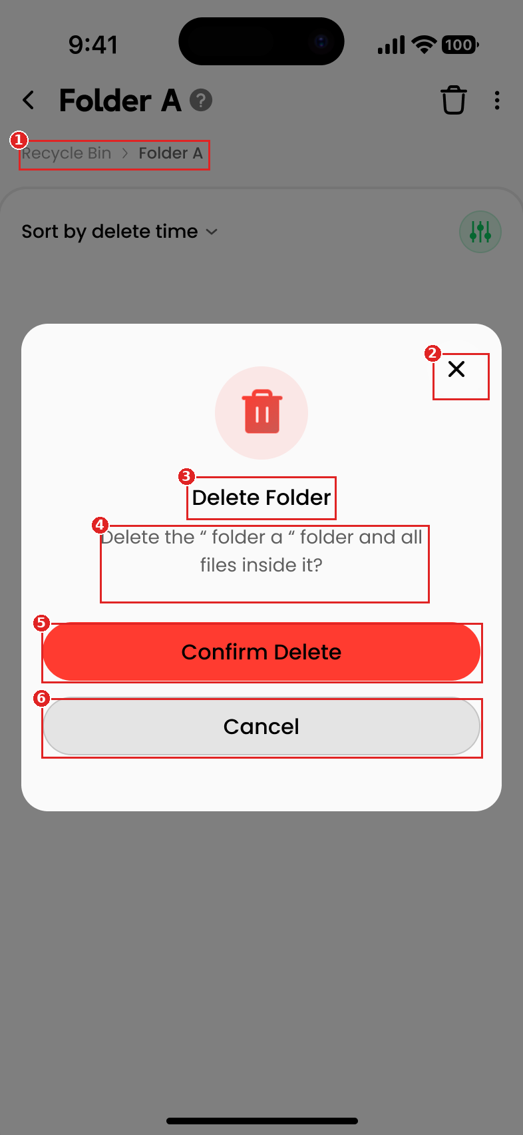
No. | Item name | Type | Description / behavior | Validation | Maps to
① | Breadcrumb (background) | Label | Folder-detail context 'Recycle Bin / <folder>' behind the dialog | — | FR-19
② | Close (×) | Button | Dismisses the dialog without deleting | — | FR-09
③ | Dialog title | Label | 'Delete Folder' | — | FR-09
④ | Dialog message | Label | 'Delete the "<name>" folder and all files inside it?' | — | FR-09
⑤ | Confirm Delete | Button (destructive) | Permanently deletes the folder and its contents; irreversible | — | FR-07
⑥ | Cancel | Button | Dismisses the dialog; nothing is deleted | — | FR-09
Screen notes
- This is a dedicated confirmation for deleting a single folder; opened only from the trash icon on the folder-detail screen (SC-07).
- Not used for deleting a file or a multi-selection — those use the shared dialog SC-08.

SC-07 — Folder detail
Purpose: Browses the contents of a deleted folder; opened by tapping a folder in the bin list.
Related to: US-002, FR-19, FR-12
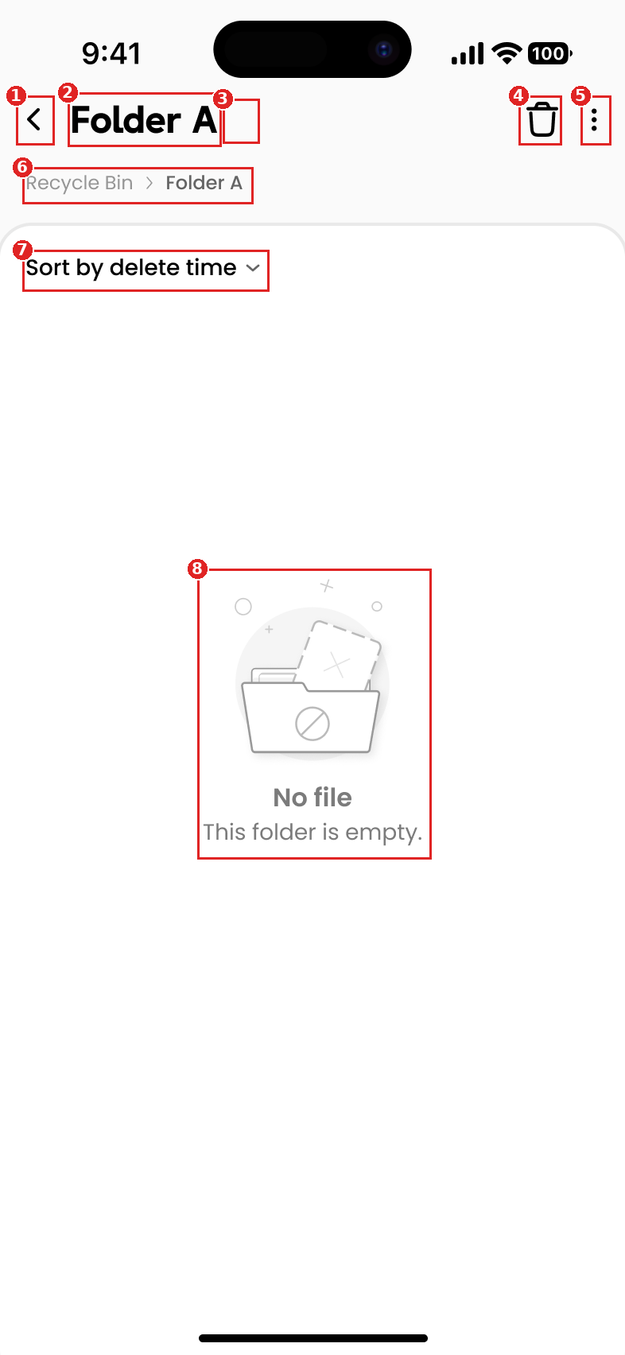
No. | Item name | Type | Description / behavior | Validation | Maps to
① | Back | Button | Returns to the bin list | — | —
② | Folder title | Label | Name of the opened folder | — | FR-19
③ | Help (?) | Button | Opens the Rules sheet | — | FR-21
④ | Delete folder (trash) | Button | Permanently deletes this folder (triggers the Delete Folder confirm, SC-06) | Confirmation required | FR-07
⑤ | Header menu (⋮) | Button | Additional actions (e.g., multi-select) | — | FR-15
⑥ | Breadcrumb | Label | 'Recycle Bin / <folder>' — navigation context | — | FR-19
⑦ | Sort control | Control | Sorts the folder's items; default days remaining (soonest to expire first) | — | FR-12
⑧ | Empty state | Illustration + Label | 'No file' / 'This folder is empty.' when the folder has no items | Shown only when the folder is empty | FR-19
Screen notes
- Inside a folder there are no type-filter chips or storage banner (simpler than the root list).
- This screen is captured in light theme while the root wireframes are dark — confirm the target theme.
- The wireframe shows 'Sort by delete time'; the decided default is days remaining (soonest to expire first).
- Folder-detail rows follow the same layout as the root list (see SC-01, FR-10).

SC-08 — Shared delete confirmation dialog (existing app dialog)
Purpose: Confirms a permanent delete at the bin-list level. This is the app's existing dialog, used when deleting a file, or deleting several multi-selected files/folders (and 'Empty all').
Related to: US-005, FR-07, FR-08, FR-09
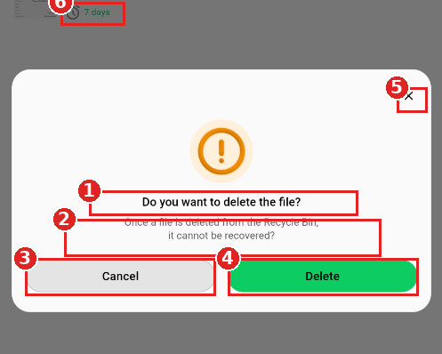
No. | Item name | Type | Description / behavior | Validation | Maps to
① | Dialog title | Label | 'Do you want to delete the file?' | — | FR-09
② | Dialog message | Label | 'Once a file is deleted from the Recycle Bin, it cannot be recovered.' | — | FR-09
③ | Cancel | Button | Dismisses; nothing is deleted | — | FR-09
④ | Delete | Button (destructive) | Permanently deletes; irreversible | — | FR-07, FR-08
⑤ | Close (×) | Button | Dismisses without deleting | — | FR-09
⑥ | Days-remaining countdown (bg) | Label | Item shows days left ('7 days') — reflects the 7-day retention | — | FR-04
Screen notes
- Reuses the app's existing dialog (not newly specified); applies to file delete, multi-select and 'Empty all'.
- For a multi-item selection, the copy may adapt per the existing app behaviour.
- Not used for deleting a single folder from folder-detail (that uses SC-06).

9. Traceability matrix
No BRD, so the BR column is omitted. A US may span several FRs (N:N).
FR | US | AC | Screen | Status
FR-01 | US-001 | AC-001.1, AC-001.2 | — | draft (entered from home page)
FR-02 | US-001, US-007 | AC-001.2, AC-007.1 | SC-04 | draft
FR-03 | US-007 | AC-007.2 | SC-01 | draft
FR-04 | US-007 | AC-007.1 | SC-01, SC-02 | draft
FR-05 | US-004 | AC-004.1, AC-004.3 | SC-05 | draft
FR-06 | US-004 | AC-004.2 | SC-04 | draft
FR-07 | US-005 | AC-005.1 | SC-05, SC-06, SC-08 | draft
FR-08 | US-005 | AC-005.2 | SC-01, SC-08 | draft
FR-09 | US-005 | AC-005.3 | SC-06, SC-08 | draft
FR-10 | US-002 | AC-002.1 | SC-01 | draft
FR-11 | US-003 | AC-003.1, AC-003.4 | SC-01 | draft
FR-12 | US-003 | AC-003.2, AC-003.5 | SC-01, SC-07 | draft
FR-13 | US-003 | AC-003.3 | — | draft (reuse existing search)
FR-14 | US-002 | AC-002.2 | SC-02 | draft
FR-15 | US-006 | AC-006.1 | SC-03 | draft
FR-16 | US-006 | AC-006.1 | SC-03 | draft
FR-17 | US-006 | AC-006.2 | SC-05 | draft
FR-18 | US-006 | AC-006.3 | SC-05 | draft
FR-19 | US-002 | AC-002.3, AC-002.4 | SC-07 | draft
FR-21 | US-007 | AC-007.3 | SC-04 | draft

10. Assumptions, open questions & conflicts
Only still-to-decide items are listed. Decisions already made are reflected in the requirements/screens above and are no longer tracked here. Retention is fixed at 7 days.

Assumptions
ID | Assumption | To confirm with
AS-01 | Search is the current app's existing search (name / hash / folder), reused as-is; the wireframes don't redraw the search bar. | PO / design
AS-02 | There is no retention-extension feature; retention is a single flat window (7 days) for all users. | PO
AS-03 | Every permanent-delete action is gated by a confirmation dialog (existing dialogs reused). | PO / design
AS-04 | Recycle Bin follows the Favorite feature's UX patterns (optimistic updates, offline sync) unless specified otherwise. | PO / engineering
AS-05 | Actions use optimistic updates (no separate loading state); failure handling follows the existing app behaviour. | engineering

Open questions
No open questions — all were resolved during the working sessions.
Web3 wallet-level behaviour is inherited from the existing wallet-bound app, and GDPR is not required for this release (PO decision); neither is specified as a functional requirement here.

