Disney Photo pass system
- Write one paragraph (2-5 sentences) describing the functionality of the system.
ANS: Disney photo pass system mainly allow users to download the photos taken by Disney photographers in Disney park. The functionality of the system is to use your Disney experience account to link to your photo database in Disney’s database which allows users to edit the photos or prints it into photo gifts such as calendar, ornaments and so on, by buying memory makers’ services then all Disney experiences account users could download photos, order those photo gifts, make their own videos.
- Create a utility tree for your system using the following table:
Quality Attribute | Quality Attribute Refinement | Architecturally Significant Requirement (ASR) | Importance | Difficulty
performance | Downloading speed | the users download the photos related to their account, and the download speed should be at least 1 mb per second | H | M
performance | User waiting time | The users process the transactions time less than 1 second for each link | M | M
performance | throughput | The system should handle at least 1000 transactions per second | H | H
usability | Create Disney photo book | users should have ability to edit the numbers of photos, layouts of photos and background colors per photo books page | H | L
usability | make attraction movies | Users should have ability to add music, order of photos, layouts to the videos | M | M
usability | Order status | When the users try to find out the order status of products, the system should provide package live locations | H | L
availability | Availability time | Users could access to their photos 7 days per week | H | L
security | Payment information | Nobody should be access to billing information | H | H
security | Password recover | When the users forget the password, users should have multiple ways to recover password | H | L
supportability | Customer service | When users have problems, should have ability to use key words to locate the problems and solve it, if there is no Q&A found, then provide 24/7 call support and online live chat | H | M

- Think about a possible high-level architectural design for your system and SKETCH it out using a UML diagram (of your choice). You should think about major components of your system. You only need to provide one view, and you can choose whichever view you are most comfortable with. As you are doing this, think about the quality concerns you have identified in your utility tree and how well your solution might meet these needs. (Note: This is an initial effort at architectural design. The purpose is just to start thinking about architectural design solutions.)
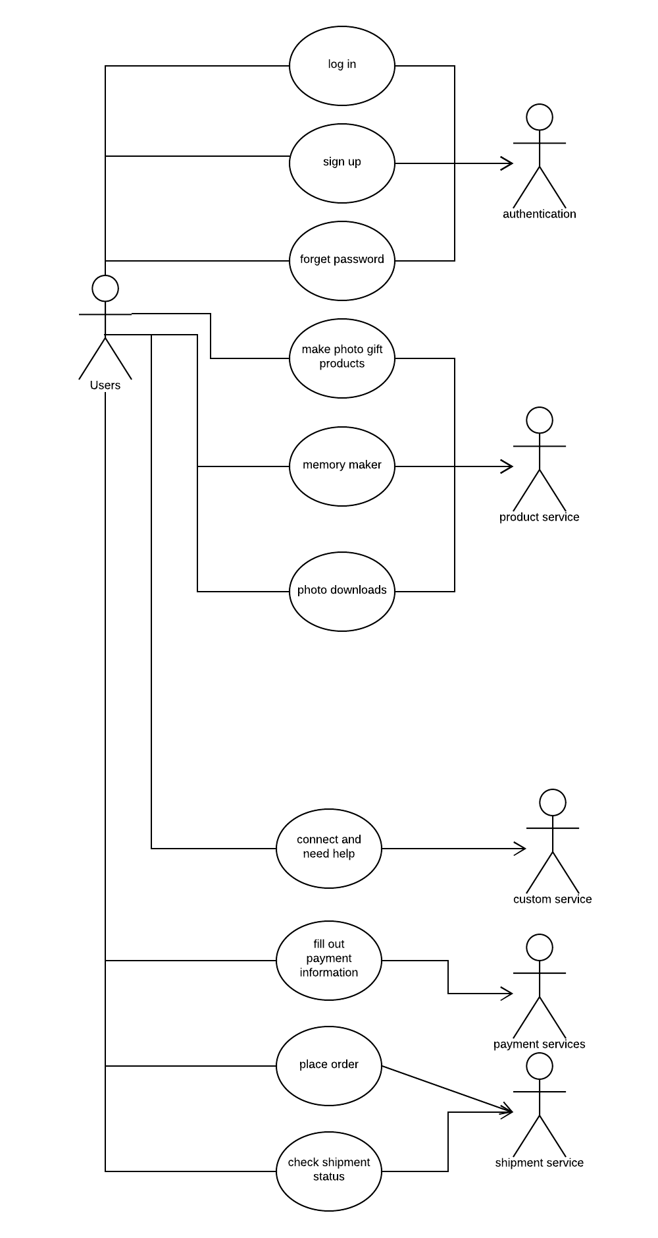
- Provide a 1/2 to 1-page rationale explaining and/or critiquing your solution. For example, if you feel unable to create a viable solution at this point in the course, then just do your best, but in your textual commentary discuss the areas of your design which you think might be inadequate. (Note: You can receive full marks on this assignment for architectural design which are inadequate, as long as you have thought about them and realized their possible shortcomings).
  - For download speed ASR, there are two ways to solve the problem, firstly, I will use photo optimizer technology to provide same quality of photos with smaller size. Secondly, I will invest in CDN that all users could connect to the servers closest to users to make sure download speed fast.
  - For user waiting time, I will minimize the HTTP Requests at same time, those it will reduce load time for users to refresh a page, and use less images as few as we can.
  - For throughput, since the Disney park visitors’ populations are millions, so system need to handle thousands of users at same time. one is to improve the hardware such as CPU, memory and so on, another is to balance the load which means to separate the transactions with different server machines.
  - For create Disney photo book, this one will be easy, developers should provide many templates of sample photo book, therefore users can edit their photo books as the style they need.
  - For make attraction movies, programmer should provide powerful plugin video cut app to enhance the movie making progress, and also provide more functionalities to let users to edit the videos.
  - For make attraction movies, cooperate with shipment carrier provider to provide GPS live maps to track each carriers’ status for packages and allow users to track anytime with given order ID.
  - For Availability time, the solution is to create redundant system when one system down then other system will be up to make sure the system is still on. During the crash time, to make sure that all transactions will be stored, we also will use log to store all transaction and use it to avoid losing data.
  - For Payment information: firstly, system will use SSL protocol to protect the communication between website server and website browser. And the system will tokenize sensitive data such as password, birth and so on, this technology will replace those sensitive data with randomly generated strings of characters which can be linked back to original data.
  - For Password recover: it will be used multiple ways to recover passwords, for example, when register account, it should provide phone number, email address or when in system mobile downloaded application, it will use a passcode generator that passcode will change every 30 second to secure the password recovering process
  - For Customer service: firstly, gather high frequency questions that users ask online and mark key words for search convince. Secondly, system provides 24-hour call and live chat customer help services. Thirdly, system will provide remote control users’ pc under users’ permits.

