Kaitlyn Head

Business Plan for Botanic Elixir HCI 525

PURPOSE

“Shift your mind. Shape your experience.”

Botanic Elixir is an immersive space that moves with your intention. Whether you're deep in thought, writing your next chapter, leveling up on game night, or settling in for date night, the environment reshapes itself around your experience. With walls that adapt to your chosen purpose and drinks designed to guide your mood, Botanic Elixir is a place created for intentional living.

GOALS

This website's three goals are to create and introduce the storyline to the viewer, help visitors customize and maximize their experience, and to increase in-person engagement and community growth.
- Create the Storyline. We will increase viewers' understanding of our concepts. Botanic Elixir is not a traditional bar, cafe, or arcade. We need to express our adaptive environment as well as how our drinks work. Our focus is to increase the time spent on informational pages, as well as the number of interactions with drink descriptions and experience guides. This is what our success will be measured by, yet the goal will be to double the number of visitors who click through to "How it Works" and "Choose Your Mood."

- Helps Visitors Choose an Experience That Fits Their Intention. Because our space transforms based on what someone wants, whether they are writing, gaming, reflecting, socializing, or having a date night, the website needs to guide people toward the experience that fits their purpose. I will measure this by tracking how many visitors explore the “Experiences” section and how often they reserve spaces or attend themed nights. The goal is to increase both reservations and participation in our curated experiences.

- Increase In-Person Engagement and Community Growth. With a desire to create a community based on intentional experiences, we create custom nights, writing sessions, wellness gatherings, and date night atmospheres. Increased in-store visitors, newsletter sign-ups, and participation at recurring events represent success. While the website’s goal will be to promote upcoming themes, allow newsletter enrollment, and provide clear pathways for guests to plan their visit.

THEMES

The central theme of this website is “Intentional Experience Through Adaptive Design”. To begin with branding, the site needs to be understandable based on the titles and their names; the home screen should represent the place and provide an introduction and be a part of the experience. Choose your desired mood and experience to continue to see the site. Again, any essential information the guest would seek, such as the drink menu, address hours, contact information, and hiring details. It should also highlight what makes Botanic Elixir different from a typical bar, cafe, or arcade. This will include an explanation of what our serums are made of and how they function, how they can choose a single, communal, or group space and customize their personal space, as well as how to sign up for directed experiences, such as writing sessions, game nights, wellness gatherings, or date night atmospheres. The website must be able to guide the user through these experiences, introduce the story behind the concept, and help develop their visit in advance, based on their intention.

TITLES AND KEYWORDS

TITLES: Home Page, Experiences, How It Works, Menu, Community & Events, Practical Info, About Us

KEYWORDS:
adaptive environment, intentional experiences, serums, mood-based drinks, creative space, writing nights, game nights, date nights, wellness events, immersive design, Binghamton, Botanic Elixir, nonalcoholic bar, experiential cafe

The page titles provide visitors with a clear understanding of what each section offers and helps them quickly navigate to the needed information. The keywords reflect what the intended audience is searching for and align with the website’s goals of explaining our concept, guiding users through their experience options, and supporting in-person engagement with Botanic Elixir’s community and events.

AUDIENCE

This website’s intended audience is the residents of London, where this imagined location of Botanic Elixir is based. Our visitors are primarily young adults, creatives, students, and professionals who are interested in intentional experiences, non-alcoholic drinks, and unique social environments. Their familiarity with writing, gaming, wellness, or reflective activities may vary, but they are drawn to spaces that offer atmosphere, mood shaping, and a sense of community.
Most visitors come to the site for information: they are looking for upcoming themed experiences, details about our mood-based serums, or guidance on how the adaptive environment works. Others are seeking practical information such as location, hours, reservations, or job opportunities within a space focused on creativity, presence, and experiential design. The website exists to help each visitor understand how Botanic Elixir fits their intention and how they can shape their experience when they arrive.

MIND MAPS
The mind map below outlines the key pages and features this website will include. The five central sections represent the core pages the site must have. Together, these pages introduce visitors to Botanic Elixir, explain how our adaptive concept works, guide them toward experiences that fit their intention, and provide practical information for planning a visit or contacting us. The connected rectangles show the specific content that will appear within each section, including details about our purpose, the experiences we offer, how our system works, our menu, and our community events.
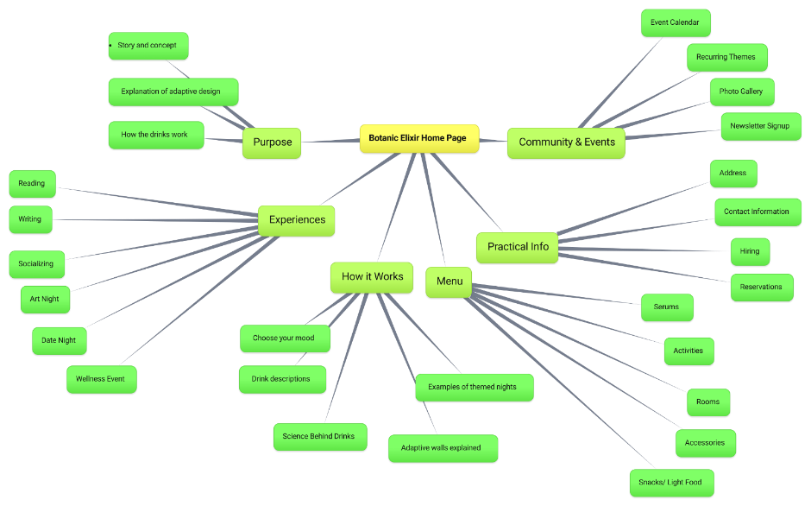

SKETCHES
The following sketches display a rough layout for the main pages of the Botanic Elixir website, including the Home Page, Experiences Page, How It Works Page, Menu Page, Community Page, and Info & Contact Page. Each page uses the same header and footer design to create consistency across the site.
The purpose of the business is introduced on the Home Page directly below the header. The Experiences, Menu, and Community pages include lists or card-based sections that display the available options, with filters provided to help users narrow their choices. The How It Works page explains how the space and system function, while the Info & Contact page provides location details, contact information, and a reservation form.

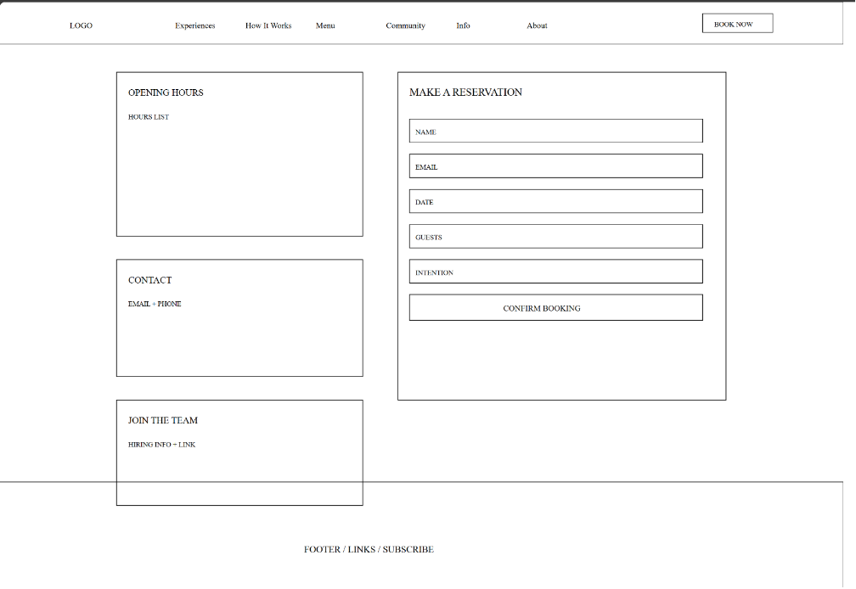
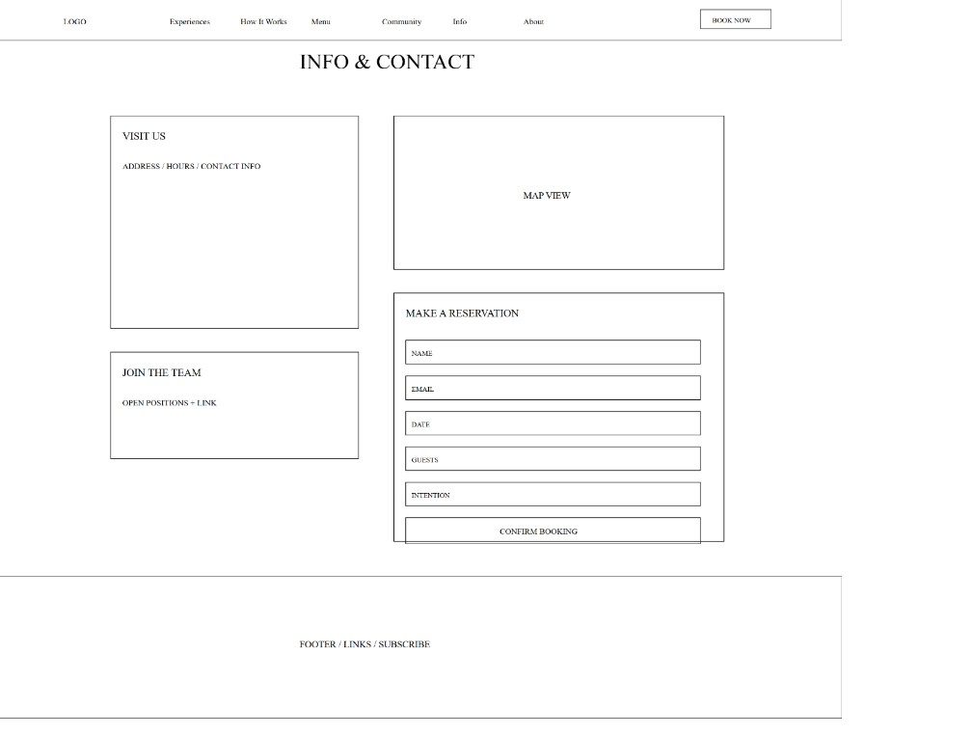
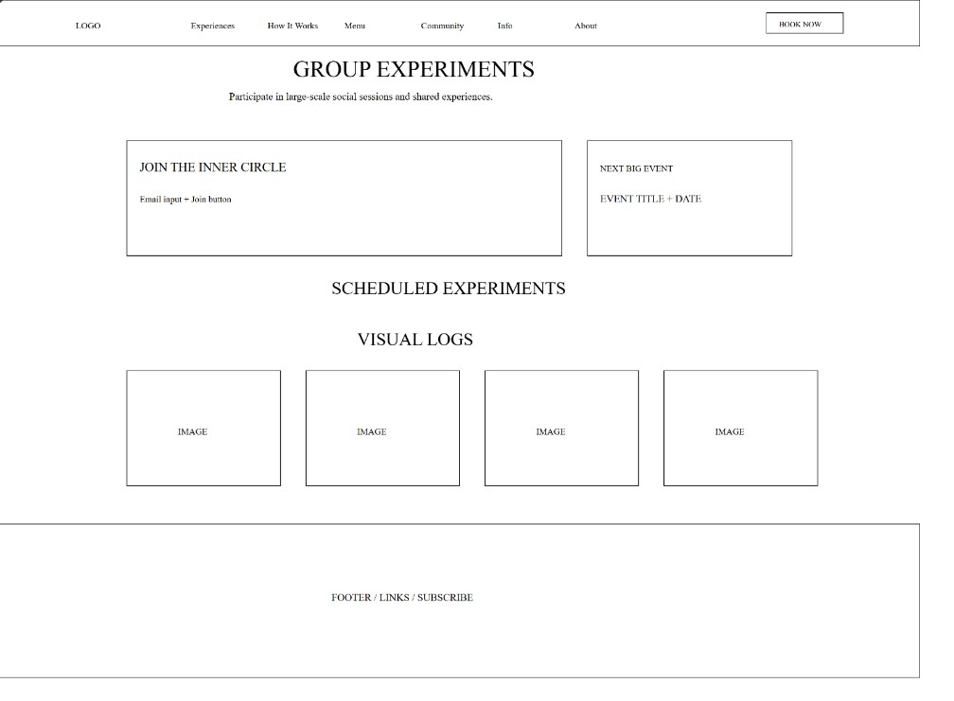

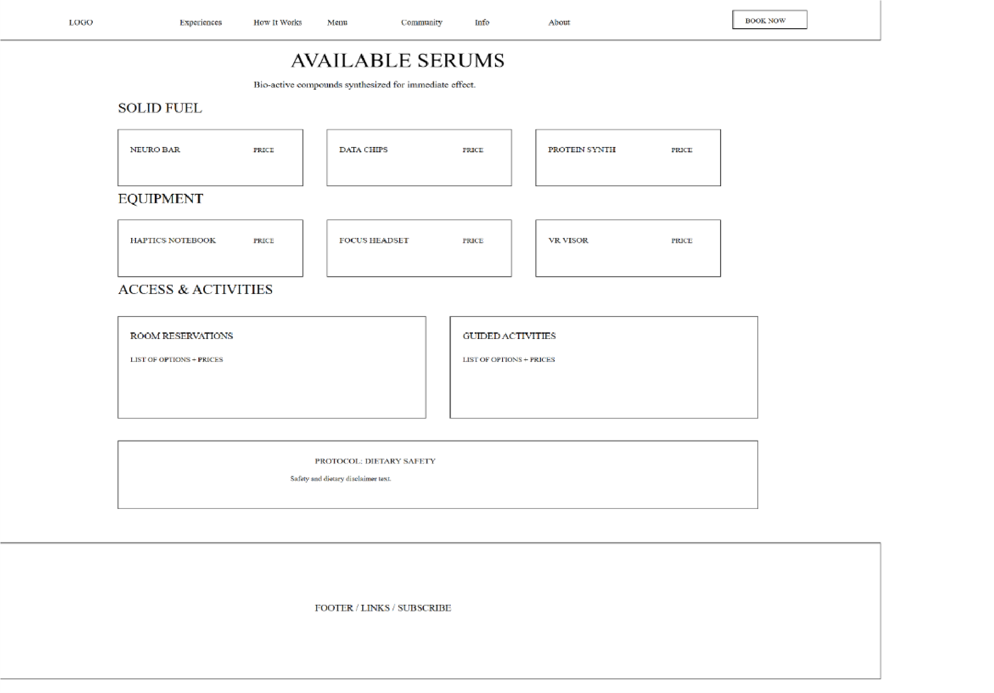

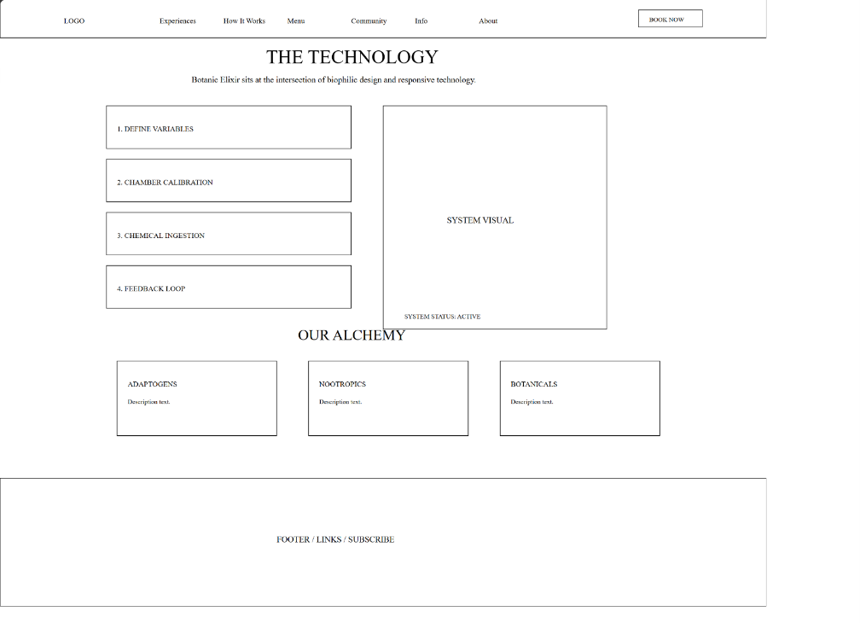
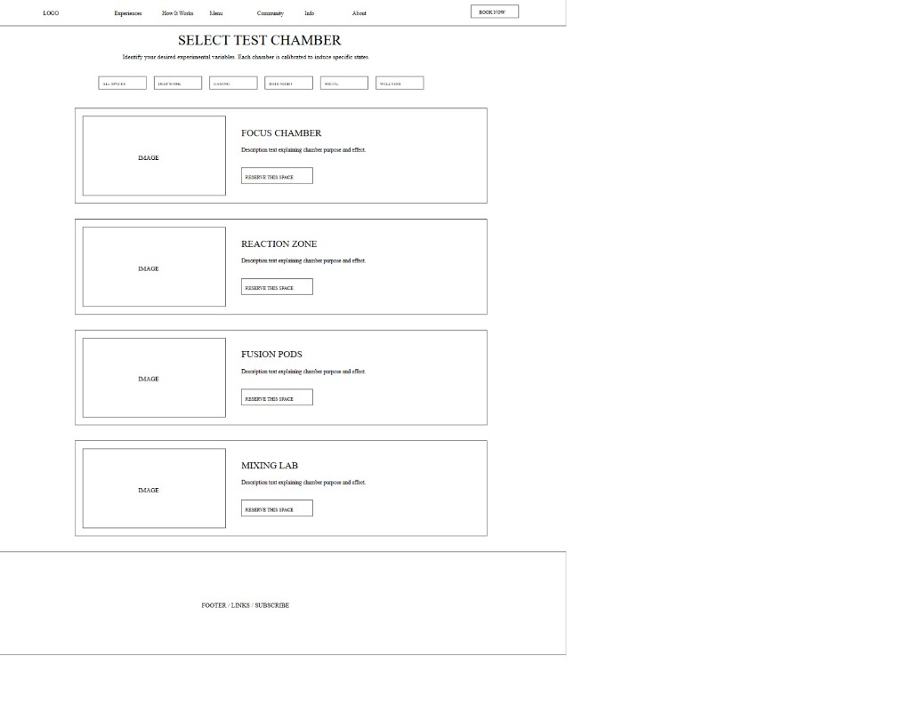
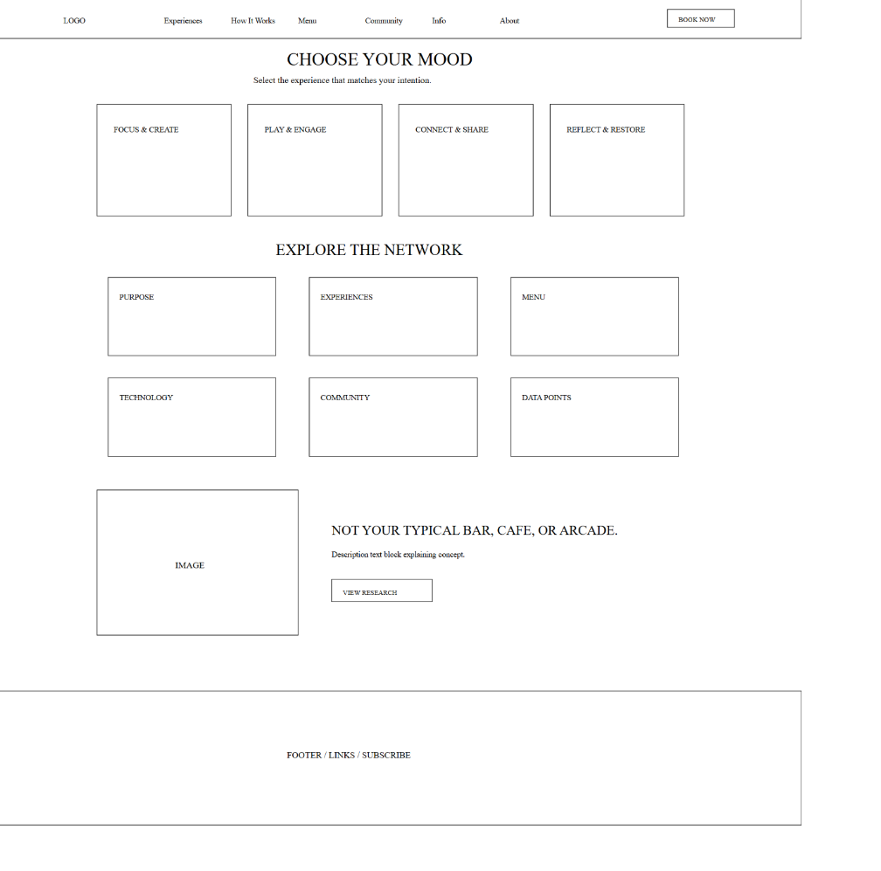
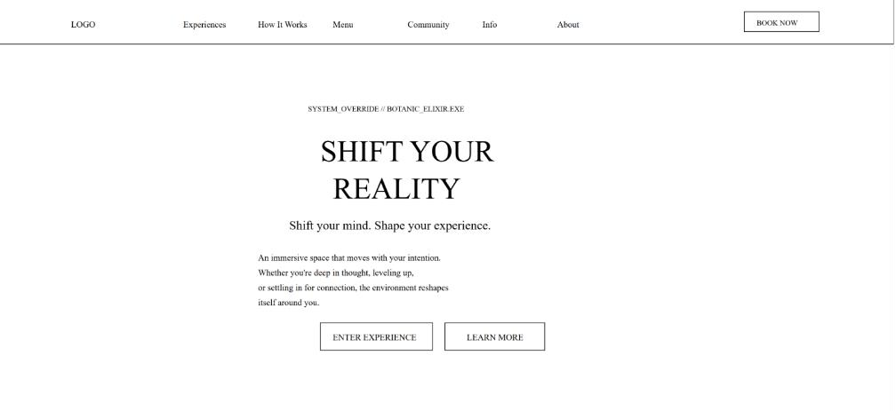

STORYBOARDS
The storyboard represents a complete site structure in which every page is fully interconnected. Each page on the website is accessible through a persistent header navigation menu, allowing users to move freely between sections at any point in their journey. The Home page functions as a central hub, clearly presenting the site’s primary sections and serving as an entry point to all other pages. This non-linear navigation ensures that users can easily locate and move to the page that best suits their needs, whether they are seeking information, exploring experiences, or planning a visit, without being restricted to a single path.

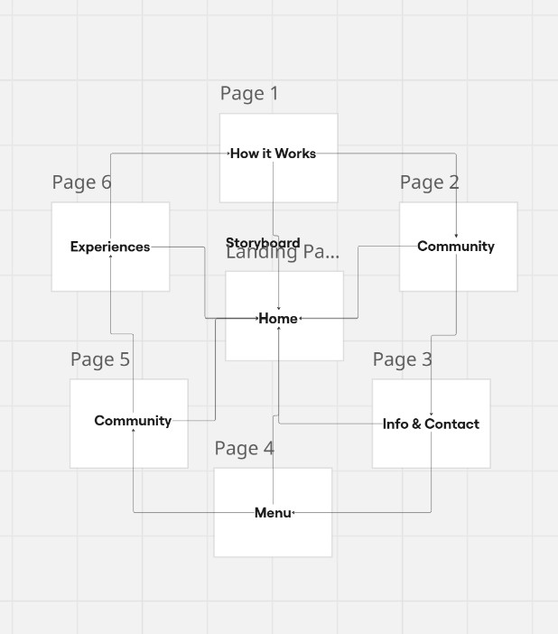

TOOLS AND CODE
For this site, I will use HTML5 and CSS. As for the code, it will be written using VS Code as an IDE (Integrated Development Environment). I also plan to use GitHub for version control, so that with any possible updates that occur, the older website versions can be viewed as well. While Google Analytics will measure the website’s traffic so that the goals can be tracked.

CONTENT AND STYLE
Visitors to the Botanic Elixir website are primarily seeking to understand the products, experiences, and systems that define the space. The website must clearly explain what Botanic Elixir offers, how its moodbased serums function, and how the adaptive environment responds to intention. Rather than serving only as an informational reference, the site is designed to help visitors learn how the experience works and envision how it can be shaped to fit their desired atmosphere for the night.
A key function of the website is to enable users to explore and sign up for curated experiences, such as writing sessions, wellness gatherings, game nights, or date-night atmospheres. Visitors should be guided through these options with clear descriptions, visuals, and prompts that help them decide which experience best aligns with their goals. The site also supports planning ahead by allowing users to customize elements of their future visit, including mood, space type, and experience preferences, before arriving in person.
The visual style of the website reflects this purpose through a modern, immersive design that balances clarity with atmosphere. Subtle digital effects, adaptive color palettes, and refined typography reinforce the idea that the space is responsive and intentional. The interface should feel intuitive and engaging, encouraging exploration without overwhelming the user. Design choices support usability while enhancing the sense that the website itself is an extension of the adaptive environment.
Overall, the website functions as a planning and discovery tool rather than a traditional promotional site. Its organization, interactions, and visual language are structured to help visitors understand the concept, select experiences, and actively shape their upcoming visit to Botanic Elixir.

NAVIGATION
This website will feature navigation in the header, with all primary pages listed using text. This allows visitors to easily navigate between sections and encourages exploration of the site. Using text-based navigation clearly communicates what each page contains and where each link will lead, helping to avoid confusion. There are a limited number of pages on the site (Home, Experiences, How It Works, Menu, Community, and Info & Contact), which keeps navigation simple and prevents the interface from feeling overwhelming. Because of the limited number of pages, a search function is not necessary. The footer will also include navigation links to the main pages for additional accessibility.

TIMESCALES/SCHEDULES
Total estimated duration: 3–4 months
The project will be completed in four main stages. The first stage will focus on creating low-fidelity wireframes for all website pages in order to establish layout, structure, and navigation. This stage will take approximately four to five weeks.
The second stage will involve developing a clickable prototype to test user flow and page transitions. This stage will take approximately three to four weeks, allowing time for iteration and refinement.
The third stage will focus on completing the full set of website pages, refining content placement and interaction details. This stage will take approximately four to five weeks, accounting for revisions and consistency checks across pages.
The final stage will involve revisions, testing, and final adjustments to produce the finished website. This stage will take approximately three to four weeks, ensuring sufficient time for feedback, testing, and final improvements.

BUDGET
The total estimated cost to design, launch, and maintain the website for the first year is approximately $2,000–$3,800. This budget reflects a small-scale project completed by a new UX designer and is intentionally conservative to allow for minor unexpected expenses while remaining cost-effective.
The cost of securing a domain name is estimated to be between $10 and $25 per year, depending on the domain extension and availability. Website hosting is estimated to cost approximately $10 to $20 per month, resulting in an annual hosting cost of $120 to $240, which is suitable for a small business or portfolio-style website.
Design and development costs are based on a reduced rate appropriate for a new UX designer. The estimated rate ranges from $20 to $30 per hour, with approximately 60 to 90 hours required to complete the project. This results in an estimated design cost of $1,200 to $2,700, which includes wireframing, prototyping, page completion, and revisions.
Promotional expenses are estimated at $200 to $500 for the initial launch period. These costs may include basic digital promotion and simple promotional materials.
Ongoing maintenance and upgrades are estimated to cost approximately $30 to $50 per month, or $360 to $600 per year, covering minor updates and general site upkeep.
Overall, this budget provides a realistic and manageable estimate for developing and maintaining the website while remaining within a limited project scope.

MARKETING
The marketing approach for this project will focus on low-cost, targeted digital promotion to build awareness and encourage engagement. Social media will be the primary channel for sharing content that introduces the concept, highlights experiences, and promotes events or offerings, with a small amount of paid promotion used during the initial launch. The website itself will support marketing efforts through clear messaging, intuitive navigation, and an accessible reservation process, while basic search engine optimization techniques will be used to improve discoverability. Email sign-ups will also be used to maintain communication with interested users and support ongoing engagement without significant additional cost.

SEARCH ENGINE OPTIMIZATION
I will use Search Engine Optimization (SEO) to increase traffic to the website and reach users who are interested in immersive experiences and events. This will be done by using relevant keywords throughout the site and by creating and maintaining a Google Business listing for Botanic Elixir. I will ensure the business listing includes accurate contact information, hours, and offerings, and I will encourage visitors to leave reviews. This approach will help attract local users searching for experiential spaces or events, while the Google Business listing will also provide a direct link to the website to increase traffic.

