Effects of Display Factors on Chinese Proofreading Performance and Preferences

Alan H.S. Chan and Annie W.Y. Ng

Department of Systems Engineering and Engineering Management
City University of Hong Kong
Kowloon Tong
Hong Kong

Abstract
This experiment investigated the influence of four display factors, viz. typeface (Ming Liu and Jheng Hei), font size (10-point and 14-point), text direction (horizontal and vertical) and copy placement (left-right and top-bottom) on Chinese proofreading performance and subjective preferences. Proofreading performance was measured in terms of time and accuracy, and preferences were examined in terms of comfort, ease and fatigue. It was found that the horizontal text direction resulted in faster proofreading than the vertical one, but the other three factors were non significant. The faster proofreading using the horizontal text direction was valid for both the left-right and the top-bottom arrangements. There was an interaction between typeface and font size such that, for the smaller character size (10-point), the Ming Liu style produced a faster performance than the Jheng Hei style. However, for the larger character size (14-point), the Jheng Hei style produced a faster performance than the Ming Liu style. Regarding proofreading accuracy, the number of non-detected missing words and related false alarm in left-right copy placement setting was significantly larger than that in top-down setting. Greater accuracy was obtained in proofreading at the cost of a speed-accuracy trade-off – the higher the accuracy in the proofreading task, the longer the proofreading time. Font size and text direction had significant effects on proofreading preferences, but typeface and copy placement did not.

Practitioner Summary:
This study examined four display factors on Chinese proofreading performance and subjective preferences. The findings of this experiment provide information and recommendations that should prove useful for the design of proofreading interfaces to improve proofreading time and accuracy, and to satisfy proofreaders’ preference.

Keywords: proofreading, typeface, font size, text direction, copy placement
1. Introduction
The Chinese writing system is used by about one fifth of the 6.90 billion people in the world (United Nations Population Division 2009). There are about 48,000 individual Chinese characters in an unabridged Chinese dictionary (Zhonghua da zidian 1978) and 2,500 of them are most frequently used (Ministry of Education of the People’s Republic of China 2005). Each Chinese word is formed by one to five characters in general, and the frequency of usage of one- and two-character Chinese words in texts is about 98.6% (Lua 1990).
Human performance in Chinese communication tasks have been investigated quite recently (Lee and Chan 2003, Chan and Lee 2005a,b,c, Zhao et al. 2005, Chan and So 2009, Li et al. 2012). Proofreading is an important task to reduce the chance of printing typographical errors and ensure accurate information presentation to readers. It involves careful reading of a passage and marking deviations (e.g. typeface, page and column breaks) from specifications, wrong end-of-line word divisions, misspellings, nonstandard grammar, and other errors in language on a live copy - the newly produced version (Smith 1993). The two main ways of proofreading are comparison proofreading and noncomparison proofreading (Anderson 1990). Noncomparison proofreading is usually used when there is no true dead copy (original version) or when the dead copy is only referred to if the proofreader sees something puzzling. The proofreader mainly checks the content, factuality, sentence structure, spelling, and logic of writing. It is usually an essential task for ensuring document readability and correctness in most office work situations.
Comparison proofreading involves directly comparing the dead copy with live copy. It is a critical process for creating an electronic book from a physical book and is to be done after optical character recognition (OCR) on the physical book is performed. With the large-scale digitization of Chinese texts, large amount of information, books, and full-text databases are scanned and indexed at a manufacturing speed. It is however known that the current OCR software cannot guarantee perfect accuracy for English scanning. Given the complex structures of Chinese characters, it is even more difficult to achieve high accuracy levels for Chinese texts than for Latin scripts and, therefore, repeated proofreading after manual input or scanning is always necessary (Yang 2007). It is believed that if the display format of the drafts and the screen design can be prepared in a more user friendly way, the work performance of proofreaders would be greatly improved which would then help the dissemination of knowledge to many more people.
In early work on proofreading, Wright and Lickorish (1983) found that speed and accuracy of proofreading a text on a CRT (cathode ray tube) were impaired compared with print on paper. Creed et al. (1987) found that proofreading accuracy was significantly worse for a VDU (video display unit) than for paper. The authors suggested that font might have been a major factor in the poor performance with the VDU. Creed et al. (1988) found that, relative to a full-screen condition, displaying text one paragraph at a time improved accuracy of performance, but at reduced speed. They also found that there was further increased accuracy and reduced speed when the text was further subdivided into sentences. Since those experiments were done, screen presentation has greatly improved and there is now much greater familiarity with the use of screens. Ron (1993) showed that users with significant previous proofreading experience did better on screen than those without experience, but there was no difference between the groups proofreading on paper and screen. Subsequently Ling and van Schaik (2006, 2007) investigated the effects of text presentation on online behaviour and preferences. They found that wider vertical line spacing resulted in better accuracy and faster reaction times and that although justified text was preferred, left-aligned text led to better performance. More recently, Buchner and Baumgartner (2007) found that proofreading performance with positive polarity was better than with negative polarity displays.
Research on non-Chinese proofreading has been reported but most studies have been on noncomparison reading (Daneman and Stainton 1993, Tullis et al. 1995, Piolat et al. 1997, Pilotti et al. 2005, Buchner et al. 2009). The proofreading efficiency of comparison reading has been shown to be significantly better than for noncomparison reading (Riefer 1993, Raskind and Higgins 1995), but there have been few studies on comparison proofreading. Currently, proofreading is usually done by using screen rather than a printout. Due to the rapid growth of large-scale digitization of Chinese texts to disseminate knowledge, there is an obvious need for ergonomics studies on comparison reading in order to examine the possibility of improving task efficiency and effectiveness through appropriate use of display factors and format. Although investigations on Chinese reading have been conducted, there have been no studies on Chinese proofreading on desktop computer workstation. It has been shown that the display factors of typeface and font size affect text readability and reading task efficiency on computer and mobile device screens (Bernard et al. 2001, 2003, Huang et al. 2009). In addition to these two factors, for Chinese proofreading tasks it is necessary to examine the effects of text direction and copy placement factors.
In Chinese, common font styles like Zhuan (篆), Li (隷), Kai (楷), and Cao (草) were developed at different times historically. Along with development of the printing process, different font types like Sung (宋), Ming (明), Hei (黑) appeared. Today there is a mixed and combined use of font styles and font types. Research studies on Chinese characters with regard to legibility assessment and reading performance have been reported. Chi et al. (2003) found that Hei characters are the most legible, followed by Ming, Kai, and Li characters. In reading a variety of message signs, Lai (2008) found that subjects achieved higher accuracy for Hei and Ming styles than for Kai style. In a character-search task, Shen et al. (2009) found that search accuracy was higher for Kai than New Ming style on paper, whereas the accuracy was better for New Ming than Kai style with electronic-paper displays. Given the diverse results regarding the effect of Chinese font type on different perceptual tasks, it is of interest to attempt to determine the best font type for the proofreading process.
In measuring readability on computer screens as a function of English character size, Snyder and Maddox (1978) examined the effects of dot element size and character size. The results showed that smaller characters (7.6 mm) produced faster reading speed than larger ones (24.32 mm). However, larger characters were found to produce faster search times in a search task. Larger characters are generally considered more readable than smaller ones, but it seems likely that there may be an optimum size such that changes in either direction (smaller or larger) will reduce reading performance (Mills and Weldon 1987). A recent study of legibility of Korean characters showed that from a comparison of correctness score and discomfort rating, participants generally preferred larger letter sizes to those that they could read (Kong et al. 2011). For reading Chinese characters, the effects of font type and size are still largely unknown, though a few ergonomics studies have shown that the legibility was enhanced by increasing font size (Cai et al. 2001), and 14-point characters produced faster reading times than 10-point characters (Chan and Lee 2005a). Therefore, it is to be expected that on the basis of previous studies, larger font size should be preferred and result in better Chinese proofreading performance.
In a comparison proofreading task of electronic publishing process, live and dead copies are usually arranged in left-right (side-by-side) orientation, with the live copy always placed to proofreader’s pen position (Anderson 1990, Tetreault 2001). For right-handers, the dead and live copies are under the left and right hands, respectively. A common practice for the top-bottom setting is that the dead copy is placed at the top and the live copy at the bottom, such that the live copy is also close to the proofreader’s hand (Newby and Franks 2003). As discussed in the following paragraph, Chinese characters can be presented in both top-bottom and left-right patterns. For Chinese characters particularly, a study on the effects of copy placement (top-bottom and left-right) on proofreading performance and subjective preferences is necessary to help designers create better interfaces for proofreading tasks on computer screens.
Chinese text has been traditionally written and printed vertically from top to bottom of a page, with columns moving from right to left. However, since the early 20th century this traditional convention has been largely westernized and, currently in much printed material Chinese characters appear horizontally (usually starting in the top left corner). Sun et al. (1985) found that horizontal Chinese characters were read at 580 cpm (characters per minute), twice as fast as the 260 cpm for vertical ones. In a visual search study, Goonetilleke et al. (2002) found that Hong Kong Chinese used predominantly horizontal search patterns whilst searching for a Chinese target character in a display with a background of distracting characters. Based on the results of these previous studies, the horizontal reading direction is expected to be more preferred and result in better Chinese proofreading performance than the vertical direction.
In view of the possible influence of the display factors discussed above on proofreading Chinese, the effects of typeface, font size, copy placement and text direction on speed, accuracy, and subjective preference in a proofreading task were examined in this study. The results are expected to provide useful design recommendations to assist in determining the display factor settings and text display layout that will improve comparison proofreading performance and experience for Chinese.

2. Methodology
2.1 Design
A within-subjects experimental design was used. Two levels of each selected four display factors (typeface, font size, text direction and copy placement) were tested in this investigation. For typeface, the commonly used font types of Ming Liu (細明體) and Jheng Hei (正黑體) were chosen. Ming Liu is a font type with serifs while Jheng Hei is a sans-serif type (Figure 1). For font size, a small (10-point) and a large (14-point) character size were used. For text direction, both the horizontal and vertical reading directions were studied (Figure 2). For the fourth factor, the left-right and top-bottom copy placements were tested. Figure 3 illustrates sample layouts of the four combinations of text direction and copy placement. Underneath the text are five typo buttons for clicking by participants to indicate typos of extra word, missing word, wrong word, wrong order, and extra spacing, and one button for undo action that was used to undo a previously selection clicking. The four display factors were studied with a full factorial design. Each participant was required to perform the 16 (2 font types x 2 font sizes x 2 text directions x 2 copy placements) experimental conditions in which different passages were proofread. With this design, the number of characters per line (last line excluded) varied with the font size, text direction, and copy placement condition, but did not change significantly with font type (Table 1). Proofreading time and accuracy for each passage were measured and analyzed. For evaluating subjective preference, a 10-point Likert scale was used to obtain participants’ opinions on the attributes of proofreading comfort, ease and fatigue.
Insert Table 1 about here
Insert Figures 1-3 about here
2.2 Participants
Twenty-seven native Chinese undergraduates (8 females and 19 males aged 20 to 26 years) at City University of Hong Kong voluntarily participated in this experiment. All participants had computer experience of six to ten years. They all used their right hand to operate a computer mouse and for handwriting in daily life.

2.3 Materials
Twenty four passages were randomly selected from the sample passages available for reference by the fifth level secondary school students preparing for the Chinese Language Examination of the Hong Kong Certificate of Education Examination. A focus group of five participants of same education background to those tested in this study was asked to preview all the passages and select 16 passages of similar difficulty. The 16 passages with the highest frequencies of choice were adopted for test in this experiment. Mean passage length, including punctuation marks, was 547 characters with a range from 483 to 600 characters. The number of typographical errors in a passage ranged from zero to eight and an average of five errors were embedded per passage of a live copy. These errors included extra word, missing word, wrong word, wrong order, and extra spacing, and were embedded randomly in different positions of a passage. However, to ensure that all typos were surrounded by other visual objects, no typos were shown at the outside edges of the test field. It was expected that this way of stimulus and typo presentation would not provide any location cues or expectation of typo occurrence to the participants. The layouts of the dead and live copies were very similar in appearance, and the locations of a character in the dead copy and its corresponding character in the live copy were roughly at the same positions in the two copies (see Figure 3). By making comparison of a live character with its corresponding dead character, same amount of eye movement distance would be expected between each character pair, and the location of the typo would not affect the eye movement distances required. All dead and live copies were presented in a positive polarity condition with black text on a white background. The ‘wrong word’ typos for each condition are summarized in Table 2. 43% and 14% of these ‘wrong word’ typos were orthographically and phonologically similar to the targets, respectively. The frequencies of occurrence of these wrong characters in the Chinese Knowledge Information Processing Group ranged from 35 to 129694 (Lo and Hue 2008).
Insert Table 2 about here

2.4 Apparatus
A personal computer (Pentium III – 1.13 GHz) with a 17-inch liquid crystal display monitor and an application program prepared with Microsoft ASP.NET were used for stimulus presentation and response capture. The screen displayed textual information with a pixel resolution of 1280 x 1024 at 70 Hz refresh rate. The centre-to-centre pixel spacing was 0.264 mm. The screen was placed on a table of 720 cm in height and the inclination of the display was 105°. The luminance of the dark characters and light background was 5 and 70 cdm⁻², respectively, while the ambient illumination was 350 lx. Participants used a computer mouse to control stimulus presentation and response input. The distance between screen centre and participants’ eyes was 400 mm. The 10-point characters (3.5 mm) and 14-point characters (5.0 mm) subtended visual angles of 0.50° and 0.72° to participants’ eyes, respectively. Including some studies on eye movement measurement, characters of visual angles in the range of 0.16º to 1.5º were tested in past research of Chinese reading (Rayner et al. 2005, Bai et al. 2008, Lin et al. 2009, Huang et al. 2009, Yang et al. 2010, Li et al. 2011, Yan et al. 2011). The visual angles of Chinese characters selected for testing in this study were within the preferred character size range (0.50º to 1.27º) found for an electronic paper display in a recent Chinese proofreading study (Wu 2011). An adjustable chair was used to ensure that each participant’s line of regard was roughly perpendicular to and at the center of the screen.

2.5 Procedure
Before the experiment began, the participants were informed of the aim of the experiment and the display factors to be studied. The procedure was explained and the types of typo were demonstrated to the participants. A few practice trials were given to familiarize participants with the experiment. In each experimental condition, one of the 16 prose passages and its corresponding live copy were presented randomly in one of the 16 display formats. Participants were asked to compare the live copy against the dead copy and to highlight the typos in the live copy as fast as they could by clicking the corresponding typo type button shown at the bottom of the screen with computer mouse (Figure 3). Under the Chinese Window environment, the application program prepared for this task allowed highlighting texts in both the vertical and horizontal directions. Then the participants were asked to rate the experience of proofreading in that condition using a 10-point Likert scale on the attributes of comfort (1 = least comfortable, 10 = most comfortable), ease (1 = least easy, 10 = most easy) and fatigue (1 = least fatiguing, 10 = most fatiguing). This process was repeated until the testing of all 16 experimental conditions was finished. To avoid mental or visual fatigue, a 2-minute rest was given after each set of four passages proofread.

3. Results
3.1 Proofreading time
Altogether 432 (27 participants x 16 conditions) data sets were collected. The mean proofreading time for the participants was 467 msC⁻¹ with standard deviation of 99 msC⁻¹. The fastest and slowest performance of the participants was 270 msC⁻¹ and 626 msC⁻¹, respectively. In this study, comparison proofreading was performed and participants were required to read both live and dead copies, and the proofreading time per character was thus longer than that for general reading of one copy. Considering the additional eye movement times needed for back and forth travelling between the two copies, a further lengthening of the proofreading time per character was thus resulted and a comparison of the noncomparison proofreading time and reading time in past studies for general reading cannot be simply made. The mean proofreading time per character for each display factor is shown in Table 3. In general, participants proofread faster with the conditions of Ming Liu style, 14-point font size, horizontal text direction, and left-right copy placement. The typo detection rate was higher for Jheng Hei style, 14-point font size, horizontal text direction, and top-bottom copy placement. Analysis of variance (ANOVA) was performed on proofreading time per character with the four display factors. Proofreading time per character in each level of a display factor was not normally distributed (Shapiro-Wilk’s test, p’s < 0.05), so the time data distributions were normalized using a logarithmic transformation before ANOVA was carried out. The results of ANOVA showed significant text direction effect [F _{(1,416)} = 90.647, p < 0.001] while font type, font size, and copy placement were non-significant (Table 4). The horizontal direction resulted in significantly faster proofreading than the vertical direction. Other than the significant interactions of font type x font size [F _{(1,416)} = 7.188, p < 0.01], text direction x copy placement [F _{(1,416)} = 4.834, p < 0.05], and font type x font size x copy placement [F _{(1,416)} = 5.664, p < 0.05], all the remaining interactions were non-significant.
For the significant three-way interaction of font type x font size x copy placement, two-way ANOVA of font type and font size was conducted at each copy placement type. The results showed that for left-right placement, there was significant interaction of font type and font size [F _{(1, 212)} = 14.321, p < 0.05]. The results of simple main effect test indicated a significant effect for font type within the 10-point character size [F _{(1,212)} = 6.98, p < 0.05] and 14-point character size [F _{(1,212)} = 5.71, p < 0.05]. Participants performed faster in the proofreading task with Ming Liu style (421msC⁻¹) than Jheng Hei style (500 ms⁻¹) under the 10-point character size, whereas participants proofread faster with Jheng Hei style (403 ms⁻¹) than Ming Liu style (469 ms⁻¹) under the 14-point character size. However, for top-down placement, no significant interaction of font type and font size was found (p > 0.05). For the significant two-way interaction of text direction and copy placement, the results of simple main effect test indicated significant effect of text direction for both left-right placement [F _{(1,416)} = 26.45, p < 0.001] and top-bottom placement [F _{(1,416)} = 67.75, p < 0.001]. Participants performed faster proofreading with horizontal text than with vertical text in both left-right and top-bottom arrangements, and the proofreading speed for the horizontal text condition was almost constant in both copy placement conditions. Figures 4 and 5 show the significant two-way interactions.
Insert Tables 3-4 about here
Insert Figures 4-5 about here
3.2 Typo detection rate
The detection rate for each type of typo viz. extra word, missing word, wrong word, wrong order, and extra spacing was 0.712, 0.815, 0.570, 0.619, and 0.843, respectively. The average detection rate across all types of typos was 0.728 with a standard deviation of 0.227. There were significant differences in typo detection rate among these five types of typos (Kruskal-Wallis test, χ² = 50.64, df = 4, p < 0.05). Bonferroni-corrected Mann-Whitney U test showed that the detection rates for wrong word and wrong order typos were significantly lower than that for extra word and missing word. The detection rate for extra spacing typo was significantly higher than extra word, wrong word and wrong order. The mean and standard deviation of typo detection rate for each display factor level are presented in Table 23. The typo detection rate in each level of a display factor was not normally distributed (Shapiro-Wilk’s test, p’s < 0.05). Mann-Whitney test was thus conducted to examine whether there were any significant differences in typo detection rates among different levels of each display factor. The results showed that all the four main factors did not have any significant effect on the overall or individual typo detection rate (p’s > 0.05).

3.3 Number of non-detected typos and related false alarms
In this study, the number of embedded typos that could not be detected by participants was defined as ‘number of non-detected typos’. The number of places incorrectly identified as a typo was classified as ‘number of related false alarms’. The sum of the number of non-detected typos and number of related false alarms, NDTFA was taken as a form of accuracy measure in this proofreading task, which was 135, 105, 185, 149, and 76 for extra word, missing word, wrong word, wrong order, and extra spacing, respectively. Chi-square test was performed to study whether there were any significant differences in NDTFA among different levels of each display factor. The results showed that copy placement had a significant influence on it (χ² = 11.59, df = 2, p < 0.005). The NDTFA in left-right copy placement setting (63) was much larger than that in top-down copy placement setting (36). Three other display factors of font type, font size, and text direction did not have any significant effects on the NDTFA (p’s > 0.05). The comparatively larger number of NDTFA found in the left-right copy placement setting might be attributed to the relatively larger average physical separation of texts in the left-right (7.84 deg arc) than the top-bottom setting (5.94 deg arc) (Table 1).
In general reading process, readers need to use information from both the internal (e.g. long term memory of phonology, syntax, domain knowledge) and external sources (printed texts) for understanding of content materials. The internal information is usually characterized as ‘top-down’ constraint and external information as ‘bottom-up’ constraint (Kelly 1995). The bottom-up models propose that reading starts from the lower level to higher level processing. The top-down models, in the contrary, suggest that readers constantly hypothesize about the conceptual meaning of a text and ‘minimize dependence on visual detail’ (Goodman 1988, p.13). Both these models are believed to be useful to account for the information processing at different levels (i.e. word, sentence, conceptual, topic, and dispositional) of text reading (Munro 1999). However, without the support of eye movement data, we are not certain which process dominated in the proofreading task. Following the given instructions, participants would visually attend and compare the details shown in the corresponding lines of texts in the live and dead documents. In this task, the number of characters per line and the physical distance between the dead and hard copies varied with different conditions (Table 1). The separation between the corresponding lines ranged from 6.87 to 17.76 deg arc. The large differences in display characteristics and physical separation for different conditions would certainly affect the participants’ eye movement parameters such as saccade amplitude, number of regressive and corrective saccades (Just and Carpenter 1980). If the participants performed the task according to the given instruction, a ‘bottom-up’ cognition is essential for focusing the details primarily by comparing texts line by line and they progressed from the individual elements to the whole (Just and Carpenter 1980, Ramskov 2010). However, the participants might also adopt a strategic approach of reading the live copy materials mainly and switched to the dead copy when a suspected typo was found, which is a top-down (‘big-chunk’) approach of directing sensory processing and cause the overlooking of the typos embedded in the passages. Further studies are thus needed to be conducted for eye movement measurement and analysis in order to determine the strategies adopted by participants during proofreading, and for understanding of the cognition process involved.
3.4 Subjective preferences
The results of preference rating towards the 16 proofreading interfaces on attributes of comfort, ease, and fatigue are summarized in Table 5. Mann-Whitney test indicated that font size and text direction were statistically significant on all three attributes (p’s < 0.001). The 14-point characters and horizontal text direction were rated significantly superior to the 12-point characters and vertical text direction, respectively. No preferences for font type and copy placement were found (p’s > 0.05).
Insert Table 5 about here

3.5 Correlations amongst proofreading time, typo detection rate, NDTFA, and subjective preferences

Spearman correlation analysis was performed to evaluate the relationships between proofreading time and accuracy performance and subjective preferences (Table 6). It was found that proofreading time per character correlated significantly with typo detection rate (r_{s} = 0.12, n = 432, p < 0.05), comfort (r_{s} = -0.30, n = 432, p < 0.01), ease (r_{s} = -0.26, n = 432, p < 0.01), and fatigue (r_{s} = 0.22, n = 432, p < 0.01). Typo detection rate was correlated significantly with NDTFA (r_{s} = -0.90, n = 432, p < 0.01) and proofreading ease (r_{s} = 0.10, n = 432, p < 0.05). Interrelationships among proofreading comfort, ease and fatigue were examined and the results showed that proofreading fatigue was negatively associated with proofreading comfort (r_{s} = -0.52, n = 432, p < 0.01) and ease (r_{s} = -0.48, n = 432, p < 0.01), while proofreading comfort was positively related to proofreading ease (r_{s} = 0.90, n = 432, p < 0.01). It is evident that an easier task was rated as a more comfortable one.
The results indicated that proofreading time per character was longer when the proofreading task was perceived to be less comfortable, less easy, and more fatiguing. The higher the typo detection rate, the lower the number of non-detected typos and related false alarm but the longer the proofreading time. The typo detection rate was also related to proofreading ease.
Insert Table 6 about here
4. Discussion
There has been research on proofreading in the past, but none of it was directed at the effects of display factors on Chinese proofreading performance (time and accuracy) and preference (comfort, ease and fatigue). Here, the display factors studied were typeface (Ming Liu, Jheng Hei), font size (10-point, 14-point), text direction (horizontal, vertical), and copy placement (left-right, top-bottom). The overall mean proofreading time found here was 462 msC⁻¹. However, the results showed that proofreading time did vary as a function of display factors. For English noncomparison proofreading, Tullis et al. (1995) tested four font types (Small Fonts, MS sans-serif, MS serif, Arial) and a number of font sizes ranging from point 6 to point 9.75. Bernard et al. (2001) also tested four font types (Times New Roman, Arial, Georgia, Verdana) and font sizes of 12 and 14 point in reading. Both studies revealed an interaction of typeface and font size in proofreading time. For the Chinese comparison proofreading task used here, there was also an interaction effect between font type and font size. Proofreading with the small 10-point character size was significantly faster with serif font (Ming Liu) than with sans-serif font (Jheng Hei). However, proofreading with the larger 14-point character size was significantly faster with Jheng Hei than with Ming Liu. The results here indicated that the serifs seem to assist in distinguishing small but not large Chinese character in proofreading, and supported the view of Anderson (1990) that ‘two different typefaces of the same size may not look – or actually measure – the same’. To improve proofreading speed, Ming Liu typeface appears to help in compensating for the drawbacks resulting from the small visual angles subtended by small fonts while Jheng Hei is to be preferred for large fonts. A similar Ming style also produced faster reading times than the sans-serif Li style of 10-point size (Chan and Lee, 2005a).
Text direction was found to have a significant influence on proofreading time in this study. As expected, the horizontal direction resulted in faster proofreading than the vertical direction. This might be due to the fact that horizontal search pattern facilitate the reading and fixation process. Previous research showed that the visual span for reading vertical Chinese text was only about half of that for horizontal one, and the fixation duration was about 290 ms for reading vertical Chinese text but 260 ms for horizontal Chinese reading (Sun et al. 1985). The advantages of using a horizontal text direction on reading efficiency were apparent for both the left-right and top-bottom arrangements. The findings here suggest that for faster Chinese proofreading, texts for both dead copy and live copy should be presented horizontally. Amongst the four display factors, only text direction contributed significantly to a prediction model for proofreading time. However, with text direction accounting for only 16.9% of the variability in proofreading times here, there is still much room for improving the prediction model because, presumably, other factors may have a substantial influence on proofreading speed.
The proofreading accuracy of participants in this study did not vary with the display factors of typeface, font size, and text direction. Regarding the copy placement, the number of non-detected missing words and related false alarm for left-right setting was significantly greater than that for top-bottom setting. The results showed that in order to increase the accuracy of proofreading, the passages should be arranged in the top-bottom pattern that the dead copy is placed at the top and the live copy at the bottom. In addition, the higher accuracy in the comparison proofreading task here was associated with longer proofreading time. In noncomparison proofreading, Nihei et al. (2002) found that the longer a subject proofread, the more contextual typos were detected. Results of the previous and the current study have demonstrated that greater accuracy obtained in proofreading is obtained at a cost, and the cost is a speed-accuracy trade-off. To increase proofreading accuracy, sufficient time should be given to proofreaders in real-life tasks. In many types of inspection tasks, giving more time for inspection results in an increase in false alarms (Gallwey, 1998). However, with a language-based task, like proofreading, subjective judgment does not play such a significant role as it does in many industrial inspection tasks, so there is less likelihood of an increase in false alarms.
Apart from the objective measures of time and accuracy for proofreading performance, the subjective preferences of the proofreaders about the settings of display factors is also an important issue to be considered in considering how to improve information presentation. Here, it was found that the three attributes of proofreading, comfort, ease and fatigue, were significantly interrelated with each other. For the four factors tested, font size and text direction were statistically significant for all of the three attributes proofreading, comfort, ease and fatigue. As expected, the larger 14-point character size was rated as significantly superior to the smaller 10-point character size. Bernard et al. (2003) also reported similar findings for English proofreading where it was found that 12-point text was considered to be easier to proofread than at 10-point text. For reading comprehension tasks on computer displays, it has also been shown that readers were more satisfied with 14-point than 10-point font size (Chan and Lee, 2005a). These findings suggest that for a normal range of viewing distances, 10-point size characters should be avoided for use in proofreading and reading interfaces. Consistent with our hypothesis, horizontal Chinese text was rated significantly superior to the vertical text. A possible explanation for this is that at present it is common for Chinese scripts to be written and printed horizontally from left to right. Therefore, it seems natural that Chinese participants would perceive the horizontal text to be better in terms of proofreading comfort, ease and fatigue. To satisfy subjective preference, it is recommended that 14-point characters and horizontal text be used for Chinese proofreading tasks.
Under the experimental conditions that were used here, this work has demonstrated the effects of four display factors, typeface, character size, text direction and copy placement, on proofreading performance and preference. Apart from these four factors, the amount of textual information presented and display settings related to the size and layout of the screen must also be considered. There are many display factors involved such as, for example, methods of textual presentation, which includes line length, line number and line spacing (Ling and van Schaik 2006, Hedrick 2002). The paged view and continuous scrolling view are two common ways of displaying a large amount of text on screen (Baker 2003). Past research examining the number of lines of text in paged view has produced varied results in reading tasks (Dyson 2004).
The problem of a crowding effect may occur if a large amount of text is confined and cramped in limited space. Ling and van Schaik (2007) investigated the effects of text presentation on information search tasks and found that wider line spacing resulted in better accuracy and faster search times. However, for reading or proofreading text of a certain length, more scrolling or larger extent of eye movements will be needed if wider line spacing is used. Previous work on line length was conducted for English reading and the results revealed that there are two opposing factors for determining the optimum line length for reading. If the line lengths are too short, not much information can be extracted from the effective visual field during each eye fixation and reading is particularly inefficient. However if the lines are too long, readers may take more time to locate the beginning of the following line in the return eye sweep. Such considerations indicate that there may be interrelationships between the display factor settings, proofreading performance and amount and distance of eye movements required. Proofreading on computer screens is increasingly common because of the convenience of manipulating documents on computers. Therefore, in addition to the four display factors studied in this experiment, other display factors related to screen size, viz. line length, line number and line spacing, need to be investigated for determining their effects on proofreading performance in future research.
In this study, there was no eye movement data measured and analyzed. The characteristics of eye movement measures such as saccade lengths, number of saccades, and fixation durations in the two copies should be useful for evaluation and discovering the comparative proofreading strategies employed for the task. However, the lack of such data limited the authors in making conclusive statements about the strategies used by participants. Another limitation was that the success of effective proofreading will most likely be affected by characteristics of the users as well as by the design of proofreading interfaces. Further research is therefore needed to examine the influence of user factors such as age, education level, and past work experience with proofreading tasks.
In summary, noncomparison proofreading tasks on English and Japanese passages were studied by other researchers before (Creed et al. 1987, Shimomura and Yokosawa 1995). The authors here did the only study for the Chinese using comparison proofreading and found an interaction effect between font type and font size, with a small (10-point) character size being significantly faster with serif font (Ming Liu) than with sans-serif font (Jheng Hei), but a reverse being the case with a larger 14-point character. Until this work, no systematic studies have been conducted on display factors or screen design aimed at improving performance for comparison proofreading, even though the proofreading efficiency of comparison reading for English has been shown to be significantly better than noncomparison reading (Raskind and Higgins 1995). The findings provide the basis for the following recommendations for designing user-friendly interfaces for the comparison proofreading of Chinese passages.
- To improve proofreading speed, Ming Liu and Jheng Hei are recommended for use in proofreading interfaces for small and large fonts, respectively. The presentation of information in a horizontal rather than a vertical direction is advantageous for both top-bottom and left-right copy placement arrangements.
- To increase the accuracy of proofreading, top-bottom copy placement setting is recommended for use in proofreading interfaces. Task time is also an important factor and sufficient time should be given for the task.
- To improve proofreaders’ experience, it is recommended that a 14-point character size and horizontal text used in Chinese proofreading tasks.
In conclusion, proofreading is an essential task that must be performed to reduce the chance of printing errors and ensure accuracy in the production of electronic texts. The results of this study should provide useful design recommendations to assist in determining the display factor and screen design settings for improving Chinese proofreading performance and subjective preferences.

Acknowledgement
The work described in this paper was fully supported by a grant from the Research Grants Council of the Hong Kong Special Administrative Region, China (Project No. CityU 110410). The authors thank for the constructive comments of Prof Paul van Schaik on an early draft of the manuscript, and the data collection done by S.M. Wong.
References
Anderson, L.K., 1990, Handbook for Proofreading, NTC Business Books, Lincolnwood.
Bai, X. Yan, G. Liversedge, S.P., Sang, C., and Rayner, K., 2008, Reading spaced and unspaced Chinese text: evidence from eye movements, Journal of Experimental Psychology, 34, 1277-1287.
Baker, R., 2003, The impact of paging vs. scrolling on reading online text passages, Usability News, 5(1). Available at http://www.surl.org/usabilitynews/102/
Bernard, M.L., Chaparro, B.S., Mills, M.M., and Halcomb, C.G., 2003, Comparing the effects of text size and format on the readability of computer-displayed Times New Roman and Arial text, International Journal of Human-Computer Studies, 59, 823-835.
Bernard, M.L., Liao, C.H. and Mills, M.M., 2001, The effects of font type and size on the legibility and reading time of online text by older adults, Proceedings of CHI’ 01, ACM, New York, pp.175-176.
Buchner, A. and Baumgartner, N., 2007, Text-background polarity affects performance irrespective of ambient illumination and colour contrast, Ergonomics, 50, 1036-1063.
Buchner, A., Mayr, S. and Brandt, M., 2009, The advantage of positive text-background polarity is due to high display luminance, Ergonomics, 52, 882-886.
Cai, D., Chi, C.F., and You, M., 2001, The legibility threshold of Chinese characters in three-type styles, International Journal of Industrial Ergonomics, 27,9-17.
Chan, A.H.S. and Lee, P.S.K. 2005a, Effect of Display Factors on Chinese Reading Times, Comprehension Scores and Preferences, Behaviour & Information Technology, 24, 81-91.
Chan, A.H.S. and Lee, P.S.K., 2005b, Effects of Different Task Factors on Speed and Preferences in Chinese Handwriting, Ergonomics, 48, 38-54.
Chan, A.H.S. and Lee, P.S.K., 2005c, Intelligibility and Preferred Rate of Chinese Speaking, International Journal of Industrial Ergonomics, 35, 217-228.
Chan, A.H.S. and So, J.C.Y., 2009, Task factor usability ratings for different age groups writing Chinese, Ergonomics, 52, 1372-1385.
Chi, C.F., Cai, D., and You, M., 2003, Applying image descriptors to the assessment of legibility in Chinese characters, Ergonomics, 46, 825-841.
Creed, A., Dennis, I., and Newstead, S., 1987, Proof-reading on VDUs. Behaviour & Information Technology, 6, 3-13.
Creed, A., Dennis, I., and Newstead, S., 1988, Effects of display format on proofreading with VDUs, Behaviour & Information Technology, 7, 467-478.
Daneman, D. and Stainton, M., 1993, The generation effect in reading and proofreading: Is it easier or harder to detect errors in one’s own writing? Reading and Writing: An Interdisciplinary Journal, 5, 297-313.
Dyson, M.C., 2004, How physical text layout affects reading from screen, Behaviour & Information Technology, 23, 377-393.
Dyson, M.C. and Haselgrove, M., 2001, The influence of reading speed and line length on the effectiveness of reading from screen, International Journal of Human-Computer Studies, 54, 585-612.
Dyson, M.C. and Kipping, G.J., 1998, The effects of line length and method of movement on patterns of reading from screen, Visible Language, 32, 150–181.
Gallwey, T.J., 1998, Evaluation and control of industrial inspection: Part II – The scientific basis for the guide, International Journal of Industrial Ergonomics, 22, 51-65.
Goodman, K.S., 1988, The reading process. In P.L. Carrell, J. Devine and D.E. Eskey (Eds.) Interactive approaches to second language reading, pp. 11-21. Cambridge: Cambridge University Press.
Goonetilleke, R.S., Lau, W.C., and Shih, H.M., 2002, Visual search strategies and eye movements when searching Chinese character screens, International Journal of Human-Computer Studies, 57, 447-468.
Hedrick, C. 2002, Guidelines for Typography in NBCS. New Brunswick Computing Services (NBCS), Rutgers, The State University of New Jersey.
Huang, D.L., Rau, P.L.P., and Liu, Y., 2009, Effects of font size, display resolution and task type on reading Chinese fonts from mobile devices, International Journal of Industrial Ergonomics, 39, 81-89.
Just, M.A. and Carpenter, P.A., 1980, A theory of reading: From eye fixations to comprehension, Psychological Review, 87, 329-354.
Kelly, L.P., 1995, Processing of bottom-up and top-down information by skilled and average deaf readers and implications for whole language instruction, Exceptional Children, 61, 318-334.
Kong, Y.K., Lee, I., Jung, M.C., and Song, Y.W., 2011, The effects of age, viewing distance, display type, font type, colour contrast and number of syllables on the legibility of Korean characters, Ergonomics, 54, 453-465.
Lai, C.J., 2008, An ergonomic study of Chinese font and color display on variable message signs, Journal of the Chinese Institute of Industrial Engineers, 25, 306-331.
Lee, P.S.K. and Chan, A.H.S., 2003, Chinese Speaking Times, International Journal of Industrial Ergonomics, 31, 313-321.
Li, B., Zhang, W., Zhou, R., Yang, C., and Li, Z., 2012, A comparative ergonomics study: Performing reading-based tasks on a large-scale tabletop vs. laptop, International Journal of Industrial Ergonomics, 42, 156-161.
Li, X., Liu, P., and Rayner, K., 2011, Eye movement guidance in Chinese reading: is there a preferred viewing location? Vision Research, 51, 1146-1156.
Lin, Y.T., Lin, P.H., Hwang, S.L., Jeng, S.C., and Liao, C.C., 2009, Investigation of legibility and visual fatigue for simulated flexible electronic paper under various surface treatments and ambient illumination conditions, Applied Ergonomics, 40, 922-928.
Ling, J. and van Schaik, P., 2006, The influence of font type and line length on visual search and information retrieval in web pages, International Journal of Human-Computer Studies, 64, 395-404.
Ling, J. and van Schaik, P., 2007, The influence of line spacing and text alignment on visual search of web pages, Displays, 28, 60-67.
Lo, M. and Hue, C.W., 2008, C-CAT: A computer software used to analyze and select Chinese characters and character components for psychological research, Behavior Research Methods, 40, 4, 1098-1105.
Lua, K.T., 1990, From character to word – an application of information theory, Computer Processing of Chinese & Oriental Languages, 4, 304-313.
Mills, C.B. and Weldon, L.J., 1987, Reading text from computer screens, Journal of ACM Computing Surveys, 19, 329-358.
Ministry of Education of the People’s Republic of China, List of Frequently Used Characters in Modern Chinese, 2005. Available at:
http://www.moe.gov.cn/edoas/website18/level2.jsp?tablename=1264
Munro, J., 1999, Plumbing the levels of reading: An information processing model of literacy learning difficulties, pp. 57-78. In D. Barwood, D. Greaves and P. Jeffrey (Eds.) Teaching Numeracy and Literacy: Interventions and strategies for ‘at risk’ students. Melbourne, Vic: AREA
Newby, G.B. and Franks, C., 2003, Distributed proofreading, Proceedings of the 3rd ACM/IEEE-CS Joint Conference on Digital Libraries, IEEE Computer Society, Washington, pp. 361-363.
Nihei, Y., Terashima, M., Suzuki, I., and Morikawa, S., 2002, Why are four eyes better than two? Effects of collaboration on the detection of errors in proofreading, Japanese Psychological Research, 44, 173-179.
Pilotti, M., Chodorow, M. and Thornton, K.C., 2005, Effects of familiarity and type of encoding on proofreading of text, Reading and Writing, 18, 325-341.
Piolat, A., Roussey, J.Y., and Thunin, O., 1997, Effects of screen presentation on text reading and revising, International Journal of Human-Computer Studies, 47, 565-589.
Ramskov, C.B., 2010, Psychology Notes, Kendall/Hunnt Publishing Company.
Raskind, M.H. and Higgins, E., 1995, Effects of speech synthesis on the proofreading efficiency of postsecondary students with learning disabilities, Learning Disability Quarterly, 18, 141-158.
Rayner, K., Li, X., and Juhasz, B.J., 2005, The effect of word predictability on the eye movements of Chinese readers, Psychonomic Bulletin & Review, 12, pp. 1089-1093.
Riefer, D.M., 1993, Behavior engineering proposals. V: An experimental comparison of team versus solo proofreading, Perceptual and Motor Skills, 76, 111-117.
Ron, O., 1993, Proof-Reading on Paper and Screens: The Influence of Practice and Experience on Performance, Journal of Computer-Based Instruction, 20, 188-24
Shen, I.H., Shieh, K.K., Chao, C.Y., and Lee D.S. 2009, Lighting, font style, and polarity on visual performance and visual fatigue with electronic paper displays, Displays, 30, 53-58.
Shimomura, M. and Yokosawa, K., 1995, The processing of constituent characters in Kanji words in proofreading Japanese sentences, Psychological Research, 58, 51-60.
Smith, P., 1993, Mark My Words: Instruction & Practice in Proofreading, EEI Press, Alexandria.
Snyder, H. L. and Maddox, M. E. 1978, Optimal element size-shape spacing combinations for a 567 matrix in information transfer from computer-generated dot-matrix displays, Tech. Rep. HFL-78-3, ARO-78-1.
Sun, F., Morita, M., and Stark, L.W., 1985, Comparative patterns of reading eye movement in Chinese and English, Perception & Psychophysics, 37, 502-506.
Tetreault, R., 2001, New models for electronic publishing, Literary and Linguistic Computing, 16, 189-198.
Tullis, T.S., Boynton, L.J., and Hersch, H., 1995, Readability of fonts in the windows environment, Proceedings of CHI’95, ACM, New York, pp.127-128.
United Nations Population Division, 2009. World Population Prospect: The 2008 Revision Population Database. Available at: http://esa.un.org/unpp
Wright, P. and Lickorish, A., 1983, Proof-reading texts on screen and paper, Behaviour & Information Technology, 2, 227 – 235.
Wu, H.C., 2011, Electronic paper display preferred viewing distance and character size for different age groups, Ergonomics, 54, 806-814.
Yan, G., Bai, X., Zang, C., Bian, Q., Cui, L., Qi, W., Rayner, K., and Liversedge, S.P., 2011, Using stroke removal to investigate Chinese character identification during reading: evidence from eye movements, Reading and Writing, DOI: 10.1007/s11145-011-9295-x
Yang, J., 2007, Approaching pre-modern China through the computer: the benefits and risks of using electronic resources in Sinological research, China & Inner Asia Session 185, the Annual Meeting of the Association for Asian Studies, March 2007.
Yang, J., Wang, S., Tong, X., and Rayner, K., 2010, Semantic and plausibility effects on preview benefit during eye fixations in Chinese reading, Reading and Writing, DOI: 10.1007/s11145-010-9281-8.
Zhao, Z., Rau, P.R.L. and Yang, A., 2005, Enhancing hearing of computer commands for the aging Chinese population by filtering the initial consonant sounds, International Journal of Industrial Ergonomics, 35, 1133-1145.
Zhonghua da zidian, 1978, Chung Hwa Book Co., Beijing.
Table 1 Number of characters per line in different display conditions.

Condition  (Font type) | Font size | Text direction | Copy placement | Number of characters per line | Physical separation between corresponding lines in live and dead documents  (mm) (deg arc)
1 (Ming Liu)  2 (Jheng Hei) | 10-point | Horizontal | Top-bottom | 76 | 48 | 3.43
3 (Ming Liu)  4 (Jheng Hei) | 14-point | Horizontal | Top-bottom | 52 | 95 | 6.77
5 (Ming Liu)  6 (Jheng Hei) | 10-point | Vertical | Top-bottom | 25 | 95 | 6.77
7 (Ming Liu)  8 (Jheng Hei) | 14-point | Vertical | Top-bottom | 17 | 95 | 6.77
9 (Ming Liu)  10 (Jheng Hei) | 10-point | Horizontal | Left-right | 37 | 125 | 8.88
11 (Ming Liu)  12 (Jheng Hei) | 14-point | Horizontal | Left-right | 25 | 125 | 8.88
13 (Ming Liu)  14 (Jheng Hei) | 10-point | Vertical | Left-right | 53 | 66 | 4.72
15 (Ming Liu)  16 (Jheng Hei) | 14-point | Vertical | Left-right | 36 | 125 | 8.88

Table 2 Summary of wrong word typos for each test condition
Condition | Dead copy (character frequency) | Live copy  (character frequency) | Phonological similar | Orthographical similar
1 | - | - | - | -
2 | 母 (3193) | 父 (2923) | No | No
3 | - | - | - | -
4 | 雄 (10224) | 紅 (3632) | Yes | No
5 | 怒 (693) | 恐 (4109) | No | Yes
6 | 湍 (35) | 端 (2522) | No | Yes
6 | 器 (4255) | 械 (2034) | No | No
7 | - | - | - | -
8 | - | - | - | -
9 | 米 (1845) | 麵 (544) | No | No
9 | 勁 (9626) | 頸 (584) | No | Yes
10 | 情 (22393) | 請 (12274) | No | Yes
11 | 弔 (45) | 引 (9066) | No | Yes
12 | 沈 (2146) | 沉 (319) | Yes | No
12 | 工 (45098) | 一 (129694) | No | No
13 | - | - | - | -
14 | 日 (63985) | 目(24909) | No | Yes
15 | 新 (28840) | 創 (3540) | No | No
16 | 面 (24564) | 臉 (970) | No | No
Note: - refers to not available
Table 3 Proofreading time per character (msC⁻¹) and typo detection rate as a function of display factors.
 |  | Proofreading time per character |  | Typo detection rate
 |  | Mean | Standard deviation | Mean | Standard deviation
Font type | Ming Liu | 461 | 174 | 0.72 | 0.23
 | Jheng Hei | 465 | 166 | 0.76 | 0.23
Font size | 10-point | 473 | 179 | 0.72 | 0.24
 | 14-point | 454 | 160 | 0.75 | 0.22
Text direction | Horizontal | 394 | 116 | 0.74 | 0.23
 | Vertical | 532 | 187 | 0.74 | 0.23
Copy placement | Top-bottom | 478 | 186 | 0.75 | 0.25
 | Left-right | 448 | 151 | 0.73 | 0.21

Table 4 Analysis of variance results for proofreading time per character (log msC⁻¹).
Sources of variance | F | p
Main effects
Font type | 0.20 | 0.659
Font size | 0.95 | 0.330
Text direction | 90.65 | <0.001
Copy placement | 2.37 | 0.124
Interactions
Font type x Font size | 7.19 | <0.01
Font type x Text direction | 0.13 | 0.720
Font type x Copy placement | 0.03 | 0.858
Font size x Text direction | 0.20 | 0.657
Font size x Copy placement | 0.45 | 0.501
Text direction x Copy placement | 4.83 | <0.05
Font type x Font size x Text direction | 2.89 | 0.090
Font type x Font size x Copy placement | 5.66 | <0.05
Font type x Text direction x Copy placement | 0.01 | 0.929
Font size x Text direction x Copy placement | 0.11 | 0.739
Font type x Font size x Text direction x Copy placement | 0.00 | 0.954
Table 5 Mann-Whitney test results of three attributes.
Attributes Factors | Level |  | Statistic | p values
Proofreading comfort | More comfortable | Less comfortable
Font type | Jheng Hei | Ming Liu | -0.451 | 0.652
Font size | 14-point | 10-point | -6.443 | 0.000*
Text direction | Horizontal | Vertical | -5.466 | 0.000*
Copy placement | Left-right | Top-bottom | -0.070 | 0.944
Proofreading ease | More ease | Less ease
Font type | Jheng Hei | Ming Liu | -0.839 | 0.401
Font size | 14-point | 10-point | -4.685 | 0.000*
Text direction | Horizontal | Vertical | -5.233 | 0.000*
Copy placement | Top-bottom | Left-right | -0.389 | 0.697
Proofreading fatigue | Less fatigue | More fatigue
Font type | Jheng Hei | Ming Liu | -0.264 | 0.792
Font size | 14-point | 10-point | -3.716 | 0.000*
Text direction | Horizontal | Vertical | -3.723 | 0.000*
Copy placement | Top-bottom | Left-right | -0.616 | 0.538
* significant at 0.001 level

Table 6 Correlations between objective and subjective measures of proofreading.
 | Proofreading time per character | Typo detection rate | NDTFA | Proofreading comfort | Proofreading ease | Proofreading fatigue
Proofreading time per character | 1
Typo detection rate | 0.12* | 1
NDTFA | -0.06 | -0.90** | 1
Proofreading comfort | -0.30** | 0.08 | -0.03 | 1
Proofreading ease | -0.27** | 0.10* | -0.04 | 0.90** | 1
Proofreading fatigue | 0.22** | 0.01 | -0.04 | -0.52** | -0.48** | 1
Note: Values are Spearman’s correlation. N = 432; * p < 0.05; ** p < 0.01.
List of Captions for Figures
Figure 1 Analysis of Ming Liu and Jheng Hei Chinese character styles.
Figure 2 The horizontal and vertical text directions used in the experiment.
Figure 3 Sample layouts of the four combinations of text direction and copy placement. Participants were asked to compare the dead copy with the live copy and to highlight every instance of typo on the live copy with the corresponding buttons at the bottom of the screen. The buttons from left to right are for indication of typos of extra word, missing word, wrong word, wrong order, and extra spacing. The rightmost one is for undo action.
Figure 4 Proofreading time as a function of font type and font size.
Figure 5 Proofreading time as a function of text direction and copy placement.

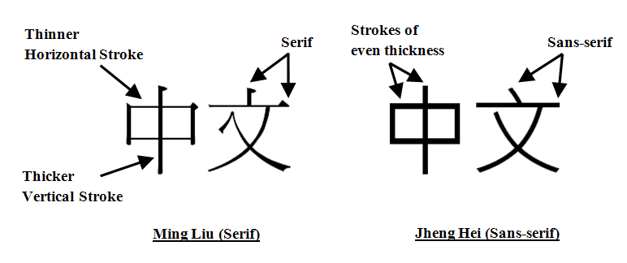
Figure 1 Analysis of Ming Liu and Jheng Hei Chinese character styles.

靜夜思 李白  床前明月光，疑是地上霜，  舉頭望明月，低頭思故鄉。 | Reading Direction  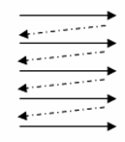 | 靜夜思 李白  床前明月光，  疑是地上霜，  舉頭望明月，  低頭思故鄉。 | 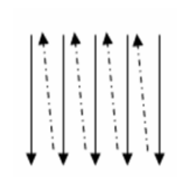  Reading Direction
Horizontal |  | Vertical

Figure 2 The horizontal and vertical text directions used in the experiment.
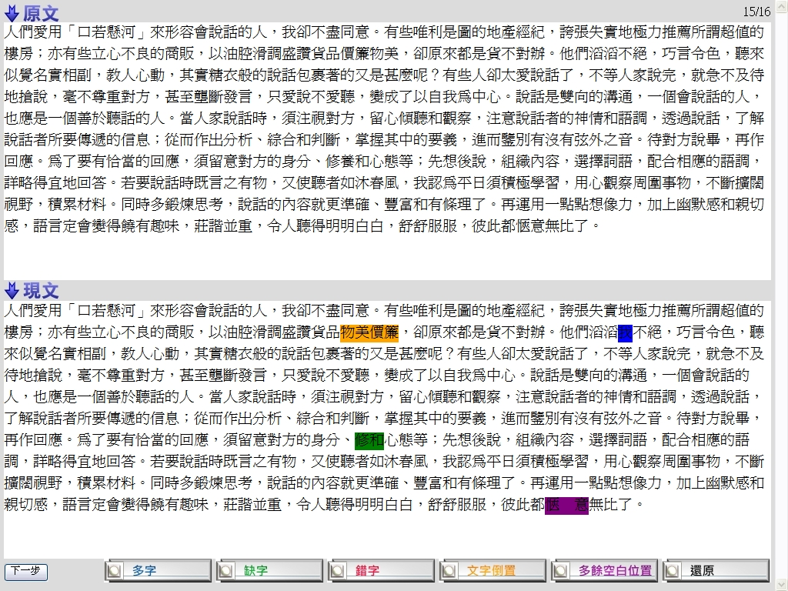
- Horizontal text and top-bottom copy placement (Dead copy at top and live copy at bottom)

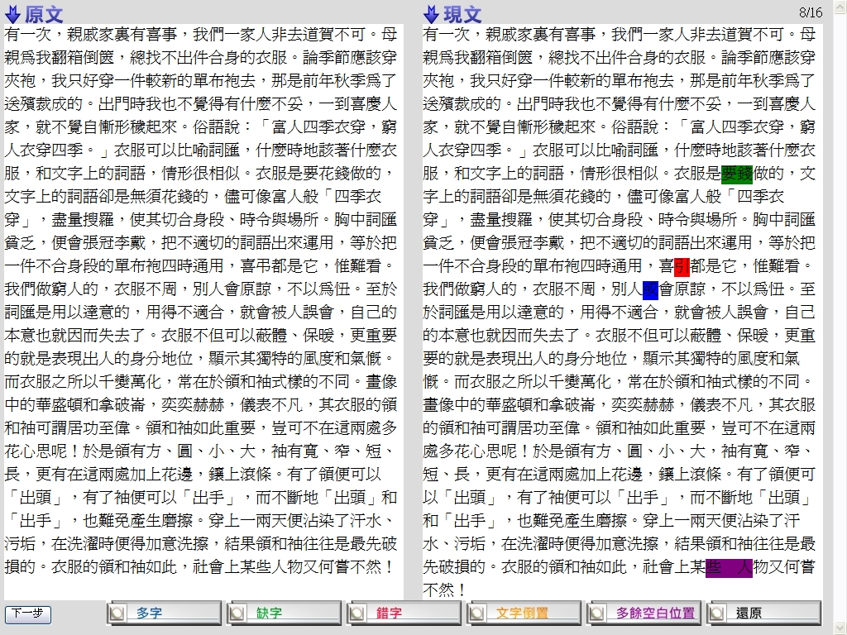
- Horizontal text and left-right copy placement (Dead copy at left and live copy at right)

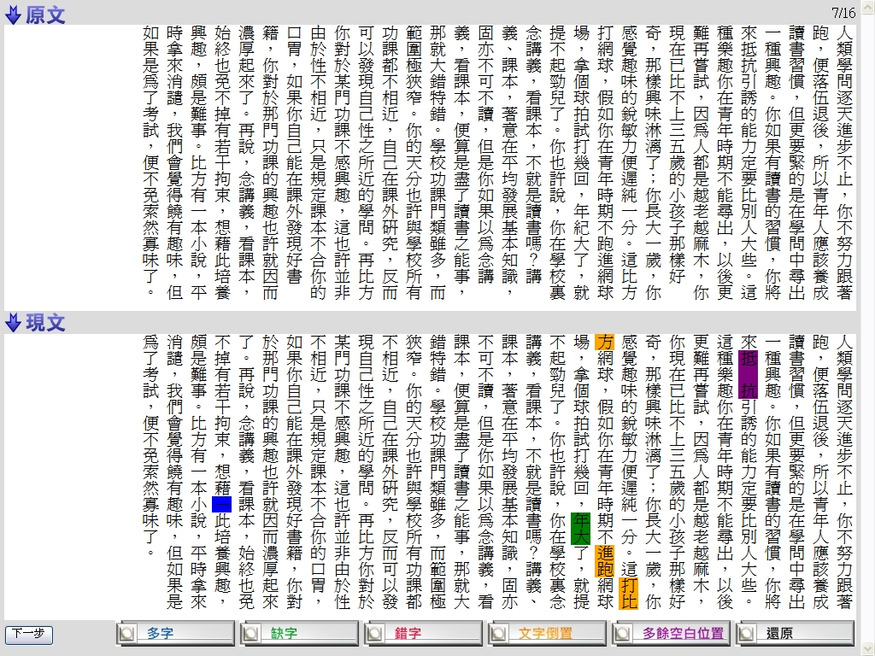
- Vertical text and top-bottom copy placement (Dead copy at top and live copy at bottom)

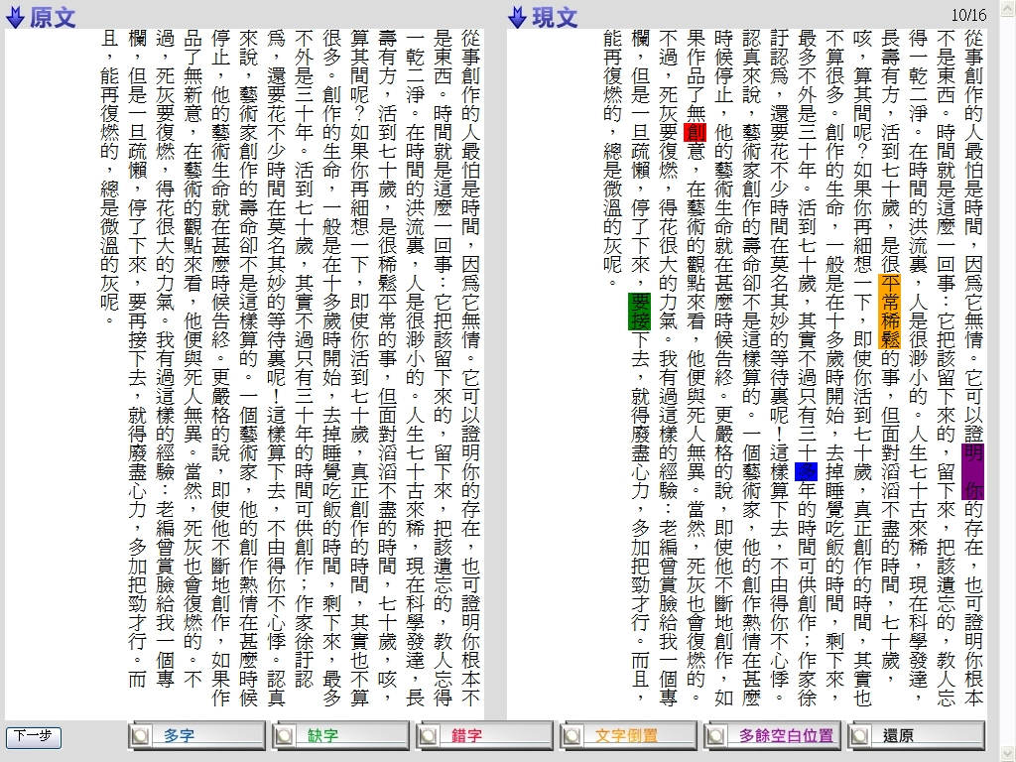
- Vertical text and left-right copy placement (Dead copy at left and live copy at right)

Figure 3 Sample layouts of the four combinations of text direction and copy placement. Participants were asked to compare the dead copy with the live copy and to highlight every instance of typo on the live copy with the corresponding buttons at the bottom of the screen. The buttons from left to right are for indication of typos of extra word, missing word, wrong word, wrong order, and extra spacing. The rightmost one is for undo action.

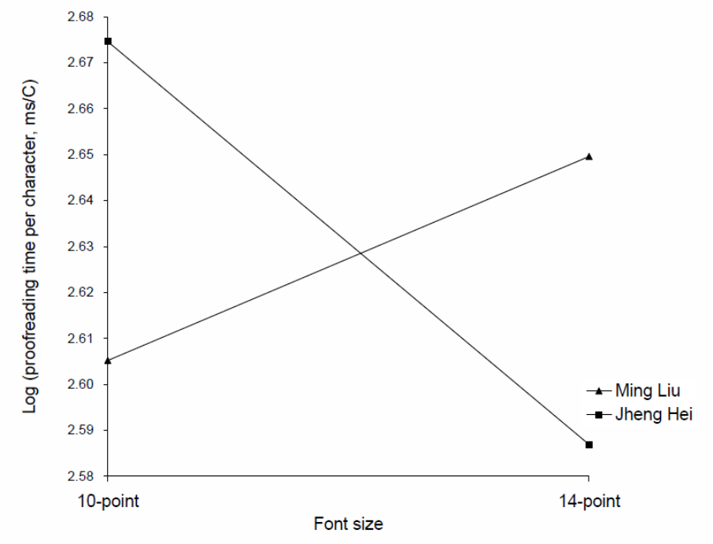
Figure 4 Proofreading time as a function of font type and font size.

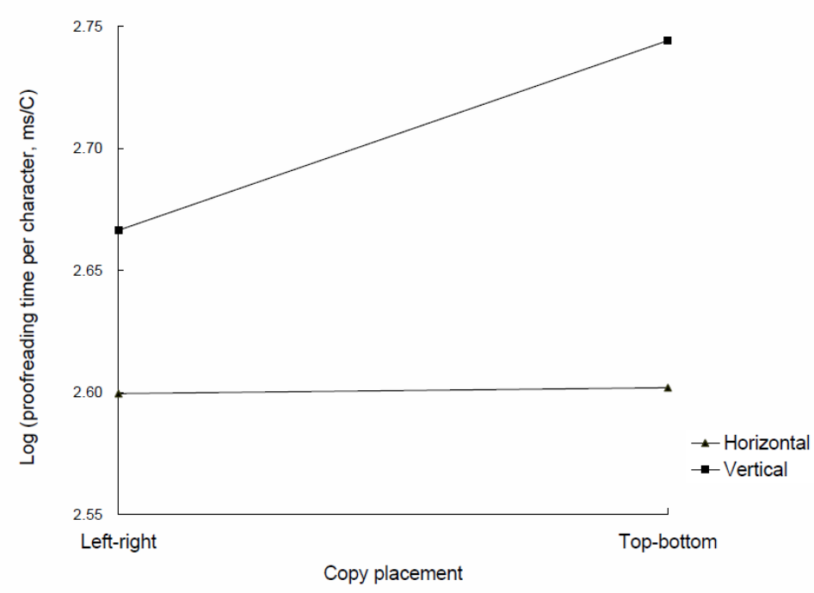
Figure 5 Proofreading time as a function of text direction and copy placement.

