Kyle Heaton
CS4640

A3 Images

Section 1
Im (Original Image, Power Spectrum, Surf)
Trees (Original image, power spectrum, surf)
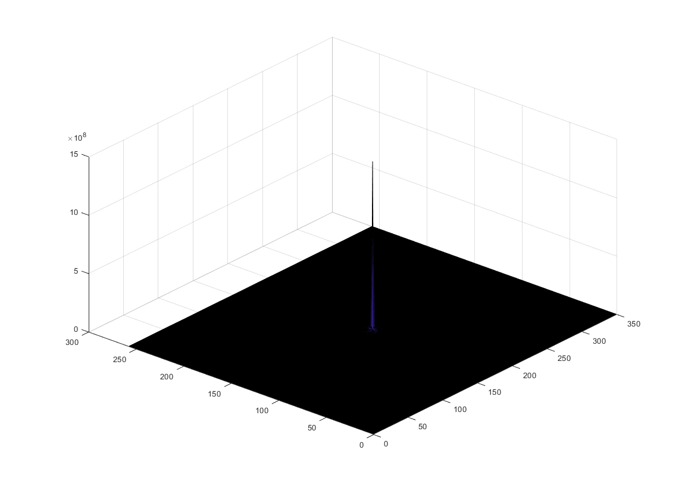

Section 2
Im(spatial filter, frequency filter, combo)
Trees (spatial filer, frequency filter, combo)
I am not sure what happened with the combo
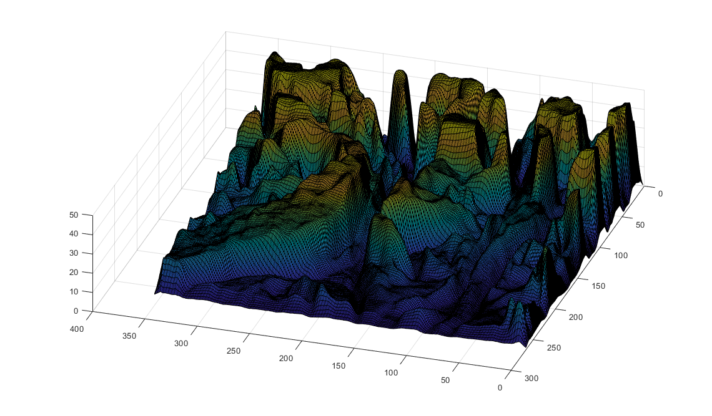
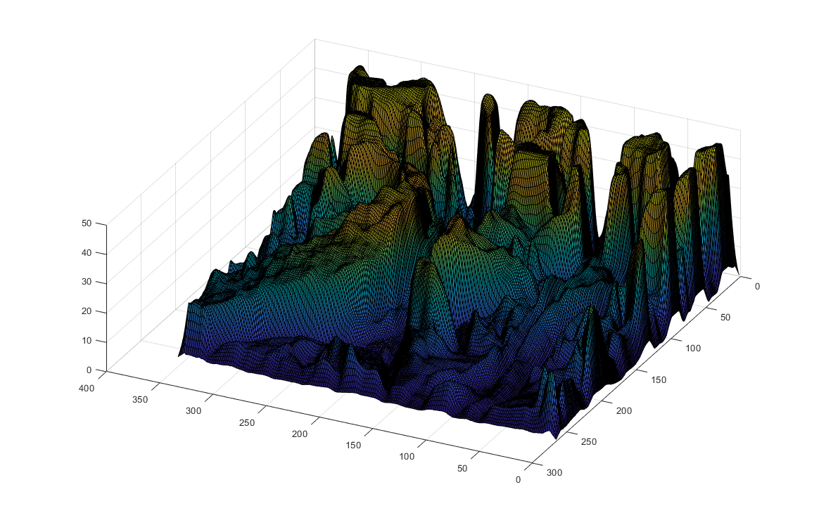

Section 3
I didn’t have time to finish this section by the time I got my functions figured out

Section 4
I didn’t have time to finish this section by the time I got my functions figured out

Section 5
I didn’t have time to finish this section by the time I got my functions figured out

