**Industrial Internship Report on**

**”Password Manager”**

**Prepared by**

**[Khechraay Arkaay]**

|  |
| --- |
| *Executive Summary* |
| This report provides details of the Industrial Internship provided by upskill Campus and The IoT Academy in collaboration with Industrial Partner UniConverge Technologies Pvt Ltd (UCT).  This internship was focused on a project/problem statement provided by UCT. We had to finish the project including the report in 6 weeks’ time.  My project was (Password Manager)  This internship gave me a very good opportunity to get exposure to Industrial problems and design/implement solution for that. It was an overall great experience to have this internship. |

**TABLE OF CONTENTS**

1 Preface 3

2 Introduction 4

2.1 About UniConverge Technologies Pvt Ltd 4

2.2 About upskill Campus 8

2.3 Objective 9

2.4 Reference 9

2.5 Glossary 10

3 Problem Statement 11

4 Existing and Proposed solution 12

5 Proposed Design/ Model 13

5.1 High Level Diagram (if applicable) 13

5.2 Low Level Diagram (if applicable) 13

5.3 Interfaces (if applicable) 13

6 Performance Test 14

6.1 Test Plan/ Test Cases 14

6.2 Test Procedure 14

6.3 Performance Outcome 14

7 My learnings 15

8 Future work scope 16

# Preface

This internship was very useful and helpful for me as I have learned a lot of new things during this period of time. During this 6 week of the internship, I have learnt about the importance of Python programming, gain skills to achieve good heights in the Understanding and implementation of Python Programing, I have also faced the problems on project which I accepted as challenges and by this I have increased my confidence and interest in the particular field.

Python is a widely used programming language applied in websites, software, data analysis and visualization. If we are looking to build a career in programming as a software developer, then a Python internship can be a valuable addition to our resume. Relevant internships are pivotal for career development as they offer targeted industry-specific skills, focused learning, and networking opportunities. They provide insights into industry dynamics, enhance resumes with practical experience, and confirm career choices. Successful internships can lead to job offers and boost confidence while applying classroom knowledge, making candidates stand out in competitive job markets. In essence, relevant internships bridge education and careers, equipping individuals with the expertise and direction needed for a successful and fulfilling professional journey.

A password manager is a secure digital tool that stores, generates, and manages complex passwords for various online accounts. It enhances online security by creating strong, unique passwords for each account and encrypting them. Users only need to remember one master password to access their password vault, streamlining login processes while significantly reducing the risk of security breaches due to weak or reused passwords.

This is a wonderful Opportunity given by USC/UCT for every learner. As python is powerful, easy to understand and fast-growing language in many fields. So once again I would like to thanks USC/UCT for providing such a great internship in python along with quizzes.

How Program was planned

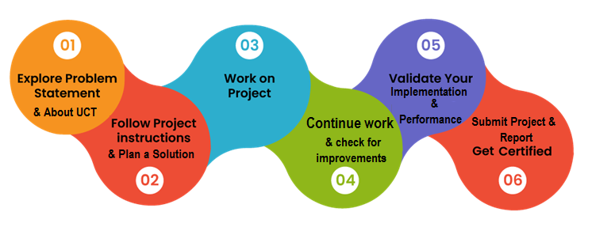

My overall experience of this internship is good and unforgettable. I loved everything about this program, I have been consistent throughout on this tenure as an intern. The Skills gained in this phase will surely help in my upbringings and also for my future endeavors.

It is my pleasure to be indebted to various people, who directly or indirectly contributed in the development of this work and who influenced my thinking, behavior and acts during the internship.

I express my sincere gratitude and thankful to Mr. Kaushlendr Singh Sisodia, Apurv and Upskill Campus team for providing me support, cooperation during this internship.

I would like to suggest everyone for joining this organization as I have been a part of this organization and it was truly so fruitful to me and also, it’s a great opportunity to every learner.

# Introduction

## About UniConverge Technologies Pvt Ltd

A company established in 2013 and working in Digital Transformation domain and providing Industrial solutions with prime focus on sustainability and RoI.

For developing its products and solutions it is leveraging various**Cutting Edge Technologies e.g. Internet of Things (IoT), Cyber Security, Cloud computing (AWS, Azure), Machine Learning, Communication Technologies (4G/5G/LoRaWAN), Java Full Stack, Python, Front end**etc.

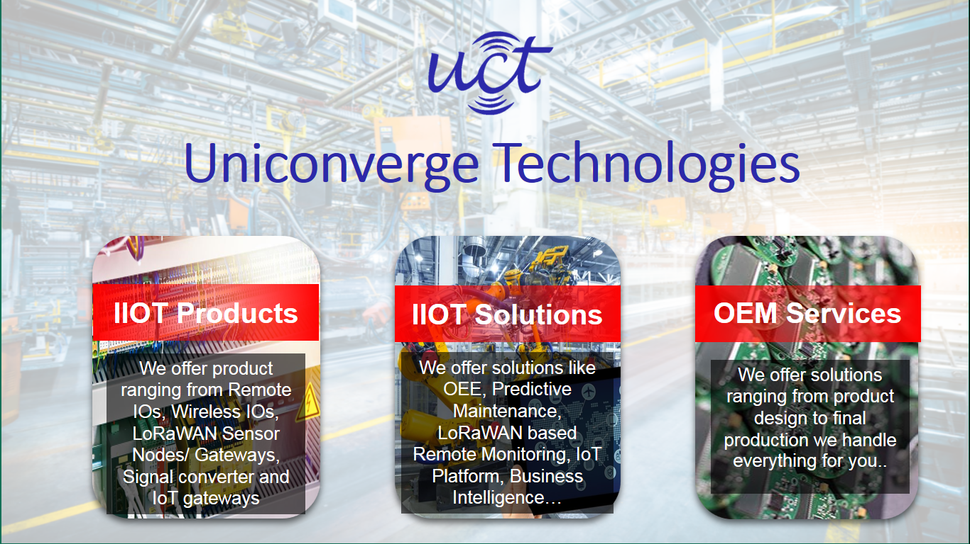

1. UCT IoT Platform **(****)**

**UCT Insight** is an IOT platform designed for quick deployment of IOT applications on the same time providing valuable “insight” for your process/business. It has been built in Java for backend and ReactJS for Front end. It has support for MySQL and various NoSql Databases.

* It enables device connectivity via industry standard IoT protocols - MQTT, CoAP, HTTP, Modbus TCP, OPC UA
* It supports both cloud and on-premises deployments.

It has features to  
• Build Your own dashboard  
• Analytics and Reporting  
• Alert and Notification  
• Integration with third party application (Power BI, SAP, ERP)  
• Rule Engine

 

1. **Smart Factory Platform (****)**

Factory watch is a platform for smart factory needs.

It provides Users/ Factory

* with a scalable solution for their Production and asset monitoring
* OEE and predictive maintenance solution scaling up to digital twin for your assets.
* to unleased the true potential of the data that their machines are generating and helps to identify the KPIs and also improve them.
* A modular architecture that allows users to choose the service that they what to start and then can scale to more complex solutions as per their demands.

Its unique SaaS model helps users to save time, cost and money.

 

1. 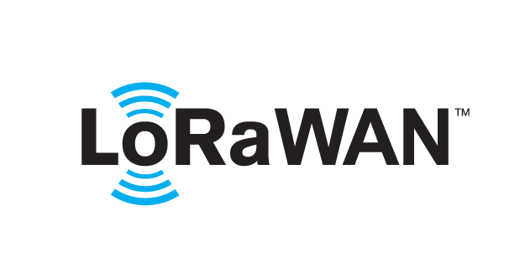 based Solution

UCT is one of the early adopters of LoRAWAN teschnology and providing solution in Agritech, Smart cities, Industrial Monitoring, Smart Street Light, Smart Water/ Gas/ Electricity metering solutions etc.

1. Predictive Maintenance

UCT is providing Industrial Machine health monitoring and Predictive maintenance solution leveraging Embedded system, Industrial IoT and Machine Learning Technologies by finding Remaining useful life time of various Machines used in production process.



## About upskill Campus (USC)

upskill Campus along with The IoT Academy and in association with Uniconverge technologies has facilitated the smooth execution of the complete internship process.

USC is a career development platform that delivers **personalized executive coaching** in a more affordable, scalable and measurable way.



Seeing need of upskilling in self paced manner along-with additional support services e.g. Internship, projects, interaction with Industry experts, Career growth Services

<https://www.upskillcampus.com/>

upSkill Campus aiming to upskill 1 million learners in next 5 year

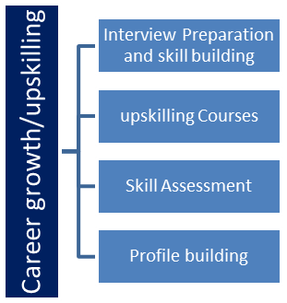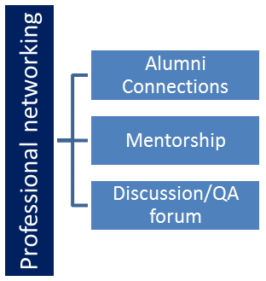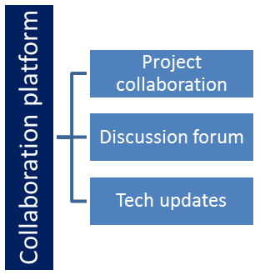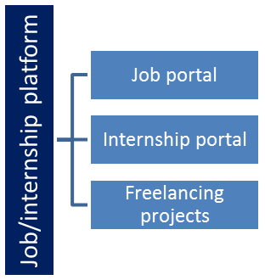

## The IoT Academy

The IoT academy is EdTech Division of UCT that is running long executive certification programs in collaboration with EICT Academy, IITK, IITR and IITG in multiple domains.

## Objectives of this Internship program

The objective for this internship program was to

 ☛ get practical experience of working in the industry.

 ☛ to solve real world problems.

 ☛ to have improved job prospects.

 ☛ to have Improved understanding of our field and its applications.

 ☛ to have Personal growth like better communication and problem solving.

## Reference

[1] UniConverge Technologies Pvt. Ltd. from upskill internship portal, uniconvergetech.in

[2] IoT academy from theiotacademy.com

[3] upSkill Campus from learn.upskillcampus.com and their youtube channel.

[4] *Learning Python 4th edition by Mark Lutz*

[5] [www.python.org](http://www.python.org)

[6] Java Tutorial Point

[7] Geeks for Geeks

[8] <https://stackoverflow.blog/2021/07/14/getting-started-with-python>

[9] *Python for everybody – Exploring Data using Python 3 by Charles R. Severance*

## Glossary

|  |  |
| --- | --- |
| Terms | Acronym |
| Encryption | The process of converting plaintext data into a scrambled format (ciphertext) to protect its confidentiality. |
| Decryption | The process of converting ciphertext back into its original plaintext form. |
| PBKDF2 | (Password-Based Key Derivation Function 2) A key derivation function that transforms a password and a salt into a cryptographic key. |
| AES | (Advanced Encryption Standard) A widely used symmetric encryption algorithm, chosen for its security and efficiency. |
| Initialization Vector (IV) | A random or pseudorandom value used in encryption algorithms to ensure that the same plaintext data encrypts into different ciphertexts. |

# Problem Statement

Password Manager

A password manager is a specialized software tool designed to simplify and enhance the way individuals manage their numerous online account credentials and sensitive information. In an increasingly digital world where security breaches and unauthorized access are common concerns, a password manager serves as a secure repository for storing, generating, and retrieving complex passwords. It employs advanced encryption techniques to safeguard these passwords from unauthorized access, ensuring that users can maintain strong and unique passwords without the burden of memorization. By offering a centralized and encrypted storage solution, along with features like password generation, synchronization across devices, and user-friendly interfaces, password managers contribute significantly to improving both the convenience and security of managing personal online identities.

our task is to create a password manager program using Python. The program should be able to generate a strong a password also and can update, delete and store with website and username. It should encrypt and decrypt the password and the encryption should be strong.

# Existing and Proposed solution

Several existing solutions and commercial password manager applications are available in the market to address the challenges of secure password management. These solutions offer a range of features and capabilities to help users manage their passwords effectively.

* LastPass: A widely-used password manager that offers features like secure password storage, password generation, form filling, and multi-device synchronization. It supports two-factor authentication (2FA) and provides a browser extension for seamless integration.
* NordPass: Developed by the makers of NordVPN, NordPass offers secure password storage and generation. It emphasizes data privacy and follows a zero-knowledge architecture, meaning the provider has no access to user data.
* Dashlane: Known for its user-friendly interface, Dashlane offers secure password storage, password generation, and a digital wallet for storing payment information. It also includes a security dashboard that assesses the overall security of your passwords.

.

This password manager project aims to create a robust and user-friendly application that effectively addresses the challenges of secure password management and accessibility. The solution encompasses several key features and functionalities like encryption and decryption mechanism, password generation and database integration.

## Code submission (Github link)

https://github.com/khechraay11/upskill_campus_python_project

## Report submission (Github link)

https://github.com/khechraay11/upskill_campus_python_project

## 

# Proposed Design/ Model

A proposed model for password manager project is a combination of the following components and their interactions:

1. Authentication and Security:

User authentication using a master password or other authentication methods (AES-256).

Ensures only authorized users can access stored passwords.

Implements security measures to protect against brute-force attacks and unauthorized access.

2. Password Encryption and Decryption:

Encrypts user passwords using strong encryption algorithms.

Decrypts passwords for authorized user access.

Utilizes encryption keys generated from the user's master password or other secure methods.

3. Password Generation:

Generates strong, unique passwords using a secure algorithm.

Offers customizable options for password complexity and length.

4. Database Management:

Manages the storage of encrypted passwords and associated data.

Stores metadata such as website, username, and IV (for encryption).

Supports efficient retrieval and updates of stored data.

## High Level Diagram

This is a High-Level Use-Case diagram which shows the Working of an Password Manager.

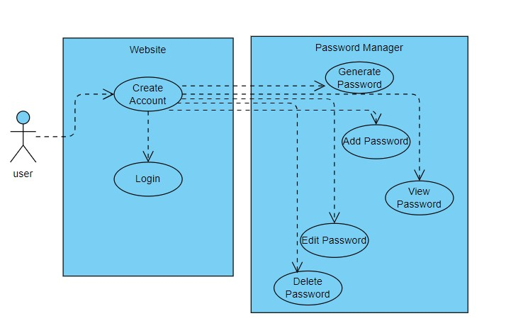

Figure 1: HIGH LEVEL DIAGRAM OF THE SYSTEM

## Low Level Diagram

* 1. Low Level Diagram

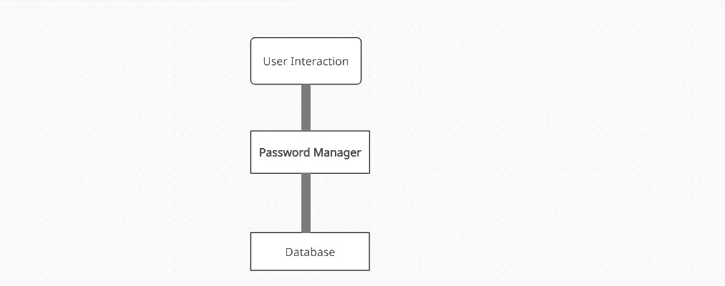

## Figure 2: Low Level Diagram of the System

# Performance Test

Performance test for a project password manager involves assessing its efficiency and responsiveness under different conditions.

**Strong-Encryption**: Strong encryption was required to make the password free of brute force theft. And to generate strong key and salt. It should be binary encoded with good initialization vector.

**Decryption**: Decryption should be accurate any error should not be there as it will not decrypt the data.

**Entropy-Test**: Entropy in the context of passwords refers to the measure of randomness and unpredictability in a password. A password with higher entropy is more complex and difficult to guess, typically achieved by including a mix of uppercase and lowercase letters, numbers, symbols, and avoiding easily guessable patterns or words. Entropy is crucial for ensuring the security of passwords, as higher entropy makes brute-force attacks and password guessing significantly more challenging.

**Real World Challenge**: A significant real-world challenge in developing a password manager project lies in striking the delicate balance between security and convenience. While enhancing password security is paramount, creating a user-friendly and accessible application can be challenging. Here making it more accessible and user friendly was necessary.

## Test Plan/ Test Cases

Test Case 1: Password Generation

1. **Description**: Verify the strong password with at least one uppercase, lowercase, digit and one special character.
2. **Input**: Run function
3. **Output**: Success

Test Case 2: Strong byte key generation

1. **Description**: key generation to cipher.
2. **Input**: Run function
3. **Output**: Success

Test Case 3: Salt Generation

1. **Description**: Salt Generation.
2. **Input**: Run function
3. **Output**: Success

Test Case 4: Create Cipher

1. **Description**: Create a strong cipher with the help of key and salt.
2. **Input**: Run function
3. **Output**: Success

Test Case 5: Encrypt Password

1. **Description**: Encrypt the password with obtain cipher.
2. **Input**: Run function
3. **Output**: Success

Test Case 5: Decrypt Password

1. **Description**: Decrypt Password with key and initialization vector.
2. **Input**: Run function
3. **Output**: Success

Test Case 6: Database Connectivity

1. **Description**: Connect to database.
2. **Input**: Run function
3. **Output**: Success

Test Case 7: Store in database

1. **Description**: store the key, initialization vector, encrypted password, username and website in database.
2. **Input**: Run function
3. **Output**: Success

## Test Procedure

**1. Preparations**

1. Setting up testing environment with required libraries, python software and debugger.
2. Deploy the individual files and functions.

**2. Unit Testing**

1. Execute the individual functions, components and objects.
2. Verify result with expected outcome.

**3. Integration Testing**

1. Test the integration of different modules and components.
2. Verify result with expected outcome.
3. Test the interactions between frontend and backend.

## Performance Outcome

Performance outcomes in the context of a password manager using Python refer to the results and measurements obtained during performance testing. These outcomes help evaluate how well the system performs under different conditions, such as varying user loads, resource utilization, and response times. Here are some key performance outcomes to measure and analyze:

**Entropy:**

It generates good and strong password making the entropy higher.

**AES-256 Encryption:**

Password is strongly encrypted in binary format.

**Resistive:**

Brute force attack cannot hack this encryption.

# My learnings

During my time as a Python intern, I embarked on an enriching learning journey that broadened my concepts and deepened the basics of the topic. Immersed in a dynamic and supportive environment, I had the privilege to work alongside seasoned professionals who generously shared their expertise and guided me through interactive webinar on new emerging technologies such as 5G, cloud computing, Machine learning, data science and particularly python programming.

I learned about many libraries in this course like pythoncryptodome, eel, secrets, cryptography and many more. I learned how the encryption and decryption works in real world with many algorithms like AES -256 which I have used in my own project.

I learned about how to convert into binary file by decrypting and encoding and decoding it and how to connect with database and the binary datatype in SQL.

As a Python intern, my learning experience was both transformative and enlightening. Throughout my internship, I delved into the intricate world of Python programming and gained insights that will undoubtedly shape my future endeavors.

Throughout the internship, I immersed myself in the world of Python, gaining an in-depth understanding of its syntax, data structures, and object-oriented programming concepts. Hands-on coding exercises and collaborative projects enabled me to grasp these fundamentals and apply them effectively to real-world scenarios. Perhaps the most enduring lesson from this experience was the value of continuous learning. Python's dynamic nature means that there is always something new to explore. Whether it's mastering the latest libraries, keeping up with best practices, or embracing emerging trends, the internship instilled in me a sense of curiosity and adaptability that will serve me well throughout my career

In conclusion, my time as a Python intern was marked by continuous growth and exploration. I emerged from this experience with not only enhanced technical proficiency but also a sense of confidence and enthusiasm to contribute meaningfully to the world of Python programming.

**8 Future work scope**

As a Python intern, my future work scope is filled with exciting and diverse possibilities.

But for this project,

Developing an interactive user-Gui so to enhance user interface.

Making it available as extension in browser to enhance usedness and making it more user friendly.

Connecting with cloud service or with mongo DB atlas.