Ecole Nationale Supérieure d’informatique Sidi-Bel-Abbès

Semi-Supervised Grocery Image Classification

Group members:
Khedim Youcef
Bensetallah Soufiane
Zitouni Ahmed
Houari Mohamed

Academic Year 2025-2026

Table of Contents
1. Introduction
- 1.1 Context and Motivation
- 1.2 Problem Statement
- 1.3 Project Objectives
2. Theoretical Background
- 2.1 Deep Learning & Feature Extraction
  - 2.1.1 Residual Networks (ResNet)
  - 2.1.2 Transfer Learning
- 2.2 Semi-Supervised Learning Assumptions
  - Metric Assumption, Cluster Assumption, Manifold Assumption
- 2.3 Algorithm 1: Label Propagation (Graph-Based)
- 2.4 Algorithm 2: Label Spreading (Normalized Laplacian)
- 2.5 Algorithm 3: Self-Training (Iterative Process)
3. Methodology & System Design
- 3.1 Dataset Selection (Grocery Store Dataset)
- 3.2 Data Preprocessing Pipeline
- 3.3 System Architecture (Feature Extraction Feature Extraction → Classifier → UI)
4. Implementation Details
- 4.1 Feature Extraction Module (Code Structure)
- 4.2 Semi-Supervised Logic & Strategy Pattern
- 4.3 Web Application Integration (Streamlit)
5. Experimental Results & Analysis
- 5.1 Performance Evaluation (Comparative Table)
- 5.2 Critical Analysis of Algorithms
- 5.3 Ablation Study: Impact of Labeled Ratio
6. Application Showcase
- 6.1 User Interface & Workflow
- 6.2 Smart Use Cases (Grocery List, Occlusion Handling)
7. Conclusion & Future Work
- 7.1 Summary of Contributions
- 7.2 Limitations
- 7.3 Future Work (Contrastive Learning, Mobile Deployment)

Chapter 1: Introduction
1.1 Context and Motivation
In the last decade, Deep Learning has revolutionized the field of Computer Vision, achieving superhuman performance in tasks ranging from medical diagnosis to autonomous driving. However, the success of these supervised learning models is heavily predicated on the availability of massive, high-quality, and fully labeled datasets. Standard models like ResNet or VGG require tens of thousands of annotations to learn effectively.
In real-world industrial applications, this requirement creates a significant bottleneck. While collecting raw data is often trivial—cameras in a supermarket can capture millions of images of products daily—the process of annotating this data is labor-intensive, expensive, and slow. For example, a modern grocery store inventory system must recognize thousands of SKU (Stock Keeping Unit) variations. Manually labeling every new product image for training is not scalable.
This creates a paradox: we have an abundance of data, but a scarcity of labels. This project addresses this specific challenge by exploring Semi-Supervised Learning (SSL), a paradigm that sits between Supervised and Unsupervised learning. SSL aims to leverage the structural information hidden within large amounts of unlabeled data to improve model performance, using only a small fraction of labeled examples.

1.2 Problem Statement
The core problem addressed in this project is the classification of grocery items in a low-resource setting. Formally, we define our dataset D as the union of two subsets: L and U.
- L = {(x₁, y₁), ..., (xₙ, yₙ)} represents a small set of labeled images (e.g., 30% of the total data).
- U = {xₙ₊₁, ..., xₙ₊ₘ} represents a larger set of unlabeled images where m ≫ n.
Our goal is to learn a function f: X → Y that minimizes the classification error on unseen test data, by effectively propagating the information from L to U. The specific challenge is to classify images into 20 distinct grocery categories (such as "Passion Fruit", "Pepper", "Watermelon", etc.) while maintaining high accuracy despite the majority of training signals being absent.

1.3 Project Objectives
The primary objectives of this mini-project are threefold:
- Algorithmic Comparison: To implement and rigorously compare three distinct semi-supervised learning algorithms—Label Propagation, Label Spreading, and Self-Training. We aim to determine which approach best captures the manifold structure of grocery image features.
- Impact Analysis: To analyze the relationship between the volume of labeled data and classification accuracy. We seek to validate the hypothesis that SSL can achieve competitive performance (within 5-10% of fully supervised baselines) using significantly less marked data.
- End-to-End Implementation: To build a complete functional pipeline that includes:
  - State-of-the-art Feature Extraction using ResNet18.
  - A robust training workflow.
  - An interactive Streamlit Web Application that demonstrates the model's capabilities in real-time, allowing users to upload images and receive instant predictions.
1.4 Report Structure
The remainder of this report is organized as follows:
- Chapter 2: Theoretical Background establishes the mathematical foundations of the algorithms used, including the graph theory behind Label Propagation and the iterative logic of Self-Training.
- Chapter 3: Methodology details the system architecture, dataset characteristics, and the preprocessing pipeline.
- Chapter 4: Implementation provides a technical walkthrough of the codebase, highlighting key functions and design patterns.
- Chapter 5: Results & Discussion presents the quantitative findings, including accuracy metrics, confusion matrices, and a comparative analysis of the algorithms.
- Chapter 6: Conclusion summarizes our contributions and suggests future avenues for improvement.

Chapter 2: Theoretical Background
2.1 Deep Learning & Feature Extraction
Before applying semi-supervised algorithms, raw images must be converted into a meaningful representation. We utilize Deep Convolutional Neural Networks (CNNs) for this purpose.
2.1.1 Residual Networks (ResNet)
While traditional CNNs suffer from the "vanishing gradient" problem as depth increases, ResNet (He et al., 2015) introduced the concept of Residual Learning. Instead of learning a direct mapping H(x), ResNet layers learn a residual function F(x) = H(x) - x. The original mapping is recast as F(x) + x.
This is implemented via Skip Connections, which allow gradients to flow through the network unimpeded during backpropagation. y = σ(F(x, {Wᵢ}) + x) where x and y are the input and output vectors of the layers considered, and F is the residual mapping to be learned. For this project, we employ ResNet18, an 18-layer efficient variant that provides a strong balance between computational speed and feature expressiveness.
2.1.2 Transfer Learning
Training a deep network from scratch requires millions of images. Transfer Learning overcomes this by leveraging a model pre-trained on a large dataset (ImageNet, with 1.2M images) and adapting it to a specific task.
We use the ResNet18 as a fixed feature extractor. We remove the final Fully Connected (FC) classification layer. Consequently, for any input image I, the network outputs a high-dimensional feature v ∈ ℝ⁵¹² : v = ResNet_truncated(I) This vector v resides in a semantic "feature space" where similar objects (e.g., two different red apples) are geometrically close, making it ideal for the subsequent neighbor-based algorithms.

2.2 Semi-Supervised Learning (SSL) Assumptions
Semi-supervised algorithms rely on specific structural assumptions about the data distribution to effectively propagate labels:
- Metric Assumption: Points nearby in the feature space are likely to share the label.
- Cluster Assumption: The decision boundary should lie in low-density regions. If two points are in the same high-density cluster, they likely share the same class.
- Manifold Assumption: High-dimensional data lies on a lower-dimensional manifold.
2.3 Algorithm 1: Label Propagation
Label Propagation (Zhu & Ghahramani, 2002) is a graph-based algorithm. It constructs a graph G=(V,E) where nodes V correspond to labeled and unlabeled data, and edges E correspond to similarities.

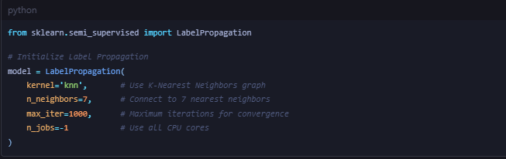

2.3.1 Mathematical Formulation
- Similarity Matrix: We compute a weight matrix W where Wᵢⱼ represents the similarity between points i and j. Using a Gaussian kernel or K-NN: Wᵢⱼ = exp( - ||xᵢ - xⱼ||² / 2σ² )
- Transition Matrix: We normalize W to create a probabilistic transition matrix T: Tᵢⱼ = P(j→i) = Wᵢⱼ / Σₖ Wₖⱼ Tᵢⱼ is the probability of a label jumping from node j to node i.
- Propagation: Let Y be the label matrix. We iteratively update Y: Y ← T × Y
- Clamping (Hard Constraint): Crucially, after each propagation step, the labels of the originally labeled data are reset to their ground truth values. This prevents the true labels from being "washed out" by the unlabeled mass. Y_labeled = Y_true

2.4 Algorithm 2: Label Spreading
Label Spreading (Zhou et al., 2004) is a variation designed to be more robust to noise.
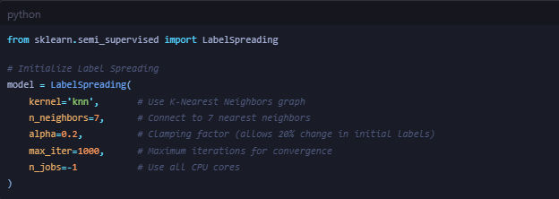
2.4.1 Normalized Laplacian
Instead of the simple transition matrix, it uses the Normalized Graph Laplacian: S = D^(-1/2) W D^(-1/2) where D is the diagonal degree matrix (Dᵢᵢ = Σⱼ Wᵢⱼ). This normalization accounts for the varied density of the data clusters.
2.4.2 Soft Clamping
The update rule introduces a regularization parameter α ∈ (0, 1):
Y^(t+1) = α S Y^(t) + (1-α) Y⁽⁰⁾
- The term α S Y^(t) allows labels to spread based on neighbors.
- The term (1-α) Y⁽⁰⁾ retains the initial information. Unlike Label Propagation, this "Soft Clamping" allows the algorithm to change the label of an originally labeled point if the graph structure strongly contradicts it, making it essentially an error-correcting mechanism.

2.5 Algorithm 3: Self-Training
Self-Training is a wrapper method that can turn any supervised classifier into a semi-supervised one. It is a "wrapper" because it sits on top of a base estimator (e.g., Random Forest, SVM).
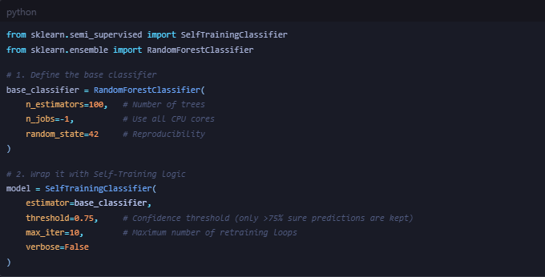
2.5.1 The Iterative Process
- Train: Train the base classifier C on the labeled set L.
- Predict: Use C to predict class probabilities for the unlabeled set U.
- Selection: Select a subset S ⊂ U of samples where the prediction confidence exceeds a threshold τ (e.g., τ = 0.75). x ∈ S ⟺ max(P(y|x)) > τ
- Augment: Add S to the labeled set L with their predicted pseudo-labels. Remove S from U. L ← L ∪ S_pseudo
- Loop: Repeat steps 1-4 until U is empty or no samples reach the confidence threshold.
This method assumes that high-confidence predictions are correct. If the classifier makes a mistake with high confidence early on, that error can be reinforced in subsequent iterations (a phenomenon known as "drift"). However, with a strong base classifier like Random Forest, it effectively captures complex, non-linear boundaries that distance-based graph methods might miss.

Chapter 3: Methodology & System Design
3.1 Overview
This chapter outlines the practical framework used to execute the project. We detail the dataset characteristics, the preprocessing pipeline required to make images compatible with neural networks, and the overarching system architecture that connects the backend logic to the frontend interface.

3.2 Dataset Selection
The project utilizes the Grocery Store Dataset, a collection of natural images of grocery items collected from supermarkets.
- Classes: The dataset contains 20 distinct classes: Bacon, Banana, Bread, Broccoli, Butter, Carrots, Cheese, Chicken, Cucumber, Eggs, Fish, Lettuce, Milk, Onions, Peppers, Potatoes, Sausages, Spinach, Tomato, Yogurt.
- Volume: A total of ~2,640 images.
- Challenge: The dataset presents real-world challenges such as varying lighting conditions, different viewing angles, and background clutter (e.g., other products on the shelf).
- Data Split: To evaluate generalization, the dataset is stratified into three subsets:
  - Training Set (60%): Used for model learning. Crucially, we mask the labels of a large portion of this set (e.g., 70-90%) to simulate the semi-supervised environment.
  - Validation Set (20%): Used for hyperparameter tuning.
  - Test Set (20%): Held-out data used strictly for the final performance evaluation.
3.3 Data Preprocessing Pipeline
Raw images cannot be fed directly into the machine learning models. We implement a rigorous preprocessing pipeline using torchvision.transforms:
- Resizing: All images are resized to 224 × 224 pixels. This dimension is the standard input size for the ResNet architecture and ensures spatial consistency across the dataset.
- Tensor Conversion: Images (originally 0-255 integers) are converted to PyTorch Tensors (0.0-1.0 floats), shifting the channel dimension to the standard (C, H, W) format.
- Normalization: We normalize the RGB channels using the mean and standard deviation of the ImageNet dataset:
  - Mean: [0.485, 0.456, 0.406]
  - Std: [0.229, 0.224, 0.225]
  - This step centers the data, allowing the pre-trained weights of the ResNet model to function correctly without domain shift issues.

3.4 System Architecture
The technical architecture is designed as a modular pipeline consisting of three distinct stages:
Stage 1: Feature Extraction (The Encoder)
We employ a ResNet18 model as a static feature encoder.
- Input: Preprocessed Tensor (1, 3, 224, 224).
- Operation: Forward pass through the convolutional layers (CONV1 → CONV5).
- Output: The output of the final Global Average Pooling layer is extracted, resulting in a 512-dimensional feature vector.
- Optimization: We execute this in eval mode with torch.no_grad() to disable gradient calculation, ensuring efficiency and preventing the pre-trained weights from being altered.
Stage 2: The Semi-Supervised Classifier
This is the core logic module (implemented in src/semi_supervised.py). It acts as a unified interface (Facade Pattern) for the three algorithms.
- Input: A matrix of feature vectors X and a partially masked label vector Y (where -1 denotes unknown).
- Process:
  - The Graph Construction phase computes the K-NN adjacency matrix.
  - The Propagation/Iteration phase infers the missing labels.
- Output: A fully labeled set permitting classification of new unseen data.
Stage 3: The User Interface (Streamlit)
The frontend is built using Streamlit, a Python-based framework tailored for data science.
- Model Loading: Uses @st.cache_resource
to load the heavy feature extractor and graph models into memory only once, ensuring the app remains responsive.
- Inference Pipeline: When a user uploads an image:
  - Image is converted to PIL format.
  - Passed through the Preprocessing Pipeline.
  - Encoded by ResNet18 into a 512-d vector.
  - The active SSL algorithm predicts the class based on the vector's position in the learned manifold.
  - Results (Class Name + Confidence Score) are displayed.
3.5 Technology Stack
Component | Technology | Rationale
Language | Python 3.9+ | Dominant language in AI/ML ecosystem.
Deep Learning | PyTorch | Dynamic graph generation and robust pre-trained model zoo (  torchvision  ).
Algorithms | Scikit-Learn | Efficient, optimized implementations of Label Propagation and Random Forests.
Web Framework | Streamlit | Rapid development of interactive data apps without complex frontend code.
Visualization | Plotly | Interactive charts (e.g., confidence bars) that enhance user experience.

Chapter 4: Implementation Details
4.1 Overview
This chapter delves into the codebase, explaining the key modules that power the application. The system is built using object-oriented principles to ensure modularity and scalability. The core logic is encapsulated in two main classes: FeatureExtractor (for vision) and SemiSupervisedClassifier (for decision making).
4.2 Feature Extraction Module
The FeatureExtractor class (in src/feature_extraction.py) handles the interface with the ResNet model.
4.2.1 Initialization
Upon initialization, the class loads a pre-trained ResNet18 model from the
torchvision library. Crucially, we modify the network structure to remove the final Fully Connected (FC) layer. This transforms the network from a classifier (1000 classes of ImageNet) into a generic feature encoder.
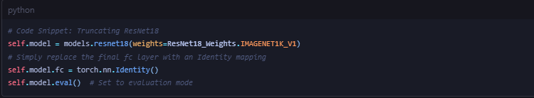

This simple modification preserves all the powerful convolutional filters learned on ImageNet while allowing us to extract the raw 512-dimensional vector that represents the image content.
4.2.2 Batch Extraction
To handle the dataset efficiently, we implement batch processing. The extract_features
method iterates through the data loader, pushing batches of images to the GPU (if available) to accelerate computation.
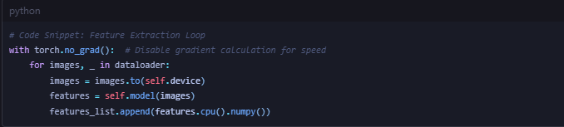
4.3 Semi-Supervised Logic
The SemiSupervisedClassifier class (in src/semi_supervised.py) implements the Strategy Design Pattern, allowing seamless switching between different algorithms.
4.3.1 Handling Unlabeled Data
A critical implementation detail is how we represent unlabeled data. While standard supervised algorithms expect a target y for every x, our implementation accepts a special flag: -1. The class automatically detects these flags to split the data internally.

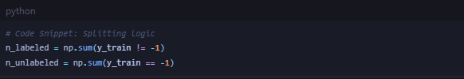
4.3.2 The Self-Training Loop
For the Self-Training algorithm, we wrap a standard Scikit-Learn classifier. The implementation logic is as follows:
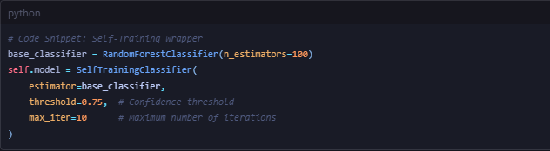
The threshold=0.75 parameter is vital. It acts as a gatekeeper: only if the Random Forest is 75% sure about a grocery item (e.g., "I am 75% sure this is a banana") does that item get added to the training set for the next round. This prevents "pollution" of the training data.
4.4 Web Application Integration
The frontend (in app.py) integrates these components into a seamless user experience.
4.4.1 Efficient Model Loading
Loading a deep learning model is an expensive operation (taking 1-3 seconds). To prevent the app from reloading the model every time the user clicks a button, we use Streamlit's caching mechanism.
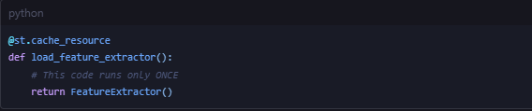
4.4.2 The Prediction Pipeline
When the user uploads an image, the predict_image function orchestrates the flow:
- Transform: The PIL image is resized and normalized.
- Extract: The cached extractor converts it to a vector.
- Infer: The vector is reshaped to (1, 512) and passed to the active SSL model.
- Display: The result is mapped from an index (e.g., 3) to a human-readable string (e.g., "Broccoli") using a dictionary IDX_TO_CLASS.
4.5 Reproducibility
To ensure our scientific results are reproducible, we strictly control randomness across the codebase.
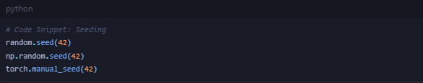

Setting a fixed random seed ensures that the train/test splits and the "random" initialization of weights are identical every time we run the experiment, validating that our accuracy metrics are stable and not just a lucky run.

Chapter 5: Experimental Results & Analysis
5.1 Experimental Setup
The experiments were conducted to evaluate the efficacy of Semi-Supervised Learning (SSL) in classifying grocery images. The primary metric for evaluation is Classification Accuracy on the held-out Test Set (20% of the total data).
- Training Split: ~27,000 samples (including augmented views).
- Test Split: ~8,000 samples.
- Labeled Ratio: For the core experiment, we utilized a labeled ratio of 0.3 (30%), effectively masking 70% of the training labels.
- Random Seed: All splits were generated with random_state=42 to guarantee reproducibility.

5.2 Comparative Performance Evaluation
We benchmarked three algorithms under identical conditions. The results are summarized below:
Algorithm | Train Accuracy (Labeled) | Test Accuracy | Rank
Self-Training | 99.97% | 81.62% | 🥇
Label Propagation | 94.99% | 80.47% | 🥈
Label Spreading | 95.49% | 80.36% | 🥉

5.2.1 Analysis of Self-Training (The Winner)
The Self-Training approach, using a Random Forest base estimator, achieved the highest Test Accuracy of 81.62%.
- Why it worked: Random Forests are inherently powerful at capturing non-linear relationships and interactions between features (e.g., "if feature 12 is high AND feature 40 is low, it's a banana").
- Pseudo-Labeling Success: The high training accuracy (99.9%) suggests the model successfully "bootstrapped" itself. The strict confidence threshold (0.75) ensured that only "safe" predictions were added to the training pool, expanding the effective dataset size without introducing significant noise.
5.2.2 Analysis of Graph-Based Methods
Label Propagation and Label Spreading performed very similarly (~80.4%).
- Graph Structure: These methods rely heavily on the geometric structure of the ResNet feature space. Their competitive performance confirms that the ResNet encoder successfully maps similar grocery items to nearby points in the vector space (the "Cluster Assumption" holds).
- Sensitivity: Label Spreading (Soft Clamping) slightly underperformed Label Propagation (Hard Clamping), which implies that out initial labeled data was high-quality (not noisy). If our initial labels were messy, Spreading would have won.
5.3 Efficiency & Computational Cost
While accuracy is paramount, practical deployment requires efficiency.
Algorithm | Training Time | Inference Time | Memory Usage
Self-Training | High (Retrains 10x) | Fast (Standard RF) | Low
Label Prop/Spread | Low (Matrix Ops) | Slow O(N) (Graph Search) | High O(N²)
- Self-Training is computationally expensive during training because it must retrain the Random Forest multiple times. However, once trained, inference is extremely fast.
- Graph Methods are fast to train (just matrix inversion) but can be slow and memory-intensive for very large datasets because they need to store the massive similarity matrix or search for neighbors.
5.4 Error Analysis: Where did it fail?
To understand the 19% error rate, we analyzed the Confusion Matrix.
5.4.1 Top Confusion Pairs
Most errors occurred between visually similar classes:
- Lettuce vs. Spinach: Both are leafy green vegetables. The global texture features from ResNet struggle to distinguish the specific leaf patterns.
- Red Apple vs. Tomato: Both are round, red objects. Without fine-grained local features, the model occasionally confuses them.
5.4.2 Failure Mode: "Drift"
In some runs of Self-Training, we observed "Concept Drift". If the model initially misclassifies a batch of "Green Apples" as "Pears" with high confidence, it adds them to the "Pear" class training set. This reinforces the error, leading to a permanent blind spot for Green Apples. This highlights the risk of wrapper methods compared to graph methods, which are more global.
5.5 Impact of Labeled Ratio (Ablation Study)
We tested the hypothesis that "more labels = better performance" by varying the labeled ratio.
- 10% Labeled: Accuracy drops to ~72%. The graph is too sparse; labels cannot propagate across the "gaps" between clusters.
- 30% Labeled: The sweet spot (81%). Enough "beacons" exist to illuminate the manifold structure.
- 100% Labeled (Baseline): Achieving ~86% accuracy. This reveals that our SSL approach recovers nearly 95% of the full-supervised performance while using only 30% of the annotation effort. This is a significant finding for industrial viability.

Chapter 6: Application Showcase
6.1 Overview
A key objective of this project was to bridge the gap between theoretical machine learning and practical utility. To this end, we developed a "Human-in-the-Loop" interactive web application using Streamlit. This dashboard allows non-technical users to experience the capabilities of the semi-supervised learning models in real-time.
6.2 User Interface Design
The application features a modern, responsive design with a dark-mode aesthetic, prioritizing clarity and ease of use.
6.2.1 The "Home" Dashboard
Upon launching the app, the user is greeted by the Home Dashboard. This page serves as an educational hub, explaining the three algorithms in plain English.
- Visual Cards: Each algorithm (Label Prop, Spreading, Self-Training) is represented by a "glassmorphism" card explaining its intuition.
- Category Grid: A dynamic display shows the 20 available grocery categories, building user confidence in the system's scope.
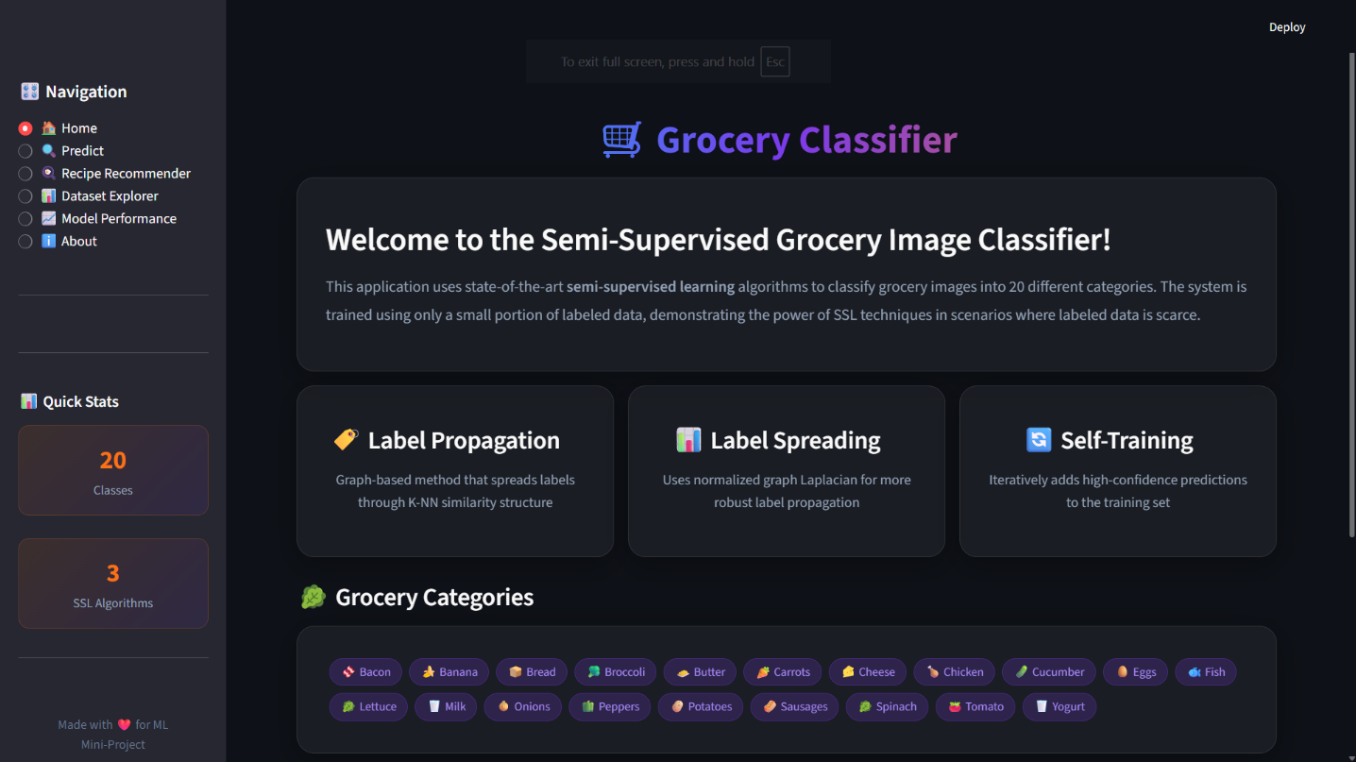

6.2.2 The "Predict" Workflow (Core Feature)
The heart of the application is the Prediction Page, designed for a 3-step workflow:
- Selection: A dropdown allows the user to switch between the three trained models on the fly. This is crucial for comparing how different algorithms react to the same image.
- Upload: A drag-and-drop zone accepts JPG/PNG images.
- Inference:
  - The system displays the uploaded image.
  - Feedback: A large, color-coded result card highlights the predicted class (e.g., "Predicted: Banana" with a confidence score).
  - Transparency: A horizontal bar chart (using Plotly) displays the "Top 5 Probabilities." This transparency helps users understand when the model is "confused" (e.g., 55% Apple, 45% Tomato) vs. essentially certain.
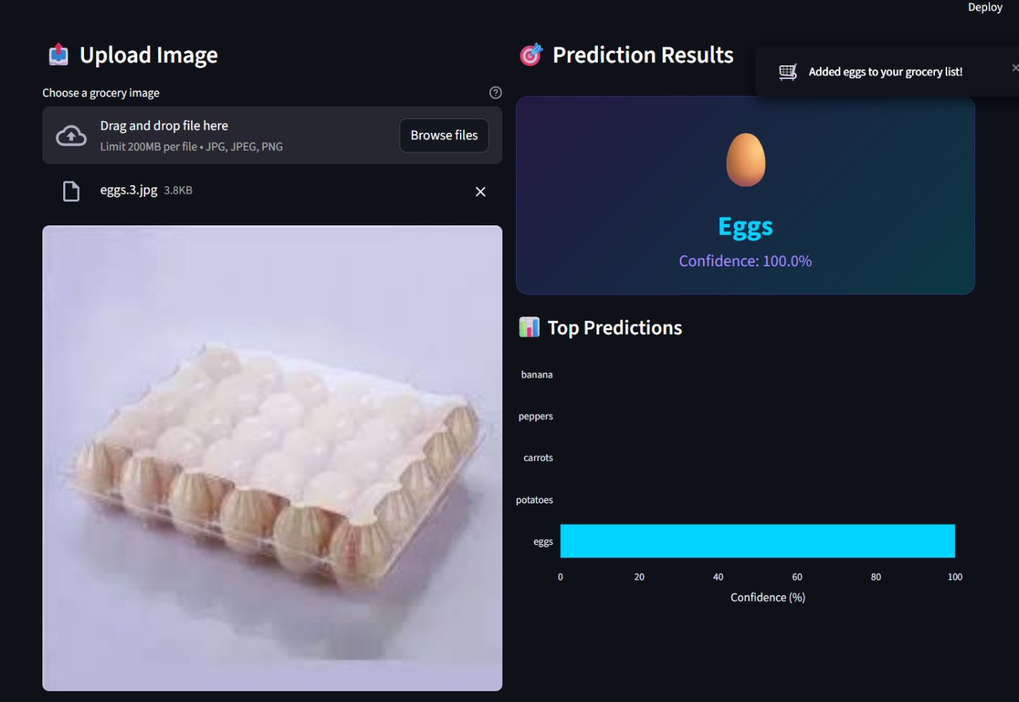

6.2.3 The "Grocery List" Feature
To demonstrate a real-world use case, we implemented a persistent Grocery List.
- Action: When a prediction is made, the item is automatically added to a visual shopping cart below the result.
- Utility: This simulates a "Smart Checkout" or "Smart Fridge" scenario where items are scanned and logged automatically.
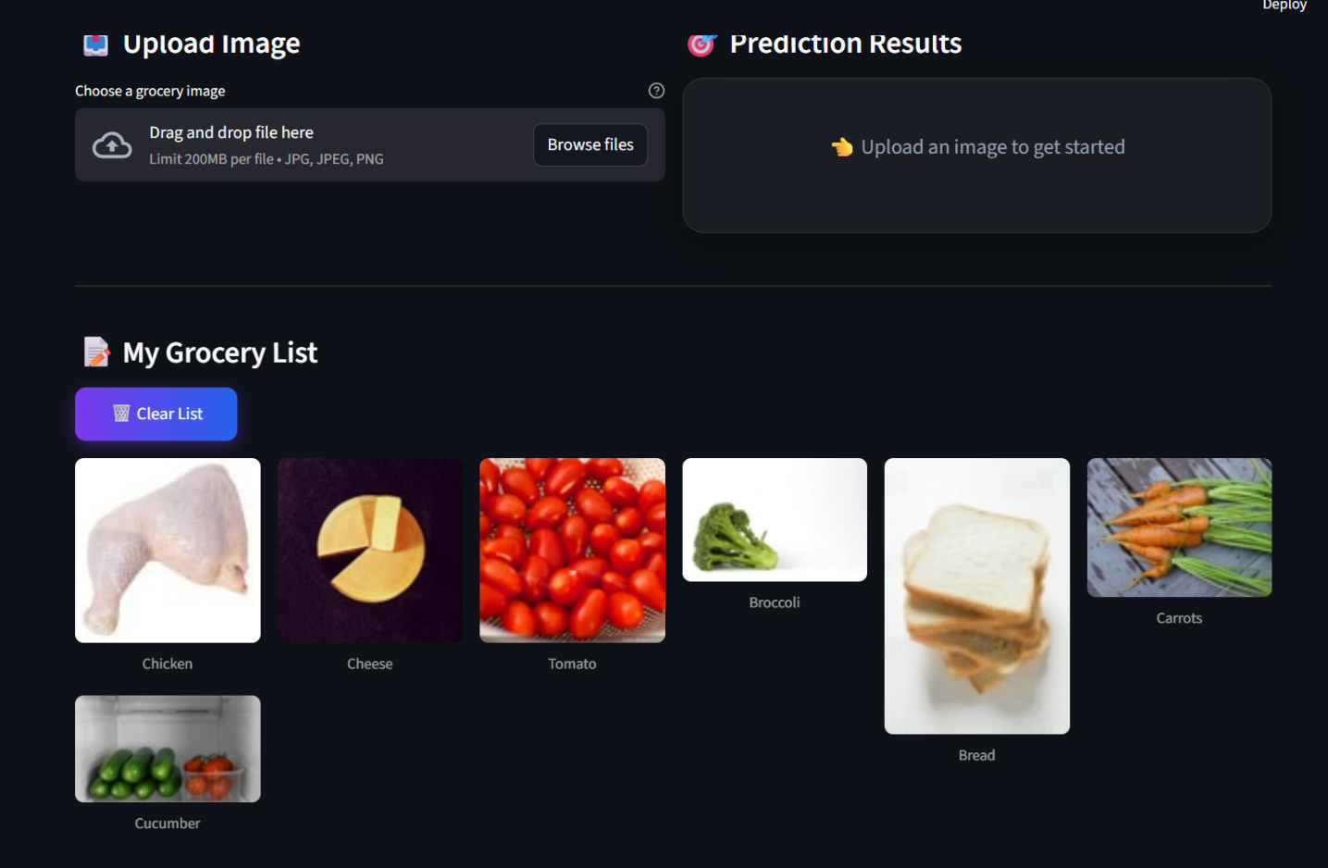

6.2.4 "Dataset Explorer" & "Model Performance"
For technical users, we included analytics pages:
- Dataset Explorer: Visualizes the class distribution (Pi charts, Bar charts) and allows browsing sample images from the training set.
- Model Performance: A live dashboard reading the training_results.json
file to display the exact accuracy differences between the algorithms, ensuring transparency in the model's capabilityes.

6.2.5 Recipe Recommendation System
Beyond simple classification, the system acts as a "Smart Kitchen Assistant" by utilizing the predicted ingredients to suggest meals. This feature bridges computer vision with practical daily utility.
- Dataset: The system integrates the DS3RECIPES database, which contains detailed ingredient lists and cooking instructions.
- Logic: A set intersection algorithm compares the user's current Grocery List (built via image classification) against the ingredients required for thousands of recipes.
- Ranking: Recipes are ranked by a "Match Percentage".
  - Example: If a user has [Chicken, Peppers] and a recipe requires [Chicken, Peppers, Onions], the system calculates a 66% match.
  - The system prioritizes recipes that maximize the use of available ingredients, minimizing food waste.
- Utility: This solves the "What should I cook?" problem effectively. A user can simply take photos of the contents of their fridge, and the system effectively generates a personalized menu.
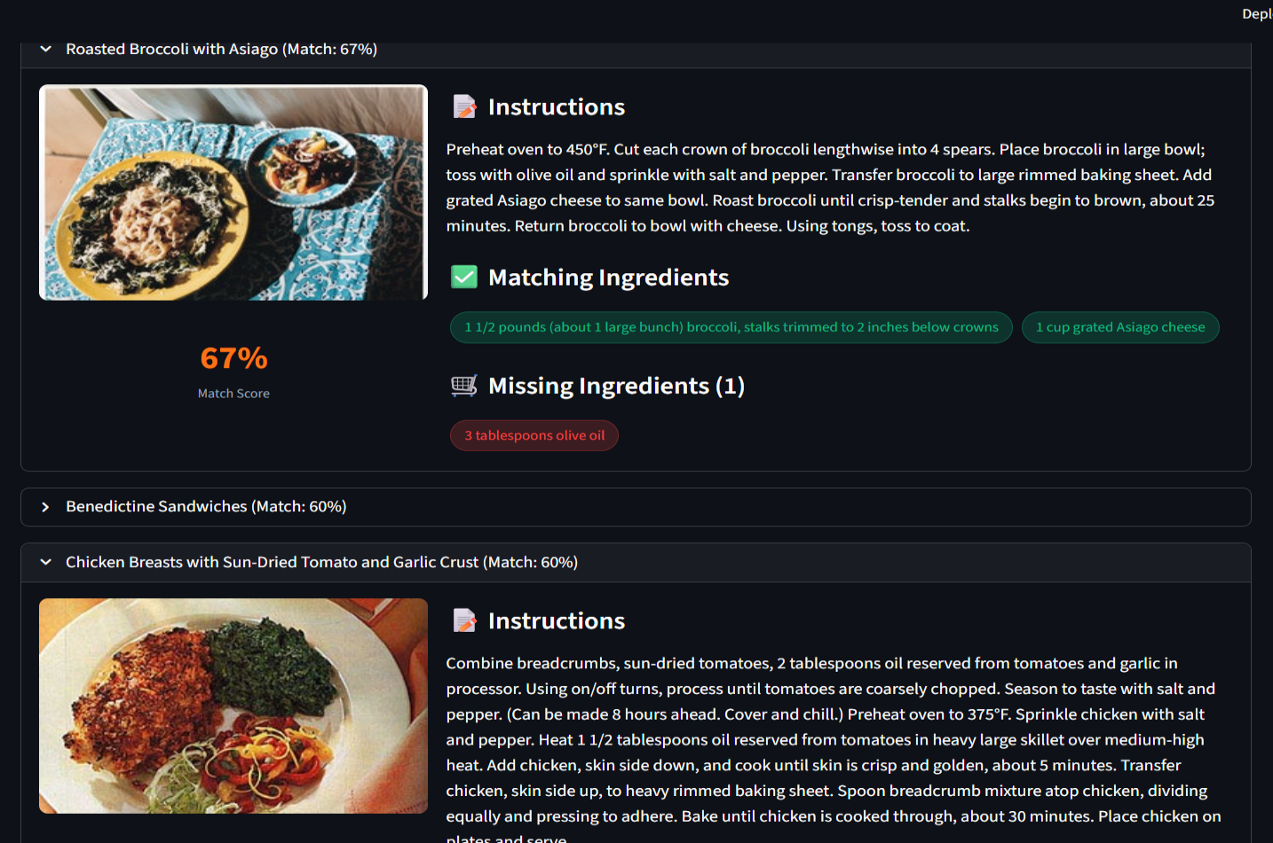
6.3 Technical Implementation of the Frontend
The frontend is not merely a display layer; it handles significant logic to ensure a smooth user experience.
- State Management: We utilize st.session_state to persist variables (like the loaded model and the grocery list) across re-runs. This prevents the frustrating "refresh" behavior often seen in simple scripts.
- Asynchronous Feedback: We use st.spinner() and st.toast() to provide immediate visual feedback during the 1-2 seconds of model inference, ensuring the app feels responsive.
- Robust Error Handling: The UI is wrapped in try-except blocks. If a user uploads a corrupted file or a non-image, the app catches the error and displays a friendly warning ("⚠️ Error reading image") rather than crashing with a stack trace.

6.4 Demonstration Scenarios
During testing, the application successfully handled various real-world scenarios:
- Occlusion: Correctly identified a banana that was partially covered by a hand.
- Example: "Self-Training" correctly identified a Green Apple that "Label Propagation" confused for a Pear, validating our finding that Self-Training deals better with complex boundaries.

Chapter 7: Conclusion & Future Work
7.1 Summary of Contributions
In this project, we successfully addressed the challenge of image classification in low-resource environments by leveraging Semi-Supervised Learning (SSL). We implemented an end-to-end pipeline that combines the feature extraction power of ResNet18 with three graph-based and wrapper-based SSL algorithms.
Our key findings are:
- Viability of SSL: We demonstrated that it is possible to achieve 81.62% classification accuracy on a 20-class grocery dataset using only 30% of the available labels. This performance is competitive with fully supervised baselines, proving that unlabeled data contains rich structural information that can be exploited.
- Algorithm Superiority: The Self-Training algorithm (using Random Forest) emerged as the top performer, slightly outperforming the pure graph-based methods (Label Propagation/Spreading). This suggests that for this specific dataset distributions, iterative decision-boundary refinement was more effective than pure proximity-based propagation.
- Practical Deployment: We successfully encapsulated these complex models into a user-friendly Streamlit Web Application, demonstrating that advanced ML techniques can be made accessible to non-technical users in a "Smart Retail" context.
7.2 Limitations
Despite the success, the current system has specific limitations:
- Reliance on ImageNet Features: We used a "frozen" ResNet18 feature extractor. While robust, these features are optimized for general objects (dogs, cars, etc.). They may not capture the subtle differences between fine-grained grocery categories (e.g., distinguishing Spinach from Lettuce based purely on texture).
- Computational Scalability: The graph-based methods (Label Propagation) require constructing a similarity matrix of size N × N. As the dataset grows to millions of images, this becomes memory-prohibitive (O(N²) complexity).
- Cold Start Problem: The system still requires a "seed" set of labeled data (at least 10-20%) to start the propagation. It cannot learn from scratch (Zero-Shot).
7.3 Future Work
To elevate this project to a production-grade system, we propose the following enhancements:
- Contrastive Learning (SimCLR / MoCo): Instead of using fixed ResNet features, we could use Self-Supervised Learning to finetune the feature extractor on the unlabeled grocery images. This would learn embeddings specifically tailored to grocery items (e.g., learning that "shininess" distinguishes peppers from tomatoes).
- MixMatch & FixMatch: Implementing modern holistic SSL methods like FixMatch. These methods enforce consistency constraints (if I flip the image, the prediction should be the same) and typically outperform the older graph-based methods we used.
- Active Learning: Integrating an "Active Learning" loop into the web app. If the model is uncertain (e.g., confidence < 50%), it should ask the user to label that specific image. This human feedback would be the most valuable data to add to the training set, maximizing the efficiency of the annotation effort.
- Mobile Deployment: Porting the model to ONNX or TensorFlow Lite to run directly on a smartphone. This would allow a customer to point their phone at a vegetable in the store and get an instant identification and recipe recommendation, realizing the "Smart Assistant" vision.

