**Q5**

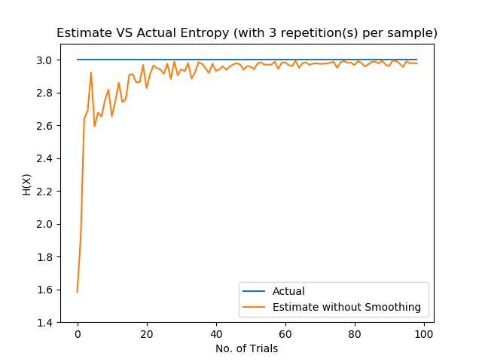

Fig 1: The estimated entropy. Calculated by picking from 8 items, n (no of trials) times, and repeated 3 times to take the average estimated probability of getting each item. The entropy is then calculated and plotted against n. This is done for 0 < n < 100 trials

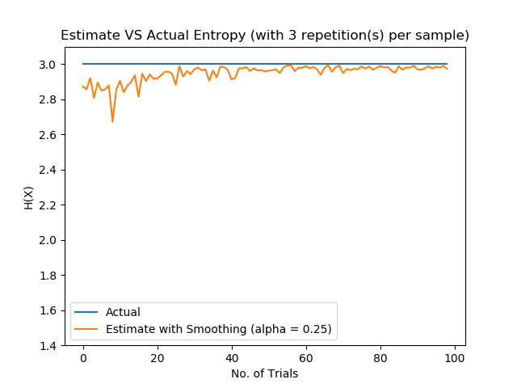

Fig 2: The estimated entropy. Calculated similarly to fig 1, however, Laplace smoothing with alpha = 0.25 is used.

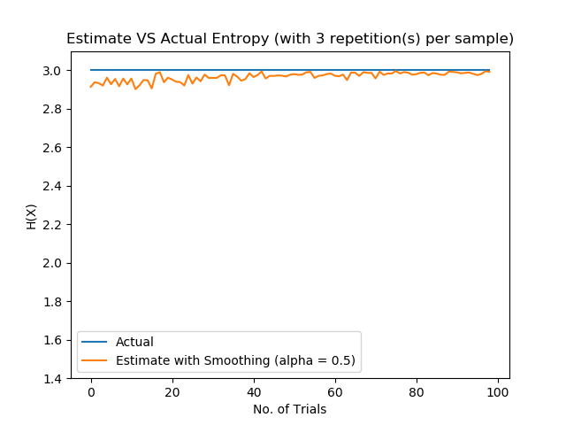

Fig 3: The estimated entropy. Calculated similarly to fig 1, however, Laplace smoothing with alpha = 0.5 is used.

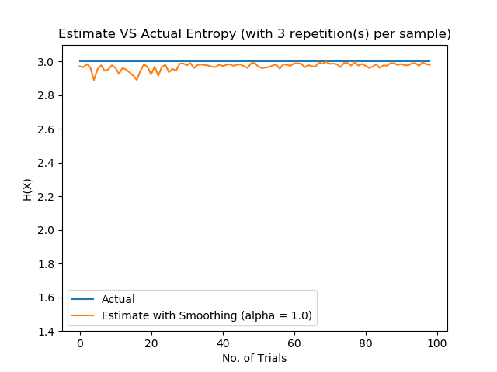

Fig 4: The estimated entropy. Calculated similarly to fig 1, however, Laplace smoothing with alpha = 1.0 is used.

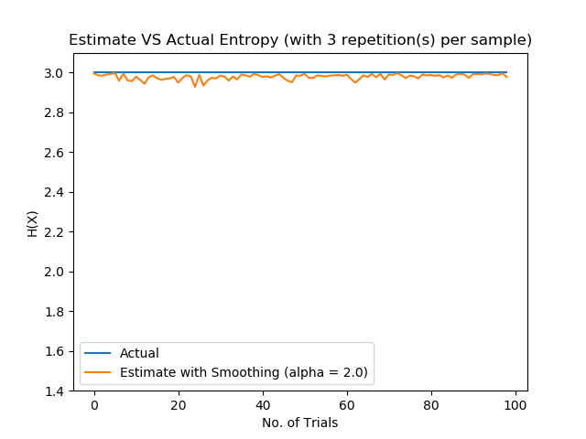

Fig 5: The estimated entropy. Calculated similarly to fig 1, however, Laplace smoothing with alpha 2.0 is used.

Conclusion

Judging by the results, Laplace Smoothing does help as the estimated entropy approaches the actual entropy quicker (in fewer no. of trials) than without the smoothing. As we increase the value of alpha, the estimate approaches the actual entropy much more quickly than without the smoothing. By analysing the equation (equation 3 in the worksheet), we see that a higher value of alpha increases our bias (and strengthens our assumption) of the distribution being a uniformly distributed one. This works well in our case, with a better result with higher alpha, because the distribution we are estimating is, in fact, uniformly distributed.