<< The Most Important Factor for Buying a Laptop>>

Introduction
In today’s highly competitive technology market, selecting the right laptop has become a critical decision for consumers. With a wide range of options available, buyers often consider various factors before making a purchase. Among these, price, brand, battery life , Performance , Design , and Portability stand out as some of the most important criteria influencing consumer choices. Understanding the relative importance of these factors can help manufacturers, retailers, and marketers better tailor their products and strategies to meet consumer demands.
This project aims to analyze the most important factor for consumers when purchasing a laptop by utilizing both descriptive statistics and inferential statistics. Descriptive statistics will be used to summarize the dataset and provide insights into the preferences of respondents, such as the average importance of each factor and their distribution across different consumer groups. Inferential statistics, on the other hand, will enable generalizations about the larger population by testing hypotheses and drawing conclusions from the data.
By combining descriptive and inferential approaches, this project seeks to answer key questions, such as: Which factor—price, brand, or battery life—is prioritized by most consumers? Are preferences consistent across different demographic groups, such as age or budget? The findings from this study will provide valuable insights into consumer behavior and help identify trends that can guide decision-making in the laptop market.

1. Data Source
For this project, I collected data from multiple sources to ensure a comprehensive analysis. A portion of the dataset was obtained from publicly available datasets on the Kaggle platform. Additionally, I used ChatGPT to assist in managing, organizing, and expanding the dataset to suit the specific needs of the project.
I also referred to open-access articles from reputable journals to support the research framework and provide context for the study. These journals include the ULAB Journal of Science and Engineering, CBS Journal of Management Practices, and West Science Journal of Economics and Entrepreneurship. These resources contributed valuable insights and helped guide the methodology and analysis.
- Age Group: The respondent's age category (18–27, 28–37, 38–47, 48–57, 58+).
- Important Factor: The most critical factor influencing their laptop purchase decision (Price, Brand, Battery Life, Performance, Design, Portability).
- Budget: The approximate budget for purchasing a laptop (<$500, $500–$1000, $1000–$1500, $1500+).
- Preferred Brand: The brand respondents prefer ( Dell, Apple, HP, Lenovo, ASUS, Acer, Samsung).
This dataset includes 200 responses and represents a diverse range of consumer preferences. While the data is simulated, it mimics realistic trends in laptop purchasing decisions.

2. Sample Size
The sample size for this analysis is 200 respondents. This size is sufficient to:
- Identify patterns and trends in the data.
- Perform meaningful statistical analyses, including hypothesis testing and confidence interval estimation.
A larger sample size increases the reliability of the results and ensures that the findings can approximate real-world scenarios

3. Statistical Tools
To analyze the data, both descriptive statistics and inferential statistics will be used. Below is an explanation of the tools and formulas applied:

Descriptive Statistics
Descriptive statistics are used to summarize and visualize the dataset. The following tools will be applied:

Measures of Central Tendency:
- Mean (Average): Summarizes the average value for a numeric variable (EX: average budget).
The mean, often called the average, is a measure of central tendency that represents the "center" or "typical value" of a dataset. It is calculated by summing up all the values in a dataset and dividing the total by the number of values. It provides a single value that summarizes the overall dataset.

Mean = 1/N (∑X)
Where:
- ∑X: The sum of all data values.
- N: The total number of data points (observations).

Grouped data: mean of a frequency distribution (direct method)
The formula for calculating the mean of a frequency distribution is used because it allows us to find the average (or central tendency) of a dataset when the data is grouped into classes or intervals (such as ranges). In a frequency distribution, the exact values of individual data points are not known, only the number of occurrences (frequencies) in each class. To estimate the mean, we use the class midpoints(class marks) and their corresponding frequencies.

Formula for the Mean of Grouped Data:
Mean = ( ∑(fi⋅xi)) / ∑fi
Where:
- fi is the frequency (number of respondents) in the i-th class.
- xi is the midpoint of the i-th class (the value representing the class).
- ∑fi is the total number of observations (sum of frequencies).
Note : I will use direct mean or Mean of Grouped Data for calculating the mean of the budget !
…………………………………………………………………………………………………………
MEDIAN:
The median is a measure of central tendency that identifies the middle value in a dataset when all the values are arranged in ascending (or descending) order. Unlike the mean, which considers all values, the median focuses on the center and is less affected by extreme values (outliers). This makes it particularly useful for datasets that are skewed or not normally distributed.

How to Calculate the Median
- Arrange the Data in Order: Sort all the values in the dataset from smallest to largest.
- Find the Middle Value:
  - If the number of values (N) is odd, the median is the middle value.
  - If N is even, the median is the average of the two middle values.
if N is odd:
median({x1, x2, . . . , xN }) = X(N+1) / 2 >>>>> (n+1) is position of x in a datasets.
if N is even:
median({x1, x2, . . . , xN }) = (xN/2 + xN/2+1) / 2 >>>>(N/2 and N/2+1) are position of x.

Median for Grouped Data:
For grouped data (data presented in frequency distribution or classes), the median is calculated using the cumulative frequency and the class intervals.
Median = L + ((n/2−F) / f ) × h
- L = Lower boundary of the median class
- n = Total number of observations (in this case, 200)
- F = Cumulative frequency of the class before the median class
- f = Frequency of the median class
- h = Width of the class interval (the difference between the upper and lower boundaries of the class)
……………………………………………………………………………………………………………..
MODE:
The mode is a measure of central tendency that identifies the most frequently occurring value in a dataset. It tells you which value appears most often, making it especially useful for categorical data (EX: the most preferred brand or most important factor).
HOW TO FIND THE MODE :
1: count the frequency of each value : How many times each value appears in the dataset.
2:Identify the value with the highest frequency : The value that occurs the most often is the Mode.
>>>>>>>>>>>>>>>>>>>>>>>>>>>>>>>>>>>>>>>>>>>>>>>>>>>>>>>>>>>>>>>>>>>>>>>
Mode for grouped datasets:
To calculate the mode for grouped data, we use a formula to approximate the mode, which is the value that occurs most frequently within the data. Since grouped data is divided into intervals, the mode is estimated based on the modal class, the class with the highest frequency.
Use the Mode Formula:
Mode = L + ((f1 – f0 ) / 2f1 – f0 – f2 ) * h
where:
- L: Lower boundary of the modal class.
- f1: Frequency of the modal class.
- f0: Frequency of the class before the modal class.
- f2: Frequency of the class after the modal class.
- h: Width of the class interval (difference between the upper and lower boundaries).
Note : I will use this formula for budget!

Why Is the Mode Useful?
- For Categorical Data:
  - It provides insights into the most common or popular category. For example, in my dataset, the mode could tell the most preferred laptop brand or the most important factor in purchasing decisions.

- For Numerical Data:
  - The mode highlights the most common value, which may not always align with the mean or median.

- Robust to Outliers:
  - Like the median, the mode is not affected by extremely high or low values.
……………………………………………………………………………………………………………
Measures of Dispersion:
The range is a measure of spread or dispersion in a dataset. It calculates the difference between the largest value (maximum) and the smallest value (minimum) in the dataset. The range gives an idea of how widely the data is spread and is one of the simplest ways to describe the variability in the data.

Formula for the Range
Range = Max − Min
  - Max: The largest value in the dataset.
  - Min: The smallest value in the dataset
Note : In my project I can use Range for the below reasons!
- The range of budgets for laptop purchases (EX:, the difference between the highest and lowest budgets).
- The range of battery life in hours across different laptops.
- The range of ages in the dataset to describe the diversity of respondents.
Variance:
Variance is a measure of dispersion that tells us how spread out the values in a dataset are from the mean. It is particularly useful when analyzing datasets where understanding the spread of data points around the average is important. In my project, I can use variance to analyze the variability of budgets, battery life, or even age groups in the dataset.
Population Variance (σ^2):
σ^2 = (∑(Xi−μ)^2) / N
- Xi: Each individual data point.
- μ: The mean of the dataset.
- N: The total number of data points.

Sample Variance (s^2):
s^2 = (∑(Xi−Xˉ)^2) / N-1
- Xˉ: The sample mean.
- n: The total number of data points in the sample.
- n−1: Known as Bessel’s correction, used to adjust for bias in small samples.

Sample Variance vs. Population Variance:
- Population Variance is used when you have data for the entire population (all the possible values in the group you are studying). It assumes that you have the complete set of data points and that there is no need to estimate anything.
- Sample Variance is used when you are working with a sample of the population, which is usually the case in most real-world situations. You would use sample variance when you have only a subset of data and you want to estimate the variance for the whole population. The formula for sample variance uses n−1 in the denominator (where n is the number of data points), which is known as Bessel's correction. This adjustment helps to correct for the bias that comes with using only a sample.
Note : In my project I try to use sample variance and variance for grouped datasets.!

VARIANCE FOR GROUPED DATA:
The formula for variance when you have grouped data is:
Variance = ∑fi * (xi − xˉ)^2 / ∑fi
Where:
- fi: Frequency of each class
- xi: Midpoint of each class
- xˉ: Mean (calculated using the midpoints and frequencies)
Standard deviation : is a widely used measure of the spread or dispersion in a dataset. It quantifies how much the individual data points deviate from the mean (average) value.
For example, in my project, I’m analyzing budget preferences or battery life, standard deviation will help me understand how varied the responses are from the average.

Formula for Standard Deviation
The formula for standard deviation is very similar to variance, but it includes a key difference: the square root. This allows it to be expressed in the original units of the data, unlike variance, which is in squared units.

Population Standard Deviation (σ):
σ = square root of variance (√ σ^2)
Note : For my project , I am going to use sample standard deviation!

Frequency Table:
A frequency table is a tool used to organize and summarize categorical or numerical data by counting how often each value or category occurs in the dataset. It is particularly useful for understanding the distribution of categorical variables (EX: preferred brands or important factors for laptop buyers).
Note : In the next page you will find the Frequency Table for Important Factor!
Visualization :
Visualization in descriptive statistics is crucial because it helps us understand and interpret data more effectively. Here's why we use it:

1 . Simplifies Complex Data
- Visualizations turn raw numbers into graphical formats that are easier to understand.
- For example, a bar or pie chart showing the frequency of laptop brands sold is easier to interpret than a long list of numbers.

2 . Enhances Comparison
- Visuals allow for quick comparisons between groups or categories.
- Example: Comparing average scores of students in different classes using a bar chart

3 . Supports Decision-Making
- By presenting data visually, it’s easier to identify key insights that can inform decisions.
- Example: A pie chart showing market share by product category can guide resource allocation.
Note : By looking at the frequency table and charts below you can figure it out by yourself which brand is popular or which factor is more important for users and also the budget possible by different age group!
Frequency table for important factor:
IMPORTANT FACTOR | FREQUENCY
PRICE | 29
PERFORMANCE | 32
BATTERY LIFE | 39
BRAND | 33
DESIGN | 32
PORTABILITY | 36

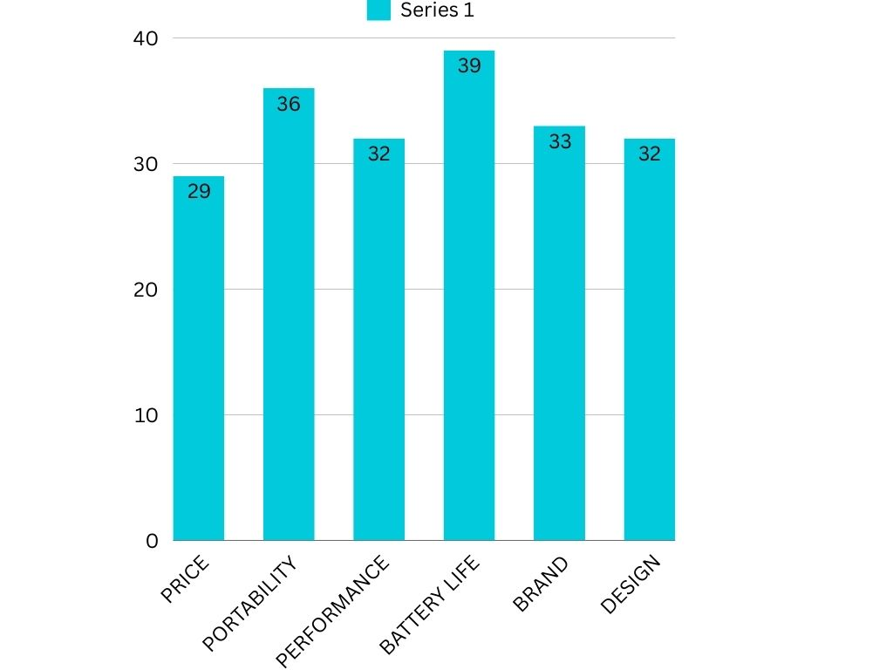
Bar chart for important factors
Frequency Table for Preferred Brand:
Preferred Brand | Frequency
HP | 34
DELL | 25
APPLE | 25
ACER | 36
LENOVO | 26
SAMSUNG | 31
ASUS | 23

Pie chart for Preferred Brand:
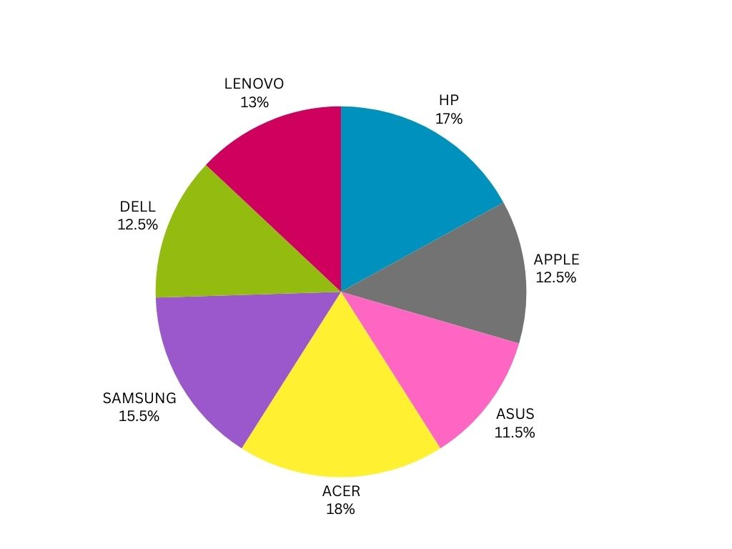

Frequency Table for Budget:
Budget | Frequency
<$500 | 48
$500–$1000 | 42
$1000–$1500 | 47
$1500+ | 63

Note : Now I start with calculating the descriptive statistics!
1 : Central tendency
"I will calculate the mean and median for the Budget variable, as it provides numeric insights into the dataset. Additionally, I will calculate the mode for the Important Factors, Preferred Brands, and Budget categories, as I have already created frequency tables for these variables."
MEAN:
these are my budget categories:
- <$500
- $500–$1000
- $1000–$1500
- $1500+
Since my data consists of ranges rather than specific values, it is not possible to calculate the mean directly. Therefore, the first step is to assign numeric values to these ranges. This can be achieved by finding the midpoint (class marks) of each range, which represents the average of its lower and upper limits.

- <$500: The upper limit is $500, so the midpoint = (0 + 500) / 2 = 250
- $500–$1000: Midpoint = (500+1000) / 2 =750
- $1000–$1500: Midpoint = (1000+1500) / 2 =1250
- $1500+: Since this range has no upper limit, I approximate the midpoint around $2000
SO:
Budget set = {250,750,1250,2000}

Budget | Midpoint | Frequency
<$500 | 250 | 48
$500–$1000 | 750 | 42
$1000–$1500 | 1250 | 47
$1500+ | 2000 | 63

Mean = (∑(fi ⋅ xi)) / ∑fi
Mean = ((250 * 48) + (750* 42) + (1250*47) + (2000*63)) / 48+42+47+63 = 1141.25
we can conclude that the average budget is 1141.25
……………………………………………………………………………………………………………..
MEDIAN:
Here , I should use median for grouping data . the formula for this median is
<<Median = L + ((n/2−CF) / f) × h >>
L: Lower boundary of the median class.(The lower boundary (L) of the median class is the lower limit of the class where the cumulative frequency first exceeds N/2.)
- N: Total frequency (∑f).
- CF: Cumulative frequency of the class before the median class.
- (The cumulative frequency (CF) of the class before the median class is the total number of observations up to, but not including, the median class.)
- f: Frequency of the median class.
- h: Class width (difference between upper and lower limits of the class).
Note = to calculate cumulative frequencies , we need just to Add the frequency of each class to the cumulative frequency of the previous class!
To compute the median :
1 : Frequency and cumulative Frequency table
Budget | Frequency | Cumulative Frequency
<$500 | 48 | 48
$500–$1000 | 42 | 48+42 = 90
$1000–$1500 | 47 | 47 + 90 = 137
$1500+ | 63 | 63+137 = 200
2 : Find the Median Class:
1) Compute N/2 where N=∑f (total frequency). 200 / 2 = 100
3 : Determine the Median Class :
The median class is the class interval where the cumulative frequency first exceeds 100.
Since 100 falls in the interval $1000−$1500, this is the median class.
4 : Extract Values for the Formula:
For the median class ($1000–$1500):
- L=1000 (lower boundary of the median class)
- CF=90 (cumulative frequency before the median class)
- f=47 (frequency of the median class)
- h=500 (class width)
5 : Apply median formula :
<<Median = L + ((n/2−CF) / f) × h >>
Median = 1000 + ((100−90) / 47 ) × 500 => Median ≈1106.4
The median budget is approximately $1106.40.
…………………………………………………………………………………………………………
Mode for grouped datasets:
1 : Identify the Modal Class:
BUDGET | FREQUENCY
<$500 | 48
$500–$1000 | 42
$1000–$1500 | 47
$1500+ | 63

The class interval with the highest frequency is $1500+, where f1 = 63. Thus, the modal class is $1500+.
2 : Collect Values for the Formula:
- L=1500: The lower boundary of the modal class.
- f1= 63: Frequency of the modal class.
- f0 = 47: Frequency of the class before the modal class ($1000−$1500).
- f2= 0: Frequency of the class after the modal class (there is no class after $1500+).
- h = 500
3 : Apply mode formula :
Mode = L+ ((f1 – f0 ) / 2f1 – f0 – f2 ) * h => 1500 + ((63) − 47 ) / 2(63) - 47 - 0) * 500 ≈1601.25
Mode ≈ 1601.25 >> The mode is approximately $1601.25 in this dataset.
Note: Now I can calculate the mode for my categorical data, such as the "Preferred Laptop Brand" and the "Important Factor for Buying a Laptop."
Preferred Brand | Frequency
HP | 34
DELL | 25
APPLE | 25
ACER | 36
LENOVO | 26
SAMSUNG | 31
ASUS | 23

Here I calculate mode for categorical data . To find the mode , we just need to chose the data with the highest Frequency (The mode is simply the category (or value) with the highest frequency.)
The highest frequency is 36, which corresponds to Acer.

- Mode for "Preferred Brand": Acer.
IMPORTANT FACTOR | FREQUENCY
PRICE | 29
PERFORMANCE | 32
DESIGN | 32
BATTERY LIFE | 39
BRAND | 33
PORTABILITY | 36

he highest frequency is 39, which corresponds to Battery Life.
- Mode for "Important Factor": Battery Life.
……………………………………………………………………………………………………………..
Measures of Dispersion:
Range = Maximum Value−Minimum Value
note : a large range suggests that the dataset has widely varying values, while a small range suggests that the data points are close to each other !
The budgets are:
<$500
$500–$1000
$1000–$1500
$1500+

- Minimum Value: <$500 (we can approximate this as 0 for range calculation)
- Maximum Value: $1500+
Assume the maximum budget in the "$1500+" category is capped at $2000 for simplicity. Then:
Range = Maximum Value − Minimum Value = 2000−0 = 2000
Range is $2000.
The range of $2000 means that the difference between the smallest and largest possible budget is $2000. This indicates a wide variety of budgets being considered, from very low (<$500) to very high ($1500+).
Range of AGE :
- 18_27
- 28–37
- 38–47
- 48–57
- 58+
these are the grouped age in my datasets .
Minimum Value: The minimum value is the lower bound of the first class, which is 18.
Maximum Value: The maximum value is the upper bound of the last class. Since "58+" is open-ended, let's assume the maximum value is 100 for simplicity.
Range = Maximum Value − Minimum Value
Range=100−18=82
The range of 82 years means the difference between the youngest age (18) and the oldest assumed age (100) is 82 years.

SAMPLE VARIANCE , VARIANCE FOR GROUPED DATA , AND STANDERD DEVIATION :
Budget | Midpoint | Frequency
<$500 | 250 | 48
$500–$1000 | 750 | 42
$1000–$1500 | 1250 | 47
$1500+ | 2000 | 63

The formula for variance when you have grouped data is:
Variance = ∑fi⋅(xi− xˉ)^2 / ∑fi
Where:
- fi : Frequency of each class
- xi: Midpoint of each class
- xˉ: Mean (calculated using the midpoints and frequencies)

FIRST STEP : calculating Mean for grouped data :
AS I already calculated the mean >> we can conclude that the average budget is $ 1141.25!

SECOND STEP : Calculate the Squared Differences(between each data point and mean)

250: (250 −1141.25)^2 = 794326.5625
750: (750 −1141.25)^2 = 153076.5625
1250: (1250 −1141.25)^2 = 11826.5625
2000 : (2000 _ 1141.25)^2 = 737451.5625

THIRD STEP : Compute fi * (xi−xˉ)^2

250 : 48 *( 794326.5625) = 38127675
750: 42 *(153076.5625) =6429215.625
1250 : 47 *(11826.5625) = 555848.4375
2000 : 63 * (737451.5625) = 46459448.4375

FOURTH STEP : Sum up fi*(xi−xˉ) ^ 2
38127675 + 6429215.625 +555848.4375 + 46459448.4375 = 91572187.5

The last step :

∑fi * (xi − xˉ)^2 = 91572187.5
∑fi = 200
Variance = 91572187.5 / 200 => 457860.9375
The variance value 457860.9375 tells us how spread out or dispersed the prices are from the mean price in my dataset.
A High Variance (like 457860.9375) indicates that the prices are widely spread out. This means there is a large variation in price across the different ranges in my data. Prices are not clustered around the mean; instead, they are more dispersed.
In practical terms, it tells us that the prices in the dataset are not uniform and can vary greatly from the average price

Standard Deviation
Since variance is in squared units, the standard deviation (the square root of variance) is often used to provide a more interpretable measure of spread in the original units (dollars).
Note :To calculate the standard deviation:
Standard Deviation = (457860.9375)^ ½ => ≈ 676.44
Thus, the standard deviation of approximately 676.44 means that, on average, individual prices deviate from the mean price by 676.44 units ( dollars)
……………………………………………………………………………………………………
To further explain the concept of variance, I created a small dataset with three categories for different laptop brands: Performance, Battery Life, and Portability. These numbers represent average values for each category and should not be considered as fully realistic, as calculating the variance for these three categories across all different types of laptops can be quite challenging. The values in this dataset are simplified averages, and the variance calculated is based on this limited data. It is important to note that these averages may not accurately reflect the wide variety of performance, battery life, and portability that can be found across different laptop models.
In reality, calculating the variance for these categories would require data from a broader range of laptops, considering different configurations, models, and usage scenarios. Therefore, the numbers provided here are not entirely reflective of real-world scenarios and are used solely for the purpose of illustrating the variance concept.
Since I have a small dataset (only 7 data points), I prefer to use sample variance rather than population variance.

Brand | Performance(rating) | Battery Life (Hours) | Portability (Weight in Kg)
HP | 8.2 | 7.5 | 1.8
DELL | 7.5 | 8 | 2
APPLE | 9.1 | 10 | 1.5
ACER | 7 | 6.5 | 2.2
LENOVO | 8 | 8.5 | 1.9
SAMSUNG | 8.5 | 9 | 1.7
ASUS | 7.8 | 7.8 | 1.6

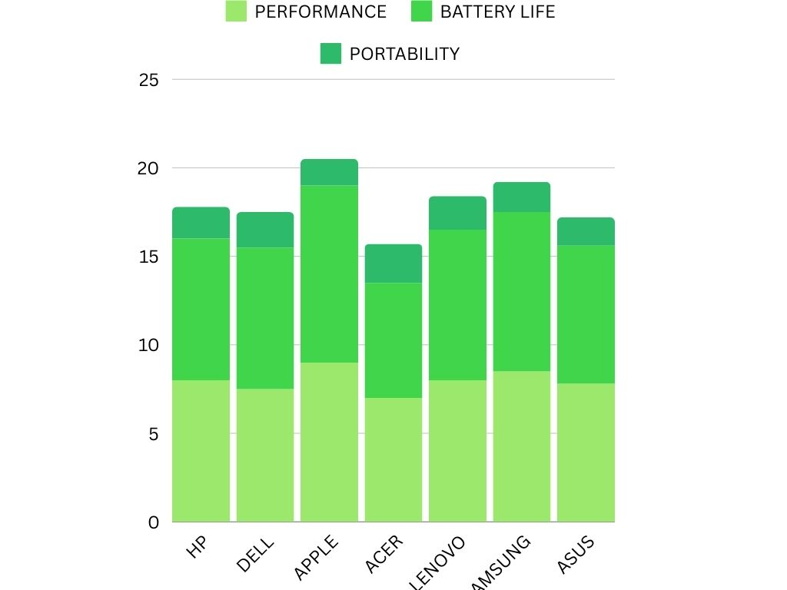

Steps to Calculate the Variance:

- Calculate the Mean for each variable.
- Calculate the squared differences from the mean for each value.
- Calculate the sum of squared differences.
- Divide the sum of squared differences by the number of data points minus 1 to get the variance.
Step 1: Calculate the Mean for Each Variable:
M (Performance) = ( 8.2+7.5+9.1+7.0+8.0+8.5+7.8) / 7 = (55.1)/7 ≈7.87
M (Battery Life) = (7.5+8.0+10.0+6.5+8.5+9.0+7.8) / 7 = (57.3) / 7 ≈8.18
M (Portability) = (1.8+2.0+1.5+2.2+1.9+1.7+1.6​) / 7 = (13.7) / 7 ≈1.96
Step 2: Calculate Squared Differences from the Mean:
Performance (Rating):
( 8.2−7.87)^2=0.1089 •••• (7.5−7.87)^2=0.1369 ••••(9.1−7.87)^2=1.5121 •••• (7.0−7.87)^2=0.7569 (8.0−7.87)^2=0.0169 •••• (8.5−7.87)^2=0.3969 •••• (7.8−7.87)^2=0.0049
Battery Life (Hours):
(7.5−8.18)^2=0.4624 ••• (8.0−8.18)^2=0.0324 ••• (10.0−8.18)^2=3.2964 •••(6.5−8.18)2=2.8324 (8.5−8.18)^2=0.1024 ••• (9.0−8.18)^2=0.6724 ••• (7.8−8.18)^2=0.1444
Portability (Weight in Kg):
(1.8−1.96)^2=0.0256 •••• (2.0−1.96)^2=0.0016 ••••(1.5−1.96)^2=0.2116 ••••(2.2−1.96)2=0.0576 (1.9−1.96)^2=0.0036 ••••(1.7−1.96)^2=0.0676 •••• (1.6−1.96)^2=0.1296

Step 3: Calculate the Sum of Squared Differences:
Performance (Rating):
Sum of squared differences = 0.1089+0.1369+1.5121+0.7569+0.0169+0.3969+0.0049 = 2.9336
Battery Life (Hours):
Sum of squared differences = 0.4624+0.0324+3.2964+2.8324+0.1024+0.6724+0.1444 = 7.5424
Portability (Weight in Kg):
Sum of squared differences=0.0256+0.0016+0.2116+0.0576+0.0036+0.0676+0.1296=0.4972

Step 4: Calculate the Variance for Each Variable
sample Variance = (∑(xi−M)^2) / n-1
n = 7 (the number of data points)
∑(xi− M )^ 2 is the sum of squared differences
bessel’s correction = 7 -1 = 6

Performance (Rating):
Variance = 2.9336 / 6 ≈ 0.4889
Battery Life (Hours):
variance = 7.5424 / 6 ≈1.2571
Portability (Weight in Kg)
variance = 0.4972 / 6 ≈0.0829
Performance has a moderate variance of 0.4889, meaning that the ratings for performance are somewhat spread out around the mean!
Battery Life has a higher variance of 1.2571, indicating that battery life varies more significantly across the different brands!
Portability has a lower variance of 0.0829, suggesting that the weights of the laptops are fairly consistent across the brands!
This was one example of sample variance and how it works and interprets.
………………………………………………………………………………
INFERENTIAL STATISTIC :
Inferential statistics is a branch of statistics that allows us to make predictions, generalizations, or conclusions about a larger population based on data collected from a sample (like the datasets I have ) .

Key Objectives of Inferential Statistics:
- To test hypotheses ( "Does brand influence performance?").
- To estimate population parameters ("What is the average performance rating for all laptops?").
- To assess relationships between variables ( "Is portability related to battery life?").
Note : I prefer to use chi-square and t-test .
The Chi-Square Test has two main types:
- Chi-Square Test for Independence
- Chi-Square Goodness-of-Fit Test

Purpose:
This test checks whether two categorical variables are independent or associated. For example:
- Does the brand of a laptop influence its performance rating category?
- Is there a relationship between gender and voting preference?

Steps:
- Formulate hypotheses:
  - H0 (Null Hypothesis): The two variables are independent (no relationship).
  - H1 (Alternative Hypothesis): The two variables are not independent (there is a relationship).
- Create a contingency table:
  - A contingency table shows the observed frequencies of each combination of categories for the two variables.
For example :
Suppose we have data on 7 laptop brands (HP, Dell, Apple, etc.) and their performance ratings, which are categorized as:
- Low (6.0–7.5)
- Medium (7.6–8.5)
- High (8.6–10.0)

Observed Data (Example):
Brand | Low | Medium | High | Total
HP | 3 | 7 | 2 | 12
Dell | 4 | 6 | 3 | 13
Apple | 1 | 3 | 5 | 9
Acer | 6 | 4 | 0 | 10
Lenovo | 2 | 5 | 4 | 11
Total | 16 | 25 | 14 | 55

Note : we need this type of table for chi-square .

3 : Calculate expected frequencies: For each cell in the table:

E = (Row Total×Column Total)/Grand total
4 : Apply the Chi-Square formula:

x^2 = ∑(O−E)^2 / E

O: Observed frequency
E: Expected frequency
5 : Degrees of freedom:

df = (Number of rows−1) × (Number of columns−1)

6 : Compare the calculated Chi-Square (χ2) with the critical value from the Chi-Square :

<< If χ^2 is greater than the critical value (or p-value < 0.05), reject H0 >>

Brand | Performance(rating) | Battery Life (Hours) | Portability (Weight in Kg)
HP | 8.2 | 7.5 | 1.8
DELL | 7.5 | 8 | 2
APPLE | 9.1 | 10 | 1.5
ACER | 7 | 6.5 | 2.2
LENOVO | 8 | 8.5 | 1.9
SAMSUNG | 8.5 | 9 | 1.7
ASUS | 7.8 | 7.8 | 1.6

Example: Laptop Brand vs Performance Category :

Contingency Table (Observed Frequencies):

Category | Low (6–7.5) | Medium (7.6–8.5) | High (>8.5) | Total
HP | 0 | 1 | 0 | 1
Dell | 0 | 1 | 0 | 1
Apple | 0 | 0 | 1 | 1
Samsung | 0 | 0 | 1 | 1
Asus | 0 | 1 | 0 | 1
Acer | 1 | 0 | 0 | 1
Lenovo | 0 | 1 | 0 | 1
Total | 1 | 4 | 2 | 7

Expected Frequencies Calculation:

Step 1: Grand Total:
The grand total is : Grand Total=7
Step 2: Formula for Expected Frequency:
E = (Row Total×Column Total)/Grand total

Step 3: Calculate Expected Frequencies for Each Cell :

Note : I will calculate one for example here and then you can observe expected frequencies table !

For the HP Row:
- HP – Low: E = (1*1) / 7 ≈ 0.14
- HP – Medium: (1* 4) / 7 ≈ 0.57
- HP – High: (1*2 ) / 7 ≈ 0.29

Category | Low E | Medium E | High E | Total
HP | 0.14 | 0.57 | 0.29 | 1
Dell | 0.14 | 0.57 | 0.29 | 1
Apple | 0.14 | 0.57 | 0.29 | 1
Samsung | 0.14 | 0.57 | 0.29 | 1
Asus | 0.14 | 0.57 | 0.29 | 1
Acer | 0.14 | 0.57 | 0.29 | 1
Lenovo | 0.14 | 0.57 | 0.29 | 1
Total | 1 | 4 | 2 | 7

NOW we can compute chi-square :

x^2 = ∑(O−E)^2 / E

O is the observed frequency for each cell
E is the expected frequency for each cell.
Note : I will do one example calculation for HP and then you can see the final result !

Row: HP
Low (HP – Low): (O−E)^2 / E = (0 − 0.14)^2 / 0.14 ≈ 0.14
Medium (HP – Medium): (1 − 0.57)^2 / 0.57 ≈ 0.32
High (HP – High): (0 − 0.29)^2 / 0.29 ≈ 0.29
Note : we do the same thing for all brands and sum up all the result together to get the final result !
The calculated Chi-Square (χ2) value for the contingency table is approximately 14.06.
To calculate the degrees of freedom (df) for a contingency table :
df=(Number of Rows−1)×(Number of Columns−1)

Number of Rows = 7 (HP, DELL, APPLE, ACER, LENOVO, SAMSUNG, ASUS)
Number of Columns = 3 (Low, Medium, High)
df = (7-1) * (3-1) = 12 >>> the degrees of freedom are 12.
Now its time to interpret the result we got :
To determine if the Chi-Square value is statistically significant, we compare it to the critical value from the Chi-Square distribution table. The critical value depends on:
- The degrees of freedom (df=12).
- The significance level (α). Common choices are:
  - α=0.05 (95% confidence level)
  - α=0.01 (99% confidence level)
Note : or α = 0.05, this means that 5% of the area of the Chi-Square distribution is in the right tail (upper tail) of the distribution.
Note : we need to use chi-square table to calculate the critical values !
A Chi-Square table provides critical values for given degrees of freedom and significance levels.
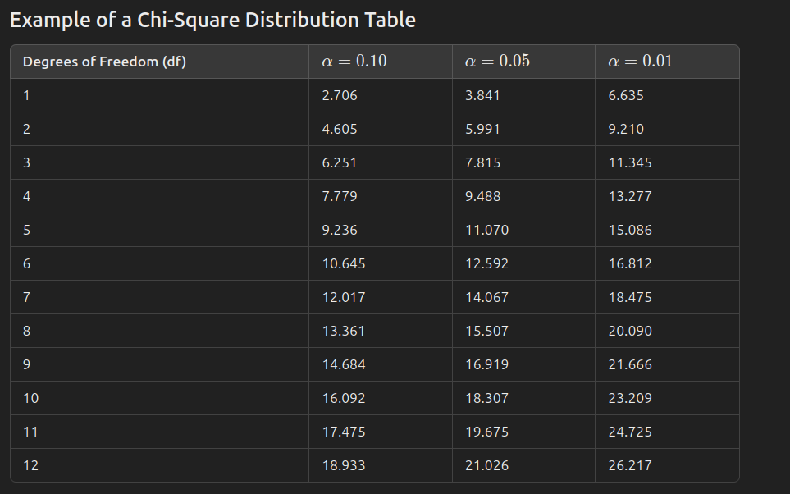

By using this picture we can conclude that :
- For df=12:
- At α=0.05, the critical value is 21.026.
- At α=0.01, the critical value is 26.217.
How we interpret the result by using the given numbers ?

If the test statistic(chi- square ) is greater than the critical value, you reject the null hypothesis.
If the test statistic is less than or equal to the critical value, you fail to reject the null hypothesis.

Compare the Calculated χ^2 Value:
- Calculated χ^2=14.06
- At α=0.05: Since 14.06 <21.026, we fail to reject the null hypothesis.
- At α=0.01: Since 14.06<26.217, we also fail to reject the null hypothesis.

Null Hypothesis (H₀): There is no significant association between the brands (rows) and the categories (ratings: Low, Medium, High). This means the ratings are independent of the brands.
Alternative Hypothesis (H₁): There is a significant association between the brands and the ratings. This means the ratings are dependent on the brands.

Conclusion:
- There is no statistically significant association between the brands (rows) and the ratings (columns) at either the 5% or 1% significance levels.
- This means the distribution of ratings (Low, Medium, High) is not significantly different across the different brands.
  - In other words, the brands do not seem to affect how ratings are distributed across the Low, Medium, and High categories.

Chi-Square Goodness-of-Fit Test :
The Chi-Square Goodness-of-Fit Test is a statistical test used to determine if a sample data matches a population with a specific distribution. It compares the observed frequencies of a categorical variable with the expected frequencies under a hypothesized distribution.
This test is commonly used to check if a set of categorical data follows a predetermined distribution, such as:
- A uniform distribution (each category is equally likely).
- A distribution with specific proportions (like expected proportions in a survey).
Steps for Performing the Chi-Square Goodness-of-Fit Test

Step 1: State the hypotheses
- Null Hypothesis (H₀): The observed frequencies match the expected frequencies (no significant difference between observed and expected distributions).
- Alternative Hypothesis (H₁): The observed frequencies do not match the expected frequencies (there is a significant difference).

Step 2: Determine the expected frequencies
- If you have a uniform distribution, the expected frequency for each category is calculated by dividing the total number of observations by the number of categories.
E = Total number of observations / Number of categories

Step 3: Calculate the Chi-Square statistic
The formula for the Chi-Square statistic (χ^2) is:
χ^2 = ∑ (Oi−Ei)^2 / Ei
Oi= Observed frequency for category i
Ei= Expected frequency for category i
This formula calculates the sum of the squared differences between the observed and expected frequencies, divided by the expected frequencies. The larger the difference between observed and expected values, the larger the Chi-Square statistic will be.

Step 4: Find the degrees of freedom
The degrees of freedom (df) for the test are calculated as:
df=k−1
Where k is the number of categories in the data.

Step 5: Determine the critical value
Using the Chi-Square distribution table, look up the critical value for your calculated degrees of freedom (df) and your chosen significance level (α).

Step 6: Compare the calculated χ^2 with the critical value
- If the calculated χ^2 is greater than the critical value, reject the null hypothesis.
- If the calculated χ^2 is less than or equal to the critical value, fail to reject the null hypothesis.

EXAMPLE :
IMPORTANT FACTOR | FREQUENCY
PRICE | 29
PERFORMANCE | 32
DESIGN | 32
BATTERY LIFE | 39
BRAND | 33
PORTABILITY | 36

Step 1: State the hypotheses
- Null Hypothesis (H₀): The observed frequencies follow a specific distribution (in this case, the expected frequencies are equal for all categories, assuming uniform distribution).
- Alternative Hypothesis (H₁): The observed frequencies do not follow the expected distribution (the frequencies are not equal across categories).

Step 2: Determine the expected frequencies
If we assume that the factors are equally important ( uniform distribution), then the expected frequency for each factor is calculated by dividing the total number of observations by the number of categories.
The total frequency is:
29+32+32+39+33+36=201
The number of categories (important factors) is 6.
The expected frequency for each category is:
E=Total Frequency / Number of Categories = 201 / 6 =33.5
So, the expected frequency for each factor is 33.5.

Step 3: Calculate the Chi-Square statistic
The formula for the Chi-Square statistic is:
χ2=∑(Oi−Ei)^2 / Ei

I do an example for price : (29−33.5)^2 / 33.5 = 0.604

Now, sum these values to get the total Chi-Square statistic:
χ^2 = 0.604 + 0.067 + 0.067+0.902+0.007+0.186 = 1.834

Step 4: Find the degrees of freedom
The degrees of freedom (df) are calculated as:
df = k−1 = 6−1 = 5
Where k is the number of categories (6 in this case).

Step 5: Find the critical value
Using the Chi-Square distribution table, for df = 5 and α = 0.05, the critical value is 11.070.

Step 6: Compare the calculated χ^2 with the critical value
- The calculated χ^2=1.834.
- The critical value = 11.070.
Since 1.834 < 11.070, we fail to reject the null hypothesis
There is no significant difference between the observed frequencies and the expected frequencies. This suggests that the importance factors (Price, Performance, Design, Battery Life, Brand, and Portability) are equally distributed in terms of frequency, and we do not have evidence to suggest that one factor is more important than the others based on this data.

T-TEST :

A t-test is a statistical test used to determine whether there is a significant difference between the means (averages) of two groups or between a sample mean and a known population mean. It's a way of answering the question: "Are these groups really different, or is the difference due to chance?

Types of T-Tests:
1) One-Sample T-Test
2) Two-Sample T-Test (Independent T-Test)
3) Paired T-Test

I want to perform a One-Sample T-Test:

a) Hypothesized Mean (μ0):
- This is the value I am comparing my sample mean (Xˉ) to.
- Example: If we believe the average budget for laptops in the general population is μ0 = 1000, this will be our hypothesized mean.

Sample Size (n):
- The number of observations in the sample.
- N = 200

Sample Standard Deviation (s):
- The standard deviation of your sample data. This measures how much the individual budgets deviate from the sample mean.
- In my case , the sample standard deviation is around 676.44 .

Degrees of Freedom (df):
- For a one-sample t-test, degrees of freedom is: df = n−1
- 200 – 1 = 199

Formula for the T-Statistic
Once we have the above values, we can use the one-sample t-test formula:
t = Xˉ − μ0 / (s/√n)
Where:
- Xˉ: Sample mean (1141.25)
- μ0: Hypothesized mean (1000)
- s: Sample standard deviation ( 676.44)
- n: Sample size 200

4. Significance Level (α)
Decide the significance level (α):
- Common choices are α=0.05 (5%) or α=0.01 (1%).
- This determines the threshold for rejecting the null hypothesis

5. Null and Alternative Hypotheses
- Null Hypothesis (H0): The sample mean is equal to the hypothesized population mean.
Example: H0: μ = 1000
- Alternative Hypothesis (H1​): The sample mean is different from the hypothesized population mean.
Example: H1 : μ !=1000 (two-tailed test).

Compare t-Statistic to Critical Value or p-Value
- I Use a t-distribution table to find the critical value for my chosen α and degrees of freedom.
- If ∣t∣> critical value , reject H0​.
- Alternatively, calculate the p-value and compare it to α:
  - If p < α, reject H0
Note : I prefer to use critical value for my calculation .

>>By applying Formula for the T-Statistic we can easily compute t-statistic , in my case it is approximately 2.95 and the degrees of freedom (df) are 199.
Note : I am testing whether the sample mean is greater than or less than the hypothesized mean, it's one-tailed.
>>So critical value due to the t-statistic table for critical value is 1.97.
>>Since the calculated t-statistic (2.95) is greater than the critical value (1.97), we reject the null hypothesis (H0).
>>There is strong evidence to suggest that the sample mean (1141.25) is significantly different from the hypothesized mean (1000) at the 5% significance level. This indicates that the average budget for buying a laptop is likely not equal to $1000.

***********************************************************************************
The analysis of the dataset on "The Most Important Factor for Buying a Laptop" provides valuable insights into consumer preferences and behavior. Here are the key findings:
- Budget Analysis:
  - The average budget for buying a laptop is $1141.25 (sample mean), with a median budget of $1106.40, indicating that half of the consumers are willing to spend around this amount or less.
  - The mode of $1601.25 reflects the most common budget range among consumers.
  - The range of $2000 suggests a significant variation in the budget, highlighting the diversity of consumer spending capacity.
  - A standard deviation of $676.44 confirms that budgets are widely dispersed around the mean.
- Demographic Insights:
  - Age ranges from 18 to 100 years, with a range of 82 years, suggesting a diverse demographic base for laptop buyers.
- Variance in Preferences:
  - Performance shows a moderate variance (0.4889), indicating that ratings for performance are moderately spread.
  - Battery Life has a higher variance (1.2571), suggesting that it is a highly variable factor across brands.
  - Portability demonstrates a low variance (0.0829), showing that laptop weights are generally consistent across brands.
- Chi-Square Test Results:
  - There is no statistically significant association between laptop brands and ratings at the 5% or 1% significance levels, indicating that brand does not influence the distribution of ratings (Low, Medium, High).
  - The Chi-Square Goodness-of-Fit Test shows that the importance factors (Price, Performance, Design, Battery Life, Brand, and Portability) are equally distributed in terms of frequency. There is no evidence to suggest that one factor is significantly more important than the others.
- T-Test Results:
  - The t-test provides strong evidence to reject the null hypothesis, concluding that the average budget ($1141.25) is significantly different from the hypothesized mean of $1000. This suggests that consumers are willing to spend more than $1000 on average when buying a laptop.

Final Answer to the Research Question
Based on the analysis, Battery Life emerged as the most important factor for buying a laptop, as it was the mode for "Important Factors." While other factors like price, performance, and brand are equally distributed in terms of importance, Battery Life stands out as the key deciding factor for consumers in this dataset.
This conclusion provides valuable insights for manufacturers and marketers to focus on enhancing battery performance to meet consumer demands and improve overall satisfaction.
Before starting this project, I hypothesized that the most important factors for buying a laptop would be price or brand. I also assumed that most people would prefer not to spend more than $600 on a laptop. However, upon completing the analysis, the findings revealed a surprising outcome: Battery Life emerged as the most important factor, surpassing both price and brand.
Additionally, the data showed that users are, in fact, willing to invest significantly more, with the average budget exceeding $1000. This highlights a shift in consumer priorities, where functionality and long-term usability, such as battery performance, take precedence over cost and brand recognition. These insights provide valuable guidance for manufacturers aiming to align their offerings with customer preferences.
…………………………………………………………………………………………………………
I extensively used resources and PDF by Professor David Barilla, alongside my personal notes from the "Mathematics for Data Analysis" course. Although I initially aimed to work with a real-life dataset, it proved to be quite challenging. As a result, I sourced some data from relevant journals to supplement my analysis. Throughout the process, I also sought assistance from ChatGPT to enhance the quality of my project .

KHEIZARAN NAZARI KHAKESHOORI

