Conditioned Area not summarized in the Input Summary
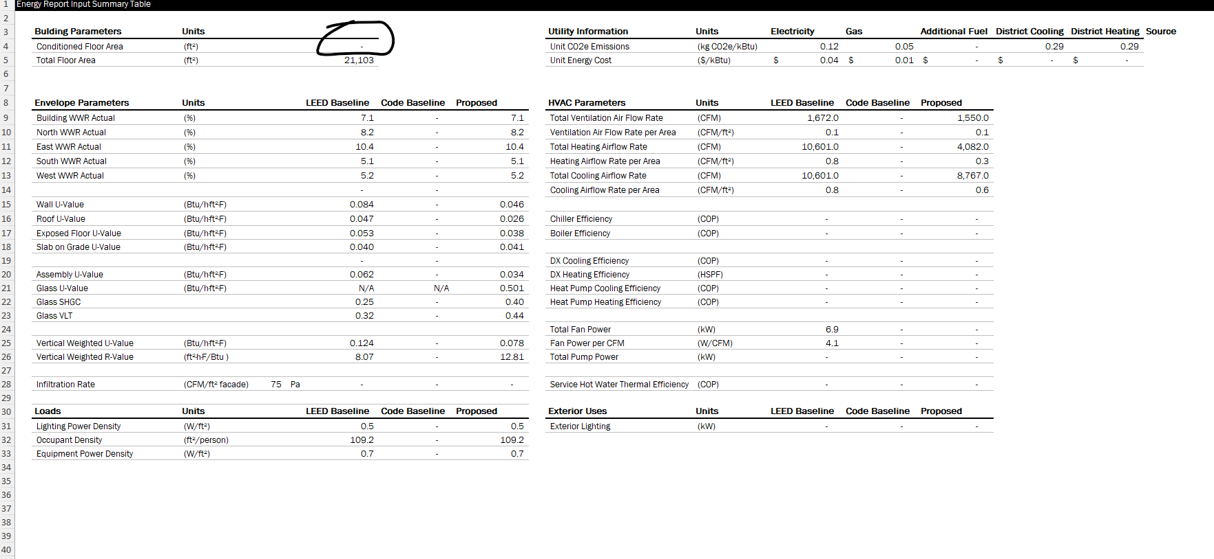

However it is available in the proposed data tab – check why is that happening and fix
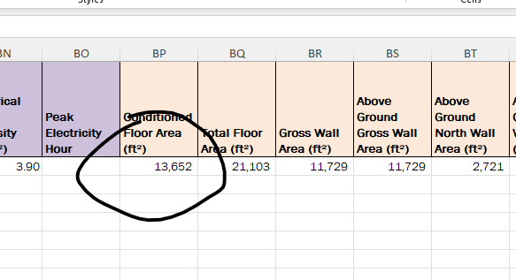

Is there no infiltration rate data available make sure it shows up on both proposed tab and input summary
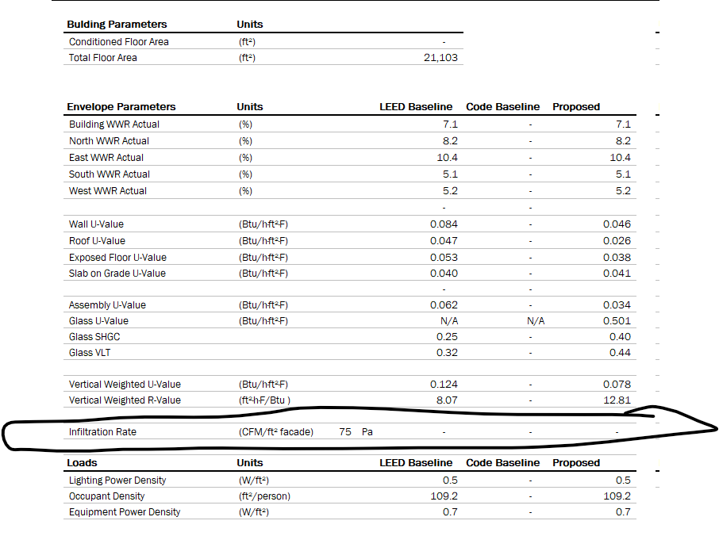

The model should have fan power since we have fan energy
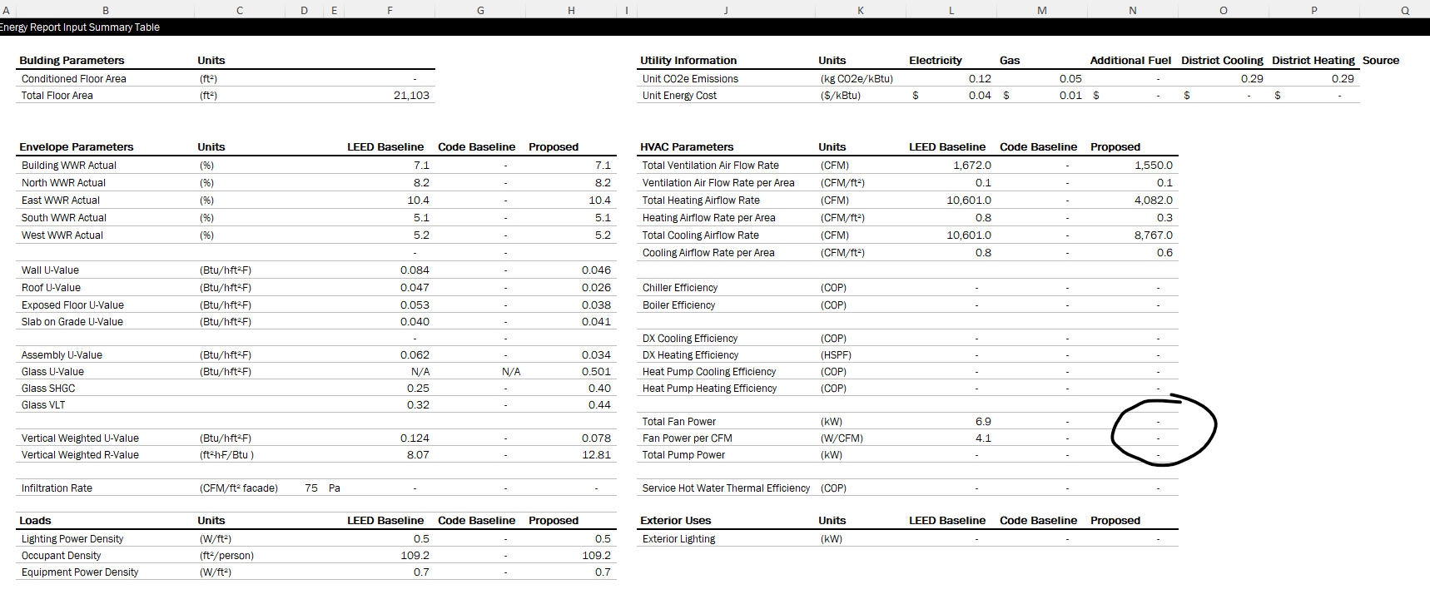
If the project does not have any additional fuel or district related charges then we should make sure all the sections are NA
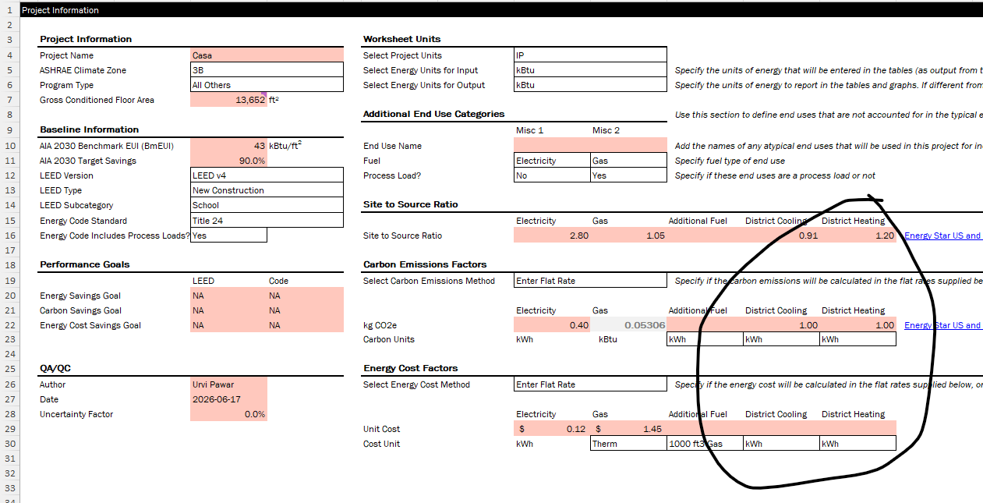

Make sure this is empty on the input summary side (empty = - )
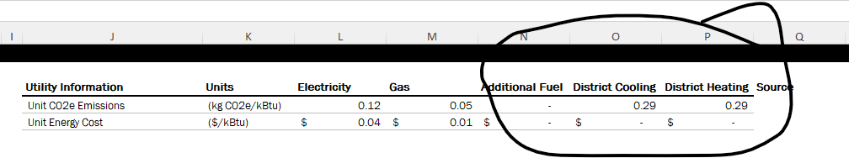
Urvi Pawar, LEED AP BD+C
Building Performance Analyst
CannonDesign

