**CompilaCompiler**

A lexical,syntaxic and semantic analyser for a hypothetical programming language called Compila

**Programmed By :**

KHELFI MOHAMMED AKRAM

CHEBBAH DJAMEL

**Programming language sample :**

Start_Program

Int_Number : i , j , Aft_5 ;;

Give i : 23 ;;

Real_Number Aft34_2 ;;

If -- i < j --

Give Aft_5 : 10 ;;

Else

Start

Affect i to j ;;

Give Af34_2 : 123.54 ;;

Finish

ShowMes : " ceci est un message " ;;

ShowVal : i ;;

//. ceci est un commentaire

End_Program

**Screenshots**

**Ajout du fichier**

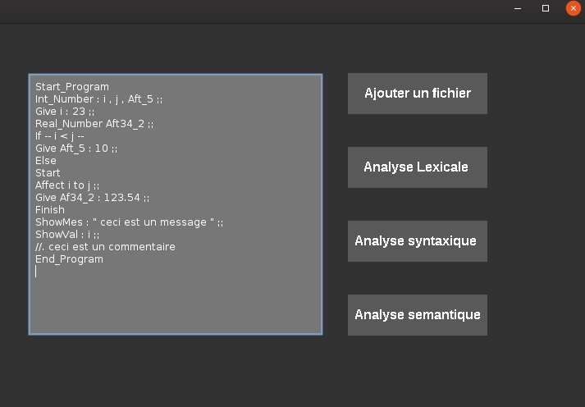

**Analyse Lexicale**

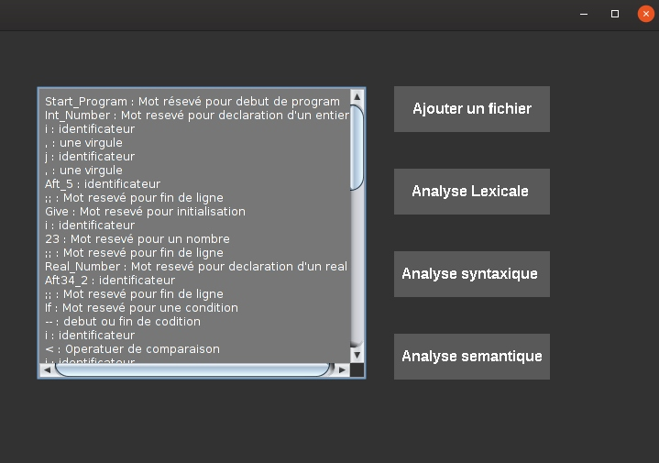

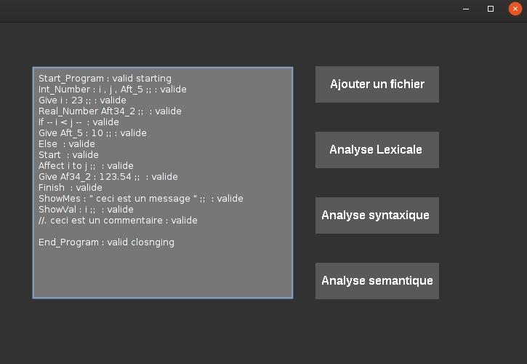**Analyse Syntaxique :**

**Analyse Semantique :**

