Below is the run time of matrices of size 10x10, 20x20,30x30...100x100

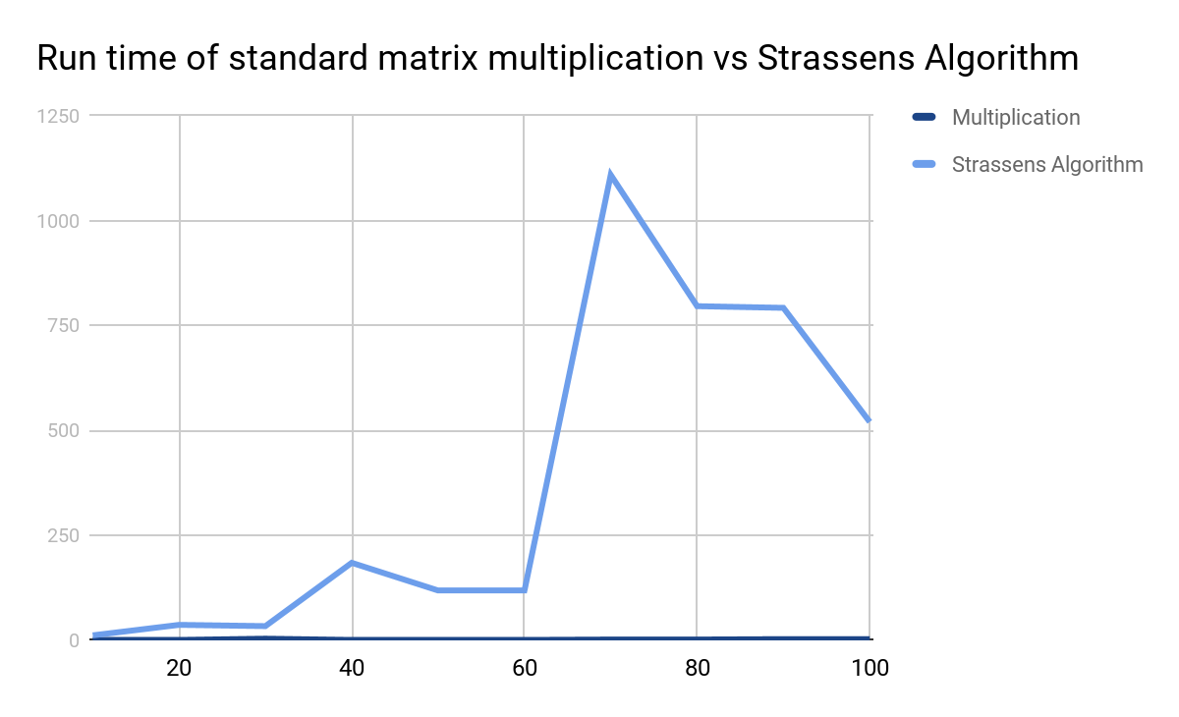

As seen strassen's algorithm was extremely inefficient for larger numbers compared to the traditional way to multiply matrices. The larger the numbers got the more inefficient the algorithm became. This algorithm did become slightly faster when the matrices size N was a power of 2 as this is what strassen's algorithm is semi[not really] efficient at.

For the second portion of this problem where we had to multiply matrices of size n\*n that are larger than 100 Strassen's Algorithm became extremely inefficient in both terms of memory management and cpu usage. My Cpu usage spiked to 100% for the duration of the running of the algorithm and i ended up running out of memory. This is on a over 4 year old laptop with an I7 and 8gb of ram if i had a more modern computer with more memory and more computational time it may be possible to calculate larger matrices in the past 25 minutes i have only been able to multiply matrices of size 300x300 and i am out of memory so i shall be ending this program.