17.Scenario: Static NAT for Web Server Hosting Problem: You are hosting a public web server in your internal network with the private IP address 192.168.1.100. The ISP provided you a public IP 203.0.113.10. Only HTTP and HTTPS traffic should be allowed from the internet to the server
Tasks: 1. Configure Static NAT to allow access to the web server.
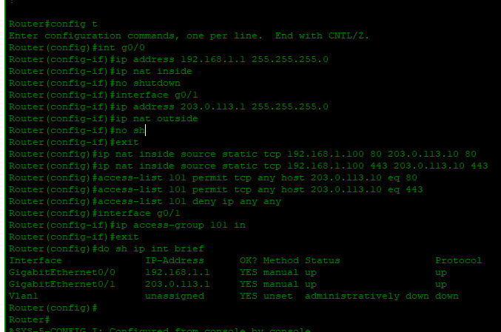
2. Explain where this NAT configuration should be applied (inside/outside interfaces).
Inside interface: Connects to the internal network (LAN) , SERVER → router interface facing the Web Server
- Command: ip nat inside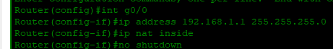
Outside interface: Connects to the external network, PC, (WAN/Internet) → router interface facing the Internet PC
- Command: ip nat outside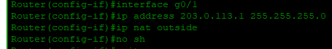

  - Add access control if required to allow only HTTP/HTTPS. 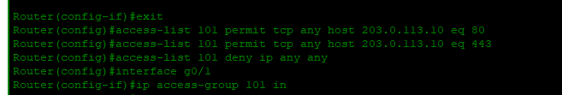
Server’s IP Configuration in LAN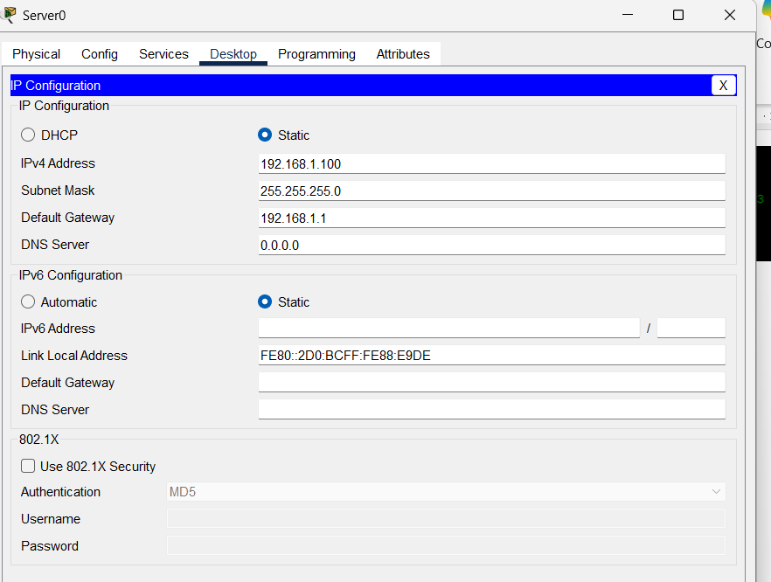
PC’s IP Configuration in WAN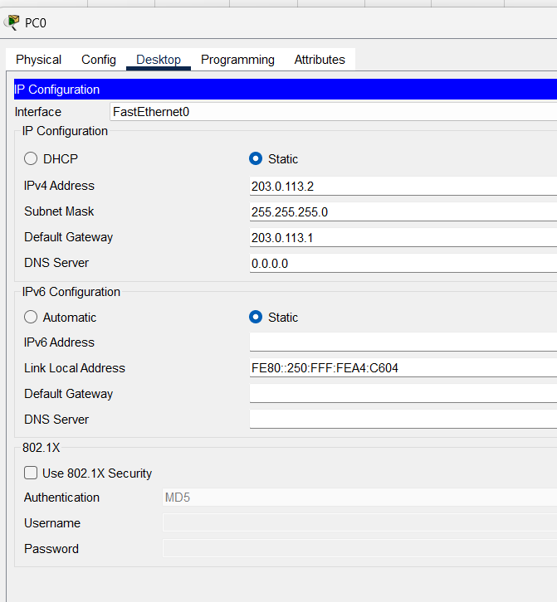
Here we did static NAT for webserver , from 192.168.1.100 → 203.0.113.10
Only TCP ports 80 (HTTP) and 443 (HTTPS) as we applied ACL to allow only these ports
successful browser access: with https: 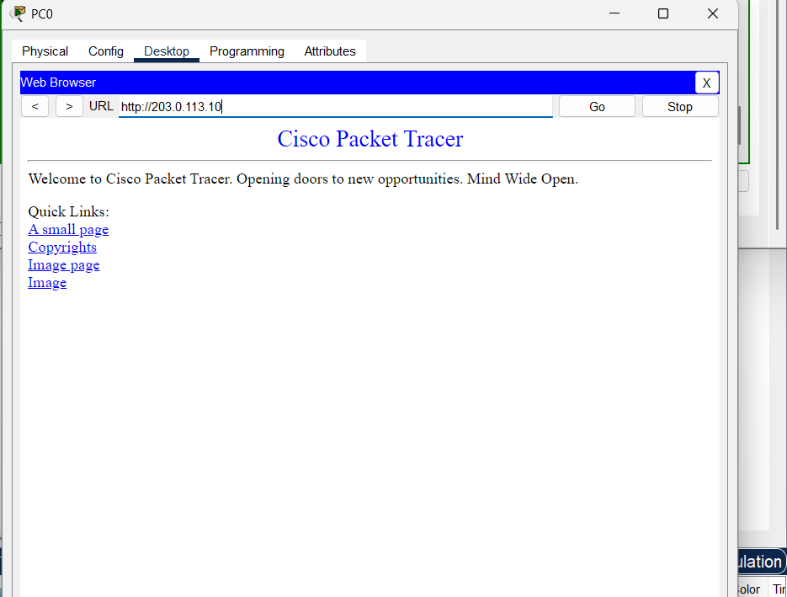
with https as well: 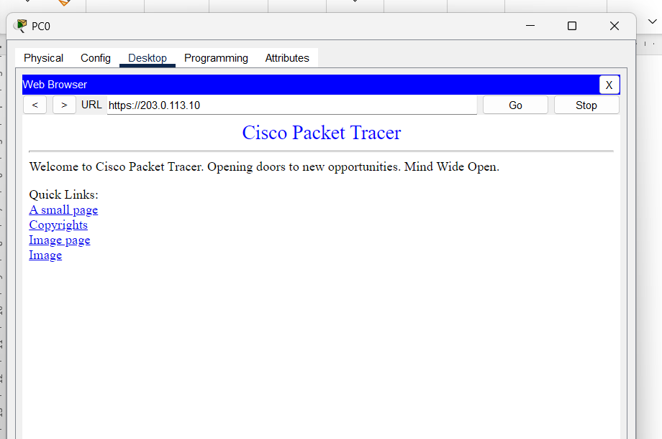
Here ping is failed because ping uses ICMP not TCP , our configured rules don’t cover ICMP so ACL blocks everything else

AS it uses TCP so when user from internet open the website HTTP/HTTPS traffic is allowed and NAT translates it correctly
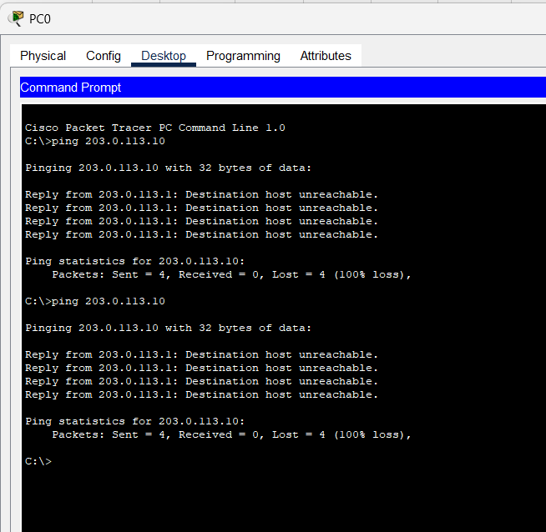
4. Draw and label a simple diagram of the setup.

