**Document Parsing Application:**

**Problem Statement**: To build an application that can parse through resume files in various formats to generate a list of eligible candidates based on the skill criteria set by the user.

**Capabilities:**

1. The application can parse through multiple documents to count the number of occurrences of a set of keywords inside them.
2. It generates an excel report displaying the document name along with the corresponding counts of the specified keywords.

**Preconditions and Limitations:**

1. All the documents to be parsed should be placed inside a single folder, Files present in sub-folders are not parsed.
2. All the documents must either be MS Word (.doc/.docx) or PDF (.pdf) files only. Presence of Files of any other formats cause the program to fail.
3. Improperly formatted and/or incorrectly saved documents may produce erroneous results.
4. If open, the “report.xslx” file should be closed before clicking on the ‘Generate Report’ button.
5. Care should be taken to enter the keywords as per the serial numbers shown in the User Interface.
6. The number of keywords entered should match the numerical value entered by the user.
7. Click on ‘Browse Directory’ button to select the location of the document files. It can only select folders and not individual files.
8. The field adjacent to ‘Browse Directory’ will display the path of the selected directory.

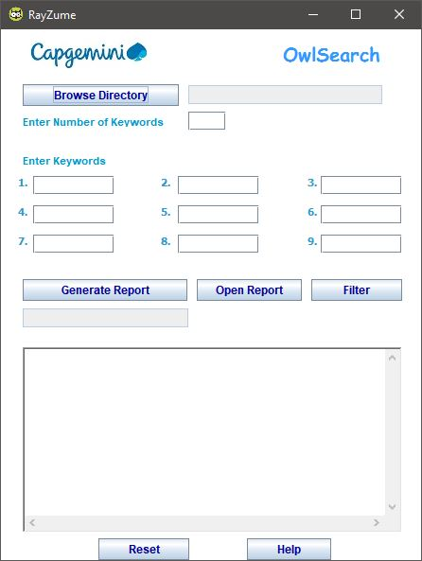

1. Enter the number of keywords into the field as shown in the image.
2. Keywords can be typed in the numbered fields as shown below.
3. Click on the ‘Generate Report’ button which will commence the actual operation.
4. The message ‘Report Generated’ should appear in the field beneath the ‘Generate Report’ button.

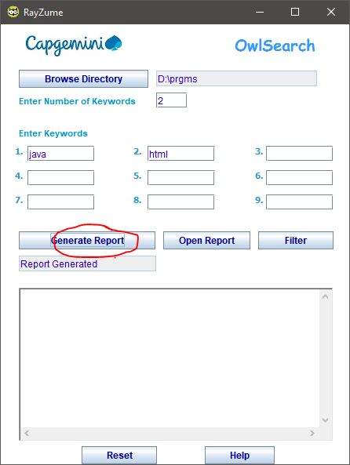

1. Click on ‘Filter’ button to display list of eligible documents having non-zero occurrences of the keywords given by the user.

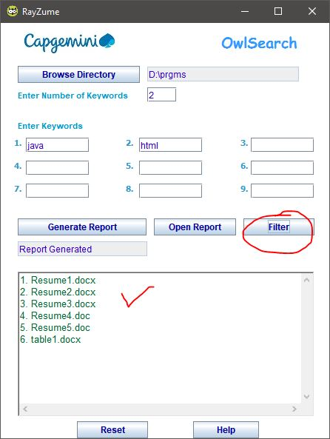

1. 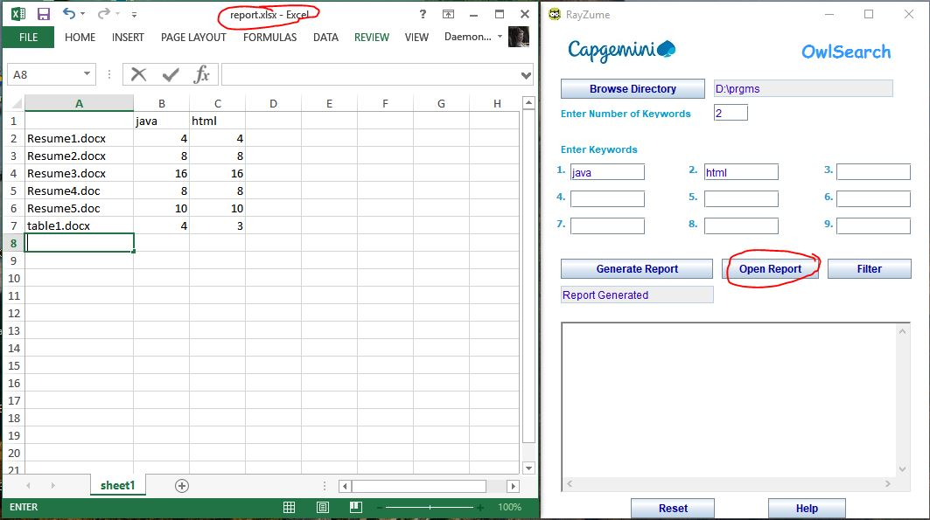Click on ‘Open Report’ to see the detailed report of the document files. The report consists of files names along with the counts of keywords
2. Clicking on ‘Help’ button will open another window containing a set of instructions.

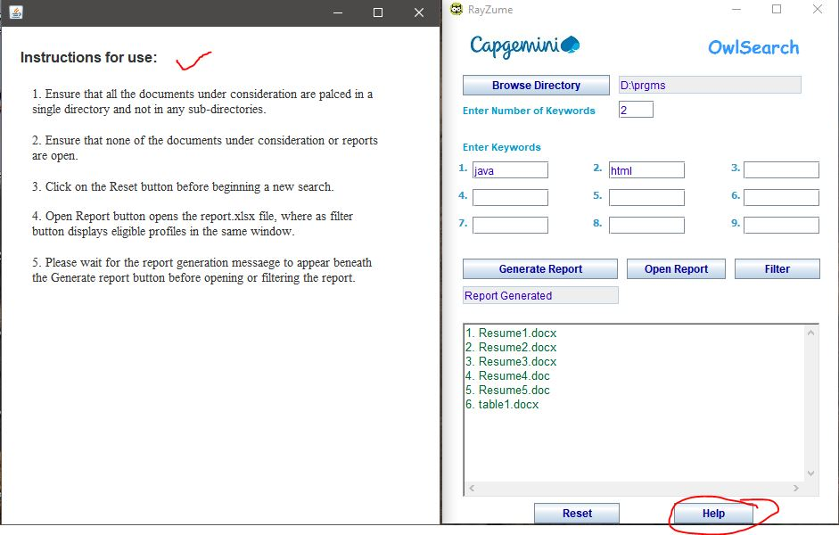

1. Click on ‘Reset Button’ to clear all the fields.

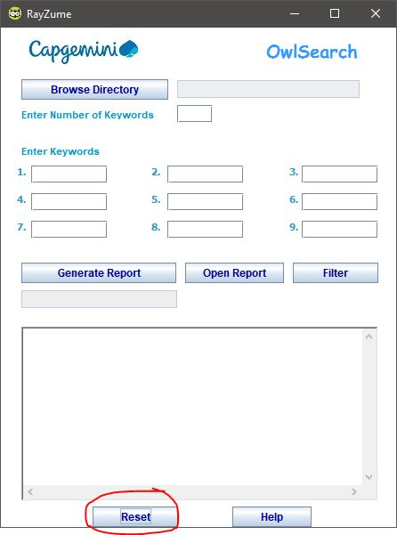

1. The user can also change the entered data and click on ‘Generate Report’ button to create a new search.