Introduction

ProTx™ is a plain-text editor that I developed to facilitate the practice and learning of HTML, especially for learners. ProTx™ is not your regular plain-text editor because it has a few extra useful features.

I developed ProTx™ almost entirely with JavaScript! It is a complete web-ware made with HTML and JavaScript you can download it free at www.htmlonline.tk/tools/protx.php.

Although at the time of writing of this material, ProTx™ is still the way it was in 2004 but I intend to improve it and release an upgraded and better version.

ProTx™ is not so different from Notepad or any other regular plain-text editor you may have access to, but ProTx™ has some extra features which you might find interesting and useful when learning HTML, and that is why I also recommend readers of my HTML lessons to use ProTx™.

Thank you for downloading ProTx™
Happy coding!

Kheme

About Me

My name is Okiemute Omuta, but I’m very well known as Kheme. I am a Nigerian freelance website designer and developer specialized in PHP & MySQL. I also have a good understanding of JavaScript, DHTML and CSS. I also have a considerable applicable knowledge of Flash, Action Scripts, AJAX, C/C++ and Oracle SQL.

I have gathered experience in designing websites commercially using PHP, MySQL, (X)HTML, CSS, JavaScript and DHTML since 2003. Hence, I am able to develop both static and dynamic websites, from small scale websites through medium scale to medium-large scale websites.

Besides developing websites, I run a free website design tutorials website where I have website design related lessons. The name of the website is HTML Online (www.htmlonline.tk); I also have a few free e-books on that website, such as this one you’re reading right now.

If you noticed any spelling or typographical errors, or you just like my tutorials, or you have problems or questions to ask, feel free to email me at Kheme@htmlonline.tk or visit my website at www.khemeonline.tk. Also, I consider it consolation for my efforts when my readers e-mail in to say a thing or two about my e-books, or simply just to say “Thanks!” :)

Feel free to share this e-book with you friends and those you feel could benefit from it.

Thanks for downloading one of my e-books.

Kheme

The Menus

The File Menu
The file menu has only three (3) sub-menus in this version of ProTx™: Save As, About ProTx™ and Exit.

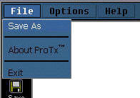

The “About ProTx™” sub-menu only launches a pop-up box with what you might call the "Credits".

The “Save As” sub-menu activates the Save As command allowing you to save your new work with a name to your computer or to save a named work with another name to your computer.

The “Exit” sub-menu when clicked closes ProTx™. If you try to exit without saving your work, ProTx™ will prompt you to save or discard resent changes made to your work before finally exiting.

Note: Also look to the end of this page for more reference pictures.

The Options Menu
The Options menu has only two (2) sub-menus in this version: Font and Music.

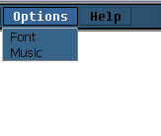

The “Font” sub-menu launches a pop-up window that allows you to format the text as you work with ProTx™. You can choose your font face type, font color and font size with this option.

The “Music” sub-menu launches a pop-up window that allows you to choose a song or music you want to listen to while you work.

To add your own songs to the play list, simply copy your songs into the “Music” folder located within the ProTx™ installation folder usually located in c:\Program Files\KhemeSoft\. You can copy the following file format types and they'll play without any problem: .wma, .wax, .wav, .mp3, .mid, .mu3, and .cda.

Note: Also look to the end of this page for more reference pictures.

The Help Menu
The Help menu has no sub-menu. Clicking the Help menu launches this user manual you are reading now, but in Microsoft CHM Help file format.

Shortcuts & Extra Features

Shortcut for Open
To activate the “Open” command, to open a file, press the Control button and the letter O (CTRL+O) like in many other applications.

Shortcut for New
To activate the “New” command, to create a new blank file, press the Control button and letter N (CTRL+N) like in many other applications.

Shortcut for Save
To activate the “Save” command, to save your work, press the Control button and the letter S (CTRL+S) like in many other applications.

Shortcut for Date & Time
To display the current date & time on your computer while you work, press the Alternate button and the letter A (ALT+A).

Shortcut for File Size
To display the present size of the file you're working on, press the Alternate button and the letter S (ALT+S).

Shortcut for Page Preview
To preview your HTML on default internet browser software while you work, press the Alternate button and the letter Z (ALT+Z).

Shortcut for Calculator
To display a simple pop-up calculator while you work, press the Alternate button and the letter C (ALT+C).

Reference Pictures

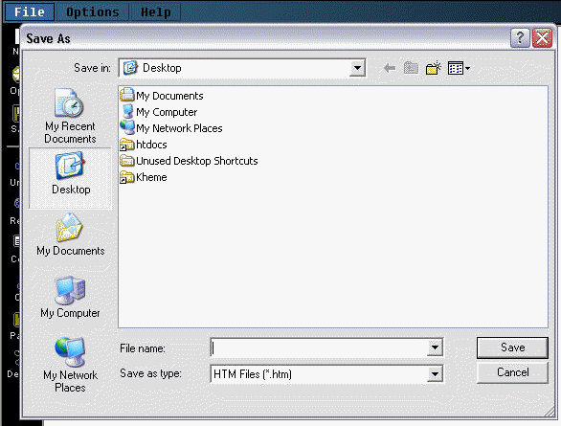
The “Save As” pop-up window

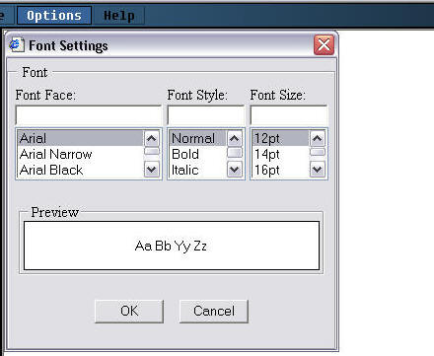
The “Font” pop-up window

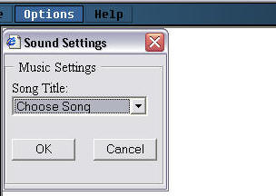
The “Song” pop-up window

www.htmlonline.tk

