**REST API document.**

**(1)Add User**

**Url**: <http://localhost/cakephp3_api/api/users/add.json>

**Header:** Content-Type: application/json

**Method**: POST

**Request:**

{"firstname":"Khemit","lastname":"verma","username":"khemit25","password":"123456","email":"khemit.verma25@gmail.com"}

**Response:**

{

"success": true,

"user": {

"firstname": "Khemit",

"lastname": "verma",

"username": "khemit25",

"email": "khemit.verma25@gmail.com",

"created": "2021-08-30T06:08:46+00:00",

"id": 22

}

}

curl -X POST -H 'Content-Type: application/json' -i 'http://localhost/cakephp3_api/api/users/add.json' --data '{"firstname":"Khemit","lastname":"verma","username":"khemit25","password":"123456","email":"khemit.verma25@gmail.com"}'

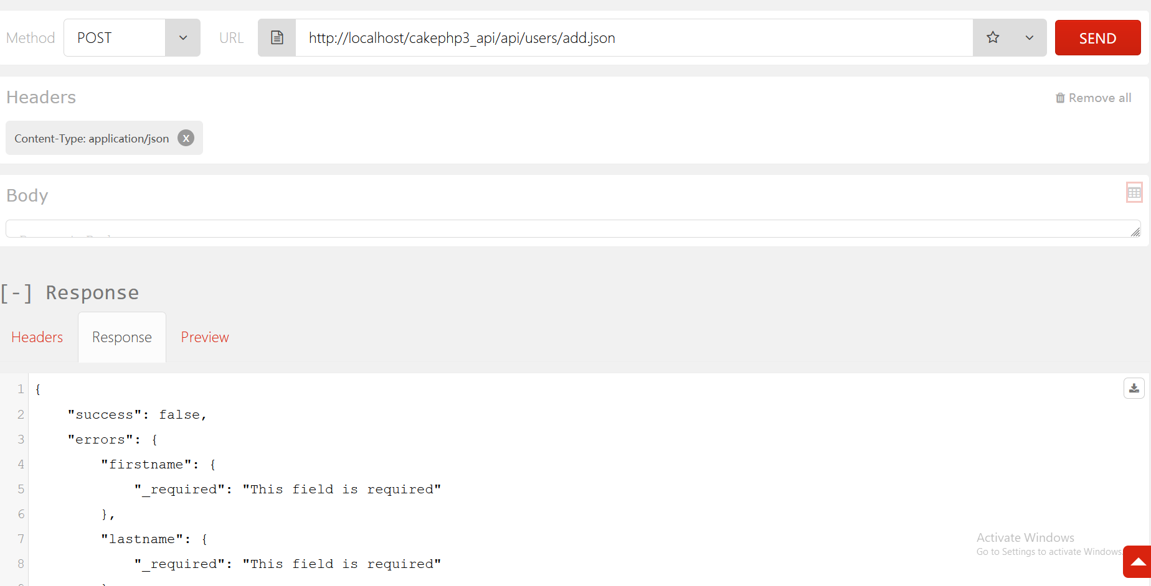

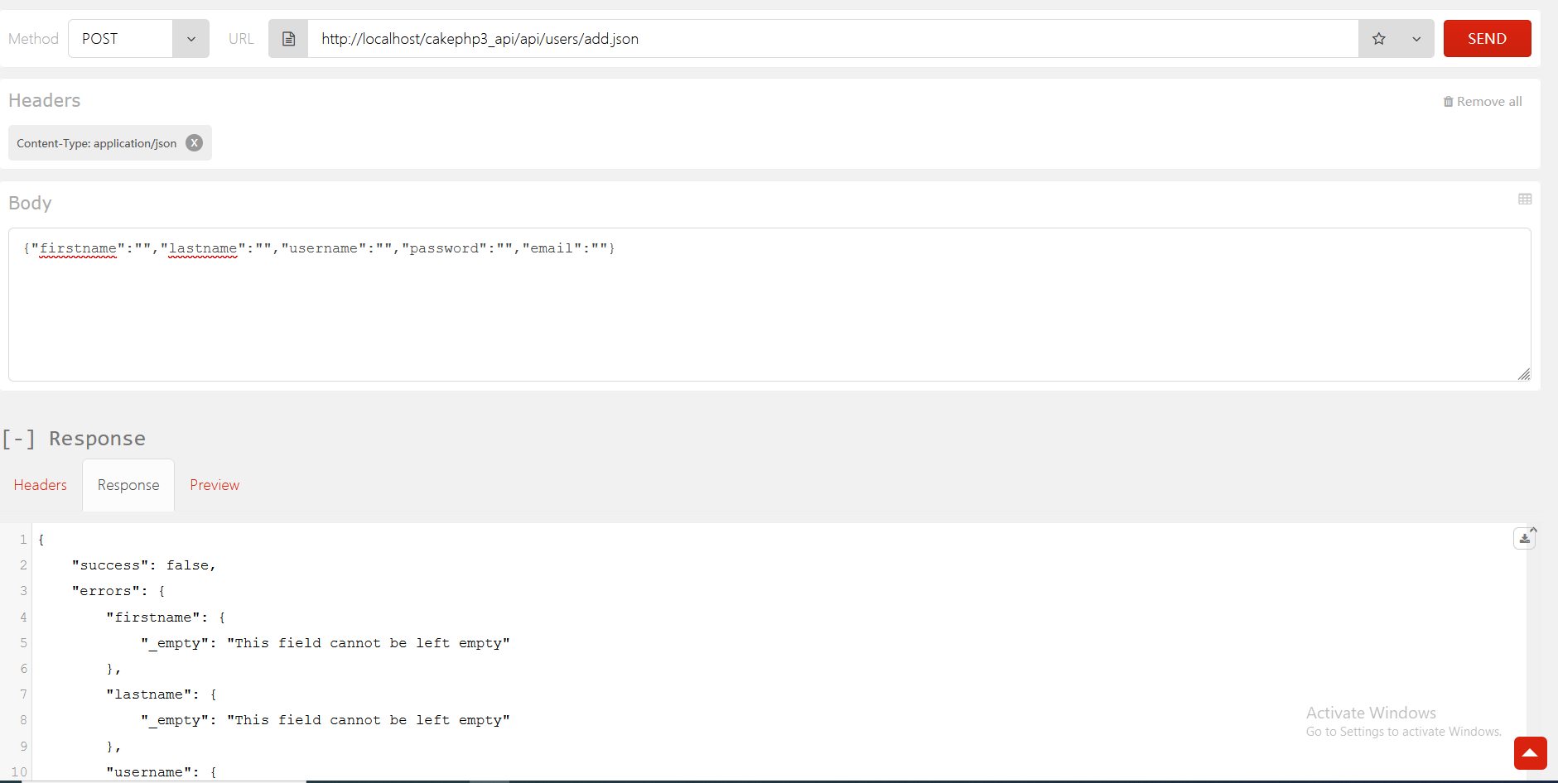

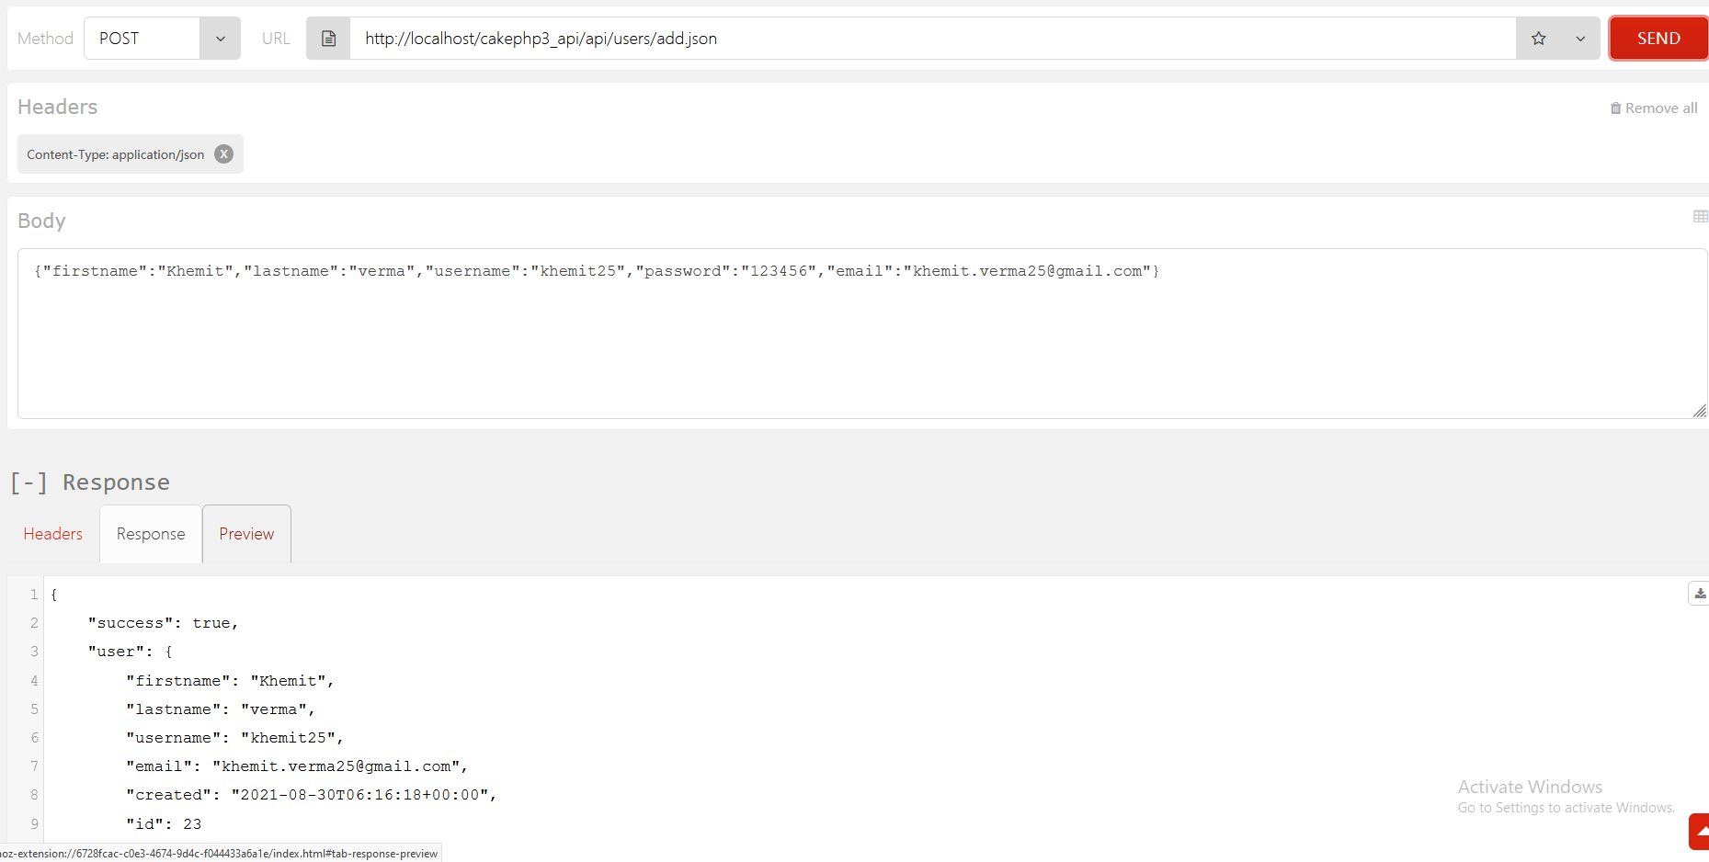

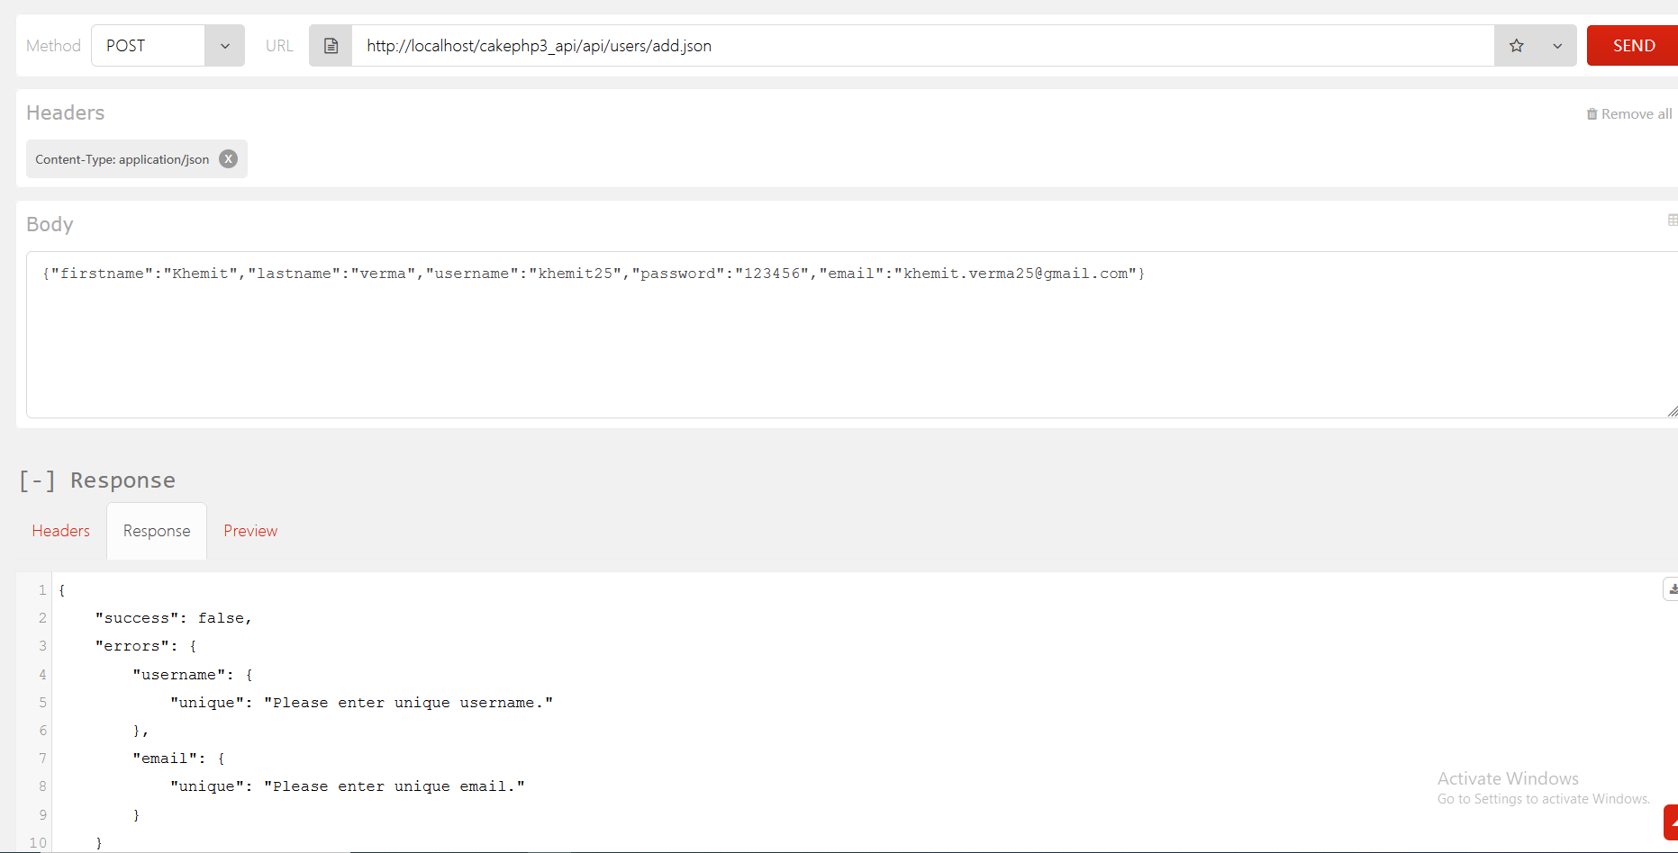

**(1)Add User**

**Url**: <http://localhost/cakephp3_api/api/users/index.json>

**Header:** Content-Type: application/json

**Method**: GET

curl -X GET -H 'Content-Type: application/json' -i 'http://localhost/cakephp3_api/api/users/index.json'

**Response:**

{

"success": true,

"users": [

{

"id": 13,

"firstname": "Sam",

"lastname": "Karan",

"username": "Sam",

"email": "sam@gmail.com",

"created": "2021-08-16T09:25:13+00:00"

},

{

"id": 14,

"firstname": "Tony",

"lastname": "Graig",

"username": "tony",

"email": "tony2gmail.com",

"created": "2021-08-16T09:44:21+00:00"

},

{

"id": 21,

"firstname": "k",

"lastname": "v",

"username": "kvh",

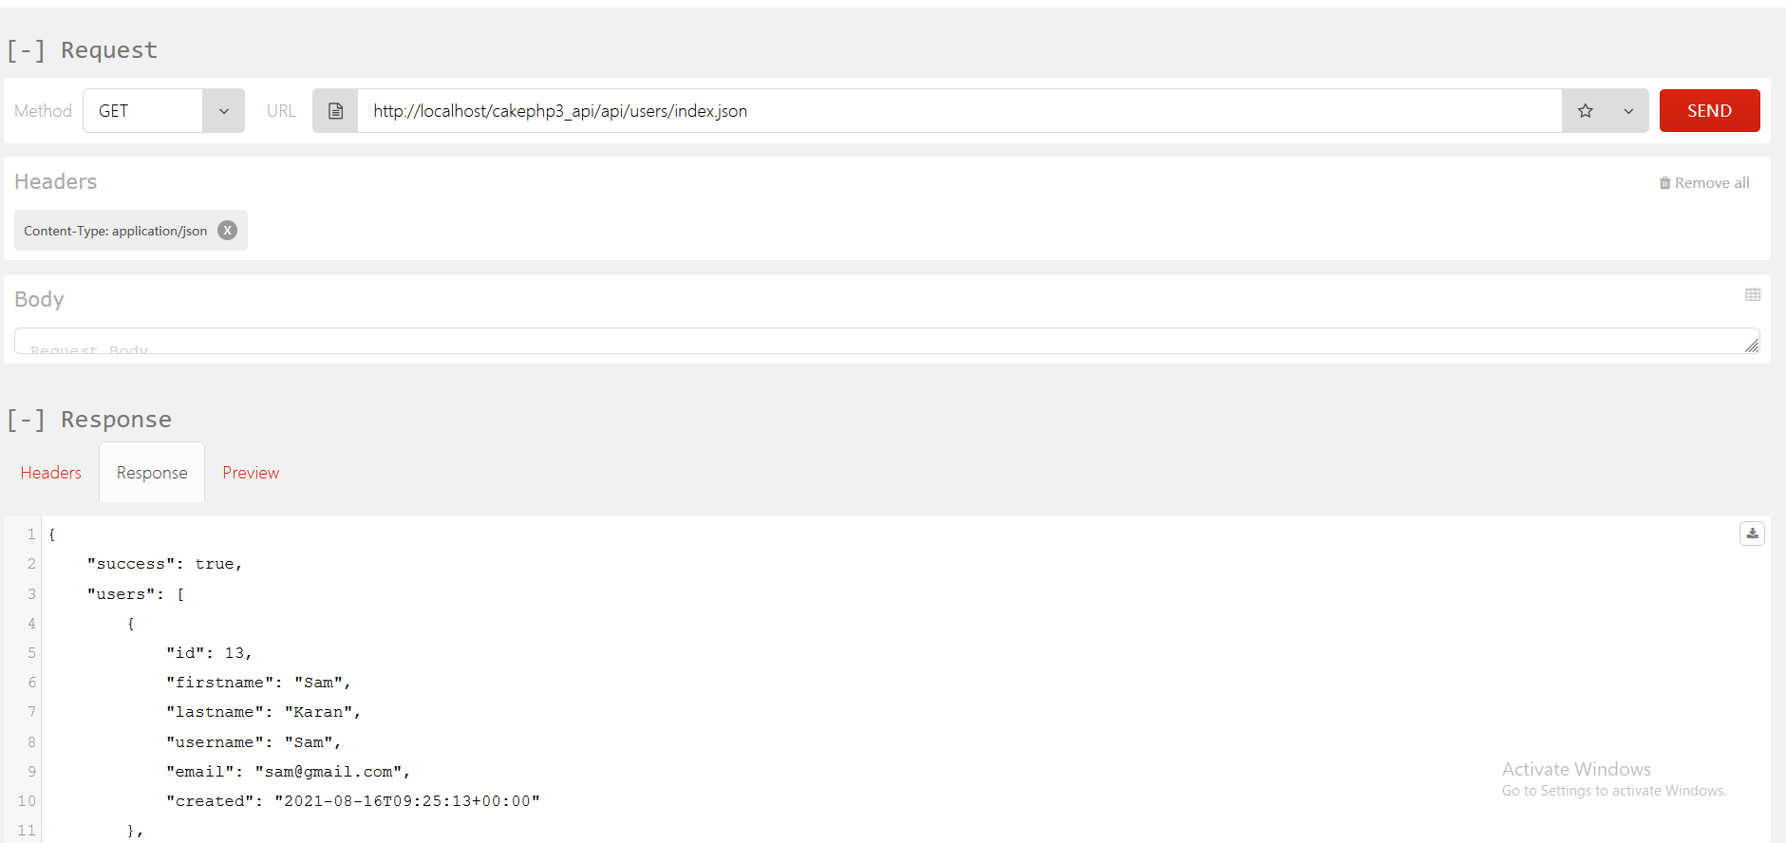

Xml Format:

Listing of Users

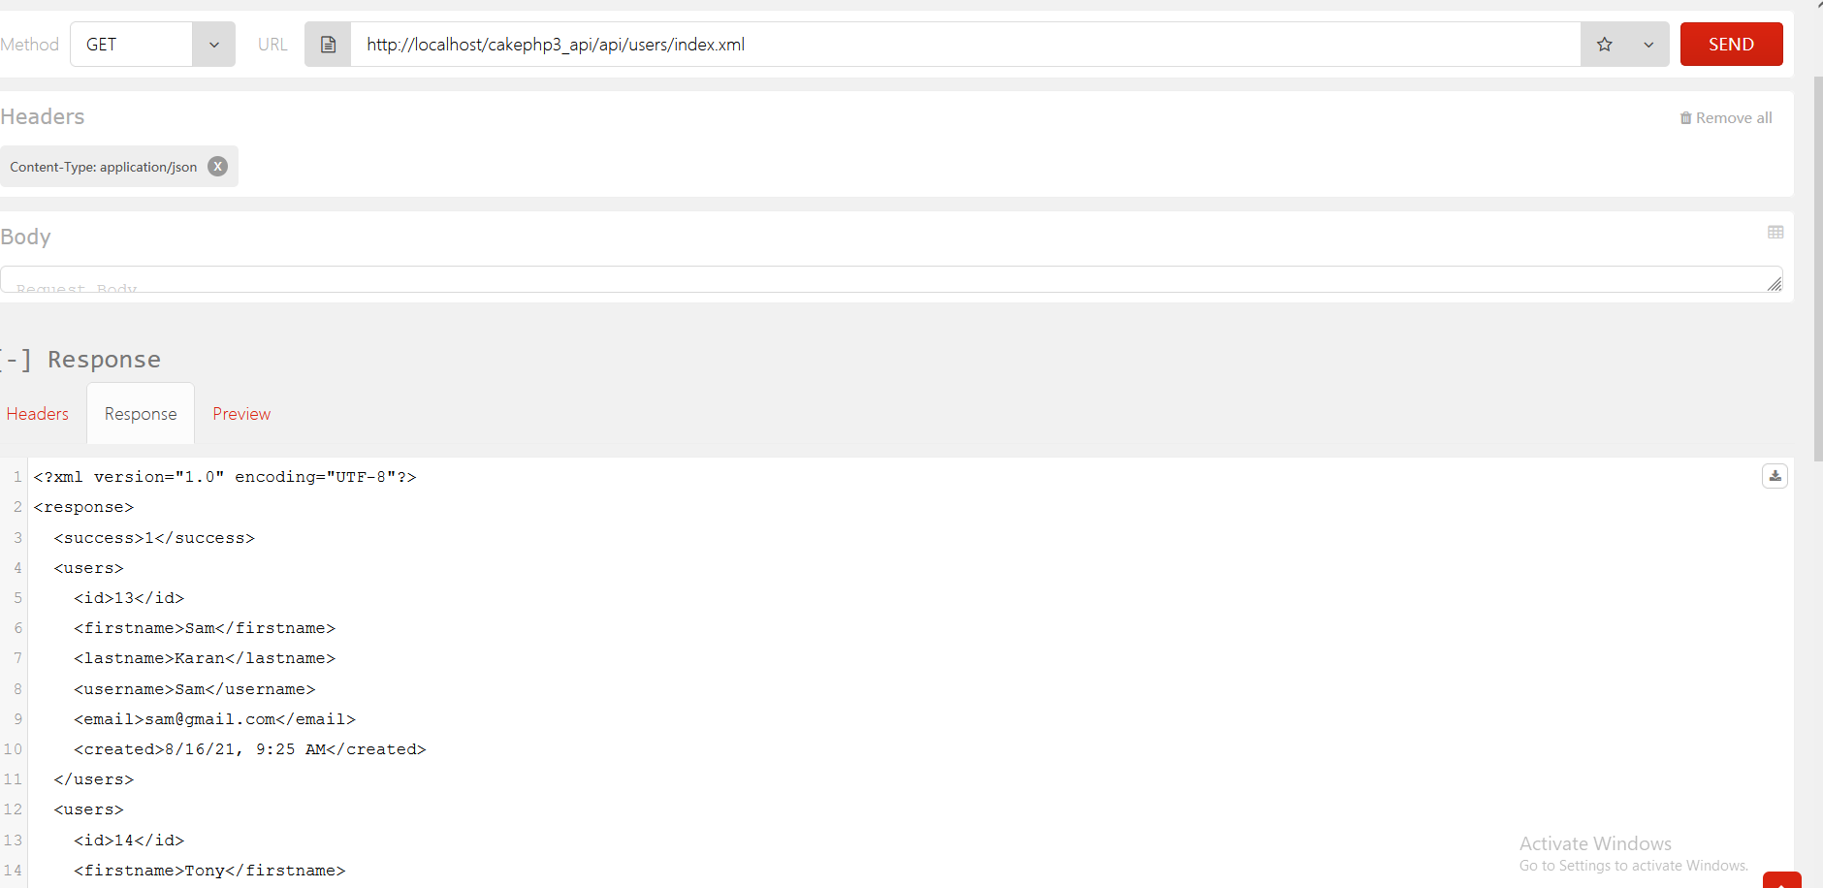

Add User:

