**REST API document.**

**(1)List of Contacts**

**Url**: http://localhost/cakephp3_api_demo/api/contacts/index.json

**Header:** Content-Type: application/json

**Method**: GET

**Response:**

{"success":true,"contacts":[{"id":1000,"first_name":"Giustina","last_name":"Whaley","phone_number":"6768543313"},{"id":999,"first_name":"Miles","last_name":"Thorneloe","phone_number":"1419522533"},{"id":998,"first_name":"Avigdor","last_name":"Drummond","phone_number":"8869432525"},{"id":997,"first_name":"Gawain","last_name":"Triggs","phone_number":"2004949877"},{"id":996,"first_name":"Rozanna","last_name":"Pikesley","phone_number":"3431329951"},{"id":995,"first_name":"Annmaria","last_name":"Belshaw","phone_number":"2188777486"},{"id":994,"first_name":"Lonny","last_name":"Harkins","phone_number":"9399976793"},{"id":993,"first_name":"Theadora","last_name":"Care","phone_number":"3117609855"},{"id":992,"first_name":"Stanislaw","last_name":"Spavon","phone_number":"2593573156"},{"id":991,"first_name":"Saxon","last_name":"Strasse","phone_number":"2917063243"},{"id":990,"first_name":"Val","last_name":"Brattan","phone_number":"4719433421"},{"id":989,"first_name":"Harmon","last_name":"Antrack","phone_number":"8671749936"},{"id":988,"first_name":"Genevieve","last_name":"Adel","phone_number":"4835683927"},{"id":987,"first_name":"Trixi","last_name":"Prosh","phone_number":"9699181934"},{"id":986,"first_name":"Katina","last_name":"Maddie","phone_number":"2955699633"},{"id":985,"first_name":"Phil","last_name":"Dougharty","phone_number":"5966203744"},{"id":984,"first_name":"Yvonne","last_name":"Barmby","phone_number":"2259532903"},{"id":983,"first_name":"Selia","last_name":"Yitzhak","phone_number":"9114306929"},{"id":982,"first_name":"Gawen","last_name":"Miroy","phone_number":"2037071743"},{"id":981,"first_name":"Mirilla","last_name":"Loads","phone_number":"2378153565"},{"id":980,"first_name":"Dyann","last_name":"Basire","phone_number":"9454514869"},{"id":979,"first_name":"Bevan","last_name":"Body","phone_number":"3234825203"},{"id":978,"first_name":"Gabi","last_name":"Epton","phone_number":"4082630059"},{"id":977,"first_name":"Dell","last_name":"Tidd","phone_number":"1056492467"},{"id":976,"first_name":"Hubey","last_name":"Schneider","phone_number":"7032037409"},{"id":975,"first_name":"Renate","last_name":"Do","phone_number":"2567576046"},

curl -X GET -H 'Content-Type: application/json' -i 'http://localhost/cakephp3_api_demo/api/contacts/index.json'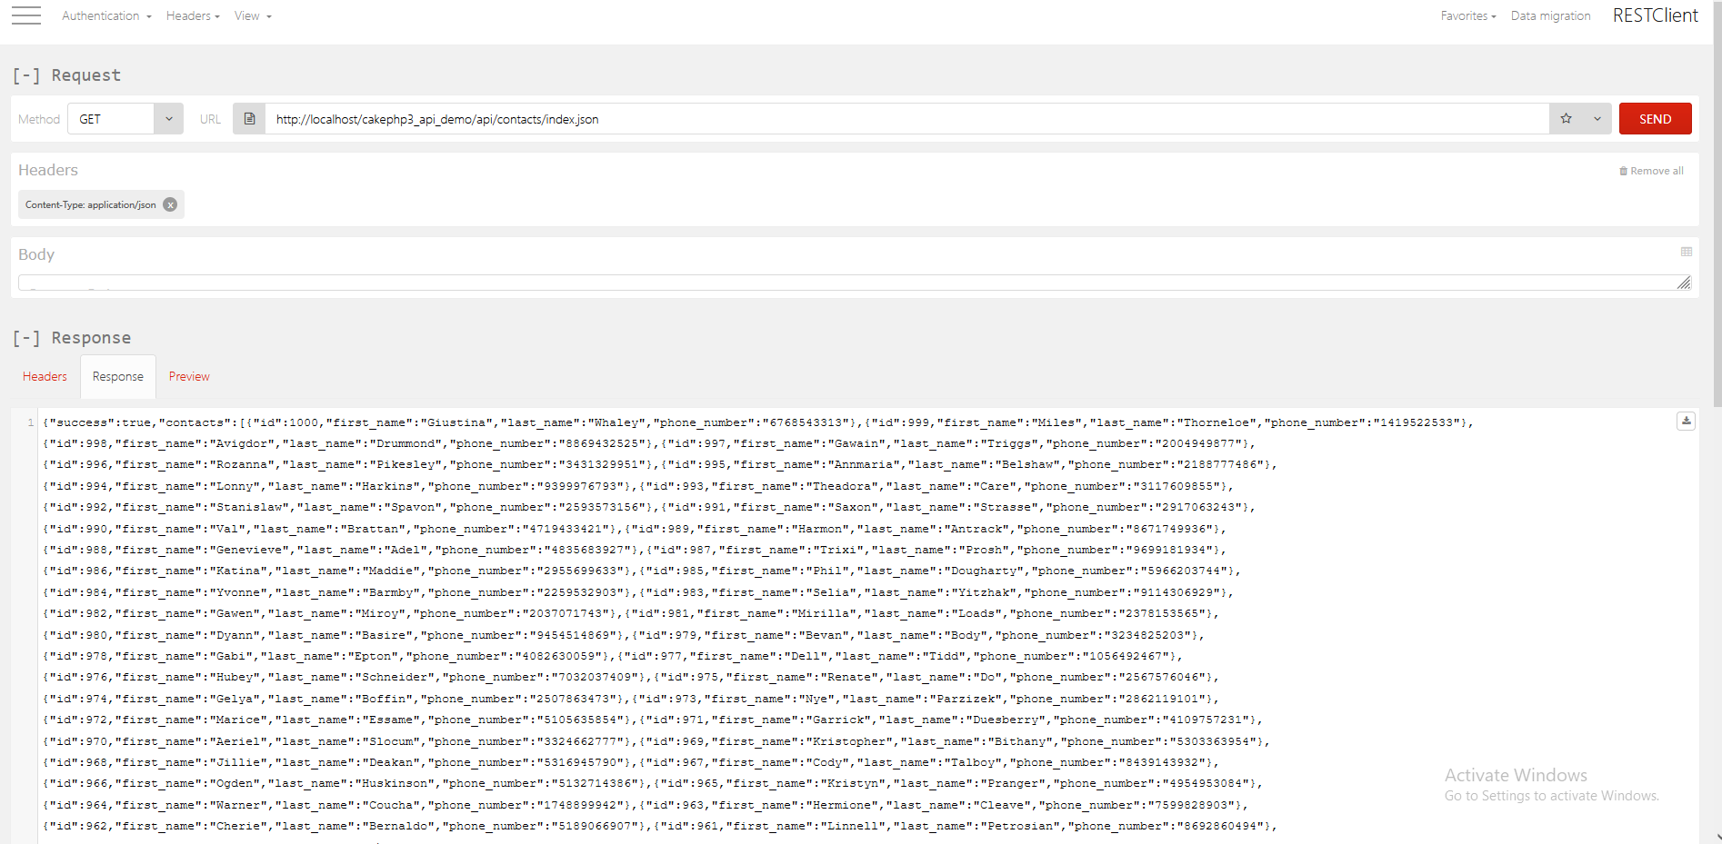

**(2)List of Contacts with company information**

**Url**: http://localhost/cakephp3_api_demo/api/contacts/index_ext.json

**Header:** Content-Type: application/json

**Method**: GET

**Response:**

{"success":true,"contacts":[{"id":1000,"first_name":"Giustina","last_name":"Whaley","phone_number":"6768543313","company":{"id":23,"company_name":"Skinder","address":"43170 Artisan Lane"}},{"id":999,"first_name":"Miles","last_name":"Thorneloe","phone_number":"1419522533","company":{"id":82,"company_name":"Topdrive","address":"3572 Montana Court"}},{"id":998,"first_name":"Avigdor","last_name":"Drummond","phone_number":"8869432525","company":{"id":56,"company_name":"Voomm","address":"58772 Eagle Crest Parkway"}},{"id":997,"first_name":"Gawain","last_name":"Triggs","phone_number":"2004949877","company":{"id":39,"company_name":"Tekfly","address":"23782 Forest Dale Center"}},{"id":996,"first_name":"Rozanna","last_name":"Pikesley","phone_number":"3431329951","company":{"id":30,"company_name":"Quire","address":"972 Prairie Rose Hill"}},{"id":995,"first_name":"Annmaria","last_name":"Belshaw","phone_number":"2188777486","company":{"id":78,"company_name":"Wikibox","address":"98542 Kropf Plaza"}},{"id":994,"first_name":"Lonny","last_name":"Harkins","phone_number":"9399976793","company":{"id":53,"company_name":"Flashdog","address":"19890 Upham Drive"}},{"id":993,"first_name":"Theadora","last_name":"Care","phone_number":"3117609855","company":{"id":20,"company_name":"Skyba","address":"8267 Pleasure Trail"}},{"id":992,"first_name":"Stanislaw","last_name":"Spavon","phone_number":"2593573156","

curl -X GET -H 'Content-Type: application/json' -i 'http://localhost/cakephp3_api_demo/api/contacts/index_ext.json'

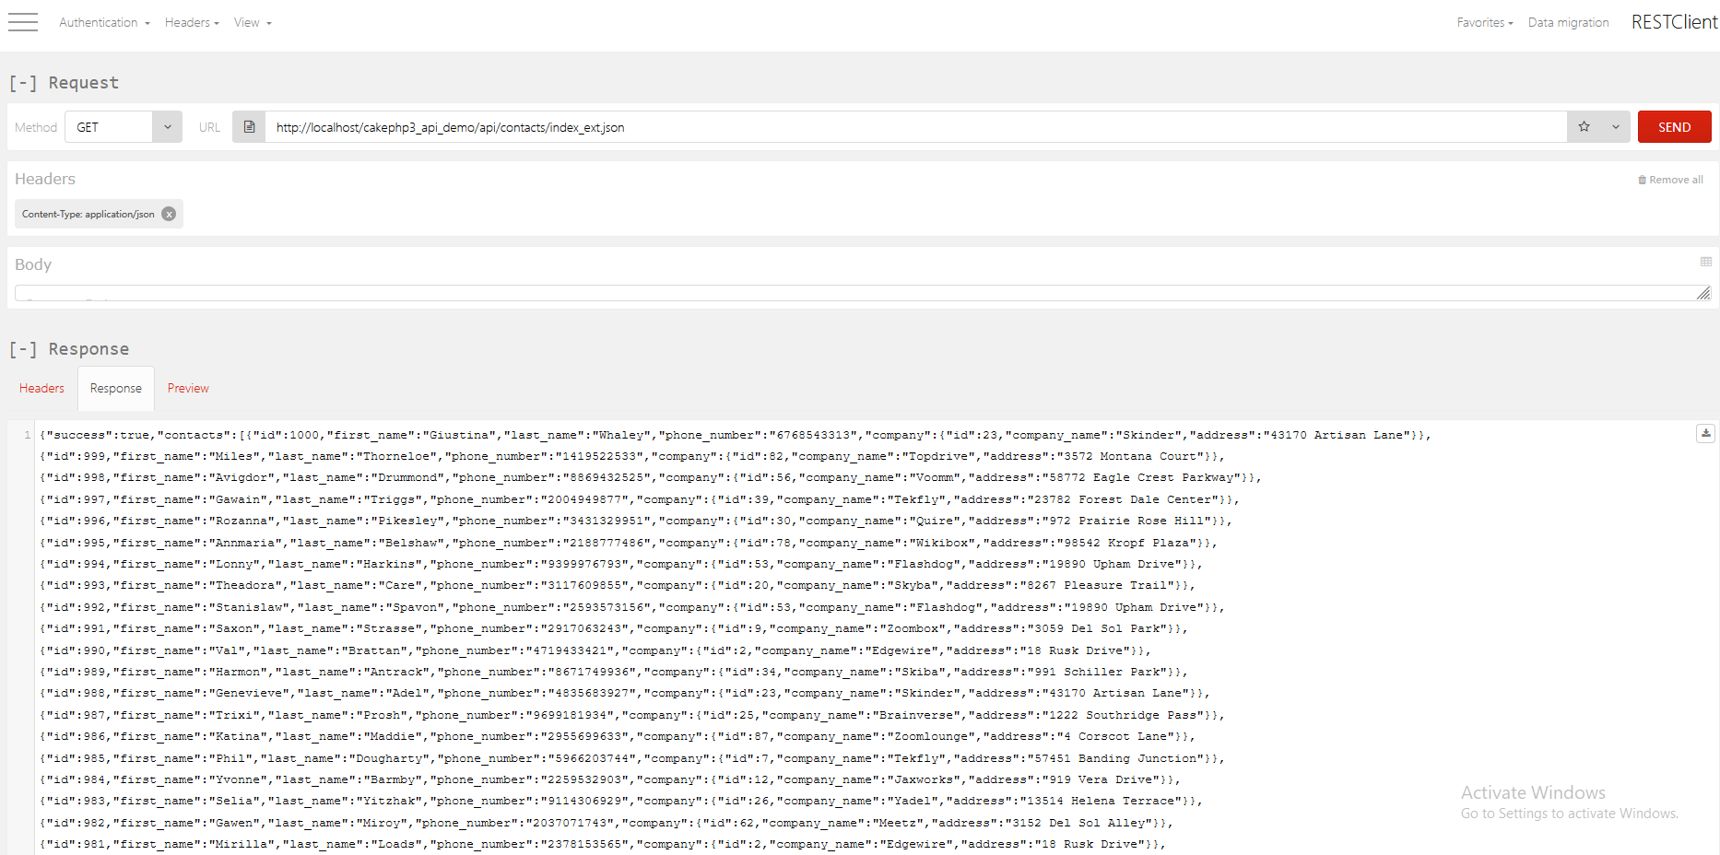

**(3)Add Contact**

**Url**: http://localhost/cakephp3_api_demo/api/contacts/add.json

**Header:** Content-Type: application/json

**Method**: Post

**Request:** When trying to post blank request then validation error will show

**Response:**

{"success":false,"errors":{"first_name":{"_required":"This field is required"},"last_name":{"_required":"This field is required"},"phone_number":{"_required":"This field is required"},"address":{"_required":"This field is required"},"company_id":{"_required":"This field is required"},"notes":{"_required":"This field is required"},"add_notes":{"_required":"This field is required"},"internal_notes":{"_required":"This field is required"},"comments":{"_required":"This field is required"}}}

curl -X POST -H 'Content-Type: application/json' -i 'http://localhost/cakephp3_api_demo/api/contacts/add.json'

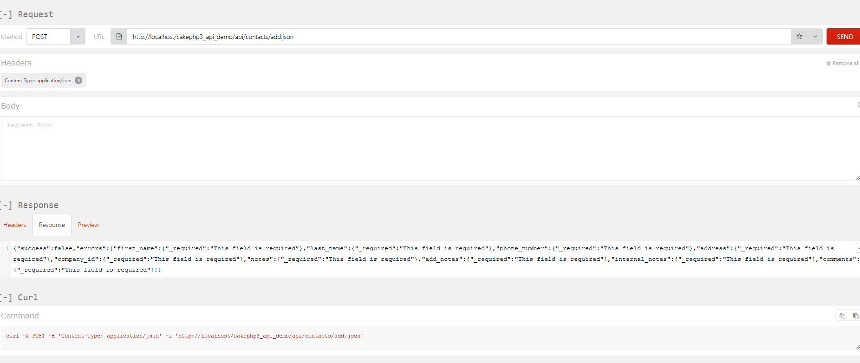

**Request:**

{"success":true,"contact":{"phone_number":"55555555","address":"moti nagar india","company_id":20,"notes":"Lorem Ipsum is simply dummy text of the printing and typesetting","add_notes":"Aldus PageMaker including versions of Lorem Ipsum","internal_notes":"Contrary to popular belief,","comments":"There are many variations of passages of Lorem Ipsum available, but the majority have suffered alteration in some form, by injected humour, or randomised words which don\u0027t look even slightly believable","id":1002}}

**Response:**

{"success":true,"contact":{"phone_number":"55555555","address":"moti nagar india","company_id":20,"notes":"Lorem Ipsum is simply dummy text of the printing and typesetting","add_notes":"Aldus PageMaker including versions of Lorem Ipsum","internal_notes":"Contrary to popular belief,","comments":"There are many variations of passages of Lorem Ipsum available, but the majority have suffered alteration in some form, by injected humour, or randomised words which don\u0027t look even slightly believable","id":1002}}

curl -X POST -H 'Content-Type: application/json' -i 'http://localhost/cakephp3_api_demo/api/contacts/add.json' --data '{"first_name":"khemit","last_name":"verma","phone_number":"55555555","address":"moti nagar india","company_id":"20","notes":"Lorem Ipsum is simply dummy text of the printing and typesetting","add_notes":"Aldus PageMaker including versions of Lorem Ipsum","internal_notes":"Contrary to popular belief,","comments":"There are many variations of passages of Lorem Ipsum available, but the majority have suffered alteration in some form, by injected humour, or randomised words which don'\''t look even slightly believable"}'

