Saturday.com — Hype Reel Storyboard (17 scenes · 2:50)
17 scenes × 10 seconds = 2:50 total. Re-watched the monday.com reference clip closely for this pass — its signature move is short flat-purple "chapter card" bumpers (e.g. "Let's dive in!", "Ask us anything") dropped between clusters of feature shots to reset energy and reinforce brand color throughout, not just at the open/close. Scenes 8 and 13 are new purple bumper beats built the same way, marked BUMPER in the first column. One single brand purple (#6256F8, sampled from the app) is used consistently across every Grok scene, and a small Narai Hospitality Group badge now appears in every single scene.
Voiceover column now includes both the English take (for recording) and a Thai translation underneath (for reference or a Thai-language cut) — record whichever language the final video needs, in the same fun, energetic, hype-video tone. Focus: core project management features (boards, items, status, priority, groups, sub-items, people, views, importing from Monday.com, updates with emoji/GIF/replies, real-time sync, filtering), closing with a Narai Hospitality Group brand card. Scene 12 shows two desktop/browser screens only — no phone mockup, since Saturday.com has no mobile app yet. Scene 17 is intentionally the one exception to the purple theme — it uses Narai's own dark green, as the closing "powered by" card, built from the real Narai logo mark pulled from the Saturday.com codebase.
Scene / Time | Topic | Reference Image | Grok Prompt (copy → paste into Grok) | Voiceover (English / ไทย) | Link
Scene 1  0:00–0:10 | เปิดเรื่อง แนะนำแบรนด์ Saturday.com อย่างมีพลัง | 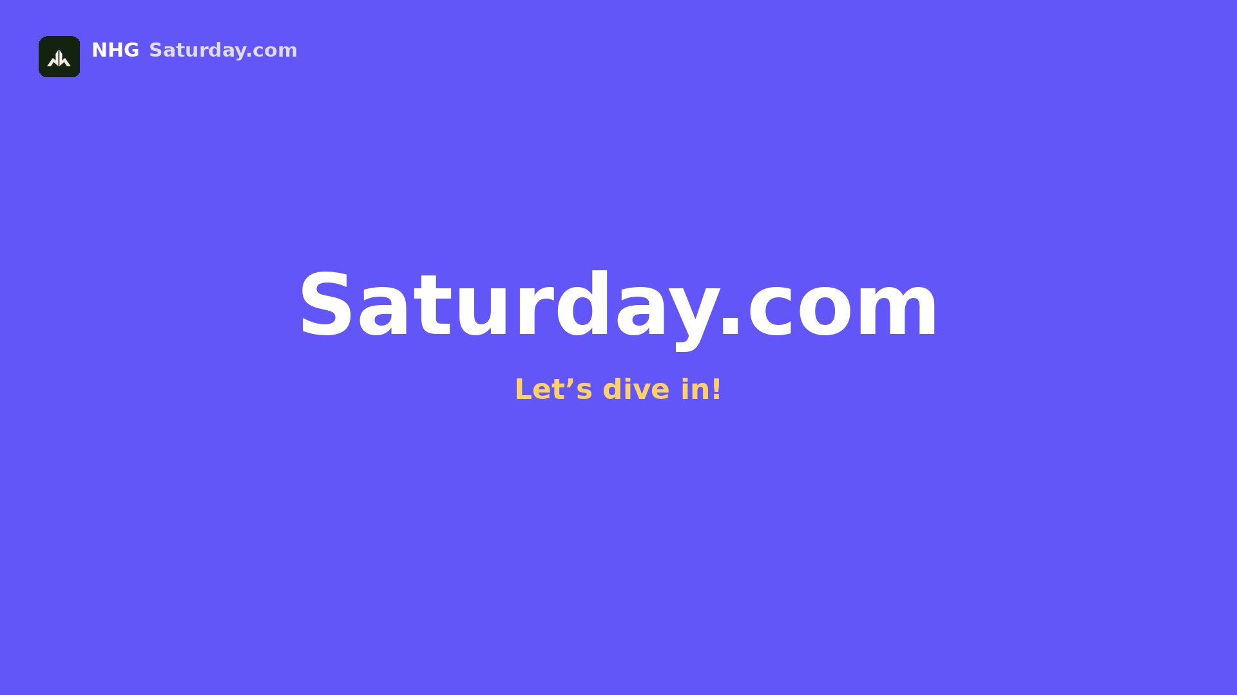 | Flat solid brand-purple background (#6256F8, no gradient) fills the frame, with two soft oversized circles drifting slowly in the far corners for depth. A bold white wordmark ‘Saturday.com’ bounces in energetically from below with a punchy overshoot-and-settle, snapping into place center-frame with a quick flash of light. A beat later, a bright yellow tagline ‘Let’s dive in!’ pops in underneath with a small bounce, and the small dark-green NHG badge (top-left) gives a quick confident pop-in of its own, tying the whole brand together from frame one. Consistent energetic visual style across the whole series: flat 2D SaaS motion-graphic look with a fun, upbeat feel — snappy pops, playful bounces, and confident quick-eased motion that never feels slow or corporate-stiff, one single solid brand purple (#6256F8) — no gradients — paired with white, green (#00C875) / orange (#FDAB3D) / red (#E2445C) accent status pills, rounded 12px cards with soft drop shadows, plain gray placeholder bars standing in for on-screen text (no dense readable text), a small glowing white cursor dot marks every click or drag with a satisfying pop and a tiny burst of motion lines, a small dark-green Narai Hospitality Group (NHG) logo badge sits quietly in the top-left corner throughout for consistent brand presence, 16:9 aspect ratio, no photorealistic humans, no camera shake, clean bright studio-lit look with an exciting, high-energy feel. | “Say hello to Saturday.com — the brand-new project management tool that's about to make your whole team excited to get things done, together!”  ทักทาย Saturday.com เครื่องมือบริหารโปรเจกต์ตัวใหม่ล่าสุด ที่จะทำให้ทั้งทีมของคุณสนุกกับการทำงานให้สำเร็จไปด้วยกัน! | Open full image  scene01_intro.png
Scene 2  0:10–0:20 | ภาพรวม Workspace และ Board | 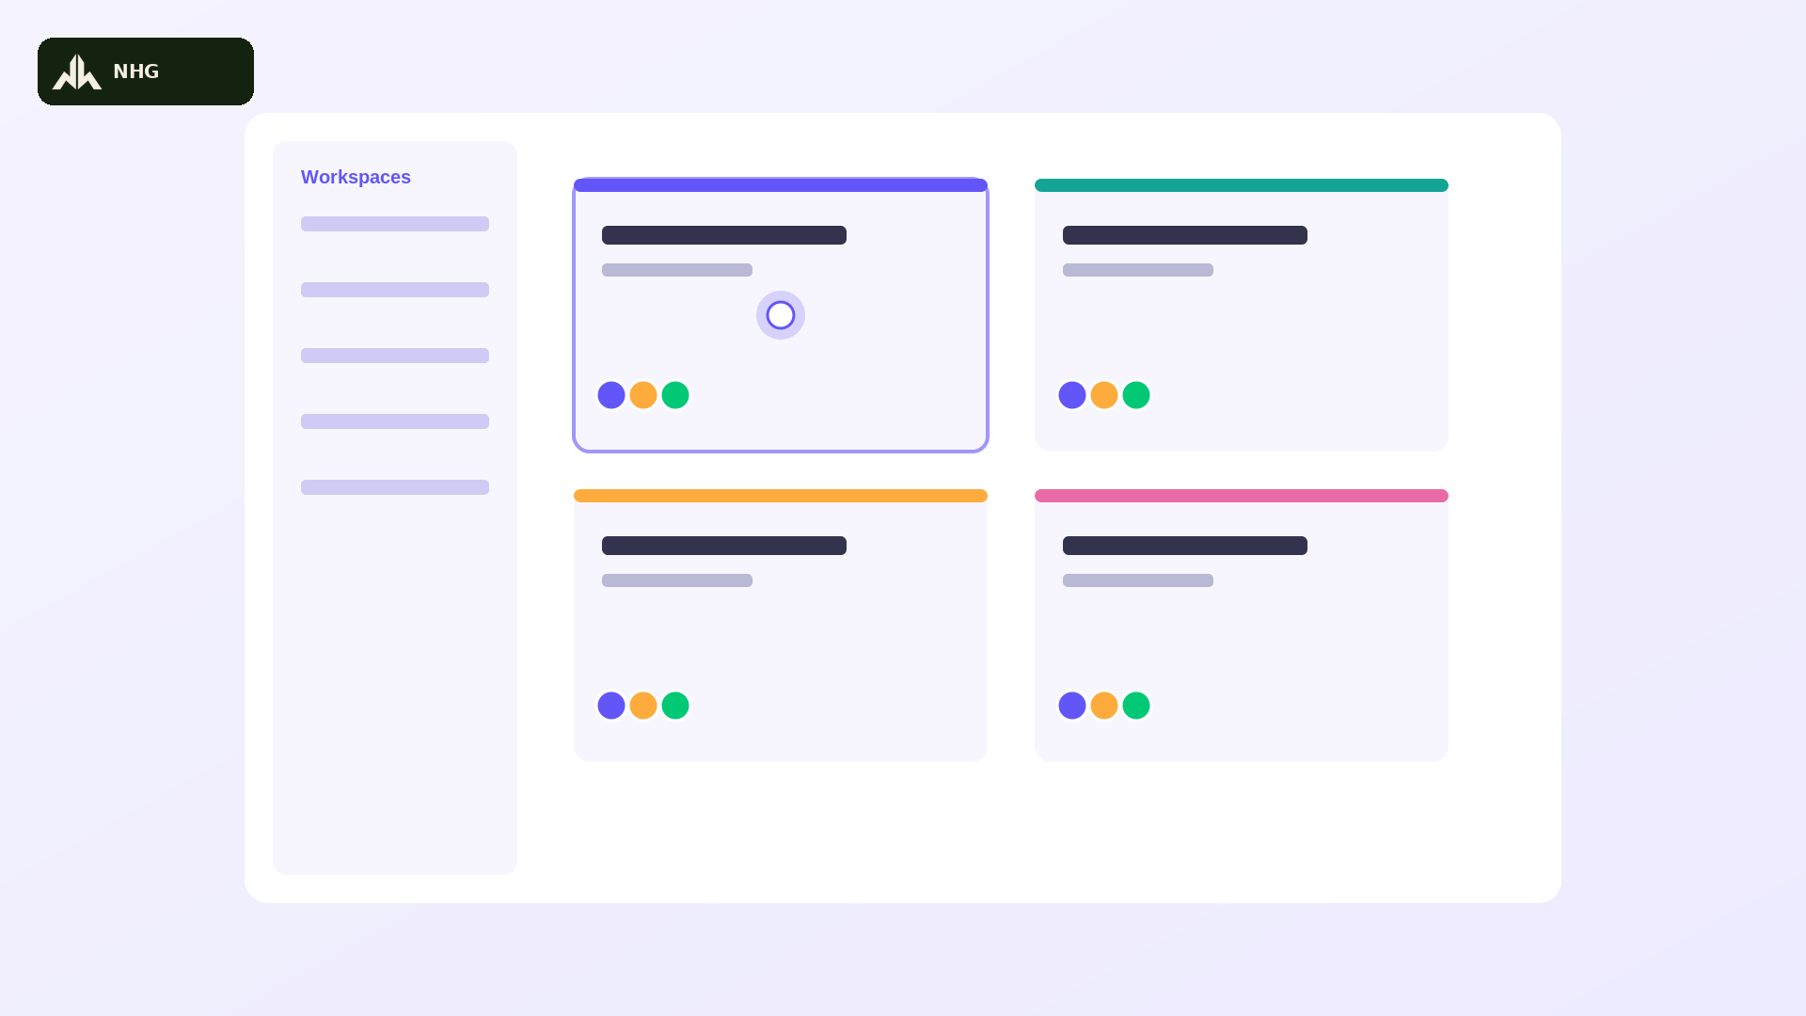 | A left sidebar lists workspace and board names as rounded gray placeholder bars on a white background, with the small NHG badge fixed top-left. The main panel shows a lively grid of board cards, each with a colored top-accent bar (brand purple #6256F8 on the featured card), popping into frame one after another with a quick staggered bounce. The glowing white cursor dot zips in from the left, hovers over the featured board card, and clicks it with a snappy pop — the card scales up energetically and the screen whip-transitions into a table view. Consistent energetic visual style across the whole series: flat 2D SaaS motion-graphic look with a fun, upbeat feel — snappy pops, playful bounces, and confident quick-eased motion that never feels slow or corporate-stiff, one single solid brand purple (#6256F8) — no gradients — paired with white, green (#00C875) / orange (#FDAB3D) / red (#E2445C) accent status pills, rounded 12px cards with soft drop shadows, plain gray placeholder bars standing in for on-screen text (no dense readable text), a small glowing white cursor dot marks every click or drag with a satisfying pop and a tiny burst of motion lines, a small dark-green Narai Hospitality Group (NHG) logo badge sits quietly in the top-left corner throughout for consistent brand presence, 16:9 aspect ratio, no photorealistic humans, no camera shake, clean bright studio-lit look with an exciting, high-energy feel. | “Every project gets its own board, instantly organized by workspace — so your team jumps straight into the action, no digging around required!”  ทุกโปรเจกต์มีบอร์ดของตัวเอง จัดระเบียบตาม Workspace ทันที ทีมของคุณเริ่มงานได้เลยโดยไม่ต้องเสียเวลาค้นหา! | Open full image  scene02_boards.png
Scene 3  0:20–0:30 | นำเข้าบอร์ดจาก Monday.com ได้ทันที | 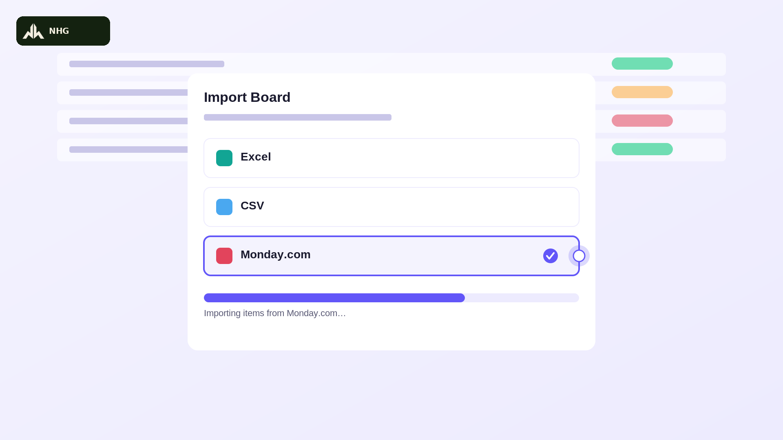 | An ‘Import Board’ modal card pops onto the screen with a quick energetic bounce, sitting centered over a softly blurred, already-populated table in the background, small NHG badge visible top-left. Inside the modal, a bold title reads ‘Import Board’ above three horizontal source-option rows: ‘Excel’ with a teal icon, ‘CSV’ with a blue icon, and ‘Monday.com’ with a red icon — the cursor dot zips straight to the Monday.com row, clicks it, and a brand-purple (#6256F8) outline and checkmark badge snap on with a satisfying pop. A progress bar fills left-to-right at a brisk, confident pace above a caption reading ‘Importing items from Monday.com…’, finishing with a bright green checkmark burst. Consistent energetic visual style across the whole series: flat 2D SaaS motion-graphic look with a fun, upbeat feel — snappy pops, playful bounces, and confident quick-eased motion that never feels slow or corporate-stiff, one single solid brand purple (#6256F8) — no gradients — paired with white, green (#00C875) / orange (#FDAB3D) / red (#E2445C) accent status pills, rounded 12px cards with soft drop shadows, plain gray placeholder bars standing in for on-screen text (no dense readable text), a small glowing white cursor dot marks every click or drag with a satisfying pop and a tiny burst of motion lines, a small dark-green Narai Hospitality Group (NHG) logo badge sits quietly in the top-left corner throughout for consistent brand presence, 16:9 aspect ratio, no photorealistic humans, no camera shake, clean bright studio-lit look with an exciting, high-energy feel. | “Switching over? Import your boards straight from Monday.com in minutes — every task, every status, ready to go from day one!”  ย้ายมาจากที่อื่น? นำเข้าบอร์ดจาก Monday.com ได้ในไม่กี่นาที ครบทั้งงานและสถานะ พร้อมใช้งานตั้งแต่วันแรก! | Open full image  scene03_import_monday.png
Scene 4  0:30–0:40 | หน้า Main Table ดูสถานะงานทั้งหมด | 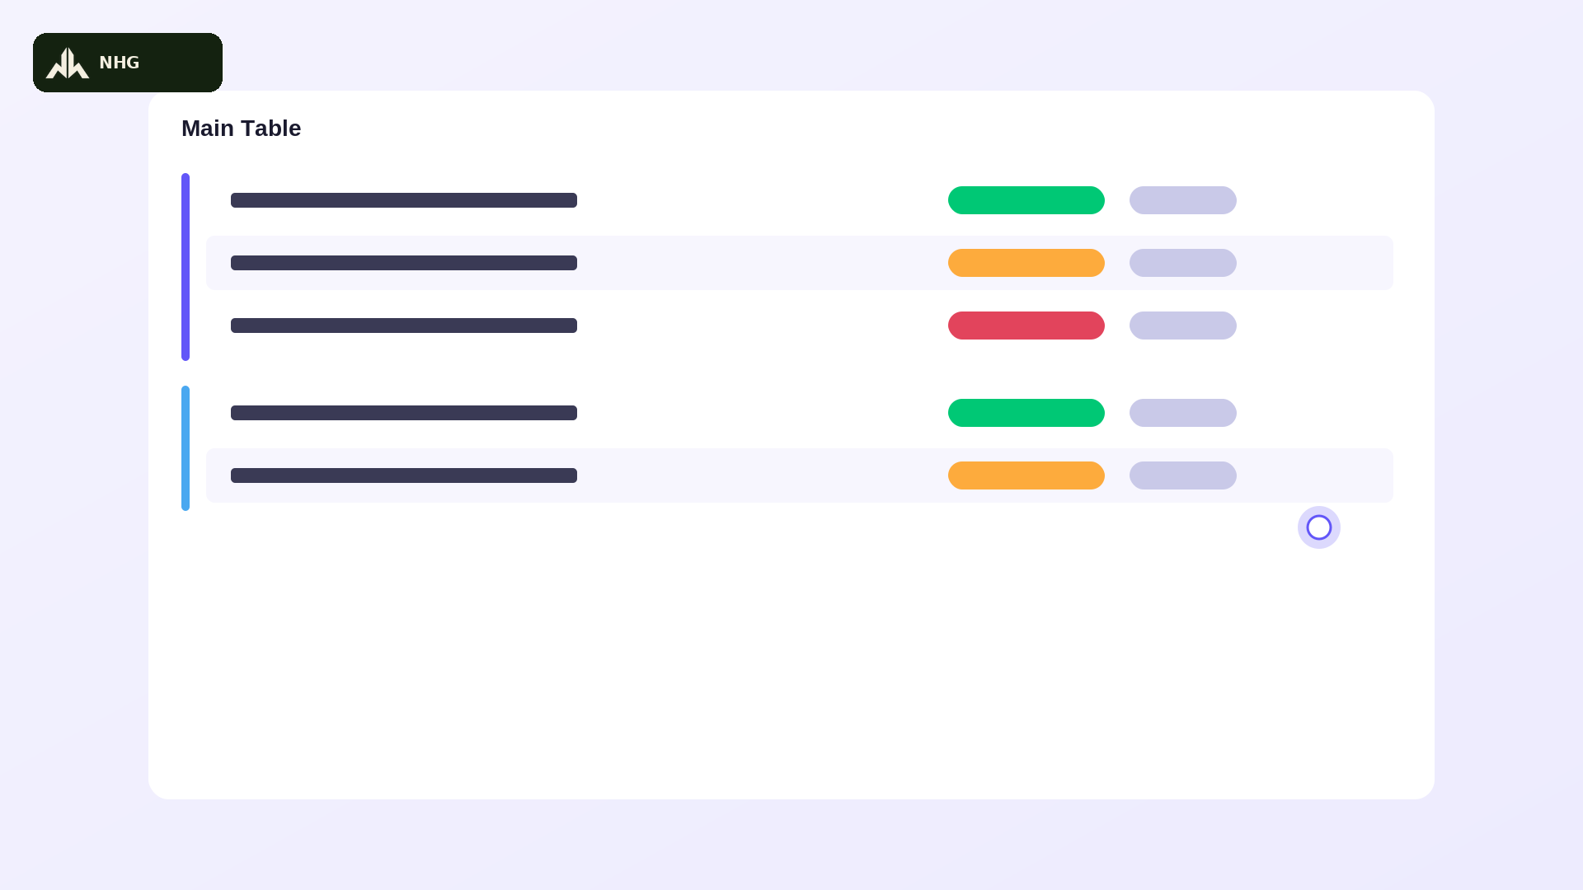 | A clean table interface with the small NHG badge top-left: colored vertical group bars on the left (brand purple #6256F8, then blue), each with rows beneath it snapping into place one after another with a quick playful bounce. Every row has a rounded colored status pill (green ‘Done’, orange ‘Working on it’, red ‘Stuck’) that pops with a tiny flash as it appears, plus a smaller priority pill beside it. The white cursor dot scrolls briskly down the list with energetic momentum as new rows keep popping in from below. Consistent energetic visual style across the whole series: flat 2D SaaS motion-graphic look with a fun, upbeat feel — snappy pops, playful bounces, and confident quick-eased motion that never feels slow or corporate-stiff, one single solid brand purple (#6256F8) — no gradients — paired with white, green (#00C875) / orange (#FDAB3D) / red (#E2445C) accent status pills, rounded 12px cards with soft drop shadows, plain gray placeholder bars standing in for on-screen text (no dense readable text), a small glowing white cursor dot marks every click or drag with a satisfying pop and a tiny burst of motion lines, a small dark-green Narai Hospitality Group (NHG) logo badge sits quietly in the top-left corner throughout for consistent brand presence, 16:9 aspect ratio, no photorealistic humans, no camera shake, clean bright studio-lit look with an exciting, high-energy feel. | “One glance at the main table and you'll see everything — status, priority, progress — color-coded, organized, and impossible to miss!”  แค่มองหน้า Main Table เดียว ก็เห็นทุกอย่าง ทั้งสถานะ ความสำคัญ และความคืบหน้า จัดสีชัดเจน มองไม่พลาดแน่นอน! | Open full image  scene03_maintable.png
Scene 5  0:40–0:50 | เพิ่มงานใหม่ และอัปเดตสถานะ | 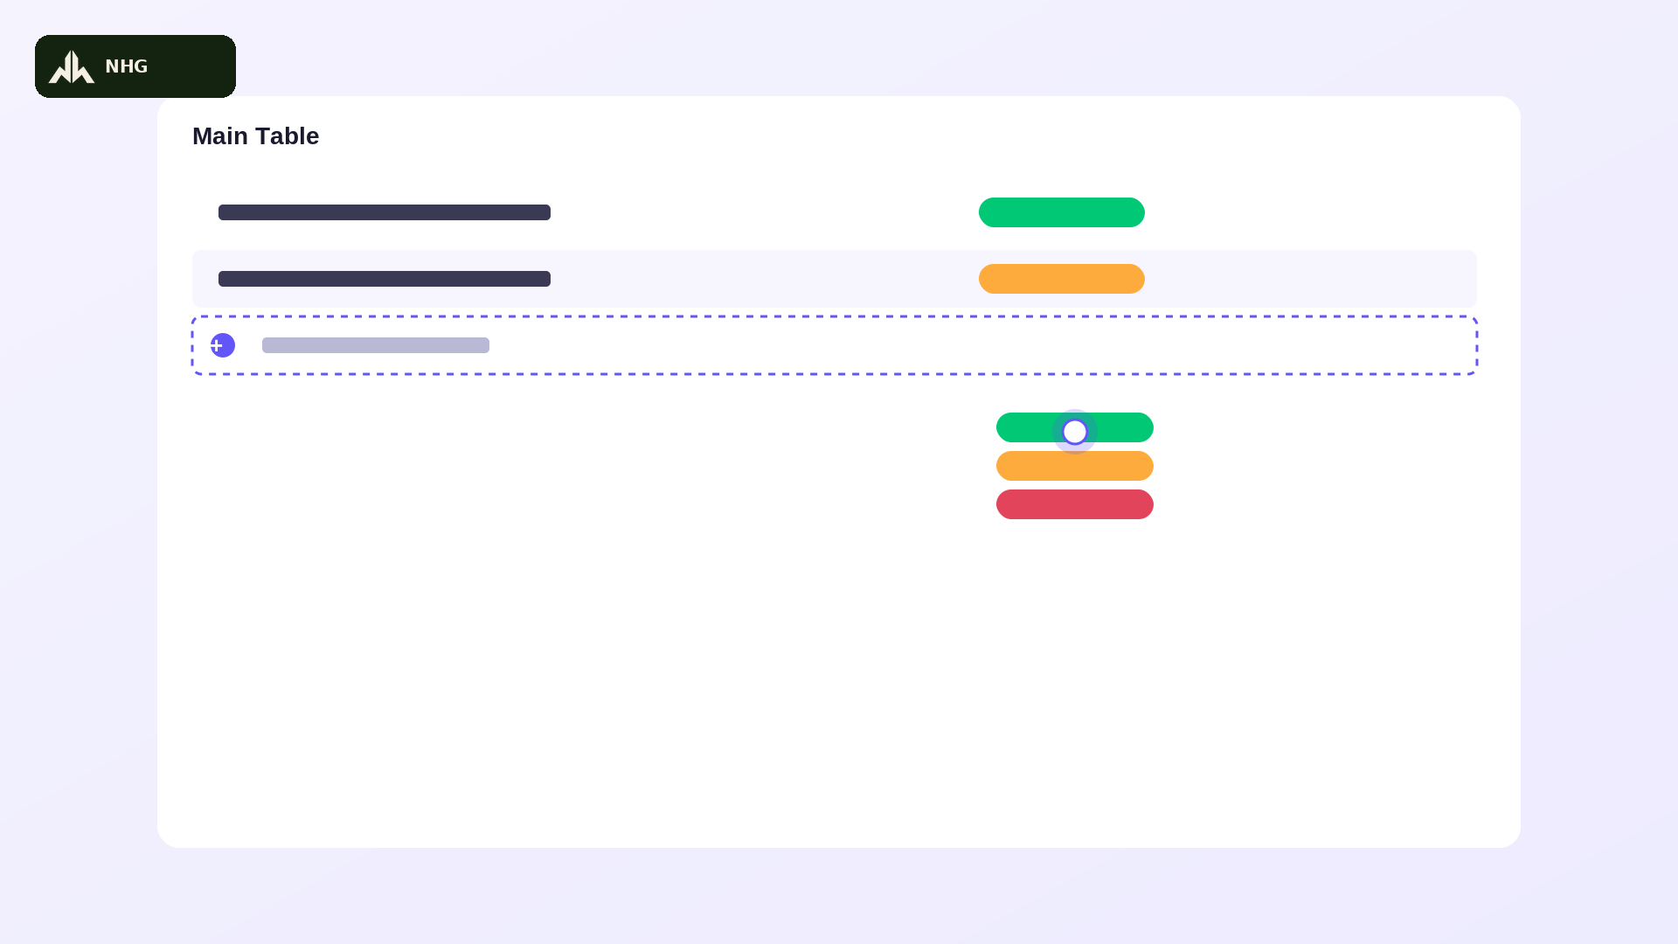 | On the same table interface (NHG badge top-left), the cursor dot zips down and clicks a ‘+ Add item’ row with a snappy pop; a new row slides in fast and a gray placeholder text bar fills in left-to-right at a brisk, satisfying pace, finishing with a quick flash. The cursor then darts to a status pill on another row, a dropdown of colored pill options springs open with a playful bounce, and the cursor confidently taps the green ‘Done’ pill, which snaps into place with a bright pop and a tiny celebratory sparkle. Consistent energetic visual style across the whole series: flat 2D SaaS motion-graphic look with a fun, upbeat feel — snappy pops, playful bounces, and confident quick-eased motion that never feels slow or corporate-stiff, one single solid brand purple (#6256F8) — no gradients — paired with white, green (#00C875) / orange (#FDAB3D) / red (#E2445C) accent status pills, rounded 12px cards with soft drop shadows, plain gray placeholder bars standing in for on-screen text (no dense readable text), a small glowing white cursor dot marks every click or drag with a satisfying pop and a tiny burst of motion lines, a small dark-green Narai Hospitality Group (NHG) logo badge sits quietly in the top-left corner throughout for consistent brand presence, 16:9 aspect ratio, no photorealistic humans, no camera shake, clean bright studio-lit look with an exciting, high-energy feel. | “Adding a task takes seconds. Update its status with one satisfying click — working on it, stuck, or done — boom, everyone's in sync!”  เพิ่มงานใหม่ใช้เวลาแค่ไม่กี่วินาที อัปเดตสถานะด้วยคลิกเดียว กำลังทำ ติดปัญหา หรือเสร็จแล้ว ทุกคนรับรู้พร้อมกันทันที! | Open full image  scene04_additem.png
Scene 6  0:50–1:00 | แตกงานย่อย (Sub-item) | 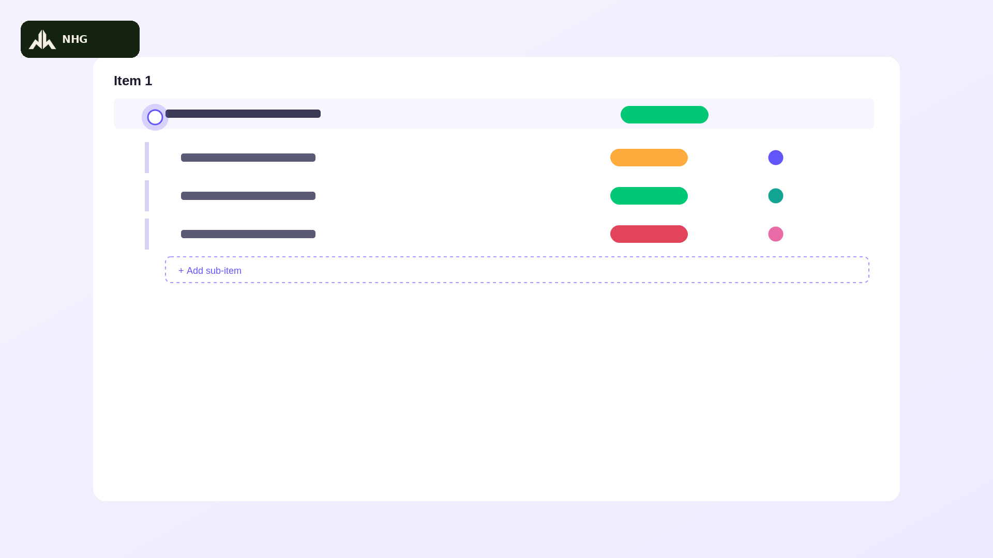 | The cursor dot taps a chevron arrow beside a table row (NHG badge top-left) with a quick pop; the row expands downward energetically, snapping open to reveal three indented sub-rows in fast succession, each popping in with its own smaller status pill and a tiny colored avatar circle. A fourth faint ‘add sub-item’ ghost row bounces in at the bottom, inviting the next click. Consistent energetic visual style across the whole series: flat 2D SaaS motion-graphic look with a fun, upbeat feel — snappy pops, playful bounces, and confident quick-eased motion that never feels slow or corporate-stiff, one single solid brand purple (#6256F8) — no gradients — paired with white, green (#00C875) / orange (#FDAB3D) / red (#E2445C) accent status pills, rounded 12px cards with soft drop shadows, plain gray placeholder bars standing in for on-screen text (no dense readable text), a small glowing white cursor dot marks every click or drag with a satisfying pop and a tiny burst of motion lines, a small dark-green Narai Hospitality Group (NHG) logo badge sits quietly in the top-left corner throughout for consistent brand presence, 16:9 aspect ratio, no photorealistic humans, no camera shake, clean bright studio-lit look with an exciting, high-energy feel. | “Break big goals into bite-sized sub-items — each with its own owner and deadline — so nothing ever slips through the cracks!”  แตกเป้าหมายใหญ่ให้เป็นงานย่อยๆ แต่ละงานมีเจ้าของและกำหนดส่งชัดเจน ไม่มีงานไหนตกหล่นแน่นอน! | Open full image  scene05_subitems.png
Scene 7  1:00–1:10 | มอบหมายผู้รับผิดชอบงาน (People) | 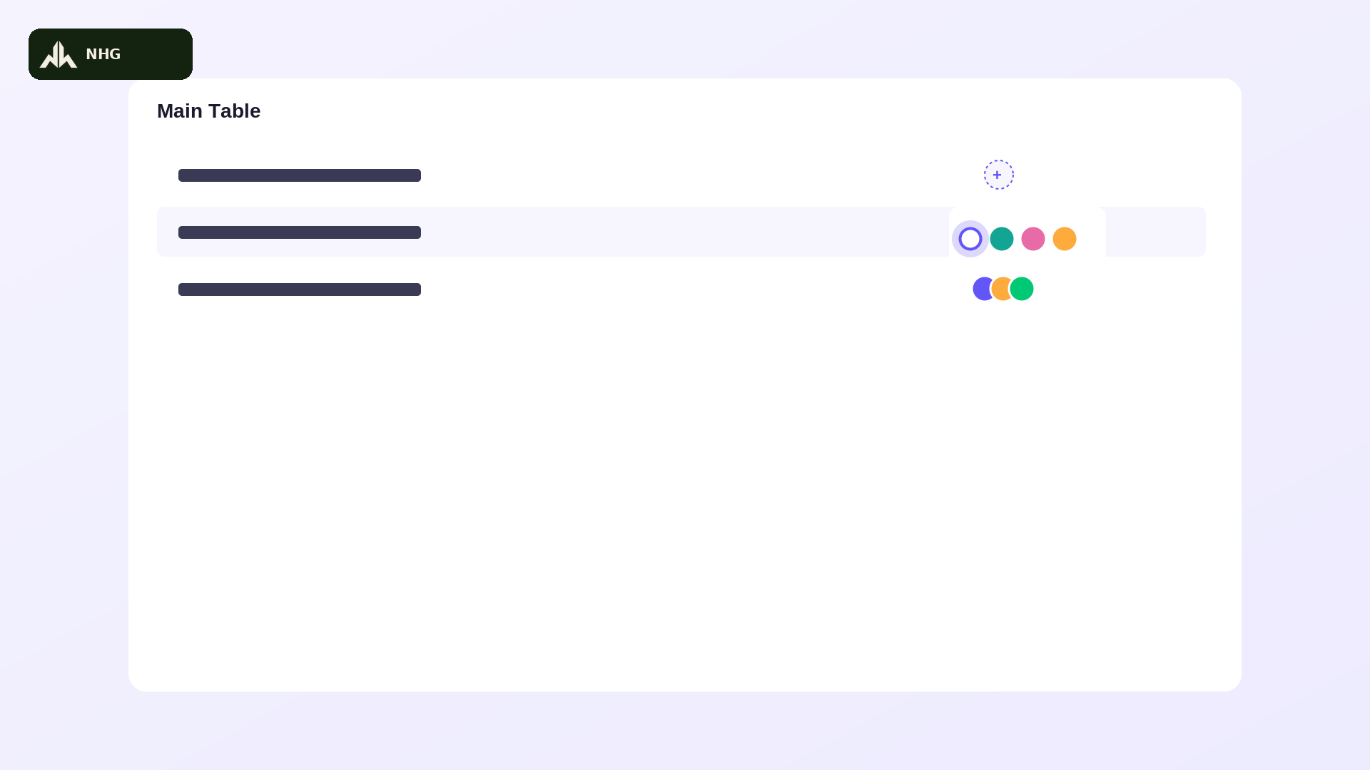 | The cursor dot clicks a circular ‘+’ avatar icon inside a table row (NHG badge top-left); a small rounded panel of plain colored avatar circles pops up above the row with a quick bounce. The cursor confidently picks one, it animates into the row with a satisfying snap, and the camera pulls back with a brisk zoom to reveal a lively stacked cluster of overlapping avatar circles building up on a group summary row, one popping in after another. Consistent energetic visual style across the whole series: flat 2D SaaS motion-graphic look with a fun, upbeat feel — snappy pops, playful bounces, and confident quick-eased motion that never feels slow or corporate-stiff, one single solid brand purple (#6256F8) — no gradients — paired with white, green (#00C875) / orange (#FDAB3D) / red (#E2445C) accent status pills, rounded 12px cards with soft drop shadows, plain gray placeholder bars standing in for on-screen text (no dense readable text), a small glowing white cursor dot marks every click or drag with a satisfying pop and a tiny burst of motion lines, a small dark-green Narai Hospitality Group (NHG) logo badge sits quietly in the top-left corner throughout for consistent brand presence, 16:9 aspect ratio, no photorealistic humans, no camera shake, clean bright studio-lit look with an exciting, high-energy feel. | “Assign the right person in one click, and instantly see who owns what — total clarity, zero confusion, across your entire team!”  มอบหมายงานให้คนที่ใช่ได้ในคลิกเดียว เห็นชัดเจนว่าใครรับผิดชอบอะไร ไม่มีความสับสนทั่วทั้งทีม! | Open full image  scene06_people.png
Scene 8  1:10–1:20  BUMPER | ช่วงเชื่อม: ดูงานได้ในมุมมองที่ทีมถนัด | 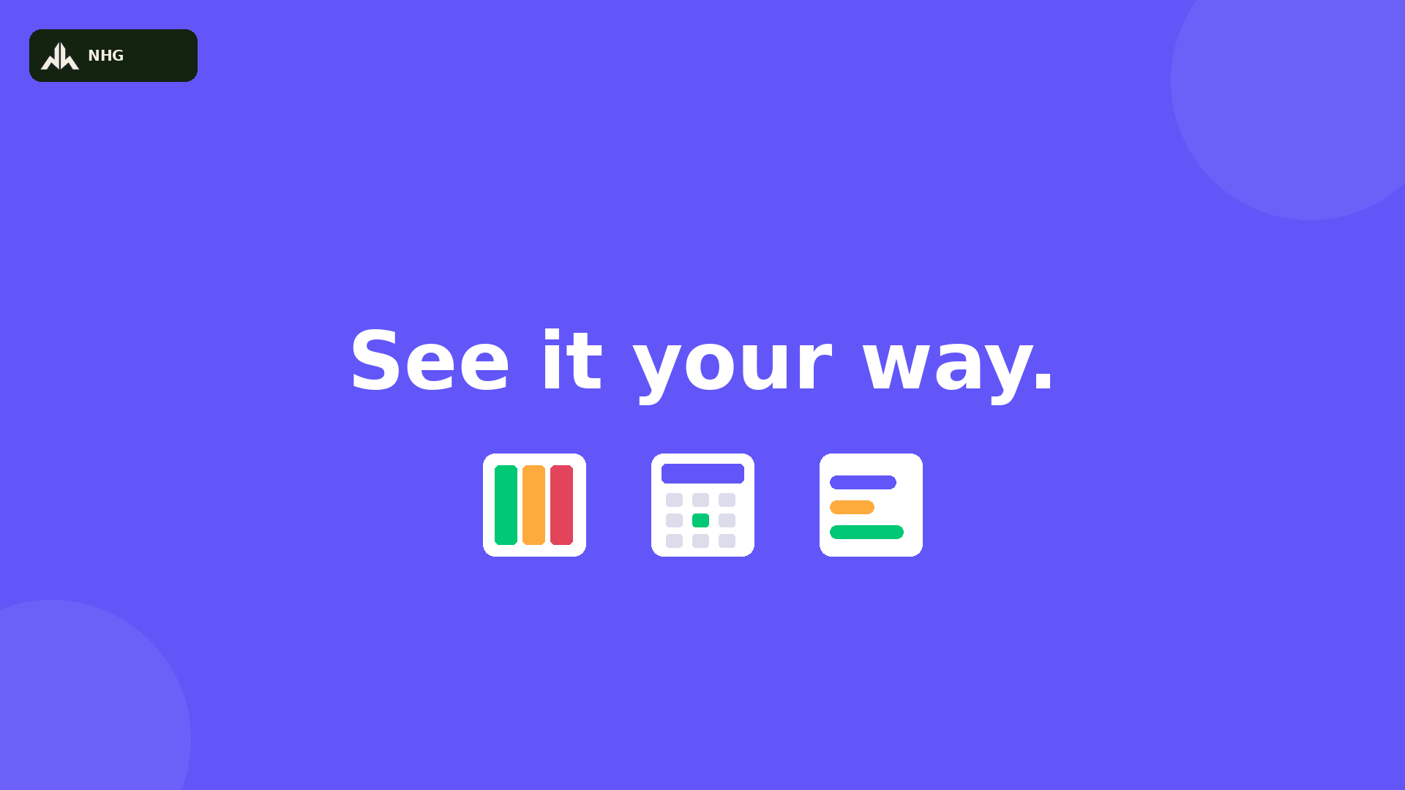 | No Grok generation required if reusing the provided reference image directly — otherwise generate to match exactly: flat solid brand-purple background (#6256F8, no gradient) fills the frame, small NHG badge top-left. Bold white text ‘See it your way.’ bounces in energetically center-frame with a confident overshoot-and-settle. A beat later, three small white rounded icon cards pop up in a row beneath the text one after another with a playful bounce — a colorful kanban-column icon, a calendar-grid icon, and a timeline-bars icon — each landing with a quick flash. Frame holds on a bright, confident final beat. Consistent energetic visual style across the whole series: flat 2D SaaS motion-graphic look with a fun, upbeat feel — snappy pops, playful bounces, and confident quick-eased motion that never feels slow or corporate-stiff, one single solid brand purple (#6256F8) — no gradients — paired with white, green (#00C875) / orange (#FDAB3D) / red (#E2445C) accent status pills, rounded 12px cards with soft drop shadows, plain gray placeholder bars standing in for on-screen text (no dense readable text), a small glowing white cursor dot marks every click or drag with a satisfying pop and a tiny burst of motion lines, a small dark-green Narai Hospitality Group (NHG) logo badge sits quietly in the top-left corner throughout for consistent brand presence, 16:9 aspect ratio, no photorealistic humans, no camera shake, clean bright studio-lit look with an exciting, high-energy feel. | “However you like to work — boards, Kanban, Timeline, or Calendar — Saturday.com bends to fit your team, your way!”  ไม่ว่าทีมคุณจะถนัดแบบไหน บอร์ด Kanban Timeline หรือ Calendar Saturday.com ปรับให้เข้ากับทีมคุณได้เสมอ! | Open full image  divider01_seeyourway.png
Scene 9  1:20–1:30 | มุมมอง Kanban ลากงานข้ามคอลัมน์ | 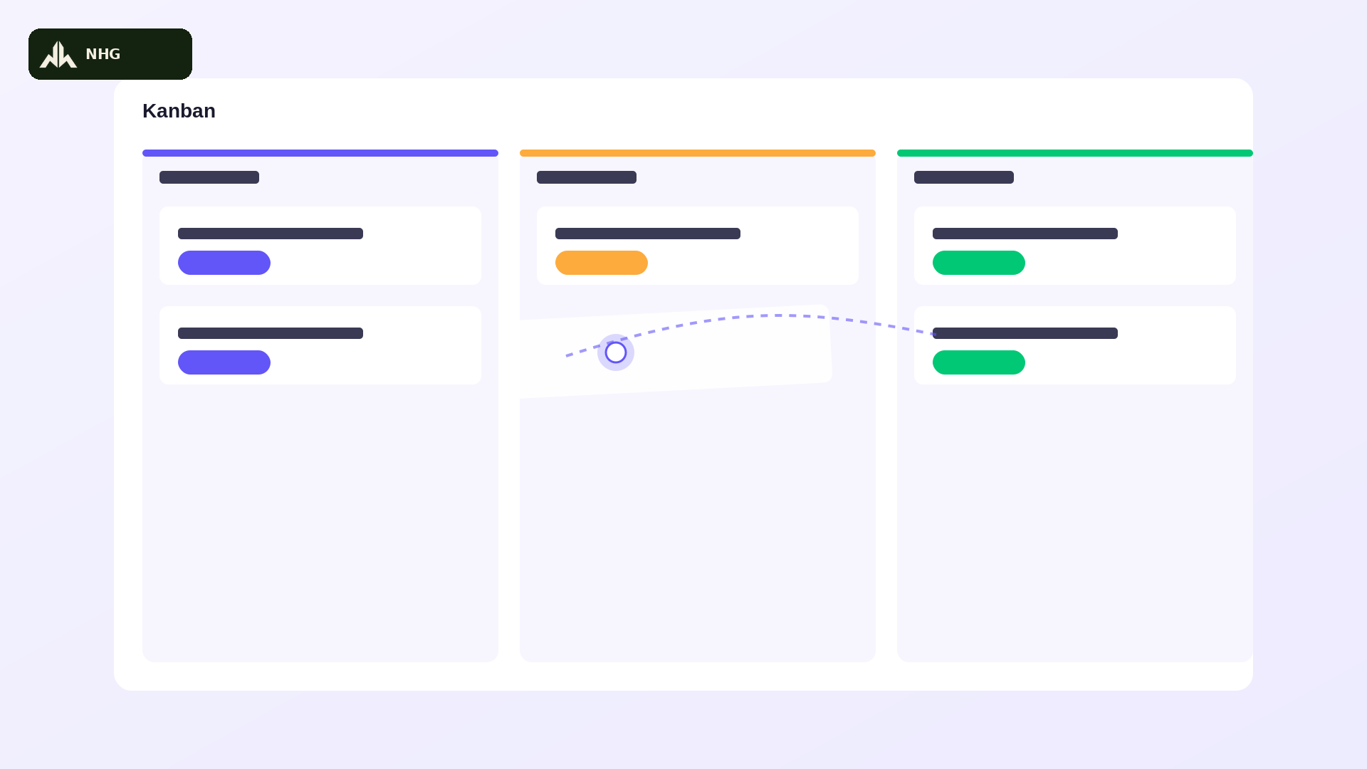 | The interface whip-transitions from a table into a kanban board of three vertical columns (NHG badge top-left), each with a colored header bar (the first in brand purple #6256F8) popping in with a quick bounce. Rounded card tiles snap into each column one after another. The cursor dot grabs a card from the middle column with a confident pop and drags it briskly into the rightmost column, dropping it in with a springy bounce as the column's count badge ticks up with a celebratory little flash. Consistent energetic visual style across the whole series: flat 2D SaaS motion-graphic look with a fun, upbeat feel — snappy pops, playful bounces, and confident quick-eased motion that never feels slow or corporate-stiff, one single solid brand purple (#6256F8) — no gradients — paired with white, green (#00C875) / orange (#FDAB3D) / red (#E2445C) accent status pills, rounded 12px cards with soft drop shadows, plain gray placeholder bars standing in for on-screen text (no dense readable text), a small glowing white cursor dot marks every click or drag with a satisfying pop and a tiny burst of motion lines, a small dark-green Narai Hospitality Group (NHG) logo badge sits quietly in the top-left corner throughout for consistent brand presence, 16:9 aspect ratio, no photorealistic humans, no camera shake, clean bright studio-lit look with an exciting, high-energy feel. | “Love a visual flow? Flip to Kanban and drag tasks across your pipeline — watch your team's momentum build, right before your eyes!”  ชอบดูงานแบบภาพรวม? สลับไปที่ Kanban แล้วลากงานข้ามคอลัมน์ได้เลย เห็นทีมคุณเดินหน้าไปพร้อมกันแบบสดๆ! | Open full image  scene07_kanban.png
Scene 10  1:30–1:40 | มุมมอง Timeline วางแผนงานตามช่วงเวลา | 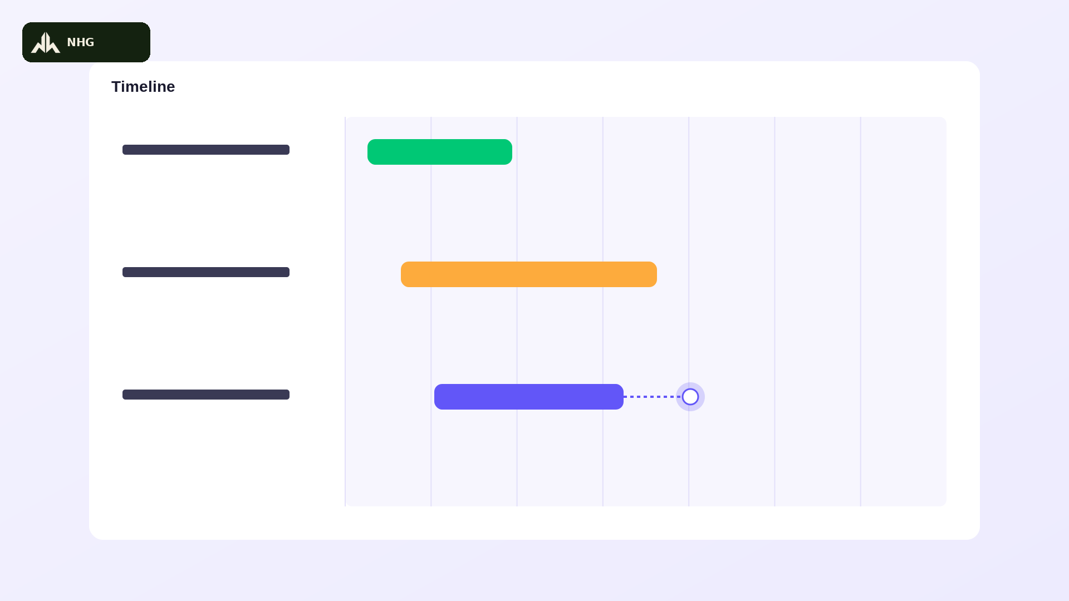 | The interface transitions briskly into a timeline layout (NHG badge top-left): a vertical list of task-name placeholder bars on the left, and horizontal colored bars (including brand purple #6256F8) snapping across a light-gridded date axis on the right, each popping into place with a quick bounce. The cursor dot grabs the right edge of one bar with a confident pop and drags it further right at a lively pace, extending its length while a thin connector line to the next bar updates instantly with a small flash. Consistent energetic visual style across the whole series: flat 2D SaaS motion-graphic look with a fun, upbeat feel — snappy pops, playful bounces, and confident quick-eased motion that never feels slow or corporate-stiff, one single solid brand purple (#6256F8) — no gradients — paired with white, green (#00C875) / orange (#FDAB3D) / red (#E2445C) accent status pills, rounded 12px cards with soft drop shadows, plain gray placeholder bars standing in for on-screen text (no dense readable text), a small glowing white cursor dot marks every click or drag with a satisfying pop and a tiny burst of motion lines, a small dark-green Narai Hospitality Group (NHG) logo badge sits quietly in the top-left corner throughout for consistent brand presence, 16:9 aspect ratio, no photorealistic humans, no camera shake, clean bright studio-lit look with an exciting, high-energy feel. | “Zoom out with Timeline view — your whole project laid across the calendar, so you can spot overlaps and plan weeks ahead, easy!”  มองภาพกว้างด้วย Timeline เห็นทั้งโปรเจกต์เรียงตามช่วงเวลา วางแผนล่วงหน้าได้หลายสัปดาห์แบบง่ายๆ! | Open full image  scene08_timeline.png
Scene 11  1:40–1:50 | มุมมอง Calendar ดูกำหนดส่งงาน | 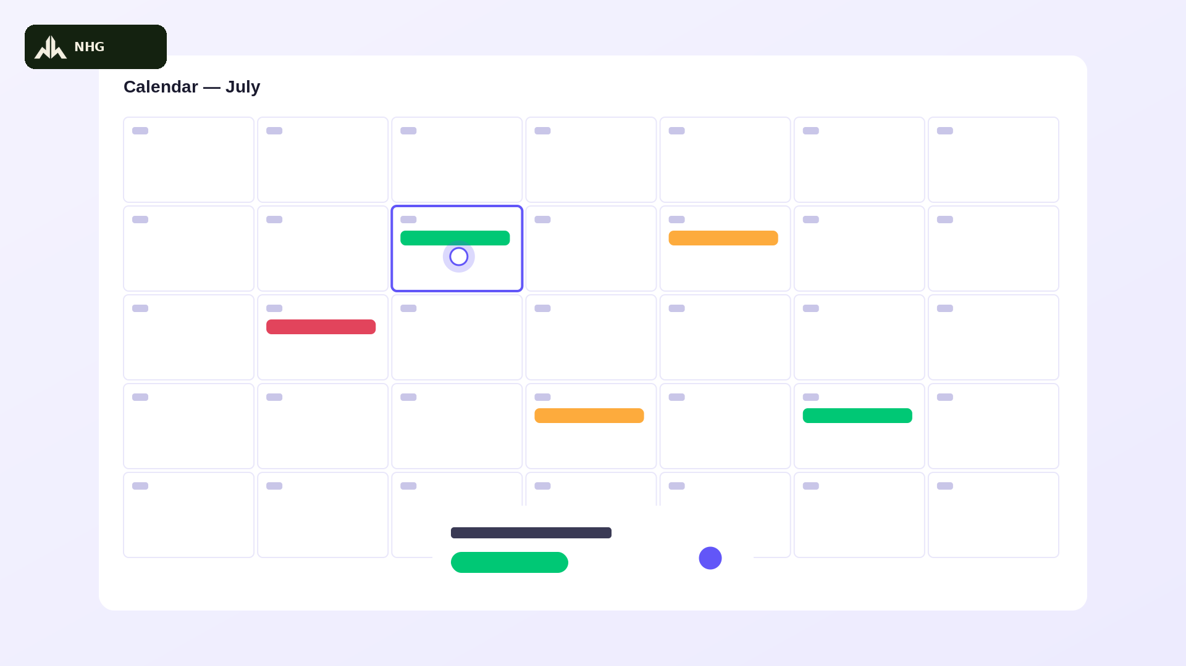 | The interface transitions into a full-month calendar grid (NHG badge top-left) with thin gray gridlines and small placeholder day numbers. Several days pop in colored task chips one after another with a quick playful bounce. The cursor dot taps a chip inside a cell outlined in brand purple (#6256F8) with a snappy pop, and a rounded detail card springs up energetically from the bottom showing an enlarged status pill and avatar for that task. Consistent energetic visual style across the whole series: flat 2D SaaS motion-graphic look with a fun, upbeat feel — snappy pops, playful bounces, and confident quick-eased motion that never feels slow or corporate-stiff, one single solid brand purple (#6256F8) — no gradients — paired with white, green (#00C875) / orange (#FDAB3D) / red (#E2445C) accent status pills, rounded 12px cards with soft drop shadows, plain gray placeholder bars standing in for on-screen text (no dense readable text), a small glowing white cursor dot marks every click or drag with a satisfying pop and a tiny burst of motion lines, a small dark-green Narai Hospitality Group (NHG) logo badge sits quietly in the top-left corner throughout for consistent brand presence, 16:9 aspect ratio, no photorealistic humans, no camera shake, clean bright studio-lit look with an exciting, high-energy feel. | “Or check Calendar view for a clean, day-by-day look at what's due — no more surprises, no more scrambling, just clarity!”  หรือดูมุมมอง Calendar เห็นกำหนดส่งรายวันชัดเจน ไม่มีเซอร์ไพรส์ ไม่ต้องรีบวุ่นวายอีกต่อไป! | Open full image  scene09_calendar.png
Scene 12  1:50–2:00 | ซิงค์ข้อมูลแบบเรียลไทม์ระหว่างทีม | 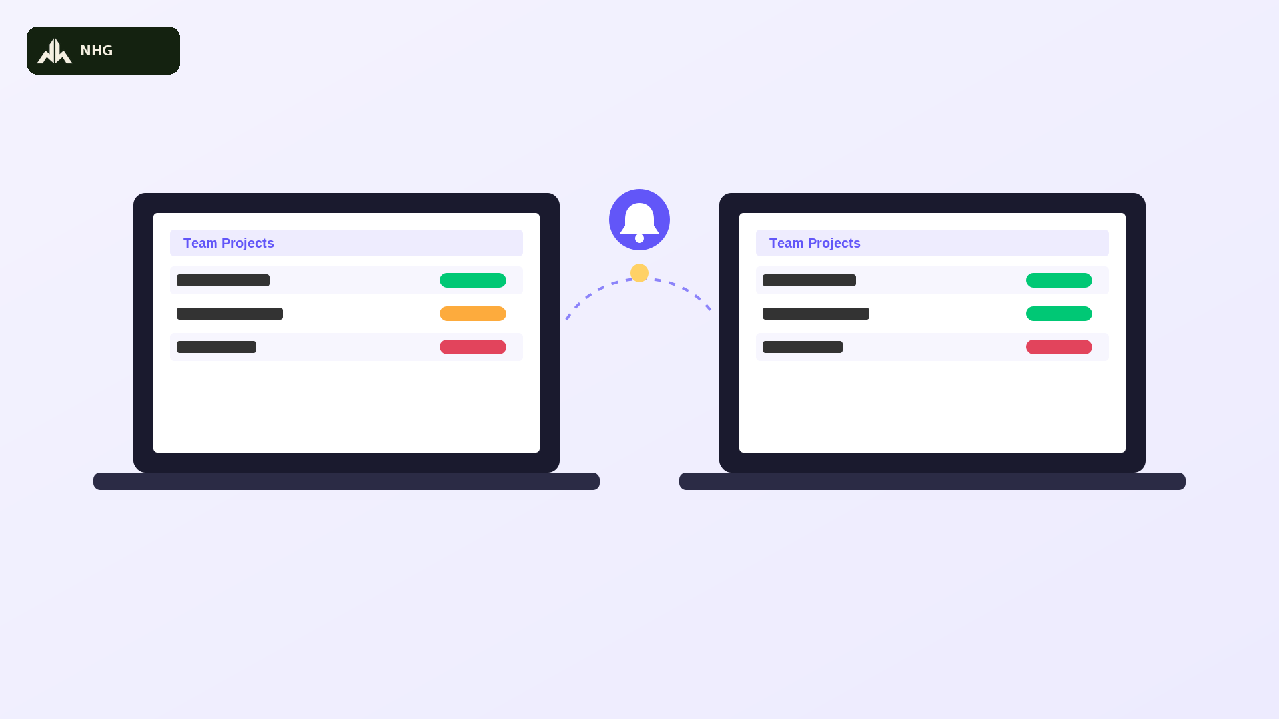 | Split screen: two laptop mockups side by side (no phone or mobile device — Saturday.com is desktop/web only), the small NHG badge visible top-left, both showing the same simplified colorful task-board interface with a brand-purple (#6256F8) header label and colored status pills. A glowing light particle zips briskly along a thin dashed arc between the two laptop screens to represent real-time sync, and a brand-purple notification bell between them pulses with an energetic pop as the particle arrives, causing both screens' pills to snap-update in perfect sync with a bright little flash. Consistent energetic visual style across the whole series: flat 2D SaaS motion-graphic look with a fun, upbeat feel — snappy pops, playful bounces, and confident quick-eased motion that never feels slow or corporate-stiff, one single solid brand purple (#6256F8) — no gradients — paired with white, green (#00C875) / orange (#FDAB3D) / red (#E2445C) accent status pills, rounded 12px cards with soft drop shadows, plain gray placeholder bars standing in for on-screen text (no dense readable text), a small glowing white cursor dot marks every click or drag with a satisfying pop and a tiny burst of motion lines, a small dark-green Narai Hospitality Group (NHG) logo badge sits quietly in the top-left corner throughout for consistent brand presence, 16:9 aspect ratio, no photorealistic humans, no camera shake, clean bright studio-lit look with an exciting, high-energy feel. | “Every change syncs instantly, everywhere — so your whole team stays on the same page, in real time, no matter where they're working!”  ทุกการเปลี่ยนแปลงซิงค์ทันทีทุกที่ ทีมของคุณเห็นข้อมูลตรงกันแบบเรียลไทม์ ไม่ว่าใครจะทำงานอยู่ที่ไหน! | Open full image  scene10_realtime.png
Scene 13  2:00–2:10  BUMPER | ช่วงเชื่อม: ทำงานร่วมกันแบบเรียลไทม์ | 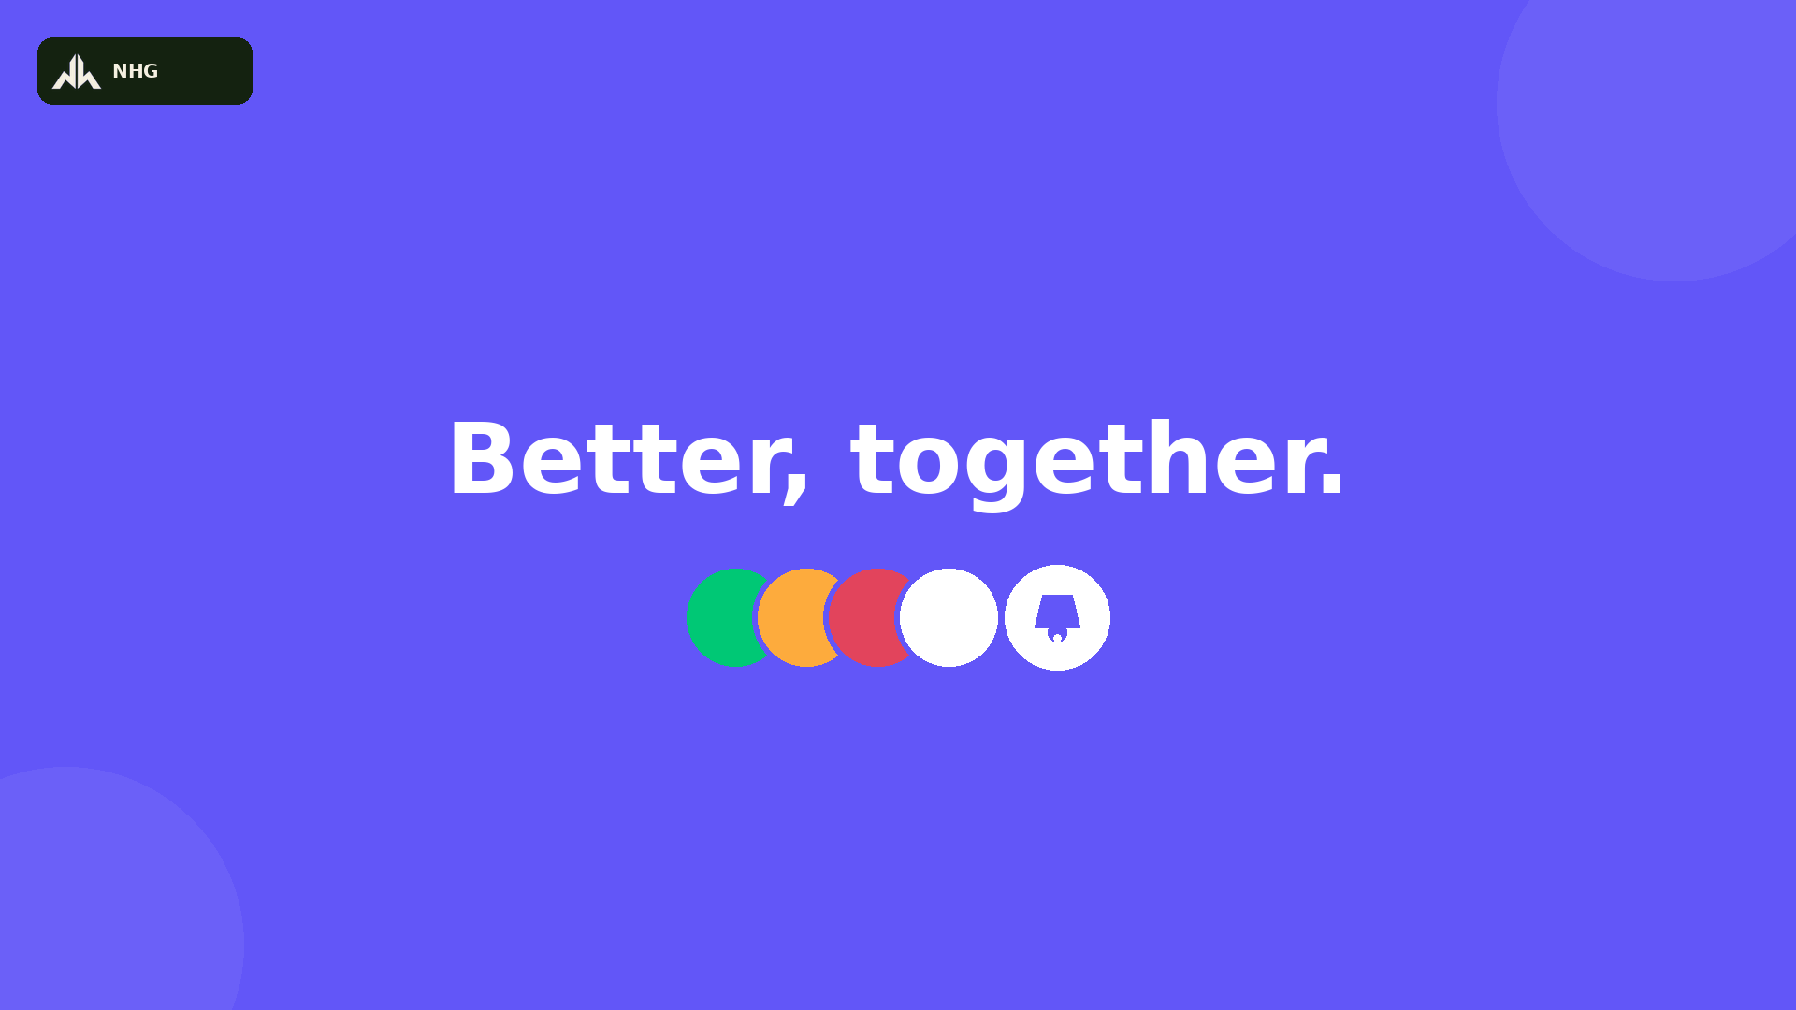 | No Grok generation required if reusing the provided reference image directly — otherwise generate to match exactly: flat solid brand-purple background (#6256F8, no gradient) fills the frame, small NHG badge top-left. Bold white text ‘Better, together.’ bounces in energetically center-frame with a confident overshoot-and-settle. A beat later, a row of small colored avatar circles pops in one after another with a playful bounce, followed by a small white notification-bell icon that pulses gently beside them. Frame holds on a bright, confident final beat. Consistent energetic visual style across the whole series: flat 2D SaaS motion-graphic look with a fun, upbeat feel — snappy pops, playful bounces, and confident quick-eased motion that never feels slow or corporate-stiff, one single solid brand purple (#6256F8) — no gradients — paired with white, green (#00C875) / orange (#FDAB3D) / red (#E2445C) accent status pills, rounded 12px cards with soft drop shadows, plain gray placeholder bars standing in for on-screen text (no dense readable text), a small glowing white cursor dot marks every click or drag with a satisfying pop and a tiny burst of motion lines, a small dark-green Narai Hospitality Group (NHG) logo badge sits quietly in the top-left corner throughout for consistent brand presence, 16:9 aspect ratio, no photorealistic humans, no camera shake, clean bright studio-lit look with an exciting, high-energy feel. | “Because the best work happens when everyone's truly in sync — connected, caught up, and moving forward, together!”  เพราะงานที่ดีที่สุดเกิดขึ้นเมื่อทุกคนซิงค์กันจริงๆ เชื่อมต่อกัน ตามทันกัน และก้าวไปข้างหน้าด้วยกัน! | Open full image  divider02_bettertogether.png
Scene 14  2:10–2:20 | ค้นหา กรอง และจัดกลุ่มงาน | 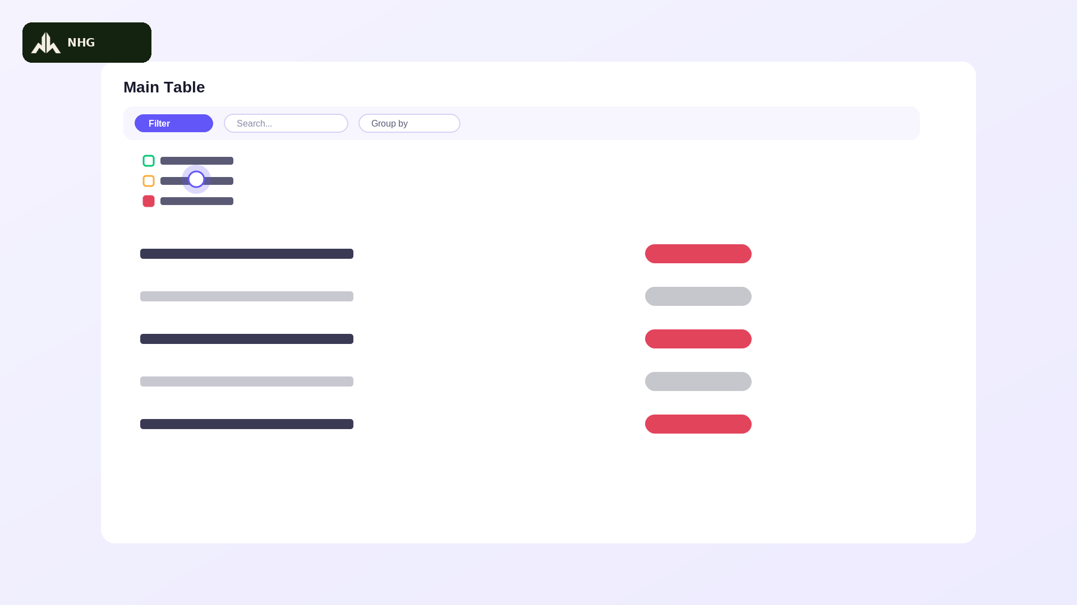 | On the table interface (NHG badge top-left), the cursor dot taps a solid brand-purple (#6256F8) ‘Filter’ pill button with a snappy pop; a dropdown springs open, a status option is picked, and non-matching rows pop out of frame quickly, leaving only the matches. The cursor then darts to a ‘Search’ field, a blinking text cursor fills in a short word at a brisk pace, and finally taps a ‘Group by’ pill, causing the colored group bars to snap-reorganize into a new arrangement with a quick energetic shuffle. Consistent energetic visual style across the whole series: flat 2D SaaS motion-graphic look with a fun, upbeat feel — snappy pops, playful bounces, and confident quick-eased motion that never feels slow or corporate-stiff, one single solid brand purple (#6256F8) — no gradients — paired with white, green (#00C875) / orange (#FDAB3D) / red (#E2445C) accent status pills, rounded 12px cards with soft drop shadows, plain gray placeholder bars standing in for on-screen text (no dense readable text), a small glowing white cursor dot marks every click or drag with a satisfying pop and a tiny burst of motion lines, a small dark-green Narai Hospitality Group (NHG) logo badge sits quietly in the top-left corner throughout for consistent brand presence, 16:9 aspect ratio, no photorealistic humans, no camera shake, clean bright studio-lit look with an exciting, high-energy feel. | “Filter, search, and group your work however you like — find exactly what matters, fast, and skip the digging entirely!”  กรอง ค้นหา และจัดกลุ่มงานได้ตามใจ หาสิ่งที่ต้องการเจอไว ไม่ต้องเสียเวลาค้นหาอีกต่อไป! | Open full image  scene11_filter.png
Scene 15  2:20–2:30 | ฟีเจอร์ Update พูดคุยในงาน ใส่ Emoji, GIF และ Reply ได้ | 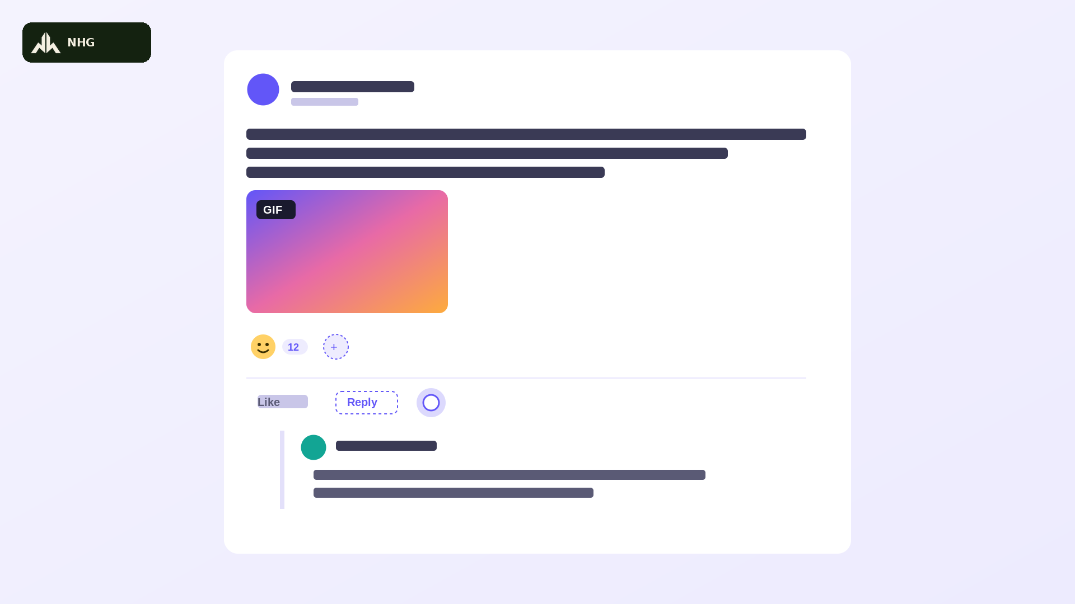 | A white update/comment card pops onto a light lavender background with a quick energetic bounce, small NHG badge top-left. At the top, a brand-purple (#6256F8) avatar circle sits beside a name placeholder bar and timestamp bar, which snap in fast. Below, gray text bars for a written update fill in briskly — a short celebratory note like a team hitting a milestone. Underneath, a colorful gradient GIF attachment card pops in with a small ‘GIF’ badge, and an emoji reaction bubble bounces to life next to a reaction-count pill and a dashed ‘add reaction’ button that pulses invitingly. The cursor dot taps ‘Reply’ with a snappy pop, and an indented threaded reply springs in below — a smaller teal avatar circle beside two gray text lines, connected by a thin vertical line, popping into place with a lively bounce. Consistent energetic visual style across the whole series: flat 2D SaaS motion-graphic look with a fun, upbeat feel — snappy pops, playful bounces, and confident quick-eased motion that never feels slow or corporate-stiff, one single solid brand purple (#6256F8) — no gradients — paired with white, green (#00C875) / orange (#FDAB3D) / red (#E2445C) accent status pills, rounded 12px cards with soft drop shadows, plain gray placeholder bars standing in for on-screen text (no dense readable text), a small glowing white cursor dot marks every click or drag with a satisfying pop and a tiny burst of motion lines, a small dark-green Narai Hospitality Group (NHG) logo badge sits quietly in the top-left corner throughout for consistent brand presence, 16:9 aspect ratio, no photorealistic humans, no camera shake, clean bright studio-lit look with an exciting, high-energy feel. | “Every task has its own conversation — drop a comment, react with an emoji, toss in a GIF, or jump into the thread!”  ทุกงานมีบทสนทนาของตัวเอง คอมเมนต์ ใส่อีโมจิ แนบ GIF หรือตอบกลับในเธรดได้เลย! | Open full image  scene12_updates.png
Scene 16  2:30–2:40 | ปิดท้าย พร้อม Call to Action สนุกสดใส | 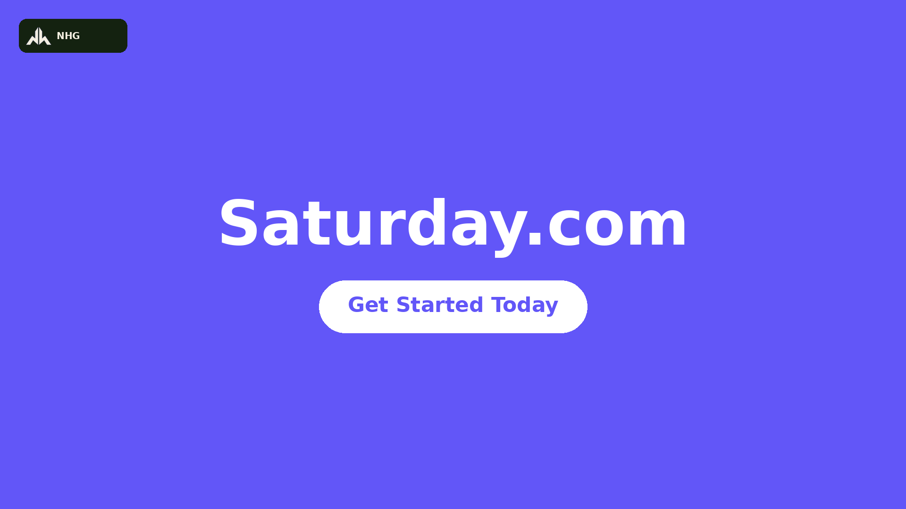 | Return to the same flat solid brand-purple background (#6256F8, no gradient) as the intro, small NHG badge popping in top-left with a confident bounce. The bold white wordmark ‘Saturday.com’ snaps back center-frame with an energetic pop; a white pill-shaped button reading ‘Get Started Today’ in brand-purple text bounces in below it a beat later and pulses with a bright, inviting glow. The frame holds on a high-energy, confident final beat. Consistent energetic visual style across the whole series: flat 2D SaaS motion-graphic look with a fun, upbeat feel — snappy pops, playful bounces, and confident quick-eased motion that never feels slow or corporate-stiff, one single solid brand purple (#6256F8) — no gradients — paired with white, green (#00C875) / orange (#FDAB3D) / red (#E2445C) accent status pills, rounded 12px cards with soft drop shadows, plain gray placeholder bars standing in for on-screen text (no dense readable text), a small glowing white cursor dot marks every click or drag with a satisfying pop and a tiny burst of motion lines, a small dark-green Narai Hospitality Group (NHG) logo badge sits quietly in the top-left corner throughout for consistent brand presence, 16:9 aspect ratio, no photorealistic humans, no camera shake, clean bright studio-lit look with an exciting, high-energy feel. | “This is Saturday.com — simple, visual, and honestly kind of fun. Ready to get your team moving? Let's get started, today!”  นี่คือ Saturday.com เรียบง่าย เห็นภาพชัด และสนุกกว่าที่คิด พร้อมให้ทีมคุณลุยแล้วหรือยัง? เริ่มต้นวันนี้เลย! | Open full image  scene12_cta.png
Scene 17  2:40–2:50 | โลโก้ Narai Hospitality Group | 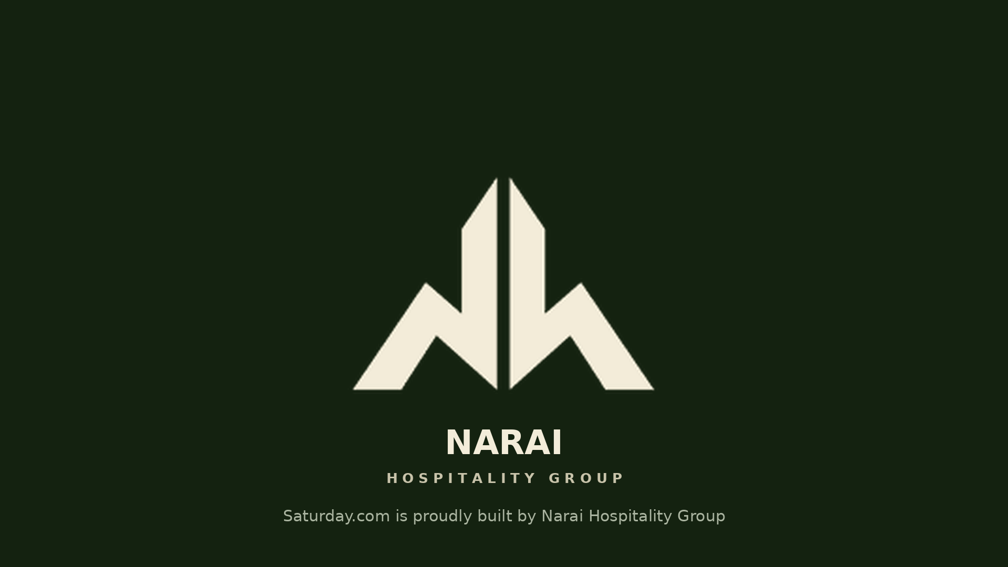 | No Grok generation for this scene — this is the official Narai Hospitality Group logo, reconstructed here directly from the real brand mark used inside Saturday.com (not AI-generated) to keep it accurate. This is intentionally the one scene that is NOT brand purple — it uses Narai's own dark green, as the closing “powered by” card. In CapCut: place the real logo file centered on a matching dark green background, fade in over 0.5s with a confident scale-up from 92% to 100% and a quick soft flash on landing, then hold for the remaining duration. Do not ask Grok to regenerate this logo — always use the exact brand file. | “Proudly built by Narai Hospitality Group — because we believe every great team deserves to work from the very same page!”  ภูมิใจสร้างสรรค์โดย Narai Hospitality Group เพราะเราเชื่อว่าทีมที่ยอดเยี่ยมสมควรได้ทำงานบนหน้าเดียวกันเสมอ! | Open full image  scene13_narailogo.png

Production Notes
Pacing: Grok generates roughly 15 seconds per clip natively. Generate each feature clip as usual, then in CapCut trim it down to its tightest, punchiest 10 seconds — cut on the snappiest motion beat (a pop, bounce, or click), not mid-motion. The two purple bumper scenes (8 and 13) can be used at their generated length or trimmed the same way — either works, since they're a static text-card style like the reference clip's own dividers.
Bumper scenes: Scenes 8 and 13 are optional but recommended — they're quick reference images you can drop straight into CapCut without regenerating in Grok if you want to save time, or paste the prompt into Grok for a version with a bit more motion. Either way keep them short and punchy (2–3 seconds shorter than a feature scene is fine) to preserve the fast-cut rhythm.
Reference images in this version are style-matched mockups redrawn using the real app's actual colors, status labels, and layout (not literal screenshots) — a tool limitation in this session stopped screenshots from being saved as files. If you want pixel-exact screenshots swapped in, send a few PNGs of the real views (Main table, Kanban, Timeline, Calendar, Filter panel) as chat attachments and they can be dropped straight into this table.
Generate all 14 Grok scenes back-to-back in one session if possible — Grok tends to stay more visually consistent within a session than across separate ones.
Voiceover delivery: record with an upbeat, enthusiastic, smiling energy — think hype-reel narrator, not corporate training video. Read at a brisk, confident pace with a little lift at the end of each line; lines are written to land tightly inside 10 seconds at that faster, excited pace, so keep energy up and don't rush the words — just trim the silence. The two bumper scenes have short punchy lines that can breathe a little more. Pick one language track (English or Thai) for the final cut — the two are not meant to be layered together.
Music direction: one upbeat, playful electronic-pop instrumental track (roughly 120–128 BPM) with punchy synth stabs, claps, or a riser landing right on each scene cut — and especially on the two bumper cards, the way the reference clip's music punctuates its own title cards. Let the energy build steadily through the middle of the video, then bring a bright, confident swell under the closing CTA in Scene 16 that resolves into a warmer, simpler musical moment for the Narai Hospitality Group card in Scene 17.
Privacy: if you do swap in real screenshots later, your live boards contain real task names and internal links — double-check nothing sensitive is visible before this video goes anywhere external.

