1. ***Write a SQL query that retrieves all languages that occur in more than 1000 Webpages. A language "occurs" in a Webpage if the Webpage contains a word in that language.***

select y.language

from Occurs x, Dictionary y

where x.word = y.word

group by y.language having count(*) > 1000

1. ***Write a SQL query that computes, for each Webpage, the largest number of words on that page in any language. For example, if a page has 100 words in French and 50 words in English (these two sets of words may be overlapping), then your query will return 100 for that page. If a Webpage has only words that do not occur in any language at all, then you do not need to return that Webpage.***

select url, max(c)

from (select x.url, y.language, count(*) as c

from Occur x, Dictionary y

where x.word = y.word

group by x.url, y.language)

group by url

1. ***We say that a Webpage is "monolingual in X" if all words occurring on that Webpage are in the language X (and may be in other languages too). Write a query in the Relational Calculus that returns all monolingual Webpages together with the language(s) in which they are monolingual. For example, if the Webpage is: Introduction to Data Management then your query should return English for that Webpage, because all four words are in English, hence the Webpage is monolingual in English. (The word Data occurs in other languages as well, but not he other three words.) On the other hand, if the Webpage is: NO SQL ! then it is monolingual in English, in French, in Italian, etc, because both NO and SQL are words in English, in French, in Italian. (But the Webpage is not monlingual in Dutch because NO is not a Dutch word; Dutch people say 'NEE').***

Add O(x, −) and D(−, z)

1. ***Design an ERM Diagram for an online video rental company:***

***• The company has data about movies, customers, rentals, reviewers, reviews.***

***• A Movie has a Title (key), Year, and Duration.***

***• A Customer has Name, Email (key), and Credit.***

***• Customers rent movies; they may rent many movies, and a movie may be rented by many; each Rental has a Date.***

***• A Reviewer is a Customer, and has a Reputation attribute.***

***• A Review has a Rating, a Date, and Text (content). Each review is uniquely identified by the movie it is reviewing, and by the reviewer who wrote it.***

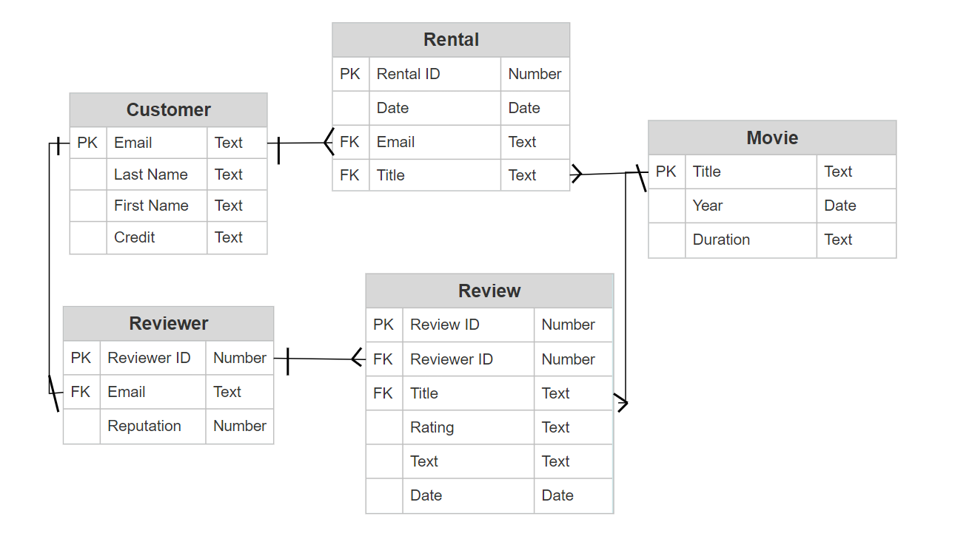

1. ***Add a view containing a sub-query to our Movie database.***

SELECT name, year, earnings_rank FROM Movie

WHERE Movie.earnings_rank <(

SELECT earnings_rank FROM Movie WHERE name LIKE 'Toy%'

);

1. ***Add a trigger to our Movie database. – Struggling with this one***

CREATE TRIGGER ParentalAdvisory

AFTER INSERT ON Movie

WHEN Movie.rating IS 'R'

1. ***Add a common table expression to our Movie database.***

WITH short_info (filmName, filmYear)AS

(

SELECT name, year

FROM Movie

)

SELECT filmName, filmYear FROM short_info;