FAQ

Flowchart

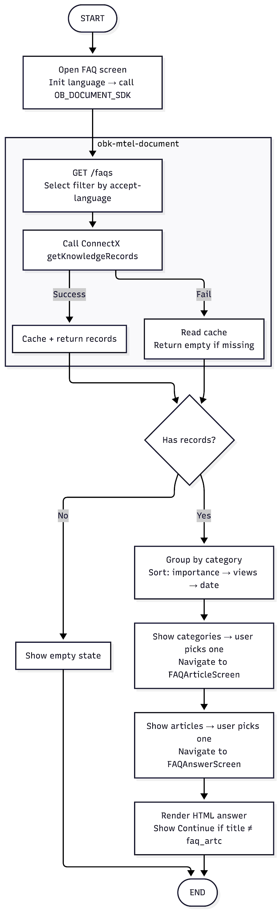

Sequence Diagram
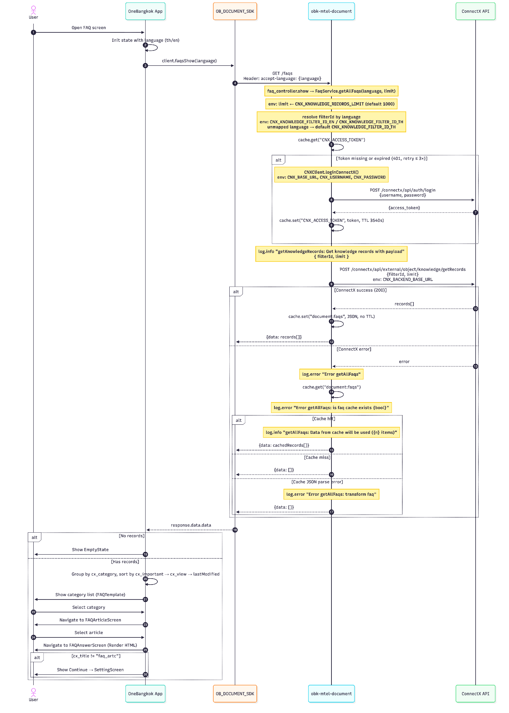

GET /faqs

Overview
- Method: GET
- Path: /faqs
- OperationId: faqs.show
- Description: Retrieves all FAQ knowledge records from ConnectX filtered by language. Falls back to Redis/local cache when ConnectX is unavailable. Always returns HTTP 200 — errors are resolved internally.

Request

Header Parameters
Name | Type | Required | Description
accept-language | string | true | Language code for filtering records. Supported: th, en. Defaults to `th` if unsupported value is given

Query Parameters
Name | Type | Required | Description
limit | number | false | Max number of records to fetch from ConnectX. Defaults to `1000` (configurable via `CNX_KNOWLEDGE_RECORDS_LIMIT` env).

Request Example
GET /faqs?limit=100
accept-language: th

Success Response

Field | Type | Description
data | array | List of FAQ knowledge records from ConnectX. Empty array `[ ]` when ConnectX is unavailable and no cache exists.
data[]._docId | string | Unique ConnectX document ID.
data[].cx_title | string | Article title displayed in the list.
data[].cx_name | string | Internal name of the record.
data[].cx_subtitle | string | Internal name of the record.
data[].cx_important | boolean | Priority flag `true` item are sorted first
data[].cx_active | boolean | Whether the record is active/visible
data[].cx_view | string or null | View count as a string, used as secondary sort key
data[].cx_category | object or null | Category the article belongs to.
data[].cx_subCategory | object or null | Sub-category (if any)
data[].cx_subCategoryType | object or null | Sub-category type (if any)
data[].cx_detail | string | Full HTML content of the answer
data[].cx_description | string or null | Short description
data[].lastModified | object or null | Firestore timestamp of last modification
data[].lastModified._seconds | number | Unix seconds of last modification.
data[].lastModified._nanoseconds | number | Nanosecond component.

Success Example
{
"data": [
{
"_docId": "abc123",
"cx_title": "How to register?",
"cx_name": "Registration FAQ",
"cx_subtitle": "Account setup",
"cx_important": true,
"cx_active": true,
"cx_view": "520",
"cx_category": {
"_docId": "cat001",
"cx_name": "Account"
},
"cx_subCategory": null,
"cx_subCategoryType": null,
"cx_detail": "<p>To register, open the app and tap Sign Up...</p>",
"cx_description": "Step-by-step registration guide",
"lastModified": {
"_seconds": 1715000000,
"_nanoseconds": 0
}
}
]
}

Error Response
This endpoint always returns HTTP 200. All internal errors (ConnectX failures, cache misses, parse errors) are caught and resolved — never propagated as HTTP errors. Errors are logged via `logging.error`

Error Scenario
Status | Scenario | Data value | Cause
200 | ConnectX unavailable, cache hit | Cached records | ConnectX unreachable — served from `document:faqs` cache.
200 | ConnectX unavailable, cache miss | [ ] | ConnectX unreachable and cache is empty — app shows EmptyState.
200 | Cache JSON parse failure | [ ] | Corrupted cached value — overwritten on next successful ConnectX call.
200 | Unsupported `accept-language` | Records (TH) | Unmapped language defaults to `CNX_KNOWLEDGE_FILTER_ID_TH`

Error Example
{
"data": []
}

ConnectX — Authentication
Internal API called by `connect_x_client.ts` to obtain a Bearer token before fetching knowledge records. Source: ConnectX API Specification for MTEL v1.0.

- Method: POST
- Path: /connectx/api/auth/login
- Base URL (UAT): https://api.connect-x.tech
- Base URL (Production): https://api-tcc-cc.connect-x.tech
- Description: Authenticates with ConnectX and returns an access token. Token is cached internally for 3540 seconds (~59 min). Auto-refreshed on 401 up to 3 retries.

Request

Header Parameters
Name | Type | Required | Description
Content-Type | string | true | application/json

Body Parameters
Name | Type | Required | Description
email | string | true | ConnectX service account email. Confidential — provided via email
password | string | true | ConnectX service account password. Confidential, provider via email

Request Example
{
"email": "tcccc-uat_api@connect-x.tech",
"password": "<provided via email>"
}

Success Response

HTTP 201

Field | Type | Description
access_token | string | Bearer token for subsequent ConnectX API calls. Expiration: 1 day

Success Example
{
"access_token": "eyJhbGciOiJIUzI1NiIsInR5cCI6IkpXVCJ9..."
}

Error Response

Error Object Format

Field | Type | Description
statusCode | number | HTTP error code.
message | string | Human-readable error message

Error Scenario

HTTP | Message | Cause
400 | Cannot find user or profile | Wrong credential or account not found, contact ConnextX team
500 | Internal server error | ConnectX internal error, inform ConnectX team

{
"statusCode": 400,
"message": "Cannot find user or profile"
}

ConnectX — Get Knowledge Records
Internal API called by `connect_x_client.ts` to fetch FAQ records. Source: ConnectX API Specification for MTEL v1.0.

Overview
- Method: POST
- Path: /connectx/api/external/object/knowledge/getRecords
- Base URL: https://backend.connect-x.tech
- Description: Fetches FAQ knowledge records from ConnectX filtered by `filterId`. Rate limited to 5 req/sec and 150,000 req/day.

Request

Header Parameters
Name | Type | Required | Description
Content-Type | string | true | Must be application/json
Authorization | string | true | Bearer token obtained from the authentication endpoint

Body Parameters
Name | Type | Required | Description
filterId | string | true | ConnectX filter ID. Determines which knowledge records are returned.
limit | number | false | Max number of records to return.

Request Example
{
"filterId": "{FilterId}",
"limit": 1000
}

Request Example (curl)
curl --location 'https://backend.connect-x.tech/connectx/api/external/object/knowledge/getRecords' \
--header 'Content-Type: application/json' \
--header 'Authorization: Bearer {access_token}' \
--data '{
"filterId": "{FilterId}"
}'

Success Response

HTTP 200
Field | Type | Description
[ ]._docId | string | Unique ConnectX document ID.
[ ].cx_title | string | Article title displayed in the list.
[ ].cx_name | string | Internal name of the record.
[ ].cx_subtitle | string | Internal name of the record.
[ ].cx_important | boolean | Priority flag `true` item are sorted first
[ ].cx_active | boolean | Whether the record is active/visible
[ ].cx_view | string or null | View count as a string, used as secondary sort key
[ ].cx_category | CategoryType or undefined | Category the article belongs to.
[ ].cx_subCategory | CategoryType or undefined | Sub-category (if any)
[ ].cx_subCategoryType | CategoryType or undefined | Sub-category type (if any)
[ ].cx_detail | string | Full HTML content of the answer
[ ].cx_description | string or null | Short description
[ ].lastModified | object or undefined | Firestore timestamp of last modification
[ ].lastModified._seconds | number | Unix seconds of last modification.
[ ].lastModified._nanoseconds | number | Nanosecond component.

Success Example
[
{
"_docId": "abc123",
"cx_title": "How to register?",
"cx_Name": "Registration FAQ",
"cx_subtitle": "Account setup",
"cx_important": true,
"cx_active": true,
"cx_view": "520",
"cx_category": {
"_docId": "cat001",
"cx_name": "Account"
},
"cx_subCategory": null,
"cx_subCategoryType": null,
"cx_detail": "<p>To register, open the app and tap Sign Up...</p>",
"cx_description": "Step-by-step registration guide",
"lastModified": {
"_seconds": 1715000000,
"_nanoseconds": 0
}
}
]

Error Response
Field | Type | Description
StatusCode | number | HTTP error code
message | string | Human-readable error message

Error Scenario

HTTP | Message | Cause
400 | Token not found | Missing or invalid token, request a new auth token
401 | Unauthorized | Token expired — service auto-retries up to 3×
403 | Forbidden resource | Account lacks permission — contact ConnectX team
429 | Too Many Requests | Exceeded 5 req/sec — retry next day at 00:01 (GMT+7)
500 | Internal Server Error | ConnectX internal error — inform ConnectX team
503 | – | Timeout — pause and inform ConnectX team

Error Example
{
"statusCode": 429,
"message": "Too Many Requests"
}

Rate Limits
Limit | Value | Response Header
Concurrent | Max 5 req/sec | `X-Rate-Limit-Second-Limit`, `X-Rate-Limit-Second-Remaining`
Daily | 150,000 req/day (resets 12:00 AM GMT+7) | `X-Rate-Limit-Daily-Limit`, `X-Rate-Limit-Daily-Remaining`
Last request | Before 11:00 PM GMT+7 | `X-Rate-Limit-Daily-Reset` (Unix ms)

Retry Policy (429 only)
Step | Action
1 | Await a response for each request before sending the next.
2 | On `429`, pause the job and log the error.
3 | Store the failed request/record.
4 | Retry the failed records the following day at 00:01 (after 24 hours).

Environment Variables
Variable | Default | Description
CNX_BASE_URL | https://api.connect-x.tech | ConnectX auth base URL.
CNX_BACKEND_BASE_URL | https://backend.connect-x.tech | ConnectX data API base URL.
CNX_USERNAME | — | ConnectX service account username.
CNX_PASSWORD | — | ConnectX service account password.
CNX_KNOWLEDGE_FILTER_ID_TH | — | ConnectX filter ID for Thai FAQ records.
CNX_KNOWLEDGE_FILTER_ID_EN | — | ConnectX filter ID for English FAQ records.
CNX_KNOWLEDGE_RECORDS_LIMIT | 1000 | Max records fetched per request.
CACHE_REDIS | false | Enable Redis as distributed cache layer.

