

PRJ301 – Assignment: FFood

Mentor: Lương Hoàng Hướng



July 17, 2023

FPT University

Can Tho, Vietnam

SU23 - SE1704 - Group 1:

1. CE171454 - Hứa Tiến Thành
2. CE160269 - Nguyễn Huy Khánh
3. CE170317 - Hồ Dương Gia Bảo
4. CE170696 - Phan Thành Quốc Bảo
5. CE171981 - Trương Mạnh Hưng

Table of Contents

I. Introduction 2

II. Software Development Model 2

III. Diagrams 2

Use Case Diagram 2

Entity-Relationship Diagram (ERD) 2

Conceptual ERD 2

Logical ERD 2

IV. Version Control System 2

V. Finished Project & User Interface 2

Home 2

Cart & Checkout 2

User Management 2

Admin Dashboard 2

VI. Member Contribution & Project Completion 2

VII. Changelog 2

v0.0: 6/6/2023 2

v0.1: 20/6/2023 2

v0.2: 9/7/2023 2

v0.3: 15/7/2023 2

v0.4: 16/7/2023 2

# Introduction

FFood is a fictional restaurant business that has recently experienced a surge in customer demand. As the business has no intentions of expanding the business nor increasing the number of staffs, it is currently overwhelmed with the amount of orders they receive per day.

To accommodate this growth and reduce stress on the business front, a website that allows customers to order food from other places will be designed. This website will provide a convenient and user-friendly experience for customers to place orders and will help FFood manage its growing customer base.

Due to being a relatively new business, the client (FFood’s owner) has requested that the application should be made with minimal cost in mind, saving cost where possible without compromising the product’s quality and functionality. The project is set to be completed within the span of approximately 2 months, and a budget enough to support 5 developers is provided. No additional budget is spent on UI/UX design, market research, so the development team must come up with their own research.

The FFood website must be user-friendly as its main goal is to have customers place orders on the website, therefore the ordering procedure must be efficient and quickly. The client stated that most of their customers’ age is within the range of 18 – 40, so the website must be intuitive and easy to use for said age group. To attract customers (especially young customers), a good-looking modern UI is a must, especially on traffic-heavy web pages like home page and checkout page.

To increase customer retention, there should also be an account system for customers. Only registered customers can save their information for future uses (such as auto-fill information during the checkout process), view and cancel their orders.

Because the traditional customer management system used in FFood is getting overwhelmed by the current demand influx and the potential future customer increase, an online application-based management system must be created. The system should have the basic functions that allow system administrators to access the food data to add, update or remove dishes from the website’s food list, and also add, update, remove customer accounts. Administrators must also be able to view all food orders made by the website for logging purposes but must not be able to modify them due to security issues. Administrators cannot order food themselves, also due to security risks. Administrators cannot add another Administrator through the website, this can only be done by the client (the only person who can directly access the database).

# Software Development Model

Due to time constraints, a traditional development model such as Waterfall is unsuitable due to the client (FFood business owner) not having concise requirements at the time of project definition.

As such, it is decided that the project will be expected to have requirement changes during development phases. The Agile development model will be used to accommodate this fact.

Team members will mostly be working online, so online meetings (which are less effective compared to on-site meetings) should be used in tandem with online management platforms. For this purpose, Kanban is a suitable option.

# Diagrams

## Use Case Diagram

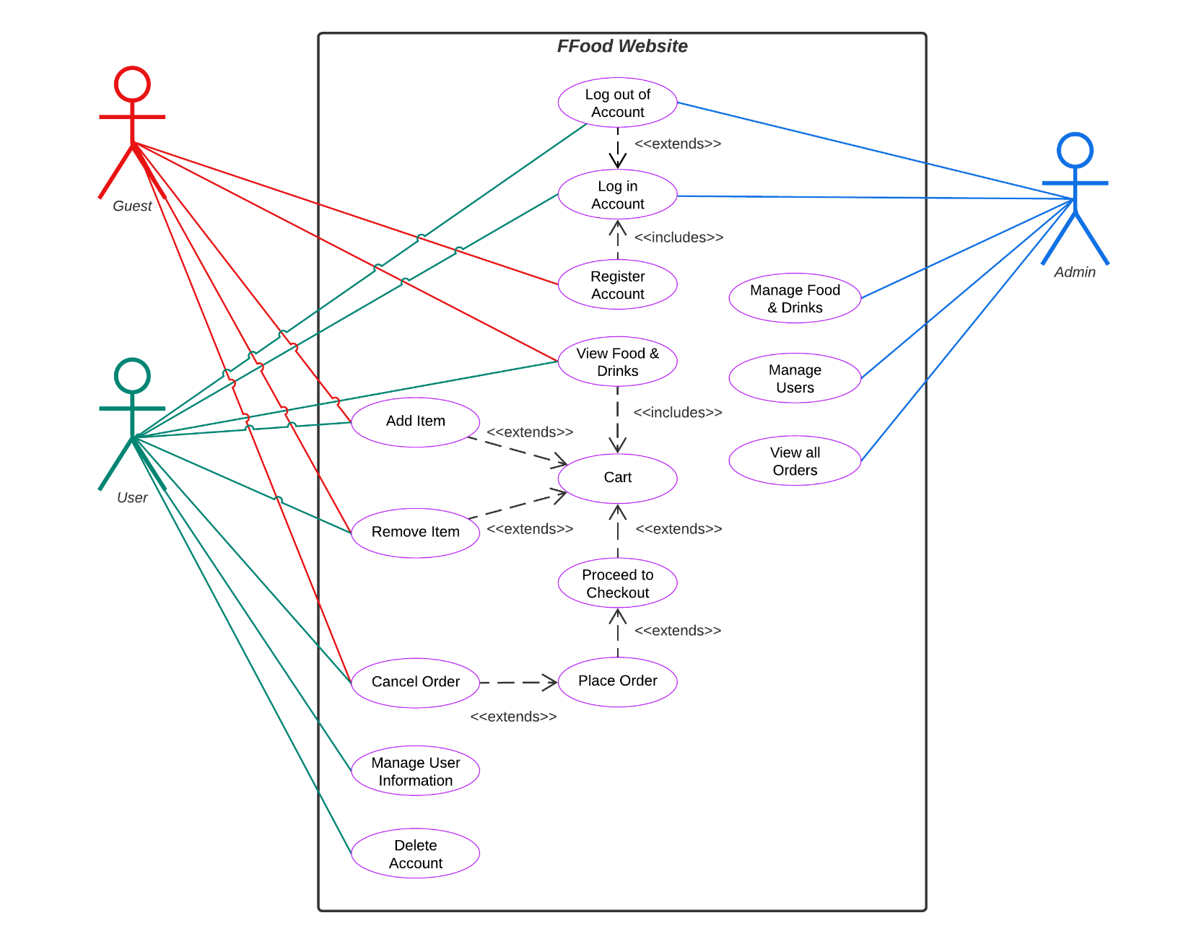

## Entity-Relationship Diagram (ERD)

### Conceptual ERD

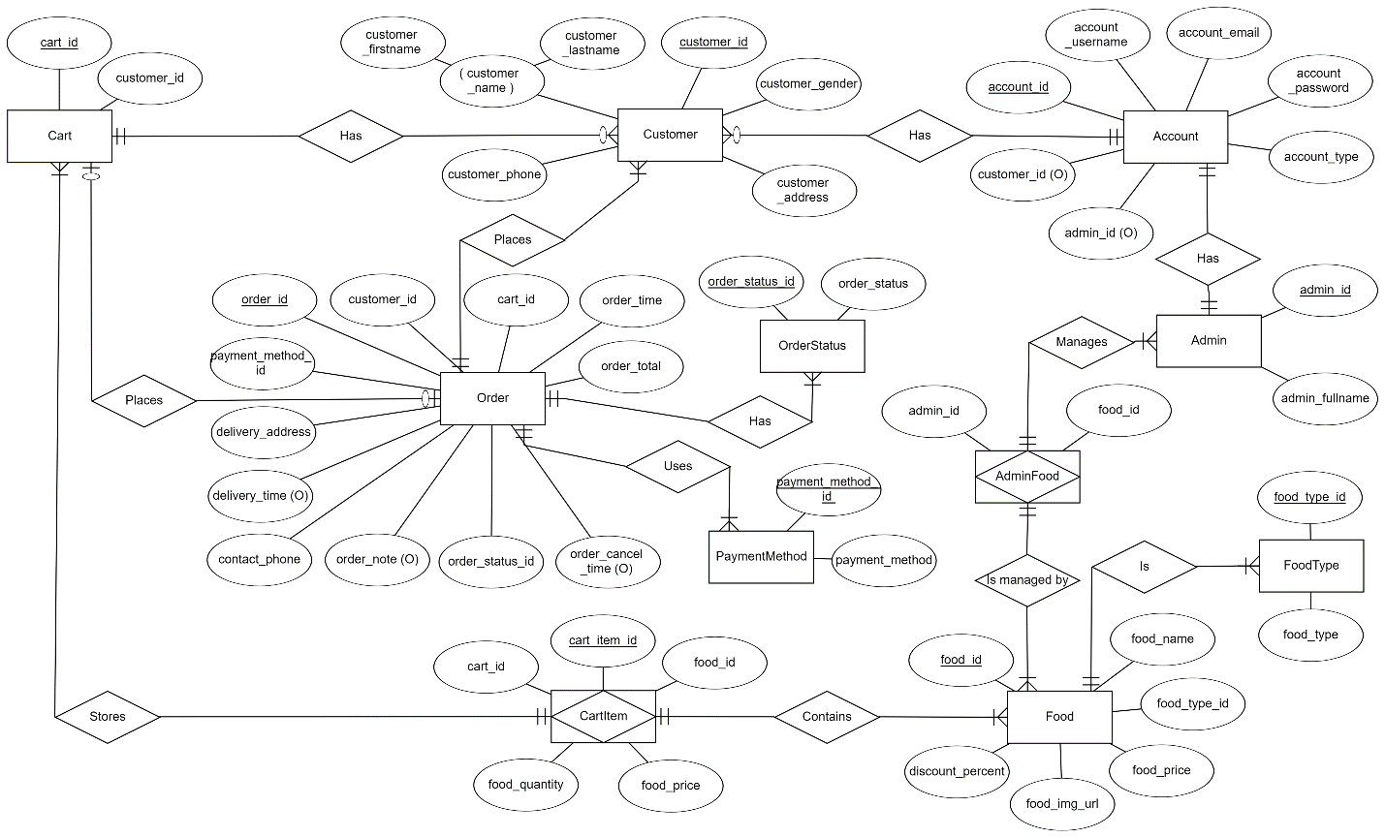

### Logical ERD

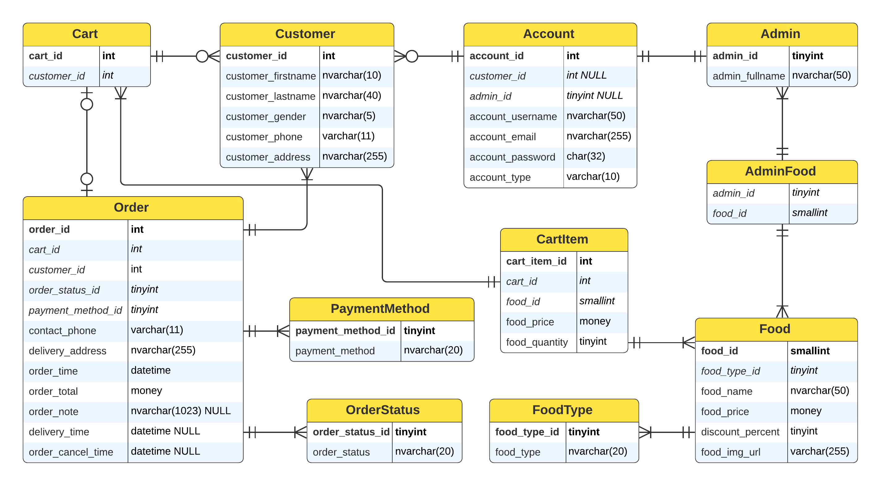

# Version Control System

Due to the complexity of the project, a Version Control System (VCS) is necessary. As our development team is comprised of students, Git is chosen as our VCS, with GitHub used to host our repository. While Git can be a difficult tool to use at first, it can be a very powerful tool for the project development.

Our repository (FFood: [github.com/tien-thanh-hua/FFood](https://github.com/tien-thanh-hua/FFood)) has 5 collaborators (all Group 1 members), with Hua Tien Thanh (project leader) the owner. We would frequently pull (and merge) code from the repo, then push changes when a functionality has been completed. This allows for an automated code synchronize system where collaborators do not have to manually upload and download the project files to their local project folder.

Although Git can be useful for tracking project file changes, it is not suitable for a document that requires detailed changelogs per adjustment to the document. The reason being: despite Git can have messages per commit, it is more suitable for multiple files, not for single files requiring detailed changelogs. To reduce unnecessary time waste and complexity, it is decided that changes to this document will be noted in this document as well, in the “Changelog” section at the bottom of the document.

# Finished Project & User Interface

This FFood website project is designed for 3 main types of users: (Refer to Use-Case Diagram for more details)

1. Guest (logged out customer)
2. User (logged in customer)
3. Admin

In terms of functionality, while both Guests and Users can do almost everything that is permitted to a regular customer (view food, add food to cart, place orders), Users have additional benefits such as information auto-fill in their Checkout page, view and cancel their orders, with more benefits added as the website gets improvements. Guests cannot access unauthorized pages such as the User Management page (“/user”) and Admin Dashboard page (“/Admin”). Attempting to access such pages will redirect them to the home page. Users can of course access their User Management page, but they obviously cannot access the Admin Dashboard.

Unlike Guests or Users, Admins cannot access the website normally. Upon successful login (as an Admin), they will be instantly redirected to their Admin Dashboard page. Attempting to access user-accessible pages (Home page, Checkout, User Management) will redirect them to the Admin Dashboard. This rule is enforced to ensure that Admins do not accidentally perform user actions while logged in as an Admin account, as this could pose security risks.

## Home

Home page (“/”) has 4 sections:

* Hero section: displays tagline and hero image with Call-To-Action button (Đặt món ngay)
* Food list (Danh sách món ăn):
  + There are 6 Food Categories (button) that filters the list to match the corresponding food category.
  + Below the category buttons is the food list, presented in a grid of maximum 4 cards/row, with each card showing the food image, name, price tag (and discount tag if present) and the Add to Cart button (Thêm vào Giỏ hang).
* Order Instruction (Cách đặt món nhanh) section shows the necessary steps for the customer.
* The Call-To-Action section at the bottom of the page is mostly decorative.

## Cart & Checkout

Upon clicking Add to Cart, the corresponding Food will be added to the user’s cart (this data is stored in the session’s attribute “cart”). To access the content of the cart, the user will have to click on the yellow cart icon on the left of the Log in/Account button.

A Cart modal (pop-up) will be shown, with the added Food displayed in tabular format. The user can change the food quantity as needed (minimum 1) or remove them from the Cart by pressing the orange “Xóa” button on the far right of each row. The “Số tiền” column displays the price of each Food item (quantity included). The “Tổng thanh toán” shows the grand total to be paid (sum of all Food item’s price * quantity). When the customer decides to proceed to checkout, they can click the Checkout (“Thanh toán”) button, which redirects them to the Checkout (“/checkout”) page.

In Checkout page, the UI will display the cart details and customer information form on two columns:

* Left column shows cart details, retrieved using the session attribute that is set after customer presses the Checkout button.
* A screenshot of a computer

  Description automatically generatedRight column shows the customer information form, consisting of **customer information** input fields such as last name, first name, gender, and **order information** such as contact phone number, delivery address, order note, payment method. Due to difficulties in implementing credit card and debit card payment methods, it has been decided that the currently (and only) supported method is Cash-On Delivery, which does not require third-party API integration to process online payments, with support for additional payment methods added in the future.  
  Under the input fields is a single row with Grand Total information and the Place Order (“Đặt món”) button. After the customer clicks the button, the order will be processed and will display a notification that the order was successfully placed. After a few seconds, the customer will be redirected to the home page.

## User Management

Customers not logged in can either log in to an existing account or create a new account if they do not have one.

Both forms have custom client-side validation to prevent customers from sending invalid data which can potentially lead to server errors.

When a user is successfully logged in, the yellow Đăng nhập (Log In) button will change to blue, showing the account username instead. Clicking it opens a dropdown menu, which can be used to go to the user management page (“/user”) or log out.

In the User Management page, there are 3 horizontal navigation tabs:

* Thông tin của tôi (My Information): the User can add their customer information (if their account does not have such) or update their existing information.

* Tài khoản đăng nhập (Account): the User can update their account login information, such as account name, email, password.

* Đơn món (Orders): the User can view their past and present orders, and the user can cancel their order(s) as long as those orders are not yet delivered (and/or cancelled).

## Admin Dashboard

Upon successful login (as an Admin), they will be instantly redirected to their Admin Dashboard page (“/admin”). Here they can perform CRUD operations to manage the website’s foods, User accounts, and orders.

The Dashboard UI has 2 main sections: the left sidebar acts as the page’s navigation bar, with tabbed buttons acting as the navigation links. The second section shows the actual content, this content depends on the navigation button pressed on the sidebar.

Currently, there are 3 main “pages” that can be accessed by Admins:

* A screenshot of a menu

  Description automatically generatedMón ăn (Food): allows Admins to view, add, update, delete food and drinks (that are displayed on FFood’s home page)

* A screenshot of a computer

  Description automatically generatedA screenshot of a computer

  Description automatically generatedA screenshot of a computer

  Description automatically generatedA screenshot of a phone

  Description automatically generatedNgười dùng (User): allows Admins to view, add, update, delete User accounts. Note that this does not include customer data (such as customer name, gender, address, etc.). There are 3 reasons for this: 1) Not all accounts have customer information (this is either manually added by the User in User Management, or added after the User successfully placed their first order while logged in), 2) Admins should not have access to such sensitive information, 3) Having customer information columns might overcomplicate the UI, which makes it harder for Admins to easily manage User accounts.

* Đơn món (Order): allows Admins to view Orders. The orders shown on the dashboard are read-only, to prevent tampering with sensitive data, which could cause financial and legal problems to FFood as a local business.

# Member Contribution & Project Completion

*Note: Refer to Work_Assignment_Table.xlsx for detailed members’ task assignment and contribution values.*

**Project Completion: 100%**

|  |  |  |
| --- | --- | --- |
| Member Name | Contribution | Comments |
| Hứa Tiến Thành | 55.33% | N/A |
| Phan Thành Quốc Bảo | 17.03% | Diligent, determined. Can get difficult tasks done well, good problem solving. Recommended on future group projects. |
| Hồ Dương Gia Bảo | 10.38% | Lazy, but gets the job done (often not fully completed). Over reliant on ChatGPT. |
| Nguyễn Huy Khánh | 9.29% | Diligent, determined, but lacks necessary skills and knowledge. Struggles with many tasks, but can finish the tasks if provided with extensive support. |
| Trương Mạnh Hưng | 7.97% | Diligent, but lacks critical skill and analysis skills needed for problem solving. Lacks basic knowledge. Has a somewhat fast learning rate but suffers from lack of motivation. |

# Changelog

## v0.0: 6/6/2023

* Document created

## v0.1: 20/6/2023

* Added headings
* Added content to Introduction, Software Development Model, Diagrams, Version Control System

## v0.2: 9/7/2023

* Added Use Case Diagram

## v0.3: 15/7/2023

* Updated Version Control System
* Combined User Interface and Final Product into Product Pages
* Added Home (completed), Cart & Checkout (completed), User Management (in progress) subsections to Product Pages

## v0.4: 16/7/2023

* Completed User Management, added Admin Dashboard (completed) subsections to Product Pages
* Renamed Product Pages to Finished Project & User Interface
* Renamed Delegation to Member Contribution & Project Completion
* Added GitHub repository link to Version Control System
* Added numbering to headings
* Added Table of Contents section