1.    Make sure the duration of each stimulus is accurate:

A.    As saved in the logfile:

The script “**check_experiment_timings**” asks you to choose one participant data (matlab file), specify the names of the timing columns in your output file (e.g., fixation time stamp vector, target time stamp vector etc…) and define “stimuli expected durations” (for each stimulus). Then, the script  runs the following funcitons: **check_fixation_duration ,check_prime_duration, check_target_duration, check_mask_duration.** These get the time stamps vectors of the different stimuli presented in a typical masking experiment (see the function documentation in the code itself for further explanation), and the expected duration of each stimulus. The functions validate each stimulus was indeed presented at the expected duration, and that the standard deviation is not above 2 msec (0.002 seconds).

Below is an example of the script’s input in the command window:

Input the name of your data table (as variable not string!): Data

Input the name of the fixation onset time-stamp vector(as string): 'fixation_onset'

Input the name of the prime onset time stamp vector(as string): 'prime_onset'

Input the name of the mask onset time stamp vector(as string): 'mask_onset'

Input the name of the target onset time stamp vector(as string): 'target_onset'

Input the name of the target offset time stamp vector(as string): 'mask_onset'

Input the expected fixation duration in msec (int): 500

Input the expected prime duration in msec (int): 50

Input the expected mask duration in msec (int): 50

Input the expected target duration in msec (int): 50

After running, the script will print the results in the command window. Here is an example of one subject results from the demo subjects:

The mean fixation duration is 499.9584 msec and it is good, the std is 0.01687 msec and it is good

The mean Prime duration is 74.9884 msec and the duration of prime is not as expected, the std is 30.1679 msec and the std of prime time is too high

The mean mask duration is 50.0002 msec and it is good, the std is 0.021028 msec and it is good

The mean target duration is -50.0002 msec and the duration of target is not as expected, the std is 0.021028 msec and it is good

The script also generates plots of the data, so you can visually inspect the mean and std of the different stimuli durations:

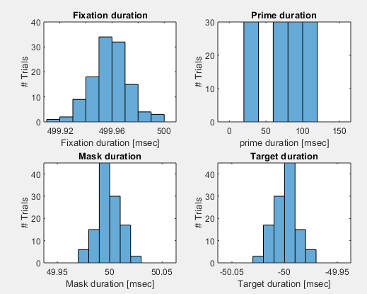

2.    Make sure the number of trials is as expected.

The function **verify_trial_num_all_subs** expects the following inputs:(i) the expected number of trials; (ii) the number of trials of each condition; (c) the number of characters to save from the file's name as the subject's name (for example if the file name you chose is “subject_12_my_cool_experiment.mat” and you just want the name ‘subject_12’ the number of characters is 10). The function counts the number of trials each participant had, and validates it is the right number. It further counts the amount of trials each participant had in the different conditions, and validates it is the right number.

If you call only this function (not using the “**check_trials_num_and_randomization”** script, see below) the input is as follows:

verify_trial_num_all_subs(120,15,9)

After running the function, matlab will ask you to choose the directory where subjects’ data is saved (for example “subjects for demo”)

Then, you will have to provide some inputs in the command window. Below is an example of the function input in the command window:

Input condition Name as string, if no more conditions enter 0: 'ISI'

Input condition Name as string, if no more conditions enter 0: 'Congruent'

Input condition Name as string, if no more conditions enter 0: 0

The output of this function will look like this:

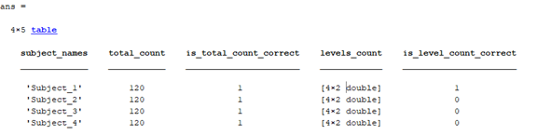

In the columns “is_total_count_correct” and “is_level_count_correct”, “1” denotes that the subject has the expected number of trials and “0” denotes that he/she hasn’t. And so, in the table above, though subjects have the correct number of trials across the entire experiment, this is not the case for the specific conditions for subjects 2-4.

The column “total_count” returns the number of trials over the entire experiment. In order to see the number of trials counted in each condition click on the “ans” variable:

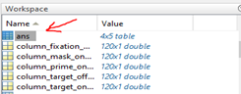

And check the “level_count” column:

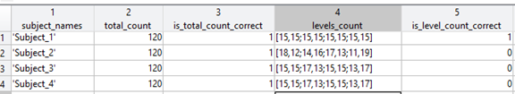

3.  Check randomization of trial order:  this function makes sure each subject has a different order of trials. The function again accepts the number of characters to save from the file's name as the subject's name. The function compares the division of conditions to trials between subjects to make sure each subject has a different order. Note that the code only inspects condition assignment; if your experiment also includes multiple stimuli (e.g., if you are using our ObScene stimulus bank), you should add a section that tests that the items are also differently ordered between subjects).

 If you call only this function (not from the “**check_trials_num_and_randomization”** script, see below) the input is as follows:

check_randomization(10)

After running the function, matlab will ask you to choose the directory with your subjects’ data (for example “subjects for demo”)

And then you will have to provide some inputs in the command window. Below is an example of the function input in the command window:

Input randomized condition Name as string: 'ISI'

 The output of this function is:

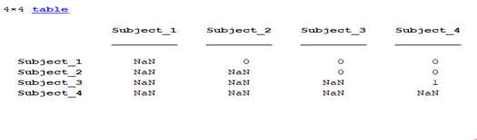

The value “1” represents the same order of trials for the two subjects represented by the row and the column.

In order to make things easier ,we’ve created a script that calls the functions mentioned above in sections 2 and 3, named “**check_trials_num_and_randomization**”. First, the script will ask you to choose the directory where subjects’ data is saved (for example “subjects for demo”).

Then, in the command window, you will be asked to provide the following information: the expected number of trials in the entire experiment, the expected number of trials in each condition, the names of the columns in the output file where the different conditions are coded, the name of the column of the randomized condition. Here is an example of a demo run:

Input the total amount of trials in your experiment (int): 120

Input the amount of trials expected in each condition (int): 15

how many characters to save from the name of the file as the subject name (int): 9

Input randomized condition name as string: 'ISI'

Input condition Name as string, if no more conditions enter 0: 'ISI'

Input condition Name as string, if no more conditions enter 0: 'Congruent'

Input condition Name as string, if no more conditions enter 0: 0

 The outputs are the same as if you run each function separately.

**Check list of all tests:**

* The instructions are presented in the right place
* The instructions are properly put with no typos
* The participant’s answers are correctly recorded
* The output contains all predefined columns (see a list above)
* The name of the columns is clear and indicative
* A separate file explains the meaning of each column
* Responses are properly recorded
* Reaction times are properly recorded
* Accuracy is properly recorded
* If EEG/Eye tracking: a separate file explains the meaning of each trigger
* Presentation times and duration are accurate (prime / masking/ stimuli, SOA are as expected): log files test
* Presentation times and duration are accurate (prime / masking/ stimuli, SOA are as expected): photodiode test
* The number of trials is as expected.
* Each condition contains the right amount of trials.
* Trial order differs between subjects
* If EEG/Eye tracking: check the triggers are accurate

4.7.4 Raw data

Remember you should always keep the raw data (the data you get after a subject completed the experiment, without any further processing) safe! There should be a designated folder named “raw data” in every experimental folder, where all the raw data is saved.

Make sure to back up the raw data after each running day (or even better- after every subject). Usually, we run the experiment locally; therefore, the data is not backed up automatically to the drive and we must remember to copy the data to the drive after every run.

**Chapter 5: Common Resources**

5.3 How to check that your experiment shows stimuli with good temporal accuracy

Author: Uri Korisky ([Uri.korisky@gmail.com](mailto:Uri.korisky@gmail.com))

When you present an experiment (especially using PsychoToolbox), correct timing of stimuli presentation is always an issue. The main bottleneck is the refresh rate of the screen, but other factors might play a role as well.

5.3.1 Programming rules

• In your PTB MATLAB code, include the following lines when initializing PsychToolbox. This can be anywhere before the presentation of the first stimulus:

Screen('Preference', 'SkipSyncTests', 0);

This line ensures that PTB carries out its synchronization tests. Without it, PTB reports about stimulus presentation timing might (and will probably) not be valid.

This function takes some time to run, ~60 seconds max, so if you’re debugging for any purpose other than checking stimuli presentation timings, you can pass “1” as the third parameter.

Screen('Preference', 'VisualDebugLevel', 4);

This line sets the graphics debugging of PTB to the highest level. It may throw way more errors and warnings than usual, and give you an idea of how problematic your code is. Again, if you don’t debug for timing at the moment, you can leave this at “1” or any other level that suits you.

• As a rule of thumb, load all your images and create all the needed textures **before** entering a loop for presenting the stimuli. You don’t need loading and processing times messing with your display accuracy.

5.3.2 Setting MATLAB to high priority

If you’re working on a desktop that is not completely dedicated to your experiment, you can never know what runs in the background, or which application might decide suddenly that it wants to update\synchronize\backup while your experiment is running. To avoid other programs from slowing down your experiment, start MATLAB with the (almost) highest priority so that windows will know not to disturb it:

1. Close all open instances of MATLAB.

2. From the start menu, type “cmd” in the search box. A DOS window will appear.

3. Type the following line and press ENTER:

start /HIGH <path_to_matlab>matlab.exe

where <path_to_matlab> is replaced with the path on your computer where the file “matlab.exe” for the version of MATLAB you want to run resides. For example in my computer the line for running MATLAB version 2013b would look like this:

start /HIGH C:/Progra~1/MATLAB/R2013b/bin/matlab.exe

Notice that in DOS environment all folder names must be 8 characters or shorter, so you might have to change “Program Files” to “Progra~1” etc.

Disconnect DropBox, to the very least! You can disconnect the computer from the net, physically, as well.