##### Event duration errors:

Sub1001 – trials4.xlsx – not a full run:

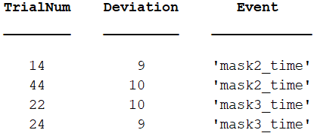

Sub1002 – trials8.xlsx – not a full run:

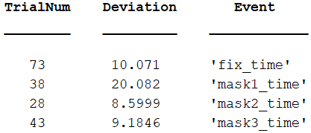

Sub1003 – trials6.xlsx – not a full run:

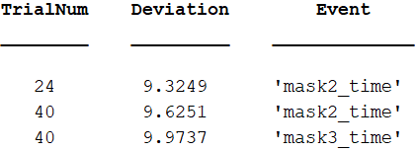

Sub1005 – trials4.xlsx – not a full run:

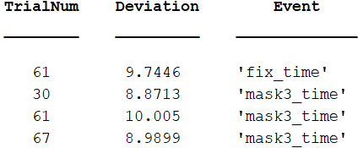

Sub1 – trials6.xlsx – full run:

------------------------------- Event Durations -------------------------------

Number of trials devaiting from desired duration:

64

Deviating trials and their deviation (in ms):

TrialNum Deviation Event

________ _________ ____________

1 20 'fix_time'

4 10.1 'fix_time'

1 10 'mask1_time'

1 60.1 'mask2_time'

2 20 'mask2_time'

3 10 'mask2_time'

5 10 'mask2_time'

12 10.1 'mask2_time'

14 10 'mask2_time'

29 10.1 'mask2_time'

32 10 'mask2_time'

103 10.4 'mask2_time'

108 10.1 'mask2_time'

131 10 'mask2_time'

150 10 'mask2_time'

151 10 'mask2_time'

161 10.1 'mask2_time'

169 10 'mask2_time'

201 10 'mask2_time'

207 10 'mask2_time'

241 10.1 'mask2_time'

259 10.1 'mask2_time'

299 10 'mask2_time'

300 10 'mask2_time'

315 10 'mask2_time'

323 10 'mask2_time'

357 9.9 'mask2_time'

360 10 'mask2_time'

365 10 'mask2_time'

379 10 'mask2_time'

1 19.9 'prime_time'

1 10.1 'mask3_time'

2 10 'mask3_time'

5 10 'mask3_time'

9 9.3 'mask3_time'

16 10 'mask3_time'

53 10 'mask3_time'

68 10 'mask3_time'

81 10.1 'mask3_time'

96 10 'mask3_time'

117 10 'mask3_time'

140 10 'mask3_time'

155 10 'mask3_time'

167 9.9 'mask3_time'

174 10 'mask3_time'

216 10 'mask3_time'

226 9.8 'mask3_time'

229 10.1 'mask3_time'

258 10 'mask3_time'

276 10 'mask3_time'

278 10.1 'mask3_time'

297 10 'mask3_time'

321 10 'mask3_time'

331 10 'mask3_time'

334 10 'mask3_time'

335 10 'mask3_time'

355 10 'mask3_time'

356 10 'mask3_time'

387 8.7 'mask3_time'

394 10 'mask3_time'

399 10 'mask3_time'

418 10 'mask3_time'

447 10.1 'mask3_time'

464 10 'mask3_time'

Deviations in ms:

Desired_duration Mean_duration STD Deviation_of_mean_from_desired

________________ _____________ _______ ______________________________

1000 1000.1 1.0281 0.077083

270 270.03 0.47673 0.030208

30 30.686 3.6271 0.68583

30 30.051 0.92482 0.05125

30 30.678 2.5245 0.67813

500 500.03 0.17702 0.027708

deviations: 0

deviation_of_mean: 1

std: 0

prime_alter: 1

data_values: 1

traj_values: 1

prime_target_common_letters: 1

prime_target_categor: 1

prime_dist_common_letters: 1

prime_dist_categor: 1

conditions: 1

word_dont_repeat: 1

block_count: 1

trial_count: 1

Sub1009 – trials9.xlsx – full run with full reaching distance:

