##### Event duration errors:

Sub1001 – trials4.xlsx – not a full run:

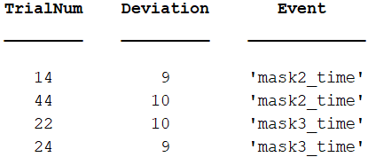

Sub1002 – trials8.xlsx – not a full run:

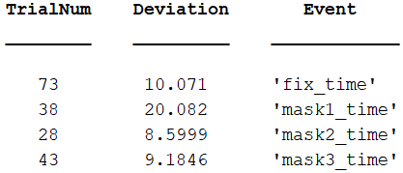

Sub1003 – trials6.xlsx – not a full run:

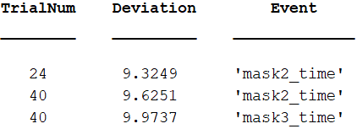

Sub1005 – trials4.xlsx – not a full run:

