**Before running read the SOP file in lab protocols!**

### Methods

#### Participants

30 right-handed students will be recruited as participants for the research.

#### Calibration

Each participant will perform a series of calibration trials in which she will reach from a starting point on the table to one of the dots representing the categories on the screen.

#### Stimuli

Forty 5-letter imageable Hebrew nouns with a frequency of at least 10 per million (Cite: <http://word-freq.mscc.huji.ac.il/>) will be used as primes and targets. Half will describe artificial products (e.g. radio, train) and half natural items (e.g. fruit). Target words will be written in typescript while prime words will be written in handwriting font. Masks will be composed of a semi-random combination of squares and diamonds whose line thickness is equal to the word's font, and will cover the central area of the screen where words can appear (approximately $2.5°× 1°$).

#### Procedure

Prime-target relation will be manipulated so that prime and target will be the same word on 50% of the trials. When prime and target are a different word, they will also belong to different categories (i.e. one natural and the other artificial) and will have no common letters in the same location. The experiment will include 4 blocks, each begins with 5 training trials followed by 120 test trials (60 trials for each type, randomly intermixed).Each trial will begin with a long mask (270ms) followed by a short forward mask (30ms), a prime (30ms), a backward mask (30ms) and a target (500ms). Then, subjects will be asked to determine if the visible target was artificial or natural as fast as they can. They will be then presented with the masked prime and a random distractor word from the noun list, belonging to the same category as the prime, yet not sharing any letter at the same location as the prime (masked word and random distractor’s positions randomly determined in each trial). They will be asked to determine which of the two words was presented, with no time constraint. Finally, subjects will use the Perceptual awareness scale task (PAS; cite: Ramsøy 2004 - Introspection and subliminal perception, Sandberg 2015 - Using the perceptual awareness scale PAS) to report prime visibility, where 1 denotes “I didn’t see anything,” 2 signifies “I had a vague perception of something but I don’t know what it was”, 3 represents “I saw a clear part of the word”, and 4 stands for “I saw the entire word clearly.”

Participants will respond using a touch screen, by lifting their right index finger from a starting point on the table and touching a dot under the selected answer on the screen. Categories in the categorization task will be assigned to different sides of the screen (counterbalanced between subjects).

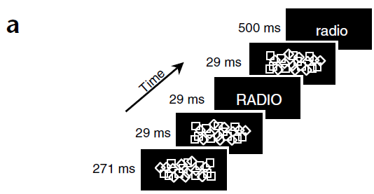

### Results

#### Target forced choice

Participants that will fail to reach 90% categorization accuracy probably did not understand the task correctly, thus will be excluded from analysis.

We expect repetition priming to shorten RTs (compared with non-repetition trials), both when fonts match and when they do not.

Response to natural items should be faster than artificial (cite: Dell'Acqua 1999 - Unconscious semantic priming from pictures)

#### Prime forced choice

We expect subjects' recognition forced choice response to be at chance level, otherwise we will conclude subject is conscious of prime.

Dehane = in exp 1 subs detected 7.1% of primed words, which was statistically not different

from new words detection (6%).

Exp 1 forced choice didn't differ from chance (52.9%, t=1.63, p>0.10).

Exp 2 dorced choice didn't differ from chance (53.6%, t=2.1, p>0.10).

#### Prime PAS

We will only include trials in which subjects’ visibility was rated as 1.

* ~~What happens when subjects get tired? Regarding PAS and regarding forced choice?~~

Guttman Yad-Brush

שדגשג