**Show some sensitivity! Using motion tracking to explore unconscious processes**

**Authors:** Khen Heller1; Craig S. Chapman2,3; Liad Mudrik1,4;

(1)Sagol School of Neuroscience, Tel Aviv University, Tel-Aviv, Israel,(2)Faculty of Kinesiology, Sport, and Recreation, University of Alberta, Edmonton, AB, Canada,(3)Neuroscience and Mental Health Institute, University of Alberta Edmonton, Alberta, Canada, (4)School of Psychological Sciences, Tel Aviv University, Tel-Aviv, Israel.

**Corresponding author:** Liad Mudrik; Tel Aviv University, PO Box 39040 Ramat Aviv Tel Aviv, 69978 Israel; mudrikli@tauex.tau.ac.il, 972-3-6409143.

## Abstract

Although invisible to us, unconsciously processed stimuli were shown to affect behavior. Yet the scope of these effects is widely debated, given contradicting findings. A possible explanation for this controversy might be the use of potentially insensitive measures, the most prominent being Response Times (RT), typically taken using keyboard presses. This measure only captures the final timing of the executed decision, but not the process of reaching it. Motion tracking, which has become a popular tool for unraveling cognitive processes, allows a richer, and arguably more sensitive, way to probe the effect of unconsciously processed stimuli. Thus far, this claim has only been directly tested in one study, which suffers from limitations both in its awareness and motion tracking measures. Here, we compared reaching responses and RTs in a variant of the classical lexical priming paradigm, while rigorously assessing awareness. In separate keyboard and reaching sessions, subjects classified the category of a target word that was preceded by an identical/different invisible prime. Both measures produced a congruency effect which, combined with the rigorous awareness testing, provided substantial evidence for the existence of unconscious word processing that cannot be easily refuted. However, unlike the previous finding, the unconscious effect in the motion tracking task was only slightly larger than in the keyboard task. We discuss possible explanations, while still highlighting the advantages of using motion tracking to probe subliminal processing.

## Introduction

Our brain continuously processes information arriving in parallel from a variety of stimuli, using different modalities (Kanwisher et al., 1997; Kappers & Bergmann Tiest, 2013; Poirier et al., 2005; Willander & Larsson, 2006). For example, upon seeing a ball flying in our direction, we process its trajectory and the likelihood of it hitting us. The produced results can lead to a change in behavior – like ducking the ball in this case (Aivar et al., 2008; von Hofsten & Lindhagen, 1979) – and/or to internal changes, like the induction of fear (Sawchuk et al., 2002; Siedlecka & Denson, 2019). Some of these processes are also accompanied by conscious experiences (Brown et al., 2019; Lamme & Roelfsema, 2000; Mashour et al., 2020; Tononi et al., 2016): I perceive the flying ball, and I experience the sense of fear. But this is not always the case: I might miss the ball altogether, for example if I am extremely occupied by a different engaging task (Hyman et al., 2009; Mack & Rock, 1998). Importantly however, I might still duck the ball following some automated response triggered by unconscious processing (Damian, 2001).

What differentiates between such conscious and unconscious processing? In the lab, studies try to answer this question by using different methods to render a stimulus invisible (for a review, see Breitmeyer, 2015; Kim & Blake, 2005). Typically, such manipulations of awareness involve some degradation of the stimulus (e.g, by manipulating its physical characteristics; Daltrozzo et al., 2011; Li et al., 2007; its temporal dynamics; Almeida et al., 2013; Dehaene et al., 1998; or the amount of attention allocated to it; Hyman et al., 2009; Mack & Rock, 1998). This almost inevitably leads to weaker neural responses to the stimulus (Dehaene et al., 1998; Yuval-Greenberg & Heeger, 2013), and – in turn – to small behavioral changes that are hard to detect (Greenwald et al., 1996). As a result, the field abounds with contradicting findings (Hesselmann & Knops, 2014; Kouider & Dehaene, 2007; Moors et al., 2016; Peters & Lau, 2015), which nourish an ongoing controversy about the scope of unconscious processing (Hassin, 2013; Hesselmann & Moors, 2015; Peters et al., 2017).

One point of disagreement concerns the extent of semantic processing without awareness (Abrams et al., 2002; Damian, 2001). Among other paradigms, it has often been studied using priming (Kouider & Dehaene, 2007). In a priming paradigm, the participant is asked to perform a certain task on a target stimulus (e.g., classify as word/non-word) that is preceded by a related/unrelated invisible prime stimulus. Typically, the participant's response is either facilitated or inhibited according to the congruency between the prime and the target. Such a congruency effect is often taken as evidence for the processing of the prime (e.g., Abrams et al., 2002; Finkbeiner et al., 2004). While some semantic priming studies found that invisible words can be processed up to the semantic level (Dell’Acqua & Grainger, 1999; Naccache & Dehaene, 2001), opposing studies failed to show any congruency effects (Pratte & Rouder, 2009). Similar controversies revolve around other types of processing: claims for arithmetic computations or reading being performed without awareness (Ric & Muller, 2012; Sklar et al., 2012) were challenged by failures to replicate (Moors & Hesselmann, 2018; Rabagliati et al., 2018), and a similar mixed picture emerged also for studies of processes like integration (Biderman & Mudrik, 2018; Mudrik et al., 2014).

How can these contradictory results be explained? One option is that they stem from methodological limitations of some of these studies. For example, the way consciousness is measured might strongly affect the obtained results: if the awareness measure is not sensitive enough to discover residual awareness, the researcher might falsely attribute unconscious processes to conscious processing (Pratte & Rouder, 2009; Sand & Nilsson, 2016).

On the other hand, unconscious processing might be underestimated due to insensitive measures of the unconscious effect. The most prominent measure for probing unconscious effects is response time, typically taken via keyboard presses (e.g., comparing RTs in the congruent vs. incongruent condition; Naccache et al., 2002; Naccache & Dehaene, 2001). Notably, RTs only index the end result of the response and do not provide insight into the process of formulating the final decision as it unfolds over time (Scherbaum et al., 2010). Thus, focusing on RTs might lead to losing rich information that could potentially unravel unconscious processing that would otherwise go unnoticed.

Motion tracking, on the other hand, provides such rich information. Already a popular tool for unraveling cognitive processes (Freeman et al., 2011) motion tracking might accordingly prove to be powerful also for detecting unconscious processes. Contrary to keyboard RTs, which produce a discrete value for each trial, motion tracking yields a continuous set of values that is better suited for tracking ongoing cognitive processes, allowing further insight into their development over time (e.g., Farmer et al., 2007; Freeman et al., 2008). Finally, the rich, continuous data afforded by motion tracking can be curated for various parameters that are not available when using non-continuous measures, and might reveal hidden effects. One such parameter is velocity, which was used, for example, to inspect participants' confidence in their answers (Dotan et al., 2018). Another parameter is Changes of Mind (COM), which are not possible to detect when responding with a keyboard, but are reflected in the trajectory when using motion tracking (e.g., Resulaj et al., 2009).

The ability to unravel cognitive conflicts and observe COM might be beneficial when studying unconscious processing, especially in priming paradigms that evoke conflicts between the prime and target. This was done in a handful of studies: two studies probed the level at which unconscious images are processed by asking participants to classify a target image preceded by an invisible prime of a person/animal using a reaching response, while movement was tracked. When the prime was incongruent with the target, reaching trajectories tended to deviate towards the incorrect answer (Experiment 1 in Finkbeiner & Friedman, 2011), thereby indicating that the semantic meaning of primes can be processed unconsciously (see also Finkbeiner et al., 2008; Friedman & Finkbeiner, 2010). A similar result was found for digits and letters classification (Experiment 2 in Finkbeiner & Friedman, 2011). Finally, another study used motion tracking to demonstrate the role of attention in facilitating priming: when participants judged a target digit as larger or smaller than 5, longer reach trajectories were observed when this target was preceded by an incongruent prime (compared to a congruent one), and this effect was larger when the participants attended to the prime (Xiao & Yamauchi, 2015).

Thus, motion tracking can be used to unravel unconscious processing as it unfolds, but are these effects indeed stronger than keyboard-RT ones? This question has hardly been studied. Two experiments combined motion tracking and keyboard RTs, yet without directly comparing them. In the first, a prime arrow pointing to the left/right/neutral direction was rendered invisible with meta-contrast masking, and participants were asked to choose to which side the mask was pointing. The task was first performed with a keyboard, revealing that prime-target congruency affects the response speed, and then with stylus tracking. In the stylus session, the stimulus was presented only after the participants initiated a movement toward the center, forcing them to correct their movement mid-way. The correcting movement's onset, length and velocity were influenced by the prime-target congruency, supporting the conclusion that subliminal stimuli can influence the ongoing execution of an already-prepared target-directed movement (Cressman et al., 2007). In the second study, the effect of unconscious dorsal – as opposed to ventral – processing on decisions was examined using a subliminal priming paradigm. Primes and targets were images of animals/tools that belonged to the same/different semantic category and had a similar/different shape (i.e., elongated/round) and therefore similar/different affordances. When responses were given via a keyboard, semantically congruent primes improved the response speed to the subsequent targets. While keyboard responses reflected a semantic priming effect, reaching movements, which were assumed to depend more heavily on dorsal processing, were used to examine if the dorsal stream elicits subliminal shape-related effects. Indeed, rounded animal primes caused a larger deviation from the elongated tool target compared with elongated animals. The researchers accordingly concluded that dorsal-stream processing contributes grasp-related information to decision-making processes (Almeida et al., 2014).

To date, only one study directly compared the strength of the effects revealed by keyboard presses and motion tracking (Xiao et al., 2015). In this study, participants classified two digits as identical/different by either pointing to the correct answer with the mouse or choosing it with the keyboard. The target digits were preceded by a positive/negative subliminal image which facilitated same/different responses, respectively. Critically, this effect was marginally significant when probed with a keyboard, but robust when measured via mouse tracking. Although this study indeed reinforces the above assumption, according to which motion tracking might be beneficial for unraveling unconscious processes, it also suffers from several limitations. First, awareness assessment was done in a separate block after the main task, with no online assessment of prime visibility on a single trial level. This is especially important since the visibility ratings of many participants were above zero, suggesting that the effect might have been driven by some conscious processing. In addition, performance was not tested against chance and was instead shown not to correlate with the congruency effect – a method that has been widely criticized (Malejka et al., 2021). Finally, the number of trials in the awareness task was 96, which might be underpowered for detecting awareness (Yaron et al., in press).

Furthermore, this study used mouse tracking, which might be less sensitive than reaching movements. Using a mouse requires participants to remap the real-world representation into 2D. Such 2D mapping constrains free movement (Desmurget et al., 1997), which can affect the trajectory and timing of the movements (Palluel-Germain et al., 2004), consequently suppressing the expression of cognitive conflicts. Indeed, when both measures were compared, reaching produced shorter reaching durations, larger curvatures, faster velocities and most importantly, it responded faster to changes of mind (Moher & Song, 2019). Reaching movements are also more intuitive than using a mouse, making them less effortful and possibly more likely to express fluctuations in the decision (Burk et al., 2014; Moher & Song, 2014). These properties accordingly suggest that reaching movements might be optimal for detecting fast and short-lasting processes such as unconscious priming effects (Greenwald et al., 1996).

The current study was aimed at testing the above hypothesis that motion tracking might be superior to the commonly used keyboard responses measure in detecting the effects of unconscious processing. To do so, both measures were compared on an identical priming task. This approach followed the one by Xiao et al. (2015) but replaced the mouse response with a more intuitive and less effortful reaching response that does not constrain free movement (Desmurget et al., 1997; Palluel-Germain et al., 2004). Additionally, it improved the validity of the unconscious results by applying a rigorous awareness detection procedure that included both an objective awareness measure (a 2-forced-choice recognition task conducted on the prime; Reingold & Merikle, 1988) and a subjective trial-by-trial awareness measure (Perceptual Awareness Scale; Ramsoy & Overgaard, 2004). As opposed to Xiao et al. (2015), which used an awareness measure on a separate block, here awareness was estimated in the trials of the main task. The priming paradigm emulated a classical study by Dehaene and colleagues (2001), in which participants were presented with a masked prime word followed by a visible identical/different target word. This task was chosen as it was supposed to evoke strong effects in a fairly simple design that probes identity priming. The participants were asked to perform a semantic judgment on the target word to determine if it describes a natural or artificial item. The reaching task was expected to express the congruency effect so that the average reaching trajectories of the incongruent trials would deviate toward the incorrect answer further than would the trajectories of the congruent trials. In addition, processing the contradictory information provided by the prime in incongruent trials should result in more frequent changes of mind than in congruent trials. In the keyboard task, the incongruent trials were expected to exhibit longer response times (RTs). In accordance with previous findings (Xiao et al., 2015; but see Dehaene et al., 2001, where a large effect was found using a keyboard), the effect found in the motion tracking session (namely, the reach area variable) was expected to be larger than the effect in the keyboard session (RT variable).

### Methods

#### Participants

Thirty participants were included in the experiment (17 females; age: M = 26.9, SD = 3.66, all right handed). Additional 15 participants were excluded for the following reasons: five because they had less than 70% correct answers in the target classification task according to a binomial test; seven since they had less than 25 valid trials in each condition; and three due to technical issues: one wore a reflective object that interfered with the motion tracking system's recordings, another for which the program crashed in the middle of the experiment, and one more who did not complete the experiment. All participants were native Hebrew speakers, with normal or corrected-to-normal vision, who declared having no neurological, attentional, or mental disorders. All participants signed a consent form and were explained that they could stop the experiment at any point if they wished to do so. They were reimbursed with course credit or cash payment. The experiment was approved by the Tel Aviv University ethics committee.

The sample size was determined following a power analysis based on the average effect of two pilot experiments that are not reported in this paper. The average effect size in those pilots was 0.88 (Cohen's d). The keyboard task's effect size was estimated to be around 30% smaller (Cohen's d = 0.61), in line with the hypothesis for a smaller RT effect, and in accordance with a previous study (Xiao et al., 2015, d=0.65, though see Dehaene et al., 2001, where the effect size was 0.8). To find such an effect with a power = 95% and α = 0.05, a sample of 30 participants was needed, based on G*Power (Faul et al., 2007, 2009).

#### Stimuli

One hundred 5-letter words were used as primes and targets. All words were imageable nouns with a frequency of at least 10 per million (Frost & Plaut, 2005). One half described artificial products (e.g., radio, train) and the other natural items (e.g., fruit). Target words were written in typescript, while prime words were written in a handwriting font

Stimuli order was dictated by a list that was randomly sampled (without replacement) out of twenty pre-composed lists of trial condition and stimuli in the experimental blocks and ten precomposed lists in the practice blocks. In each list, the order of words was pseudorandom, with the following constraints: (a) In the congruent condition the prime was identical to the target word; (b) In the incongruent condition, a prime which doesn't share letters in common locations with the target was selected from the alternative category (artificial/natural). For example, in the congruent condition, the word "phone" would be preceded by "PHONE", while in the incongruent condition it could be preceded by "GRASS"; (c) Half the trials were congruent and half incongruent; (d) Each word was equally frequent as a target at the congruent and incongruent conditions; (e) All words were used as targets the same number of times; (f) A target never repeated in the same block. Each prime was further paired with a random distractor from the same category (artificial/natural) to be used in the prime recognition task. The distractor shared no letters in common locations with the prime, so seeing one letter only sufficed for correct discrimination.

Masks were composed of a semi-random combination of squares and diamonds whose line thickness was equal to the word's font size, covering the central area of the screen where words can appear (approximately ). Forty words were used for the practice block, and the remaining sixty were used in the test blocks.

#### Apparatus

Stimuli were displayed on a VPIXX monitor (VIEWPixx /3D Lite LCD display and data acquisition system, version 3.7.6287) using Matlab R2020b (*MATLAB*, 2020) and Psychtoolbox 3.0.18 (Brainard, 1997). The monitor was set to full brightness at a resolution of 1920 x 1080 and a refresh rate of 100Hz with VPIXX's "Scanning backlight" feature turned on, to synchronize the stimulus display to the screen's refresh rate. A Perspex cover was placed over the screen to protect it. The cover was spray painted with a light layer of transparent matte lacquer to avoid reflections. The participants sat approximately 60cm away from the screen and placed their index finger on a marked starting point located on the table 35cm away from the screen, in line with its center. Stimuli were displayed 24cm above the table and the classification answers were displayed on each side of it, 20 cm apart (Figure 1). Participants wore a Velcro ring with a marker at the tip of their index finger. A touch was registered when the marker was 0.7cm away from the screen or closer. A system of 6 OptiTrack Flex 13 cameras by NaturalPoint, Inc. tracked the marker's location using Motive 2.3.0 software (*Motive*, 2021) at a sampling rate of 120Hz. The coordinates were broadcasted online to a NatNet client (*NatNet SDK*, 2021) and recorded with Matlab.

.

#### Procedure

Two main sessions were conducted on the same day with their order counterbalanced between participants: one session for keyboard response and the other for motion tracking, each included a practice block and six test blocks of 40 trials each (i.e., 40 practice trials and 240 test trials). Half the trials were congruent and half incongruent (pseudorandomly intermixed, as explained in the Stimuli section above). Breaks were given between blocks.

The procedure within each block closely followed the one used by Dehaene et al. (2001). Every trial consisted of a fixation cross (1000ms), a first mask (270ms), a second mask (30ms), a prime word (30ms), a third mask (30ms) and a target (500ms). Once the target was displayed, participants classified the target word as describing a natural/artificial item (Figure 1).

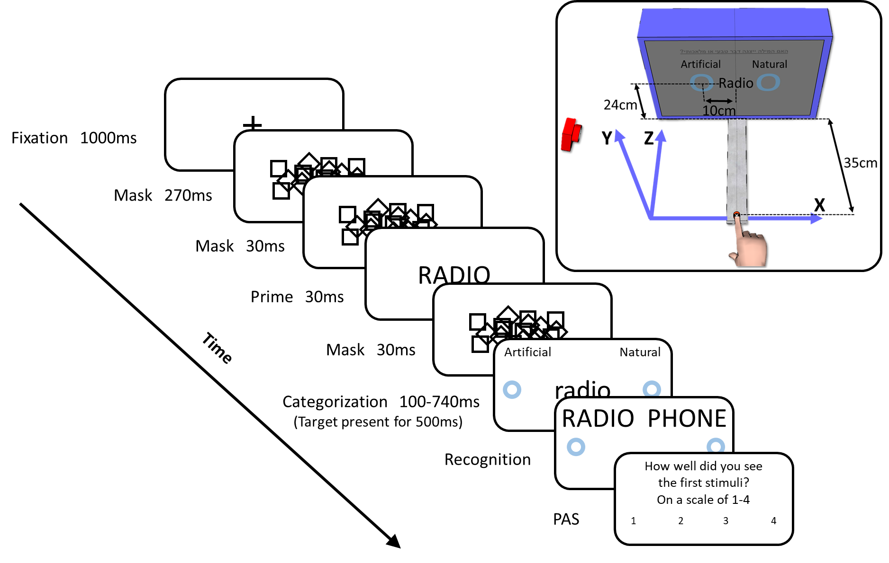

**1.**  and an Illustration of the Experimental Setup. Each trial was composed of a fixation cross (1000 ms), a first mask (270 ms), a second mask (30 ms), a prime word (30 ms), a third mask (30 ms), a classification task (100-740 ms, out of which the target was displayed for 500 ms), a recognition task (0-7000 ms) and a PAS task (no time limit). The blue circles appearing on the screen were presented as markers for the participants to know where they should touch in order to make their response. The circles and the Artificial/Natural category names were presented on the screen from the beginning of the trial, but for clarity purposes are presented here only after the last mask. The inset on the top right corner depicts a participant placing his finger on the starting point, which is located 35cm away from the screen. The target is positioned 24 cm above the starting point and the answers are placed on each of its sides, 20 cm apart. Z axis maps the path to and from the screen. X-axis maps the left and right directions. Y axis maps the up and down directions.

In the reaching session, this was done by selecting the side of the screen that contained the appropriate category. Following Gallivan & Chapman (2014), for the response to be valid, the finger had to leave the starting point within 100 ms-320 ms post target presentation and then reach the screen within 420 ms. The finger was defined as leaving the starting point when it was 1cm away from it (Euclidean distance), and as reaching the screen when it was 0.7cm from the screen (on the Z axis). Early or late initiations, as well as long durations, were followed by a "Too Early", "Too late" and "Too slow" feedback, respectively. The purpose of the "Too early" feedback was to prevent predictive responses, which are planned before the stimulus is displayed and are therefore less affected by it. To avoid interrupting the participant's movement, the "Too slow" feedback was given after the movement was completed.

In the keyboard task, the response to the target was given by pressing the "E"/"Y" keys with the left/right hand to select the left/right side. The response had to be given within a time window of 100-740 ms from the target display, otherwise a "Too Early"/ "Too Late" feedback was given.

After classifying the targets, the participants were asked to recognize the prime (i.e., an objective measure of prime awareness). Participants were presented with two words – the prime and a distractor word from the same category. Since the distractor word did not include any overlapping letters with the prime, consciously perceiving even one letter of the prime word should have sufficed for correctly identifying it, rendering the test sensitive. The response was given in an identical fashion to the target classification task, within a 7 seconds response window. Then, a subjective measure of prime awareness was taken using the PAS. Participants used the keyboard numbers 1-4 to rate how well they saw the prime (1 – "Didn't see anything", 2 – "Saw something vaguely, but can't say what it is", 3 – "Saw part of the prime clearly", 4 – "Saw the entire prime clearly"). Finally, in the reaching session, participants were asked to return their finger to the starting point.

Trials in which either a technical malfunction occurred, or a problematic response was given, as well as trials that had a visibility rating that is higher than one, were excluded from the analysis. A technical malfunction alludes to trajectories that had less than 100 ms of existing data or more than 100 ms of missing data, or trials in which the stimuli duration was incorrect. Problematic responses include incorrect answers and trajectories that missed the target by more than 12 cm, as well as reaching movements that were shorter – when measured along the Z-axis – than the distance between the starting point and the screen, minus a three-centimeter allowance that accounts for small variations in reaching onset. In both sessions, "Too Early" and "Too Late" trials were also defined as problematic trials. "Too Slow" trials, on the other hand, were excluded only if they were located more than 3 SD from the participant's average reaching duration among correct trials that were not too short, had no missing data and were completed in time (i.e., started between 100 ms and 320 ms after target display and lasted no longer than 420 ms). *Valid trials* were those that were not excluded due to any exclusion criteria.

#### Trajectory preprocessing

The preprocessing procedures followed those described in Gallivan & Chapman (2014). Missing values were interpolated using the inpaint_nans function (D’Errico, 2022) to fill gaps in the trajectory, which was then filtered with a low pass Butterworth filter (2nd order with cutoff at 8Hz) to reduce noise. The axis' origin was set at the first sample of each trial. To locate reaching onset, a low-pass butterworth filter (2nd order with a 10Hz cutoff) was applied to the 3D velocity. *Reaching onset* was defined as four consecutive samples having a velocity greater than 20mm/s and a total acceleration of at least 20mm/s2. *Reaching offset* was defined as the point along the trajectory that is closest to the screen. The trajectories were normalized to the distance traveled along the axis perpendicular to the screen (Z axis). To do so, a B-spline of the 6th order with a roughness penalty on the 4th derivative was fitted to each axis with a spline at every data point. The fitted function was used to produce a high-resolution representation of the trajectory (1000 samples) from which 200 points equally spaced along the traveled distance on the Z axis were extracted (e.g., if the participant moved 2cm forward and 1cm backward, the distance that was traveled was 3cm). These points represented the proportion of path traveled until each point. Finally, a *change of mind* was registered every time the implied endpoint crossed from one side of the screen to the other.

#### Analysis

All the comparisons between the congruent and incongruent conditions, throughout the entire manuscript, were corrected for multiple comparisons using the Tree-BH method (Supplementary Figure 1) suggested in Bogomolov et al. (2021). All reported p-values are the corrected ones. The normality of the residuals was tested with a QQ-plot, and a permutation test (Kohl, 2019) was used to assess differences in variables that did not pass the normality test (for a list of such variables see Supplementary Figure 2).

Three comments received from colleagues after the submission of the pre-registration document prompted additional exploratory analyses. The first addressed the high variability between participants which can obscure smaller but highly consistent effects. To tackle this issue, the discrete variables were normalized within participant. The second involved an analysis of the averaged non-normalized trajectories, with all trials trimmed to an identical length of 340ms. Ninety percent of the trials were 340ms long or longer, and the other 10% were excluded. To approximate the onset and offset of the congruency effect, the deviation from the center was estimated for each point in time. The third focused on the implied endpoint, which is held to be sensitive to changes in direction and should therefore reflect the participant's intentions earlier than the raw trajectory (Dotan & Dehaene, 2013). Implied endpoint was indicated by the intersection between the present tangent to the trajectory and the screen. The onset and offset of the congruency effect were estimated by conducting a t-test at every time point, and clustering together adjacent significant values of a similar sign. Then, a permutation and clustering procedure (Maris & Oostenveld, 2007) was conducted to evaluate the significance of the clusters and correct for multiple comparisons. Finally, the value was divided by two to correct for the permutation and clustering procedures performed (i.e., deviation from center and implied endpoint).

### Results

*Trial exclusion*

The number of excluded trials in the reaching task was higher than in the keyboard task (Mreach = 106.23, SDreach = 32.59, Mkeyboard = 50.2, SDkeyboard = 14.47, t(29) = 9.78, p < 0.001, 95% CI [44.31, 67.75], Cohen's d = 1.78). This difference stemmed from the late and early responses, but not from incorrect answers, which were significantly less common in the reaching task (Table 1).

Table 1

Comparison of the Number of Excluded Trials Between the Reaching Session and the Keyboard Session

|  |  |  |  |  |  |
| --- | --- | --- | --- | --- | --- |
|  | **Reaching** | **Keyboard** |  |  |  |
|  | **M (SD)** | **M (SD)** | **t(29)** | **p** | **CI** |
| **Early responses** | 23.26 (19.79) |  |  |  |  |
| **Late responses** | 32.06 (19.24) | 14.06 (10.33) | 4.71 | <0.001 | 10.19, 25.80 |
| **Slow movement** | 31.16 (20.94) |  |  |  |  |
| **Incorrect answers** | 21.90 (12.33) | 36.13 (15.29) | 6.31 | <0.001 | -18.84, -9.62 |
| *Note.* t(df) = t-test score, degrees of freedom are in parenthesis; p = p-value; CI = 95% confidence intervals. | | | | | |

*Prime visibility*

In the reaching session, 94.41% of the trials were given a visibility rating of 1, 4.80% a visibility rating of 2, 0.64% a visibility rating of 3 and 0.15% a visibility rating of 4, while in the keyboard session, 92.13% of them were given a visibility rating of 1, 7.04% a visibility rating of 2, 0.71% a visibility rating of 3 and 0.12% a visibility rating of 4. Because using identical prime and target words in the congruent condition biases the responses towards the target, only the incongruent trials were used to estimate prime visibility. Objective recognition performance for the subjectively invisible stimuli was not better than chance, both in the reaching session (M = 50.82%, SD = 4.32, t(29) = 1.03, p = 0.31, 95% CI = [49.20, 52.43]) and the keyboard session (M = 50.22%, SD = 4.55, t(29) = 0.26, p = 0.790, 95% CI = [48.52, 51.92]). Thus, both awareness measures indicate that the subjectively invisible stimuli were not consciously perceived (Figure 2).

Figure 2

*Objective Task Performance*

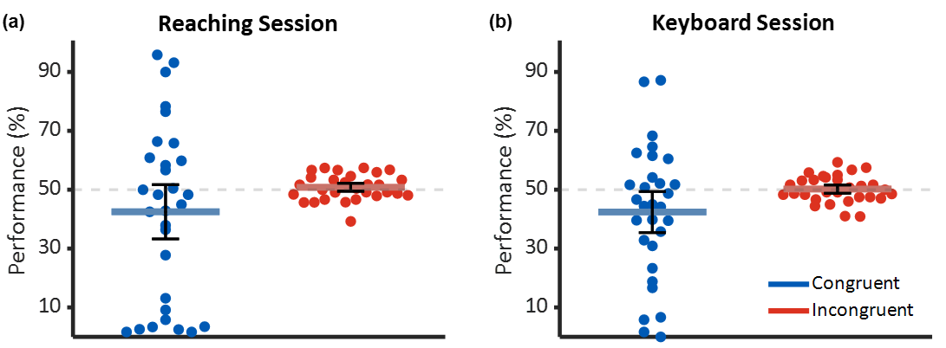

*Note.* Performance in the objective awareness task. Dots mark each participant's performance and the red/blue horizontal lines represent the average. Black error bars depict the CIs.

*Preregistered congruency effect*:

A congruency effect was found with both measures. In the reaching task, the reach area, which is the area confined between the average trajectory to the left side when the correct answer is on the left and the average trajectory to the right when the correct answer is on the right, was smaller in the incongruent condition. Since the average trajectories depict the bias but not the actual paths, panels (h-k) of Figure 3 describe the entire trajectories for two randomly selected participants. In the keyboard task, slower RTs were observed in the incongruent condition. A comparison of the effect sizes surprisingly revealed that the keyboard-RT effect (Cohen's d=1.17; Minc=545.46, SD=32.87, Mcon=525.53, SD=35.76, t(29)=6.42, p<0.001, CIs=-26.27, -13.58) was larger than the reach area effect (Cohen's d=0.68; Minc=1.74, SD=0.49, Mcon=2.09, SD=0.51, t(29)=3.75, p<0.001, CIs=0.15, 0.53). However, when normalizing the results within participants, reaching duration, which was longer for incongruent trials, produced a larger effect (Cohen's dnormalized reaching duration=1.25; Cohen’s d=1.17; Minc=429, SD=28.32, Mcon=415.88, SD=29.76, p<0.001, CIs=-17.08, -9.17) than the normalized keyboard-RT (Cohen's dnormalized keyboard RT=1.18). Furthermore, incongruent trials exhibited a greater traveled distance (Minc=39.09, SD=1.67) than congruent ones (Mcon=38.20, SD=1.44 t(29)=5.19, p<0.001, CIs=-1.25, -0.54; Cohen's d =0.94), determined by adding up the Euclidean distances between all adjacent samples within a single trial. On the other hand, reaching onset, defined as the time from stimulus presentation up to movement onset, did not differ between the conditions (Cohen's d=0.19; Minc=173.06, SD=23.95, Mcon=171.29, SD=22.42, p=0.318, CIs=-5.12, 1.58). Examination of the implied endpoint revealed that changes of mind occurred slightly more often in the incongruent condition (Minc=1.99, SD=0.48) than in the congruent one (Mcon=1.77, SD=0.40, p=0.02, CIs=-0.39, -0.05; Cohen's d=0.46).

Figure 3

*Results of the Pre-registered Analysis*

*Note.* a) Reaching trajectories in valid trials, averaged across participants. Shaded areas are the standard error (SE). (b-f) Results of the different measures taken in the experiments. Dots represent single-participant averages across valid trials, while the red/blue horizontal lines depict the average of all participants. Black error bars symbolize the SE (used here instead of CI since some of the variables did not distribute normally). Full/dashed grey lines represent a numerical incline/decline (respectively) between the congruent and incongruent conditions and asterisks indicate a significant difference (after correction for multiple comparisons). (h-k) Reaching trajectories of valid trials from two examples participants. Thin lines signify single trials while thick lines are the averages. Measures in the figure were not normalized within participant.

*Exploratory congruency effect:*

Although the average time-dependent trajectories deviated towards the incorrect answer in incongruent trials, the permutation-based cluster analysis determined that this bias was not statistically significant. The implied endpoint did reveal a significant congruency effect between 150-340 ms after movement onset (Figure 4), where congruent trials were more laterally oriented than incongruent trials (p = 0.001, Cohen's d = 0.71).

Figure 4

Results of the Exploratory Analysis



*Note.* Time-dependent x-coordinates and implied endpoint. Instead of normalizing the trajectories to the Z-axis, valid trials were trimmed to 340 ms and then averaged across participants. The shaded areas mark the CI while grey rectangles highlight the time range where a significant difference between the conditions was detected using the permutation and clustering procedure. The first 100 ms of the implied endpoint figure indicate participants tended to initiate their movement towards the left. This outcome may be attributed to a motor artifact caused by positioning the right reaching arm near the center of the body.

## Discussion

One of the key driving forces behind the long-lasting debate about the extent of unconscious processing (Hassin, 2013; Hesselmann & Moors, 2015; Michel, 2019; Peters et al., 2017) pertains to the weak effect sizes that are usually found in the field (Greenwald et al., 1996; Van den Bussche et al., 2009). The current study set out to examine if motion tracking could solve this problem by providing more sensitive measures that could potentially yield stronger effects (Xiao et al., 2015). To do so, motion tracking was introduced to a variant of the classical word repetition priming paradigm previously used by Dehaene et al. (2001). This allowed tracking participants' reaching responses as they performed a semantic judgment (i.e., determine whether the word described a natural item or a man-made artifact) on a visible target word that was preceded by an invisible prime. To compare reaching's sensitivity to more prominent measures, each participant completed an additional session using keyboard responses (session order counterbalanced).

Irrespective of the measure used, a large congruency effect was found. In the reaching session, presenting an incongruent prime biased the participant's responses towards the incorrect answer, resulting in average trajectories that curve towards the center of the screen. The area between these trajectories was smaller than between the congruent ones, providing quantifiable evidence for the invisible prime's effect on movement. Temporally, this effect can be placed approximately between 150-340 ms post target presentation, as depicted by the implied endpoint measurements (note however that this analysis should not be taken as evidence for the exact latency/offset of the effect; see Sassenhagen & Draschkow, 2019). The curved trajectories of the incongruent trials were longer than the congruent trajectories and took longer to complete, reflecting the prime's interference with the participant's decision-making. The results go beyond previous studies, as the current design included stringent awareness testing, with trial-by-trial subjective and objective measures, thereby addressing previous criticisms that attribute unconscious effects to residual undetected awareness (Lloyd et al., 2013; Merikle, 1992; Zerweck et al., 2021). Additionally, the unconscious effect could not result from regression to the mean of the awareness measurement (Shanks, 2017) since no participants were excluded for seeing the prime. To conclude, this experiment provides strong evidence for an unconscious word repetition effect, in line with previous studies reporting similar effects (yet with somewhat less strict awareness measures; Bodner & Masson, 1997, 2003; Dehaene et al., 2001; Forster & Davis, 1984).

Importantly, this experiment demonstrated how motion tracking can be beneficial to the study of unconscious processes. Unlike keyboard responses, which are one-dimensional and mark the outcome of the decision process, the reaching measure allows tracking the decision as it unfolds (Dotan et al., 2019; Freeman et al., 2011). Evidence that the decision occurs during the movement and not before is provided by the reaching onset and reaching duration measurements. Had the decision been made before the reaching was initiated, the prime-target congruency would have been expected to influence the onsets, which was not the case. Instead, a difference was found between the durations of the movements, confirming the assumption that the decision process coincides with the movement. Indeed, monitoring the decision process allows to capture interesting events such as changes of mind and online corrections of response, which were not expressed in the averaged trajectories. As expected, such indecisive behavior was more frequent in the incongruent condition (though not to a high degree). Chane of mind behavior is particularly interesting in priming experiments because it might reflect a strong conflict between the prime and the target. An additional advantage of this measure is that it unravels the otherwise hidden regrets and self-corrections during the trial, leading to a lower number of incorrect responses, as was indeed found in the reaching session compared with the keyboard one (though notably, there more trials were excluded due to early or late responses).

In line with our predictions, the effect size in the keyboard condition was smaller than that found for the reaching condition, though to a lesser extent than we expected. Notably, this advantage was evident in the reaching duration variable, rather than the anticipated reach area variable, and only when applying normalization. In addition, no difference was found between the keyboard effect and the reach area measure. This result does not align with the finding of Xiao et al. (2015), which suggested a dramatic advantage for mouse tracking over keyboard responses. This discrepancy might stem from the different forms of movement tracking used in each study; while the current experiment used camera-based motion tracking for reaching movements, Xiao and colleagues have used mouse tracking, which might turn out to be more sensitive than reaching responses. This is surprising given that reaching is held to be more intuitive than mouse pointing since it places fewer constraints on movements (Desmurget et al., 1997; Palluel-Germain et al., 2004) and accordingly is expected to express more variability between conditions. Additionally, previous findings showed that reaching responds faster and with greater curvatures to changes of mind than mouse tracking (Moher & Song, 2019).

Another difference between the current study and Xiao et al. (2015) pertains to the dependent variable. While the current study used the reach area measure, which is calculated on the average trajectories with a single value per participant, Xiao et al. used AUC, which is computed separately for each trial. The latter accordingly includes more information on the variance that is lost when averaging trajectories over trials. However, a post hoc analysis that estimated the AUC measure for the current data revealed similar effect size to that produced by the reach area measure (see Supplementary Table 1). Thus, this difference in analysis approaches cannot explain the differential results.

A more critical difference between the studies pertains to the awareness measures in the two studies. Xiao et al. (2015) assessed the contribution of awareness by examining the correlation between the objective visibility of the prime and the size of the congruency effect. This type of analysis has been shown to inflate unconscious effects since the correlation measurement is limited by the reliability of either of the variables (Vadillo et al., 2022). Furthermore, visual examination of the reported d' in that work reveals that the masking procedure was actually ineffective in rendering the prime completely invisible (as for most participants, d’ was higher than 0), allowing it to be consciously perceived. Thus, it seems plausible that the reported effect is mainly driven by consciously processed primes, which might affect movements to a larger extent than unconscious ones and could account for the large effect found by Xiao and colleagues.

Finally, the discrepancy between the studies could also be accidental. It is plausible that one set of reported results is erroneous, thereby calling for further investigations of the relation between reaching and keyboard responses. One way by which such studies could go beyond the current work would be to use a dynamic starting condition, in which the stimuli are presented only after the movement was initiated. This paradigm has been shown to increase movement consistency and curvature and decrease the amount of noise (Scherbaum & Kieslich, 2018). Moreover, it will decrease the number of excluded trials, as no trials will be excluded due to early or late responses. This could potentially increase the signal-to-noise ratio in the reaching task and allow reaching to unravel a larger congruency effect.

Assuming the results obtained here are genuine, one could go beyond the discrepancy between them and those reported by Xiao et al. (2015) and ask how can they be explained. That is, why was the movement tracking's effect only slightly larger than that of the keyboard response? One possible explanation concerns the larger amount of noise that was observed in the reaching measure. Specifically, reaching movements are more complex than a simple keypress as they could potentially be affected by a multitude of parameters that do not influence keypresses (e.g., trajectory planning, muscle exhaustion, arm length and posture, and so forth). A larger amount of free parameters leaves more room for variability when executing the response, which, in turn, might obscure the congruency effect. This notion is supported by the larger relative standard deviation (Everitt & Skrondal, 2010) observed in the reaching area (SD = 1.45) compared to the keyboard RT (SD = 0.85). In addition, the SNR was further decreased in the reaching session due to the higher number of excluded trials.

An alternative explanation for the results proceeds from the short-lived nature of unconscious effects (Greenwald et al., 1996). As reaching responses are a relatively long ongoing procedure, they might be less affected by short-lived effects. However, this interpretation does not align with the cluster-based permutation results which show that the primes exerted their effects approximately until 340ms post reaching onset, extending over 80% of the average reaching duration (422ms). On the contrary, the length of the response window used in the current experiment was relatively short and could potentially account for the outstanding effects that were found here. Unconscious effects have been shown to diminish over time and therefore be largest for short RTs (Avneon & Lamy, 2019). Indeed, a comparison of the current study's keyboard session with the original study by Dehaene et al. (Dehaene et al., 2001) reveals that although a similar experimental procedure was used, here the observed RT was approximately 80ms shorter and the effect size was larger. Taken together, these results stress the importance of short response windows in experiments that probe unconscious processes.

Large effects such as those exhibited here are uncommon to unconscious priming experiments (Van den Bussche et al., 2009). Implementing a more difficult task to the keyboard condition is expected to reduce the effect size (Pratte & Rouder, 2009), though its effect on the reaching condition is yet to be discovered. If the reaching task proves to be less susceptible to the effect of task difficulty, it would provide further evidence of its superiority over the keyboard measure.

To conclude, although only a small advantage in effect size was found for motion tracking, this study does suggest that it might be a fruitful venue for future research. First, the effects are comparable to – and sometimes larger than – those found when using a keyboard response measure of unconscious processing. Second, it provides rich data and online sensitivity that is not possible with a keyboard measure. This opens the gate for delving into the temporal aspects of unconscious effects on behavior. When taken together, these results should encourage researchers to further explore the features and potential of movement tracking as a tool for studying unconscious processes. New analyses and parameters should be devised and extracted from the trajectory data to potentially expand our knowledge of processes taking place without consciousness.

## Declarations

### Funding

This study was funded by the CIFAR Brain, Mind, and Consciousness program.

### Conflicts of interest

All authors declare that they have no conflicts of interest.

### Ethics approval

Approval was granted by the Ethics Committee of Tel Aviv University (02/01/2022, Ethics approval No. 1-0004328).

### Consent to participate

All participants signed an informed consent to participate in the study.

### Consent for publication

Informed consent to publish their data was received from each of the participants.

### Availability of data and materials

This study was preregistered (<https://osf.io/8dsvp>), its materials and data are available in the GitHub repository, [ref].

### Code availability

All the scripts used to produce this experiment and analyze its results are available at [ref to GitHub].

### Acknowledgments

We would like to thank Prof. Jason Friedman and Dr. Dror Dotan for their valuable insights and professional advice in analyzing the acquired data. We further express our gratitude to Uri Korisky for guidance and troubleshooting when implementing the OptiTrack motion tracking system.

In addition, we would like to acknowledge the codes we used to produce our graphs and perform certain computations; We applied "stdshade" (Musall, 2022) to plot the SE around our trajectories in Figure 3 and Figure 4 and "plotSpread" (Jonas, 2020) to produce the averages distribution in Figure 2 and Figure 3. "invprctile" (Shrestha, 2014) was used to estimate the clusters' p-value, while "myBinomTest" (Nelson, 2015) was used to test participant's performance in the main task and the objective awareness task.

L.M. is CIFAR Tanenbaum Fellow in the Brain, Mind, and Consciousness program.

## Supplementary materials

Supplementary Figure 1

*Tree-BH Method's Tree Hierarchy, Used to Correct for Multiple Comparisons*

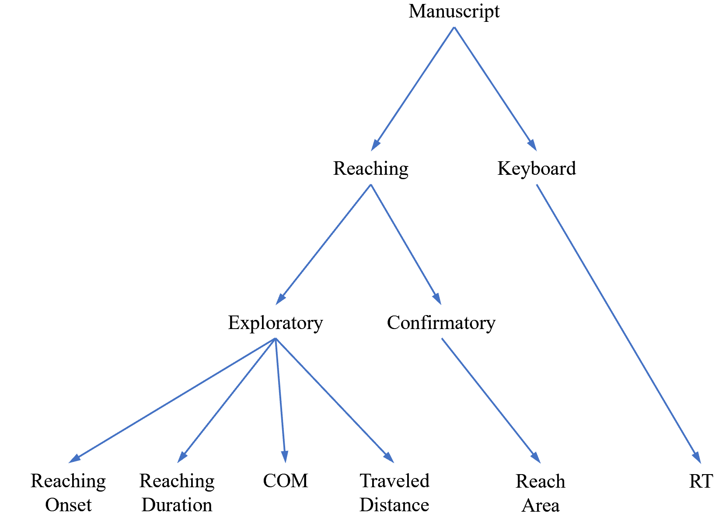

**Supplementary Figure 2**

*QQ-plots for the Dependent Variables that Violated the Normality Assumption*

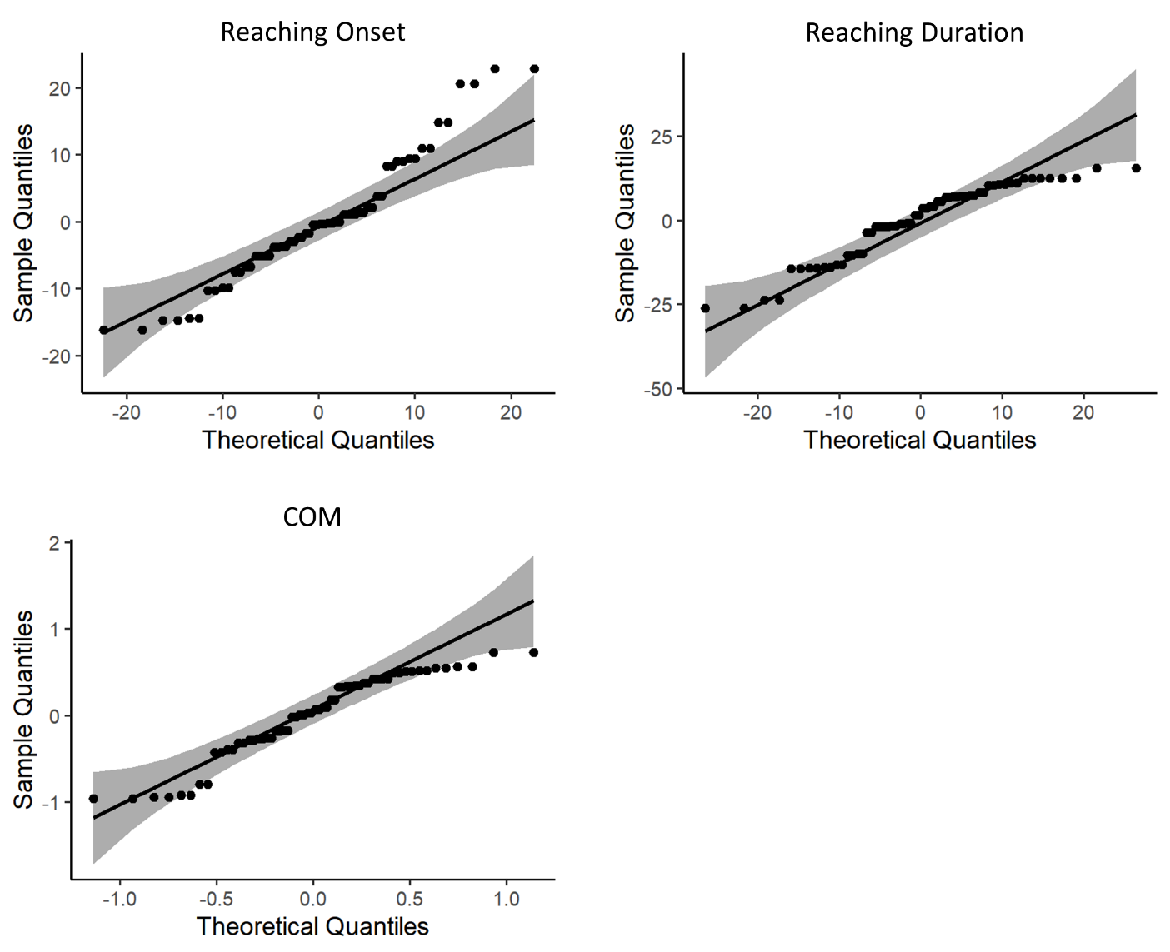

Supplementary Table 1

*Congruency Effect in the Reaching Session, Measured with AUC*

|  |  |  |  |  |  |  |
| --- | --- | --- | --- | --- | --- | --- |
|  | **Congruent** | **Incongruent** |  |  |  |  |
|  | **M (SD)** | **M (SD)** | **t(29)** | **p-value** | **CI** | **d** |
| **AUC** | 0.75 (0.22) | 0.92 (0.26) | 3.91 | <0.001 | -0.25, -0.08 | 0.71 |
| *Note.* t(df) = t-test score. Degrees of freedom are in parenthesis; CI = 95% confidence intervals; d = Cohen's d. | | | | | | | |

## References

Abrams, R. L., Klinger, M. R., & Greenwald, A. G. (2002). Subliminal words activate semantic categories (not automated motor responses). *Psychonomic Bulletin & Review*, *9*(1), 100–106. https://doi.org/10.3758/BF03196262

Aivar, M. P., Brenner, E., & Smeets, J. B. J. (2008). Avoiding moving obstacles. *Experimental Brain Research*, *190*(3), 251–264. https://doi.org/10.1007/s00221-008-1475-9

Almeida, J., Mahon, B. Z., Zapater-Raberov, V., Dziuba, A., Cabaço, T., Marques, J. F., & Caramazza, A. (2014). Grasping with the eyes: The role of elongation in visual recognition of manipulable objects. *Cognitive, Affective, & Behavioral Neuroscience*, *14*(1), 319–335. https://doi.org/10.3758/s13415-013-0208-0

Almeida, J., Pajtas, P. E., Mahon, B. Z., Nakayama, K., & Caramazza, A. (2013). Affect of the unconscious: Visually suppressed angry faces modulate our decisions. *Cognitive, Affective, & Behavioral Neuroscience*, *13*(1), 94–101. https://doi.org/10.3758/s13415-012-0133-7

Avneon, M., & Lamy, D. (2019). Do semantic priming and retrieval of stimulus-response associations depend on conscious perception? *Consciousness and Cognition*, *69*, 36–51. https://doi.org/10.1016/j.concog.2019.01.010

Biderman, N., & Mudrik, L. (2018). Evidence for Implicit—But Not Unconscious—Processing of Object-Scene Relations. *Psychological Science*, *29*(2), 266–277. https://doi.org/10.1177/0956797617735745

Bodner, G. E., & Masson, M. E. J. (1997). Masked Repetition Priming of Words and Nonwords: Evidence for a Nonlexical Basis for Priming. *Journal of Memory and Language*, *37*(2), 268–293. https://doi.org/10.1006/jmla.1996.2507

Bodner, G. E., & Masson, M. E. J. (2003). Beyond spreading activation: An influence of relatedness proportion on masked semantic priming. *Psychonomic Bulletin & Review*, *10*(3), 645–652. https://doi.org/10.3758/BF03196527

Bogomolov, M., Peterson, C. B., Benjamini, Y., & Sabatti, C. (2021). Hypotheses on a tree: New error rates and testing strategies. *Biometrika*, *108*(3), 575–590. https://doi.org/10.1093/biomet/asaa086

Brainard, D. H. (1997). The Psychophysics Toolbox. *Spatial Vision*, *10*(4), 433–436. https://doi.org/10.1163/156856897X00357

Breitmeyer, B. G. (2015). Psychophysical “blinding” methods reveal a functional hierarchy of unconscious visual processing. *Consciousness and Cognition*, *35*, 234–250. https://doi.org/10.1016/j.concog.2015.01.012

Brown, R., Lau, H., & LeDoux, J. E. (2019). Understanding the Higher-Order Approach to Consciousness. *Trends in Cognitive Sciences*, *23*(9), 754–768. https://doi.org/10.1016/j.tics.2019.06.009

Burk, D., Ingram, J. N., Franklin, D. W., Shadlen, M. N., & Wolpert, D. M. (2014). Motor Effort Alters Changes of Mind in Sensorimotor Decision Making. *PLoS ONE*, *9*(3), e92681. https://doi.org/10.1371/journal.pone.0092681

Cressman, E. K., Franks, I. M., Enns, J. T., & Chua, R. (2007). On-line control of pointing is modiﬁed by unseen visual shapes. *Consciousness and Cognition*, 11.

Daltrozzo, J., Signoret, C., Tillmann, B., & Perrin, F. (2011). Subliminal Semantic Priming in Speech. *PLoS ONE*, *6*(5), e20273. https://doi.org/10.1371/journal.pone.0020273

Damian, M. F. (2001). Congruity effects evoked by subliminally presented primes: Automaticity rather than semantic processing. *Journal of Experimental Psychology: Human Perception and Performance*, *27*(1), 154–165. https://doi.org/10.1037/0096-1523.27.1.154

Dehaene, S., Naccache, L., Clec’H, G. L., Koechlin, E., Mueller, M., & Dehaene-Lambertz, G. (1998). *Imaging unconscious semantic priming*. *395*, 4.

Dehaene, S., Naccache, L., Cohen, L., Bihan, D. L., Mangin, J.-F., Poline, J.-B., & Rivière, D. (2001). Cerebral mechanisms of word masking and unconscious repetition priming. *Nature Neuroscience*, *4*(7), 752–758. https://doi.org/10.1038/89551

Dell’Acqua, R., & Grainger, J. (1999). Unconscious semantic priming from pictures. *Cognition*, *73*(1), B1–B15. https://doi.org/10.1016/S0010-0277(99)00049-9

D’Errico, J. (2022). *Inpaint_nans*. MATLAB Central File Exchange. https://www.mathworks.com/matlabcentral/fileexchange/4551-inpaint_nans

Desmurget, M., Jordan, M., Prablanc, C., & Jeannerod, M. (1997). Constrained and Unconstrained Movements Involve Different Control Strategies. *Journal of Neurophysiology*, *77*(3), 1644–1650. https://doi.org/10.1152/jn.1997.77.3.1644

Dotan, D., & Dehaene, S. (2013). How do we convert a number into a finger trajectory? *Cognition*, *129*(3), 512–529. https://doi.org/10.1016/j.cognition.2013.07.007

Dotan, D., Meyniel, F., & Dehaene, S. (2018). On-line confidence monitoring during decision making. *Cognition*, *171*, 112–121. https://doi.org/10.1016/j.cognition.2017.11.001

Dotan, D., Pinheiro-Chagas, P., Al Roumi, F., & Dehaene, S. (2019). Track It to Crack It: Dissecting Processing Stages with Finger Tracking. *Trends in Cognitive Sciences*, *23*(12), 1058–1070. https://doi.org/10.1016/j.tics.2019.10.002

Eriksen, C. W. (1960). Discrimination and learning without awareness: A methodological survey and evaluation. *Psychological Review*, *67*(5), 279–300. https://doi.org/10.1037/h0041622

Everitt, B. S., & Skrondal, A. (2010). *The Cambridge dictionary of statistics*. http://196.43.179.6:8080/xmlui/handle/123456789/1213

Farmer, T. A., Cargill, S. A., Hindy, N. C., Dale, R., & Spivey, M. J. (2007). Tracking the Continuity of Language Comprehension: Computer Mouse Trajectories Suggest Parallel Syntactic Processing. *Cognitive Science*, *31*(5), 889–909. https://doi.org/10.1080/03640210701530797

Faul, F., Erdfelder, E., Buchner, A., & Lang, A.-G. (2009). Statistical power analyses using G*Power 3.1: Tests for correlation and regression analyses. *Behavior Research Methods*, *41*(4), 1149–1160. https://doi.org/10.3758/BRM.41.4.1149

Faul, F., Erdfelder, E., Lang, A.-G., & Buchner, A. (2007). G*Power 3: A flexible statistical power analysis program for the social, behavioral, and biomedical sciences. *Behavior Research Methods*, *39*(2), 175–191. https://doi.org/10.3758/BF03193146

Finkbeiner, M., Forster, K., Nicol, J., & Nakamura, K. (2004). The role of polysemy in masked semantic and translation priming. *Journal of Memory and Language*, *51*(1), 1–22. https://doi.org/10.1016/j.jml.2004.01.004

Finkbeiner, M., & Friedman, J. (2011). The Flexibility of Nonconsciously Deployed Cognitive Processes: Evidence from Masked Congruence Priming. *PLoS ONE*, *6*(2), e17095. https://doi.org/10.1371/journal.pone.0017095

Finkbeiner, M., Song, J.-H., Nakayama, K., & Caramazza, A. (2008). Engaging the motor system with masked orthographic primes: A kinematic analysis. *Visual Cognition*, *16*(1), 11–22. https://doi.org/10.1080/13506280701203838

Forster, K. I., & Davis, C. (1984). Repetition priming and frequency attenuation in lexical access. *Journal of Experimental Psychology: Learning, Memory, and Cognition*, *10*, 680–698. https://doi.org/10.1037/0278-7393.10.4.680

Freeman, J. B., Ambady, N., Rule, N. O., & Johnson, K. L. (2008). Will a category cue attract you? Motor output reveals dynamic competition across person construal. *Journal of Experimental Psychology: General*, *137*, 673–690. https://doi.org/10.1037/a0013875

Freeman, J. B., Dale, R., & Farmer, T. A. (2011). Hand in Motion Reveals Mind in Motion. *Frontiers in Psychology*, *2*. https://doi.org/10.3389/fpsyg.2011.00059

Friedman, J., & Finkbeiner, M. (2010). Temporal dynamics of masked congruence priming: Evidence from reaching trajectories. *Proceedings of the 9th Conference of the Australasian Society for Cognitive Science*, 98–105. https://doi.org/10.5096/ASCS200916

Frost, R., & Plaut, D. (2005). *The word-frequency database for printed Hebrew*. http://word-freq.huji.ac.il/index.html

Gallivan, J. P., & Chapman, C. S. (2014). Three-dimensional reach trajectories as a probe of real-time decision-making between multiple competing targets. *Frontiers in Neuroscience*, *8*. https://doi.org/10.3389/fnins.2014.00215

Greenwald, A. G., Draine, S. C., & Abrams, R. L. (1996). Three Cognitive Markers of Unconscious Semantic Activation. *Science*, *273*(5282), 1699–1702. https://doi.org/10.1126/science.273.5282.1699

Hannula, D. E., Simons, D. J., & Cohen, N. J. (2005). Imaging implicit perception: Promise and pitfalls. *Nature Reviews. Neuroscience*, *6*(3), 247–255. https://doi.org/10.1038/nrn1630

Hassin, R. R. (2013). Yes It Can: On the Functional Abilities of the Human Unconscious. *Perspectives on Psychological Science*, *8*(2), 195–207. https://doi.org/10.1177/1745691612460684

Hesselmann, G., & Knops, A. (2014). No conclusive evidence for numerical priming under interocular suppression. *Psychological Science*, *25*(11), 2116–2119. https://doi.org/10.1177/0956797614548876

Hesselmann, G., & Moors, P. (2015). Definitely maybe: Can unconscious processes perform the same functions as conscious processes? *Frontiers in Psychology*, *6*. https://doi.org/10.3389/fpsyg.2015.00584

Hyman, I. E., Boss, S. M., Wise, B. M., McKenzie, K. E., & Caggiano, J. M. (2009). Did you see the unicycling clown? Inattentional blindness while walking and talking on a cell phone. *Applied Cognitive Psychology*, *24*(5), 597–607. https://doi.org/10.1002/acp.1638

Jonas. (2020). *PlotSpread* (Version 1.2.0.0) [Source code]. https://www.mathworks.com/matlabcentral/fileexchange/37105-plot-spread-points-beeswarm-plot

Kanwisher, N., McDermott, J., & Chun, M. M. (1997). The Fusiform Face Area: A Module in Human Extrastriate Cortex Specialized for Face Perception. *Journal of Neuroscience*, *17*(11), 4302–4311. https://doi.org/10.1523/JNEUROSCI.17-11-04302.1997

Kappers, A. M. L., & Bergmann Tiest, W. M. (2013). Haptic perception. *Wiley Interdisciplinary Reviews: Cognitive Science*, *4*(4), 357–374. https://doi.org/10.1002/wcs.1238

Kim, C.-Y., & Blake, R. (2005). Psychophysical magic: Rendering the visible ‘invisible.’ *Trends in Cognitive Sciences*, *9*(8), 381–388. https://doi.org/10.1016/j.tics.2005.06.012

Kohl, M. (2019). *MKinfer: Inferential Statistics* (0.7). http://www.stamats.de

Kouider, S., & Dehaene, S. (2007). Levels of processing during non-conscious perception: A critical review of visual masking. *Philosophical Transactions of the Royal Society B: Biological Sciences*, *362*(1481), 857–875. https://doi.org/10.1098/rstb.2007.2093

Lagnado, D. A., Newell, B. R., Kahan, S., & Shanks, D. R. (2006). Insight and strategy in multiple-cue learning. *Journal of Experimental Psychology: General*, *135*(2), 162–183. https://doi.org/10.1037/0096-3445.135.2.162

Lamme, V. A. F., & Roelfsema, P. R. (2000). The distinct modes of vision offered by feedforward and recurrent processing. *Trends in Neurosciences*, *23*(11), 571–579. https://doi.org/10.1016/S0166-2236(00)01657-X

Li, W., Moallem, I., Paller, K. A., & Gottfried, J. A. (2007). Subliminal Smells can Guide Social Preferences. *Psychological Science*, *18*(12), 1044–1049. https://doi.org/10.1111/j.1467-9280.2007.02023.x

Lloyd, D. A., Abrahamyan, A., & Harris, J. A. (2013). *Brain-Stimulation Induced Blindsight: Unconscious Vision or Response Bias?* e82828. https://doi.org/10.1371/journal.pone.0082828

Mack, A., & Rock, I. (1998). Inattentional blindness: Perception without attention. In *Visual attention* (pp. 55–76). Oxford University Press.

Macmillan, N. A., & Creelman, C. D. (2004). *Detection Theory: A User’s Guide* (2nd ed.). Psychology Press. https://doi.org/10.4324/9781410611147

Malejka, S., Vadillo, M. A., Dienes, Z., & Shanks, D. R. (2021). Correlation analysis to investigate unconscious mental processes: A critical appraisal and mini-tutorial. *Cognition*, *212*, 104667. https://doi.org/10.1016/j.cognition.2021.104667

Maris, E., & Oostenveld, R. (2007). Nonparametric statistical testing of EEG- and MEG-data. *Journal of Neuroscience Methods*, *164*(1), 177–190. https://doi.org/10.1016/j.jneumeth.2007.03.024

Mashour, G. A., Roelfsema, P., Changeux, J.-P., & Dehaene, S. (2020). Conscious Processing and the Global Neuronal Workspace Hypothesis. *Neuron*, *105*(5), 776–798. https://doi.org/10.1016/j.neuron.2020.01.026

*MATLAB* (9.9.0.14677003 (R2020b)). (2020). The MathWorks Inc.

Merikle, P. M. (1992). Perception without awareness: Critical issues. *American Psychologist*, *47*, 792–795. https://doi.org/10.1037/0003-066X.47.6.792

Michel, M. (2019). Consciousness Science Underdetermined: A Short History of Endless Debates. *Ergo, an Open Access Journal of Philosophy*, *6*(20201214). https://doi.org/10.3998/ergo.12405314.0006.028

Michel, M. (2022). How (not) to underestimate unconscious perception. *Mind & Language*, *n/a*(n/a). https://doi.org/10.1111/mila.12406

Moher, J., & Song, J.-H. (2014). Perceptual decision processes flexibly adapt to avoid change-of-mind motor costs. *Journal of Vision*, *14*(8), 1–1. https://doi.org/10.1167/14.8.1

Moher, J., & Song, J.-H. (2019). A comparison of simple movement behaviors across three different devices. *Attention, Perception, & Psychophysics*, *81*(7), 2558–2569. https://doi.org/10.3758/s13414-019-01856-8

Moors, P., Boelens, D., van Overwalle, J., & Wagemans, J. (2016). Scene integration without awareness: No conclusive evidence for processing scene congruency during continuous flash suppression. *Psychological Science*, *27*, 945–956. https://doi.org/10.1177/0956797616642525

Moors, P., & Hesselmann, G. (2018). A critical reexamination of doing arithmetic nonconsciously. *Psychonomic Bulletin & Review*, *25*(1), 472–481. https://doi.org/10.3758/s13423-017-1292-x

*Motive* (2.3.0). (2021). NaturalPoint, Inc. https://optitrack.com/software/motive/

Mudrik, L., Faivre, N., & Koch, C. (2014). Information integration without awareness. *Trends in Cognitive Sciences*, *18*(9), 488–496. https://doi.org/10.1016/j.tics.2014.04.009

Musall, S. (2022). *Stdshade* (Version 1.40.0.1) [Source code]. https://www.mathworks.com/matlabcentral/fileexchange/29534-stdshade

Naccache, L., Blandin, E., & Dehaene, S. (2002). Unconscious Masked Priming Depends on Temporal Attention. *Psychological Science*, *13*(5), 416–424. https://doi.org/10.1111/1467-9280.00474

Naccache, L., & Dehaene, S. (2001). Unconscious semantic priming extends to novel unseen stimuli. *Cognition*, *80*(3), 215–229. https://doi.org/10.1016/S0010-0277(00)00139-6

*NatNet SDK* (4.0.0). (2021). NaturalPoint, Inc. https://optitrack.com/software/motive/

Nelson, M. (2015). *MyBinomTest* (Version 2.0.0.0) [Source code]. https://www.mathworks.com/matlabcentral/fileexchange/24813-mybinomtest-s-n-p-sided

Newell, B. R., & Shanks, D. R. (2014). Unconscious influences on decision making: A critical review. *Behavioral and Brain Sciences*, *37*, 1–18. https://doi.org/10.1017/S0140525X12003214

Ogilvie, R., & Carruthers, P. (2014). Better tests of consciousness are needed, but skepticism about unconscious processes is unwarranted. *Behavioral and Brain Sciences*, *37*(1), 36–37. https://doi.org/10.1017/S0140525X13000800

Palluel-Germain, R., Boy, F., Orliaguet, J. P., & Coello, Y. (2004). Visual and motor constraints on trajectory planning in pointing movements. *Neuroscience Letters*, *372*(3), 235–239. https://doi.org/10.1016/j.neulet.2004.09.045

Peters, M. A. K., Kentridge, R. W., Phillips, I., & Block, N. (2017). Does unconscious perception really exist? Continuing the ASSC20 debate. *Neuroscience of Consciousness*, *2017*(1). https://doi.org/10.1093/nc/nix015

Peters, M. A. K., & Lau, H. (2015). *Human observers have optimal introspective access to perceptual processes even for visually masked stimuli*. 30.

Phillips, W. A., & Baddeley, A. D. (1971). Reaction time and short-term visual memory. *Psychonomic Science*, *22*(2), 73–74. https://doi.org/10.3758/BF03332500

Poirier, C., Collignon, O., DeVolder, A. G., Renier, L., Vanlierde, A., Tranduy, D., & Scheiber, C. (2005). Specific activation of the V5 brain area by auditory motion processing: An fMRI study. *Cognitive Brain Research*, *25*(3), 650–658. https://doi.org/10.1016/j.cogbrainres.2005.08.015

Pratte, M. S., & Rouder, J. N. (2009). A task-difficulty artifact in subliminal priming. *Attention, Perception, & Psychophysics*, *71*(6), 1276–1283. https://doi.org/10.3758/APP.71.6.1276

Rabagliati, H., Robertson, A., & Carmel, D. (2018). The importance of awareness for understanding language. *Journal of Experimental Psychology: General*, *147*(2), 190. https://doi.org/10.1037/xge0000348

Reingold, E. M., & Merikle, P. M. (1988). Using direct and indirect measures to study perception without awareness. *Perception & Psychophysics*, *44*(6), 563–575. https://doi.org/10.3758/BF03207490

Reingold, E. M., & Merikle, P. M. (1990). On the Inter-relatedness of Theory and Measurement in the Study of Unconscious Processes. *Mind & Language*, *5*(1), 9–28. https://doi.org/10.1111/j.1468-0017.1990.tb00150.x

Resulaj, A., Kiani, R., Wolpert, D. M., & Shadlen, M. N. (2009). Changes of mind in decision-making. *Nature*, *461*(7261), Article 7261. https://doi.org/10.1038/nature08275

Ric, F., & Muller, D. (2012). Unconscious addition: When we unconsciously initiate and follow arithmetic rules. *Journal of Experimental Psychology: General*, *141*, 222–226. https://doi.org/10.1037/a0024608

Sand, A., & Nilsson, M. E. (2016). Subliminal or not? Comparing null-hypothesis and Bayesian methods for testing subliminal priming. *Consciousness and Cognition*, *44*, 29–40. https://doi.org/10.1016/j.concog.2016.06.012

Sandberg, K., & Overgaard, M. (2015). Using the perceptual awareness scale (PAS). In M. Overgaard (Ed.), *Behavioral Methods in Consciousness Research* (pp. 181–196). Oxford University Press. https://doi.org/10.1093/acprof:oso/9780199688890.003.0011

Sandberg, K., Timmermans, B., Overgaard, M., & Cleeremans, A. (2010). Measuring consciousness: Is one measure better than the other? *Consciousness and Cognition*, *19*(4), 1069–1078. https://doi.org/10.1016/j.concog.2009.12.013

Sassenhagen, J., & Draschkow, D. (2019). Cluster-based permutation tests of MEG/EEG data do not establish significance of effect latency or location. *Psychophysiology*, *56*(6), e13335. https://doi.org/10.1111/psyp.13335

Sawchuk, C. N., Lohr, J. M., Westendorf, D. H., Meunier, S. A., & Tolin, D. F. (2002). Emotional responding to fearful and disgusting stimuli in specific phobics. *Behaviour Research and Therapy*, *40*(9), 1031–1046. https://doi.org/10.1016/S0005-7967(01)00093-6

Scherbaum, S., Dshemuchadse, M., Fischer, R., & Goschke, T. (2010). How decisions evolve: The temporal dynamics of action selection. *Cognition*, *115*(3), 407–416. https://doi.org/10.1016/j.cognition.2010.02.004

Scherbaum, S., & Kieslich, P. J. (2018). Stuck at the starting line: How the starting procedure influences mouse-tracking data. *Behavior Research Methods*, *50*(5), 2097–2110. https://doi.org/10.3758/s13428-017-0977-4

Shanks, D. R. (2017). Regressive research: The pitfalls of post hoc data selection in the study of unconscious mental processes. *Psychonomic Bulletin & Review*, *24*(3), 752–775. https://doi.org/10.3758/s13423-016-1170-y

Shrestha, D. L. (2014). *Invprctile* (Version 1.2.0.0) [Source code]. https://www.mathworks.com/matlabcentral/fileexchange/41131-inverse-percentiles-of-a-sample

Siedlecka, E., & Denson, T. F. (2019). Experimental Methods for Inducing Basic Emotions: A Qualitative Review. *Emotion Review*, *11*(1), 87–97. https://doi.org/10.1177/1754073917749016

Sklar, A. Y., Levy, N., Goldstein, A., Mandel, R., Maril, A., & Hassin, R. R. (2012). Reading and doing arithmetic nonconsciously. *Proceedings of the National Academy of Sciences*, *109*(48), 19614–19619. https://doi.org/10.1073/pnas.1211645109

Spivey, M. J., Grosjean, M., & Knoblich, G. (2005). Continuous attraction toward phonological competitors. *Proceedings of the National Academy of Sciences of the United States of America*, *102*(29), 10393–10398. https://doi.org/10.1073/pnas.0503903102

Tononi, G., Boly, M., Massimini, M., & Koch, C. (2016). Integrated information theory: From consciousness to its physical substrate. *Nature Reviews Neuroscience*, *17*(7), 450–461. https://doi.org/10.1038/nrn.2016.44

Vadillo, M. A., Malejka, S., Lee, D. Y. H., Dienes, Z., & Shanks, D. R. (2022). Raising awareness about measurement error in research on unconscious mental processes. *Psychonomic Bulletin & Review*, *29*(1), 21–43. https://doi.org/10.3758/s13423-021-01923-y

Van den Bussche, E., Van den Noortgate, W., & Reynvoet, B. (2009). Mechanisms of masked priming: A meta-analysis. *Psychological Bulletin*, *135*(3), 452–477. https://doi.org/10.1037/a0015329

von Hofsten, C., & Lindhagen, K. (1979). Observations on the development of reaching for moving objects. *Journal of Experimental Child Psychology*, *28*(1), 158–173. https://doi.org/10.1016/0022-0965(79)90109-7

Willander, J., & Larsson, M. (2006). Smell your way back to childhood: Autobiographical odor memory. *Psychonomic Bulletin & Review*, *13*(2), 240–244. https://doi.org/10.3758/BF03193837

Xiao, K., & Yamauchi, T. (2015). Subliminal semantic priming in near absence of attention: A cursor motion study. *Consciousness and Cognition*, *38*, 88–98. https://doi.org/10.1016/j.concog.2015.09.013

Xiao, K., Yamauchi, T., & Bowman, C. (2015). *Assessing Masked Semantic Priming: Cursor Trajectory versus Response Time Measures*. 7.

Yuval-Greenberg, S., & Heeger, D. J. (2013). Continuous Flash Suppression Modulates Cortical Activity in Early Visual Cortex. *Journal of Neuroscience*, *33*(23), 9635–9643. https://doi.org/10.1523/JNEUROSCI.4612-12.2013

Zerweck, I. A., Kao, C.-S., Meyen, S., Amado, C., von Eltz, M., Klimm, M., & Franz, V. H. (2021). Number processing outside awareness? Systematically testing sensitivities of direct and indirect measures of consciousness. *Attention, Perception, & Psychophysics*, *83*(6), 2510–2529. https://doi.org/10.3758/s13414-021-02312-2