## Design

## Modeling

#### Reach area

The area circumscribed by the average left trajectory and the average right trajectory.

Has a single value for each subject.

Results when using subjects as a random factor in Exp 2:

#### X Position

~~Deviation from the center line on the X axis, at each point along the Z axis.~~

It should be deviation but currently it is the actual X value. Which isn't good since the center isn't 0.

200 values for each trial.

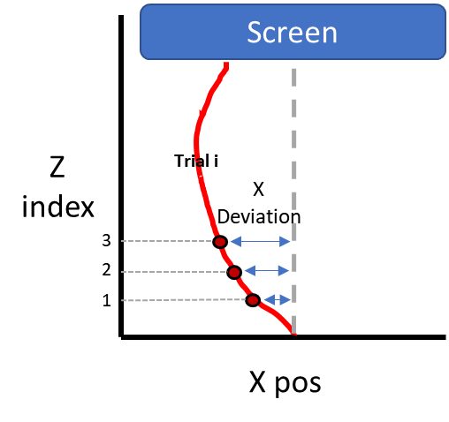

Results with subjects as a random factor in Exp 2:

#### MAD

Maximal absolute deviation.

The biggest distance from the optimal trajectory.

Produced for each trial.

#### AUC

Area circumscribed by the "optimal path" and the actual path.

There are 2 versions:

* Use only the area that exceeds the optimal path towards the unselected answer.
* Area that exceeds the optimal path towards the unselected answer is considered positive, while area that exceeds towards the selected answer is considered negative.

Produced for each trial.

### Questions

Are in Trello 🡪 Exp 4 – PreReg 🡪 Consultation with statistics center.