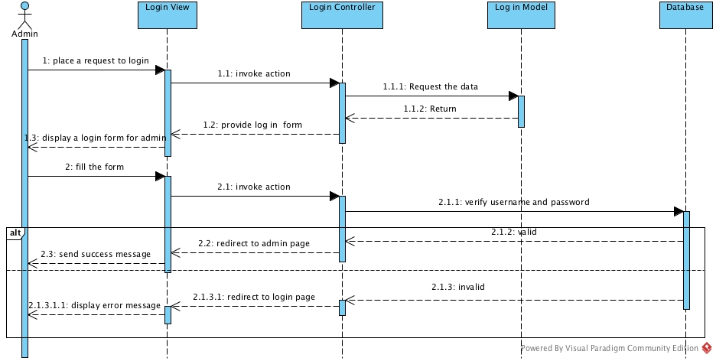

*Admin can login to Wat ChaiMongkol website as an admin.*

*Sequence diagram of “Wat ChaiMongKol” SD-25*

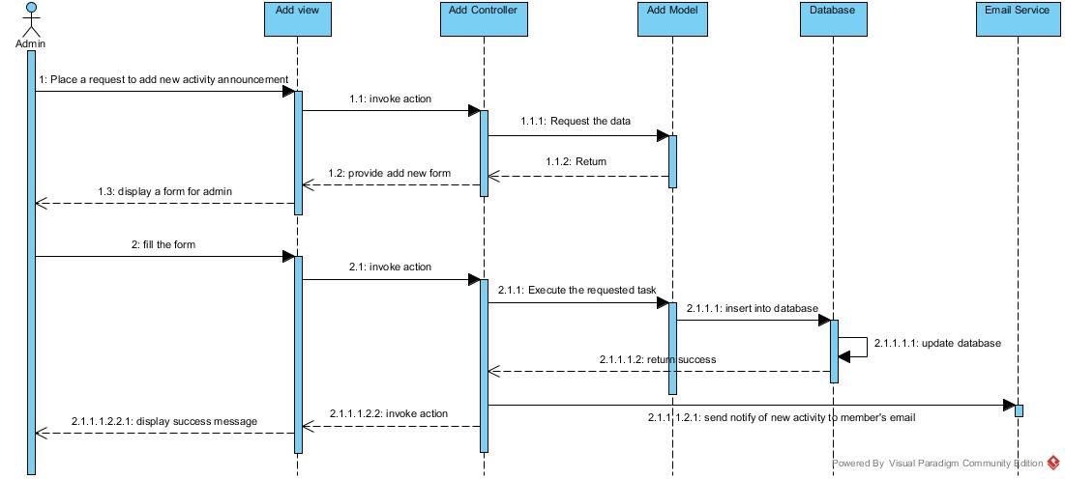

*Admin can add new activity announcement*

*Sequence diagram of “Wat ChaiMongKol” SD-26*

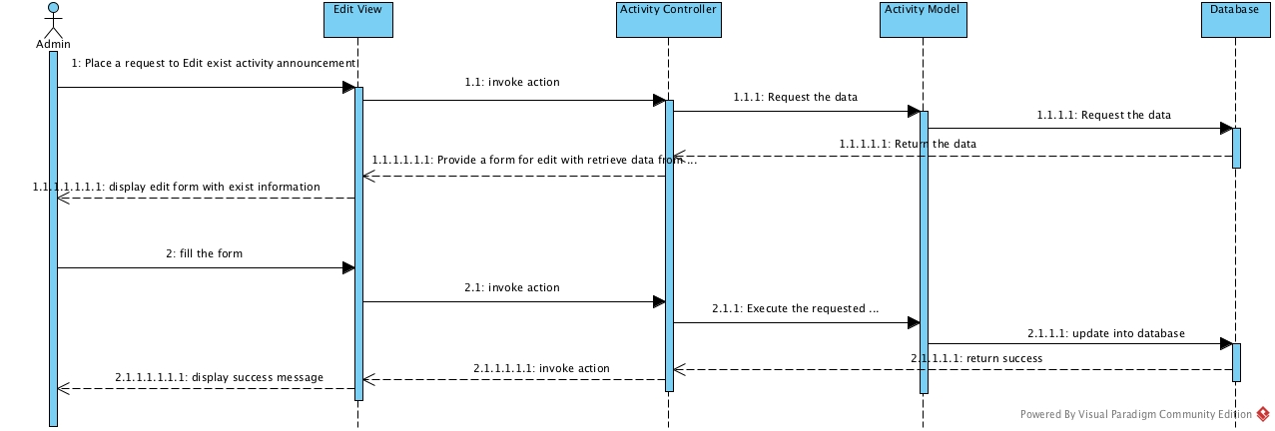

*Admin can edit exist activity announcement*

*Sequence diagram of “Wat ChaiMongKol” SD-27*

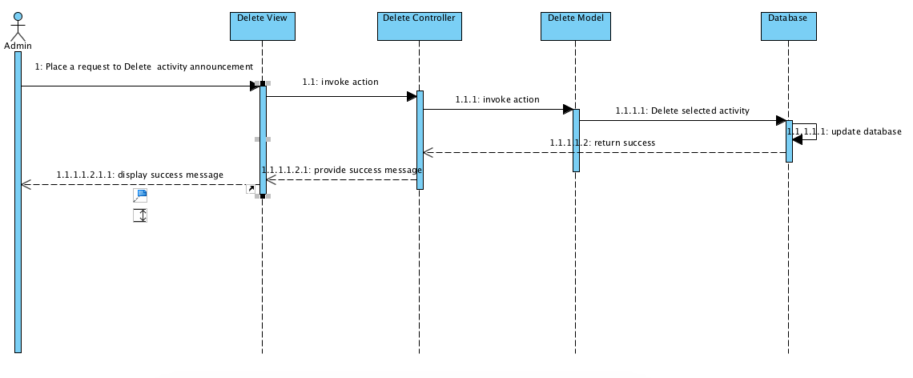

*Admin can delete the temple’s activity.*

*Sequence diagram of “Wat ChaiMongKol” SD-28*

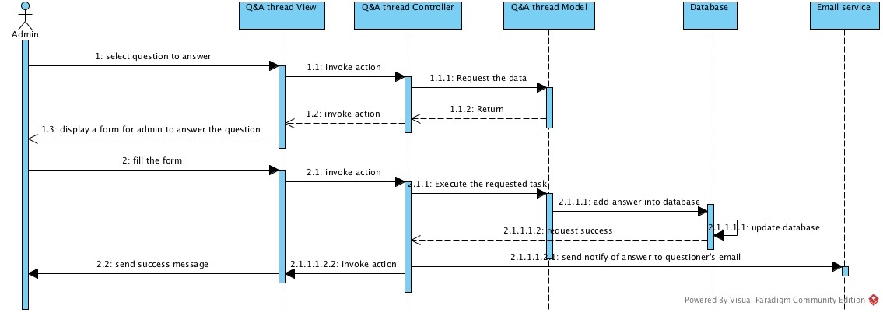

*Admin can answer the Dharma question in Q&A thread.*

*Sequence diagram of “Wat ChaiMongKol” SD-29*

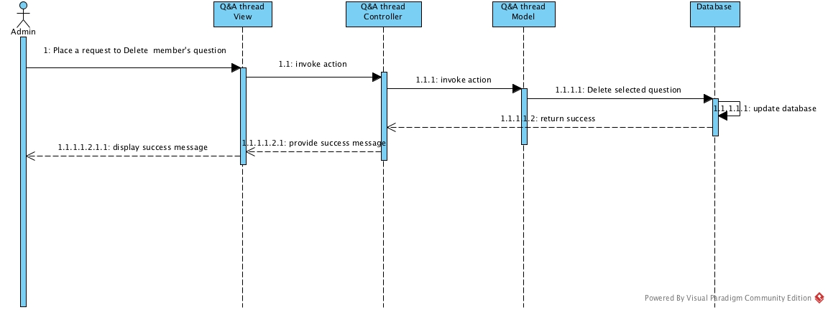

*Admin can delete the Dharma question in Q&A thread.*

*Sequence diagram of “Wat ChaiMongKol” SD-30*

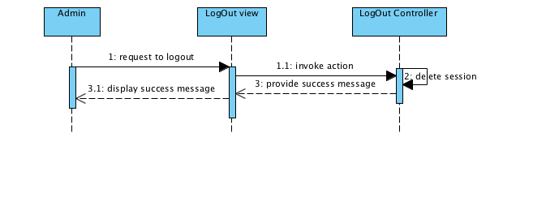

*Admin can can log out off the system.*

*Sequence diagram of “Wat ChaiMongKol” SD-31*

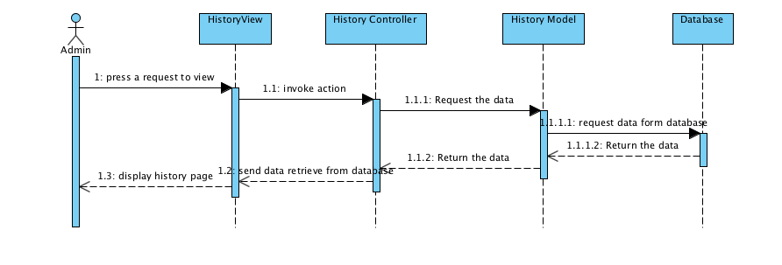

*Admin can view the temple’s history.*

*Sequence diagram of “Wat ChaiMongKol” SD-32*

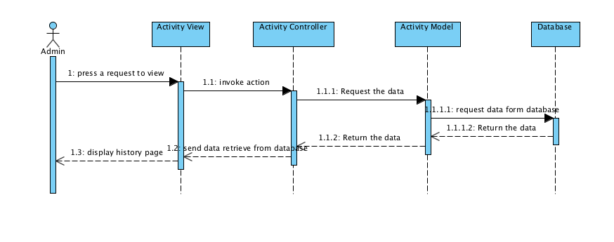

*Admin can view the activity announcement****.***

*Sequence diagram of “Wat ChaiMongKol” SD-33*

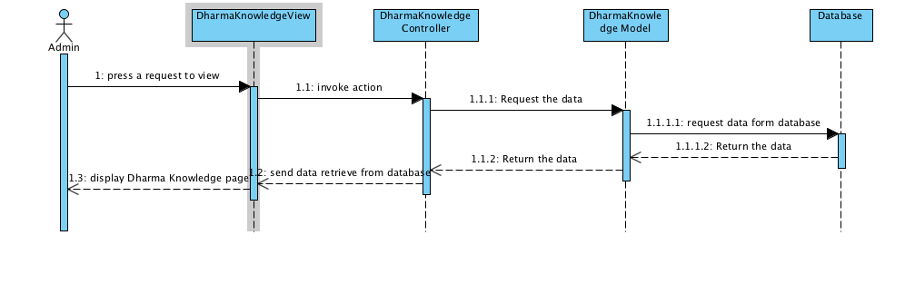

*Admin can view Dharma Knowledge*

*Sequence diagram of “Wat ChaiMongKol” SD-34*

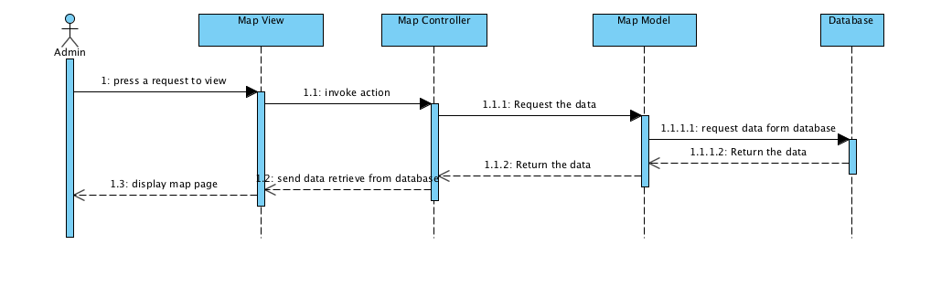

*Admin can view the map of the temple.*

*Sequence diagram of “Wat ChaiMongKol” SD-35*

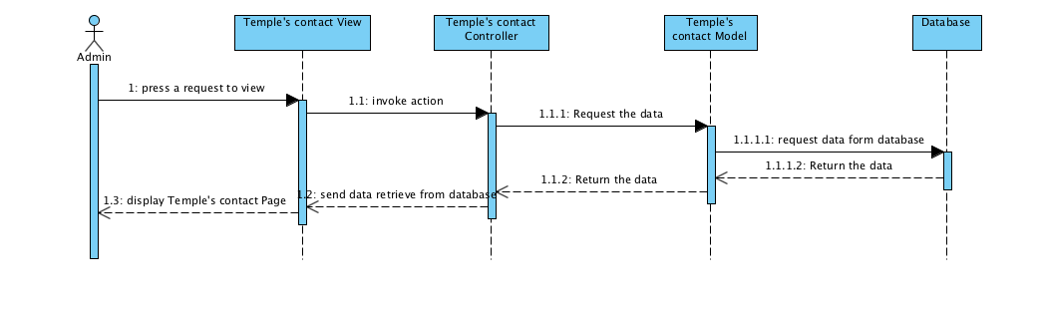

*Admin can view the temple’s contact information.*

*Sequence diagram of “Wat ChaiMongKol” SD-36*

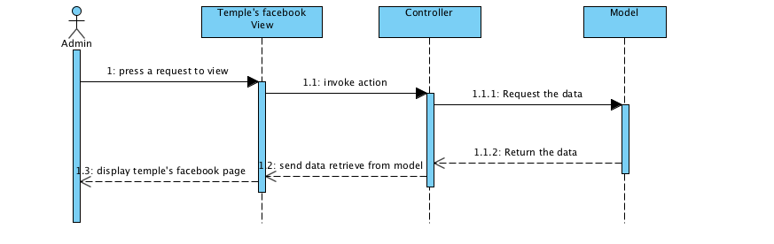

*Admin can link directly to the temple’s facebook page.*

*Sequence diagram of “Wat ChaiMongKol” SD-37*

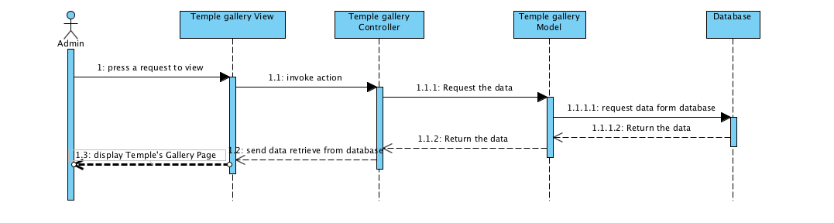

*Admin can view the temple’s gallery.*

*Sequence diagram of “Wat ChaiMongKol” SD-38*

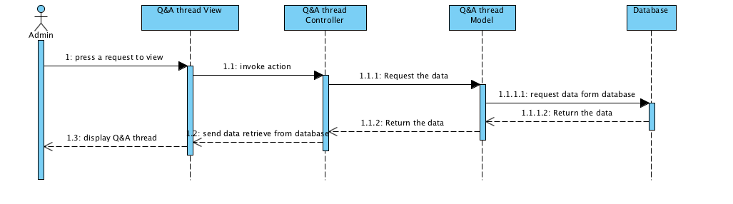

*Admin can view the Dharma Q&A thread*

*Sequence diagram of “Wat ChaiMongKol” SD-39*

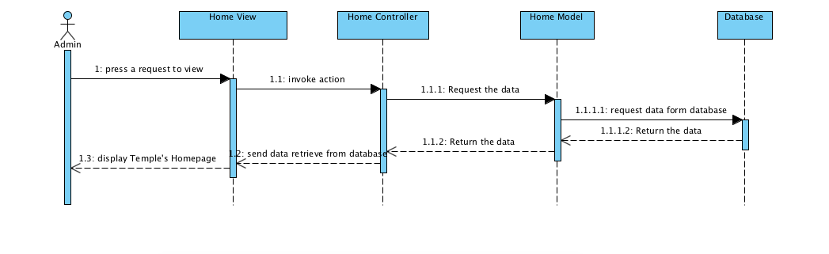

*Admin can view homepage of the temple’s website*

*Sequence diagram of “Wat ChaiMongKol” SD-40*