GROUP 26
ARCHITECTURE STRATEGIES


University of Zululand
Faculty of Science and Agriculture

Student number | Surname & Initials
240107185 | Zulu K

Note: this document was originally produced by an eight-member group (Group 26, module 4CPS212). Group membership has since changed; it is now maintained solely by the author listed above.

1. System Architecture
Revision note: The original diagram showed a separate “processing” tier and an “application server (API)” distinct from the web interface. The implementation is a single Django monolith: one process serves both the HTML pages and handles form processing, backed directly by SQLite. There is no separate API tier and no JSON API endpoint other than the corpus-download file. The diagram below reflects the actual deployment.
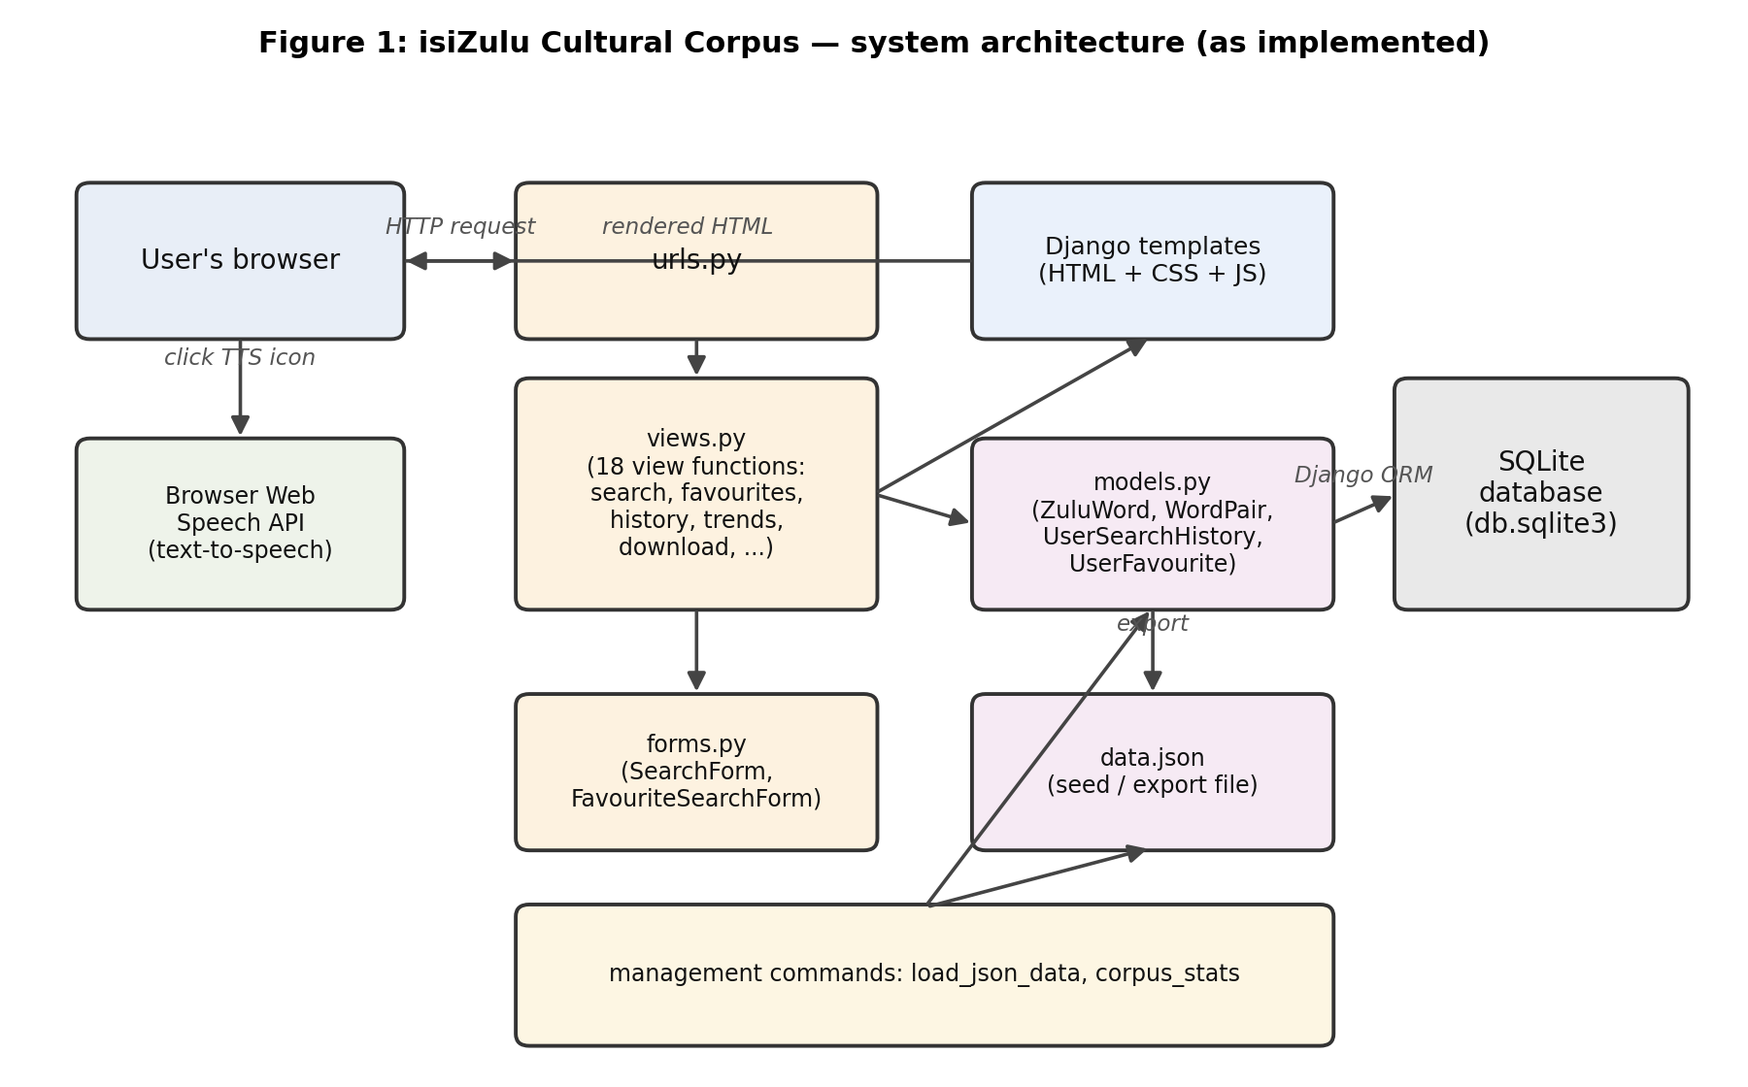

2. Data Model
The database has four models (see full field list below). The previous version of this section listed paired_zulu and paired_english fields on the word table; these do not exist — that relationship is implemented as the separate WordPair model shown below, and cultural_context, the per-language example sentences, and synonyms were previously omitted from this section entirely.
Model | Key fields | Notes
ZuluWord | zulu_word, english_translation, swati_translation, sotho_translation, pronunciation_guide, part_of_speech, cultural_context, example_sentence_(zulu/english/swati/sotho), synonyms (M2M to self), date_added | Core dictionary entry. part_of_speech now has 14 choices (noun, verb, adjective, adverb, greeting, farewell, phrase, proverb, idiom, expression, interjection, number, response, unknown) to match the data actually loaded.
WordPair | word1 (FK), word2 (FK), frequency | Tracks which two entries were returned together by the same search. Was defined in the database but never read by any view or template; the Trends page now displays it.
UserSearchHistory | user (FK), search_query, search_results (M2M), search_date | One row per search. Ordered newest-first; the History view keeps only the 5 most recent distinct queries per user.
UserFavourite | user (FK), word (FK), date_added | Unique per (user, word). Toggled by the star button.

3. Module Design
Revision note: The previous version of this section described views.py as a set of classes (a views.py: class with methods) and stated the project had “13 modules”. views.py is function-based (18 functions, no classes), and the module count below reflects what is actually in the repository.
Module | Responsibility
corpus/settings.py, urls.py | Project configuration and top-level routing (admin, auth, main_app).
main_app/models.py | 4 models: ZuluWord, WordPair, UserSearchHistory, UserFavourite, plus the phrase_filter() helper.
main_app/forms.py | SearchForm and FavouriteSearchForm — validate and clean user input server-side.
main_app/views.py | 18 view functions (function-based, not classes): home, register, search, word_detail, favourites, add_to_favourites, history, remove_history_entry, clear_all_history, trends, download_corpus_data, help_page, profile, cultural_stories, custom_logout, plus 4 private helpers.
main_app/urls.py | Maps the 15 main_app routes to their views.
main_app/utils/json_loader.py | load_words_from_json() (import) and export_corpus() (export) — shared by the download view and the load_json_data management command.
main_app/management/commands/ | load_json_data (seed the DB from data.json), corpus_stats (print a text summary), populate_zulu_data (original bulk-insert script).
main_app/admin.py | Django admin registration for all 4 models.
templates/*.html (15 files) | Page templates, all extending base.html.
static/js/script.js | Text-to-speech (Web Speech API), the favourite-star AJAX toggle, and the Trends chart (Chart.js).
static/css/style.css | All styling.

4. Key Design Decisions

4.1 Search
Search validates input through SearchForm (length limit, an allow-list of safe characters) before it reaches the database, and returns an HTML page — not a JSON API response as previously stated here. Three filters narrow a search: Search in (word/translation, phrases & examples, or cultural context), Part of speech, and Exact match. If nothing matches, a difflib-based “Did you mean” suggestion list is shown instead of a plain error.

4.2 Favourites
The star button calls /favourites/add/<id>/ over AJAX (fetch with a CSRF token) and toggles the favourite without a page reload. This endpoint previously existed but nothing in the templates or JavaScript called it, so the feature had no effect; it is now wired up on every page that shows a favourite star.

4.3 Trends
Total Phrases previously counted every word in the corpus (it was identical to Total Words). It now counts only entries whose part of speech is phrase, proverb, idiom or expression, or whose zulu_word contains a space. The Word Pairs table, computed by WordPair but never displayed, is now shown alongside the word-frequency table and chart.

4.4 Download
The corpus download previously linked directly to a static file (static/data/data.json) that only had 95 of the 139 words in the live database and required no login despite the requirement that it should. It is now a view (download_corpus_data) that generates the JSON from the database on request and is protected by @login_required, matching the original design intent.

5. Interface Design (current screenshots)
Screenshots below are taken from the running application, logged in as the sole current author.

5.1 Search, with filters and a favourited result
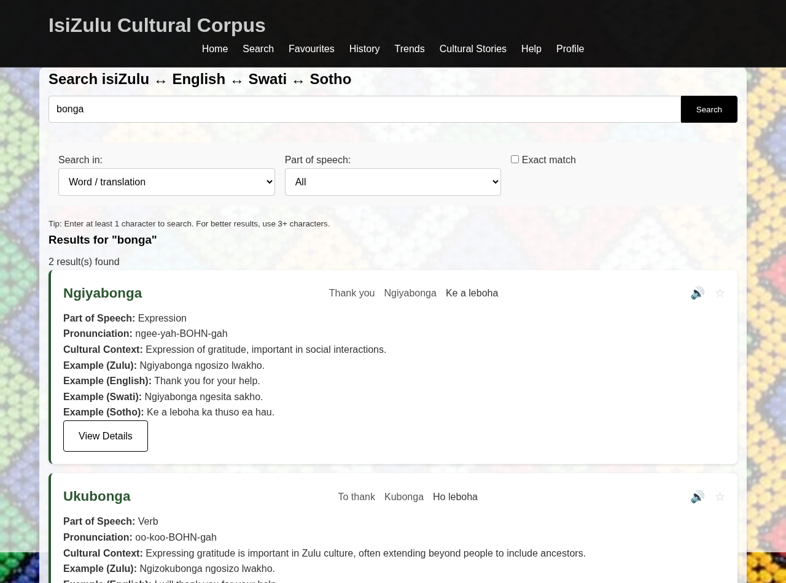

5.2 Favourites panel
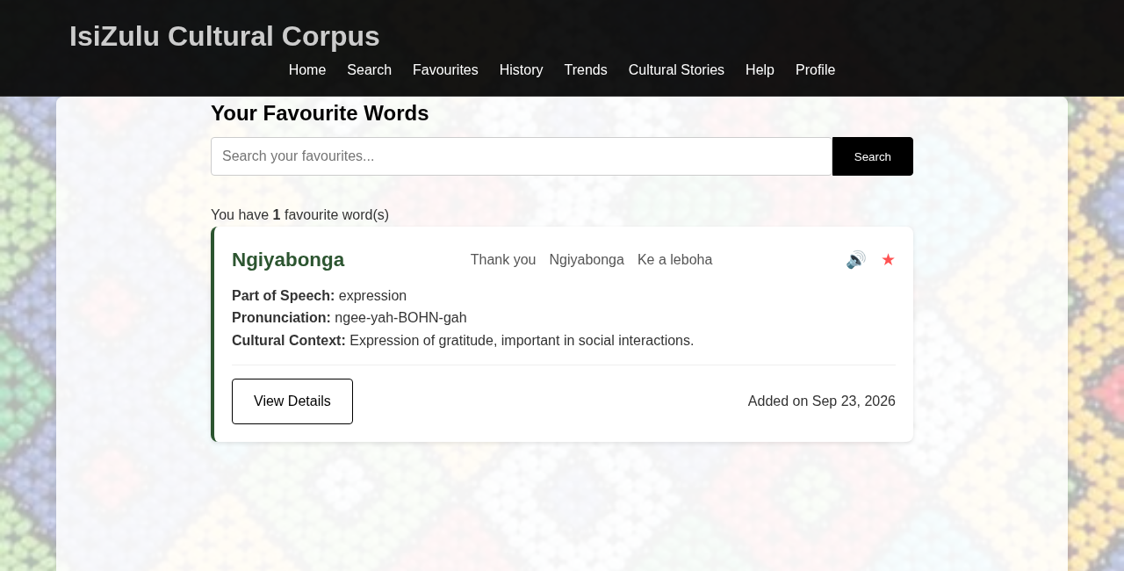

5.3 Search History
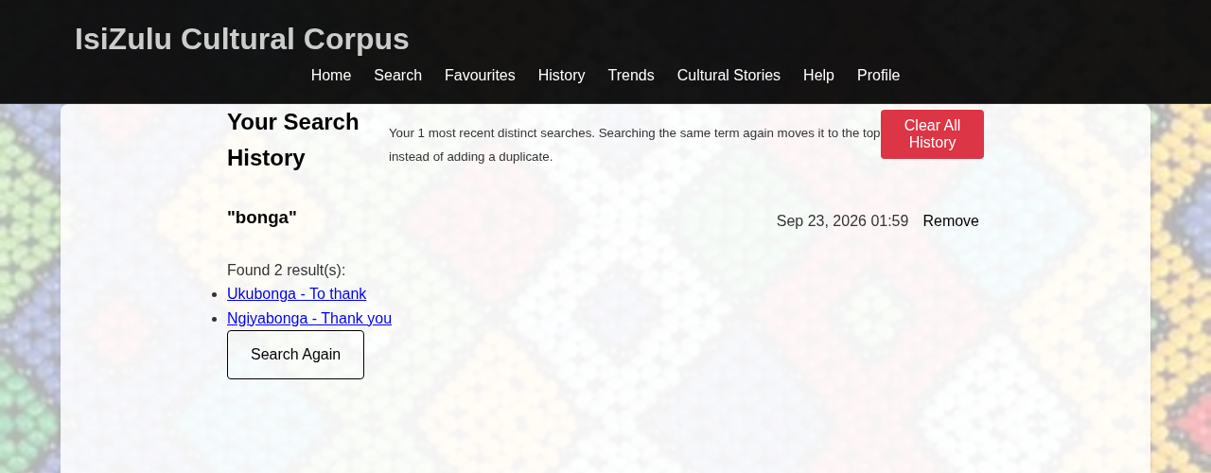

5.4 Trends, including the Word Pairs table
