GROUP 26

SYSTEM DESIGN DOCUMENT (SDD)



University of Zululand
Faculty of Science and Agriculture

Student number | Surname & Initials
240107185 | Zulu K

Note: this document was originally produced by an eight-member group (Group 26, module 4CPS212). Group membership has since changed; it is now maintained solely by the author listed above, who is credited as sole author of this revision.

1. Purpose and Scope
This System Design Document (SDD) describes the design of the isiZulu Cultural Corpus, a Django web application for exploring isiZulu words and phrases with English, Swati and Sotho translations, cultural context and example sentences.
This revision corrects the previous version of this document, which covered only the Home and Help pages and duplicated text from the Software Requirements Specification (SRS) rather than describing the system's design. The full design — architecture, data model, and module breakdown — is covered in the companion Architecture Strategies document; this SDD focuses on page-level design for Home and Help, plus a system overview.

2. System Overview
The system is a single Django project (corpus/) containing one app (main_app/) with 18 views, 4 database models, 15 HTML templates and a small amount of client-side JavaScript for text-to-speech and the favourite-star toggle. Data is stored in SQLite and can be exported to, or seeded from, a single JSON file (data.json).
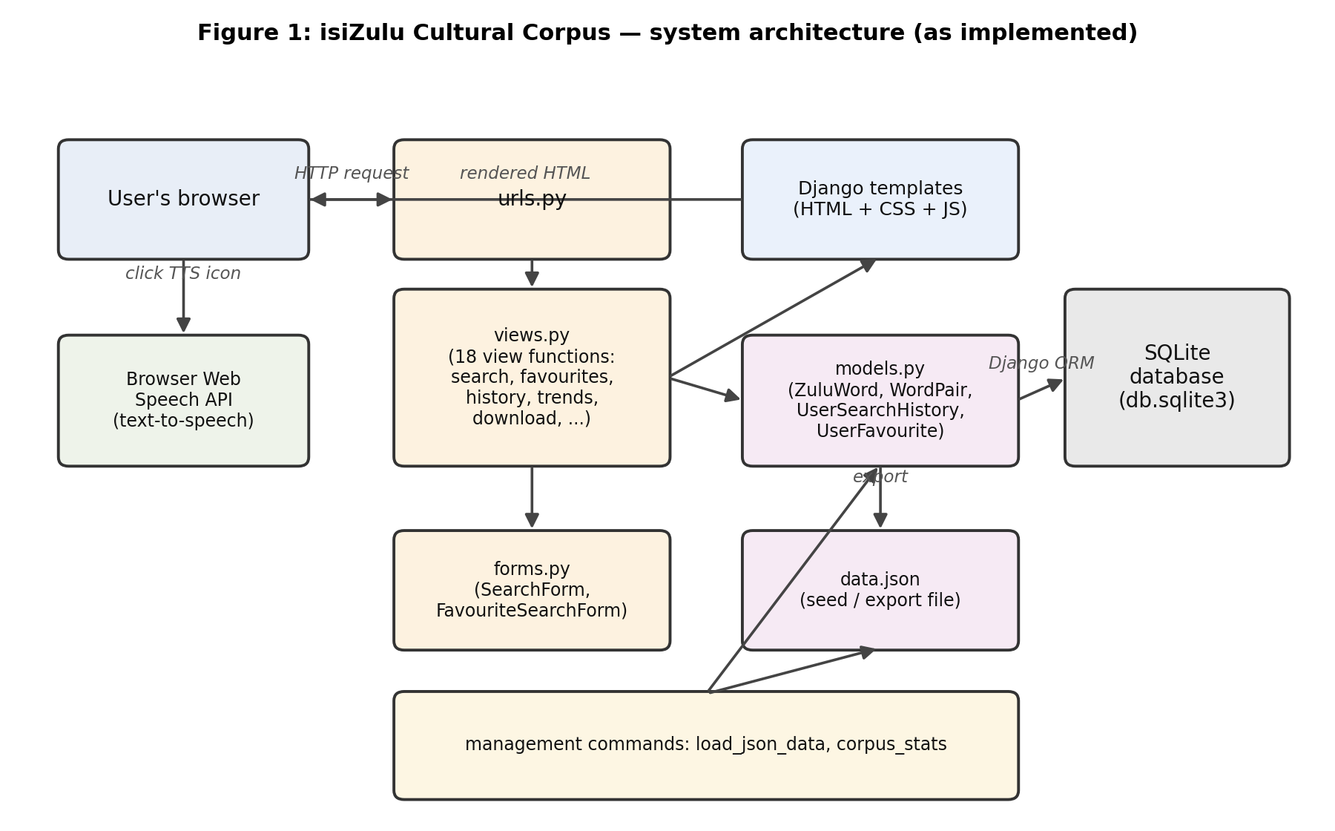

3. Home Page Design
Route: / (view: home)
Purpose: entry point after login. Shows a search box and two lists of words: the 5 most recently added entries, and the 5 most-searched entries (by number of history records referencing them), each with a text-to-speech button and a favourite-star toggle.
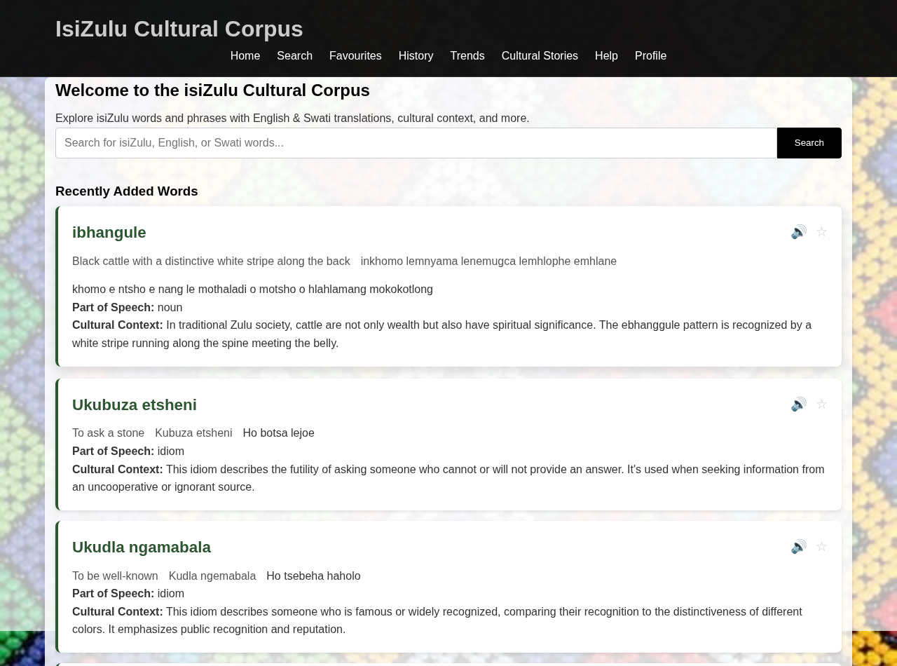

4. Help Page Design
Route: /help/ (view: help_page)
Purpose: a static guide describing how to use Search (including the Search in / Part of speech / Exact match filters and “Did you mean” suggestions), Text-to-Speech, Favourites, Trends, Search History, and the corpus download. The page content is fixed HTML; it is not generated from the other pages, so it must be kept in sync by hand when a feature changes — this revision updates it to match the current Search, History and Download behaviour.
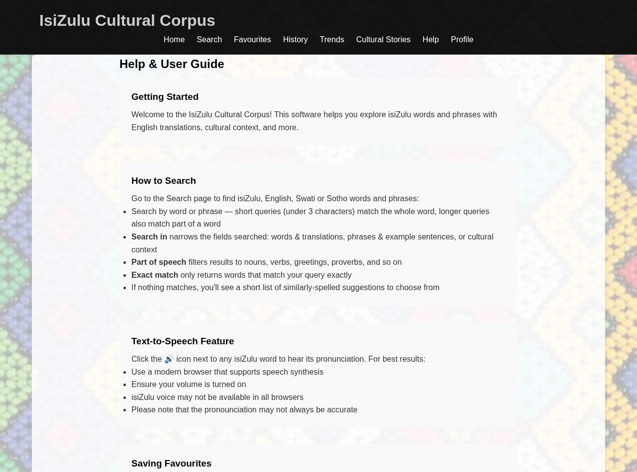

5. Traceability
This document should be read together with:
- Architecture Strategies — full architecture, data model, and module design
- Software Requirements Specification (SRS) — functional requirements per feature
- Test Plan — verification that the design in this document is met by the implementation

