Apportionment simulations

Kari Fenske, Curry Cunningham, Dana Hanselman

August 16, 2019

# Introduction and methods overview

Apportionment of sablefish ABC among management regions has been fixed at 2013 recommended ratios since 2014. An objective of the analyses presented in this document is to examine pros and cons of a suite of sablefish ABC apportionment methods. This document presents the apportionment simulation work to date. This is a work in progress and we are seeking feedback on oerating model (OM) and estimation model (EM) design, alternative performance metrics that would be useful in comparing apportionment methods and developing recommendations, and any other suggestions for simulation and model performance.

These apportionment simulation analyses contain two primary components, a 6-area OM and a 1-area EM. The OM is spatial so that potential spatial dynamics in fleet or fish behavior (via catchability, selectivity, and fish movement) may be simulated. The OM simulates data in two periods - a deterministic conditioning period which occurs for years 1977-2018 and is the same across simulations, and a stochastic forward projecting portion which runs for years 2019-2029. The EM is similar to the EM used for sablefish management, but begins in 1977 instead of 1960, does not include length compositions, and does not fit a trawl survey. After the conditioning period data is generated by the OM, the OM population is sampled, and the simulated data is combined into a single area dataset which is passed to the EM.

In the forward projecting period, the OM-EM is iterative, looping through years. The order of operations for year y are:  
1. OM - Read in previous year’s apportioned ABC by area  
2. estimate the F required to catch ABC for each area  
3. apply F and M to OM population  
4. move fish between areas  
5. sample the population for fishery and longline survey abundance indices and for longline survey and fixed gear fishery age compositions  
6. build the .dat file and pass it to the EM in ADMB  
7. run the EM (fit the simplified assessment model to simulated data) and get an estimate of the next year’s ABC (then repeat for the next year).

For each apportionment method we examined, we are running 50 simulations covering years 1977-2029. For November, we hope to present results for 100 (or more) simulated datasets each looping over years 2019-2049 (30 years for forward looping years).

There are some inherent assumptions in this simulation we would like to present up front:  
1) We assume ABC=TAC and 100% of apportioned ABC is caught in each region.  
2) We do not correct for whale depredation in the ABC or survey index.  
3) Recruitment occurs at age 2 and recruitment is split equally between males and females. Recruitment for the 2014 year class has been reduced in the conditioning period from 150 million fish to 50 million to improve EM convergence and reduce crashing. Recruitment draws for the forward projecting period are also capped at 50 million.  
4) The NPFMC Tier 3 harvest control rules are still in place and used for determining ABC in the EM, we are only simulating different methods for apportioning ABC to management areas.

## Alternative apportionment scenarios examined

In the analyses presented in this document we examine 10 apportion methods: Equal, Fixed, Equilibrium, NPFMC, Exp_survey_wt, Exp_fishery_wt, Non-Exp_NPFMC, Partial_fixed, Age_based, Term_LLsurv. A shorthand summary of what each apportioment method does is below.  
1 - Equal: Each region receives 1/6 of the ABC.  
2 - Fixed: The apportionment proportions from the 2013 assessment that have been applied as fixed proportions for 2014-2018.  
3 - Equilibrium: Based on the stationary distribution of the movement rates.  
4 - NPFMC: A 5-yr exponentially weighted moving average of fishery and survey indices; survey weight is 2x fishery weight.  
5 - Exp_survey_wt: Similar to ‘NPFMC’ option but using survey index only.  
6 - Exp_fishery_wt: Similar to ‘NPFMC’ option but using fishery index only.  
7 - Non-Exp_NPFMC: A 5-yr moving average of fishery and survey indices.  
8 - Partial_fixed: BS and AI receive 10% of the ABC each, WG, CG, WY, and EY are apportioned based on NPFMC method.  
9 - Age_based: Based on the proportions of fish at age of 50% maturity in each area - i.e. areas with greater proportion of fish at age of 50% maturity or greater will be apportioned a greater proportion of ABC.  
10 - Term_LLsurv: Terminal year of longline survey (no exponential weighting).

## Performance metrics and simulation summary results

Please note that these results are PRELIMINARY and should not be used for decision-making. OM and EM specifications are still being refined based on Plan Team and other feedback.

There are several key concerns regarding apportionment which we are examining and they can be loosely grouped into broader (yet still related) categories of 1) sustainability, 2) stability, and 3) value.

### Sustainability

The sustainability of the sablefish population is a primary concern and we evaluate how different methods of apportioning perform with respect to a B40 biological reference point.

For each year, simulation, and apportioment method we calculate the SSB(end_year)/B40 from the EM. The NPFMC harvest control rule is designed to limit fishing mortality when SSB(end_year)/B40 falls below 1. The apportioment methods all perform similarly with respect to SSB(end_year)/B40, which suggests the harvest control rule is functioning. The large number of outliers are due simulations which are crashing (and have not been removed from analyses at this point).

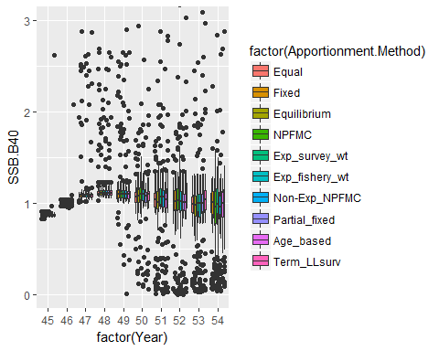

Depletion, or the spawning biomass in the terminal year of each EM run relative to the spawning biomass in the EM starting year. For these simulations, the EM starting year is 1977 and end years range from 2019-2029. Note that 1977 is not virgin biomass so ‘depletion’ in this context may not provide any relevant information for us to consider.  
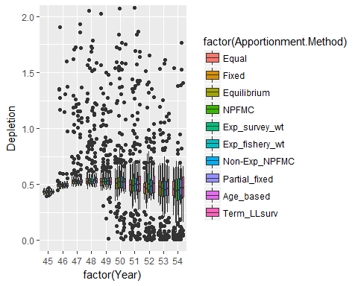

Because we have a single area stock assessment, we do not currently have estimates of sablefish biomass or spawning stock biomass in each management area, though the longline survey may give us a pretty good estimate. Since this is a simulation, we can, however, examine how well each apportionment method tracks the ‘true’ (simulated) population’s spawning stock biomass in each management area.

This is the mean absolute relative percent difference between ‘true’ spawning stock biomass and apportioned ABC by area for each apportionment method. Low values are good if we want apportionment to track the underlying population spawning stock biomass by area.

## Equal Fixed Equilibrium NPFMC Exp_survey_wt Exp_fishery_wt  
## BS 107.4 56.7 48.8 37.9 20.8 65.4  
## AI 66.3 37.2 42.6 2.7 8.6 13.9  
## WG 47.0 5.4 20.6 28.3 11.8 54.5  
## CG 60.4 9.2 15.2 5.1 0.5 17.0  
## WY 7.6 32.4 10.9 9.1 5.5 17.3  
## EY/SEO 55.8 30.4 18.4 13.2 10.5 19.4  
## Non-Exp_NPFMC Partial_fixed Age_based Term_LLsurv  
## BS 36.5 56.4 79.0 20.0  
## AI 5.7 7.2 65.1 7.8  
## WG 26.2 26.3 30.1 11.8  
## CG 5.5 7.8 60.0 0.7  
## WY 8.2 12.1 17.9 5.4  
## EY/SEO 11.8 16.2 30.5 10.6

Taking the average across spatial areas gives a single value for how well each apportionment method matches underlying spawning stock biomass. Again, lower values mean a better match to ‘true’ population. If there are benefits to maintaining spawning biomass in all spatial areas (i.e. if there were spatial differences in fecundity that we are not aware of), an apportioment method with a low value here would be better.

## Equal Fixed Equilibrium NPFMC Exp_survey_wt   
## 57.4 28.5 26.1 16.0 9.6   
## Exp_fishery_wt Non-Exp_NPFMC Partial_fixed Age_based Term_LLsurv   
## 31.2 15.6 21.0 47.1 9.4

[some discussion of results here when we have final results]

### Variability in ABC from year to year

Total ABC and the proportion of ABC apportioned to management areas can change each year, and individual management area ABC may not move in the same direction or proportion as overall ABC. In 2013, the year-to-year change in ABC apportioned to each management area was higher than desired and prompted the recommendation to freeze ABC proportions to management regions for the next several years.

The mean absolute percent change in ABC for each apportionment method, reflects the inherent variability in ABC from year to year.

## Equal Fixed Equilibrium NPFMC Exp_survey_wt   
## 21.18498 29.80556 28.08948 65.35501 28.97589   
## Exp_fishery_wt Non-Exp_NPFMC Partial_fixed Age_based Term_LLsurv   
## 30.24145 23.85287 33.00980 25.98383 27.12225

Drilling down further, the mean absolute percent change in ABC for each area and apportionment method is

## Equal Fixed Equilibrium NPFMC Exp_survey_wt Exp_fishery_wt  
## 1 21.18498 29.80556 28.08948 78.51234 30.01189 32.40894  
## 2 21.18498 29.80556 28.08948 78.42358 29.29134 31.46621  
## 3 21.18498 29.80556 28.08948 68.36633 29.35991 31.60844  
## 4 21.18498 29.80556 28.08948 62.72025 28.72330 29.83998  
## 5 21.18498 29.80556 28.08948 54.55994 28.40129 28.16040  
## 6 21.18498 29.80556 28.08948 49.54761 28.06760 27.96475  
## Non-Exp_NPFMC Partial_fixed Age_based Term_LLsurv  
## 1 25.35773 32.54430 30.01002 28.27438  
## 2 24.16697 32.54430 25.86647 27.43673  
## 3 24.74883 38.00142 27.48212 27.42575  
## 4 23.23763 33.14555 25.10159 26.79256  
## 5 22.82379 31.16305 24.05050 26.53102  
## 6 22.78228 30.66017 23.39227 26.27304

This reflects what an individual management area may experience in terms of average change in ABC from year to year for each apportionment method. Higher values mean more change in ABC from year to year.

[some discussion of results here when we have final results]

### Sablefish value and other considerations (*from a non economist)

The standardized mean ABC for each apportionment method combines data across years, fleets (a.k.a. gears), areas, and simulations for 2019-2029.

## Equal Fixed Equilibrium NPFMC Exp_survey_wt   
## 0.7550103 1.1782162 1.0191574 0.9310284 1.3256813   
## Exp_fishery_wt Non-Exp_NPFMC Partial_fixed Age_based Term_LLsurv   
## 0.9366814 0.9308350 1.0113346 0.7621094 1.1499459

For this set of runs (noting that non-converged and crashed runs are still being included) there are relatively small differences in mean ABC between the different apportionment methods.

Mean ABC apportioned to each management area (mean of all years and simulations) under the different apportionment methods is a key output of interest. The next figure shows mean ABC values, by area, for each apportionment method.  
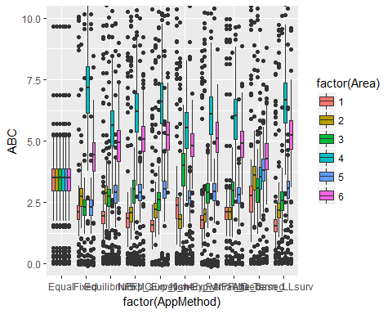

Next we examine the proportion of years and sims where apportioned ABC summed over areas is above a specified threshold value. It is simple to change the threshold value being evaluated; the present value of the ABC threshold for management areas combined is 12 kilotons.

The proportion of years and simulations where total ABC is above the all-area threshold (12 kt) is:

## Equal Fixed Equilibrium NPFMC Exp_survey_wt   
## 0.97 0.96 0.95 0.96 0.98   
## Exp_fishery_wt Non-Exp_NPFMC Partial_fixed Age_based Term_LLsurv   
## 0.95 0.97 0.95 0.96 0.96

It may also be of value to set a threshold for individual management areas. We are presenting results for a threshold of 2 kilotons for each management area.

## Equal Fixed Equilibrium NPFMC Exp_survey_wt Exp_fishery_wt  
## BS 0.97 0.62 0.42 0.32 0.15 0.66  
## AI 0.97 0.89 0.91 0.56 0.67 0.24  
## WG 0.97 0.73 0.89 0.92 0.86 0.95  
## CG 0.97 0.97 0.97 0.97 0.98 0.96  
## WY 0.97 0.73 0.92 0.95 0.97 0.92  
## EY/SEO 0.97 0.96 0.97 0.97 0.98 0.96  
## Non-Exp_NPFMC Partial_fixed Age_based Term_LLsurv  
## BS 0.24 0.59 0.78 0.14  
## AI 0.50 0.59 0.95 0.66  
## WG 0.89 0.89 0.92 0.85  
## CG 0.98 0.97 0.96 0.97  
## WY 0.95 0.92 0.97 0.96  
## EY/SEO 0.98 0.97 0.98 0.97

Other metrics of interest that are not yet coded include:  
mean age of fish in each management area (from the OM)  
mean age of catch in each management area (from the OM data)  
value of catch in each management area (using apportioned ABC, OM fishery age comp for each area to convert catch biomass to size, some estimate of mean ‘price’ or ‘value’ at size)

## [1] 54 30 6 50 10

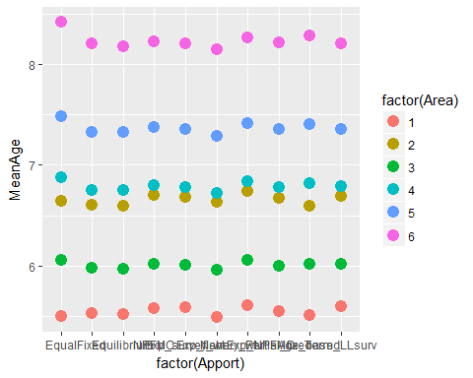

What are additional metrics that should be included in analyses for November Plan Team?

# Further details on OM and EM, model valiation figures, and more output

# OM Conditioning period

The OM model set up begins by establishing initial numbers at age for each area in 1976. Initial N for 1976 is input as the 2018 management EM totaly abundance estimated for 1977. This is split into 6 spatial areas using the proportion of abundance by area from the longline survey abundance estimate and split into initial age and sex proportions using proportion by sex and age from 2018 management EM for 1976 numbers at age. Numbers at age are conveted to biomass at age using the age-weight relationship as described in the sablefish 2018 SAFE report.

The OM conditioning period is deterministic and thus is the same for all simulations. Movement rates are specified between all 6 areas and the OM is set up to accommodate age-based movement, however, at present movement age-invariant. During the OM conditioning period, recruitment is input as values from the management EM, catch is input, and the F which generated that catch estimated and applied to the population. Please see the Appendix 2 for OM population dynamics equations.

Movement rates used in the OM are externally estimated and based on the Hanselman et al. (2015) sablefish movement paper. The model described in the paper was re-run for 6 areas and those movement values are input.

Table 1: Movement rates used in the OM are based on 30+ years of tag release and recapture data, as detailed in Hanselman et al. (2015).

## To EY To WY To CG To WG To BS To AI  
## From EY 0.744367 0.076350 0.149227 0.026232 0.002098 0.001726  
## From WY 0.137189 0.191575 0.478710 0.152110 0.021954 0.018462  
## From CG 0.108443 0.193604 0.486216 0.162973 0.026394 0.022370  
## From WG 0.037484 0.120964 0.320461 0.290733 0.122029 0.108328  
## From BS 0.005357 0.031088 0.092290 0.215184 0.627622 0.028460  
## From AI 0.002495 0.014990 0.045060 0.113111 0.046442 0.777902

## Conditioning period validation

The figures and tables below are presented to show the ability of the spatial OM within the conditioning period to match the current EM historical data, and to further describe the methods for setting up the OM. In general, the OM results for the conditioning period provide a good match to estimates from the most recent stock assessment (“Management EM”, Hanselman et al. 2018). However some differences exist due to movement, the initial conditions specification, and spatial OM parameters which differ from the management EM. Because this isn’t a full MSE, alternative states of nature are not the examamined here.

Abundance in numbers, biomass, and spawning biomass generated from the OM generally matches the Management model EM quite closely (Figures 1-3). However, the current runs being shown reduce the 2014 OM recruitment from 150 million recruits to 50 million recruits to see if this helps improve model convergence and reduce incidences of crashing (it did). This reduction is evident in the comparison figures below.  
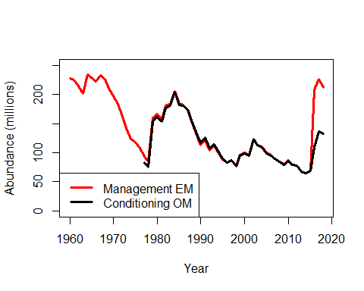

Figure 1: Abundance in numbers (millions of fish, summed over areas) generated from the OM matches the Management model EM.

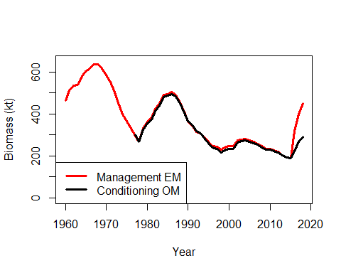

Figure 2: Biomass (kt, summed over areas) generated from the OM compared to the Management model EM.

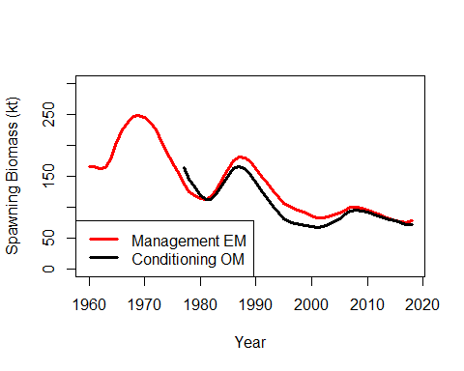

Figure 3: Spawning biomass (kt, summed over areas) generated from the OM compared to the Management model EM.

OM catch was designed to match Management EM observed catch. An F-solving function in the OM takes input catch by gear/fleet, area, and year and estimates the fishing mortality required to realize that level of catch, using OM numbers at age and selectivity. The estimated F rate is then used to simulate abundance in the next year of an OM iteration.  
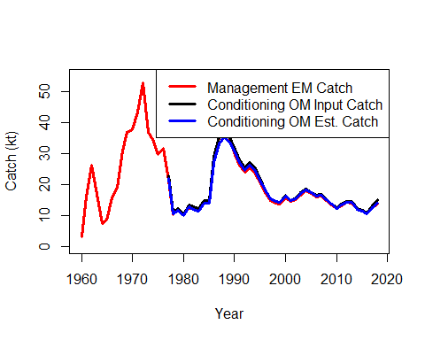

Figure 4: Catch (kt) for the Management EM, the input catch values for the OM, and the estimated OM catch values.

OM recruitment for the conditioning period was designed to match EM recruitment. Management EM recruitment values (in numbers) for 1977-2018 are input and split into 6 areas based on the average proportion of age-2 sablefish in each area of the longline survey , and also split equally between males and females (see equations in Appendix 2).  
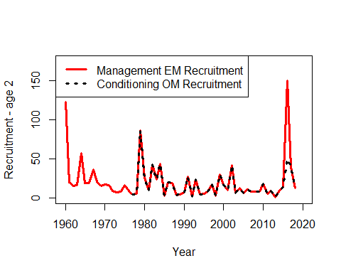

Figure 5: OM and EM recruitment for the conditioning period (in millions of fish) for all management areas summed are identical by design, excecpt for the 2014 year class which we reduced in the OM in improve convergence in the forward simulation period.

Table 2: These values for age-2 proportions by area from the longline survey are used to split recruitment into spatial areas.

## BS AI WG CG WY EY/SEO   
## 0.14 0.07 0.14 0.43 0.14 0.09

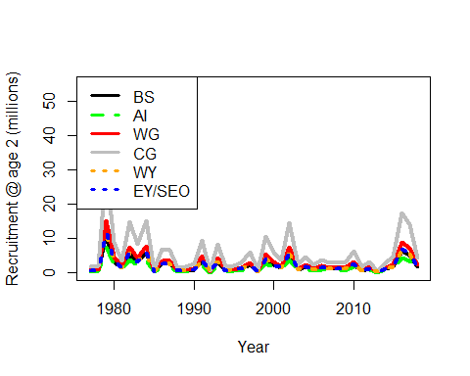

Figure 6: The resulting recruitment of age-2 fish to each management area for the conditioning period, after splitting into spatial areas using the proportions in Table 2.

Recruitment for the forward projecting period is the same across apportionment simulations and does not assume a stock recruitment relationship. Using the same suite of recruitment draws across each apportionment method allows for a more similar comparison of results. Recruitment for n.years x n.sims is drawn once (from a multinomial distribution with mu=16.5 and sigma=0.8 and with autocorrelation parameter = 0.2) and used for all apportionment methods. Recruitment is also capped at 100 million recruits; any simuated values greater than that value are reduced to 100 million. Mean recruitment (mu; average log-recruitment) and recruitment standard deviation (sigma) for the multinomial are input from the management EM. Recruitment in each year is divided into OM spatial areas based on the mean proportion of age-2 (recruitment age) sablefish in each area from the longline survey for 1977-2018, as described above.

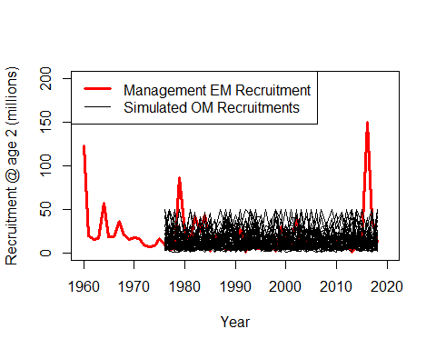

Figure 7: For comparison, the conditioning period recruitment draws for 50 compared to management EM estimated recruitment is shown here, though note that these values ARE NOT USED in the conditioning period.

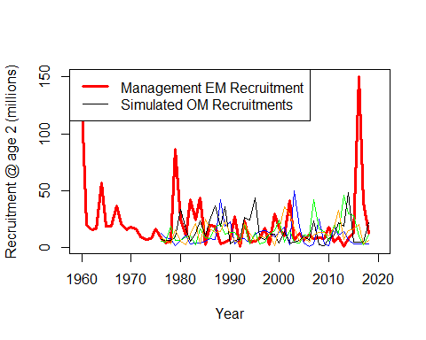

Bonus figure 8: this shows a few individual simulations of recruitment to better view the individual variability and scale of simulated recruitment.

## Selectivity in OM

The following figures show the selectivity at age and for each area used in the OM. These are used for all years of the OM, not just the conditioning period.  
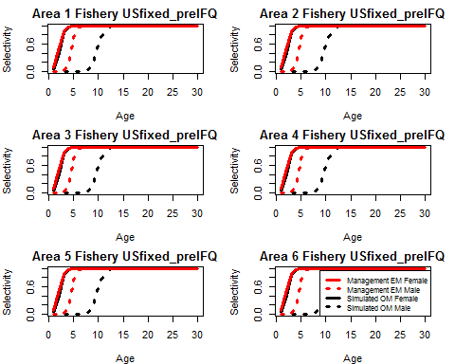

Figure 9: US fixed gear pre-IFQ selectivity for each area has a logistic form. US fixed gear pre-IFQ selectivity is sex-specific but does not differ between spatial areas; OM values are the the same as the values estimated from the spatial ‘research’ EM which is under development and has been reported on to the PT in the past.  
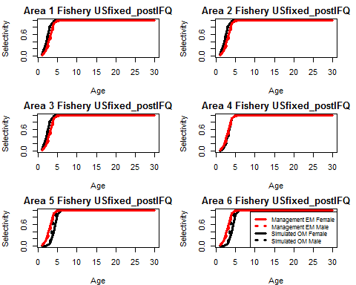

Figure 10: US fixed gear post-IFQ selectivity for each area has a logistic form. The values are sex-specific and there are some spatial differences for some areas. OM values for each area are based on the estimated selectivity values from the spatial ‘reseach’ EM.

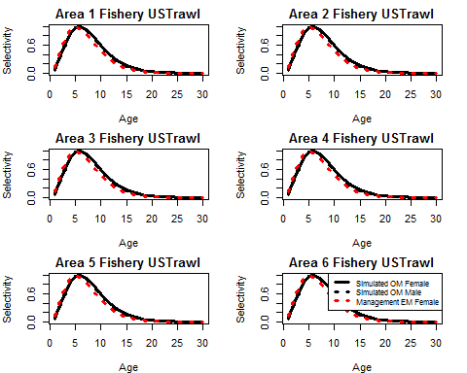

Figure 11: US trawl fishery selectivity for the OM has a domed shape. The values are sex specific and do not vary spatially. Values are from the ‘research’ spatial EM.

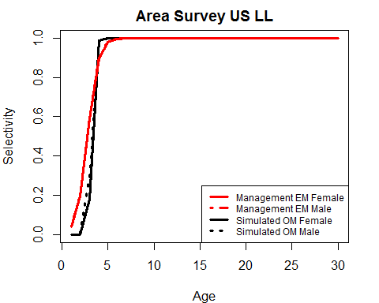

Figure 12: US longline survey selectivity parameters are not spatial but are sex specific and are based on the spatial ‘research’ EM values.

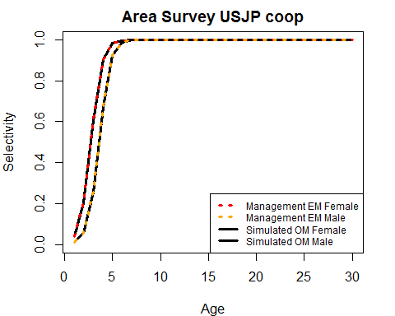

Figure 13: The USJP ll cooperative survey selectivity parameters are not spatial but are sex specific and values are based on the management EM values.

## Sampling OM population for abundance indices, age comps

The EM requires a longline survey abundance index, a fishery CPUE index, and survey and fishery age compositions. For both the conditioning period and the forward projecting period, the OM population is ‘sampled’ with logistic observation error for the indices of abundance. For each spatial area in the OM, we sample abundance for the survey and biomass for the fishery index, both with 15% sigma for observation error. Spatial areas are summed for each index, resulting in a single fishery and a single survey index. Fits to indices of abundance are shown in the next section.

Age compositions are sampled from each spatial OM regional abundance using Dirichlet multinomial error and a sample size of 200. Age compositions are combined across spatial errors (weighted by catch/survey abundance in each area) to a single set of survey and a single set of fishery age comps that are not sex specific.

# EM specifications

For 2019 onward in each annual time step, the EM is fit to data ‘sampled’ from the OM population, or to simulated population attributes with added observation error. As a reminder the order of operations for year y are: OM - Read in previous year’s apportioned ABC by area (from the EM), estimate the F required to catch ABC for each area, apply F and M to OM population, move fish between areas, sample the population for fishery and longline survey abundance indices and for longline survey and fixed gear fishery age compositions, add observation error to these data types, update the .dat file with new data for the simulation year, and fit the EM in ADMB to the updated data (.dat file), and return the EM and get an estimate of the next year’s ABC (then repeat for the next year).

## Forward looping model output

### EM Convergence

First, we look at the proportion of years within a simulation and apportionment scenario which converged. Non-converged models/years/sims ARE NOT removed from the following analyses. For these simulations, a model was considered ‘converged’ for a given year if the max gradient component was < 0.01. It is important to note that in the real world, a stock assessment scientist would have several options for improving convergence, first and foremost by iteratively adjsting both starting values and estimation phase for key model parameters. Non-convergence in this simulation exercise may be resulting from specific iterations (alternative states of nature) wherein the sablefish population is outside the range of what has been observerd historically and where manual tuning of the EM would be required, a prodcess that has not been replicated here.

Table 3. The proportion of simulations which converged for each year for each apportionment method.

## Equal Fixed Equilibrium NPFMC Exp_survey_wt Exp_fishery_wt  
## 2020 0.76 0.74 0.74 0.86 0.72 0.76  
## 2021 0.72 0.70 0.66 0.80 0.82 0.58  
## 2022 0.68 0.68 0.72 0.78 0.86 0.78  
## 2023 0.78 0.62 0.80 0.60 0.68 0.50  
## 2024 0.68 0.72 0.62 0.76 0.70 0.56  
## 2025 0.68 0.62 0.64 0.54 0.54 0.62  
## 2026 0.78 0.70 0.70 0.72 0.60 0.68  
## 2027 0.70 0.68 0.74 0.56 0.70 0.76  
## 2028 0.84 0.76 0.70 0.64 0.60 0.66  
## 2029 0.84 0.76 0.80 0.72 0.70 0.84  
## Non-Exp_NPFMC Partial_fixed Age_based Term_LLsurv  
## 2020 0.74 0.78 0.68 0.78  
## 2021 0.80 0.72 0.82 0.66  
## 2022 0.82 0.70 0.70 0.72  
## 2023 0.60 0.66 0.74 0.70  
## 2024 0.80 0.70 0.70 0.60  
## 2025 0.70 0.54 0.70 0.52  
## 2026 0.58 0.62 0.72 0.58  
## 2027 0.70 0.78 0.74 0.72  
## 2028 0.68 0.62 0.78 0.72  
## 2029 0.68 0.78 0.74 0.66

Table 4. The overall proportion of years and sims that converged for each apportionment method.

## Equal Fixed Equilibrium NPFMC Exp_survey_wt   
## 0.746 0.698 0.712 0.698 0.692   
## Exp_fishery_wt Non-Exp_NPFMC Partial_fixed Age_based Term_LLsurv   
## 0.674 0.710 0.690 0.732 0.666

### Objective function values for EM

Model convergence isn’t the only metric worth examining. It is useful to know which years and simulations (across apportionment methods) had models crash completely (where the objective function value is ‘nan’). A crashed model tends to have a domino effect on performance of models (in both convergence and crashing) in subsequent years. The following table shows the percentage of all years and simulations for which the EM produced an objective funtion value (the model ran to completion, though it may still have not adequately converged based on our defined convergence criteria).

Table 5. The percentage of years and sims which resulted in a crashed model (‘nan’ for the objective function value) for each apportionment method.

## Equal Fixed Equilibrium NPFMC Exp_survey_wt   
## 0.01 0.05 0.01 0.03 0.02   
## Exp_fishery_wt Non-Exp_NPFMC Partial_fixed Age_based Term_LLsurv   
## 0.03 0.03 0.04 0.02 0.02

### EM Selectivity

The next series of figures shows the EM estimated selectivity alongside the OM selectivity for the post-IFQ fixed gear fishery and the longline survey. Additional selectivity figures showing pre-IFQ selectivity are available in Appendix 1.

#### Longline fishery Post-IFQ

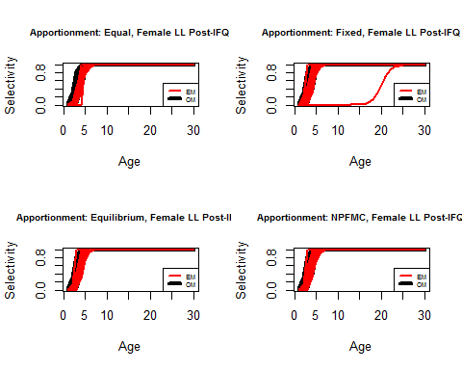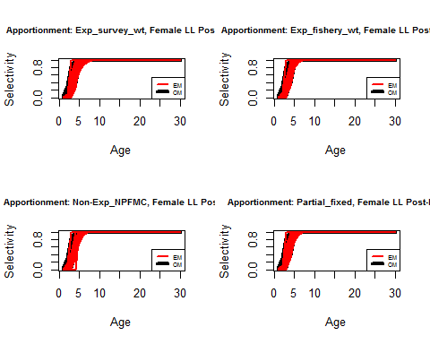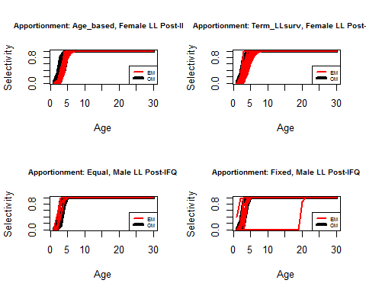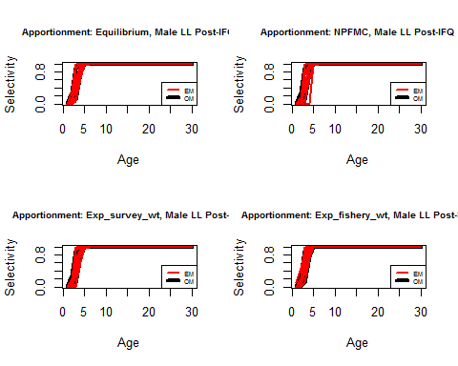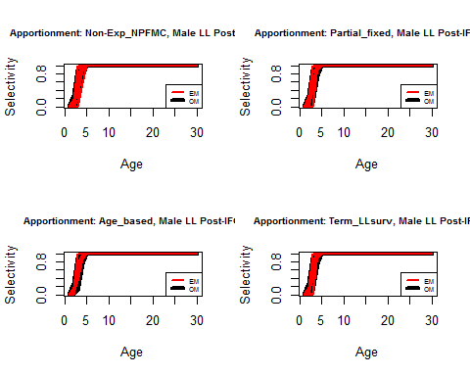

Figure 14. EM estimated selectivity for the longline fishery, Post-IFQ years for each sex and apportionment method. Each red line in a single figure panel represents a different simulation and year. Selectivity does differ over some spatial areas in the OM, but cannot be estimated spatially in the single-area EM.

#### Longline survey

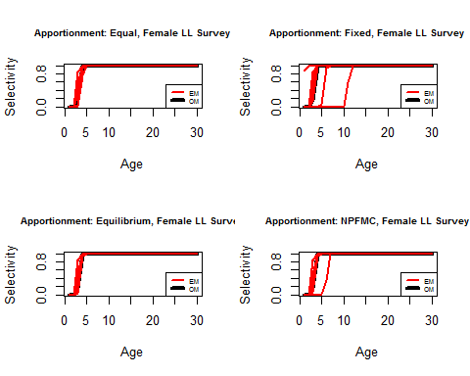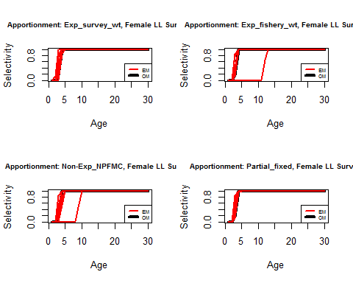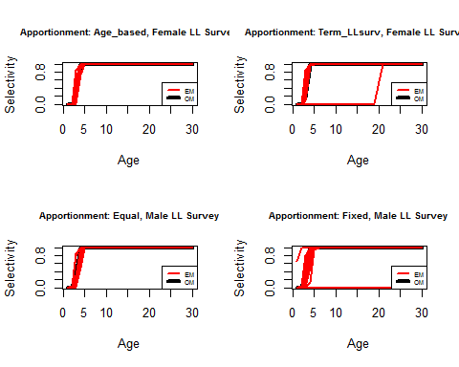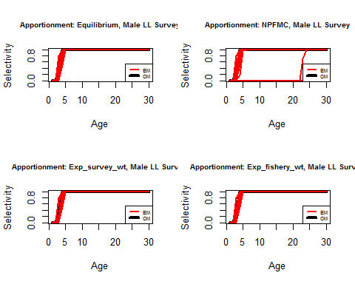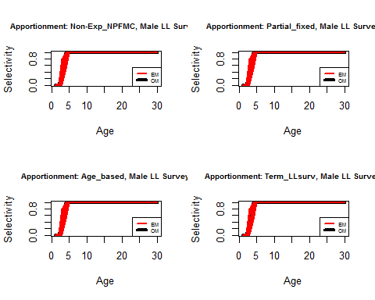

Figure 15. EM estimated selectivity for the longline survey, for each sex and apportionment method. Each red line in a single figure panel represents a different simulation and year. Selectivity does not differ over spatial areas in the OM.

### Catchability

The distribution of catchability (q) parameter estimates from the EM is shown below as boxplots. For each apportionment option (x axis) the box shows the median (thick line inside the box) and the 25th and 75th percentile interquartile range (box lower and upper border) of EM q estimates across all years and sims. The vertical bars represent the largest and smallest values within 1.5 times the interquartile range, and any values outside these ranges are shown as points. The red line is the OM value of catchability.

#### Fixed gear fishery, foreign years

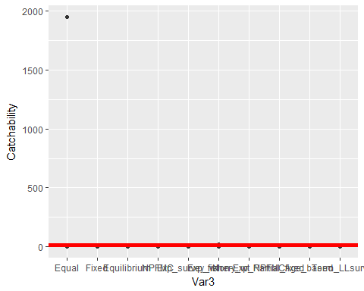

## <ggproto object: Class CoordCartesian, Coord>  
## aspect: function  
## distance: function  
## expand: TRUE  
## is_linear: function  
## labels: function  
## limits: list  
## range: function  
## render_axis_h: function  
## render_axis_v: function  
## render_bg: function  
## render_fg: function  
## train: function  
## transform: function  
## super: <ggproto object: Class CoordCartesian, Coord>

Figure 16. Catchability (q) parameter estimates from the EM (black) for each apportionment method. The red line is the OM value of q.

#### Longline fishery Pre-IFQ

For the boxplots below, the dashed red line is OM q for BS, AI, and WG. The solid red line is OM q for CG, and the dotted line is OM q for WY and EY/SEO.  
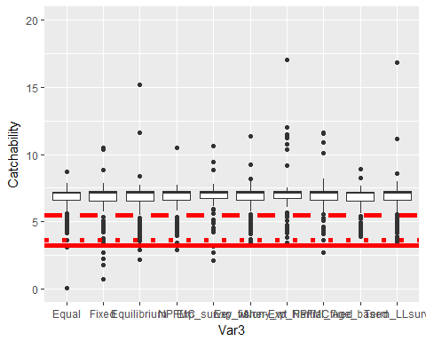

Figure 17. Catchability (q) parameter estimates from the EM (black) for each apportionment method. The red line is the OM value of q.

#### Longline fishery Post-IFQ

For the boxplots below, the dashed red line is OM q for BS, AI, and WG. The solid red line is OM q for CG, and the dotted line is OM q for WY and EY/SEO.  
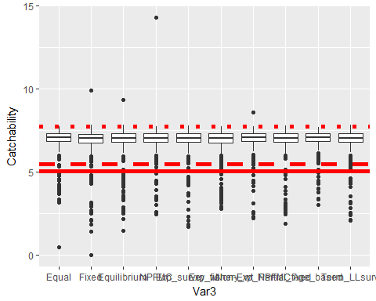

Figure 18. Catchability (q) parameter estimates from the EM (black) for each apportionment method. The red line is the OM value of q.

#### Longline survey (US years)

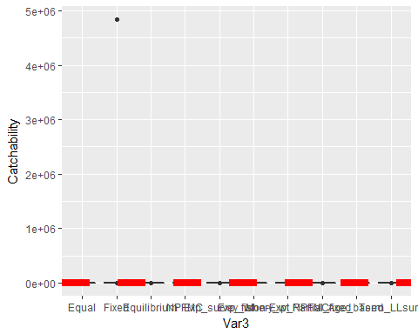

## <ggproto object: Class CoordCartesian, Coord>  
## aspect: function  
## distance: function  
## expand: TRUE  
## is_linear: function  
## labels: function  
## limits: list  
## range: function  
## render_axis_h: function  
## render_axis_v: function  
## render_bg: function  
## render_fg: function  
## train: function  
## transform: function  
## super: <ggproto object: Class CoordCartesian, Coord>

Figure 19. Catchability (q) parameter estimates from the EM (black) for each apportionment method. The red line is the OM value of q.

#### Longline survey (USJP years)

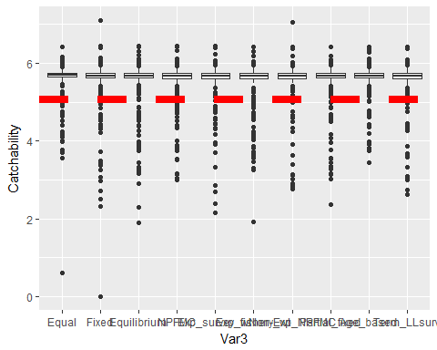

Figure 20. Catchability (q) parameter estimates from the EM (black) for each apportionment method. The red line is the OM value of q.

### Indices

#### US longline survey index (RPN)

The OM (‘true’) and EM estimates for the longline survey abundance index are shown below for each apportionment method.  
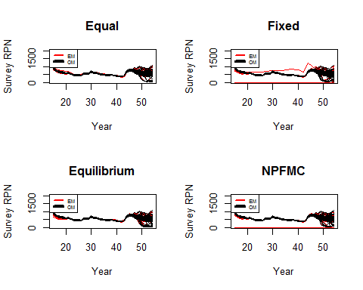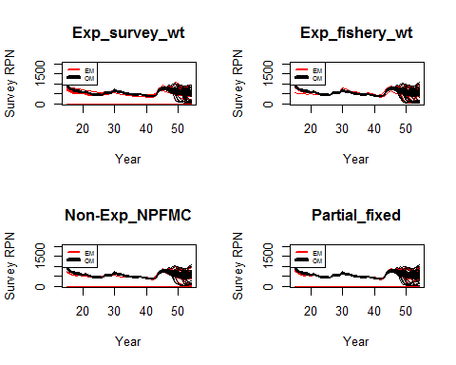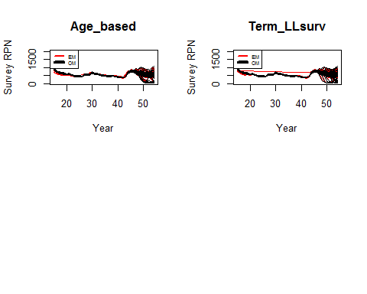

Figure 21. US longline survey indices for all years and sims. Note that the forward projecting perior begins in year 44 (2019), prior to that the Conditioning period is deterministic.

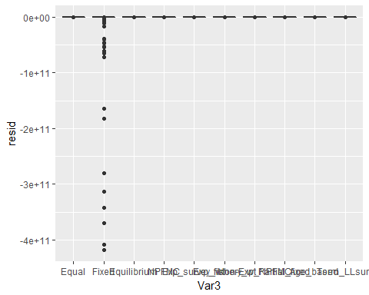

Figure 22. These boxplots are showing the residuals between the EM and OM for EM terminal year (2029) for all simulations and each apportionment method.

#### US longline fishery index (RPW)

The OM (‘true’) and EM estimates for the longline fishery abundance index are shown below for each apportionment method.  
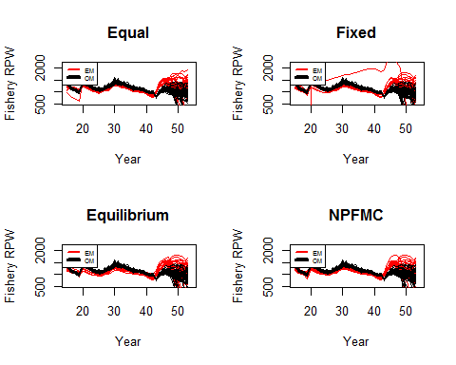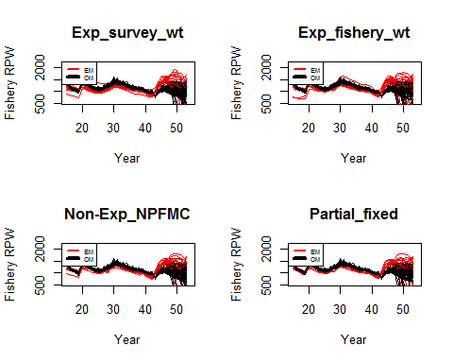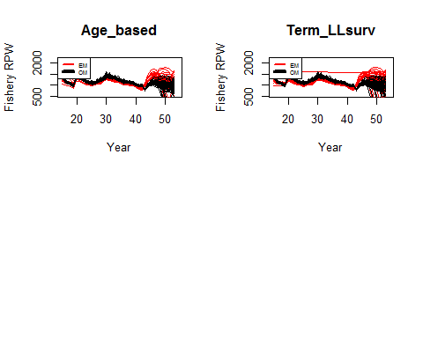

Figure 23. US fixed gear fishery index for all years and sims. Note that the forward projecting perior begins in year 44 (2019), prior to that the Conditioning period is deterministic.

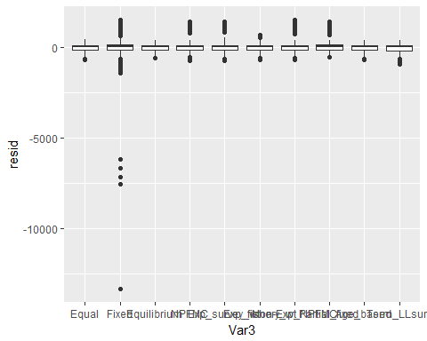

Figure 24. These boxplots are showing the residuals between the EM and OM for EM terminal year of the fishery index (2029) for all simulations and each apportionment method.

### Recruitment

The min and max OM recruitment values (over all sims and years) are:  
Min: 0.6363891  
Max: 50

The min and max EM recruitment values (over all sims and years) are:  
Min: 1.1981510^{-6}  
Max: 1.5435310^{5}

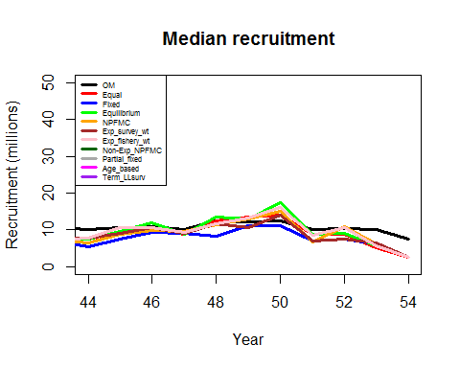

Figure 25. Median EM estimated recruitment and the OM recruitment, across all simulations. Recall that OM recruitment (black line) is the same across apportionment methods and it is only the estimated recruitment from the EM for each apportionment method that will vary.

Then look at the mean EM and mean OM recruitment draws by apport scenario. There is something very wrong with these EM mean values (right now).  
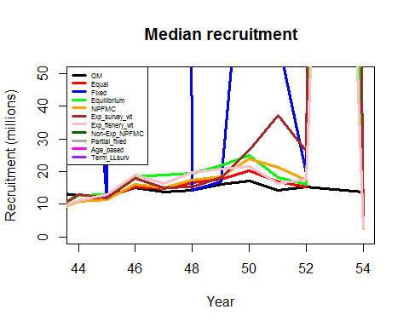

Figure 26. Mean EM estimated recruitment and the OM recruitment, across all simulations. Recall that OM recruitment (black line) is the same across apportionment methods and it is only the estimated recruitment from the EM for each apportionment method that will vary.

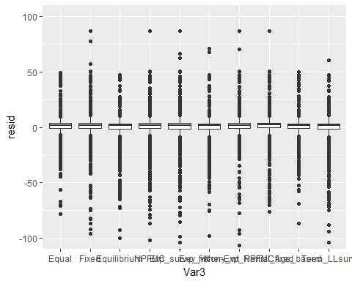

Figure 27. This shows the OM-EM residual distribution for each apportionment method.

### SSB time series

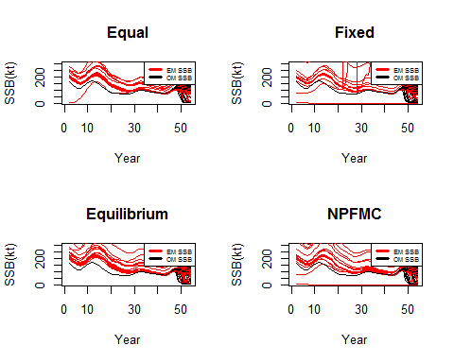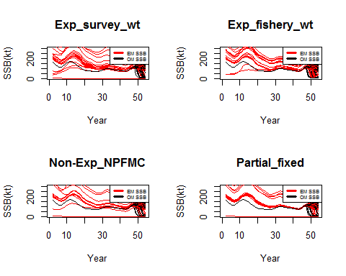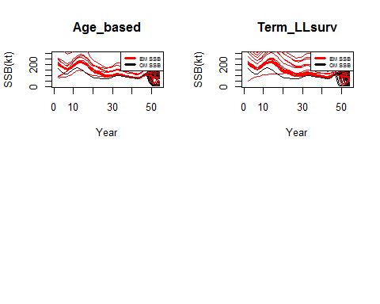

Figure 28. SSB for the OM (black) and EM (red); each line is a separate simulation. Recall that the conditioning period (years 0-43 which are equivalent to 1977-2018) is deterministic for the OM and is the same for all simulations.

SSB residuals These are the OM ssb - EM ssb residuals for all years and simulations, for each apportionment method.  
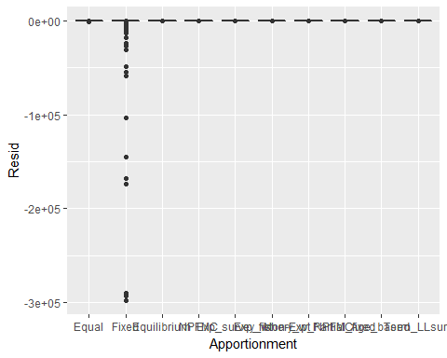

Figure 29. This shows the OM-EM SSB residual distribution for each apportionment method.

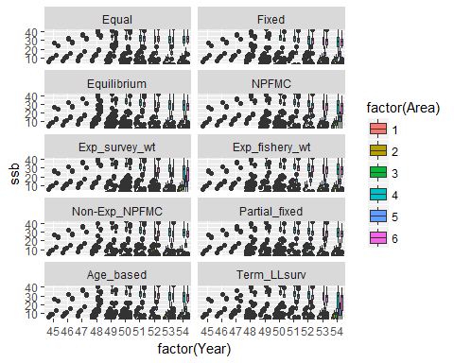

Figure 30. Spawning stock biomass (kt) for the OM population by area and apportionment method.

# Appendix 1 - additional information and figures

### Apportionment specifics

Several opportionment methods have fixed or input specifications.  
For ‘Fixed’ apportionment, the proportions of ABC by area (in order Bering Sea, Aleutian Islands, Western GOA, Central GOA, West Yakutat, East Yakutat/SEO) are: 10%, 13%, 11%, 34%, 11%, 21%.

For ‘Equilibrium’ apportionment, the proportions of ABC under the stationary distribution of the movement rates (areas in same order as above): 9%, 14%, 13%, 27%, 14%, 23%.

For ‘Fixed’ apportionment, Bering Sea and Aleutian Islands each receive 10% of the ABC. This value can be easily changed if desired.

For ‘A_L.mat’ apportionment, the age at 50% maturity is assumed to be age-5 (it is really closer to age 5.5 but we cannot use half ages).

### Selectivity

There are no length comps in the EM and only age comps for 1999 forward for the longline survey and the fixed gear fishery. As such, there’s no data informing selectivity for the pre-IFQ fishery or trawl fishery in the EM. However, figures below show EM estimates and OM values for selectivity for these fisheries.  
#### Longline fishery Pre-IFQ selectivity

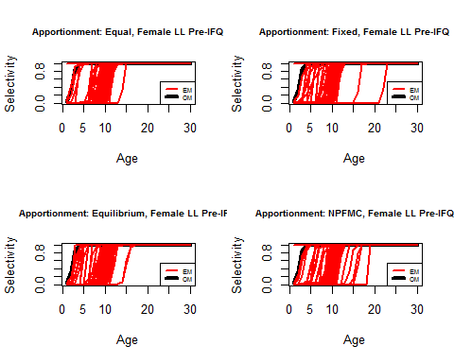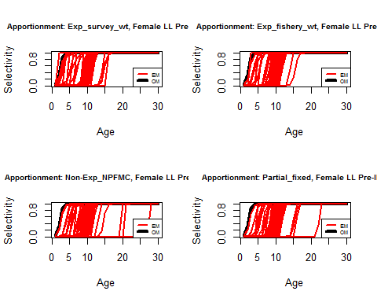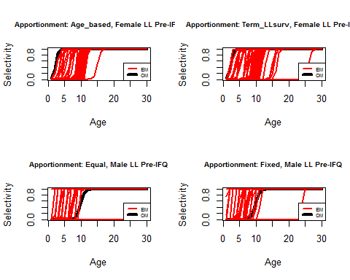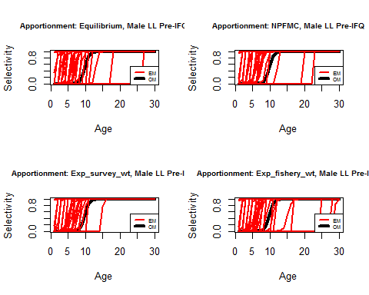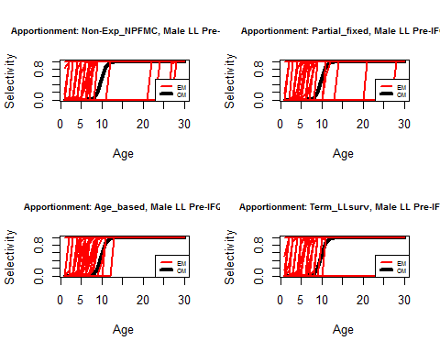

Figure x. EM estimated selectivity for the longline fishery, Pre-IFQ years for each sex and apportionment method. Each red line in a single figure panel represents a different simulation and year. Pre-IFQ selectivity does not differ over spatial areas in the OM.

#### Trawl fishery

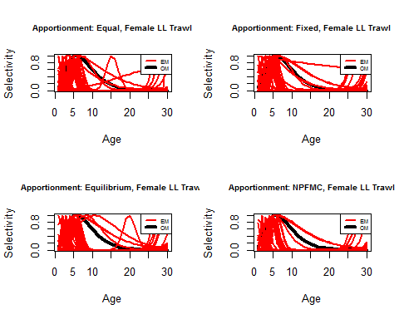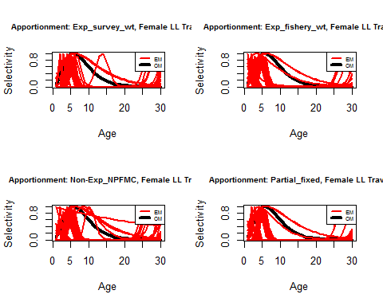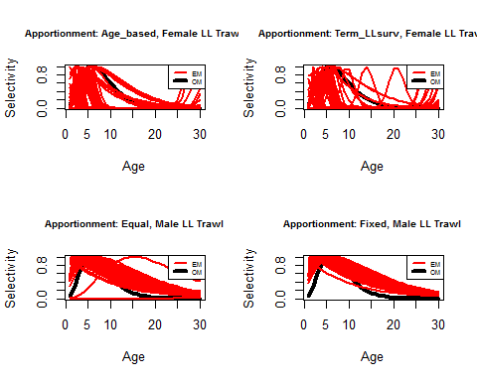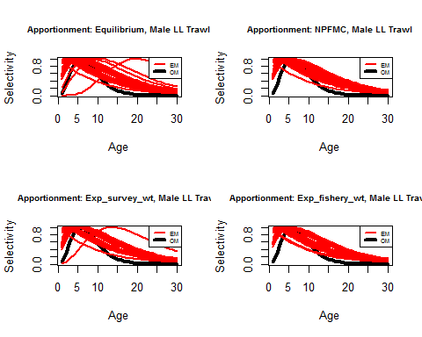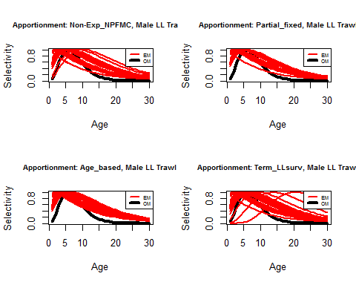

Figure x. EM estimated selectivity for the trawl fishery, for each sex and apportionment method. Each red line in a single figure panel represents a different simulation and year. Selectivity does not differ over spatial areas in the OM.

Recruitment from the Management EM is used during the conditioning period for the OM, and it has a small amount of autocorrelation (in its ‘uncorrected’ form, before we reduce 2014 from 150 million recruits to 50 million recruits). For the simulations shown here, we have used an autocorrelation parameter of 0.2 when generating OM recruitment. With the 2014 high recruitment removed, there does not appear to be any appreciable autocorrelation in recruitment:  
