### This solution sets up a complete observability pipeline using **Minikube**, **OpenTelemetry Collector**, a Python demo application, and **Grafana Cloud**. It enables collection and visualization of **metrics**, **logs**, and **traces** with alerting, SLOs, and a runbook.

### 1. **Minikube Setup**

* Minikube installed on Windows using Docker driver.
* Networking configured via cluster DNS i.e. otel-collector

### 2. **Python App Deployment**

* Used example Python demo app with OpenTelemetry SDK.
* Configured environment variables for OTLP endpoint, protocol, and headers.
* Exporter settings:

OTEL_EXPORTER_OTLP_PROTOCOL="http/protobuf"

OTEL_EXPORTER_OTLP_ENDPOINT="http://otel-collector:4317"

### 3. **OpenTelemetry Collector**

* Custom otel-collector.yaml defined with three exporters.
* Collector exposed via ClusterIP and referenced by in-cluster DNS.

### 4. **Grafana Cloud Configuration**

* Copied OTLP endpoint and token from the **Grafana Cloud Portal**.
* Currently somehow I am facing issue in viewing data in below, however for me everything seems correct. Need more time to troubleshoot
  + **Metrics → Explore**
  + **Logs → Loki**
  + **Traces → Tempo**

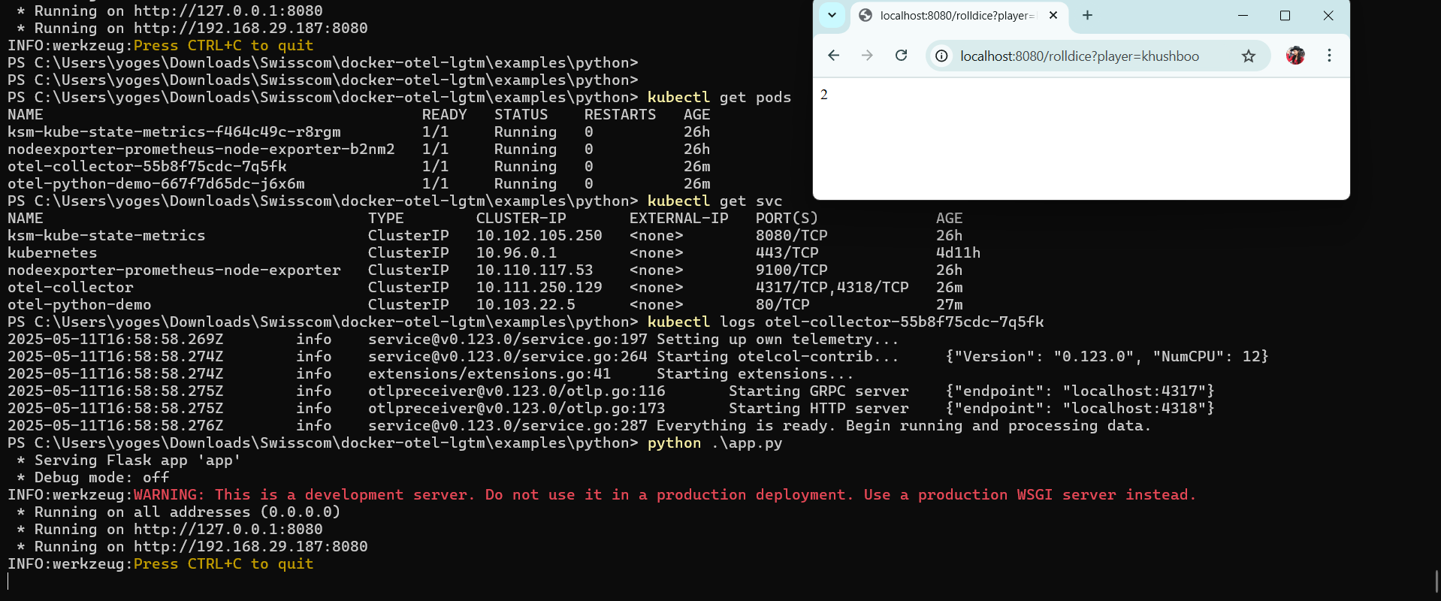

**Assumption:**

1. OpenTelemetry Collector runs with proper apiVersion: v1, valid exporter
2. Grafana Cloud account is already set up with access to Tempo, Loki, Prometheus.
3. OTLP API token is stored securely (not hardcoded in production)
4. otel-python-demo app uses auto-instrumentation or manual instrumentation.
5. K8s default namespace is used for simplicity

**Components Overview**

| **Component** | **Purpose** |
| --- | --- |
| Minikube (Docker driver) | Local Kubernetes cluster |
| Python Demo App | Generates telemetry |
| OpenTelemetry Collector | Aggregates and exports telemetry data |
| Grafana Cloud | Visualizes metrics, logs, traces |
| PrometheusRule + Sloth | Provides alerting and SLO management |
|  |  |

**How to Run**

# 1. Start Minikube

minikube start --driver=docker

# 2. Apply all manifests

kubectl apply -f otel-collector.yaml

kubectl apply -f python-app.yaml

kubectl apply -f infra-alerts.yaml

kubectl apply -f app_slo_alert.yaml