**1:What is SDLC?**

SDLC stands for software development life cycle,it is a step by step process used to plan,create,test,and deploy software efficiently and with quality

**2:Why is SDLC?**

We use SDLC to follow a structured and organized way of developing software.it helps to avoid mistakes saves time and ensures the final product meets user requirements without it development can lead to issues like delays or poor quality

**3:What are the stages in SDLC?**

1.**PLANNING**-This is the fist stage where goals are defined,project requirements are gathered,it helps to understand what the software should do and what resources are needed

2.**ANALYSIS**-In this stage the team studies the requirements in detail,it ensures a clear understanding of what needs to be built and identify any risks

3.**DESIGN**-In this stage system architecture and technical details are planned it includes deciding how the software will look and how components will interact

4.**DEVELOPMENT**-The actual coding of the software takes place in thi stage.developers write code based on the design documents

5.**TESTING**-The software is tested to find and fix bugs or errors,this ensures the product works as expected and meets quality standards

6.**DEPLOYMENT**-The software is released for users to use in a real environment,it can be developed fully or in phases depending on the project

7.**MAINTENANCE**-After deployment,the software is updated and supported,This includes fixing bugs,making improvements,and adding new features.

**4:SDLC Models**

SDLC has different models like:

1-Waterfall model

2-Agile model

3-V-model

4-Spiral model

5.Iterative model

Waterfall model-This is linear model where each phase is completed one after the other.its simple but doesnt allow changes once a phase is done

Applications of Waterfall Model:  
Used in projects where requirements are clear and fixed, such as government systems, construction projects, and manufacturing software.

Advantages

simple ,easy to manage,clear milestones

Disadvantages

Not flexible,hard to handle changes

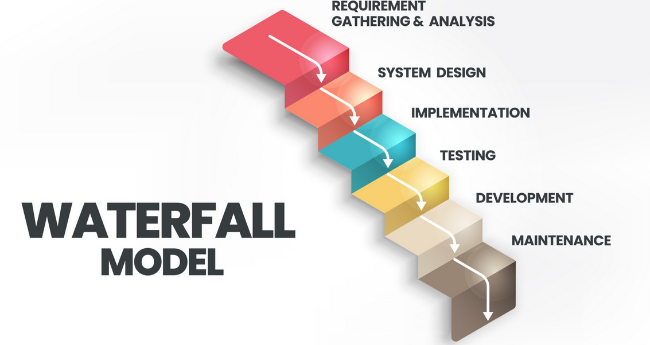

Agile model -It is an iterative approach with work divided into sprints and continuous client feedback

Applications of Agile Model-Common in web development, mobile apps, startups, and products with changing requirements needing frequent updates.

Advantages

Flexible,fast delivery,client feedback

Disadvantages

Needs active client involvement,less predictable

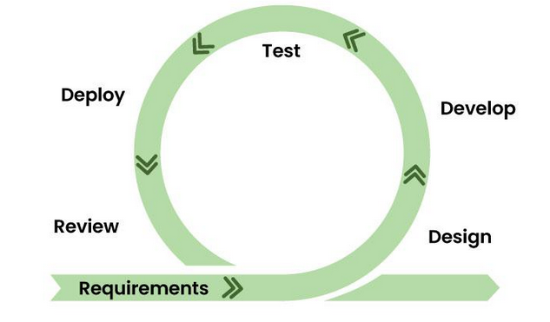

V-model- A development model where each phase has a corresponding testing phase

Applications of v model-used in health care,banking applications,and safety-critical software where strict testing is needed

Advantages

Early testing,structured process

Disadvantages

Rigid and not flexible to change,expensive if req change mid-way

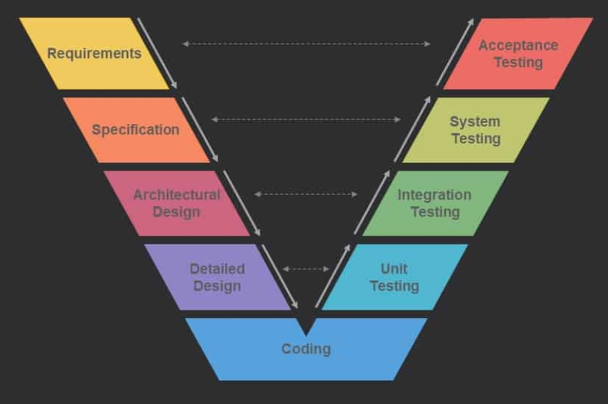

Iterative model- A model where software is developed through repeated cycles improving with each version

Application-Used in software that evolves over time like social media platforms, enterprise applications, and products with ongoing feature improvements.

Advantages

Allows improvements in version,flexible

Disadvantages

Requires good planning,not all features are delivered at once.

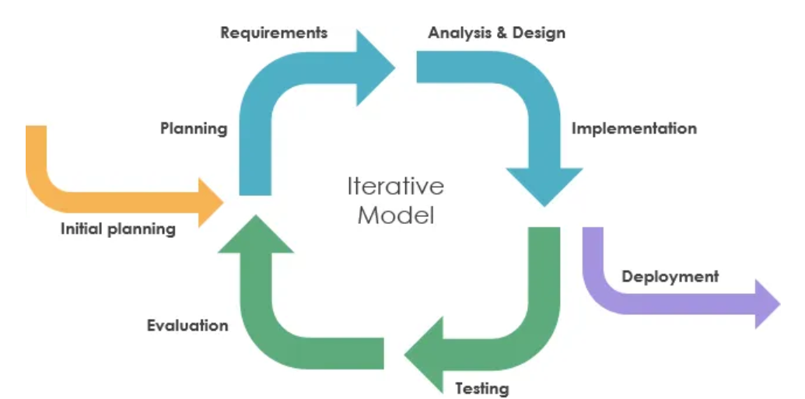

Spiral model-it combines iterative development with risk analysis it focusses on repeating cycles where each cycle includes planning,risk assessment,engineering and evaluation

Applications of Spiral Model:Applied in aerospace, defense projects, and large complex software with high risk and uncertainty.

Advantages

Focus on risk management,good for complex projects

Disadvantages

Complex to manage,expensive,not suitable for small or low-risk projects

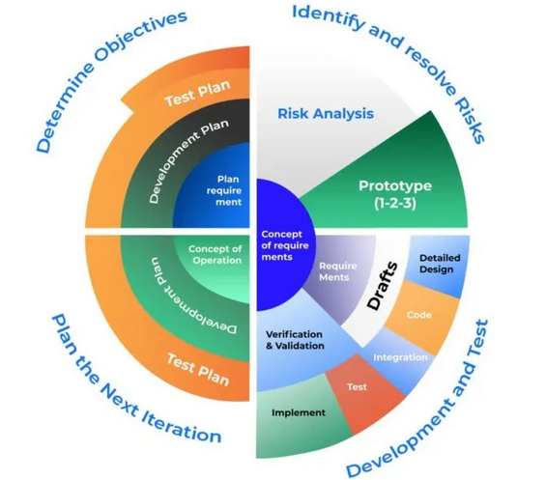

**5:What is scrum?**

It is an Agile framework used for managing software development it breaks work into small cycles called sprints,helping teams deliver working software frequently and adapt to the changes quickly.

**6:What is a sprint?**

A sprint is a short,fixed period in scrum(usually 2-4 weeks) during which the team works to complete a specific set of tasks and deliver a working product.

**7:What to do and not do during sprints**

**TO DO**

Attend daily stand-up meetings

Focus on sprint goals

Complete the tasks committed for the sprint

**Not to do in a sprint**

Not to add new tasks after sprint starts

Dont skip daily stand ups

Dont change sprint goals without team agreement

Backlog - is a list of all the work items or features that need to be done in a project it is maintained by the product owner

User stories - are individual items in the backlog that describe a feature or requirement from the users perspective

SCRUM ARTIFACTS

Product backlog-A list of all features,improvements,and fixes needed in the product

Sprint backlog- Alist of selected tasks the team will complete during the current sprint

Increment - The working product or feature delivered at te end of the sprint

Burndownchart- A visual chart that shows the remaining work in the sprint over time

—----------------------------------------------------------------------------------------------------------------------------

**NETWORKING**

1:**What are ports and protocols and what do you understand by them and what is the difference?**

Port - is a logical endpoint through which data is sent and received on a network

Protocol - is a set of rules that defines how data is transmitted between devices

Difference-port is like a door for communication,while protocol defines how communication happens

2:**What are the different network types that you come across?**

1.LAN (Local Area Network)

2.WAN(Wide Are Network)

3.MAN(Metropolitan Area Network)

4.PAN(Personal Area Network)

5.VPN(Virtual Private Network)

**3:What are the types of servers**

Web server - Hosts websites and delivers web pages to users through HTTP/HTTPS

Application Server - Runs business logic and handles application operations between user and databases

Database server - Stores and manages files in a network,allowing users to share and access them

File server - Stores and manages files in a network,allowing users to share and access them

Dns server- converts domain names into IP address

**4:What do you know about DNS(Domain name system)**

It is used to translate domain names like [google.com](http://google.com) into IP addresses like 142.250.190.14 so browsers can load the correct website

**5:Different types of network topologies?**

Network topologies define how devices are connected in a network

1-Bus topology

2-Star topology

3-Ring topology

4-Mesh topology

5-Tree topology

6-Hybrid topology

Bus topology: In this there is a single cable to which all the devices are connected but if the cable fails,the whole network goes down

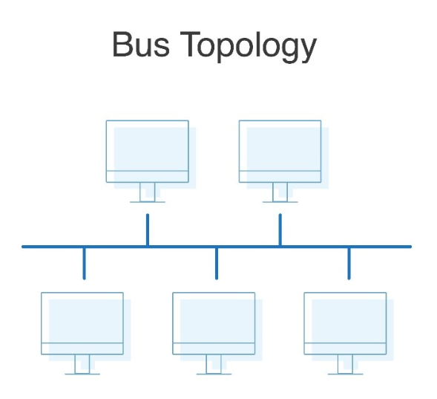

Star topology: All devices connect to a central switch its easy to manage,but if te hub fails,the network stops.

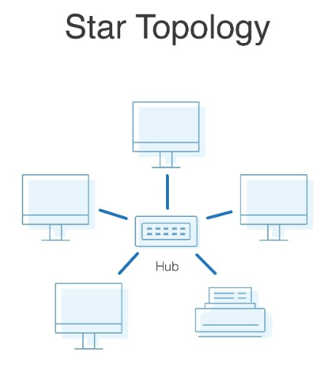

Mesh topology:It is strong and reliable used where high availability is important,like in data centers

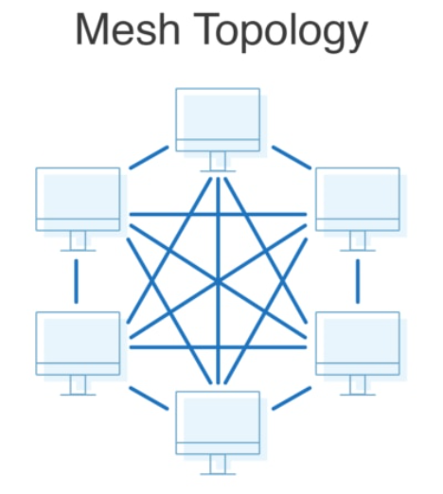

Tree topology:It is a combination of star and bus topologies,Devices are connected in a hierarchical manner

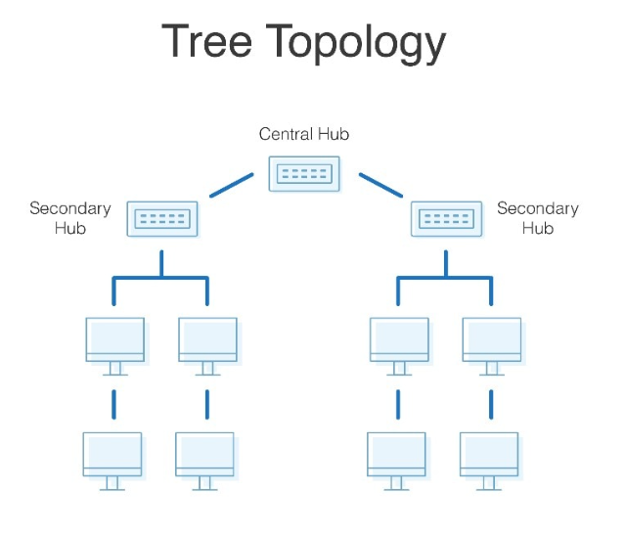

**6:What is OSI Model? Describe the 7 layers with description?**

**OSI(Open Systems Interconnection)** Model is a conceptual framework that describes how data travels from one computer to another in a network.It has 7 layers each responsible for specific tasks in data communication.

**7 Layers of OSI Model:**

1-Physical Layer-Transfers raw bits over a physical medium like cables handles hardware like switches and connectors.

2-Data link layer-Ensures error-free data transfer between two directly connected nodes.Adds MAC addresses

3-Network Layer-Decides the best path for data using IP addresses(routing)

4-Transport Layer-Provides reliable data transfer using protocols like TCP/UDP

5-Session layer-Manages sessions or connections between two systems

6-Presentation Layer-Converts data into a format readable by the application(Encryption,Compression)

7-Application Layer-Closest to the user.Deals with network services like email,web browsers etc.