**Task1**

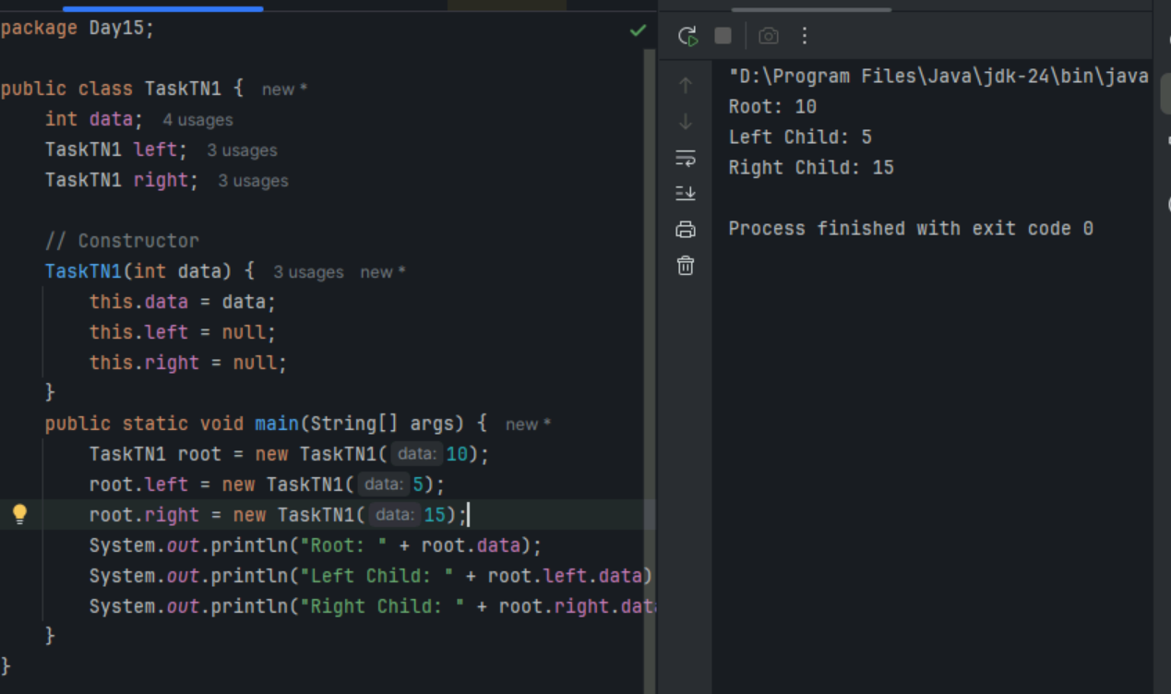

**Task2**

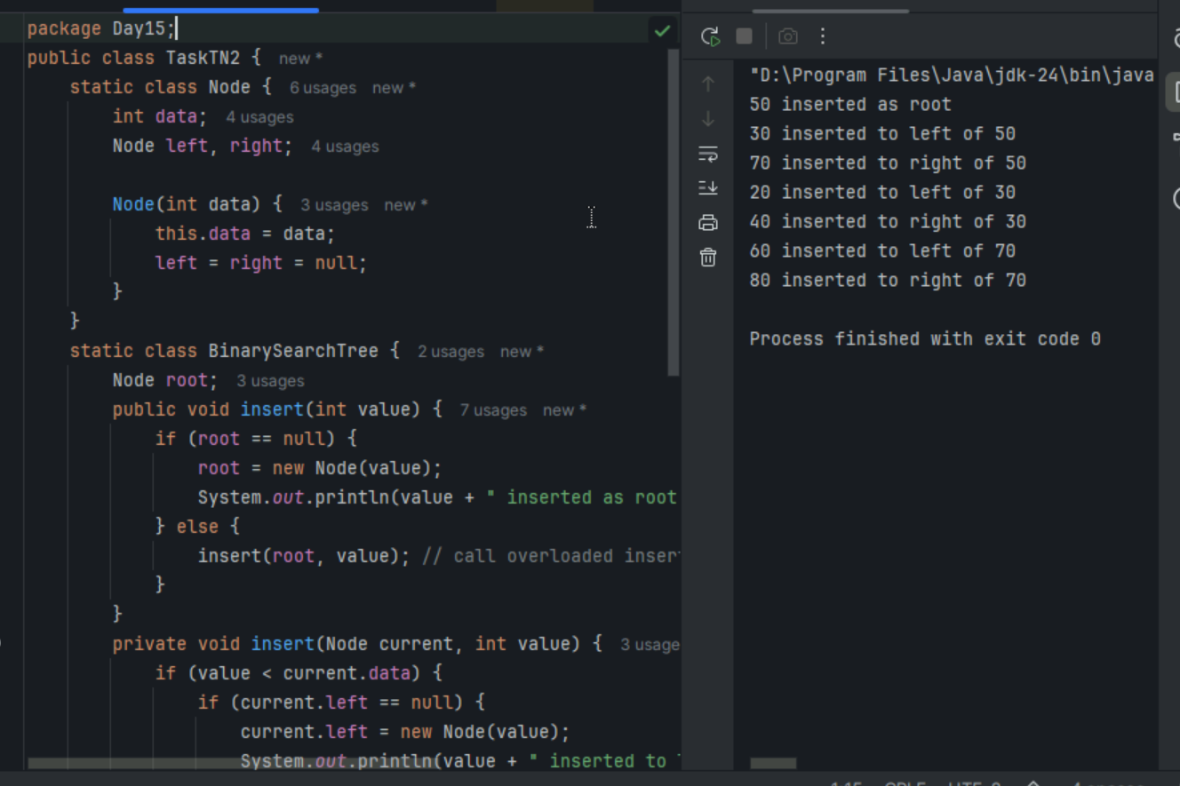

**Task3**

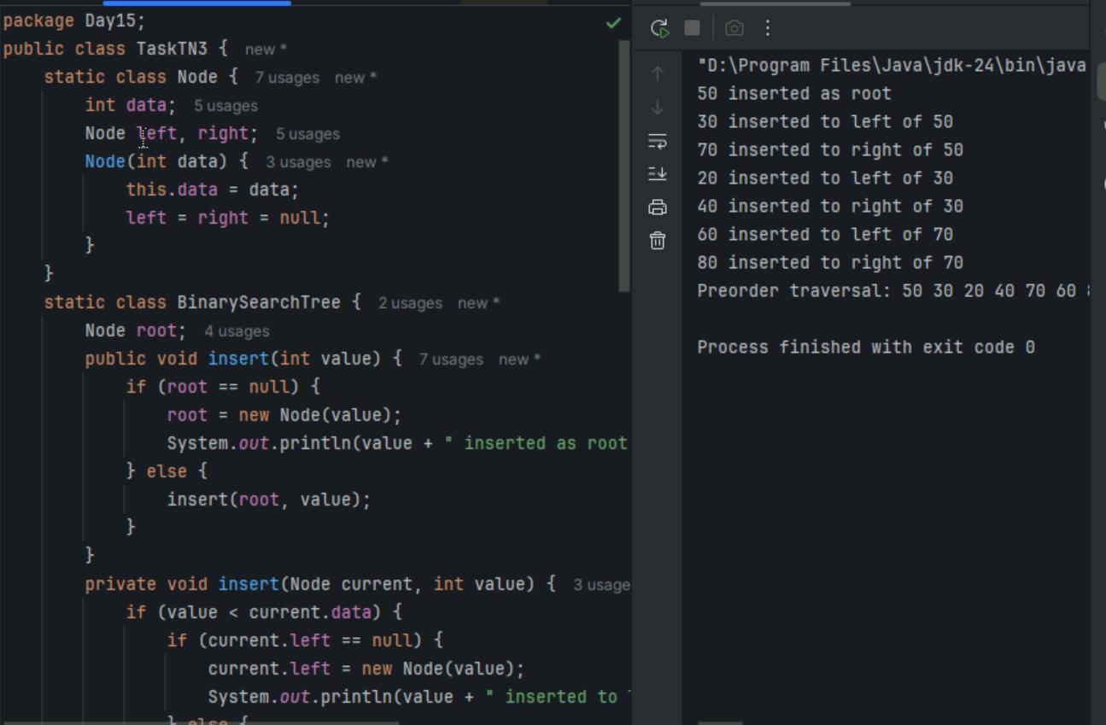



**Task5-Application of trees**

1. **Hierarchical Data: Representing structures like file systems, organizational charts, and XML/HTML documents.**
2. **Searching: Efficiently searching for data using binary search trees.**
3. **Sorting: Sorting data with structures like AVL trees and Red-Black trees.**
4. **Databases: Implementing indexing in databases with B-trees and B+ trees.**
5. **Compilers: Parsing expressions and syntax trees in compiler design.**

**Task6**

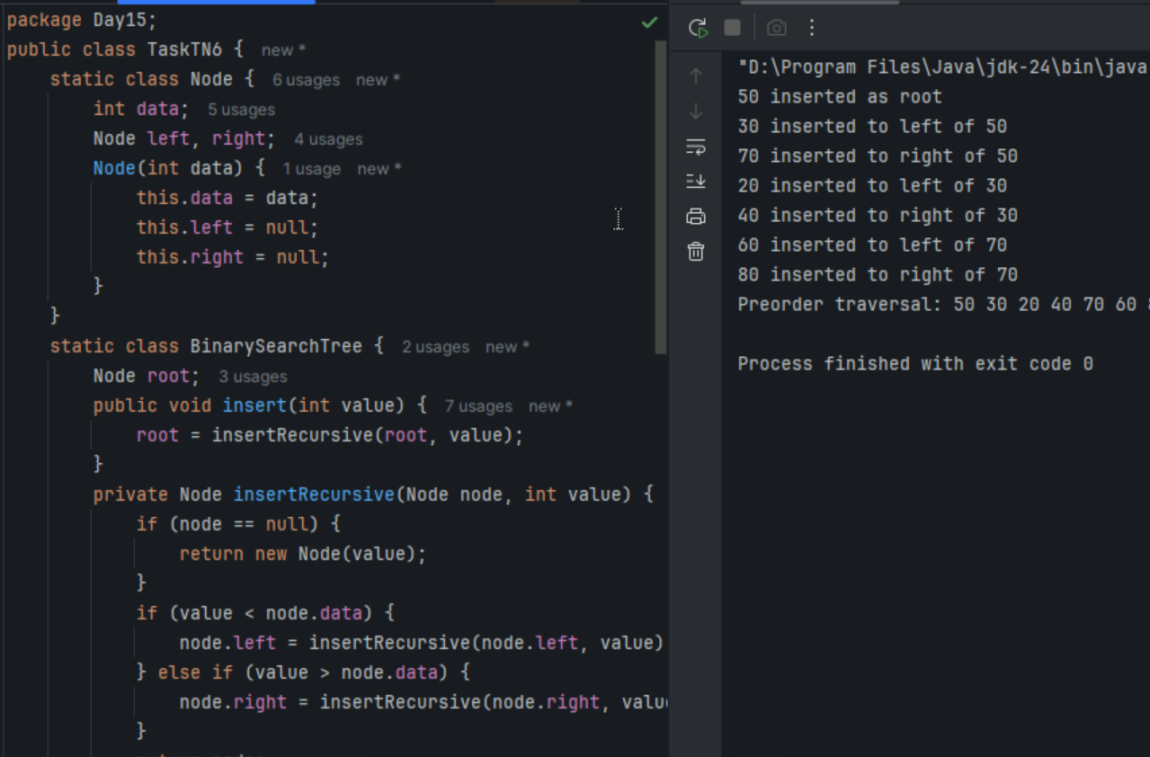

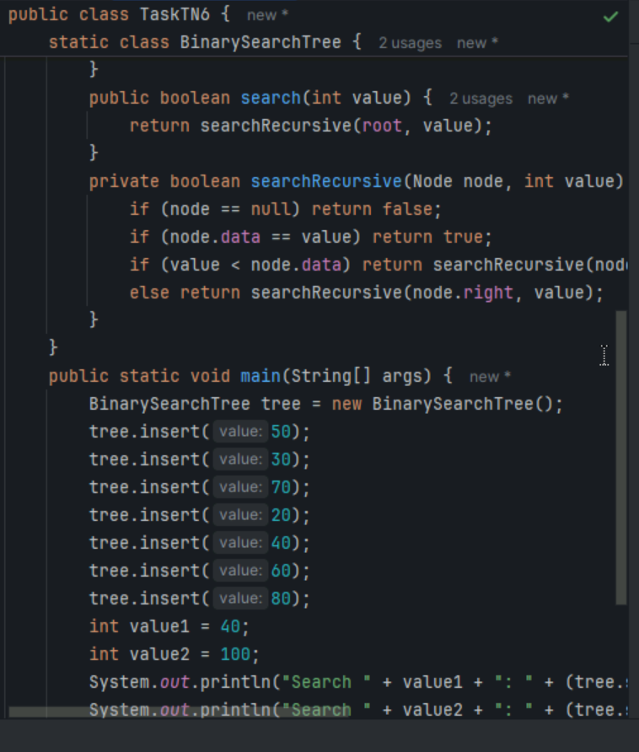

**Task7**

1. Full Binary Tree: Every node has either 0 or 2 children. No node has only one child [[1]](https://www.geeksforgeeks.org/dsa/types-of-binary-tree/).
2. Complete Binary Tree: All levels are completely filled except possibly the last, which is filled from left to right
3. Perfect Binary Tree: All internal nodes have exactly two children, and all leaf nodes are at the same level
4. Balanced Binary Tree: The height of the left and right subtrees of any node differ by at most one
5. Degenerate (or Pathological) Tree: Each parent node has only one child, making it essentially a linked list
6. Skewed Binary Tree: All nodes are either to the left or right, forming a linear structure. It can be left-skewed or right-skewed

Task 8: Applications of Graphs

1. Social Networks: Representing relationships between users, such as friends on Facebook or followers on Twitter
2. Transportation Networks: Modeling roads, railways, and flight paths to find the shortest or most efficient routes
3. Web Page Ranking: Google's PageRank algorithm uses graphs to rank web pages based on their importance
4. Biological Networks: Analyzing protein-protein interactions, gene regulatory networks, and other biological systems
5. Communication Networks: Representing connections between routers and switches in computer networks
6. Resource Allocation: Managing resources in operating systems to avoid deadlocks
7. Recommendation Systems: Suggesting products, movies, or friends based on user preferences and connections

**Task 9: Types of Graphs:**

1. Line Graphs: Display data points connected by straight lines, often used to show trends over time
2. Bar Graphs: Use rectangular bars to represent data values, useful for comparing different categories
3. Pie Charts: Show proportions of a whole as slices of a pie, ideal for displaying percentage distributions
4. Histograms: Similar to bar graphs but used for continuous data, showing frequency distributions
5. Scatter Plots: Use dots to represent values for two different variables, helpful for identifying correlations
6. Venn Diagrams: Illustrate relationships between different sets, showing commonalities and differences

**Task10**

