Task 1: What do you understand about data structures?

Data structures are special formats used in programming to store, organize, and manage data so that it can be used efficiently.

Task 2: What are the types of data structures you know .. list them out..

• Array
• Linked List
• Stack
• Queue
• Deque
• Tree
• Binary Tree
• Binary Search Tree (BST)
• Heap
• Trie
• Graph
• HashMap
• HashTable
• HashSet
• Priority Queue
• Segment Tree
• Disjoint Set (Union-Find)
• Matrix

Task 3: What all operations can we do in Data structures?

• Insertion
• Deletion
• Traversal
• Searching
• Sorting
• Access (or Retrieval)
• Updating
• Merging
• Splitting
• Resizing
• Reversing
• Rotating
• Cloning or Copying
• Filtering
• Mapping
• Aggregation (like sum, count, average)
Task4 : What are static and dynamic arrays? Explain or summarize key points in a table like
Size, performance, memory, flexibility, limitations

Feature | Static Array | Dynamic Array
Size | Fixed at the time of creation | Can grow or shrink during runtime
Memory | Allocated at compile-time | Allocated at runtime(heap memory)
Performance | Faster access and operations | Slightly slower due to resizing
Flexibility | Less flexible(size cant change) | More flexible(resizable)
Limitations | Wastes space if too big;can overflow if too small | Resizing may be costly in performance sometimes
Examples | C-style arrays (int arr[10]) | Javas ArrayList,pythons list

Task 5: What is the binary value of a?

The binary value of the lowercase letter ‘a’ is: 01100001

Explanation:
• The ASCII value of 'a' is 97.
• Binary of 97 is 01100001 (8-bit representation).

Task 6: Types of Computer memory with examples.. Explain ..

1. Primary Memory
• RAM: Temporary memory used while programs run. Data is lost when power goes off.
Example: Opening a game or file loads it into RAM.
• ROM: Permanent memory with startup instructions.
Example: Helps the computer start when turned on.

2. Secondary Memory

Used to store data for a long time.
Examples: Hard drives, SSDs, pen drives, CDs.

3. Cache Memory

Very fast memory close to the CPU.
Example: Stores recently used data to speed up tasks.

4. Virtual Memory

When RAM is full, the computer uses part of the hard drive as extra memory.
Example: Helps when many apps are open.

5. Registers

Tiny memory units inside the CPU for quick calculations.
Example: Stores numbers briefly during processing.

Task 10:

This program merges two sorted arrays into a single sorted array. It compares elements from both arrays one by one and stores the smaller one in a new array. After comparing, it adds any remaining elements from either array. Finally, it prints the merged sorted array.

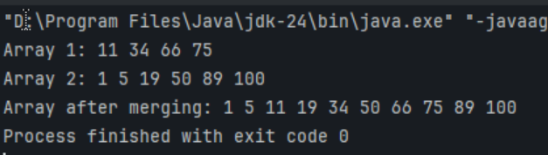

Task 11:What do you understand by hash table?

A hash table is a data structure that stores data in key-value pairs, where each key is mapped to a value using a process called hashing.

Task 14: Difference between Hash Table and Hash Map

Map is an interface, not a class.
Hashtable is a class that implements Map.

Map is not synchronized (not thread-safe).
Hashtable is synchronized (safe for multi-threading).

Map (like HashMap) allows one null key and multiple null values.
Hashtable does not allow null keys or null values.

Map is faster (especially HashMap) because it’s not synchronized.
Hashtable is slower due to synchronization.

Map doesn’t guarantee order (unless using LinkedHashMap).
Hashtable also doesn’t maintain any order.

Map was introduced in Java 1.2.
Hashtable is older, from Java 1.0.

