Task1

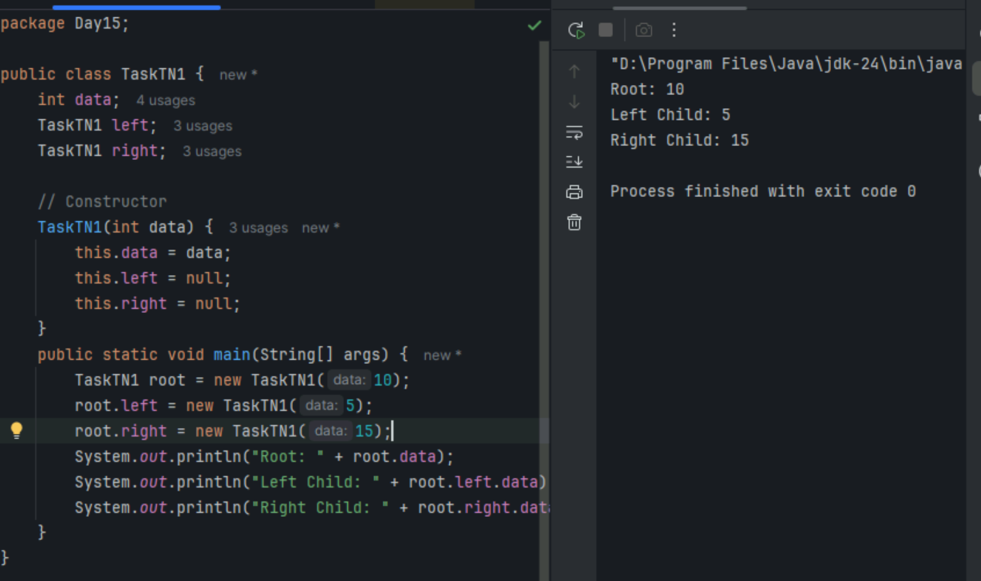

Task2

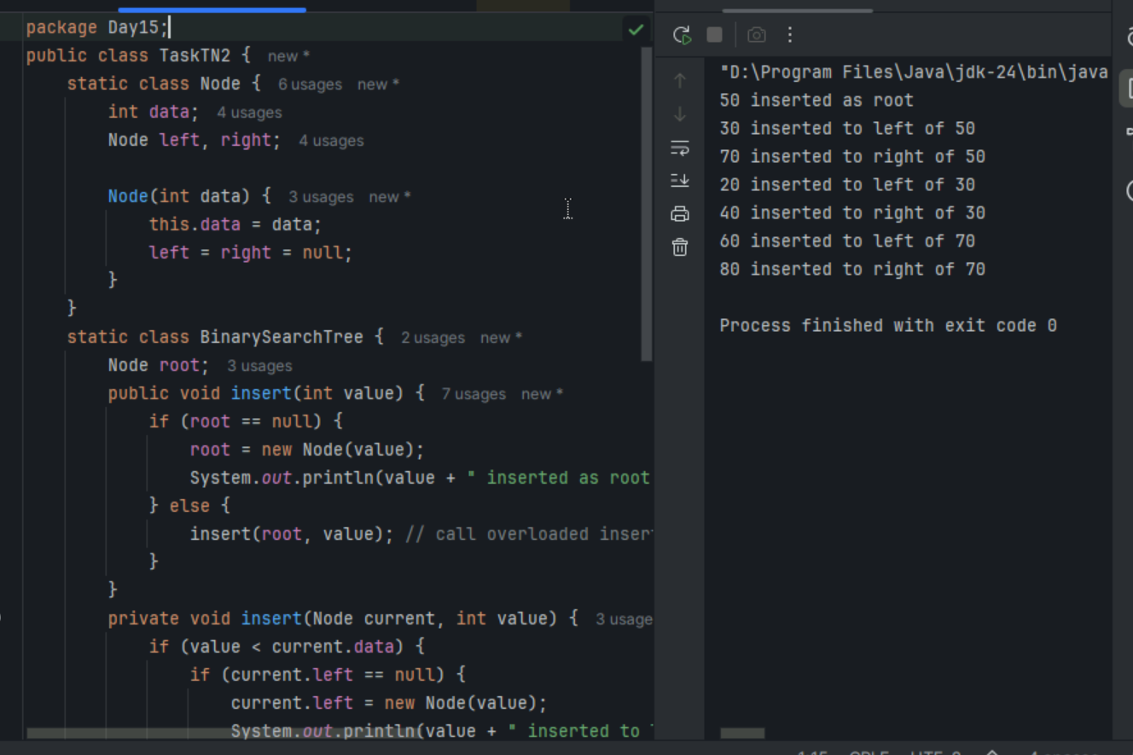
Task3

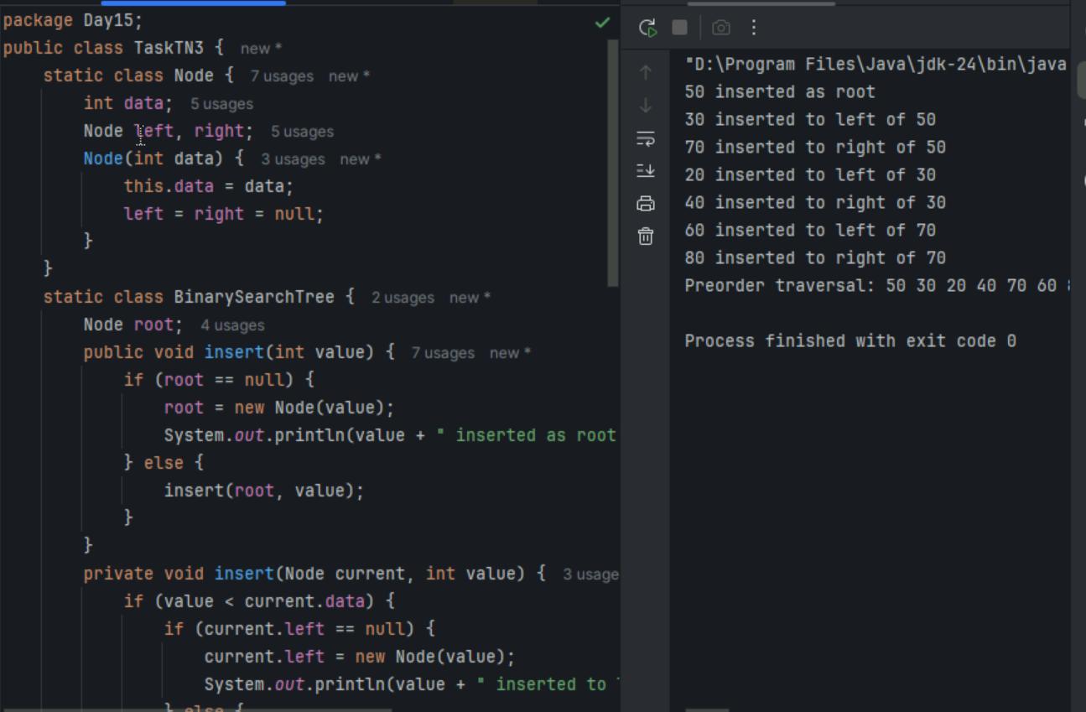
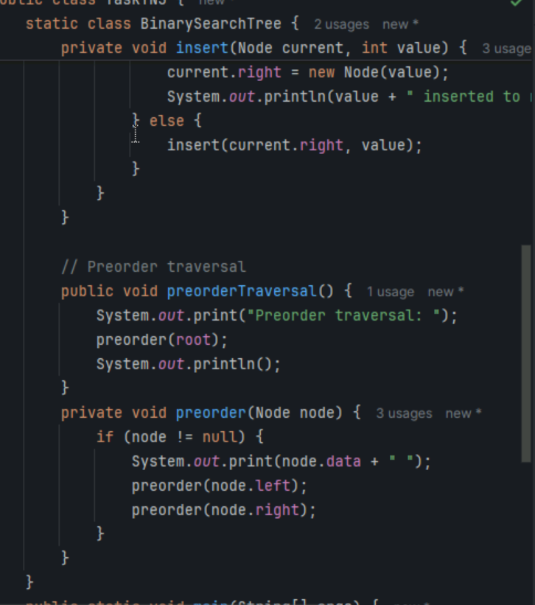

Task5-Application of trees
- Hierarchical Data: Representing structures like file systems, organizational charts, and XML/HTML documents.
- Searching: Efficiently searching for data using binary search trees.
- Sorting: Sorting data with structures like AVL trees and Red-Black trees.
- Databases: Implementing indexing in databases with B-trees and B+ trees.
- Compilers: Parsing expressions and syntax trees in compiler design.
Task6
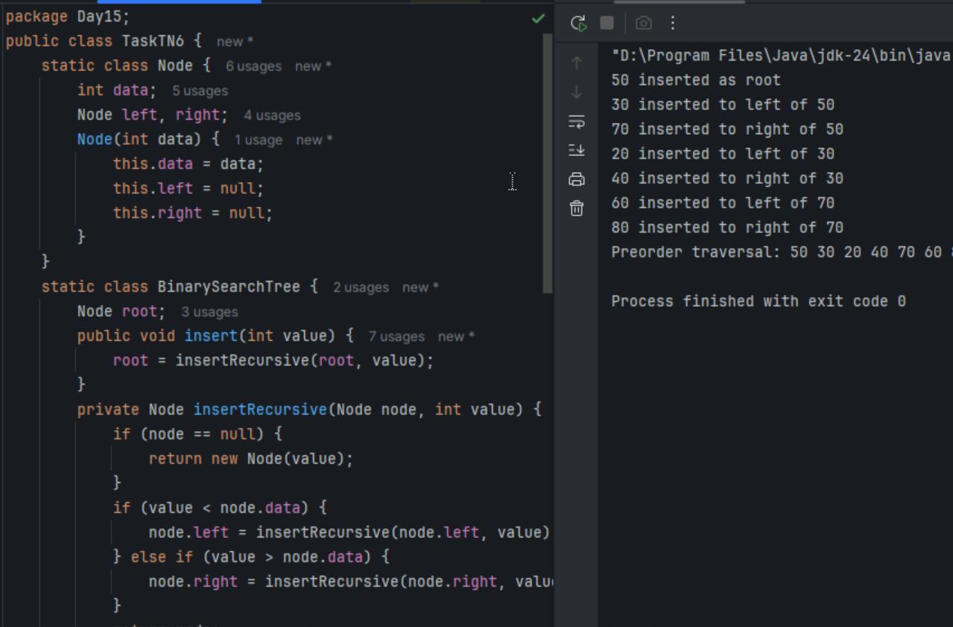
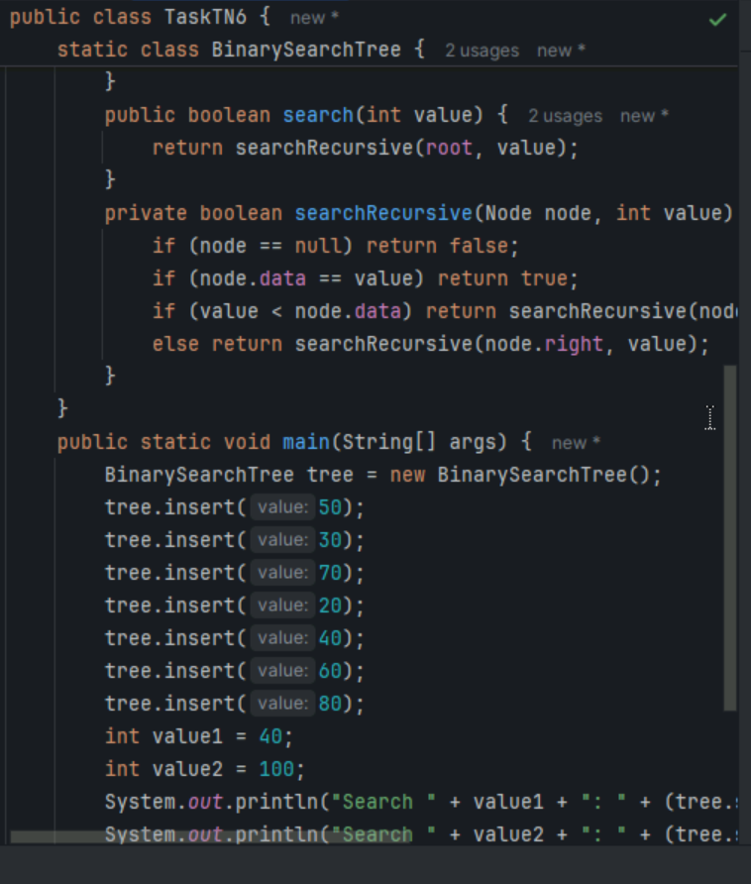
Task7
- Full Binary Tree: Every node has either 0 or 2 children. No node has only one child [1].
- Complete Binary Tree: All levels are completely filled except possibly the last, which is filled from left to right
- Perfect Binary Tree: All internal nodes have exactly two children, and all leaf nodes are at the same level
- Balanced Binary Tree: The height of the left and right subtrees of any node differ by at most one
- Degenerate (or Pathological) Tree: Each parent node has only one child, making it essentially a linked list
- Skewed Binary Tree: All nodes are either to the left or right, forming a linear structure. It can be left-skewed or right-skewed
Task 8: Applications of Graphs

- Social Networks: Representing relationships between users, such as friends on Facebook or followers on Twitter
- Transportation Networks: Modeling roads, railways, and flight paths to find the shortest or most efficient routes
- Web Page Ranking: Google's PageRank algorithm uses graphs to rank web pages based on their importance
- Biological Networks: Analyzing protein-protein interactions, gene regulatory networks, and other biological systems
- Communication Networks: Representing connections between routers and switches in computer networks
- Resource Allocation: Managing resources in operating systems to avoid deadlocks
- Recommendation Systems: Suggesting products, movies, or friends based on user preferences and connections
Task 9: Types of Graphs:

- Line Graphs: Display data points connected by straight lines, often used to show trends over time
- Bar Graphs: Use rectangular bars to represent data values, useful for comparing different categories
- Pie Charts: Show proportions of a whole as slices of a pie, ideal for displaying percentage distributions
- Histograms: Similar to bar graphs but used for continuous data, showing frequency distributions
- Scatter Plots: Use dots to represent values for two different variables, helpful for identifying correlations
- Venn Diagrams: Illustrate relationships between different sets, showing commonalities and differences
Task10
