Banking Transaction System – Day 2
Prepared By: Harika Kantipudi
Date: [09/07/2025]
Project Name: Banking Transaction System

Contents
- Customer Class Diagram
- Account Class Diagram
- Transaction Class Diagram
- ER Diagram (Database Design)
- Conclusion

1. Customer Class Diagram
Description:
The Customer class captures all information related to a bank customer. A single customer can hold multiple accounts.
Attributes:
- CustomerID : int (Primary Key)
- Name : string
- DateOfBirth : date
- Address : string
- Email : string
- PhoneNumber : string
- Password : string (secured)
Relationships:
- One customer can own multiple accounts (1-to-many).
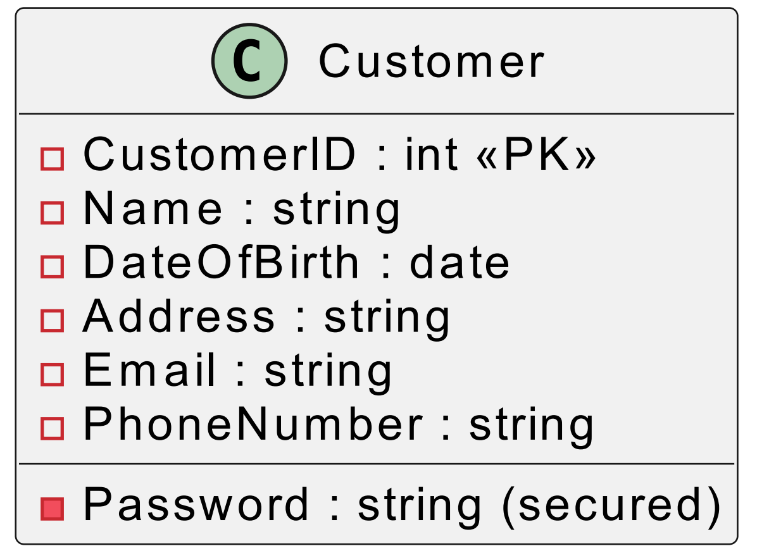

2. Account Class Diagram
Description:
The Account class represents different types of accounts held by customers and keeps track of balance and branch details.
Attributes:
- AccountNumber : int (Primary Key)
- AccountType : string (Savings / Current)
- Balance : float
- BranchName : string
- CustomerID : int (Foreign Key)
Relationships:
- An account belongs to exactly one customer.
- An account can have multiple transactions (1-to-many).
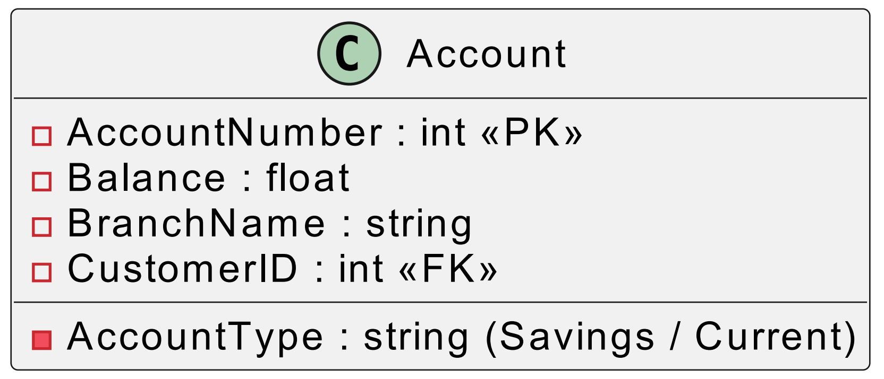

3. Transaction Class Diagram
Description:
The Transaction class represents deposits, withdrawals, and transfers performed on accounts.
Attributes:
- TransactionID : int (Primary Key)
- Date : datetime
- Amount : float
- TransactionType : string (Deposit / Withdrawal / Transfer)
- SourceAccountNumber : int (FK)
- DestinationAccountNumber : int (FK, optional for deposits/withdrawals)
- Status : string (Success / Failed)
Relationships:
- Each transaction is linked to one account (or two in case of transfers).
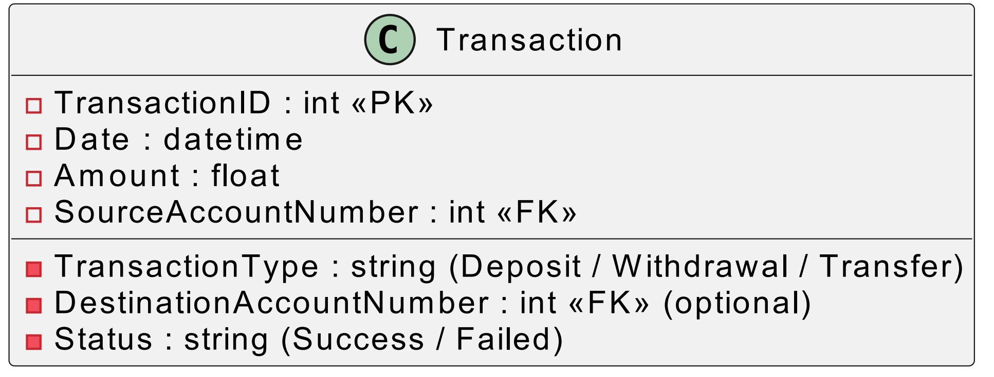

4. ER Diagram (Database Design)
Entities and Keys:
- Customer(CustomerID PK, Name, DateOfBirth, Address, Email, PhoneNumber, Password)
- Account(AccountNumber PK, AccountType, Balance, BranchName, CustomerID FK)
- Transaction(TransactionID PK, Date, Amount, TransactionType, SourceAccountNumber FK, DestinationAccountNumber FK, Status)
Relationships:
- Customer (1) → (M) Account
- Account (1) → (M) Transaction
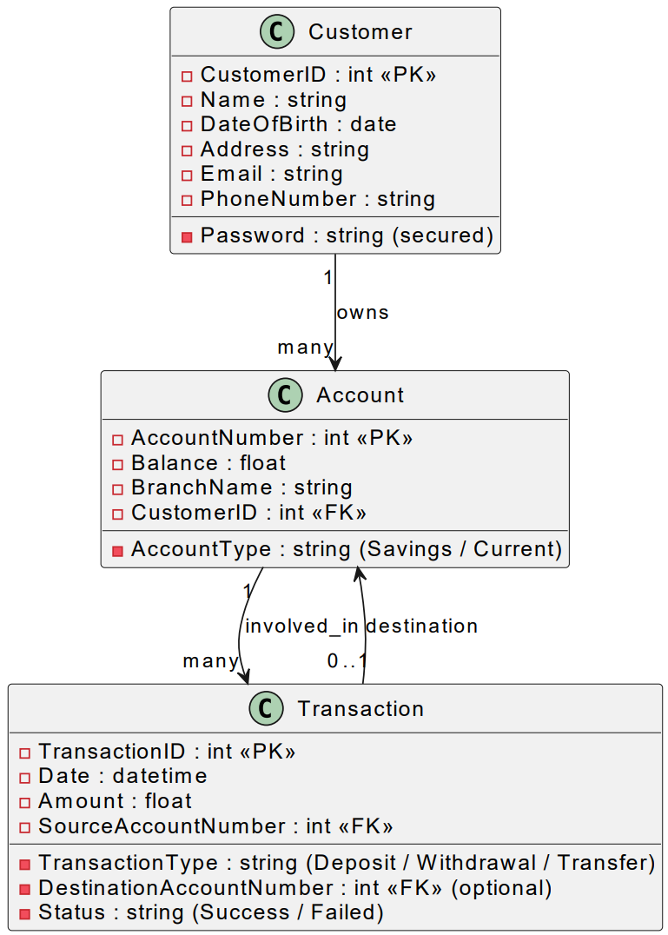

5. Conclusion
On Day 2, the Banking Transaction System design was documented using UML Class Diagrams for Customer, Account, and Transaction entities, along with an ER Diagram to model database relationships.

