Task1:

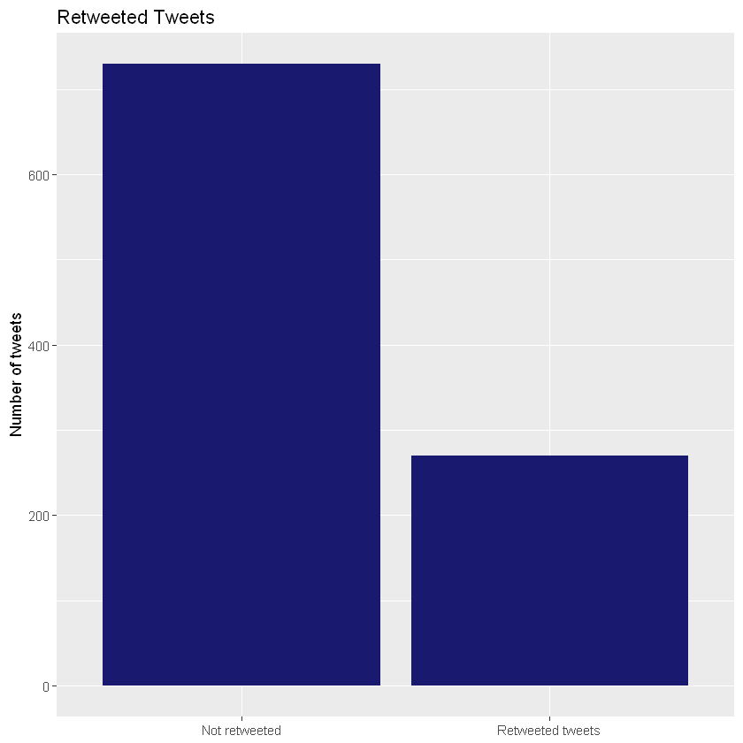

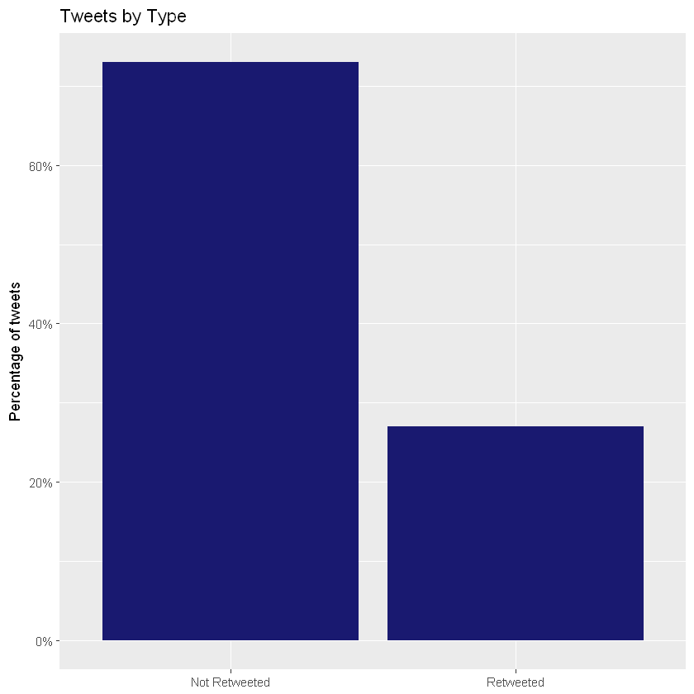

Task 2:

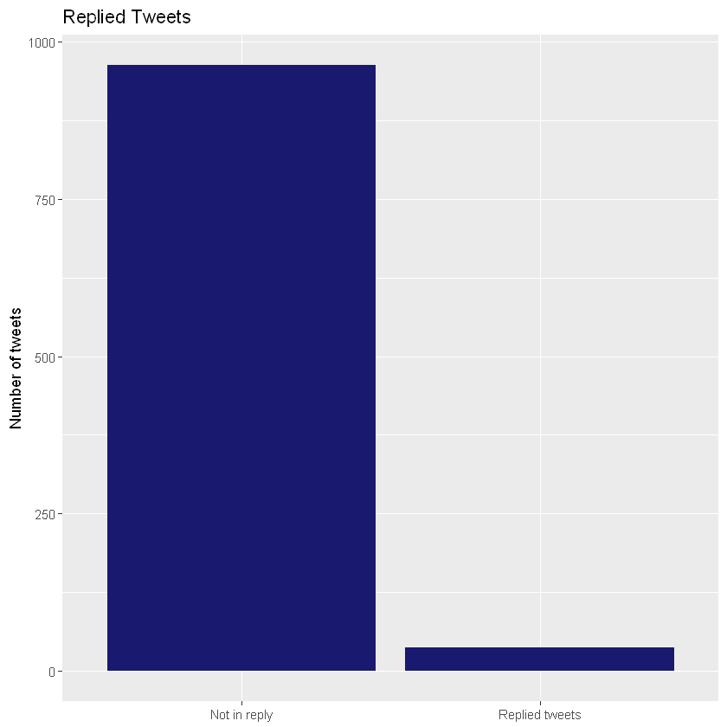

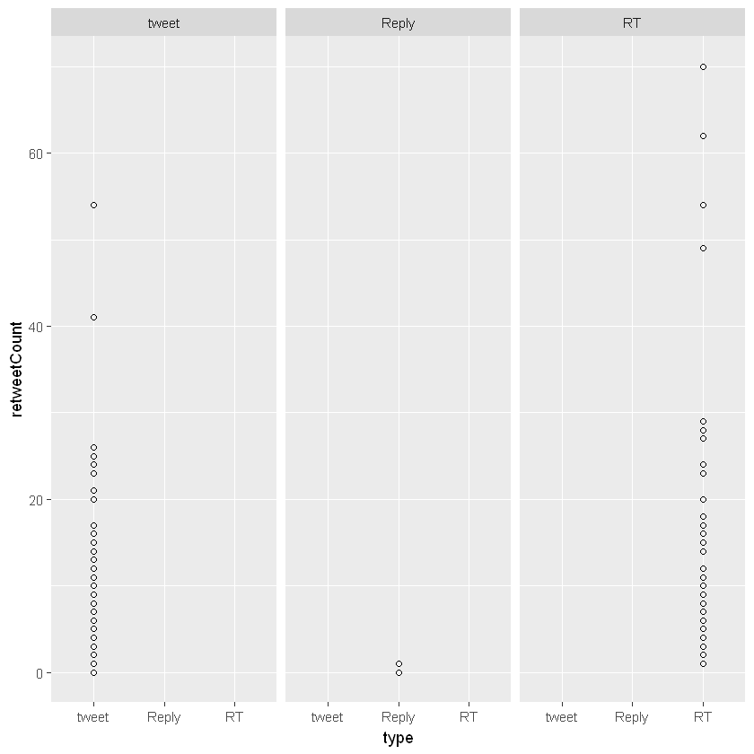

Task 4:

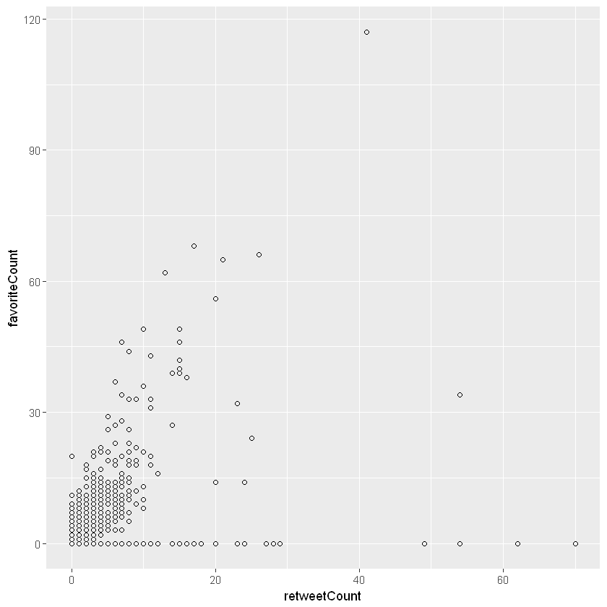

**3. How would you change the script to display percentages instead of the actual counts in Chart 1 & 2?**

The changes to display percentages are marked in below:

#Task1.1 -Change the display in percentage

ggplot(tweetsDF, aes(x = tweetsDF$isRetweet)) +

geom_bar(aes(y=(..count..) / sum(..count..)), fill = "midnightblue") +

theme(legend.position="none", axis.title.x = element_blank()) +