Testing

Differential Thresholding and morphology

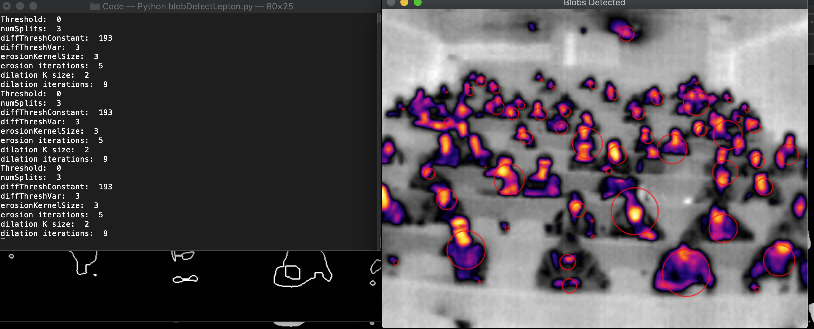

Basic Thresholding (no morphology)

