Intermediate Value theorem

IVT

Calculus theorem

Calculus

Theorems

Suppose that f(x) is continuous on [a, b] and let M be any number between f(a) and f(b). Then there exists a number c such that, All the **Intermediate Value Theorem** is really saying is that a continuous function will take on all **values** between f(a) and f(b).

"title": "Intermediate Value Theorem",

    "subtitle": "They’ll never intersect!",

    "desc": "lines that are everywhere equidistant",

    "img": "math-img/parallel_lines.jpg",

    "tags": ["intermediate value theorem", "ivt", "calculus theorems", "theorems", “calculus”],

"created": "Destinee Bell"

[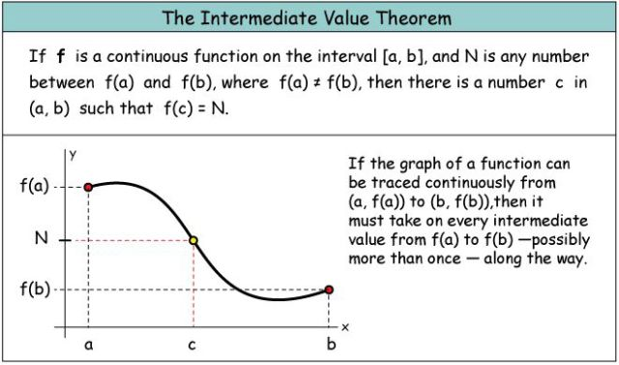](https://www.google.com/url?sa=i&rct=j&q=&esrc=s&source=images&cd=&cad=rja&uact=8&ved=0ahUKEwigxoCjoqzUAhXGGz4KHT0jARoQjRwIBw&url=https://crushlusher.com/2016/08/30/ap-calculus-august-30-2016-intermediate-value-theorem-ivt/&psig=AFQjCNGyaawBMiLCggBm4vqILavXiqcbxw&ust=1496942759838365)