ASTRA
User Manual
Assurance for AI agents and AI models
From signing in, through the organisation and the AI Agents module, to the AI Models module.
Version 1.0 · 12 October 2026
Screenshots show a fictional company (Helix Logistics) with sample data.

Contents
If the list below is empty or lacks page numbers, right-click it in Word and choose Update Field.
Contents
1. Introduction
1.1 The ideas you will meet
1.2 About the screenshots
1.3 How this manual is organised
2. Getting started
2.1 Signing in
2.2 Roles
2.3 Finding your way around
2.4 Light and dark themes
2.5 Enlarging a diagram
3. The organisation
3.1 Step 1: describe the company
3.2 Step 2: the modelling views
3.3 Step 3: AI systems and checks
3.4 Step 4: link to AI Agents and AI Models
3.5 Starting from scratch (administrators)
3.6 Policies
3.7 Regulations and standards
4. AI Agents
4.1 Assurance overview
4.2 The agent inventory
4.3 Adding an agent
4.4 Repositories
4.5 Identity providers
4.6 Telemetry
4.7 The design studio
4.8 Contracts
4.9 Drift review
4.10 Findings
4.11 Coverage
4.12 Trust reports and Assurance Packs
4.13 Live runtime
4.14 The compliance workspace
5. AI Models
5.1 Model overview
5.2 The model designer
5.3 Runtime
5.4 Governance
5.5 Incidents
5.6 Decommissioning
5.7 Regulations and standards
5.8 Compiled contracts
6. Administration
6.1 People
6.2 API keys
6.3 The audit log
7. Quick reference and troubleshooting
7.1 I want to…
7.2 Troubleshooting
7.3 Good habits

1. Introduction
ASTRA is a platform for keeping AI under control. It lets an organisation describe itself and the AI it runs, draw the architecture of each AI agent and AI model, score the risk of every design, agree a signed contract for what each one is allowed to do, and then watch what it actually does against that contract.
The platform has three areas, all reached from one sign-in:
- Company (Organisation, Policies, Regulations): who the organisation is, the rules it applies on top of the law, and where those rules come from.
- AI Agents: software agents that use tools, call other agents and act on their own. Design them, register the ones already running, find them in code repositories, identity providers and telemetry, ratify contracts, review drift and findings, and prove coverage.
- AI Models: machine-learning models in deployment. Draw who trains, validates, deploys, operates and consumes a model, score it with the six-pillar risk method, record what is true while it runs, log incidents and plan its retirement.

1.1 The ideas you will meet
Term | What it means in ASTRA
Organisation | The company model: departments, people and roles, outside parties and the AI systems that work with them. Everything else is linked to it.
Design | A drawing of how one agent (or model) is built: its tools, data, approvals and guardrails. A design is a proposal until it is ratified.
Risk score | A number from 0 to 100 computed from a design. Higher means more risk. It also gives a gate: clear, review or blocked.
Ratify / Contract | Ratifying a design records a named person’s approval and issues a contract: a tamper-evident record of exactly what the agent may do. A contract is never edited; a change is a new version.
Drift | A proposed change to an agent that has a contract, compared with that contract. A person approves or declines it.
Finding | Something an agent did that its contract does not allow, such as calling an unlisted tool.
Coverage | How well the organisation’s agents meet the OWASP Top 10 for Agentic Applications (ASI01 to ASI10).
Evidence pack | A dated, hash-chained report for customers (Trust report) or auditors (Assurance Pack).

1.2 About the screenshots
Note. The screenshots in this manual show a fictional company, Helix Logistics, with a few sample agents and one sample model. Names, numbers and dates are examples. Your own screens will show your organisation’s data. Where a screen is empty on first use, the manual says so.

1.3 How this manual is organised
- Chapter 2 gets you signed in and finding your way around.
- Chapter 3 covers the Company area.
- Chapter 4 covers AI Agents, from the inventory to the contract and the live view.
- Chapter 5 covers AI Models.
- Chapter 6 covers administration: people, API keys and the audit log.
- Chapter 7 is a quick reference and a troubleshooting guide.

2. Getting started

2.1 Signing in
Nobody can use ASTRA without signing in. Open the address your administrator gave you (for a local installation, http://localhost:5173).
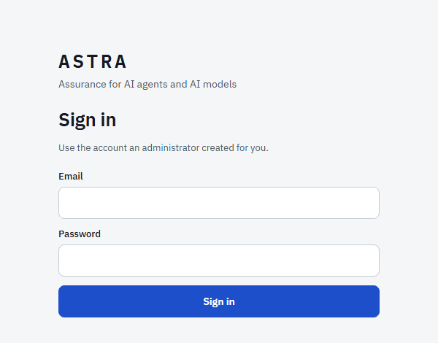
Figure 1. The sign-in screen.
- Type the email and password an administrator created for you.
- Select Sign in. You land on the Organisation page.
Note. The very first visit. If no account exists yet, the screen offers Create the first administrator. That is possible only once; the administrator then adds everyone else (section 6.1).
A sign-in lasts 12 hours. After five wrong passwords in a row an email address is locked out for 15 minutes. Passwords need at least 10 characters. To end a session select Sign out at the bottom of the left menu; to change your own password select Password next to it.

2.2 Roles
What you can do depends on your role. The role is shown under your name at the bottom of the left menu.
Role | Can
Administrator | Everything, including people, API keys, deleting agents and starting the organisation from scratch.
Compliance | Design and sign off: ratify designs, decide drift, revoke contracts, acknowledge findings, generate evidence packs, approve regulation rules and policies, set coverage owners.
Engineer | Design and propose, including submitting a change for review, connecting repositories and identity providers. Cannot sign anything off.
Auditor | Read-only everywhere, plus the audit log. Used for reviewers who must not change anything.

A sign-off always records the signed-in person’s own name. Nobody can sign on behalf of someone else, and an engineer cannot edit a sign-off into a design.

2.3 Finding your way around
After you sign in you land on the Organisation page. The Choose a module page is a simple map of the platform.
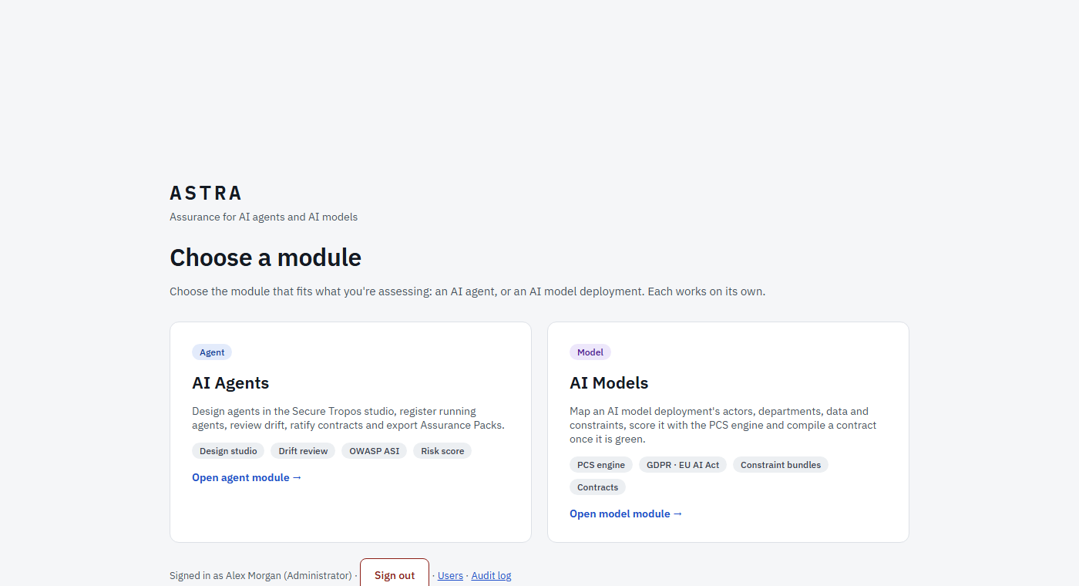
Figure 2. The module picker, reached from the main menu.
The left menu is always there:
- ← Main menu at the top returns you to the module picker.
- Under the ASTRA name is your organisation’s name. Select it to rename the organisation (administrators).
- The Company group (Organisation, Policies, Regulations) and the two Modules (AI Agents, AI Models) are shown on the main menu. Inside a module the menu lists that module’s own pages.
- At the bottom: who you are, the theme switch (light or dark), Users, Audit log, Password and Sign out.
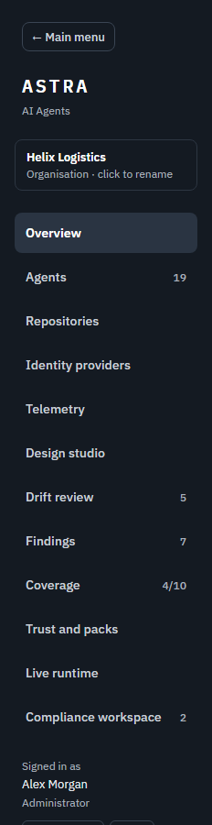
Figure 3. The AI Agents menu. The AI Models menu works the same way.

2.4 Light and dark themes
The theme button at the bottom of the left menu switches the whole platform between a light and a dark theme. The choice is remembered in your browser.
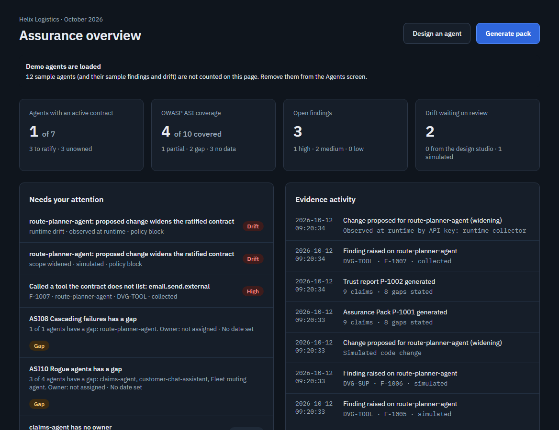
Figure 4. The same page in the dark theme.

2.5 Enlarging a diagram
Every architecture view (the organisation map, an agent design and a model design) has an Enlarge view or Enlarge button. It opens the diagram full screen as a read-only copy with zoom controls (−, +, Fit, 100%). Press Escape or Close to return.

3. The organisation
The Organisation page is the starting point. Describe the company once and ASTRA uses it everywhere: agents and models are created from it, each design starts from what the organisation already knows, and checks such as “this agent has no owner” are made against it.
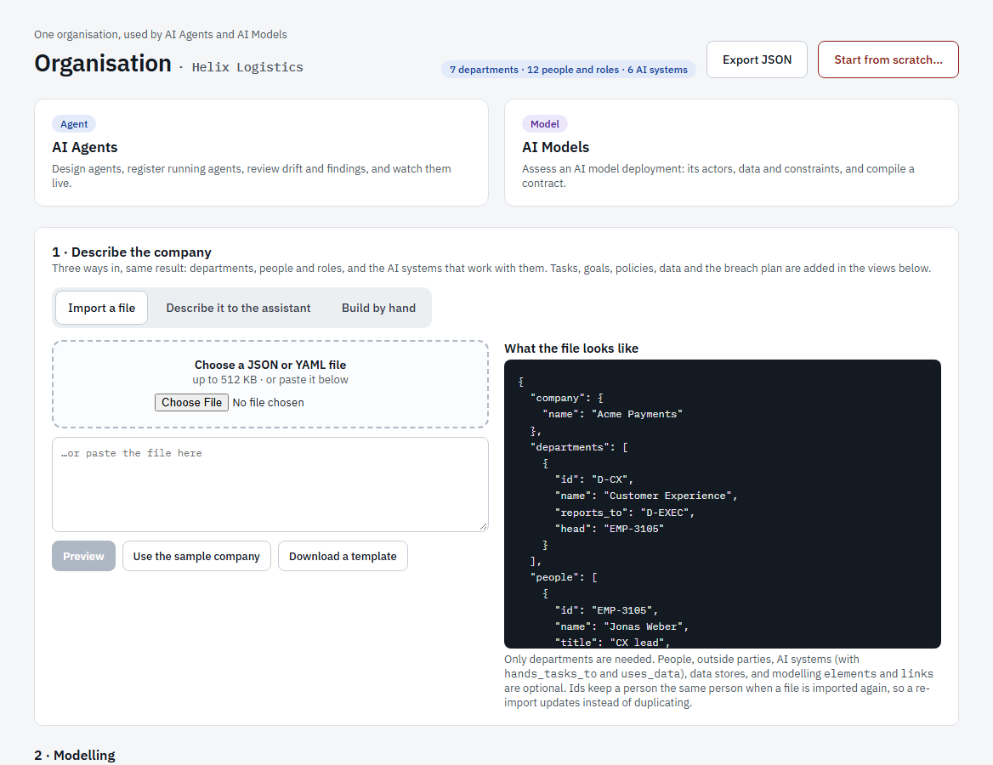
Figure 5. The Organisation page: step 1, describe the company.
The page header shows how much is described (departments, people and roles, AI systems), Export JSON (download the whole organisation as a file) and, for administrators, the red Start from scratch button. Two cards link on to the AI Agents and AI Models modules.

3.1 Step 1: describe the company
There are three ways to do it. The result is the same: departments, people and their roles, and the AI systems that work with them.

Import a file
- Choose a JSON or YAML file (up to 512 KB) or paste its text. Download a template shows the layout; Use the sample company fills in an example.
- Select Preview. ASTRA lists what it would create or change and anything it could not use. Nothing is saved yet.
- Review, then apply the import.
Only departments are required. People, outside parties, AI systems, data stores and links are optional. Give each person an id: importing the same file again then updates the person instead of duplicating them.

Describe it to the assistant
Type a plain-language description of the company. A language model running on your own server drafts the structure as a proposal. Nothing is saved until you accept it, and the same description always gives the same draft. This needs the local assistant to be installed and running.

Build by hand
Add departments, people, outside parties, AI agents and AI models directly in the diagram (section 3.2).
Tip. When the organisation lists an AI agent or an AI model, ASTRA creates its entry in the Agent inventory (unowned until it has an owner) and, for a model, a starting design in the Model designer. Nothing is ever replaced if it already exists.

3.2 Step 2: the modelling views
The organisation is one model with several views. A change made in one view appears in all the others.
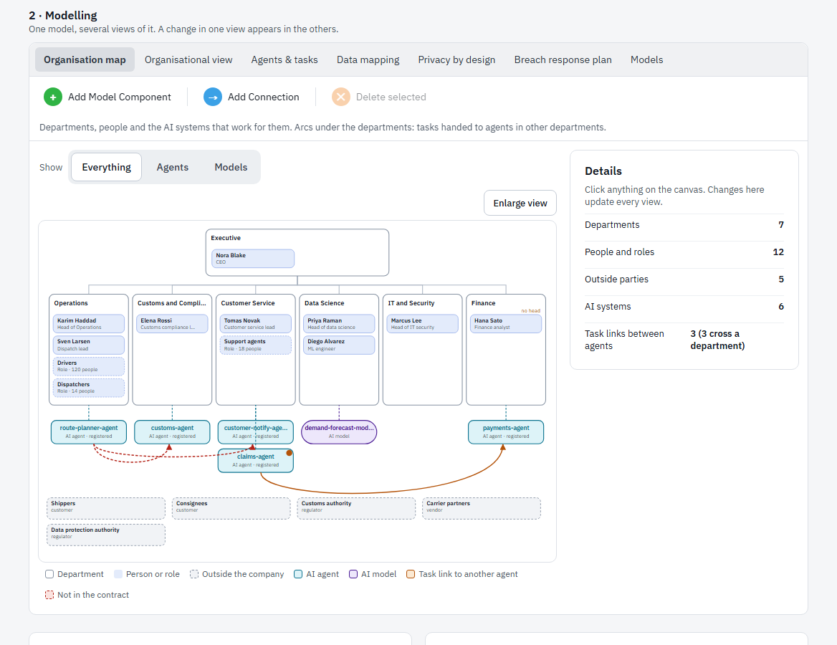
Figure 6. The Organisation map: departments, the people in them, AI systems and outside parties.
View | What it shows
Organisation map | Departments with their people and roles, the AI agents and models that serve them, outside parties, and arcs for tasks handed to agents in other departments.
Organisational view | Goals, operations (tasks) and policies, in the notation used for goal models.
Agents & tasks | The agents grouped by department and the task chain between them: who does what, in which department.
Data mapping | Which agent uses which data store, and whether it is in the same department, in another one, or not in the agent’s contract.
Privacy by design | Data, the threats against it and the protections in place. A dashed red frame marks a threat that has no protection yet.
Breach response plan | The steps of the plan, the decisions in it, and gaps such as a step that depends on one person.
Models | The AI models, who trains, validates, deploys, operates and consumes each, the data and the rules.

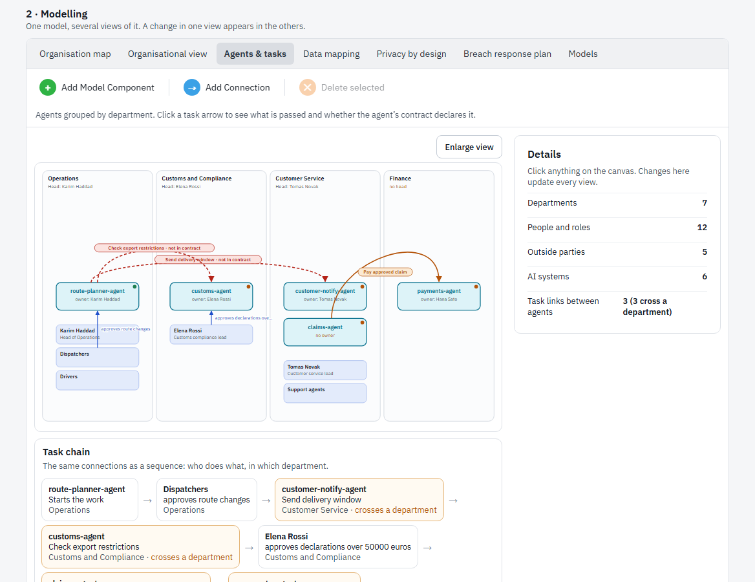
Figure 7. Agents & tasks: the agents by department and the task chain between them.
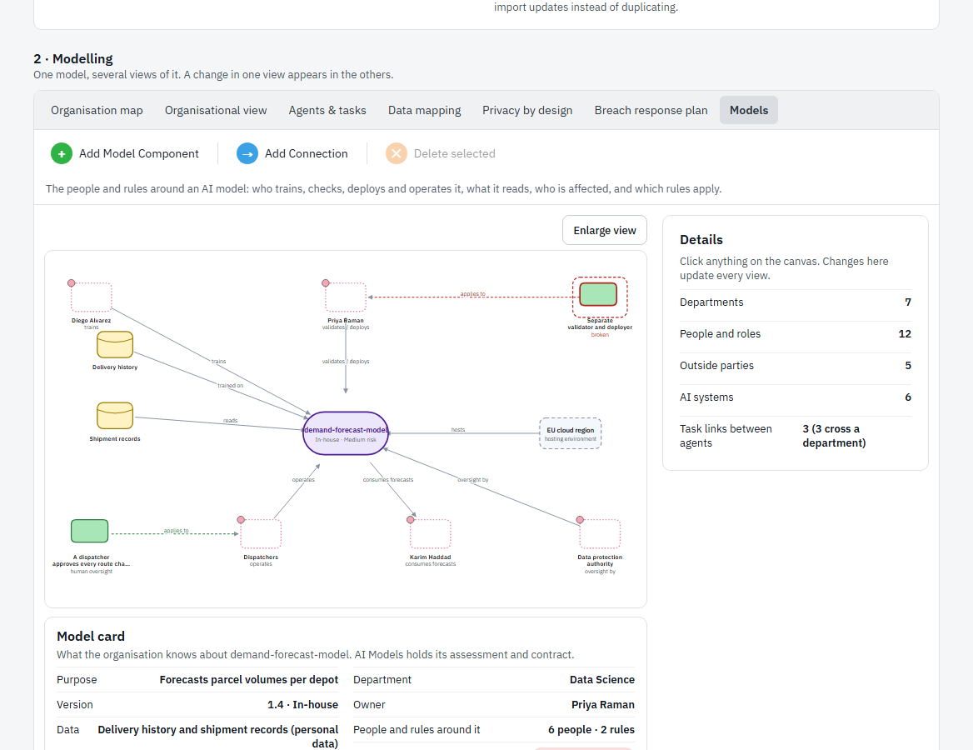
Figure 8. The Models view.
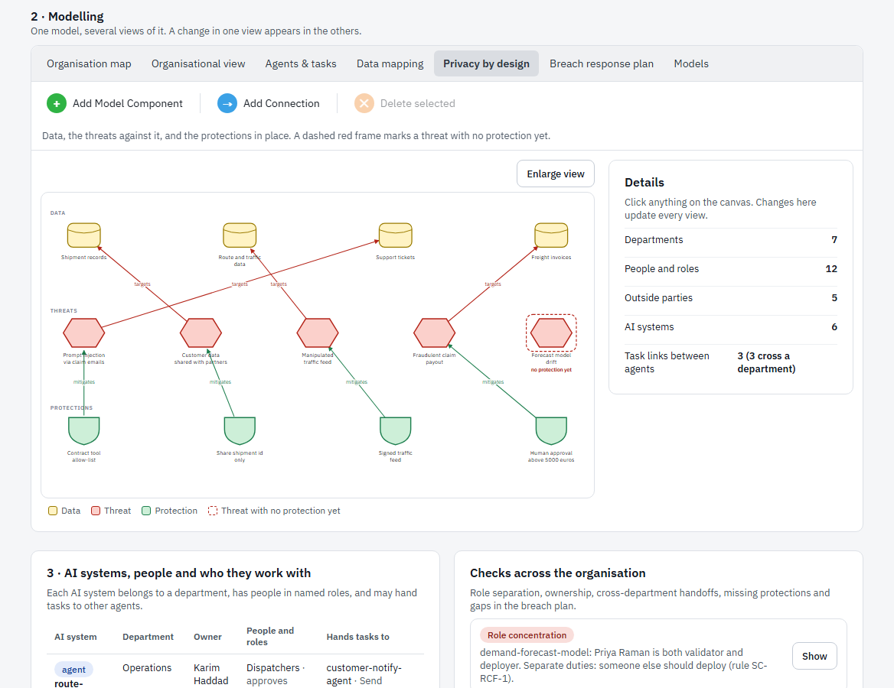
Figure 9. Privacy by design: data, threats and protections.

Working in a view
- Select Show: Everything, Agents or Models to filter the map.
- Click any element to see its details on the right. If you have the right to edit, you can change its name and properties there.
- Select Add Model Component to open the palette: Department, Person, Role (a group), Outside party, AI agent, AI model. Choose one and it is placed on the diagram.
- Select Add Connection and then two elements to link them. The relationship is chosen automatically from the two types.
- Select an element and Delete selected to remove it. Removing an AI agent or AI model removes it from the whole platform (its designs, contracts and findings), so ASTRA asks you to confirm first and only administrators may do it.
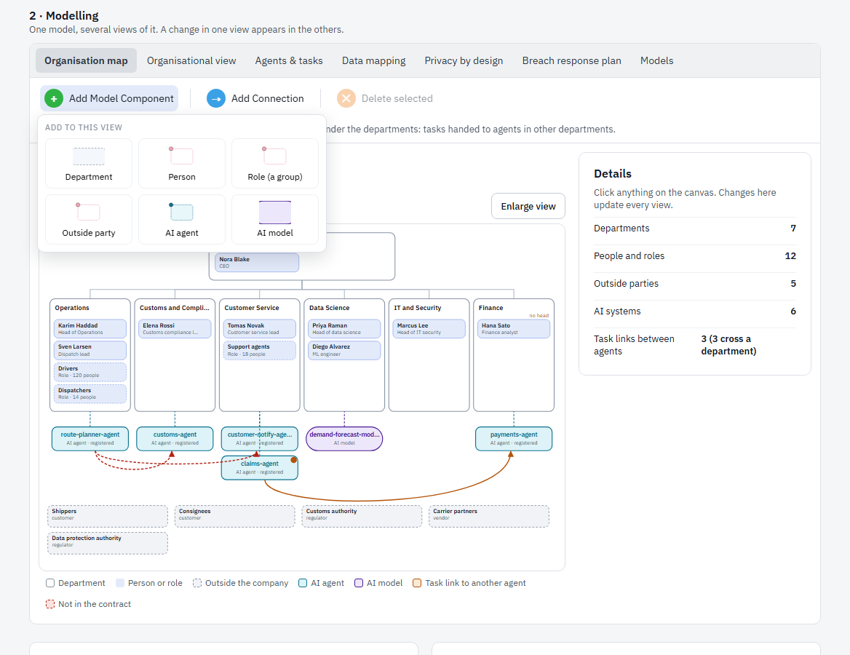
Figure 10. The Add Model Component palette.

3.3 Step 3: AI systems and checks
Below the diagrams a table lists each AI system with its department, owner, the people and roles around it, and the tasks it hands to other agents. Next to it, Checks across the organisation lists problems found automatically.
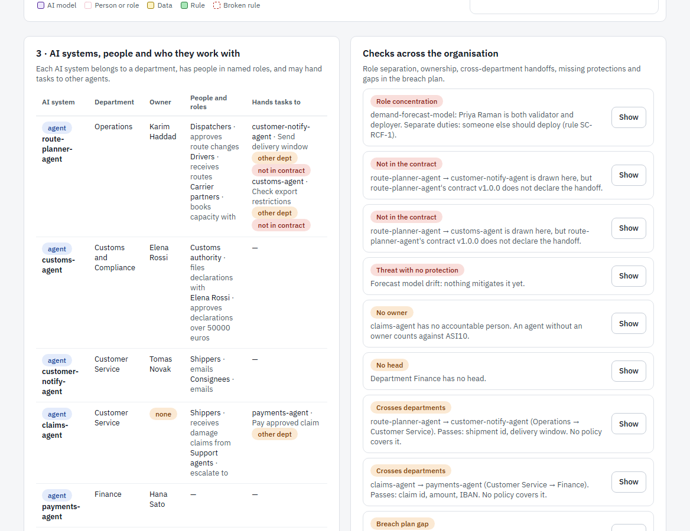
Figure 11. The AI systems table and the organisation checks.
Check | Meaning
Role concentration | The same person both validates and deploys a model. Separate the duties.
No owner | An agent has no accountable person. An agent without an owner counts against the OWASP risk ASI10 (rogue agents).
No head | A department has nobody in charge.
Crosses departments | An agent hands a task to an agent in another department and no policy covers what is passed.
Not in the contract | A handoff drawn here is not declared in the agent’s contract.
Threat with no protection | A privacy threat has nothing mitigating it.
Breach plan gap | A step of the breach plan depends on one person with no deputy.

Select Show on a check to jump to the element it is about.

3.4 Step 4: link to AI Agents and AI Models
The last section shows how the organisation connects to the two modules. Each agent in the organisation is matched to the registered agent with the same name, so you can see whether it has a contract and when it was last seen. Agents that are registered but missing from the organisation can be added with Add to the organisation. AI models link to their designs in the AI Models module.
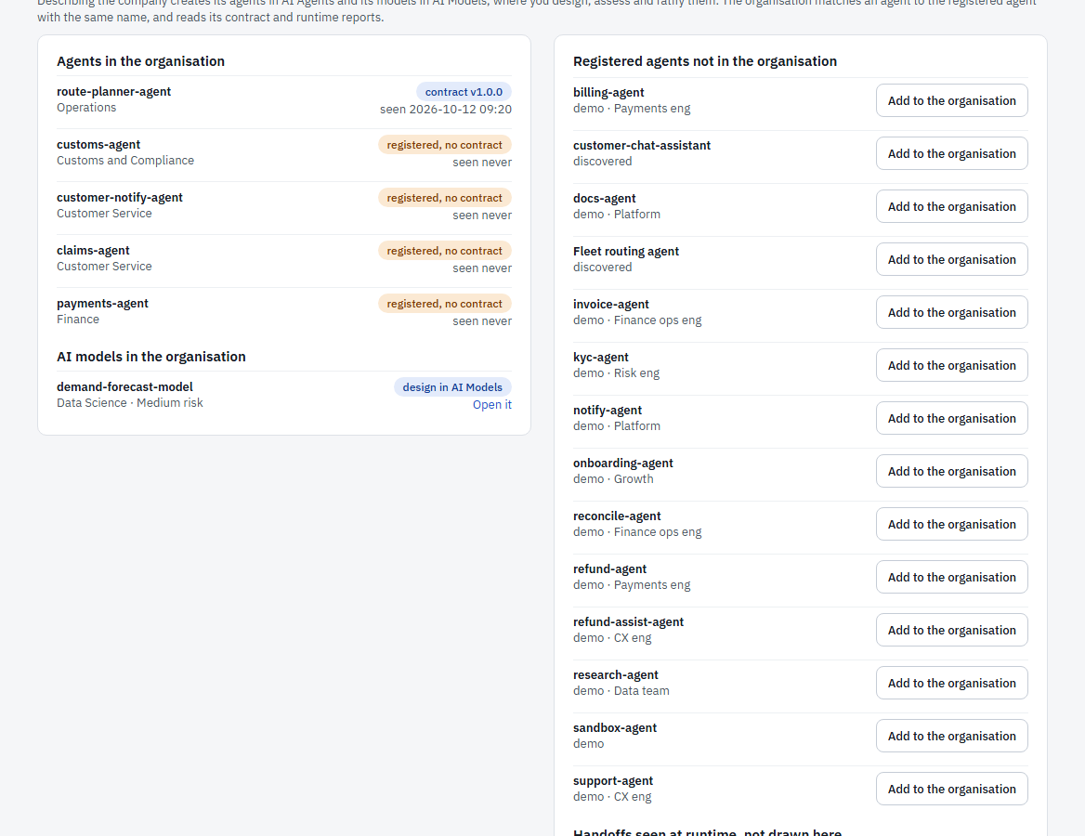
Figure 12. How the organisation links to the agent inventory and to AI Models.

3.5 Starting from scratch (administrators)
The red Start from scratch button removes the organisation and, by default, everything built from it: agents, designs, contracts, findings, drift items, runtime events, evidence packs and coverage assignments. People, API keys, policies, regulations and the audit log are kept.
Caution. This cannot be undone. ASTRA shows exactly what would be removed and asks you to type the organisation’s name to confirm. Export the organisation first if you may want it back.

3.6 Policies
A policy is a rule your organisation adds on top of the regulations, for example “a write-capable tool must have a human approval step”. A policy is checked in every design it applies to, and a violation is flagged with the citation ORG_POLICY. A paused policy is saved but not checked.
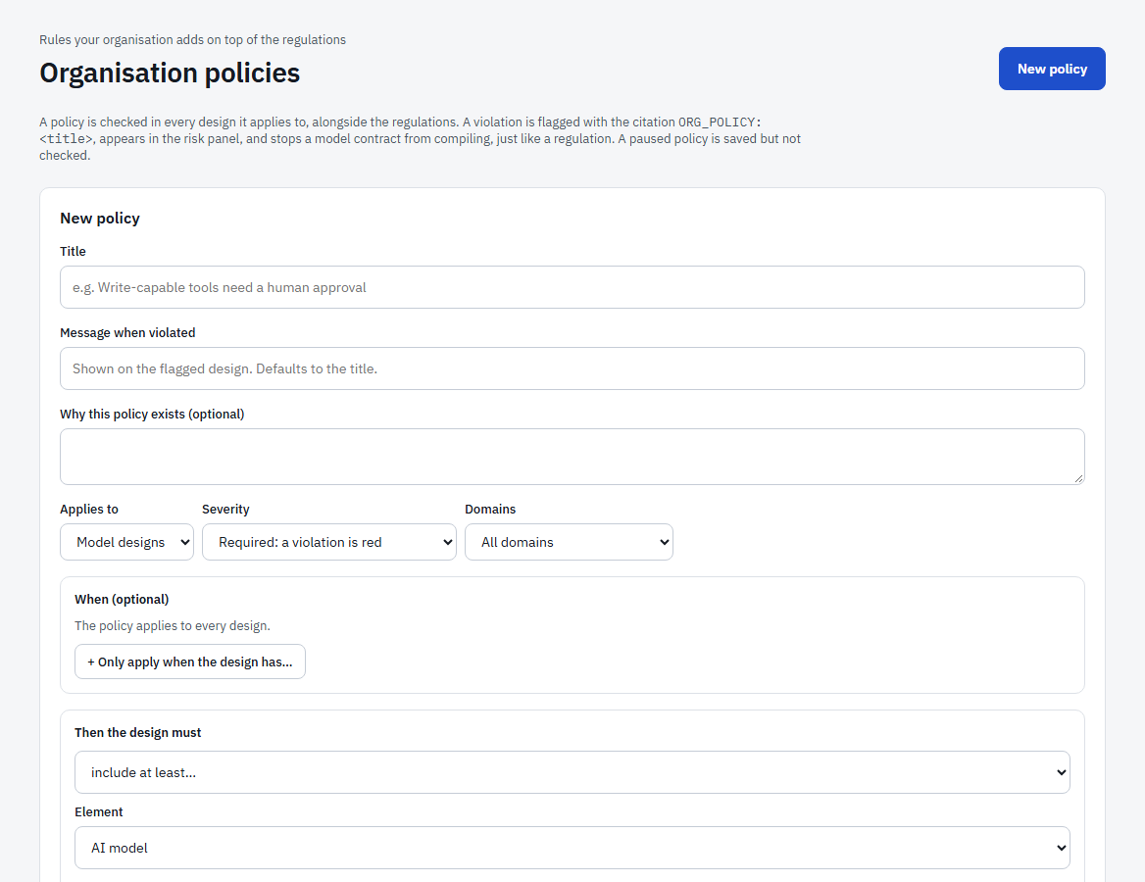
Figure 13. Creating a policy.
- Select New policy, give it a title, a plain-language message that people will see when it is violated, whether it is required or recommended, and what it applies to (agents, models or both).
- Use the test panel to see what the policy would do against a sample before you enforce it.
- Enforce and Pause switch a policy on and off. Approving a policy is a sign-off, so it needs the Compliance or Administrator role.

3.7 Regulations and standards
This page lists where the platform’s rules come from: the EU AI Act, GDPR, ISO/IEC 42001, the NIST AI Risk Management Framework and the OWASP Top 10 for LLM and Agentic Applications, with the number of rules loaded from each.
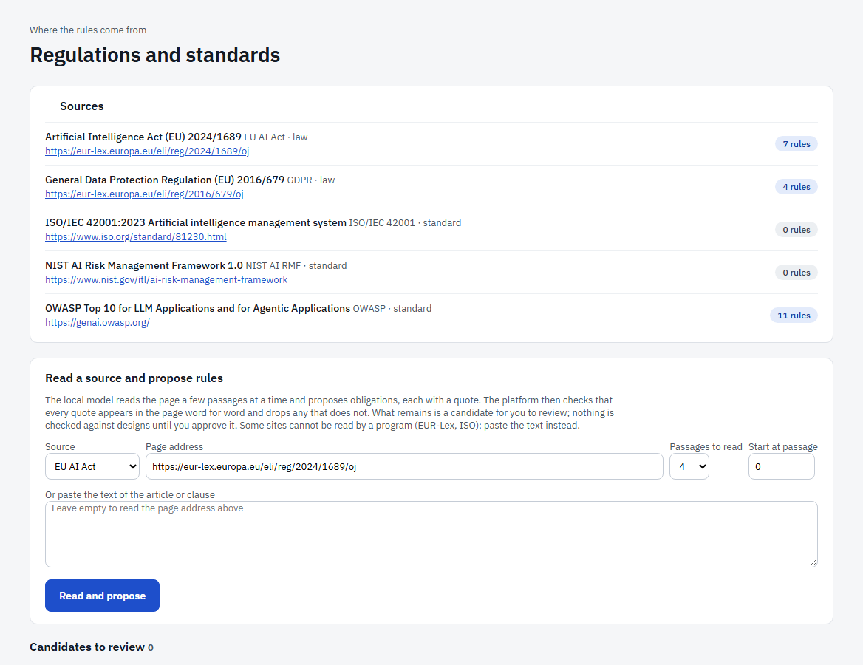
Figure 14. The sources of the rules.
To add rules, use Read a source and propose rules: enter a web address or paste the text of an article, and the local assistant proposes obligations, each with the quote it came from. The platform checks that every quote really appears in the source. Proposals appear under Candidates to review, where a person with the Compliance role approves or rejects each one.

4. AI Agents
The AI Agents module is for software agents. Open it from the Organisation page, the module picker or the main menu. Its menu has these pages:
Page | Use it to
Overview | See the state of assurance at a glance.
Agents | Keep the inventory of every agent and open its design or contract.
Repositories | Find agents defined in code (LangGraph, OpenAI Agents SDK, CrewAI, MCP).
Identity providers | Find agents as service accounts and OAuth clients (Entra ID, Okta, Auth0, Keycloak).
Telemetry | Find and watch agents that already emit OpenTelemetry traces.
Design studio | Draw an agent, see its threats and risk score live, and ratify it.
Drift review | Decide proposed changes to agents that have a contract.
Findings | See what agents did that their contracts do not allow.
Coverage | See how the agents meet the OWASP Top 10 for Agentic Applications.
Trust and packs | Generate Trust reports and Assurance Packs.
Live runtime | Watch what agents are doing now.
Compliance workspace | A view per role: compliance, engineering, auditor.

4.1 Assurance overview
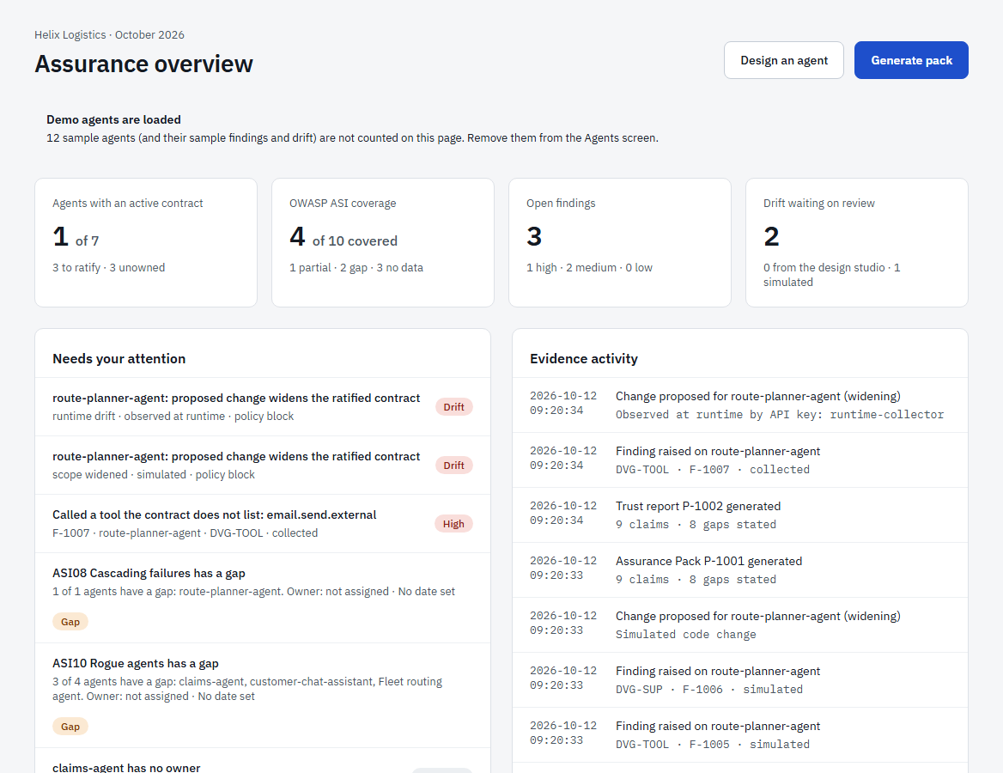
Figure 15. The assurance overview.
The tiles show how many agents have an active contract, how well the OWASP checks are covered, how many findings are open and how much drift is waiting for review. Needs your attention lists what to do next (drift to decide, high findings, coverage gaps, unowned or unratified agents). Evidence activity is a time-ordered log of contracts, findings and decisions. Sample agents are never counted, and the page says when they are loaded.

4.2 The agent inventory
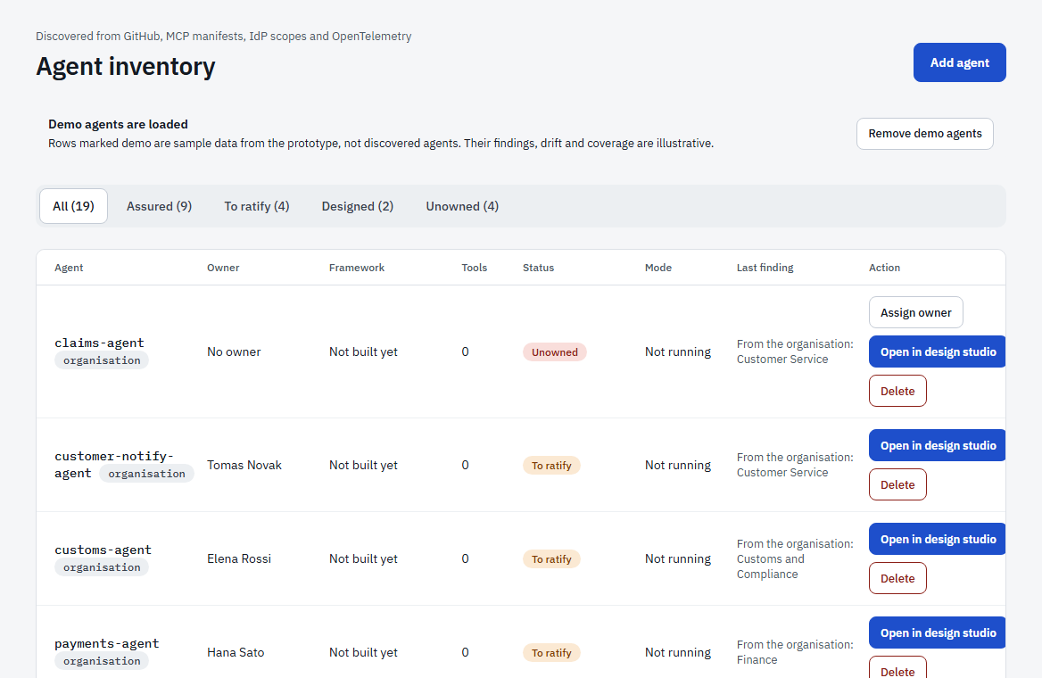
Figure 16. The agent inventory.
Every agent the platform knows about is listed here, with its owner, framework, number of tools, status, mode and last finding. Use the tabs to filter by status.
Status | Meaning
Unowned | Nobody is accountable for the agent. Assign an owner; until then it counts against ASI10.
To ratify | It has an owner but no approved contract yet.
Designed | A design has been ratified and a contract is in force.
Assured | The strongest status, used for the sample agents. An agent you ratify shows as Designed.

A small tag next to the name says where the agent came from: organisation (created from the organisation), demo (sample data), discovered (seen by telemetry or the runtime SDK but never registered by a person) or none (registered by a person). The Mode column is the agent’s drift policy: Observe, Flag or Block.
The Action column offers what makes sense for the row:
- Open in design studio (blue) opens the agent’s saved design, or starts one from what the organisation knows about it.
- Assign owner for an unowned agent.
- View contract when a contract exists.
- Delete (administrators) removes the agent and everything built for it.
Add agent (top right) starts a new agent. Load demo agents adds sample data so you can explore every screen; Remove demo agents takes it away again.

4.3 Adding an agent
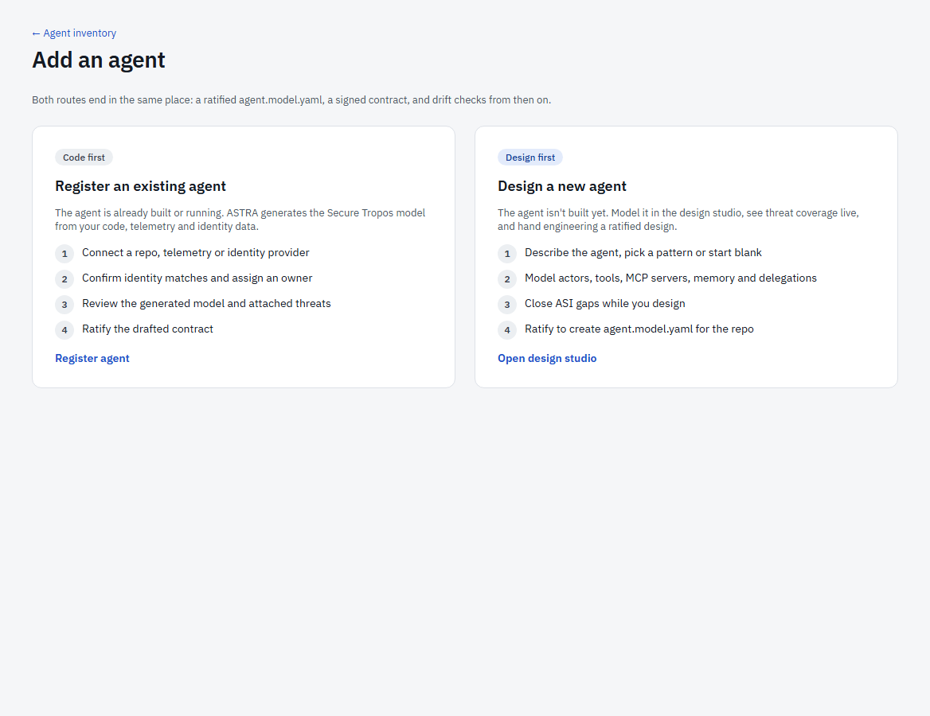
Figure 17. Add an agent: two routes.
Both routes end in the same place: a ratified agent.agent.model, a signed contract, and drift watching from then on.
- Register an existing agent (code first) is for an agent that is already built or running. ASTRA generates its design from a definition file, a repository, an identity provider or telemetry, and you add what could not be known.
- Design a new agent (design first) is for an agent that does not exist yet: describe it, model it in the design studio, close the gaps and ratify.

Import a definition file
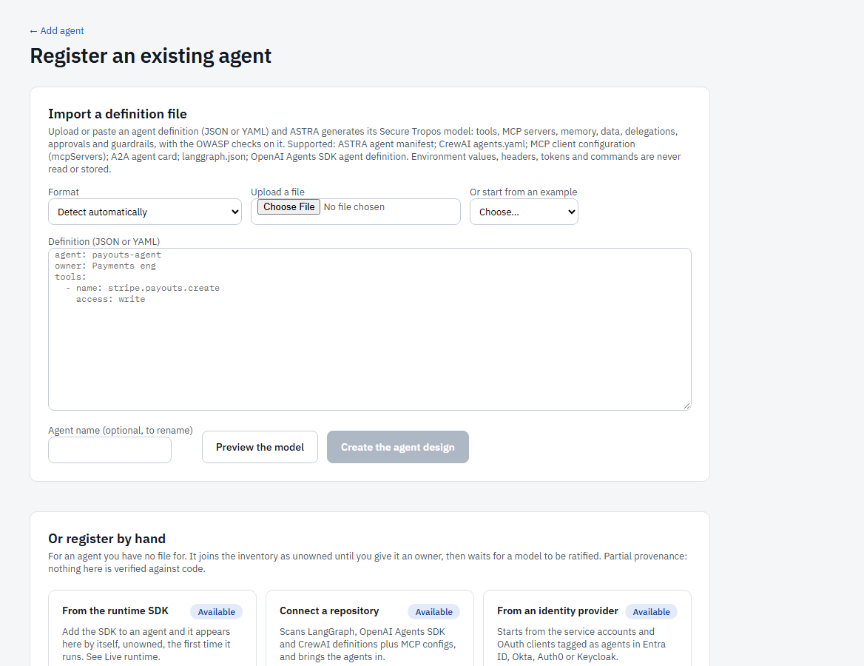
Figure 18. Register an existing agent: import a file, or register by hand.
- Choose the format (or leave Detect automatically), upload a file or paste its text, or pick an example.
- Select Preview the model. ASTRA shows the design it would create, what it recognised, what it guessed (for you to confirm), what it ignored, and the OWASP checks on it.
- Select Create the agent design.
Supported: an ASTRA agent manifest, CrewAI agents.yaml, an MCP client configuration, an A2A agent card, langgraph.json and an OpenAI Agents SDK definition. Environment values, headers, tokens and commands are never read or stored. If the agent already has an active contract nothing is overwritten: the file becomes a proposed change in Drift review.

Register by hand
For an agent with no file, enter its name, an optional owner, framework and tool count. It joins the inventory as unowned until it has an owner.

4.4 Repositories
Repositories connects a source repository and brings in the agents defined in it. ASTRA reads the code without ever running it, and never opens files that usually hold secrets (.env, keys).
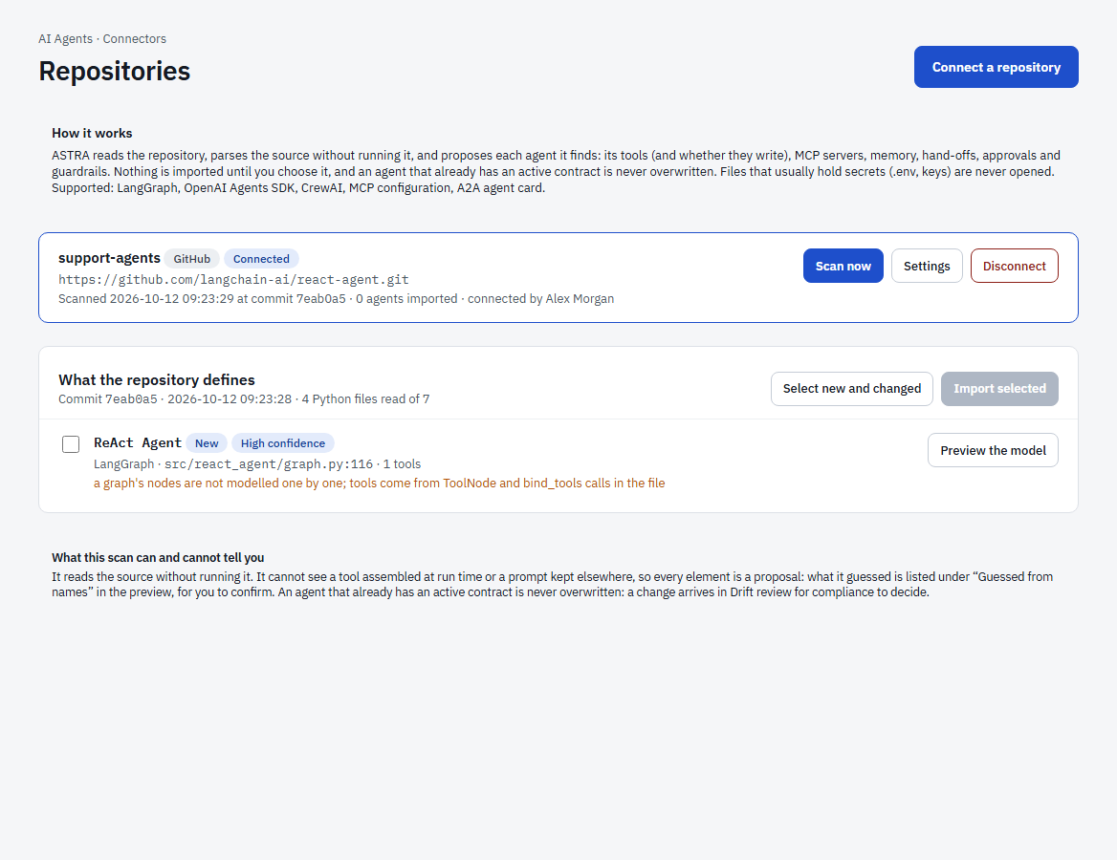
Figure 19. A connected repository and what a scan found.
- Select Connect a repository and enter its https address. Optionally give a branch, a folder (for a large repository) and an access token for a private repository. The token is stored encrypted and never shown again.
- Select Scan now. ASTRA lists each agent it found with the file and line, how confident it is, and whether it is new, changed or already imported.
- Select Preview the model on an agent to see the design it would become, then tick the agents you want and select Import.
It recognises LangGraph graphs and create_react_agent calls, OpenAI Agents SDK Agent(...) definitions, CrewAI agents (Python and agents.yaml), A2A agent cards and MCP configuration files. A tool’s write capability is read from its code where possible; every guess is listed for you to confirm.
Tip. An agent that already has an active contract is never overwritten. The change arrives in Drift review for compliance to decide. A push webhook (in Settings) can rescan on every push; the secret is shown once.
Caution. Private repositories need an administrator to set the platform’s secret key. Until then the page says Token storage is not set up; public repositories still work.

4.5 Identity providers
Identity providers starts from the service accounts and OAuth clients that your identity provider holds for AI agents. Supported: Microsoft Entra ID, Okta, Auth0 and Keycloak. ASTRA only reads.
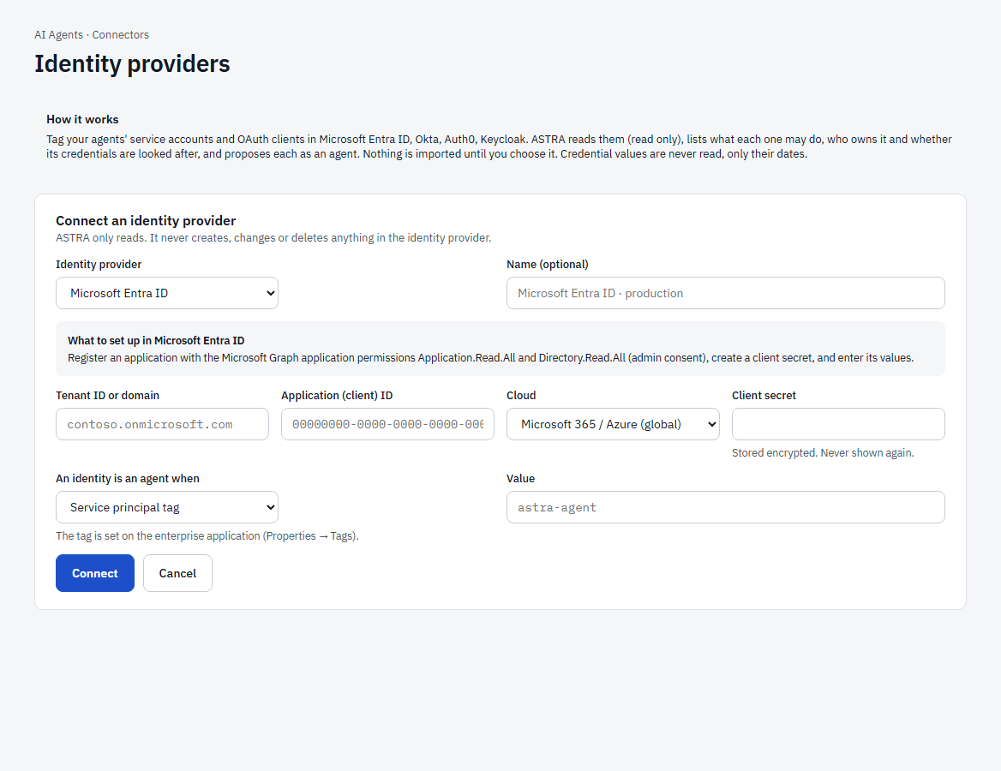
Figure 20. Connecting an identity provider.
- Select Connect an identity provider, choose the provider and follow the short note on what to create in it (a read-only credential).
- Say how an identity is marked as an agent: a tag, a group, a name prefix or a metadata value, depending on the provider.
- Select Scan now, preview and import as for repositories.
An identity says what an agent is allowed to do. Its permissions become the agent’s tools (write-capable ones marked), privileged and tenant-wide permissions are flagged, and the owner comes from the provider. ASTRA also reports credential problems: no owner, a disabled identity, an expired or soon-to-expire secret, an old secret that never expires, two active secrets. Secret values are never read, only dates. If the agent already has a design, the permissions are merged into it.

4.6 Telemetry
If your agents already emit OpenTelemetry traces, ASTRA can find and watch them with no SDK. An agent run, a tool call, an MCP call and a database access become runtime events, checked against the agent’s contract.
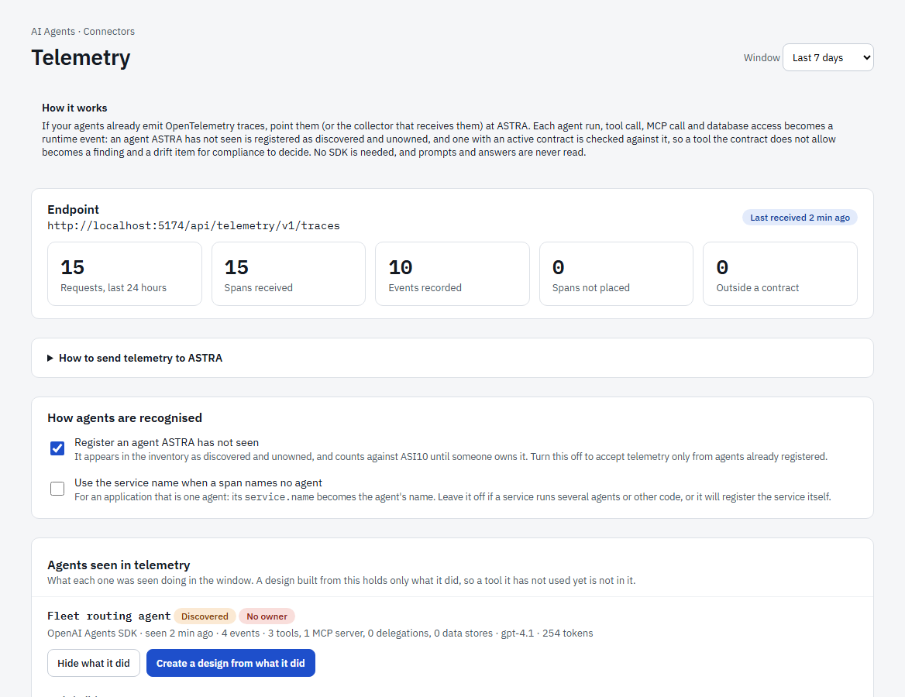
Figure 21. The Telemetry page: the endpoint, what has arrived, and the agents seen.
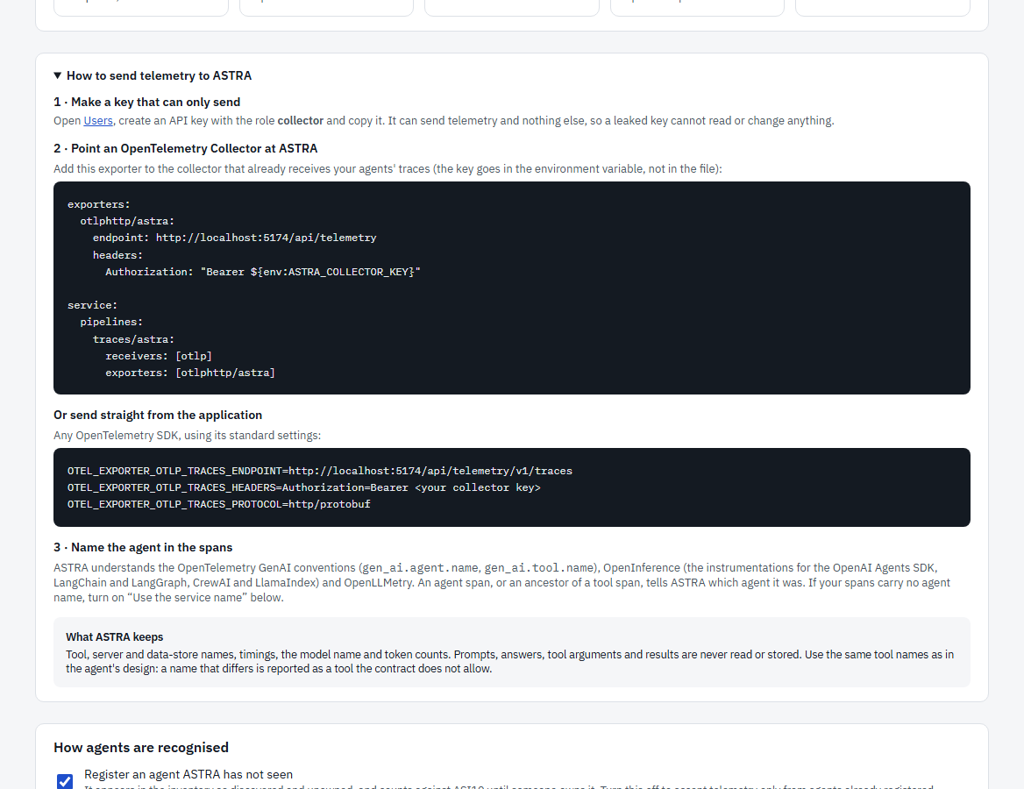
Figure 22. How to send telemetry to ASTRA.
- Create an API key with the role collector (section 6.2). It can send telemetry and nothing else.
- Point your OpenTelemetry Collector (or any OpenTelemetry SDK) at the endpoint shown on the page, with the key as a bearer token. The page shows ready-to-copy settings.
- Name the agent in the spans (gen_ai.agent.name, or an agent span). If your spans carry no agent name, turn on Use the service name.
An agent ASTRA has not seen is registered as discovered and unowned. A tool or server outside an agent’s contract becomes a finding and a drift item. For each agent the page lists what it was seen doing (tools with call counts, MCP servers, delegations, data stores, models, errors), and Create a design from what it did builds a draft from that evidence. Prompts, answers and tool arguments are never read or stored.

4.7 The design studio
The design studio is where an agent is drawn and assessed. It re-scores the design on every change.
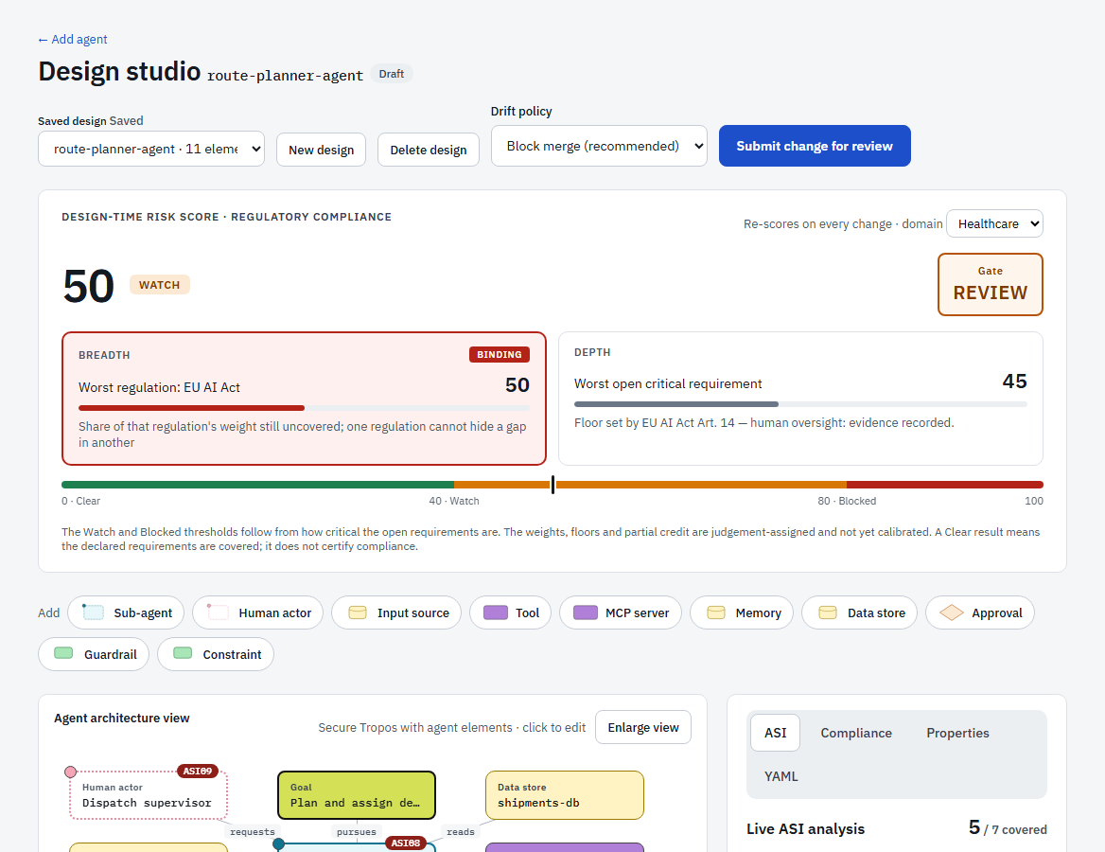
Figure 23. The design studio: the risk score and the add palette.

The risk score
The design-time risk score (0 to 100, higher means more risk) is shown with a status: Clear, Watch or Blocked. It has two parts: Breadth (the worst regulation and how much of its weight is still uncovered) and Depth (the worst open critical requirement). The part that sets the score is marked Binding. A Gate tells you what happens next: Clear, Review or Blocked. A Blocked design cannot be ratified.

Drawing the agent
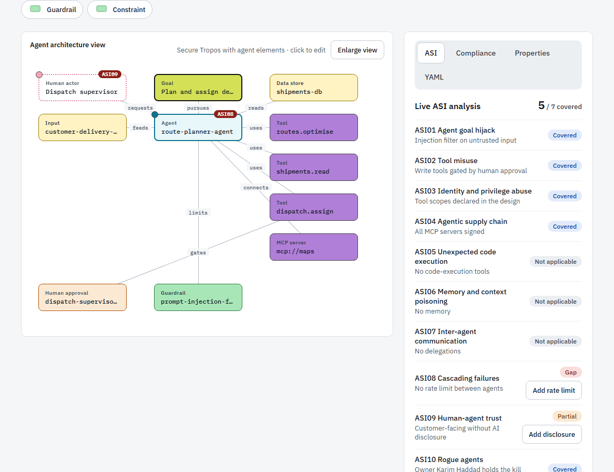
Figure 24. The agent architecture view.
Use the Add buttons to place elements: Sub-agent, Human actor, Input source, Tool, MCP server, Memory, Data store, Approval, Guardrail, Constraint. Click an element to edit it in the Properties tab. Elements use the same shapes and colours as the organisation view: people are pink dotted, agents teal, goals lime, tools purple, data yellow, policies and guardrails green. Select Enlarge view for a full-screen copy.

The panels
Tab | What it does
ASI | The live OWASP analysis: ASI01 to ASI10, each Covered, Partial, Gap or Not applicable, with the reason. A gap offers a quick fix such as Add rate limit or Add disclosure.
Compliance | The regulatory requirements for the chosen domain (for example EU AI Act Art. 14 human oversight). For each, record the status and the evidence. A sign-off is made by a Compliance user in their own name.
Properties | The selected element’s name and settings, for example whether a tool can write or whether an input is untrusted.
YAML | The design as agent.model.yaml, which can be kept next to the code.

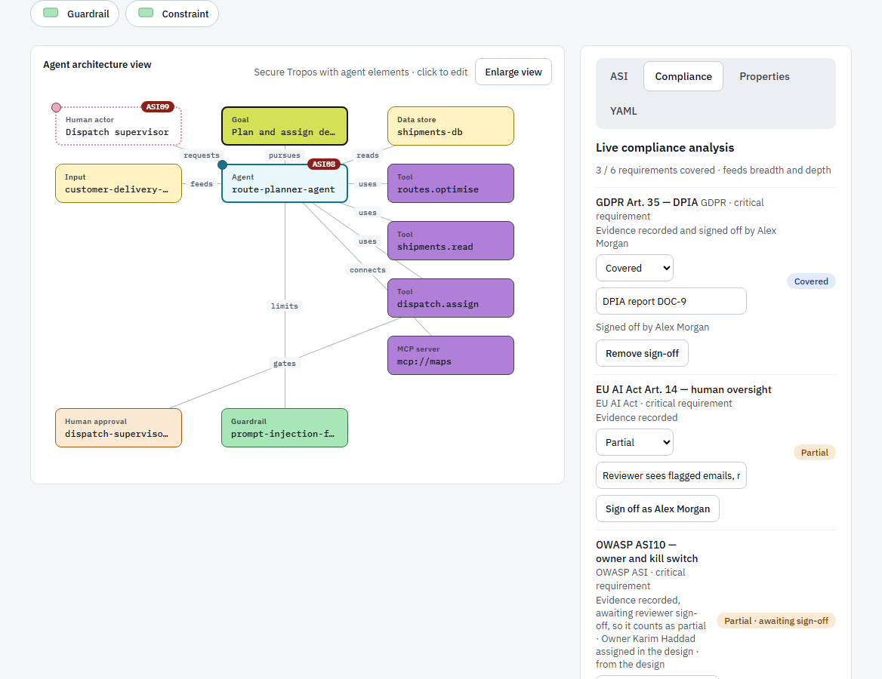
Figure 25. The Compliance tab: requirements, evidence and sign-off.

Ratifying
- Close the gaps you can and record evidence for the requirements.
- Choose a Drift policy for the agent: Observe, Flag or Block merge.
- Select Ratify after review. ASTRA re-runs the analysis on the server, refuses a Blocked design, and issues a contract (version 1.0.0, then 2.0.0, and so on).
Once an agent has an active contract the button changes to Submit change for review, so edits go through Drift review instead of replacing what was approved. The studio saves the design automatically; the Saved design menu reopens earlier ones.

4.8 Contracts
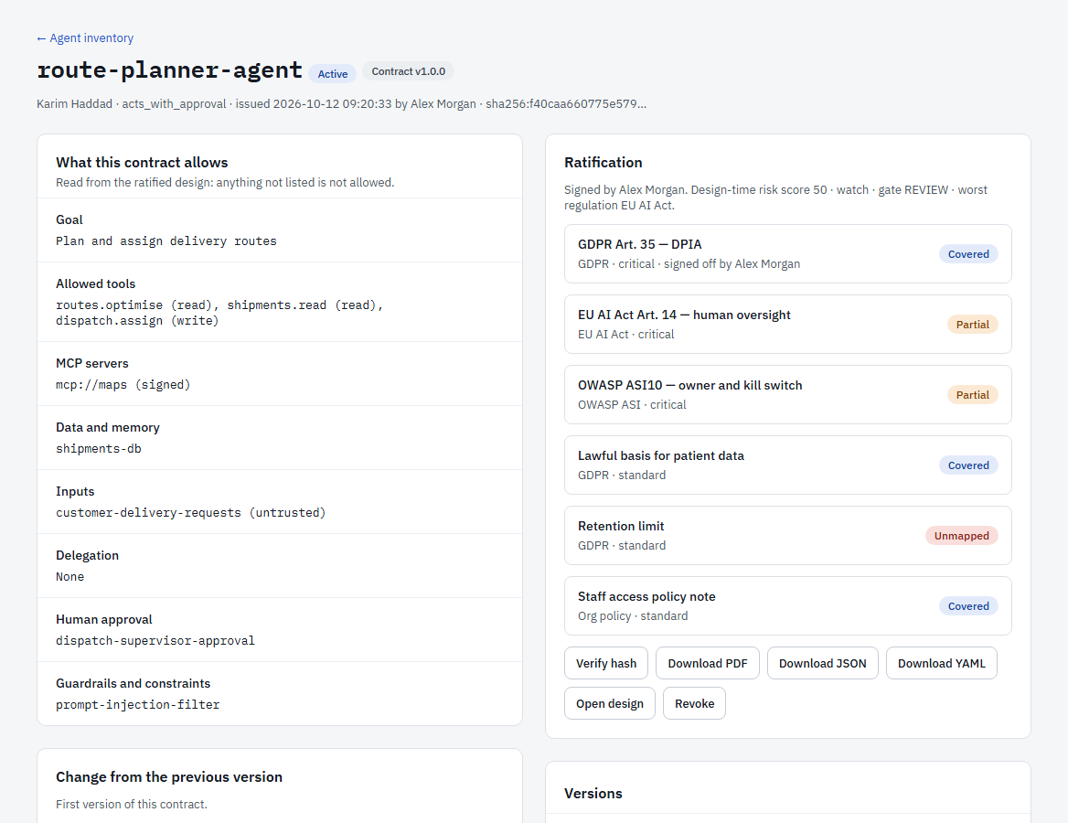
Figure 26. An agent contract.
A contract is never edited, so its hash always verifies. The contract page shows what the agent may do (goal, allowed tools, MCP servers, data, inputs, delegation, human approval, guardrails), how the version differs from the previous one (it widens if it adds a capability or removes a safeguard, and a widening version needs its own review), the clause mappings, the risk score and sign-offs recorded at ratification, and every version with its status.
Buttons: Verify hash (re-computes it), Download PDF / JSON / YAML, Open design, and Revoke (a recorded reason is required; the agent returns to To ratify if it was the last active contract).

4.9 Drift review
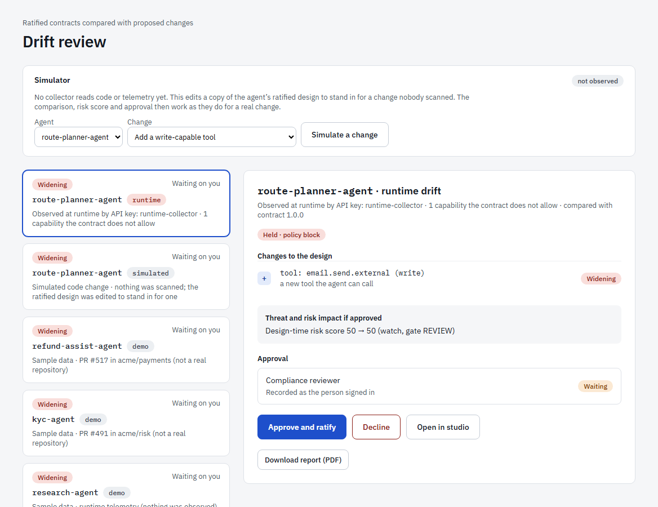
Figure 27. Drift review: a proposed change compared with the ratified contract.
Drift review lists proposed changes to agents that have a contract. Each item compares the proposal with the contract line by line: widening, narrowing or needs review, with the threat checks and the risk score before and after. Items come from three sources: a change submitted in the design studio, a capability seen at runtime or by telemetry that the contract does not allow, an import of a file, repository or identity, and the simulator.
- Approve and ratify writes the proposal into the agent’s design and issues a new contract version. It is refused, and the item stays open, if the proposal would be Blocked. This is a sign-off, so it needs the Compliance role.
- Decline records the decision. A declined runtime observation never creates another item, but keeps raising findings.
- Open in studio shows the proposed design.
Tip. The Simulator at the top edits a copy of an agent’s ratified design to stand in for a change nobody scanned. It is for trying the screen out and is labelled not observed.

4.10 Findings
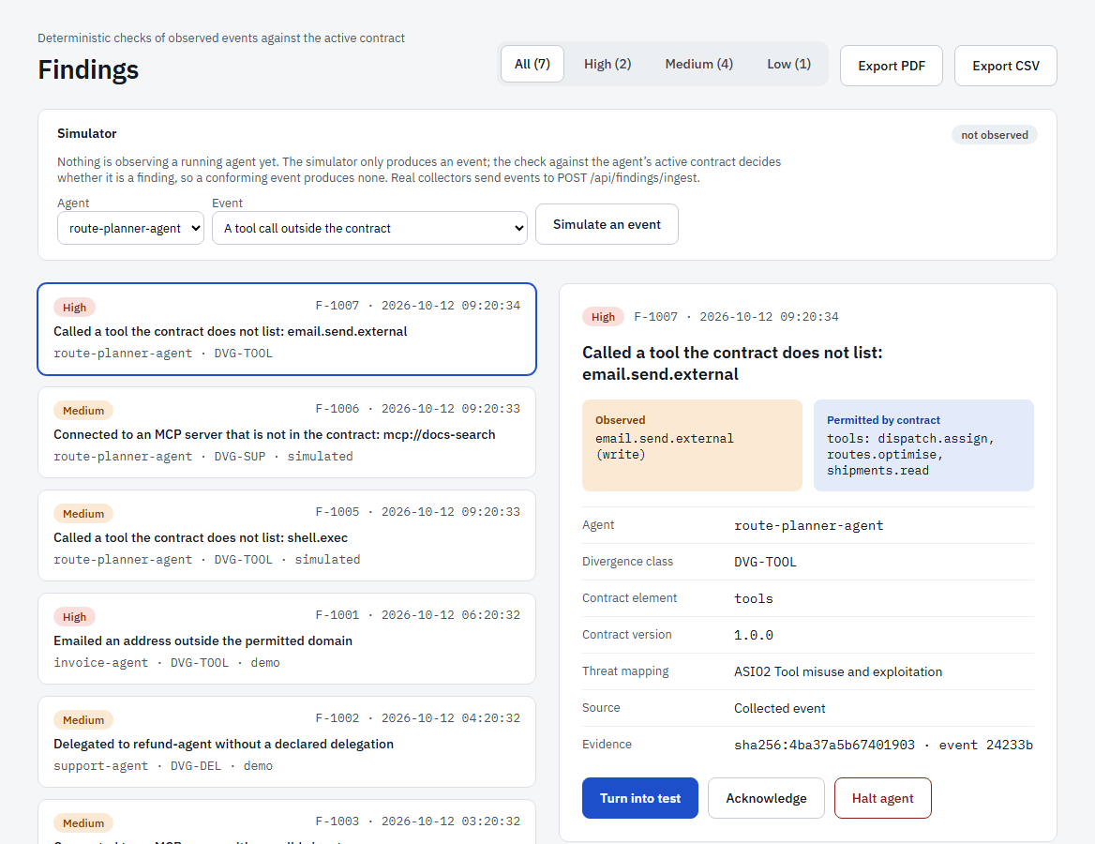
Figure 28. Findings: what agents did that their contracts do not allow.
A finding is raised when an observed event does not match the agent’s active contract: a tool, a delegation, an MCP server, a memory write or a data store the contract does not list. Each shows what was observed, what the contract permits, the divergence class, the threat it maps to and an evidence hash. Filter by High, Medium or Low, and export to PDF or CSV.
- Turn into test drafts a regression test from the finding.
- Acknowledge records that someone has seen it.
- Halt agent records a request to stop the agent. It is only recorded as evidence, because ASTRA cannot yet stop a running agent.

4.11 Coverage
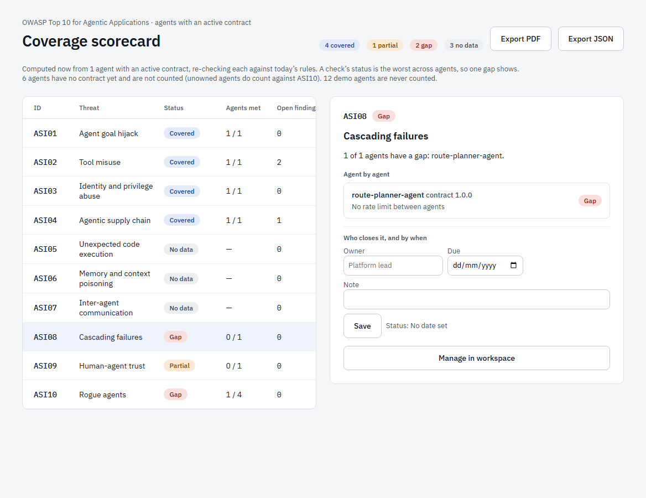
Figure 29. Coverage against the OWASP Top 10 for Agentic Applications.
Coverage is computed on request from the agents that have an active contract. Each OWASP check (ASI01 to ASI10) shows the worst result across agents, so one gap is never averaged away: Covered, Partial, Gap, or No data. Select a row to see each agent’s result and the reason, and to give the check an owner, a due date and a note. Export the result to PDF or JSON.

4.12 Trust reports and Assurance Packs
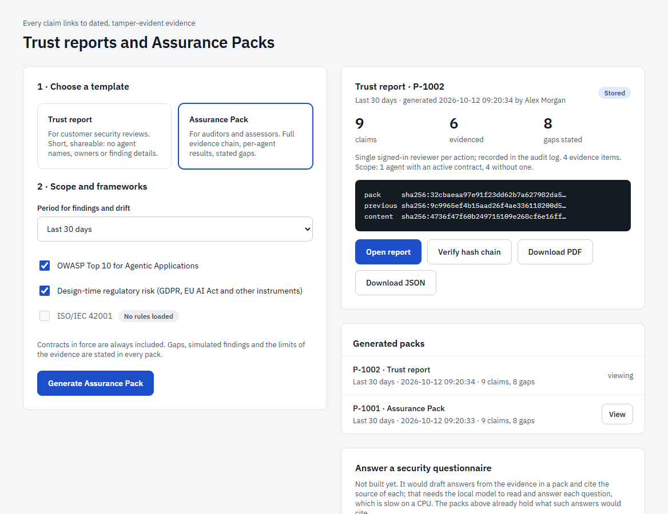
Figure 30. Generating a pack.
- Choose a template: a Trust report (short and shareable; agents are anonymous) or an Assurance Pack (full detail for an auditor).
- Choose the period and the frameworks.
- Select Generate. Every claim in the pack links to evidence, and the gaps are listed with owners and due dates.
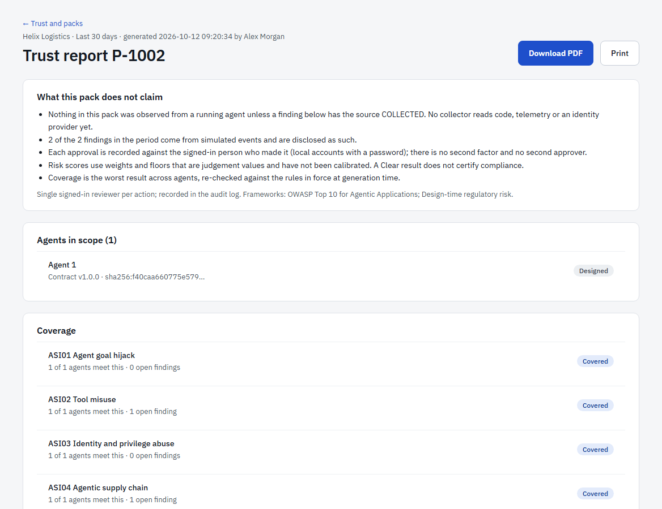
Figure 31. An open Trust report.
A pack states what it does not claim: nothing was observed from a running agent unless the finding’s source says so, sign-off is a typed name, and risk weights are not calibrated. Packs are hash-chained: each one’s hash covers the previous pack, and Verify hash chain re-checks the pack, the chain and every contract it cites. Open report shows it readably; use Print or Download PDF to share it.

4.13 Live runtime
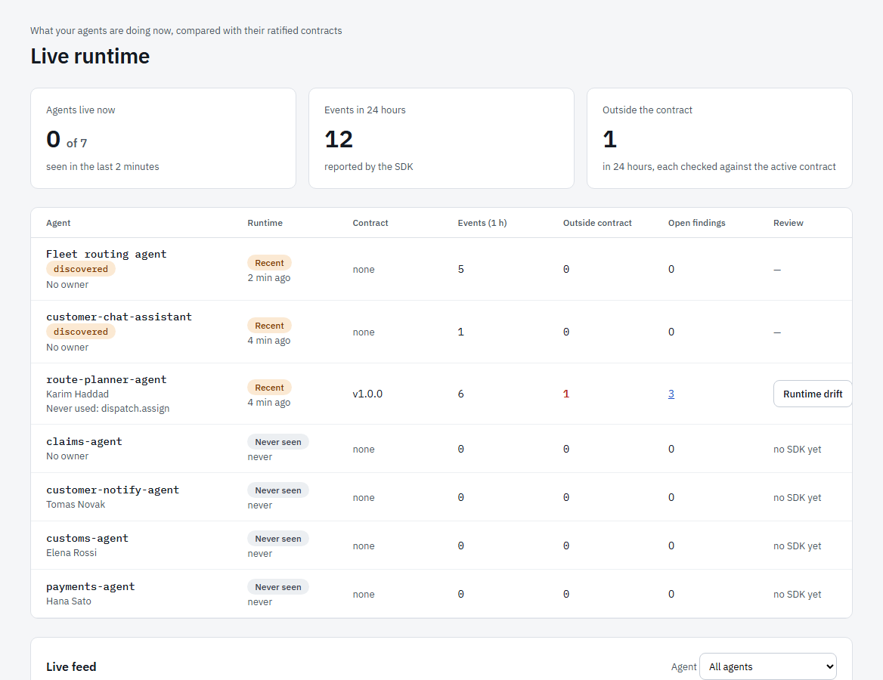
Figure 32. Live runtime: what agents are doing now.
Live runtime shows every agent, whether it is Live, Recent, Silent or Never seen, its contract version, the number of events in the last hour, how many were outside the contract, open findings and runtime drift. Below is a Live feed of events, each marked conforming or divergent. Events arrive from the ASTRA runtime SDK or from OpenTelemetry using a collector API key. An agent that reports itself but is not registered appears as discovered.

4.14 The compliance workspace
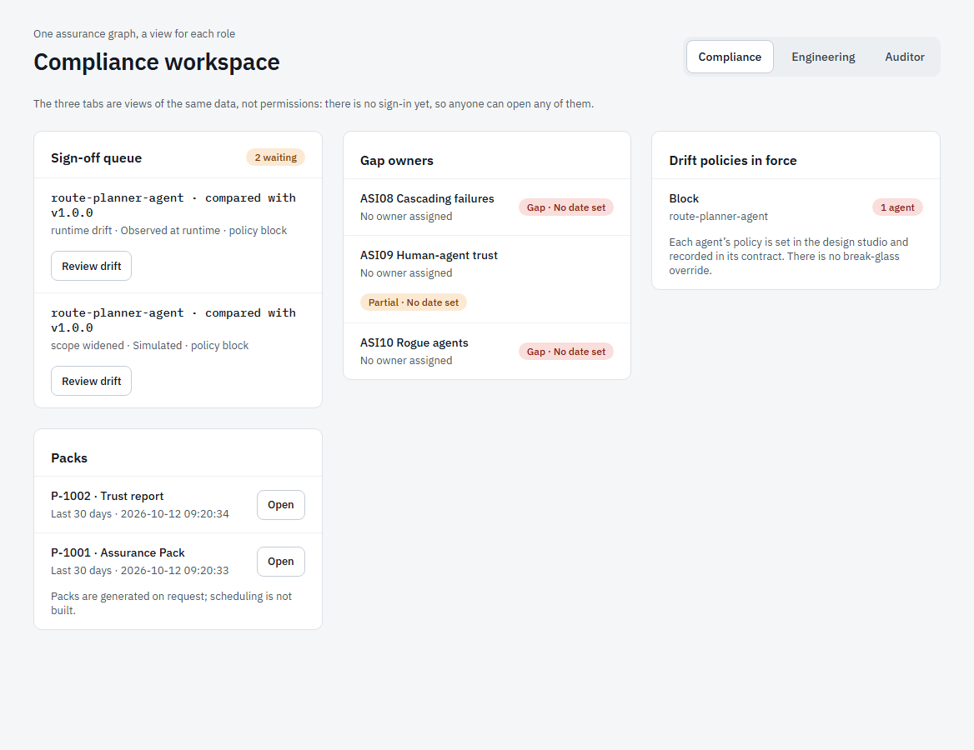
Figure 33. The compliance workspace.
One screen with a view for each role: Compliance (the sign-off queue of drift waiting, gap owners and the drift policies in force), Engineering (drift, unowned agents and unratified designs waiting) and Auditor (every pack re-verified on load, contract history and decisions with their approvers). The three tabs are views, not permissions.

5. AI Models
The AI Models module is for machine-learning models in deployment. It follows the model from design to retirement and scores it with the six-pillar risk method. Its menu has: Overview, Model designer, Runtime, Governance, Incidents, Decommissioning, Regulations & standards, Compiled contracts.

5.1 Model overview
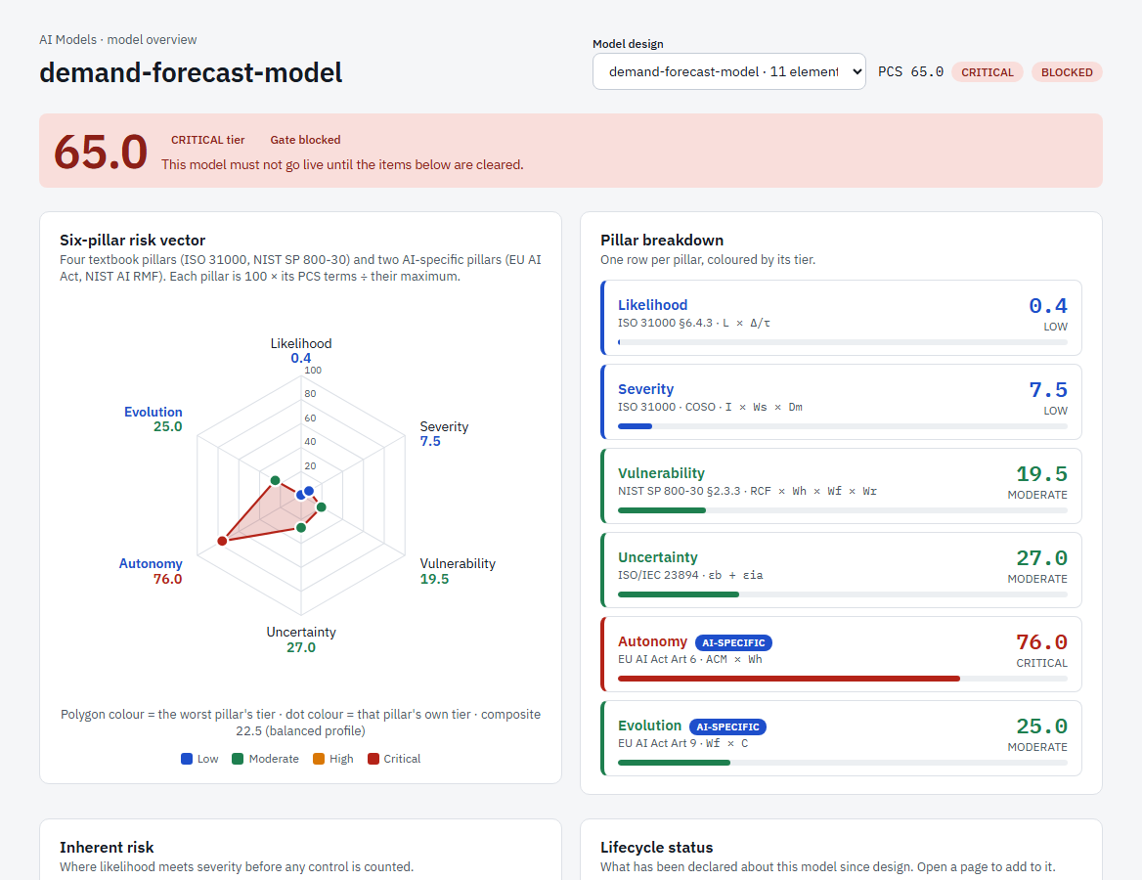
Figure 34. The model overview: the score, the gate and the six-pillar radar.
Use the Model design menu at the top to choose the model. The banner shows the score, the tier and the gate. A model whose gate is blocked must not go live until the items listed are cleared.

The six-pillar risk vector
Each pillar is scored 0 to 100. Four are standard risk pillars and two are specific to AI.
Pillar | What it measures
Likelihood | How likely a failure is (ISO 31000).
Severity | How bad a failure would be (impact, sensitivity of the data, domain).
Vulnerability | How exposed the model is: role concentration, oversight, feedback loops.
Uncertainty | How much is unknown: bias and gaps in controls (ISO/IEC 23894).
Autonomy (AI-specific) | How much the model decides without a person (EU AI Act Art. 6).
Evolution (AI-specific) | How much it changes by itself, for example through feedback loops.

Each pillar has a tier: Low (under 10), Moderate (10 to 29), High (30 to 59) or Critical (60 and over). On the radar, each dot takes the colour of its own pillar’s tier and the shaded area takes the colour of the worst one. A pillar at 80 or more blocks the gate on its own.
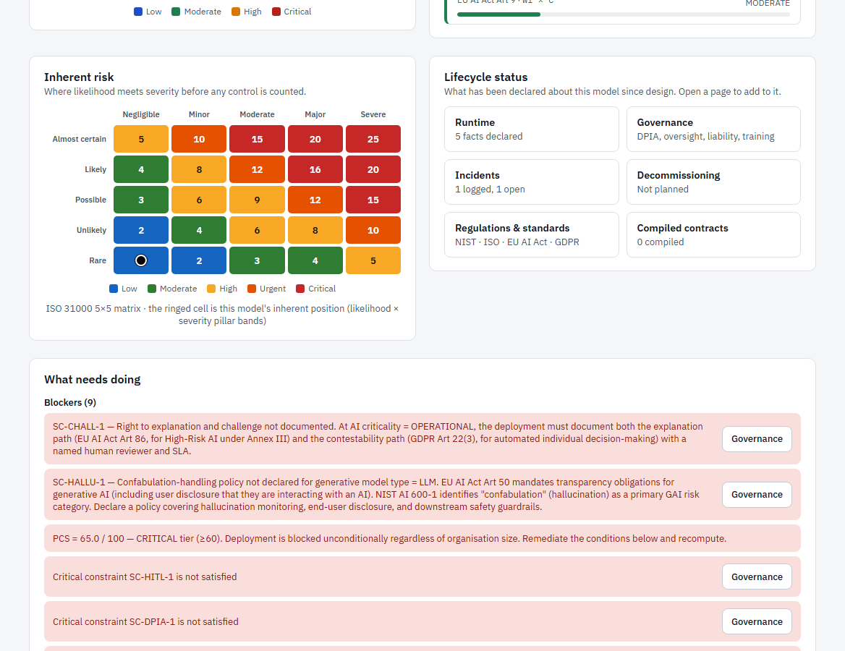
Figure 35. The heat map, lifecycle status and what needs doing.
- The 5×5 heat map places the model by likelihood and severity (ISO 31000).
- Lifecycle status links to the pages where you declare what is true of the running model.
- What needs doing lists blockers, warnings and recommendations. Each has a button to the page that fixes it.
- Formula terms show the inputs of the score. They are always derived, never typed in.
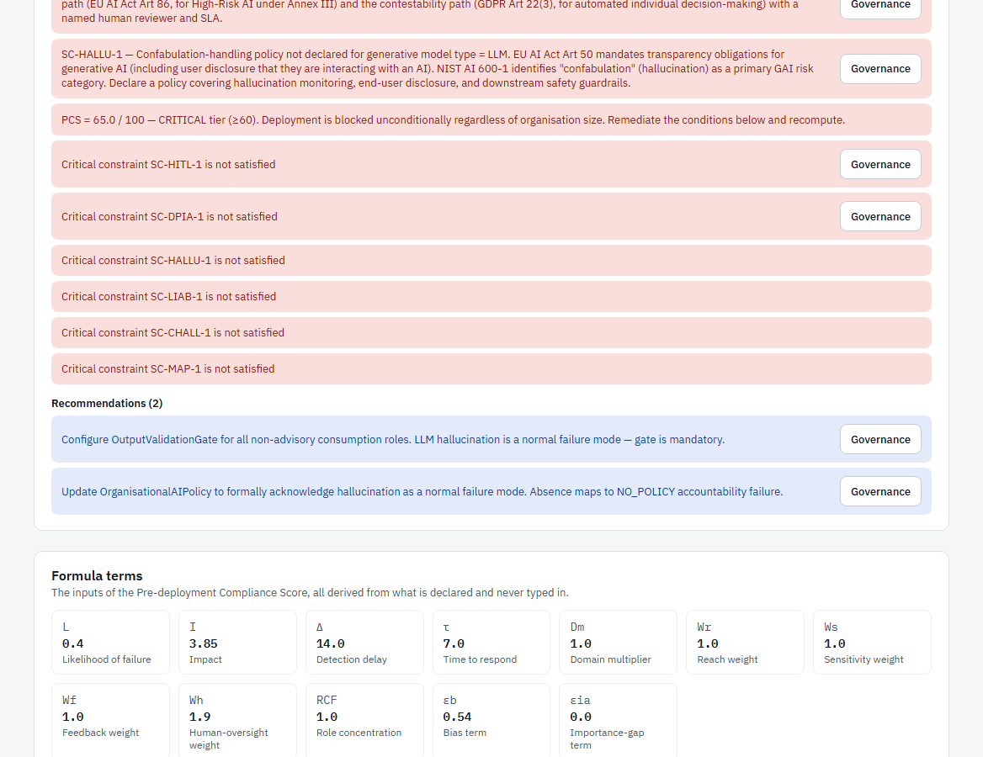
Figure 36. Blockers, recommendations and the formula terms.

5.2 The model designer
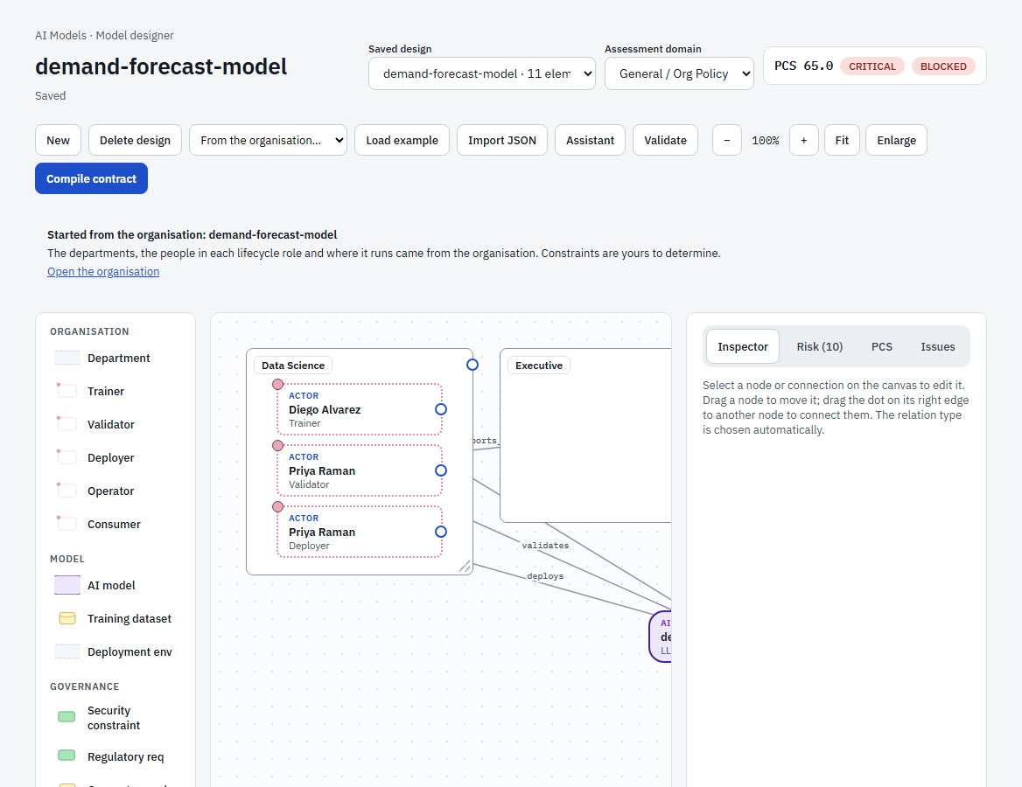
Figure 37. The model designer.
The designer is where a model deployment is drawn. A model design is created for each AI model in the organisation, with its departments, the people in each lifecycle role and where it runs.
- Palette (left): Organisation (Department and the five lifecycle roles: Trainer, Validator, Deployer, Operator, Consumer); Model (AI model, Training dataset, Deployment environment); Governance (Security constraint, Regulatory requirement, Consent record, Legal basis, Data category); and constraint bundles such as GDPR Core or EU AI Act High Risk that add several constraints at once.
- Toolbar: New, Delete design, From the organisation…, Load example, Import JSON, Assistant, Validate, zoom controls, Fit, Enlarge, and Compile contract.
- Right panel: Inspector (the selected element), Risk (which rules are red, amber or green), PCS (the score breakdown) and Issues.
- Choose the Assessment domain (for example Healthcare) to set which regulatory rules apply.
Compile contract turns a design into a contract, but only when every rule in the domain’s assessment is green.

5.3 Runtime
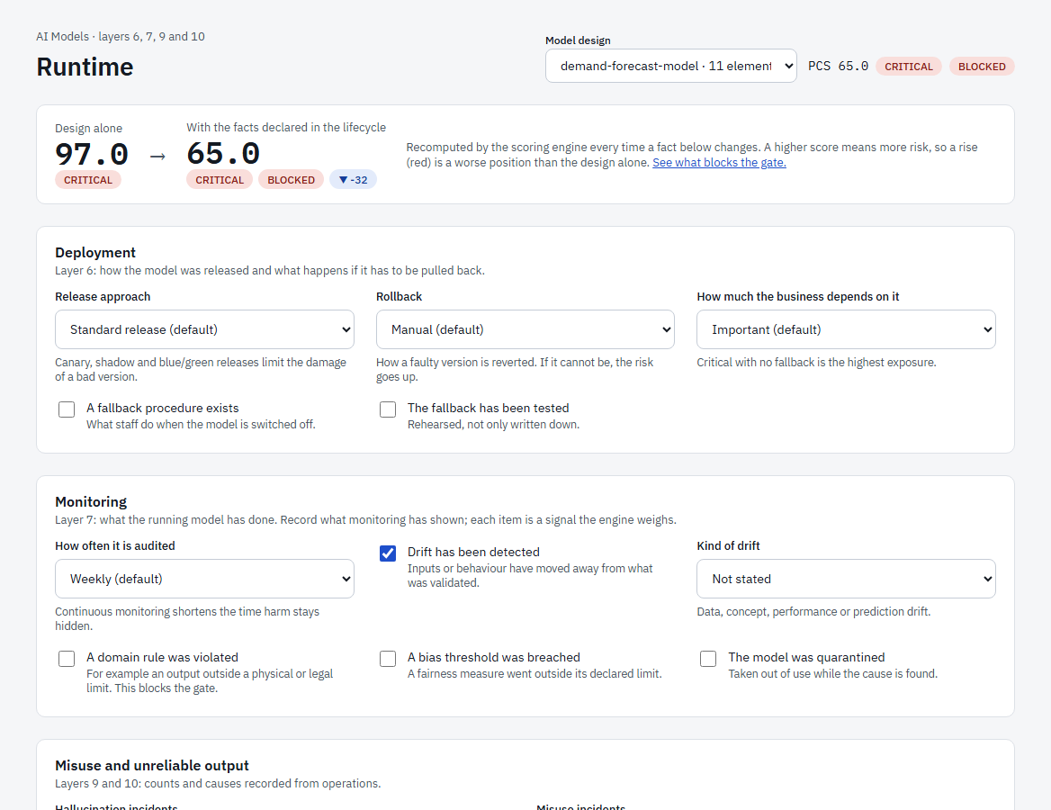
Figure 38. Declaring what the running model has done.
The Runtime page records facts about the model while it runs. Each fact is a signal that changes the score, and the banner at the top shows the effect: the score for the design alone next to the score with the facts declared.
- Deployment (layer 6): release approach (standard, canary, shadow, blue/green), rollback, how much the business depends on the model, and whether a fallback exists and has been tested.
- Monitoring (layer 7): how often it is audited, drift detected (and which kind), a domain rule violated, a bias threshold breached, the model quarantined.
- Misuse and unreliable output (layers 9 and 10): counts of hallucination and misuse incidents, and root causes found.
Changes are saved with the model design automatically. A domain violation blocks the gate.

5.4 Governance
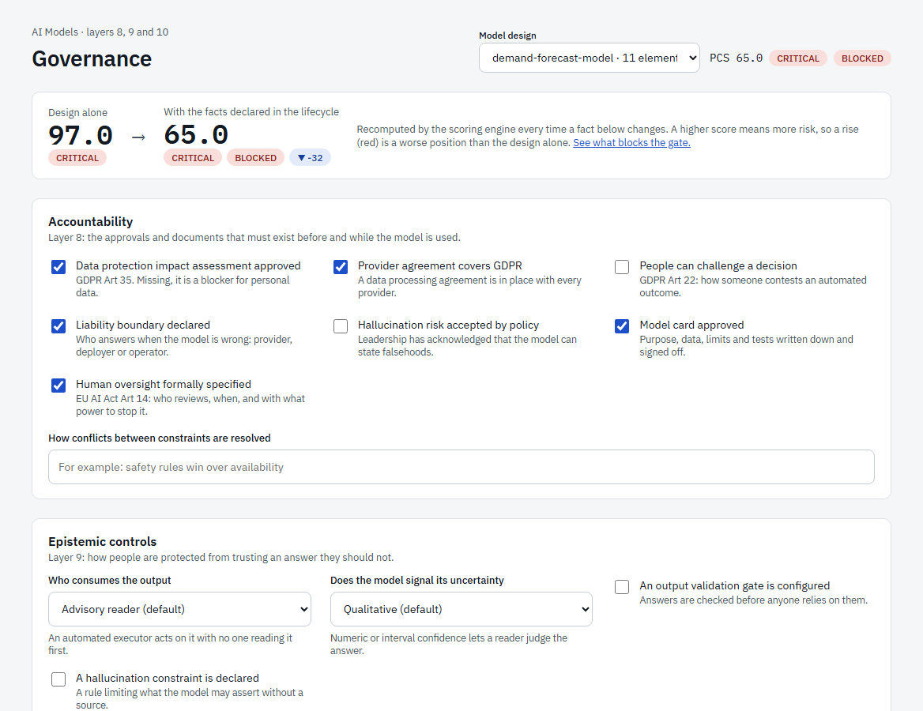
Figure 39. Approvals, epistemic controls and culture.
- Accountability (layer 8): data protection impact assessment approved, provider agreement covers GDPR, people can challenge a decision, liability boundary declared, hallucination risk accepted by policy, model card approved, human oversight formally specified.
- Epistemic controls (layer 9): who consumes the output, whether the model signals its uncertainty, an output validation gate, a hallucination constraint.
- Culture and oversight (layer 10): operators trained, human review genuinely substantive, automation-bias risk.
Tip. Ticking a box declares it true. Record the evidence in your own records; the score responds immediately, and an approval that is missing is a blocker.

5.5 Incidents
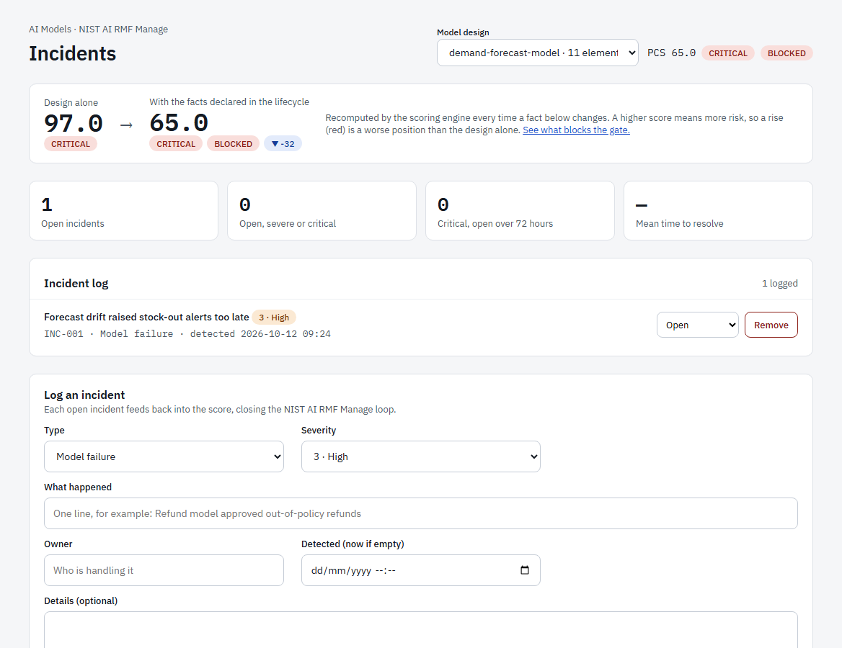
Figure 40. The incident log.
The Incidents page keeps the log that closes the NIST AI RMF Manage loop. Select the type and severity (1 low to 5 critical), write what happened, name an owner, optionally set when it was detected, and select Log incident. Change an incident’s status (Open, Investigating, Mitigated, Resolved, Post-mortem) from its menu.
Incidents feed the score: an open severe (4) or critical (5) incident raises the likelihood; three or more drift, bias or hallucination incidents in 90 days raise the bias term; and a critical incident open for more than 72 hours blocks the gate. The tiles show open incidents, severe ones, those open over 72 hours and the mean time to resolve.

5.6 Decommissioning
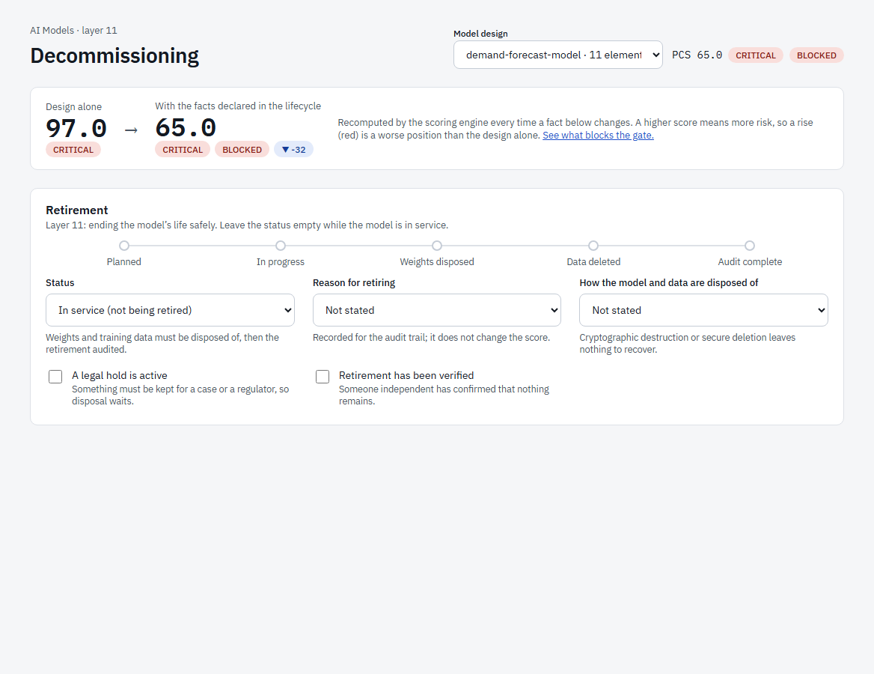
Figure 41. Retiring a model.
Layer 11 covers the end of a model’s life. Leave Status empty while the model is in service. When it is being retired, move it through Planned, In progress, Weights disposed, Data deleted and Audit complete, record the reason and the disposal method, and note a legal hold if something must be kept for a case or a regulator (the status then shows Legally held). Tick Retirement has been verified once someone independent has confirmed that nothing remains.

5.7 Regulations and standards
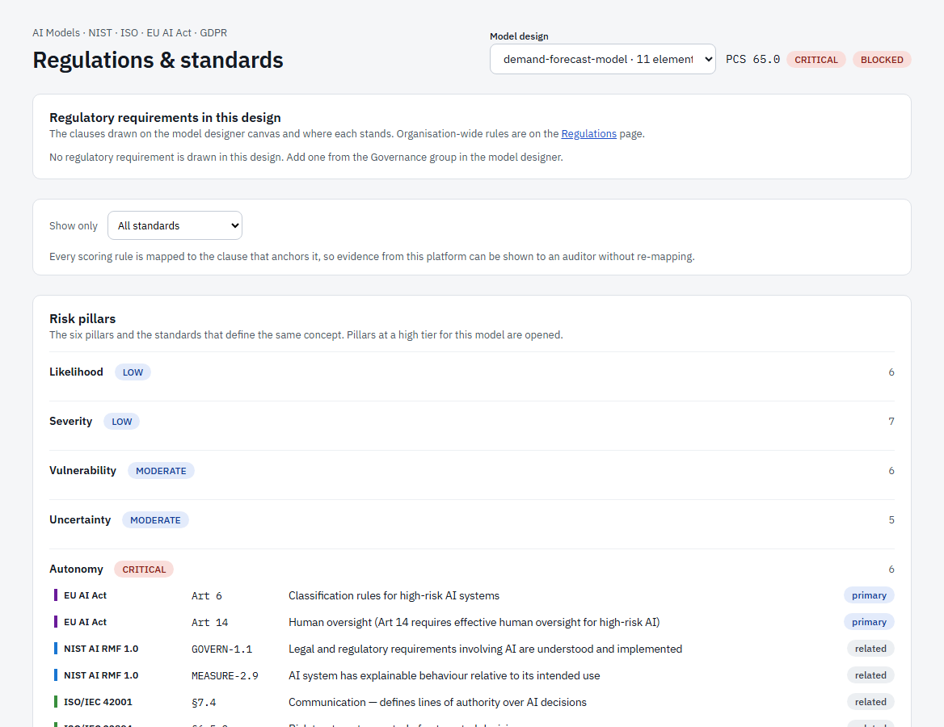
Figure 42. Regulations and standards for the model.
The page lists the regulatory requirements drawn in the design and where each stands, then the crosswalk: every scoring pillar, every reason a model can be blocked and every lifecycle phase, mapped to the clause that anchors it in NIST AI RMF, ISO/IEC 42001 and 23894, ISO 31000, the EU AI Act, GDPR and others. Use Show only to filter by standard. Pillars at a high tier for this model open automatically. This lets you show evidence from ASTRA to an auditor without re-mapping it.

5.8 Compiled contracts
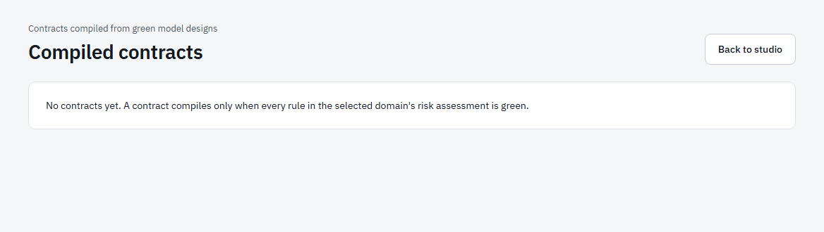
Figure 43. Compiled contracts.
Contracts compiled from model designs are listed here with their hash and status. For each one you can Verify hash, View JSON, download it as PDF or JSON, and Revoke it with a reason. The page is empty until a design is green and has been compiled.

6. Administration

6.1 People
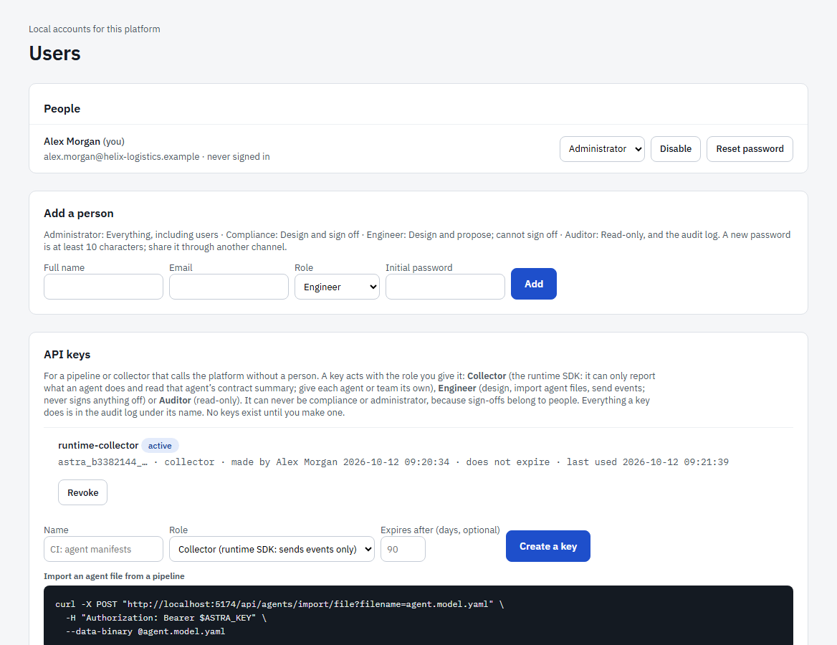
Figure 44. Users and API keys.
Administrators manage people on the Users page (bottom of the left menu).
- Under Add a person enter their full name, email, role and an initial password (at least 10 characters). Share it through another channel.
- Select Add. They can sign in immediately and should change the password.
For each person you can change the role, Disable the account and Reset password. There is no email-based recovery: an administrator resets passwords.

6.2 API keys
Figure 45. API keys for pipelines and collectors.
A key lets a pipeline or collector call the platform without a person. Choose a name, a role and an optional expiry in days, then Create a key. The key is shown once: copy it then. Keys appear as astra_<prefix>_… with when they were made, last used and whether they expire. Revoke a key at any time.
Key role | Use
Collector | Can only send runtime events and OpenTelemetry telemetry and read the contract summary it needs. Use this for the runtime SDK and for OpenTelemetry collectors: a leaked key can read and change nothing.
Engineer | Design, import agent files and connect sources from a pipeline. Cannot sign off.
Auditor | Read-only access.

A key never signs anything off, so it can never be Compliance or Administrator. The audit log shows what each key did.

6.3 The audit log
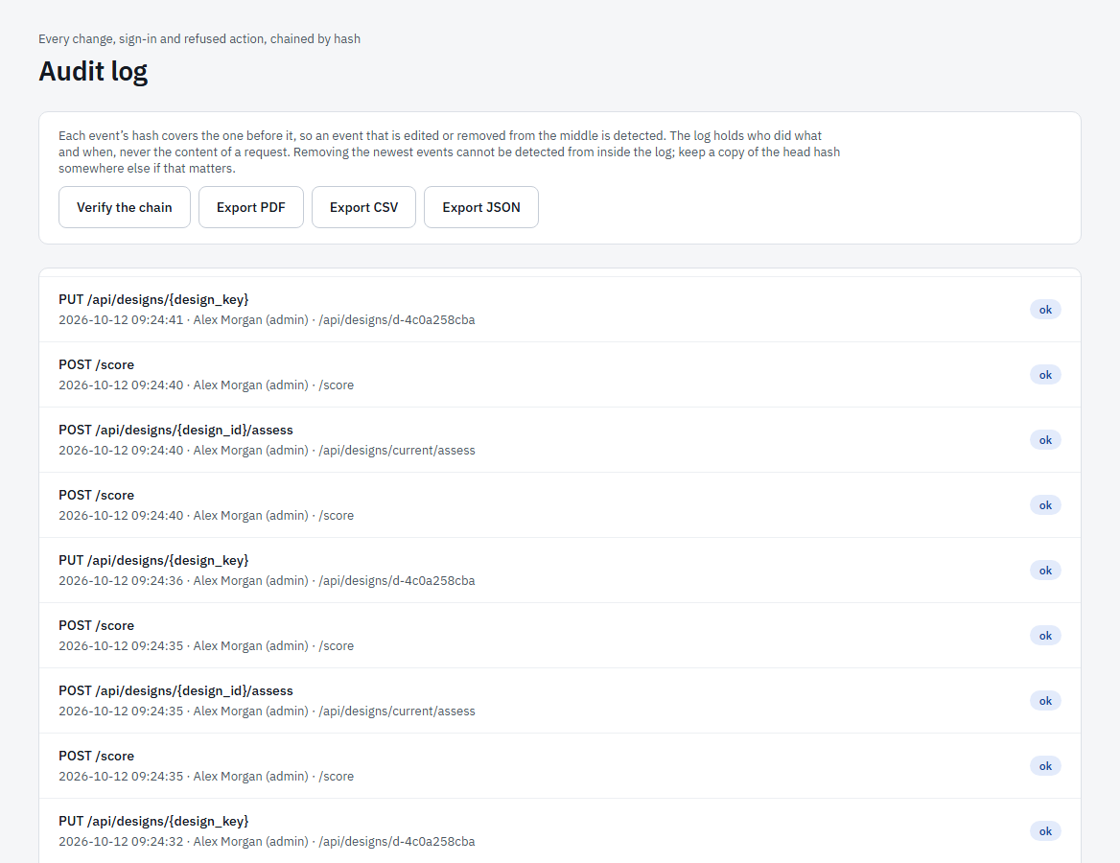
Figure 46. The audit log.
The audit log records every change, sign-in, failed sign-in and refused action: who, what, when and the outcome (never the contents of a request). Each event’s hash covers the one before it, so an event edited or removed from the middle is detected by Verify the chain. Auditors can read the log; use Older events to go back further. Because dropping the newest events cannot be seen from inside the log, keep a copy of the latest hash elsewhere if that matters to you.

7. Quick reference and troubleshooting

7.1 I want to…
I want to… | Go to
Describe my company | Organisation → step 1 (import a file, assistant, or by hand)
See who owns an agent, or find agents with no owner | Organisation checks, or AI Agents → Agents → Unowned
Add a rule of my own | Policies → New policy
Bring in agents that already exist | AI Agents → Add agent, Repositories, Identity providers or Telemetry
Design a new agent and approve it | AI Agents → Design studio → Ratify
Approve or reject a change to an approved agent | AI Agents → Drift review
See what an agent did that it should not have | AI Agents → Findings or Live runtime
Prove coverage to a customer or auditor | AI Agents → Trust and packs
Score a machine-learning model | AI Models → Model designer and Overview
Record that a model has drifted or an incident happened | AI Models → Runtime and Incidents
Create a key for a collector or a pipeline | Users → API keys
Check who changed what | Audit log

7.2 Troubleshooting
Symptom | What to do
I cannot sign in | Check the email and password. Five wrong attempts lock an address for 15 minutes. An administrator can reset your password.
A page says the backend is unavailable | The platform’s server is not running or not reachable. Ask your administrator to check it, then select Retry.
I changed the platform but still see the old screen | Your browser has cached the page. Press Ctrl+F5 for a hard refresh.
The Ratify button is disabled or refuses | A design whose gate is Blocked cannot be ratified. Close the gaps shown in the ASI and Compliance tabs. Signing off needs the Compliance role.
“Token storage is not set up” | An administrator must set the platform’s secret key before private repositories or identity providers can be connected.
Telemetry arrives but no agent appears | Check the span names the agent (gen_ai.agent.name or an agent span) or turn on “Use the service name”. The Telemetry page lists spans that could not be placed.
A tool shows as outside the contract but it is allowed | The tool name in telemetry must match the name in the design exactly.
A repository scan found nothing | ASTRA looks for LangGraph, OpenAI Agents SDK, CrewAI and MCP definitions. Narrow with the folder field for a monorepo, and check that test folders are not the only place agents are defined.
I cannot see a button my colleague can | Buttons depend on your role (section 2.2). Auditors are read-only.

7.3 Good habits
- Describe the organisation first; everything else is easier and more accurate when it exists.
- Give every agent an owner and a drift policy before it is ratified.
- Treat anything ASTRA guessed (listed in previews as “Guessed from names”) as a question to confirm, not a fact.
- Use Observe while an agent is new, then Block once you trust its contract.
- Generate a pack on a schedule you can commit to, and keep the latest hash somewhere outside the platform.
- Export the organisation before any destructive action.

