**What is JDK,JRE,JVM?**

JDK is Java Development Kit: compiler, debugger, javadoc

JRE is Java Runtime Environment: jvm java virtual machine + java library(java.lang.io) | jre

Jre: JVM memory, classloader, interpreter+execution engine + java libraries

JVM is Java Virtual Machine

**Is JVM, a compiler or interpreter ?**

A compiler and does not get interpreted until machine code

**Why Java don't use pointers ?**

Points are not secure because they allow for manipulation and Java is considered secured

**What are various types of Class loaders used by JVM ?**

ClassLoaders:

1. Bootstrap: rt.jar (has java libraries) jdk/jre/lib/rt.jar native(another language)
2. Extension: ext folder (jdk/jre/lib/ext) java
3. Application/System (ClassLoaderDemo) java

**How are classes loaded by JVM ?**

ClassLoaders:

1. Bootstrap: rt.jar (has java libraries) jdk/jre/lib/rt.jar native(another language)
2. Extension: ext folder (jdk/jre/lib/ext) java
3. Application/System (ClassLoaderDemo) java

**Which memory areas does instance and static variables use ?**

Stack and Heap

**What is PermGen or Permanent Generation ?**

A separate region of memory to hold internal representations of java classes

**What is metaspace ?**

It is permagen that stores metadata of class which have been loaded

**Describe what happens when an object is created in Java.**

1.Memory is allocated from heap to hold all instance variables and implementation-specific data of the object and its super classes. Implementation-specific data includes pointers to class and method data.

2.The instance variables of the objects are initialized to their default values.

3.The constructor for the most derived class is invoked. The first thing a constructor does is call the constructor for its super classes. This process continues until the constructor for java.lang.Object is called, as java.lang.Object is the base class for all objects in java. Before the body of the constructor is executed, all instance variable initializers and initialization blocks are executed.

4.Then the body of the constructor is executed. Thus, the constructor for the base class completes first and constructor for the most derived class completes last.

**Different types of memory used by JVM ?**

Method Area, Heap, Java Stack, Native Method Stacks

**Does Java Pass by Value or Pass by Reference?**

Java passes by value

**What are native methods?**

An instance or class methods which is written in another language

Lab work:

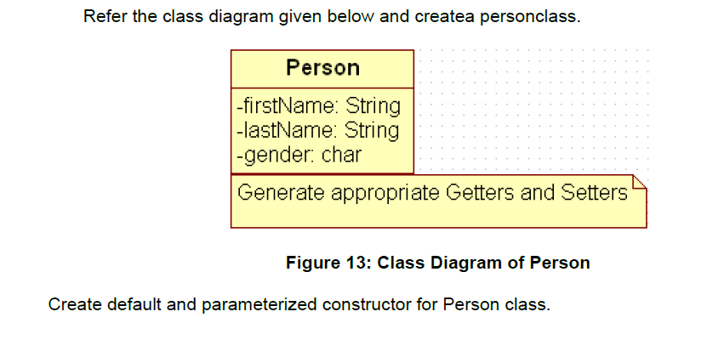

Also Create “PersonMain.java” program and write code for following operations:

a) Create an object of Person class and specify person details through constructor.

b): Modify to accept phone number of a person. Create a new method to implement the same and also define method for displaying persondetails.

c): Modify the above program, to accept only ‘M’ or ‘F’ as gender field values. Use Enumeration for implementing the same

**public** **class** Person {

String firstName;

String lastName;

**char** gender;

**byte** phoneNumber;

}

--After spring--

d) Add a method called calculateAge which should accept person’s date of birth and calculate age of a person.

e) Add a method called getFullName(String firstName, String lastName) which should return full name of a person

f) Display person details with age and fullname.

.

|  |
| --- |
| Write a program to accept a number from user as a command line argument and check whether the given number is positive or negative number. |
| function user(number) {  **if** (number > 0 ) {  System.out.println("It is a postive number!");  } **else** {number < 0} {  System.out.println("It is a negative number!");  }    } |
|  |