A

PROJECT REPORT

ON

**School Management System**

**Submitted By:-**

2205101260017 – Smit Miyani

2205101240042 – Siddhant Patel

2205101240008 – Khilan Mangukiya

**as**

Partial fulfilment of Semester V

of Bachelors of Computer Applications

Technology

for A.Y. 2024-2025

**Under the Guidance of**

Internal Guide name : Prof . Sohil Parmar

External Guide name : Prof . Sohil Parmar

Company name : SSK Vidhyalya

**Submitted To:-**

**Parul Institute of Computer Application,**

**Parul University.**

­­­­­­

**Acknowledgement**

The success and final outcome of this project required a lot of guidance and assistance from many people and we are extremely privileged to have got this all along the completion of our project. All that we have done is only due to such supervision and assistance and we would not forget to thank them.

 I respect and thank Dr. Priya Swaminarayan, Dean, FITCS for providing us an opportunity to do the project work in BCA and giving us all support and guidance which made us complete the project duly. We are extremely thankful to Mam for providing her support and guidance, although she had a busy schedule managing the academic affairs.

We would not forget to remember Prof. Hina Chokshi, HOD, BCA department for her encouragement and more over for her timely support and guidance till the completion of our project work.

We owe our deep gratitude to our project guide prof. Sohil Parmar who took keen interest on our project work and guided us all along, till the completion of our project work by providing all the necessary information for developing a good system.

 I am thankful to and fortunate enough to get constant encouragement, support and guidance from our Parents, all Teaching staff of the BCA Department which helped us in successfully completing our project work. Also, we would like to extend our sincere esteems to all staff in the laboratory for their timely support.

**2205101260017 – Smit Miyani**

**2205101240042 – Siddhant Patel**

**2205101240008 – Khilan Mangukiya**



**PARUL INSTITUTE OF COMPUTER APPLICATION**

**CERTIFICATE**

This is to certify that ***Smit Miyani , Khilan Mangukiya, Siddhant Patel*** the student(s) of Parul Institute of Computer Application, has/have satisfactorily completed the project entitled ***“School Management System”*** as a part of course curriculum in B.Sc. IT semester-V for the academic year 2024-2025 under guidance of ***( Prof. Sohil Parmar ).***

Enrollment Number: 2205101260017 (CSF)

Enrollment Number: 220510124042(AI)

Enrollment Number: 2205101240008(AI)

|  |  |  |
| --- | --- | --- |
| **Quality of work** | **Grade** | **Sign of Internal guide** |
| **Poor / Average / Good /**  **Excellent** | **B /B+ / A / A+** |  |

Date of submission:

HOD, Principal,

Prof. Hina Chokshi Dr.Priya Swaminarayan

**INDEX**

|  |
| --- |
| **Content Page No.** |
| 1. Introduction to Project System 6 |
| 2. System Requirement Specification 8 |
| 2.1 Introduction to SRS 8 |
| 2.2 Hardware Requirement 8 |
| 2.3 Software Requirement 8 |
| 2.4 System Users 9 |
| 2.5 Description of User Role 9 |
| 2.6 System Modules 10 |
| 2.7 Timeline Chart 10 |
| 3. System Flow Diagram 11 |
| 4. Data Flow Diagram (All Levels of DFDs) 12 |
| 5. Use Case Diagram 15 |
| 6. Data Dictionary 16 |
| 7. Screenshots of Development Phase -1 19 |
| 8. Screenshots of Development Phase -2 20 |
| 9. Conclusion 21 |
| 10. Future Enhancement 22 |
| 11. References 23 |

**ABSTRACT**

The School Management System (SMS) is a comprehensive, web-based platform designed to streamline and manage all aspects of school operations. This system is tailored for educational institutions of various sizes, providing tools for administration, faculty, students, and parents to interact efficiently within a single, unified Platform. It will cater to the needs of educational institutions, including primary, secondary, and higher education schools. The system will offer functionalities for administrators, teachers, students, and parents, covering areas such as student information management, attendance tracking, academic records, fee management, timetable scheduling, and communication.

**Chapter 1 Introduction to Project System**

# Introduction:

In today's rapidly evolving educational landscape, the efficient management of school operations is crucial to ensuring the success of both students and staff. The School Management System (SMS) is a comprehensive software solution designed to address the administrative, academic, and communication needs of educational institutions. By automating routine tasks and providing a centralized platform for managing information, the SMS enhances the productivity and effectiveness of schools, allowing educators to focus on their primary mission: delivering quality education.

The traditional methods of school management, often reliant on paper-based processes and manual data entry, are increasingly inadequate in handling the growing demands of modern education. As schools expand and diversify, the complexity of managing student records, scheduling classes, tracking attendance, communicating with parents, and processing payments can become overwhelming. A School Management System addresses these challenges by integrating various functions into a single, user-friendly platform.

# Background

The traditional model of school management has long relied on manual processes and paper-based systems to handle administrative tasks such as student enrollment, attendance tracking, grading, and communication. While these methods were sufficient in the past, the rapid growth of educational institutions and the increasing complexity of academic environments have highlighted significant limitations. As schools expanded, managing vast amounts of data became more challenging, leading to inefficiencies, errors, and a lack of real-time access to critical information. In the pre-digital era, school administrators were tasked with managing an overwhelming amount of paperwork, from maintaining student records and generating reports to scheduling classes and coordinating events. Teachers often faced similar challenges, with manual grading and attendance processes consuming valuable time that could be better spent on instruction and student engagement. Additionally, communication between schools, students, and parents was often slow and inconsistent, relying on physical notices, phone calls, or in-person meetings.

# Objective

The primary objective of the School Management System (SMS) is to provide a comprehensive, user-friendly platform that automates and streamlines the various administrative, academic, and communication processes within a school. By doing so, the SMS aims to enhance the overall efficiency of school operations, improve the educational experience for students, and foster better communication and collaboration among all stakeholders, including administrators, teachers, students, and parents.

# Purpose and Scope

* + 1. **Purpose**

School Management system would have the following goals.

* + - * Automate and simplify routine administrative tasks to reduce workload and improve efficiency.
      * Foster better communication among administrators, teachers, students, and parents through integrated communication tools.
      * Facilitate the efficient management of academic activities such as curriculum planning, grading, and attendance tracking.
      * Provide a unified platform for storing and managing all school-related information, ensuring easy access and retrieval.
      * Allow authorized users to access real-time information for informed decision-making.
      * Efficiently manage school resources such as classrooms, staff, and learning materials.
    1. **Scope**
* Manage user roles and permissions for administrators, teachers, students, and parents.
* Facilitate curriculum planning, timetable scheduling, and exam management.
* Automate student and staff attendance tracking with real-time monitoring and reporting.
* Generate financial reports and track school expenses.
* Facilitate announcements, event reminders, and updates through the platform.
* Manage school bus routes, schedules, and real-time tracking for safety and efficiency.
* Schedule and manage school events, exams, and holidays with a centralized calendar.
* Implement security measures to protect sensitive data and ensure compliance with privacy regulations.

By successfully implementing the project, a substantial knowledge has been acquired on the implementation of a database system using .net technologies.

This knowledge will be useful in the future in creating any type of desktop application or online database systems.

**Chapter 2**

**System Requirement Specification**

* 1. **Introduction to SRS**

# What is SRS?

A software requirements specification (SRS) is a description of a software system to be developed. It lays out functional and non-functional requirements, and may include a set of use cases that describe user interactions that the software must provide.

# Need of SRS

In order to fully understand one’s project, it is very important that they come up with a SRS listing out their requirements, how are they going to meet it and how will they complete the project. It helps the team to save upon their time as they are able to comprehend how are going to go about the project. Doing this also enables the team to find out about the limitations and risks early on.

* 1. **Hardware Requirement**

|  |  |
| --- | --- |
| **Hardware Components** | **Specification** |
| Processor | Intel core I3,/I5 |
| RAM | 4GB/8GB |
| Hard disk | 512GB/1TB |
| Monitor | 14-17 colour monitor |
| Device | Keyboard, Mouse |

* 1. **Software Requirement (For PHP)**

|  |  |
| --- | --- |
| **Name of component** | **Specification** |
| Operating System | WindowsXP,windows10 |
| Control Panel | Xampp Control Panel/Wamp  Control Panel |
| Software development kit | Google Chrome, Internet Explorer,  Mozilla Firefox ( any appropriate or suitable browser) |
| Programming Language | PHP, HTML, JAVASCRIPT |
| Server | Apache Web Server |
| Database | MySQL |

* 1. **System Users**
     1. User 1 :- Administrators: These are the users who have full access to all system modules, including administrative, academic, financial, and communication tools.
     2. User 2 :- Parents: Guardians responsible for supporting and monitoring their child’s academic progress.
     3. User 3 :- Teachers: These are the users who have access to academic management tools, attendance tracking, communication features, and student performance data.
     4. User 4 :- Students: These are the users who enrolled in the school who are the primary beneficiaries of the educational services.
  2. **Description of User Role**

# Administrators

* + - * Search for books to purchase
      * Add books to their shopping cart
      * Make payments for their purchases
      * Leave reviews and ratings for the books they have purchased

# Teachers

* Create listings for their books
* Set prices for their books
* Manage inventory of their books
* Receive payments for their sales
* Respond to customer inquiries and issues related to their sales

# Students

* Manage website features and settings
* Manage user accounts and permissions
* Monitor website activity and performance
* Handle technical issues and support requests
* Develop and implement website strategies and policies
  1. **System Features**
     1. Feature 1 :- Dashboard: it providing quick access to key features and real-time updates for different user roles.
     2. Feature 2 :- Attendance Tracking: Automated attendance tracking for students and staff, with options for manual entry, biometric integration, and real-time reporting.
     3. Feature 3 :- Timetable: Tools for creating and managing class timetables, exam schedules, and event calendars with automated conflict resolution.
     4. Feature 4:- Fee and Payment Management: Integrated system for managing school fees, including invoicing, online payment options, and financial reporting.
  2. **Timeline Chart**

|  |  |  |  |  |  |  |  |  |  |  |  |  |  |  |  |  |  |  |
| --- | --- | --- | --- | --- | --- | --- | --- | --- | --- | --- | --- | --- | --- | --- | --- | --- | --- | --- |
| **Development phase** | ***75 Days*** | | | | | | | | | | | | | | | | **Duration N**  **(days)** | |
| 0to10 days | | | 11to20 days | | | 21to30 days | | | 31to40 days | | 41to50 days | | | 51to75 days | |
| **Requirement Gathering** |  |  | | |  | |  | | |  | |  | | |  | | 07 | |
|  | | |  | | |
| **Analysis** |  | |  | | | | | |  |  | |  | | |  | | 09 | |
| **Design** |  | | |  | |  | | | |  | |  | | |  | | 10 | |
| **Development**  **Phase 1** |  | | |  | | |  |  | | |  |  | | |  | | 13 | |
|  | | |  | |
| **Development**  **Phase 2** |  | | |  | | |  | | |  | | |  | |  | | 13 | |
|  | |  | | |
| **Development Phase 3** |  | | |  | | |  | | |  | |  | | | |  | 13 | |
|  | | |  | |
| **Documentation** |  | | |  | | |  | | |  | |  | |  | | | | 10 |
|  | | |  | |  | |
| **Total time (Days)** |  | | | | | | | | | | | | | | | | **75** | |

2.7 Time line chart of School Management System

**Chapter 3**

**System Flow Diagram**

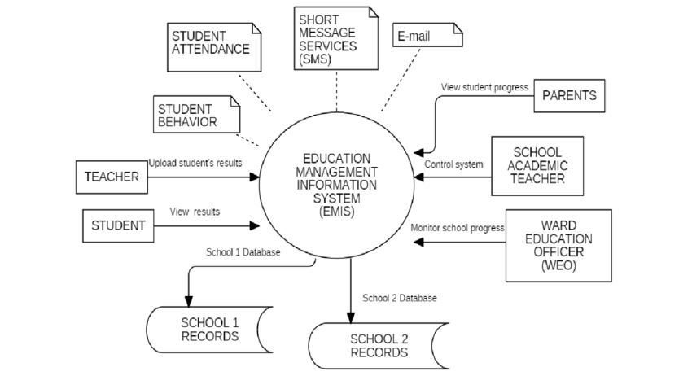

Figure 1: System Flow Diagram of School Management System Website

**Chapter 4**

**Data Flow Diagram ( All Levels)**

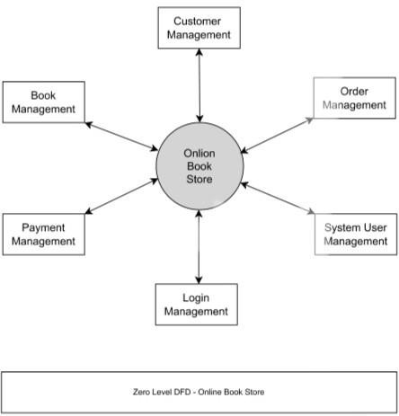

Figure 4.1 Data Flow Diagram of Zero level

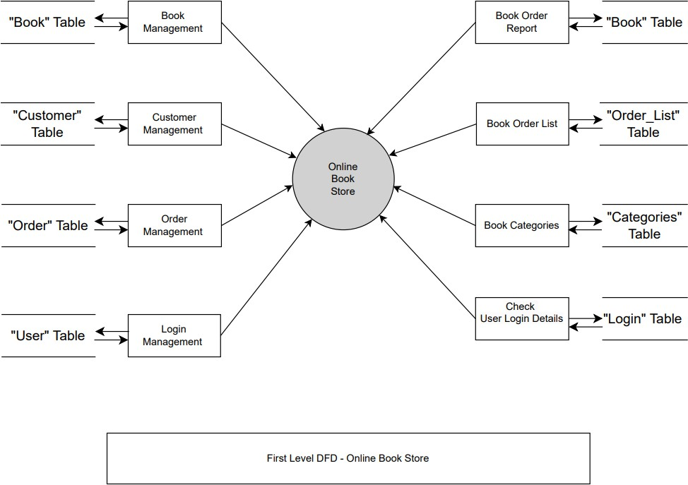

Figure 4.2 Data Flow Diagram of First level

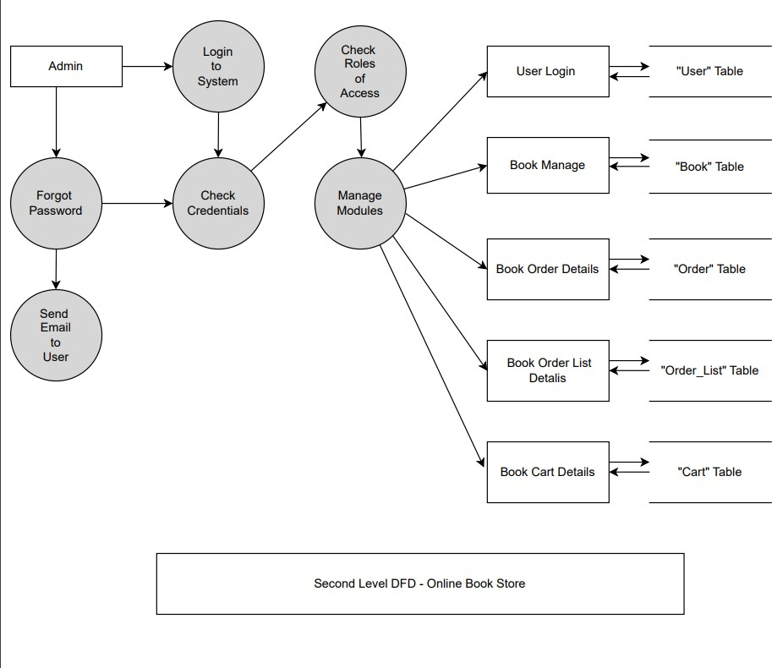

Figure 4.3 Data Flow Diagram of Second level

**Chapter 5 Use Case Diagram**

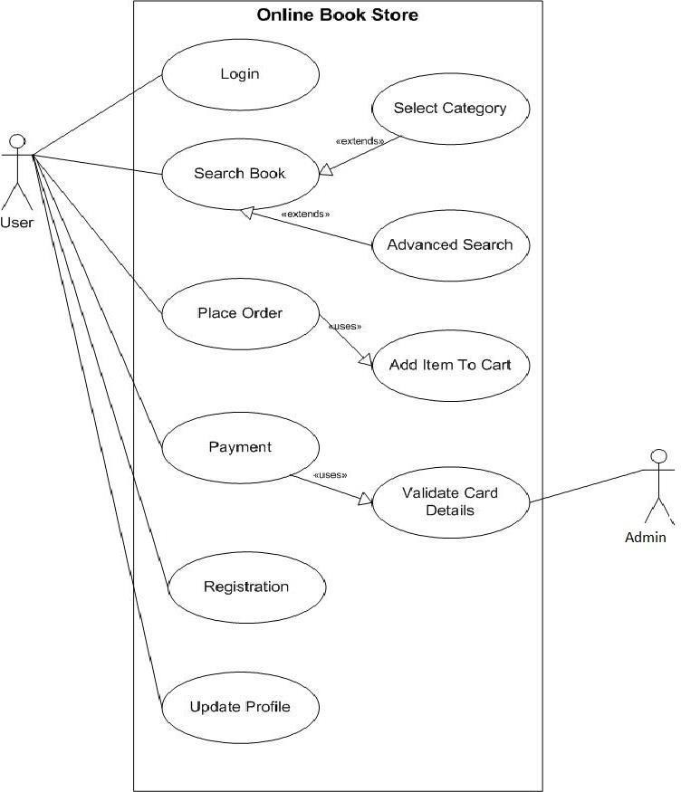

Figure 5.1: Use Case Diagram of Online bookselling website

* 1. **Login Table**

**Chapter 6 Data Dictionary**

* + - Names of all the database tables and their schemas.

|  |  |  |  |  |
| --- | --- | --- | --- | --- |
| **Sr.**  **No.** | **Field Name** | **Data**  **Type** | **Size** | **Constraint** |
| 1 | Email | varchar | 12 | Not null |
| 2 | Password | varchar | 20 | Not null |

* 1. **Ragistration Table**

Table Fig 6.1 : Login table

|  |  |  |  |  |
| --- | --- | --- | --- | --- |
| **Sr.**  **No.** | **Field Name** | **Data Type** | **Size** | **Constraint** |
| 1 | id | int | 30 | Not Null (PK) |
| 2 | Name | Varchar2 | 20 | Not null |
| 3 | Username | Varchar2 | 15 | Not null |
| 4 | Password | Text | 50 | Not null |
| 5 | type | Varchar2 | 50 | Not null |

* 1. **LoginTable**

Table Fig 6.2 : Registration Table

|  |  |  |  |  |
| --- | --- | --- | --- | --- |
| **Sr.**  **No.** | **Field Name** | **Data Type** | **Size** | **Constraint** |
| 1 | id | int | 20 | Not null |
| 2 | Category_ids | Number | 10 | Not null |
| 3 | Title | Varchar2 | 30 | Not null |
| 4 | Auther | Varchar2 | 15 | Not null |

Table Fig 6.3 : Login table

**Book Order Table**

|  |  |  |  |  |
| --- | --- | --- | --- | --- |
| **Sr.**  **No.** | **Field Name** | **Data Type** | **Size** | **Constraint** |
| 1 | id | int | 20 | Not null |
| 2 | Customer_id | int | 10 | Not null |
| 3 | Address | Text | 30 | Not null |
| 4 | Total_amount | Float | 15 | Not null |
| 5 | Status | Varchar2 | 50 | Not null |

* 1. **Order List Table**

Table Fig 6.4 : Login table

|  |  |  |  |  |
| --- | --- | --- | --- | --- |
| **Sr.**  **No.** | **Field Name** | **Data Type** | **Size** | **Constraint** |
| 1 | id | int | 20 | Not null |
| 2 | Order_id | int | 10 | Not null |
| 3 | Book_id | int | 30 | Not null |
| 4 | Qty | int | 15 | Not null |
| 5 | Price | float | 50 | Not null |

Table Fig 6.5 : Login table

* 1. **Customer Table**

|  |  |  |  |  |
| --- | --- | --- | --- | --- |
| **Sr.**  **No.** | **Field Name** | **Data Type** | **Size** | **Constraint** |
| 1 | id | int | 20 | Not null |
| 2 | Name | text | 10 | Not null |
| 3 | Address | text | 30 | Not null |
| 4 | Contact | varchar | 15 | Not null |
| 5 | Email | varchar | 50 | Not null |
| 6 | Password | text | 24 | Not null |

* 1. **Book Cart Table**

|  |  |  |  |  |
| --- | --- | --- | --- | --- |
| **Sr.**  **No.** | **Field Name** | **Data Type** | **Size** | **Constraint** |
| 1 | id | int | 20 | Not null |
| 2 | Book_id | text | 10 | Not null |
| 3 | Qty | text | 30 | Not null |
| 4 | Price | varchar | 15 | Not null |
| 5 | Customer_id | varchar | 50 | Not null |

Table Fig 6.7 : Login table

**Chapter 7**

**Screenshot of Development Phase 1**

* 1. **Home Page**

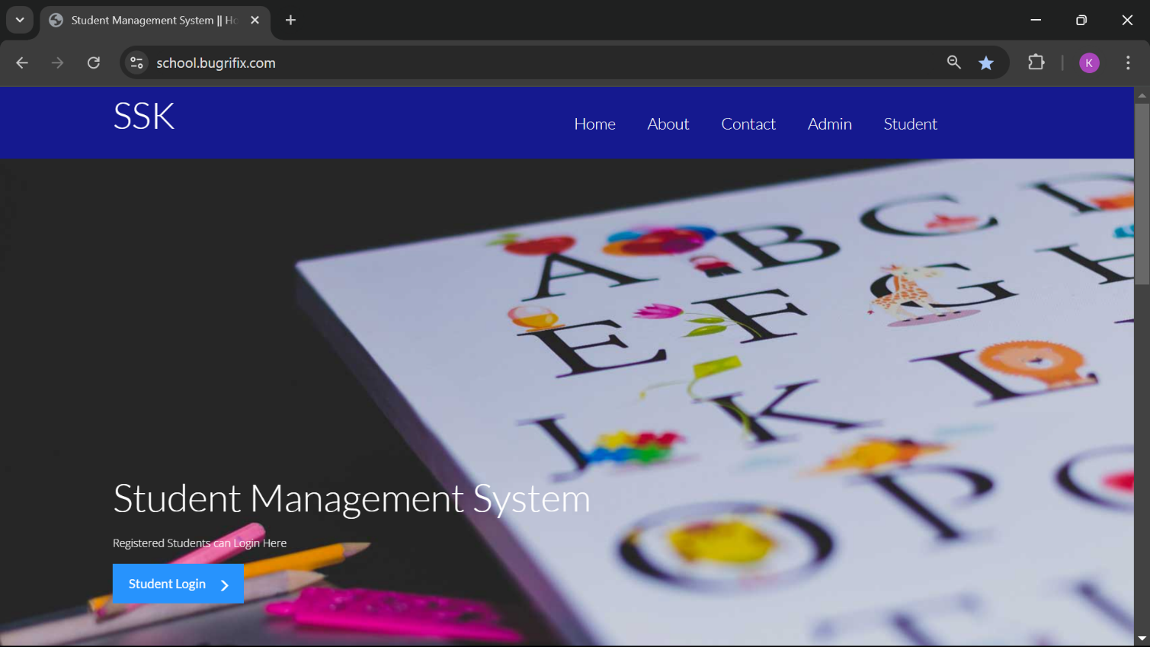

Figure 7.1 Home Page Design

* 1. **Code of home page**

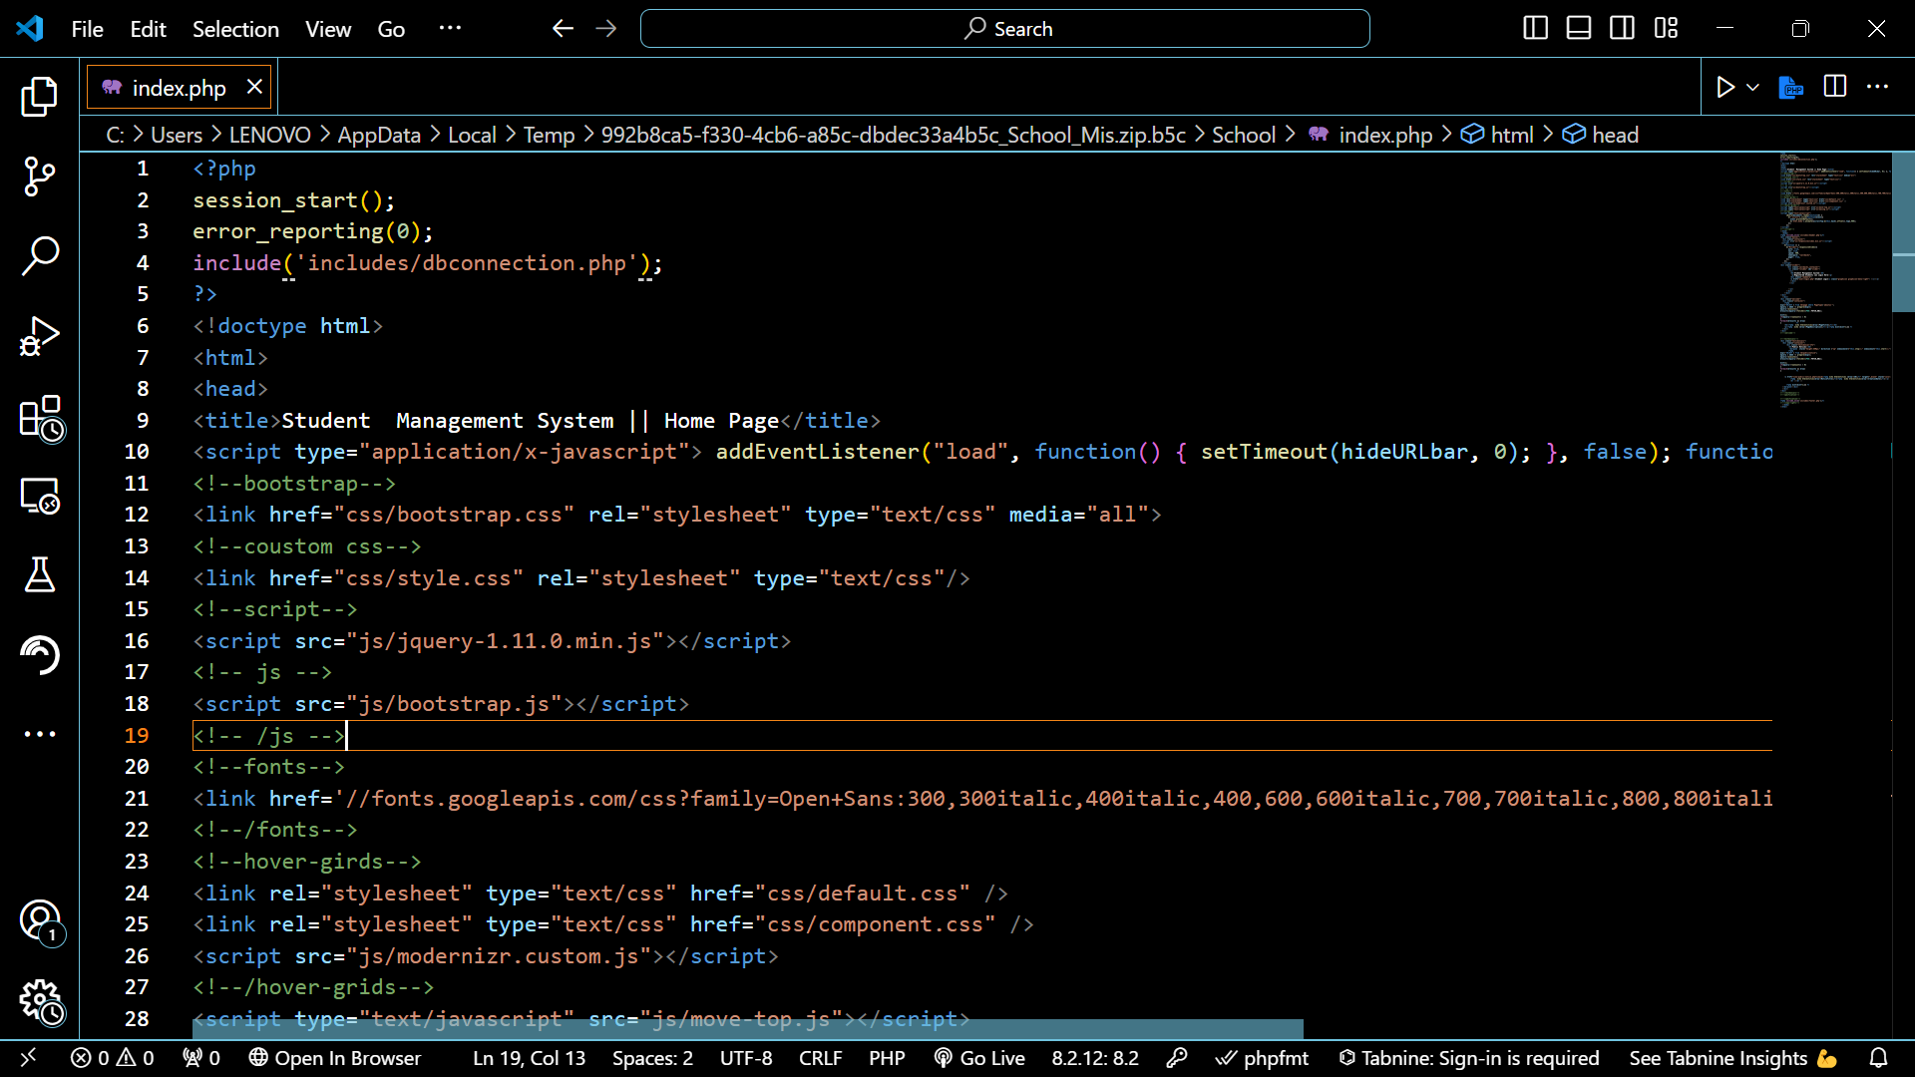

Figure 7.2 Code of Home page

* 1. **Login page**

**Chapter 8**

**Screenshot of Development Phase 2**

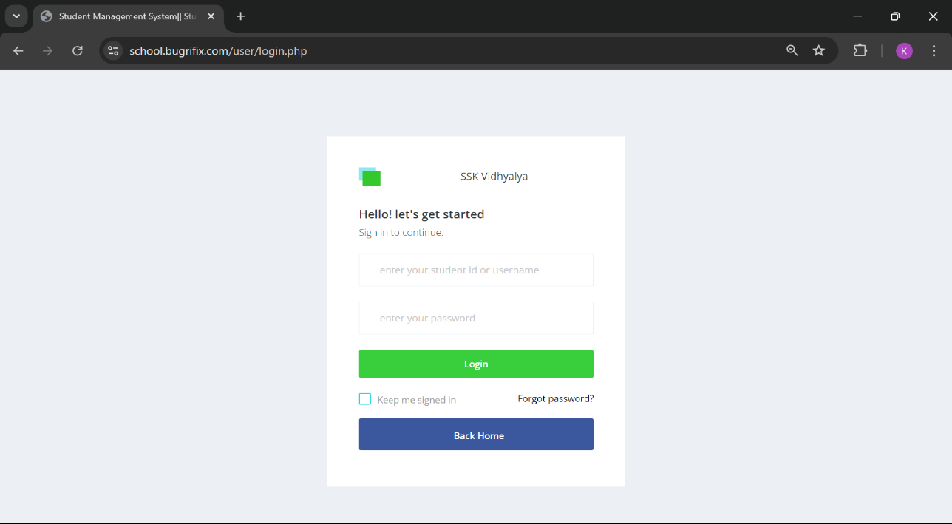

Figure 8.1 Login Page Design

F

* 1. **Code of Login page**

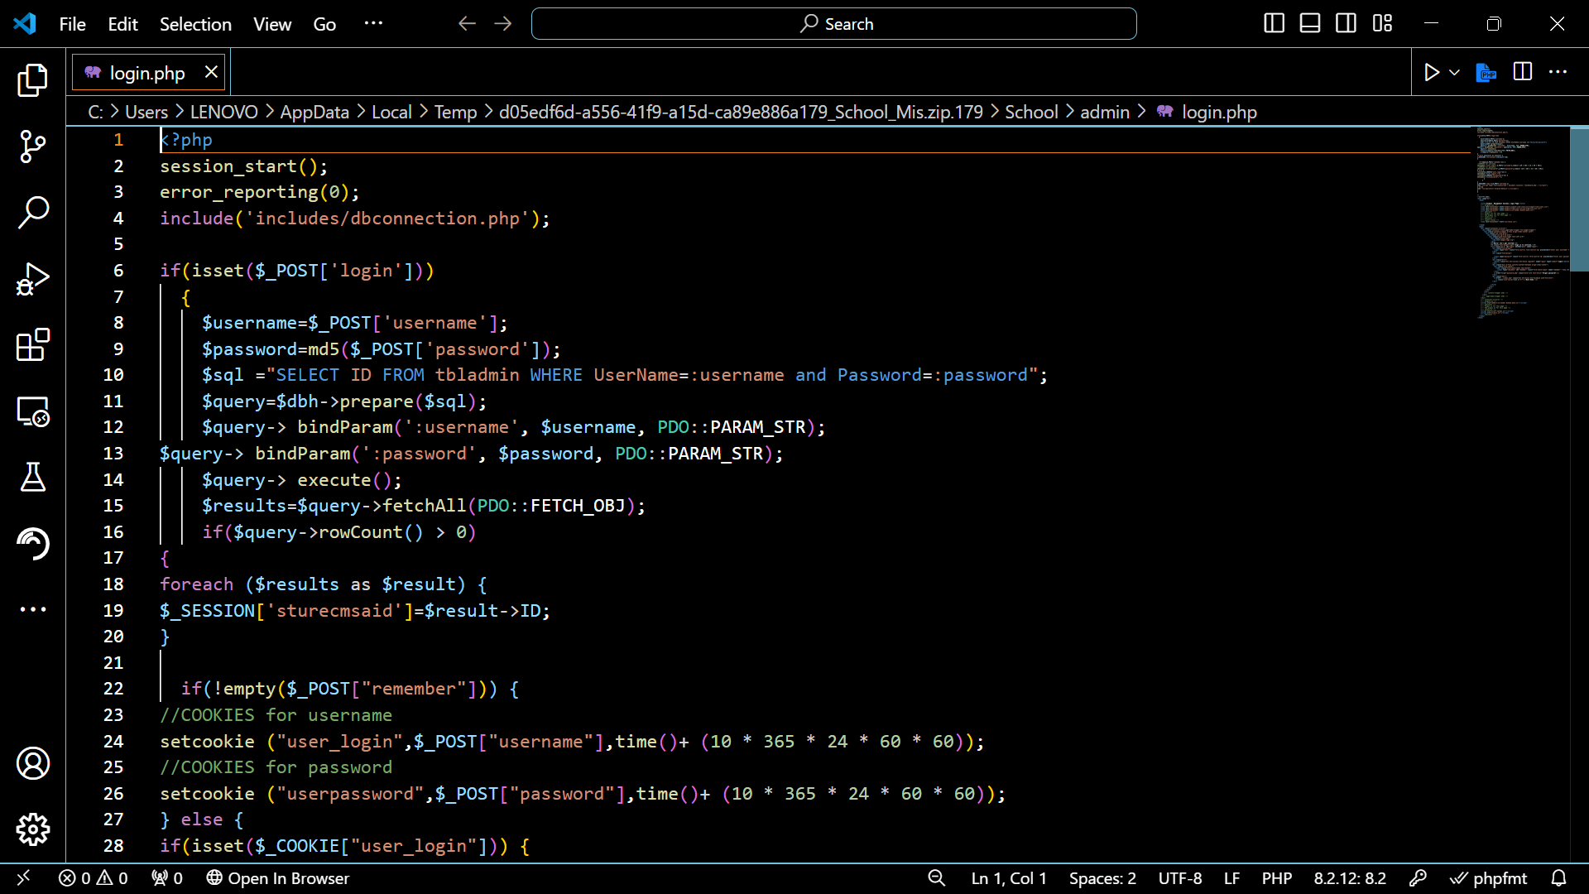

Figure 8.2 Code of Login page