Identifying At-Risk Customers with Logistic Regression

Khin Chan Thar

Abstract
The banking industry encounters sizeable financial losses due to customer defection, necessary robust predictive models to quickly pinpoint at-risk clients for intervention. Customer churn is a significant issue in banking, impacting profitability and customer retention. This report examines a publicly accessible retail banking dataset to employ a statistically based method for estimating the probability of a customer leaving the bank.
The main aim of the report is to determine if a customer’s demographic and behavioural factors are significantly associated with churn and can yield a practical predictive model. The central hypothesis is that geography, age and engagement indicators such as active membership status are significant predictors of churn.
The dataset comprises 10,000 customers with mixed-type predictors. Analysis of this dataset uses logistic regression, a suitable GLM model for binary outcomes. The model fit and predictive capability were assessed using a held-out set and quantified by metrics including Odds ratio, Accuracy and the Area Under the Curve (AUC).
Findings of the analysis showed that the model achieved an overall Accuracy of 80.83% and an AUC of 0.8037, demonstrating a good discriminatory power. On the other hand, due to the high-class imbalance of 79.6% non-churners, the model exhibited a very poor Specificity of 19.97% for identifying actual churners.
Overall, the analysis showed that while customer profiles are significantly associated with churn, the current model’s low Specificity renders it impractical for direct intervention strategies since it misses the majority of the true churners. The analysis also revealed the limitations of standard GLMs on highly skewed data, and the implication that future system improvements must focus on advanced sampling techniques to deliver a reliable and actionable benefit to the bank’s retention processes.

1. Introduction
Customer retention is the cornerstone of long-term profitability in competitive service sectors such as retail banking. The inability to anticipate customer churn rate, which is the process of a client leaving a service provider, results in significant costs associated with loss of revenue and marketing expenditure to acquire new clients. Accurate predictive modelling offers the bank with a strategic advantage by transforming reactive retention efforts into proactive and targeted campaigns. (Prabadevi et al., 2023)
2. Methods
Data
The original source of the data is from an anonymised internal banking dataset intended for academic research on predictive modelling. The source is referred to as Sharmaroshan. (2019). The data were sampled from the general population of retail banking customers. The data was collected retrospectively from the bank’s transactional and customer relationship management (CRM) systems. The data set comprises a sample size (n) of 10,000 unique customer records. The sampling process was systematic, capturing records for all customers at a specific point in time, leading to a sample representative of the bank’s overall customer base. The initial database contained 14 variables. By following feature selection, 10 primary predictor variables were used. These included:
- Response Variable: Exited (Binary, Factor, 0=Retained, 1=Churned).
- Predictor Variable: CreditScore (Interval), Geography (Categorical), Gender (Categorical), Age (Number), Tenure (Number), Balance (Number), Number of products (Number), HasCrCard (Categorical), IsActiveMember (Binary, Categorical), EstimatedSalary (Number)
Data Analyses
The goal was to model the probability of churn, π, as a function of the 10 predictor variables.
Model Structure
A Logistic Regression Model was used, representing the most appropriate Generalized Linear Model (GLM) for a binary response variable. The model structure is as follow:
$$log\left(\frac{π}{1-π}\right) = β_{0} + β_{1}X_{1} + β_{2}X_{2 }+ . . . + β_{10}X_{10}$$Where log $log\left(\frac{π}{1-π}\right)$is the link function (logit), and π is P(Y = 1 | X).
Data Processing
- Data Preparation: Categorical variables such as Gender and IsActiveMember were converted to factors.
- Data Splitting: The dataset is randomly portioned into a 70% training set for model fitting and a 30% held-out test set for unbiased model assessment.
- Parameter Estimation: The model parameters (β coefficients) were estimated using the maximum likelihood estimation (MLE) method on the training data.
- Model Selection: An initial GLM using logistic link function was fitted to the training data, including all predictors and the engineered feature. The Step-wise Akaike Information Criterion (AIC) procedure was then applied to remove non-significant predictors, yielding the most optimal GLM.
- Model Diagnostics: The final, optimal model was subjected to diagnostic checks to make sure that the validity and stability of the parameter estimates:
  - Multicollinearity: The variance Inflation Factor (VIF) was calculated for all predictors to make sure that no significant collinearity exists.
  - Cook’s Distance: It was calculated to identify observations with undue influence on the model’s coefficients.
- Model Performance: The predictive capability of the GLM was evaluated on the held-out test set:
  - Accuracy: A Confusion Matrix was generated to quantify prediction accuracy, sensitivity and specificity at a 0.5 classification threshold.
  - Discriminative Power: The model’s ability to distinguish between churned and non-churned customers was measured using the Receiver Operating Characteristics (ROC) curve and the Area Under the Curve (AUC).
- Model Interpretation: The estimated parameters were exponentiated to obtain Odds Ratios (ORs), allowing for substantive interpretation of the relationship between each predictor and the odds of customer churn (Excited = 1).
All statistical analyses were done using the R statistical programming environment. (R Core Team, 2023)
3. Result and Discussion
The primary findings of the report lies in the critical failure of the model to accurately predict the minority class of interest, evidenced by the Specificity of 19.97%. However, the model identifies 96.4% of non-churners (high sensitivity for class 0), but it misses approximately 80% of true churners, resulting to a high number of False Negatives.
This significant limitation is a direct result of a severe class imbalance, where only 20.37% of the total sample represents churners. When training a standard GLM, the MLE method prioritises overall accuracy, leading to a bias towards the majority class of non-churners.
Linking this back to the bank’s objective, a model with a Specificity this low is not fit for purpose. Using such a model would mean that the majority of high-risk customers would not be flagged, rendering proactive retention campaign investment ineffective and inefficient.
In terms of specific predictors, detailed coefficients analysis (Appendix) confirms the importance of variables such as Age which often positively correlates with churn, Balance, which indicates a non-linear relationship, and IsActiveMember where it shows a strong negative predictor of churn, which aligns with expectations that customer life cycle and engagement are crucial determinants of financial attrition risk.
Conclusion
This report applied a Generalized Linear Model (Logistic Regression) to the financial customer churn problem, establishing a statistically significant relationship between the 10 customer profile variables and the binary outcome of attrition. This has achieved a moderate AUC of 0.8037.
However, a severe class imbalance inherent in banking data was in the identification of the critical minority class. The resulting low Specificity (19.97%) showed that the standard GLM is not an efficient tool to accurately identify high-risk customer prediction.
Thus, future research and development must focus on addressing data imbalance through advanced sampling techniques (e.g., SMOTE) or model-based cost-sensitive adjustments to improve the model's Specificity for reducing financial customer attrition in the system.
References
Prabadevi, B., Shalini, R., & Kavitha, B. (2023). Customer churning analysis using machine learning algorithms. International Journal of Intelligent Networks, 4, 145–154. https://doi.org/10.1016/j.ijin.2023.05.005
Sharmaroshan. (2019). GitHub - sharmaroshan/Churn-Modelling-Dataset: Predicting which set of the customers are gong to churn out from the organization by looking into some of the important attributes and applying Machine Learning and Deep Learning on it. GitHub. https://github.com/sharmaroshan/Churn-Modelling-Dataset
R Core Team. (2023). R: A language and environment for statistical computing. R Foundation for Statistical Computing, Vienna, Austria.

Appendix
Khin Chan Thar
2025-11-10

Part 1: Data Setup and Wrangling
dataset = Churn_Modelling.csv

Load Libraries
library(ggplot2)
## Warning: package 'ggplot2' was built under R version 4.4.3
library(MASS)
## Warning: package 'MASS' was built under R version 4.4.3
library(caret)
## Warning: package 'caret' was built under R version 4.4.3
## Loading required package: lattice
## Warning: package 'lattice' was built under R version 4.4.3
library(dplyr)
##
## Attaching package: 'dplyr'
## The following object is masked from 'package:MASS':
##
## select
## The following objects are masked from 'package:stats':
##
## filter, lag
## The following objects are masked from 'package:base':
##
## intersect, setdiff, setequal, union
library(car)
## Warning: package 'car' was built under R version 4.4.3
## Loading required package: carData
## Warning: package 'carData' was built under R version 4.4.3
##
## Attaching package: 'car'
## The following object is masked from 'package:dplyr':
##
## recode
library(pROC)
## Warning: package 'pROC' was built under R version 4.4.3
## Type 'citation("pROC")' for a citation.
##
## Attaching package: 'pROC'
## The following objects are masked from 'package:stats':
##
## cov, smooth, var

Read and Clean the Data
# Read the Churn_Modelling.csv file
customers <- read.csv("Churn_Modelling.csv")
#Display Information
head(customers)
## RowNumber CustomerId Surname CreditScore Geography Gender Age Tenure
## 1 1 15634602 Hargrave 619 France Female 42 2
## 2 2 15647311 Hill 608 Spain Female 41 1
## 3 3 15619304 Onio 502 France Female 42 8
## 4 4 15701354 Boni 699 France Female 39 1
## 5 5 15737888 Mitchell 850 Spain Female 43 2
## 6 6 15574012 Chu 645 Spain Male 44 8
## Balance NumOfProducts HasCrCard IsActiveMember EstimatedSalary Exited
## 1 0.00 1 1 1 101348.88 1
## 2 83807.86 1 0 1 112542.58 0
## 3 159660.80 3 1 0 113931.57 1
## 4 0.00 2 0 0 93826.63 0
## 5 125510.82 1 1 1 79084.10 0
## 6 113755.78 2 1 0 149756.71 1
# Count total missing values in file
sum(is.na(customers))
## [1] 0
# Check for duplicates
customers[duplicated(customers),]
## [1] RowNumber CustomerId Surname CreditScore
## [5] Geography Gender Age Tenure
## [9] Balance NumOfProducts HasCrCard IsActiveMember
## [13] EstimatedSalary Exited
## <0 rows> (or 0-length row.names)
# drop irrelevant columns (Data Cleaning)
customers_clean <- customers %>%
dplyr::select(-RowNumber, -CustomerId, -Surname)
customers_clean <-customers_clean %>%
mutate(Age_Group = case_when(Age<= 30 ~"Young Adult",
Age<= 50 ~ "Middle Aged",
TRUE ~ "Senior"))
# to check if a variable is categorical (Factor)
is.factor(customers_clean$HasCrCard)
## [1] FALSE
is.factor(customers_clean$IsActiveMember)
## [1] FALSE
is.factor(customers_clean$Exited)
## [1] FALSE
# To check the class of the variable
class(customers_clean$Age_Group)
## [1] "character"
class(customers_clean$Geography)
## [1] "character"
class(customers_clean$Gender)
## [1] "character"
# Convert Categorical Variables to categorical variable(factor)
customers_clean <- customers_clean %>% mutate(across(c(Geography, Gender,HasCrCard, IsActiveMember, Age_Group, Exited), as.factor))
# Ensure that the variable Excited has levels "0" as Not Exited and "1"as Exited
levels(customers_clean$Exited) <- c("0","1")
# To see a summary of your categorical variables
summary(customers_clean$Exited)
## 0 1
## 7963 2037
summary(customers_clean$Geography)
## France Germany Spain
## 5014 2509 2477
summary(customers_clean$Gender)
## Female Male
## 4543 5457
summary(customers_clean$HasCrCard)
## 0 1
## 2945 7055
summary(customers_clean$Age_Group)
## Middle Aged Senior Young Adult
## 6771 1261 1968
summary(customers_clean$IsActiveMember)
## 0 1
## 4849 5151
#Display the structure to confirm the changes
summary(customers_clean)
## CreditScore Geography Gender Age Tenure
## Min. :350.0 France :5014 Female:4543 Min. :18.00 Min. : 0.000
## 1st Qu.:584.0 Germany:2509 Male :5457 1st Qu.:32.00 1st Qu.: 3.000
## Median :652.0 Spain :2477 Median :37.00 Median : 5.000
## Mean :650.5 Mean :38.92 Mean : 5.013
## 3rd Qu.:718.0 3rd Qu.:44.00 3rd Qu.: 7.000
## Max. :850.0 Max. :92.00 Max. :10.000
## Balance NumOfProducts HasCrCard IsActiveMember EstimatedSalary
## Min. : 0 Min. :1.00 0:2945 0:4849 Min. : 11.58
## 1st Qu.: 0 1st Qu.:1.00 1:7055 1:5151 1st Qu.: 51002.11
## Median : 97199 Median :1.00 Median :100193.91
## Mean : 76486 Mean :1.53 Mean :100090.24
## 3rd Qu.:127644 3rd Qu.:2.00 3rd Qu.:149388.25
## Max. :250898 Max. :4.00 Max. :199992.48
## Exited Age_Group
## 0:7963 Middle Aged:6771
## 1:2037 Senior :1261
## Young Adult:1968
##
##
##

Part 2: Exploratory Data Analysis (EDA)

Overall Churn Distribution
churn_dist <- customers_clean %>%
count(Exited) %>%
mutate(percentage = n / sum(n) * 100)
ggplot(churn_dist, aes(x = "", y = percentage, fill = Exited)) +
geom_col(width = 1) +
coord_polar(theta = "y") +
geom_text(aes(label = paste0(round(percentage,1), "%")), position = position_stack(vjust = 0.5)) +
labs(title = "Churn Distribution Pie Chart", x = NULL, y = NULL) +
theme_void()
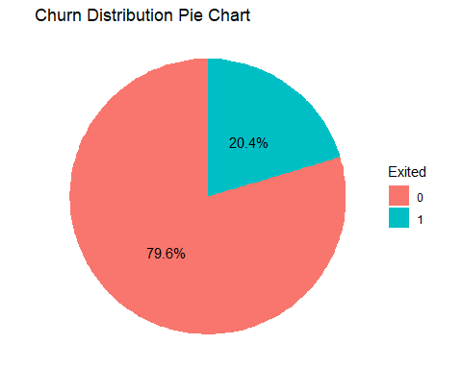

Churn Rate by Geography
# Plot stacked bar chart for Geography and Churn Status
# Use position= "fill" to show proportions (churn rate) by country
ggplot(customers_clean, aes(x=Geography, fill=Exited)) + geom_bar(position = "fill") + scale_y_continuous(labels = scales::percent) + scale_fill_manual(values = c("0" = "#4ECDC4", "1" = "#FF6B6B")) +
labs(
title = "Churn Rate Distribution by Country of Residence",
x = "Country",
y = "Percentage of Customers",
fill = "Exited (1=Yes)"
) +
theme_minimal() +
theme(plot.title = element_text(hjust = 0.5))
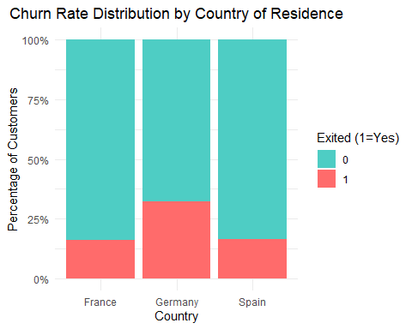

Churn Rate by Age Group
# Plot stacked bar chart for Age Group and Churn status
ggplot(customers_clean, aes(x=Age_Group, fill= Exited)) + geom_bar(position = "fill") +
scale_y_continuous(labels = scales::percent) +
scale_fill_manual(values = c("0" = "#4ECDC4", "1" = "#FF6B6B")) +
labs(
title = "Churn Rate Distribution by Age Group",
x = "Age Group (Engineered Feature)",
y = "Percentage of Customers",
fill = "Exited (1=Yes)"
) +
theme_minimal() +
theme(plot.title = element_text(hjust = 0.5))
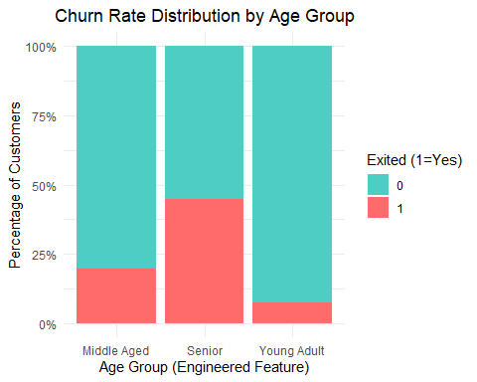 ## Histogram of Age by churn status
ggplot(customers_clean, aes(x = Age, fill = Exited)) +
geom_histogram(binwidth = 5, position = "identity", alpha = 0.6) +
labs(title = "Age Distribution by Churn", x = "Age", y = "Count") +
theme_minimal()
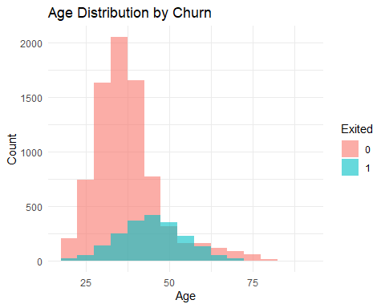 ## Boxplot of Balance by churn status
ggplot(customers_clean, aes(x = Exited, y = Balance, fill = Exited)) +
geom_boxplot(alpha = 0.7) +
labs(title = "Balance Distribution by Churn", x = "Churn", y = "Balance") +
theme_minimal()
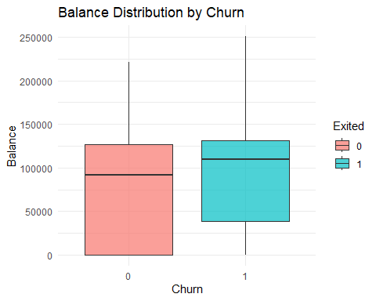

Correlation heatmap among numeric values
numeric_vars <- dplyr::select(customers_clean, CreditScore, Age, Tenure, Balance, NumOfProducts, EstimatedSalary)
correlation <- cor(numeric_vars)
library(ggcorrplot)
## Warning: package 'ggcorrplot' was built under R version 4.4.3
ggcorrplot(correlation, lab = TRUE) +
ggtitle("Correlation Heatmap of Numeric Variables")
## Warning: `aes_string()` was deprecated in ggplot2 3.0.0.
## ℹ Please use tidy evaluation idioms with `aes()`.
## ℹ See also `vignette("ggplot2-in-packages")` for more information.
## ℹ The deprecated feature was likely used in the ggcorrplot package.
## Please report the issue at <https://github.com/kassambara/ggcorrplot/issues>.
## This warning is displayed once every 8 hours.
## Call `lifecycle::last_lifecycle_warnings()` to see where this warning was
## generated.
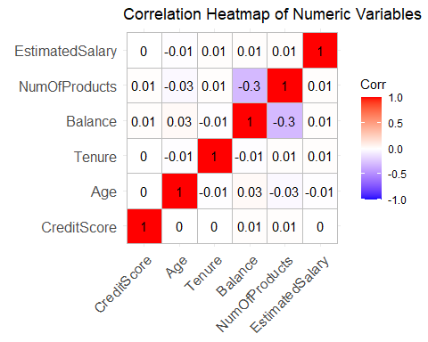 # Part 3: GLM Fitting and Optimal Model Selection

Data Splitting
# Set seed for reproducibility and replicability
set.seed(42)
# Create a 70% training partition (for training) and 30% (for testing)
train_index <- createDataPartition(customers_clean$Exited, p = 0.7, list = FALSE)
train_data <- customers_clean[train_index, ]
test_data <- customers_clean[-train_index, ]

Fit initial and Optimal Logistic Regression
# Fit the initial Logistic Regression GLM
full_model <- glm(Exited ~ CreditScore + Geography + Gender + Age + Tenure + Balance + NumOfProducts + HasCrCard + IsActiveMember + EstimatedSalary + Age_Group, data = train_data, family = "binomial")
# Use Stepwise AIC to find the optimal GLM model
optimal_model <- stepAIC(full_model, direction = "both", trace = FALSE)
#Print the summary of the final, optimal model
print("--- Optimal GLM Summary ---")
## [1] "--- Optimal GLM Summary ---"
summary(optimal_model)
##
## Call:
## glm(formula = Exited ~ CreditScore + Geography + Gender + Age +
## Balance + NumOfProducts + IsActiveMember + Age_Group, family = "binomial",
## data = train_data)
##
## Coefficients:
## Estimate Std. Error z value Pr(>|z|)
## (Intercept) -3.080e+00 3.404e-01 -9.048 < 2e-16 ***
## CreditScore -7.142e-04 3.331e-04 -2.144 0.0320 *
## GeographyGermany 7.568e-01 8.076e-02 9.370 < 2e-16 ***
## GeographySpain 6.106e-02 8.402e-02 0.727 0.4674
## GenderMale -5.205e-01 6.492e-02 -8.018 1.08e-15 ***
## Age 6.655e-02 5.900e-03 11.280 < 2e-16 ***
## Balance 2.410e-06 6.148e-07 3.920 8.85e-05 ***
## NumOfProducts -1.337e-01 5.686e-02 -2.352 0.0187 *
## IsActiveMember1 -1.075e+00 6.884e-02 -15.621 < 2e-16 ***
## Age_GroupSenior 2.794e-02 1.438e-01 0.194 0.8459
## Age_GroupYoung Adult -2.679e-01 1.323e-01 -2.025 0.0429 *
## ---
## Signif. codes: 0 '***' 0.001 '**' 0.01 '*' 0.05 '.' 0.1 ' ' 1
##
## (Dispersion parameter for binomial family taken to be 1)
##
## Null deviance: 7077.6 on 7000 degrees of freedom
## Residual deviance: 6026.4 on 6990 degrees of freedom
## AIC: 6048.4
##
## Number of Fisher Scoring iterations: 5

Part 4: Diagnositcs and Assessment

Multicollinearity Check
# Check for multicollinearity in the optimal model
print("--- Variance Inflation Factor (VIF) ---")
## [1] "--- Variance Inflation Factor (VIF) ---"
vif(optimal_model)
## GVIF Df GVIF^(1/(2*Df))
## CreditScore 1.000924 1 1.000462
## Geography 1.221912 2 1.051381
## Gender 1.004368 1 1.002182
## Age 3.957807 1 1.989424
## Balance 1.299765 1 1.140072
## NumOfProducts 1.079324 1 1.038905
## IsActiveMember 1.084580 1 1.041432
## Age_Group 3.930617 2 1.408041

Cook’s distance for Influential Observations
# Calculate Cook's Distance
cooks_d <- cooks.distance(optimal_model)
threshold <- 4 / nrow(train_data) # Typical threshold for influential points (4/N)
print(paste("Cook's Distance Threshold (4/N):", round (threshold, 5)))
## [1] "Cook's Distance Threshold (4/N): 0.00057"
# Plot Cook's Distance
plot(cooks_d,
main = "Cook's Distance Plot",
ylab = "Cook's Distance",
xlab = "Observation Index",
col = ifelse(cooks_d > threshold, "red", "blue"))
abline(h = threshold, lty = 2, col = "red")
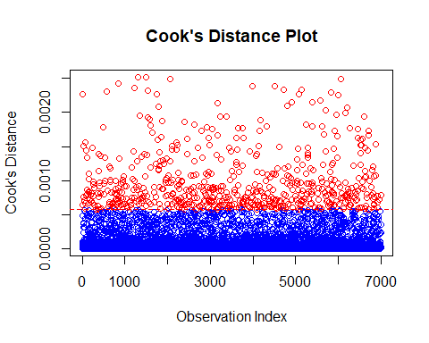

Interpretation: Odds Ratios
# Calculate the odds ratios and 95% Confidence Intervals
coefs <- summary(optimal_model)$coefficients
odds_ratios <- exp(coef(optimal_model))
conf_intervals <- exp(confint(optimal_model))
## Waiting for profiling to be done...
results_table <- data.frame(
OddsRatio = odds_ratios,
Lower_CI = conf_intervals[, 1],
Upper_CI = conf_intervals[, 2]
)
print("--- Odds Ratio Table (Final Interpretation) ---")
## [1] "--- Odds Ratio Table (Final Interpretation) ---"
print(results_table)
## OddsRatio Lower_CI Upper_CI
## (Intercept) 0.0459615 0.0235317 0.08938175
## CreditScore 0.9992861 0.9986335 0.99993853
## GeographyGermany 2.1313906 1.8198042 2.49771220
## GeographySpain 1.0629632 0.9008195 1.25234155
## GenderMale 0.5942314 0.5231165 0.67472967
## Age 1.0688196 1.0565694 1.08129758
## Balance 1.0000024 1.0000012 1.00000361
## NumOfProducts 0.8748376 0.7821861 0.97752128
## IsActiveMember1 0.3411907 0.2978860 0.39017705
## Age_GroupSenior 1.0283345 0.7756701 1.36305670
## Age_GroupYoung Adult 0.7649778 0.5885308 0.98890370

QQ-plot of deviance residuals
# Calculate the Deviance Residuals from the optimal model
# Residuals should be stored as a simple dataframe for ggplot
residual_df <- data.frame(deviance_residuals = residuals(optimal_model, type = "deviance"))
# Create a QQ plot using ggplot2 (stat_qq and stat_qq_line)
ggplot(residual_df, aes(sample = deviance_residuals)) +
# Add the points
stat_qq(color = "blue") +
# Add the reference line
stat_qq_line(color = "red", linetype = "dashed") +
labs(
title = "QQ Plot of Deviance Residuals (Optimal GLM)",
x = "Theoretical Quantiles",
y = "Sample Quantiles"
) +
theme_minimal()
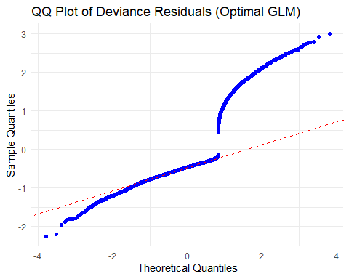

Model Prediction and Accuracy on test data
# Predict probabilities on the held-out test set
test_probabilities <- predict(optimal_model, test_data, type = "response")
# Convert probabilities to binary predictions (using a 0.5 threshold)
test_predictions <- ifelse(test_probabilities > 0.5, 1, 0)
# Assess model performance using the Confusion Matrix
print("--- Confusion Matrix (Prediction Accuracy) ---")
## [1] "--- Confusion Matrix (Prediction Accuracy) ---"
confusionMatrix(as.factor(test_predictions), test_data$Exited)
## Confusion Matrix and Statistics
##
## Reference
## Prediction 0 1
## 0 2302 489
## 1 86 122
##
## Accuracy : 0.8083
## 95% CI : (0.7937, 0.8222)
## No Information Rate : 0.7963
## P-Value [Acc > NIR] : 0.05296
##
## Kappa : 0.2169
##
## Mcnemar's Test P-Value : < 2e-16
##
## Sensitivity : 0.9640
## Specificity : 0.1997
## Pos Pred Value : 0.8248
## Neg Pred Value : 0.5865
## Prevalence : 0.7963
## Detection Rate : 0.7676
## Detection Prevalence : 0.9306
## Balanced Accuracy : 0.5818
##
## 'Positive' Class : 0
##

Model Validity (ROC and AUC)
# Create the ROC curve object using the held-out test data
roc_curve <- roc(response = test_data$Exited,
predictor = test_probabilities)
## Setting levels: control = 0, case = 1
## Setting direction: controls < cases
# Plot the ROC Curve
plot(roc_curve,
main = "ROC Curve on Test Data",
col = "blue",
lwd = 2)
legend("bottomright",
legend = paste("AUC =", round(auc(roc_curve), 4)),
col = "blue",
lwd = 2)
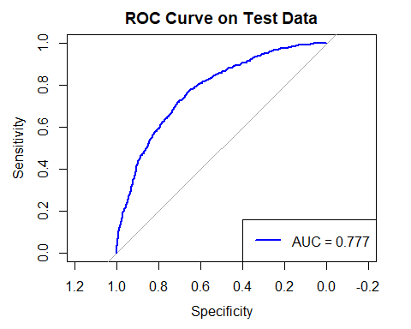
# Calculate and print the Area Under the Curve (AUC)
print(paste("Area Under the Curve (AUC):", round(auc(roc_curve), 4)))
## [1] "Area Under the Curve (AUC): 0.777"

