MA2405_Assessment_3
Khin Chan Thar
2025-11-10

Part 1: Data Setup and Wrangling
dataset = Churn_Modelling.csv

Load Libraries
library(ggplot2)
## Warning: package 'ggplot2' was built under R version 4.4.3
library(MASS)
## Warning: package 'MASS' was built under R version 4.4.3
library(caret)
## Warning: package 'caret' was built under R version 4.4.3
## Loading required package: lattice
## Warning: package 'lattice' was built under R version 4.4.3
library(dplyr)
##
## Attaching package: 'dplyr'
## The following object is masked from 'package:MASS':
##
## select
## The following objects are masked from 'package:stats':
##
## filter, lag
## The following objects are masked from 'package:base':
##
## intersect, setdiff, setequal, union
library(car)
## Warning: package 'car' was built under R version 4.4.3
## Loading required package: carData
## Warning: package 'carData' was built under R version 4.4.3
##
## Attaching package: 'car'
## The following object is masked from 'package:dplyr':
##
## recode
library(pROC)
## Warning: package 'pROC' was built under R version 4.4.3
## Type 'citation("pROC")' for a citation.
##
## Attaching package: 'pROC'
## The following objects are masked from 'package:stats':
##
## cov, smooth, var

Read and Clean the Data
# Read the Churn_Modelling.csv file
customers <- read.csv("Churn_Modelling.csv")
#Display Information
head(customers)
## RowNumber CustomerId Surname CreditScore Geography Gender Age Tenure
## 1 1 15634602 Hargrave 619 France Female 42 2
## 2 2 15647311 Hill 608 Spain Female 41 1
## 3 3 15619304 Onio 502 France Female 42 8
## 4 4 15701354 Boni 699 France Female 39 1
## 5 5 15737888 Mitchell 850 Spain Female 43 2
## 6 6 15574012 Chu 645 Spain Male 44 8
## Balance NumOfProducts HasCrCard IsActiveMember EstimatedSalary Exited
## 1 0.00 1 1 1 101348.88 1
## 2 83807.86 1 0 1 112542.58 0
## 3 159660.80 3 1 0 113931.57 1
## 4 0.00 2 0 0 93826.63 0
## 5 125510.82 1 1 1 79084.10 0
## 6 113755.78 2 1 0 149756.71 1
# Count total missing values in file
sum(is.na(customers))
## [1] 0
# Check for duplicates
customers[duplicated(customers),]
## [1] RowNumber CustomerId Surname CreditScore
## [5] Geography Gender Age Tenure
## [9] Balance NumOfProducts HasCrCard IsActiveMember
## [13] EstimatedSalary Exited
## <0 rows> (or 0-length row.names)
# drop irrelevant columns (Data Cleaning)
customers_clean <- customers %>%
dplyr::select(-RowNumber, -CustomerId, -Surname)
customers_clean <-customers_clean %>%
mutate(Age_Group = case_when(Age<= 30 ~"Young Adult",
Age<= 50 ~ "Middle Aged",
TRUE ~ "Senior"))
# to check if a variable is categorical (Factor)
is.factor(customers_clean$HasCrCard)
## [1] FALSE
is.factor(customers_clean$IsActiveMember)
## [1] FALSE
is.factor(customers_clean$Exited)
## [1] FALSE
# To check the class of the variable
class(customers_clean$Age_Group)
## [1] "character"
class(customers_clean$Geography)
## [1] "character"
class(customers_clean$Gender)
## [1] "character"
# Convert Categorical Variables to categorical variable(factor)
customers_clean <- customers_clean %>% mutate(across(c(Geography, Gender,HasCrCard, IsActiveMember, Age_Group, Exited), as.factor))
# Ensure that the variable Excited has levels "0" as Not Exited and "1"as Exited
levels(customers_clean$Exited) <- c("0","1")
# To see a summary of your categorical variables
summary(customers_clean$Exited)
## 0 1
## 7963 2037
summary(customers_clean$Geography)
## France Germany Spain
## 5014 2509 2477
summary(customers_clean$Gender)
## Female Male
## 4543 5457
summary(customers_clean$HasCrCard)
## 0 1
## 2945 7055
summary(customers_clean$Age_Group)
## Middle Aged Senior Young Adult
## 6771 1261 1968
summary(customers_clean$IsActiveMember)
## 0 1
## 4849 5151
#Display the structure to confirm the changes
summary(customers_clean)
## CreditScore Geography Gender Age Tenure
## Min. :350.0 France :5014 Female:4543 Min. :18.00 Min. : 0.000
## 1st Qu.:584.0 Germany:2509 Male :5457 1st Qu.:32.00 1st Qu.: 3.000
## Median :652.0 Spain :2477 Median :37.00 Median : 5.000
## Mean :650.5 Mean :38.92 Mean : 5.013
## 3rd Qu.:718.0 3rd Qu.:44.00 3rd Qu.: 7.000
## Max. :850.0 Max. :92.00 Max. :10.000
## Balance NumOfProducts HasCrCard IsActiveMember EstimatedSalary
## Min. : 0 Min. :1.00 0:2945 0:4849 Min. : 11.58
## 1st Qu.: 0 1st Qu.:1.00 1:7055 1:5151 1st Qu.: 51002.11
## Median : 97199 Median :1.00 Median :100193.91
## Mean : 76486 Mean :1.53 Mean :100090.24
## 3rd Qu.:127644 3rd Qu.:2.00 3rd Qu.:149388.25
## Max. :250898 Max. :4.00 Max. :199992.48
## Exited Age_Group
## 0:7963 Middle Aged:6771
## 1:2037 Senior :1261
## Young Adult:1968
##
##
##

Part 2: Exploratory Data Analysis (EDA)

Overall Churn Distribution
churn_dist <- customers_clean %>%
count(Exited) %>%
mutate(percentage = n / sum(n) * 100)
ggplot(churn_dist, aes(x = "", y = percentage, fill = Exited)) +
geom_col(width = 1) +
coord_polar(theta = "y") +
geom_text(aes(label = paste0(round(percentage,1), "%")), position = position_stack(vjust = 0.5)) +
labs(title = "Churn Distribution Pie Chart", x = NULL, y = NULL) +
theme_void()
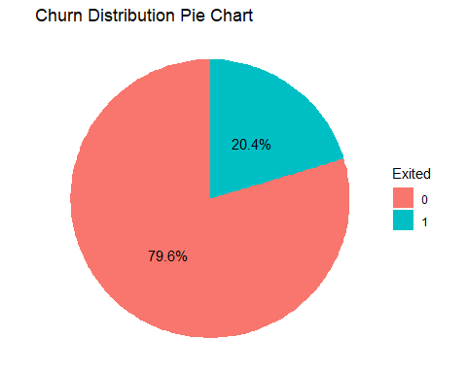

Churn Rate by Geography
# Plot stacked bar chart for Geography and Churn Status
# Use position= "fill" to show proportions (churn rate) by country
ggplot(customers_clean, aes(x=Geography, fill=Exited)) + geom_bar(position = "fill") + scale_y_continuous(labels = scales::percent) + scale_fill_manual(values = c("0" = "#4ECDC4", "1" = "#FF6B6B")) +
labs(
title = "Churn Rate Distribution by Country of Residence",
x = "Country",
y = "Percentage of Customers",
fill = "Exited (1=Yes)"
) +
theme_minimal() +
theme(plot.title = element_text(hjust = 0.5))
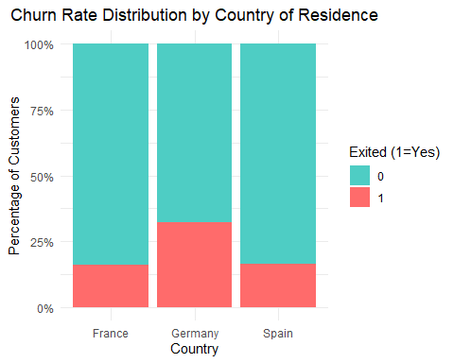

Churn Rate by Age Group
# Plot stacked bar chart for Age Group and Churn status
ggplot(customers_clean, aes(x=Age_Group, fill= Exited)) + geom_bar(position = "fill") +
scale_y_continuous(labels = scales::percent) +
scale_fill_manual(values = c("0" = "#4ECDC4", "1" = "#FF6B6B")) +
labs(
title = "Churn Rate Distribution by Age Group",
x = "Age Group (Engineered Feature)",
y = "Percentage of Customers",
fill = "Exited (1=Yes)"
) +
theme_minimal() +
theme(plot.title = element_text(hjust = 0.5))
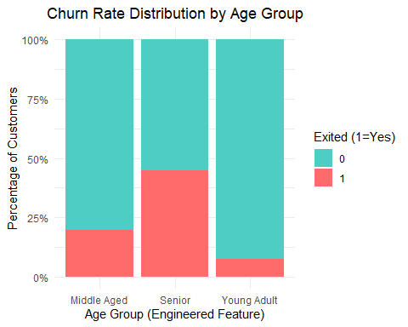 ## Histogram of Age by churn status
ggplot(customers_clean, aes(x = Age, fill = Exited)) +
geom_histogram(binwidth = 5, position = "identity", alpha = 0.6) +
labs(title = "Age Distribution by Churn", x = "Age", y = "Count") +
theme_minimal()
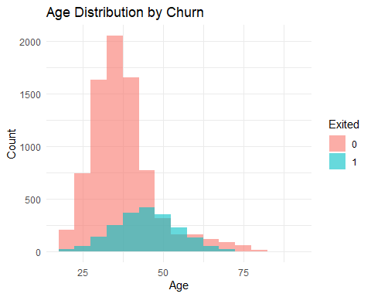 ## Boxplot of Balance by churn status
ggplot(customers_clean, aes(x = Exited, y = Balance, fill = Exited)) +
geom_boxplot(alpha = 0.7) +
labs(title = "Balance Distribution by Churn", x = "Churn", y = "Balance") +
theme_minimal()
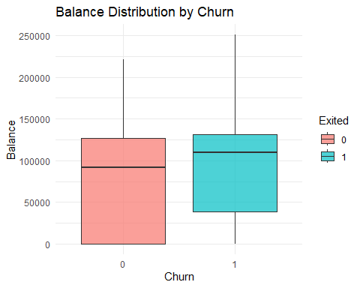

Correlation heatmap among numeric values
numeric_vars <- dplyr::select(customers_clean, CreditScore, Age, Tenure, Balance, NumOfProducts, EstimatedSalary)
correlation <- cor(numeric_vars)
library(ggcorrplot)
## Warning: package 'ggcorrplot' was built under R version 4.4.3
ggcorrplot(correlation, lab = TRUE) +
ggtitle("Correlation Heatmap of Numeric Variables")
## Warning: `aes_string()` was deprecated in ggplot2 3.0.0.
## ℹ Please use tidy evaluation idioms with `aes()`.
## ℹ See also `vignette("ggplot2-in-packages")` for more information.
## ℹ The deprecated feature was likely used in the ggcorrplot package.
## Please report the issue at <https://github.com/kassambara/ggcorrplot/issues>.
## This warning is displayed once every 8 hours.
## Call `lifecycle::last_lifecycle_warnings()` to see where this warning was
## generated.
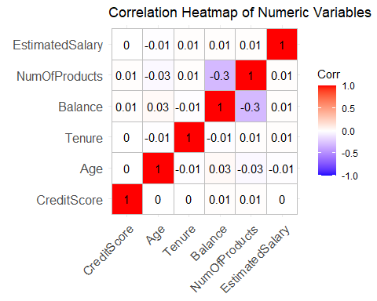 # Part 3: GLM Fitting and Optimal Model Selection

Data Splitting
# Set seed for reproducibility and replicability
set.seed(42)
# Create a 70% training partition (for training) and 30% (for testing)
train_index <- createDataPartition(customers_clean$Exited, p = 0.7, list = FALSE)
train_data <- customers_clean[train_index, ]
test_data <- customers_clean[-train_index, ]

Fit initial and Optimal Logistic Regression
# Fit the initial Logistic Regression GLM
full_model <- glm(Exited ~ CreditScore + Geography + Gender + Age + Tenure + Balance + NumOfProducts + HasCrCard + IsActiveMember + EstimatedSalary + Age_Group, data = train_data, family = "binomial")
# Use Stepwise AIC to find the optimal GLM model
optimal_model <- stepAIC(full_model, direction = "both", trace = FALSE)
#Print the summary of the final, optimal model
print("--- Optimal GLM Summary ---")
## [1] "--- Optimal GLM Summary ---"
summary(optimal_model)
##
## Call:
## glm(formula = Exited ~ CreditScore + Geography + Gender + Age +
## Balance + NumOfProducts + IsActiveMember + Age_Group, family = "binomial",
## data = train_data)
##
## Coefficients:
## Estimate Std. Error z value Pr(>|z|)
## (Intercept) -3.080e+00 3.404e-01 -9.048 < 2e-16 ***
## CreditScore -7.142e-04 3.331e-04 -2.144 0.0320 *
## GeographyGermany 7.568e-01 8.076e-02 9.370 < 2e-16 ***
## GeographySpain 6.106e-02 8.402e-02 0.727 0.4674
## GenderMale -5.205e-01 6.492e-02 -8.018 1.08e-15 ***
## Age 6.655e-02 5.900e-03 11.280 < 2e-16 ***
## Balance 2.410e-06 6.148e-07 3.920 8.85e-05 ***
## NumOfProducts -1.337e-01 5.686e-02 -2.352 0.0187 *
## IsActiveMember1 -1.075e+00 6.884e-02 -15.621 < 2e-16 ***
## Age_GroupSenior 2.794e-02 1.438e-01 0.194 0.8459
## Age_GroupYoung Adult -2.679e-01 1.323e-01 -2.025 0.0429 *
## ---
## Signif. codes: 0 '***' 0.001 '**' 0.01 '*' 0.05 '.' 0.1 ' ' 1
##
## (Dispersion parameter for binomial family taken to be 1)
##
## Null deviance: 7077.6 on 7000 degrees of freedom
## Residual deviance: 6026.4 on 6990 degrees of freedom
## AIC: 6048.4
##
## Number of Fisher Scoring iterations: 5

Part 4: Diagnositcs and Assessment

Multicollinearity Check
# Check for multicollinearity in the optimal model
print("--- Variance Inflation Factor (VIF) ---")
## [1] "--- Variance Inflation Factor (VIF) ---"
vif(optimal_model)
## GVIF Df GVIF^(1/(2*Df))
## CreditScore 1.000924 1 1.000462
## Geography 1.221912 2 1.051381
## Gender 1.004368 1 1.002182
## Age 3.957807 1 1.989424
## Balance 1.299765 1 1.140072
## NumOfProducts 1.079324 1 1.038905
## IsActiveMember 1.084580 1 1.041432
## Age_Group 3.930617 2 1.408041

Cook’s distance for Influential Observations
# Calculate Cook's Distance
cooks_d <- cooks.distance(optimal_model)
threshold <- 4 / nrow(train_data) # Typical threshold for influential points (4/N)
print(paste("Cook's Distance Threshold (4/N):", round (threshold, 5)))
## [1] "Cook's Distance Threshold (4/N): 0.00057"
# Plot Cook's Distance
plot(cooks_d,
main = "Cook's Distance Plot",
ylab = "Cook's Distance",
xlab = "Observation Index",
col = ifelse(cooks_d > threshold, "red", "blue"))
abline(h = threshold, lty = 2, col = "red")
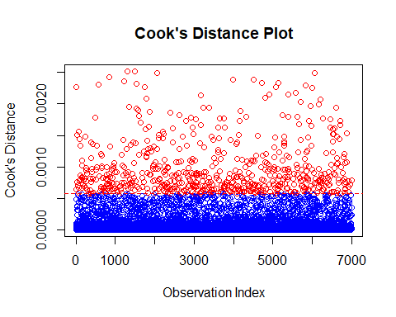

Interpretation: Odds Ratios
# Calculate the odds ratios and 95% Confidence Intervals
coefs <- summary(optimal_model)$coefficients
odds_ratios <- exp(coef(optimal_model))
conf_intervals <- exp(confint(optimal_model))
## Waiting for profiling to be done...
results_table <- data.frame(
OddsRatio = odds_ratios,
Lower_CI = conf_intervals[, 1],
Upper_CI = conf_intervals[, 2]
)
print("--- Odds Ratio Table (Final Interpretation) ---")
## [1] "--- Odds Ratio Table (Final Interpretation) ---"
print(results_table)
## OddsRatio Lower_CI Upper_CI
## (Intercept) 0.0459615 0.0235317 0.08938175
## CreditScore 0.9992861 0.9986335 0.99993853
## GeographyGermany 2.1313906 1.8198042 2.49771220
## GeographySpain 1.0629632 0.9008195 1.25234155
## GenderMale 0.5942314 0.5231165 0.67472967
## Age 1.0688196 1.0565694 1.08129758
## Balance 1.0000024 1.0000012 1.00000361
## NumOfProducts 0.8748376 0.7821861 0.97752128
## IsActiveMember1 0.3411907 0.2978860 0.39017705
## Age_GroupSenior 1.0283345 0.7756701 1.36305670
## Age_GroupYoung Adult 0.7649778 0.5885308 0.98890370

QQ-plot of deviance residuals
# Calculate the Deviance Residuals from the optimal model
# Residuals should be stored as a simple dataframe for ggplot
residual_df <- data.frame(deviance_residuals = residuals(optimal_model, type = "deviance"))
# Create a QQ plot using ggplot2 (stat_qq and stat_qq_line)
ggplot(residual_df, aes(sample = deviance_residuals)) +
# Add the points
stat_qq(color = "blue") +
# Add the reference line
stat_qq_line(color = "red", linetype = "dashed") +
labs(
title = "QQ Plot of Deviance Residuals (Optimal GLM)",
x = "Theoretical Quantiles",
y = "Sample Quantiles"
) +
theme_minimal()
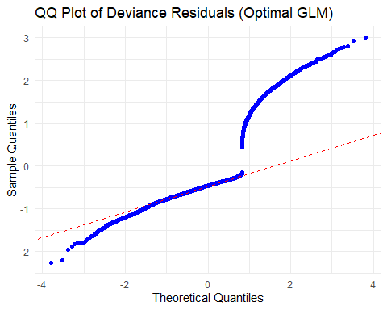

Model Prediction and Accuracy on test data
# Predict probabilities on the held-out test set
test_probabilities <- predict(optimal_model, test_data, type = "response")
# Convert probabilities to binary predictions (using a 0.5 threshold)
test_predictions <- ifelse(test_probabilities > 0.5, 1, 0)
# Assess model performance using the Confusion Matrix
print("--- Confusion Matrix (Prediction Accuracy) ---")
## [1] "--- Confusion Matrix (Prediction Accuracy) ---"
confusionMatrix(as.factor(test_predictions), test_data$Exited)
## Confusion Matrix and Statistics
##
## Reference
## Prediction 0 1
## 0 2302 489
## 1 86 122
##
## Accuracy : 0.8083
## 95% CI : (0.7937, 0.8222)
## No Information Rate : 0.7963
## P-Value [Acc > NIR] : 0.05296
##
## Kappa : 0.2169
##
## Mcnemar's Test P-Value : < 2e-16
##
## Sensitivity : 0.9640
## Specificity : 0.1997
## Pos Pred Value : 0.8248
## Neg Pred Value : 0.5865
## Prevalence : 0.7963
## Detection Rate : 0.7676
## Detection Prevalence : 0.9306
## Balanced Accuracy : 0.5818
##
## 'Positive' Class : 0
##

Model Validity (ROC and AUC)
# Create the ROC curve object using the held-out test data
roc_curve <- roc(response = test_data$Exited,
predictor = test_probabilities)
## Setting levels: control = 0, case = 1
## Setting direction: controls < cases
# Plot the ROC Curve
plot(roc_curve,
main = "ROC Curve on Test Data",
col = "blue",
lwd = 2)
legend("bottomright",
legend = paste("AUC =", round(auc(roc_curve), 4)),
col = "blue",
lwd = 2)
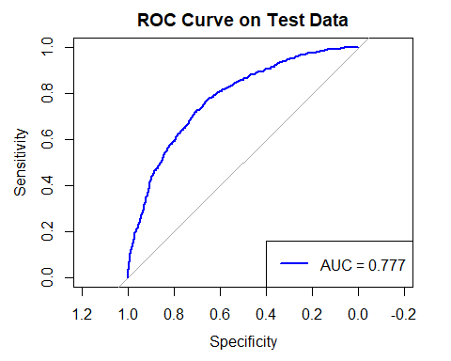
# Calculate and print the Area Under the Curve (AUC)
print(paste("Area Under the Curve (AUC):", round(auc(roc_curve), 4)))
## [1] "Area Under the Curve (AUC): 0.777"

