Capstone Report: Hedging Nvidia with Nasdaq Dashboard Analysis
By Khin Chan Thar
  - Introduction & Context
Modern investing practices revolve around portfolio risk management, and while high-growth stocks like Nvidia Corporation (NVDA) provide significant upside, they are also vulnerable to significant declines because of sector concentration, volatility, and macroeconomic shocks. Investors frequently employ hedging strategies to reduce risks by acquiring positions in correlated instruments to balance potential losses.
The goal is to evaluate whether QQQ can reduce downside risk while preserving the upside potential of NVDA. By using Tableau dashboards, regression analysis, and stress testing. We assess hedge effectiveness across multiple dimensions such as drawdown, volatility, correlation and equity growth. The project can help portfolio managers and risk analysis in making data-driven decisions on the stock market.
  - Definitions
Portfolio Assets (NVDA): The high-growth equity being protected
Hedge Instrument (QQQ): A diversified ETF used to offset NVDA’s risk.
Hedge Ratio: Estimated via regression by determining how much QQQ is needed to hedge NVDA.
Beta: Measures NVDA’s sensitivity to the market movements.
Drawdown: Peak-to-trough decline in portfolio value.
Sharpe Ratio: Risk-adjusted return metric.
Stress Windows: Periods of market disruption used to test hedge robustness.
Static vs. Dynamic Hedge: Static uses a fixed ratio; dynamic adjusts based on rolling beta or volatility regimes.
  - Data & Instruments
In this project, I hedge a long position in Nvidia (ticker: NVDA) using Nasdaq (ticker: QQQ) as the hedge instrument. Daily adjusted closing prices for both tickers were obtained from Google Finance over the period 22/11/2022 to 21/11/2025, downloaded using Google Sheets' GOOGLEFINANCE function, and cleaned into a single file, prices_clean.csv, with columns Date, PortfolioClose, and HedgeClose (plus optional helper fields such as Date (Months) and Stress Window). The portfolio series represents the asset I am trying to protect, while the hedge series represents the instrument used to reduce risk. These exact tickers are consistently used in my data pipeline, Tableau workbook, and dashboards (D1 Overview in particular, Stress Windows, Hedge Effectiveness provide) visual evidence of the hedge’s performance, enabling stakeholders to interpret results intuitively.

  - Methodology
Tableau Dashboard: Dashboards were built to visualize equity growth, correlations, drawdowns, and monthly return patterns. All are calculated and validated using calculation fields and regression logic on Tableau.
Regression-Based Hedge Ratio: To get the ideal hedge ratio, NVDA returns were regressed on QQQ returns. Both static and dynamic hedge methods used this ratio.
Rolling Beta Analysis: To account for NVDA's fluctuating sensitivity to QQQ, a 90-day rolling beta was computed. The dynamic hedging logic was informed by this.
Stress Window Identification: Volatility spikes and drawdown thresholds were used to identify important times like the COVID crash, inflationary shocks, and AI-driven rallies.

  - Key Performance Indicators (KPIs)
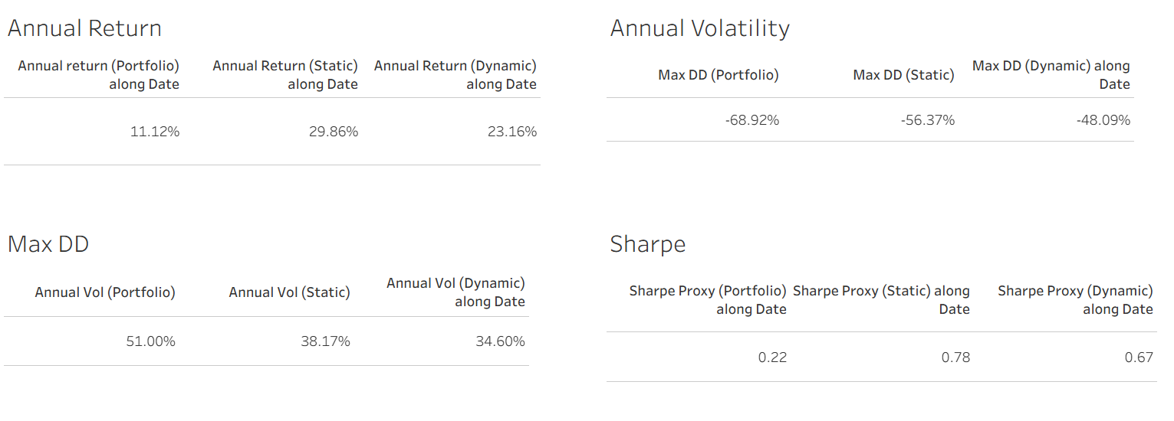
The static hedge significantly improves the Sharpe ratio and reduces drawdown. On the other hand, dynamic hedge offers smooth volatility and better downside protection, with slightly lower returns.

  - Sensitivity Analysis
Monthly Return Heatmap: NVDA produced large returns in May 2023 (45.54%) and Nov 2022 (28.70%), although its performance was inconsistent. Hedging timing is guided by seasonal patterns, which indicate increased volatility in Q2 and Q4.
Daily Return Box Plot: The daily returns of the portfolio exhibit greater dispersion in monthly box plots, particularly in May and July. The histogram also confirms flat tails and kurtosis, justifying the need for the portfolio to be hedged.
Rolling Beta Regime: NVDA’s beta fluctuates between 1.5 and 2.5 from Oct 2022 to Oct 2023. High betas were flagged in red, which means that they indicate periods of elevated risk. Dynamic hedge adjusted exposure based on beta, reducing risk during volatile periods.
  - Stress Window
Correlation Breakdown for Rolling 90-day Correlation
The range of the correlation between NVDA and QQQ was -1.0 to +0.9. Perfect negative correlation (-1.0) was seen in January 2022; however strong positive correlation was observed in mid-2023. Heatmap also reveals that correlation is not stable, weakening hedge effectiveness during peculiar rallies.
Drawdown Comparison
The dynamic hedge, represented by the dark brown line, consistently displayed the lowest drawdowns.
The crimson static hedge provided a decent level of protection. Deep drawdowns were experienced by the unhedged portfolio (pink), particularly during macro shocks.
  - Equity Growth Analysis
The unhedged NVDA saw significant reversals after reaching a peak above 300.
The static hedge offered smoother growth, peaking at about 220. The dynamic hedge had the most consistent trajectory, peaking at about 200. In conclusion, the unhedged portfolio has the highest risk, even if it yields the highest returns. The dynamic hedge offers better risk-adjusted performance at the expense of some upside.
  - Recommendations
The Choice: Dynamic vs. Static
For the typical investor looking for a balanced strategy, the Static Hedge (1.0) is the best option; but, in some situations, the Dynamic Hedge provides better risk management.
Advantage
Among the hedged strategies, the Static Hedge (1.0) produced the highest Sharpe Ratio (2.06), offering the best return per volatility unit. In comparison to the Unhedged portfolio, it dramatically decreased the maximum drawdown by 14.65 percentage points (from -36.89% to -22.24%) and decreased annualized volatility by over 12 percentage points, indicating efficient risk reduction without unduly compromising long-term returns.
Restrictions
With a higher Max Drawdown (-27.30%) than the Static Hedge (-22.24%), the Dynamic Hedge underperformed during abrupt market shocks. This demonstrates rolling beta's main drawback: the 90-day computation lags market reality. When correlation abruptly drops or the beta suddenly spikes, the dynamic hedge is sized based on old, less relevant data, leading to a temporarily mis-sized hedge during peak stress events
Recommendations
Statistic Hedge is optimal for investors seeking a balance between return and risk (e.g., Pension Funds, Endowments).
Dynamic Hedge is preferable for risk-averse investors or during high-beta regimes where capital preservation is the absolute priority (e.g., funds near distribution, highly leveraged portfolios).
Use dynamic hedging when there is macro uncertainty or increased beta (over 1.2), as determined by the D2 Rolling Beta dashboard. Use beta dashboards and rolling correlation to track hedge performance in real time and serve as a regime change warning system. When the 90-day correlation is low or unstable, think about layering techniques like protective puts as this provides better protection against the quick and abrupt shocks that rolling beta strategies frequently miss.

