MA3405
Khin Chan Thar
2025-11-28

Part 1: Data Setup and Wrangling
dataset = “Default of Credit Card Clients” default_of_credit_card_clients.csv

Load Libraries
library(dplyr)
##
## Attaching package: 'dplyr'
## The following objects are masked from 'package:stats':
##
## filter, lag
## The following objects are masked from 'package:base':
##
## intersect, setdiff, setequal, union
library(ggplot2)
## Warning: package 'ggplot2' was built under R version 4.4.3
library(glmnet) # shrinkage (lasso/ridge)
## Warning: package 'glmnet' was built under R version 4.4.3
## Loading required package: Matrix
## Warning: package 'Matrix' was built under R version 4.4.3
## Loaded glmnet 4.1-10
library(tree) # CART
## Warning: package 'tree' was built under R version 4.4.3
library(randomForest) # Random Forest (bagging extension)
## Warning: package 'randomForest' was built under R version 4.4.3
## randomForest 4.7-1.2
## Type rfNews() to see new features/changes/bug fixes.
##
## Attaching package: 'randomForest'
## The following object is masked from 'package:ggplot2':
##
## margin
## The following object is masked from 'package:dplyr':
##
## combine
library(cluster) # clustering
## Warning: package 'cluster' was built under R version 4.4.3
library(factoextra) # PCA visuals
## Warning: package 'factoextra' was built under R version 4.4.3
## Welcome! Want to learn more? See two factoextra-related books at https://goo.gl/ve3WBa
library(pROC) # AUC
## Warning: package 'pROC' was built under R version 4.4.3
## Type 'citation("pROC")' for a citation.
##
## Attaching package: 'pROC'
## The following objects are masked from 'package:stats':
##
## cov, smooth, var
library(e1071) # SVM
## Warning: package 'e1071' was built under R version 4.4.3
##
## Attaching package: 'e1071'
## The following object is masked from 'package:ggplot2':
##
## element
library(caret)
## Warning: package 'caret' was built under R version 4.4.3
## Loading required package: lattice
## Warning: package 'lattice' was built under R version 4.4.3
set.seed(77)

Read and Clean the Data
# Read default_of_credit_card_clients.csv file
raw <- read.csv("default_of_credit_card_clients.csv", skip = 1)
# Display Information
head(raw)
## ID LIMIT_BAL SEX EDUCATION MARRIAGE AGE PAY_0 PAY_2 PAY_3 PAY_4 PAY_5 PAY_6
## 1 1 20000 2 2 1 24 2 2 -1 -1 -2 -2
## 2 2 120000 2 2 2 26 -1 2 0 0 0 2
## 3 3 90000 2 2 2 34 0 0 0 0 0 0
## 4 4 50000 2 2 1 37 0 0 0 0 0 0
## 5 5 50000 1 2 1 57 -1 0 -1 0 0 0
## 6 6 50000 1 1 2 37 0 0 0 0 0 0
## BILL_AMT1 BILL_AMT2 BILL_AMT3 BILL_AMT4 BILL_AMT5 BILL_AMT6 PAY_AMT1 PAY_AMT2
## 1 3913 3102 689 0 0 0 0 689
## 2 2682 1725 2682 3272 3455 3261 0 1000
## 3 29239 14027 13559 14331 14948 15549 1518 1500
## 4 46990 48233 49291 28314 28959 29547 2000 2019
## 5 8617 5670 35835 20940 19146 19131 2000 36681
## 6 64400 57069 57608 19394 19619 20024 2500 1815
## PAY_AMT3 PAY_AMT4 PAY_AMT5 PAY_AMT6 default.payment.next.month
## 1 0 0 0 0 1
## 2 1000 1000 0 2000 1
## 3 1000 1000 1000 5000 0
## 4 1200 1100 1069 1000 0
## 5 10000 9000 689 679 0
## 6 657 1000 1000 800 0
# drop irrelevant columns and begin chain
cc <- raw %>%
select(-ID) %>%
rename(Y = "default.payment.next.month") %>%
# Convert PAY_* to integer first, as they are used in case_when logic
mutate(across(c("PAY_0","PAY_2","PAY_3","PAY_4","PAY_5","PAY_6"), as.integer)) %>%
# Simplify EDUCATION, MARRIAGE, and PAY_* in one chain
mutate(
# Simplify EDUCATION
EDUCATION = case_when(
EDUCATION == 1 ~ "Graduate",
EDUCATION == 2 ~ "University",
EDUCATION == 3 ~ "HighSchool",
TRUE ~ "Other" # Combines 0, 4, 5, 6
),
# Simplify MARRIAGE
MARRIAGE = case_when(
MARRIAGE == 1 ~ "Married",
MARRIAGE == 2 ~ "Single",
TRUE ~ "Other" # Combines 0, 3
),
# Collapse payment status into 3 groups (Normal, Delay, Severe Delay)
across(c("PAY_0","PAY_2","PAY_3","PAY_4","PAY_5","PAY_6"), ~ case_when(
. %in% c(-2, -1, 0) ~ "Normal",
. %in% c(1, 2) ~ "Delay_1_2M",
TRUE ~ "Severe_Delay" # 3+ months delay
)),
# Create factor response and remove Y (must be the last step using Y)
default = factor(Y, levels = c(0,1), labels = c("NoDefault", "Default"))
) %>%
select(-Y) # Remove the original numeric response column
# Check factor levels (optional but recommended)
print(lapply(cc %>% select(where(is.character) | where(is.factor)), unique))
## $EDUCATION
## [1] "University" "Graduate" "HighSchool" "Other"
##
## $MARRIAGE
## [1] "Married" "Single" "Other"
##
## $PAY_0
## [1] "Delay_1_2M" "Normal" "Severe_Delay"
##
## $PAY_2
## [1] "Delay_1_2M" "Normal" "Severe_Delay"
##
## $PAY_3
## [1] "Normal" "Delay_1_2M" "Severe_Delay"
##
## $PAY_4
## [1] "Normal" "Delay_1_2M" "Severe_Delay"
##
## $PAY_5
## [1] "Normal" "Delay_1_2M" "Severe_Delay"
##
## $PAY_6
## [1] "Normal" "Delay_1_2M" "Severe_Delay"
##
## $default
## [1] Default NoDefault
## Levels: NoDefault Default

Part 2: Split the data into Training (70%) and Test (30%) sets
set.seed(77)
index <- sample(1:nrow(cc), size = 0.7*nrow(cc))
train <- cc[index, ]
test <- cc[-index, ]

Part 3: Standardize numeric predictors
num_cols <- c(
"LIMIT_BAL","AGE",
paste0("BILL_AMT",1:6),
paste0("PAY_AMT",1:6)
)
train_means <- sapply(train[,num_cols], mean)
train_sds <- sapply(train[,num_cols], sd)
# For regression
train[,num_cols] <- scale(train[,num_cols], center=train_means, scale=train_sds)
test[,num_cols] <- scale(test[,num_cols], center=train_means, scale=train_sds)

Part 4: Unsupervised Learning (PCA and Clustering)

PCA
pca <- prcomp(train[, num_cols], scale. = FALSE)
summary(pca)
## Importance of components:
## PC1 PC2 PC3 PC4 PC5 PC6 PC7
## Standard deviation 2.4256 1.2545 1.01945 0.9757 0.95377 0.93962 0.91476
## Proportion of Variance 0.4202 0.1124 0.07423 0.0680 0.06498 0.06306 0.05977
## Cumulative Proportion 0.4202 0.5326 0.60688 0.6749 0.73986 0.80292 0.86269
## PC8 PC9 PC10 PC11 PC12 PC13 PC14
## Standard deviation 0.88774 0.83921 0.51882 0.26478 0.20436 0.15946 0.15320
## Proportion of Variance 0.05629 0.05031 0.01923 0.00501 0.00298 0.00182 0.00168
## Cumulative Proportion 0.91898 0.96929 0.98852 0.99352 0.99651 0.99832 1.00000
plot(pca, type = "l", main = "PCA Scree Plot")
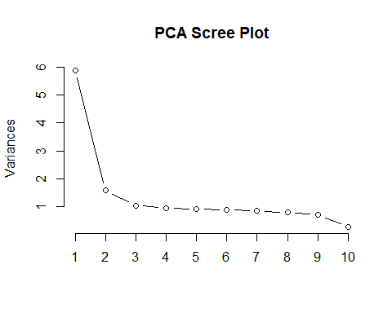
plot(pca$x[,1], pca$x[,2],
xlab="PC1", ylab="PC2",
main="PCA — PC1 vs PC2",
col="blue", pch=19)
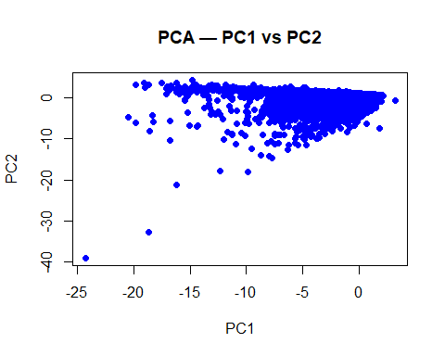 ## K-means clustering on first 3 PCs
km <- kmeans(pca$x[,1:3], centers=3, nstart=20)
table(km$cluster)
##
## 1 2 3
## 967 4053 15980
plot(pca$x[,1], pca$x[,2],
col = km$cluster,
pch = 19,
main = "K-means Clustering on PCA (PC1 vs PC2)",
xlab = "PC1", ylab = "PC2")
legend("topright", legend=1:3, col=1:3, pch=19)
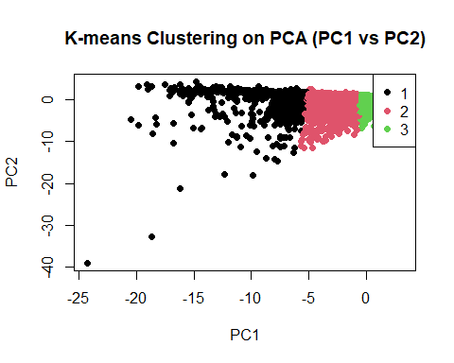
# Hierarchical clustering (subset)
sub_id <- sample(1:nrow(pca$x), 1000)
hc <- hclust(dist(pca$x[sub_id,1:3]), method="complete")
plot(hc)
rect.hclust(hc, k=3, border="red")
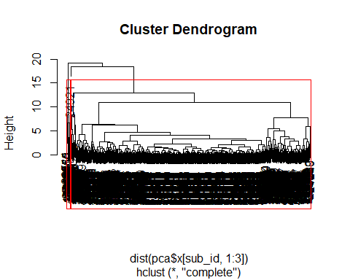 # Part 5: Logistic Regression
log_model <- glm(default ~ ., data=train, family=binomial)
summary(log_model)
##
## Call:
## glm(formula = default ~ ., family = binomial, data = train)
##
## Coefficients:
## Estimate Std. Error z value Pr(>|z|)
## (Intercept) 1.124788 0.098396 11.431 < 2e-16 ***
## LIMIT_BAL -0.202258 0.024375 -8.298 < 2e-16 ***
## SEX -0.131769 0.037942 -3.473 0.000515 ***
## EDUCATIONHighSchool -0.006552 0.058504 -0.112 0.910824
## EDUCATIONOther -1.065732 0.233963 -4.555 5.24e-06 ***
## EDUCATIONUniversity 0.006315 0.043786 0.144 0.885323
## MARRIAGEOther -0.230612 0.166088 -1.388 0.164986
## MARRIAGESingle -0.083579 0.042688 -1.958 0.050240 .
## AGE 0.061798 0.021141 2.923 0.003465 **
## PAY_0Normal -1.375158 0.050673 -27.138 < 2e-16 ***
## PAY_0Severe_Delay 0.548259 0.141774 3.867 0.000110 ***
## PAY_2Normal -0.057400 0.070047 -0.819 0.412533
## PAY_2Severe_Delay -0.291328 0.140666 -2.071 0.038352 *
## PAY_3Normal -0.429435 0.069229 -6.203 5.53e-10 ***
## PAY_3Severe_Delay -0.196825 0.166249 -1.184 0.236446
## PAY_4Normal -0.304476 0.076956 -3.957 7.61e-05 ***
## PAY_4Severe_Delay -0.331854 0.198178 -1.675 0.094028 .
## PAY_5Normal -0.353264 0.083870 -4.212 2.53e-05 ***
## PAY_5Severe_Delay -0.156230 0.203553 -0.768 0.442776
## PAY_6Normal -0.298694 0.073222 -4.079 4.52e-05 ***
## PAY_6Severe_Delay 0.285668 0.198691 1.438 0.150506
## BILL_AMT1 -0.118562 0.092396 -1.283 0.199427
## BILL_AMT2 0.241406 0.116105 2.079 0.037599 *
## BILL_AMT3 0.030412 0.103276 0.294 0.768398
## BILL_AMT4 0.013208 0.098486 0.134 0.893318
## BILL_AMT5 0.024079 0.105757 0.228 0.819890
## BILL_AMT6 -0.084324 0.079877 -1.056 0.291117
## PAY_AMT1 -0.174918 0.040750 -4.292 1.77e-05 ***
## PAY_AMT2 -0.202072 0.058763 -3.439 0.000584 ***
## PAY_AMT3 -0.031168 0.032130 -0.970 0.332027
## PAY_AMT4 -0.019632 0.029584 -0.664 0.506938
## PAY_AMT5 -0.013842 0.030323 -0.456 0.648053
## PAY_AMT6 -0.063874 0.028816 -2.217 0.026650 *
## ---
## Signif. codes: 0 '***' 0.001 '**' 0.01 '*' 0.05 '.' 0.1 ' ' 1
##
## (Dispersion parameter for binomial family taken to be 1)
##
## Null deviance: 22163 on 20999 degrees of freedom
## Residual deviance: 18607 on 20967 degrees of freedom
## AIC: 18673
##
## Number of Fisher Scoring iterations: 6
log_prob <- predict(log_model, test, type="response")
log_class <- factor(
as.numeric(log_prob > 0.5),
levels = c("NoDefault", "Default")
)
hist(log_prob,
col="lightblue",
main="Logistic Regression — Predicted Probabilities",
xlab="Predicted Probability of Default")
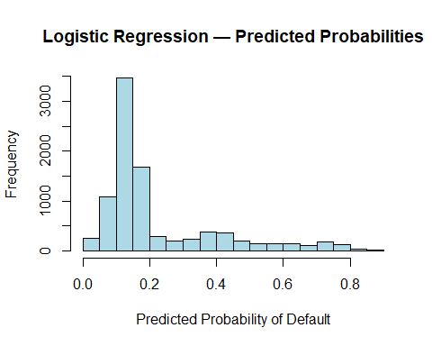
roc_log <- roc(test$default, log_prob, levels = c("NoDefault", "Default"))
## Setting direction: controls < cases
# ROC curve
plot(roc_log, # Now defined
col="blue",
lwd=2,
main="ROC Curve — Logistic Regression")
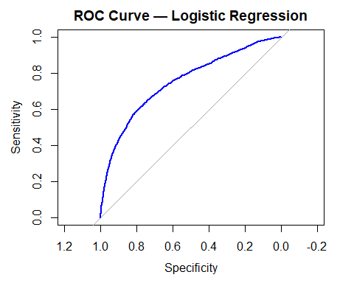 # Part 6: Lasso
x_train <- model.matrix(default ~ . , train)[,-1]
y_train <- ifelse(train$default=="Default",1,0)
cv_lasso <- cv.glmnet(x_train, y_train, alpha=1, family="binomial")
lasso_best <- cv_lasso$lambda.min
x_test <- model.matrix(default ~ ., test)[,-1]
lasso_prob <- predict(cv_lasso, newx=x_test, s=lasso_best, type="response")
lasso_pred <- factor(as.numeric(lasso_prob > 0.5),
levels = c("NoDefault", "Default"))
roc_lasso <- roc(test$default, lasso_prob, levels = c("NoDefault", "Default"))
## Warning in roc.default(test$default, lasso_prob, levels = c("NoDefault", :
## Deprecated use a matrix as predictor. Unexpected results may be produced,
## please pass a numeric vector.
## Setting direction: controls < cases
# LASSO CV Plot
plot(cv_lasso)
title("LASSO Cross-Validation Curve")
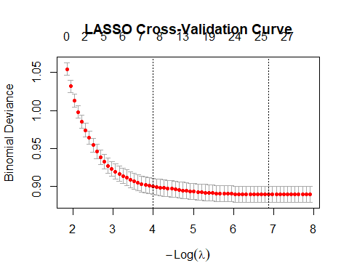
# LASSO Coefficient Paths
plot(cv_lasso$glmnet.fit, xvar="lambda")
title("LASSO Coefficient Paths")
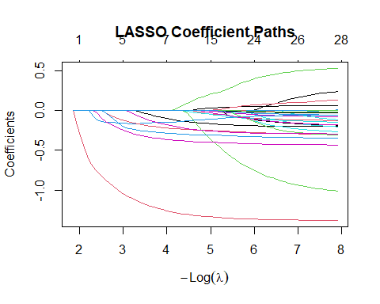 # Part 7: Tree-Based Methods

Classification Tree
set.seed(77)
set.seed(77)
tree_model <- tree(default ~ ., data=train)
## Warning in tree(default ~ ., data = train): NAs introduced by coercion
plot(tree_model)
text(tree_model, pretty=0)
title("Classification Tree")
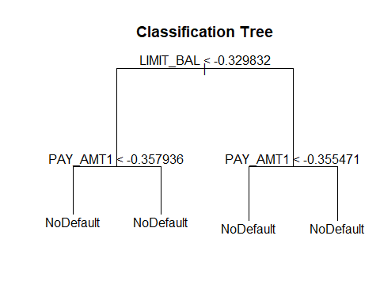
tree_prob <- predict(tree_model, test)[, "Default"]
## Warning in pred1.tree(object, tree.matrix(newdata)): NAs introduced by coercion
tree_class <- factor(as.numeric(tree_prob > 0.5),
levels = c("NoDefault", "Default"))

Part 8: Random Forest
set.seed(77)
rf_model <- randomForest(default ~ ., data=train, ntree=300)
rf_prob <- predict(rf_model, test, type="prob")[,2] # Probability of Default (1)
# FIX: Correct labels to match the factor definition (0=NoDefault, 1=Default)
rf_class <- factor(as.numeric(rf_prob > 0.5),
levels = c("NoDefault", "Default"))
varImpPlot(rf_model, main="Random Forest — Variable Importance")
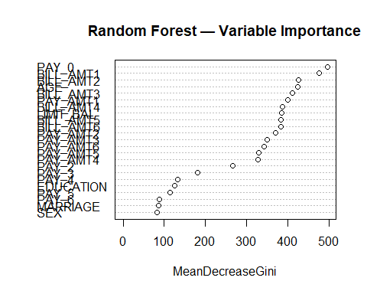
roc_rf <- roc(test$default, rf_prob, levels = c("NoDefault", "Default"))
## Setting direction: controls < cases
plot(roc_rf,
col="red",
lwd=2,
main="ROC Curve — Random Forest")
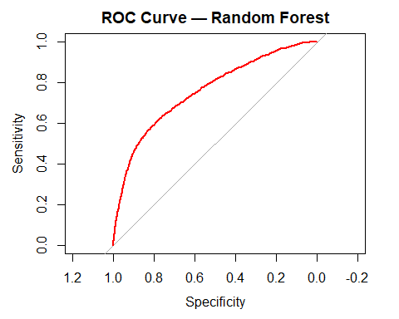

Part 9: Model Comparison Table
# Step 1: Subsample the Training Data (e.g., 30% of the training set)
set.seed(77)
sub_train_index <- sample(1:nrow(train), size = floor(0.3 * nrow(train)))
sub_train <- train[sub_train_index, ]
# Step 2: Retrain the SVM model on the subset
set.seed(77)
svm_model <- svm(default ~ ., data=sub_train, kernel="radial", probability=TRUE)
svm_prob <- attr(predict(svm_model, test, probability=TRUE), "probabilities")[,"Default"]
svm_pred <- factor(
as.numeric(svm_prob > 0.5),
levels = c("NoDefault", "Default") # Correct: Level 0 is NoDefault
)
svm_pred <- factor(
as.numeric(svm_prob > 0.5),
levels = c(0, 1),
labels = c("NoDefault", "Default")
)

Get Predictions
get_metrics <- function(true, prob, pred){
cm <- table(True=true, Pred=pred)
acc <- sum(diag(cm))/sum(cm)
roc_obj <- roc(true, prob, levels=c("NoDefault","Default"))
return(c(
Accuracy = round(acc,3),
Sensitivity = round(sensitivity(pred, true),3),
Specificity = round(specificity(pred, true),3),
AUC = round(auc(roc_obj),3)
))
}
# Compile Comparison Table
perf_df <- bind_rows(
data.frame(Model = "Logistic", get_metrics(test$default, log_prob, log_class)),
data.frame(Model = "Lasso", get_metrics(test$default, lasso_prob, lasso_pred)),
data.frame(Model = "Classification Tree", get_metrics(test$default, tree_prob, tree_class)),
data.frame(Model = "Random Forest", get_metrics(test$default, rf_prob, rf_class)),
data.frame(Model = "SVM Radial", get_metrics(test$default, svm_prob, svm_pred))
)
## Setting direction: controls < cases
## Warning in roc.default(true, prob, levels = c("NoDefault", "Default")):
## Deprecated use a matrix as predictor. Unexpected results may be produced,
## please pass a numeric vector.
## Setting direction: controls < cases
## Setting direction: controls < cases
## Setting direction: controls < cases
## Setting direction: controls < cases
print(perf_df)
## Model
## Accuracy...1 Logistic
## Sensitivity...2 Logistic
## Specificity...3 Logistic
## AUC...4 Logistic
## Accuracy...5 Lasso
## Sensitivity...6 Lasso
## Specificity...7 Lasso
## AUC...8 Lasso
## Accuracy...9 Classification Tree
## Sensitivity...10 Classification Tree
## Specificity...11 Classification Tree
## AUC...12 Classification Tree
## Accuracy...13 Random Forest
## Sensitivity...14 Random Forest
## Specificity...15 Random Forest
## AUC...16 Random Forest
## Accuracy...17 SVM Radial
## Sensitivity...18 SVM Radial
## Specificity...19 SVM Radial
## AUC...20 SVM Radial
## get_metrics.test.default..log_prob..log_class.
## Accuracy...1 NaN
## Sensitivity...2 NA
## Specificity...3 NA
## AUC...4 0.75
## Accuracy...5 NA
## Sensitivity...6 NA
## Specificity...7 NA
## AUC...8 NA
## Accuracy...9 NA
## Sensitivity...10 NA
## Specificity...11 NA
## AUC...12 NA
## Accuracy...13 NA
## Sensitivity...14 NA
## Specificity...15 NA
## AUC...16 NA
## Accuracy...17 NA
## Sensitivity...18 NA
## Specificity...19 NA
## AUC...20 NA
## get_metrics.test.default..lasso_prob..lasso_pred.
## Accuracy...1 NA
## Sensitivity...2 NA
## Specificity...3 NA
## AUC...4 NA
## Accuracy...5 NaN
## Sensitivity...6 NA
## Specificity...7 NA
## AUC...8 0.749
## Accuracy...9 NA
## Sensitivity...10 NA
## Specificity...11 NA
## AUC...12 NA
## Accuracy...13 NA
## Sensitivity...14 NA
## Specificity...15 NA
## AUC...16 NA
## Accuracy...17 NA
## Sensitivity...18 NA
## Specificity...19 NA
## AUC...20 NA
## get_metrics.test.default..tree_prob..tree_class.
## Accuracy...1 NA
## Sensitivity...2 NA
## Specificity...3 NA
## AUC...4 NA
## Accuracy...5 NA
## Sensitivity...6 NA
## Specificity...7 NA
## AUC...8 NA
## Accuracy...9 NaN
## Sensitivity...10 NA
## Specificity...11 NA
## AUC...12 0.629
## Accuracy...13 NA
## Sensitivity...14 NA
## Specificity...15 NA
## AUC...16 NA
## Accuracy...17 NA
## Sensitivity...18 NA
## Specificity...19 NA
## AUC...20 NA
## get_metrics.test.default..rf_prob..rf_class.
## Accuracy...1 NA
## Sensitivity...2 NA
## Specificity...3 NA
## AUC...4 NA
## Accuracy...5 NA
## Sensitivity...6 NA
## Specificity...7 NA
## AUC...8 NA
## Accuracy...9 NA
## Sensitivity...10 NA
## Specificity...11 NA
## AUC...12 NA
## Accuracy...13 NaN
## Sensitivity...14 NA
## Specificity...15 NA
## AUC...16 0.757
## Accuracy...17 NA
## Sensitivity...18 NA
## Specificity...19 NA
## AUC...20 NA
## get_metrics.test.default..svm_prob..svm_pred.
## Accuracy...1 NA
## Sensitivity...2 NA
## Specificity...3 NA
## AUC...4 NA
## Accuracy...5 NA
## Sensitivity...6 NA
## Specificity...7 NA
## AUC...8 NA
## Accuracy...9 NA
## Sensitivity...10 NA
## Specificity...11 NA
## AUC...12 NA
## Accuracy...13 NA
## Sensitivity...14 NA
## Specificity...15 NA
## AUC...16 NA
## Accuracy...17 0.799
## Sensitivity...18 0.950
## Specificity...19 0.273
## AUC...20 0.730
evaluate_threshold <- function(prob, truth, model_name, thresholds = c(0.3, 0.5, 0.7)) {
results <- lapply(thresholds, function(t) {
pred_class <- factor(ifelse(prob >= t, "Default", "NoDefault"),
levels = levels(truth))
cm <- caret::confusionMatrix(pred_class, truth, positive = "Default")
tibble(
Model = model_name,
Threshold = t,
Accuracy = round(cm$overall["Accuracy"], 3),
Sensitivity = round(cm$byClass["Sensitivity"], 3),
Specificity = round(cm$byClass["Specificity"], 3)
)
})
bind_rows(results)
}
thresholds <- c(0.3, 0.5, 0.7)
results_all <- bind_rows(
evaluate_threshold(log_prob, test$default, "Logistic", thresholds),
evaluate_threshold(lasso_prob, test$default, "Lasso", thresholds),
evaluate_threshold(tree_prob, test$default, "Classification Tree", thresholds),
evaluate_threshold(rf_prob, test$default, "Random Forest", thresholds),
evaluate_threshold(svm_prob, test$default, "SVM Radial", thresholds)
)
print(results_all)
## # A tibble: 15 × 5
## Model Threshold Accuracy Sensitivity Specificity
## <chr> <dbl> <dbl> <dbl> <dbl>
## 1 Logistic 0.3 0.777 0.504 0.855
## 2 Logistic 0.5 0.804 0.279 0.954
## 3 Logistic 0.7 0.793 0.121 0.986
## 4 Lasso 0.3 0.777 0.505 0.855
## 5 Lasso 0.5 0.804 0.277 0.955
## 6 Lasso 0.7 0.793 0.119 0.986
## 7 Classification Tree 0.3 0.763 0.158 0.936
## 8 Classification Tree 0.5 0.777 0 1
## 9 Classification Tree 0.7 0.777 0 1
## 10 Random Forest 0.3 0.775 0.555 0.838
## 11 Random Forest 0.5 0.806 0.349 0.937
## 12 Random Forest 0.7 0.793 0.113 0.988
## 13 SVM Radial 0.3 0.803 0.396 0.92
## 14 SVM Radial 0.5 0.799 0.273 0.95
## 15 SVM Radial 0.7 0.795 0.138 0.983

