  - Tue 18 NOV
PostgresSQL install
DB super user postgres
Password super
Port 5432

NodeJs install
Angular install
Component + Template = View

Command
ng serve -–open
ng serve -–host 192.168.0.97
node server

ng new projectname

Planning to learn
https://angular.io/ (Tutorials and References)

Tue Nov 24
Short to the point >>
How to build an Angular 8 app from scratch in 11 easy steps (freecodecamp.org)
Creating http client
Creating UI component
Got error in middle way

Detail >>
Complete Angular Tutorial For Beginners - TekTutorialsHub
Logistic Regression: Train Model In Python And Use It on Angular Front End | Hacker Noon
This week plan to finish to combine ML and angular front end

Wed Nov 25
Angular Tutorial - 1 - Introduction - YouTube
59 in total and try to accomplish 20 per days

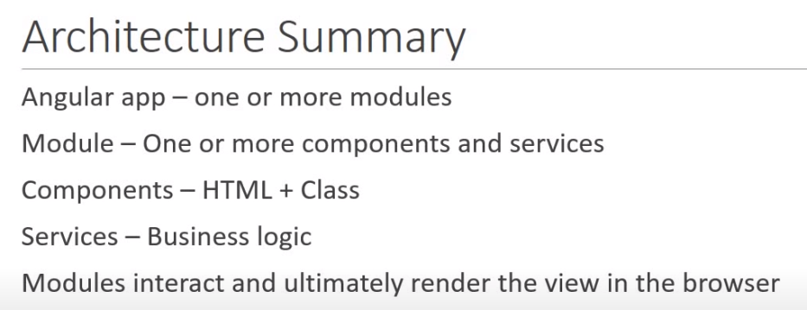

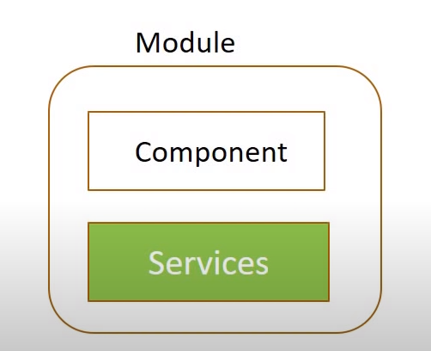
Component Html, view
Services , business logic

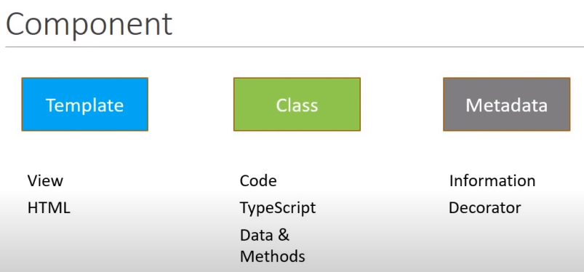

Creating new component

Keyword “Machine learning model to angular”
How to Work with Angular and MySQL | Okta Developer
Angular HTTP POST Example - TekTutorialsHub

How to Integrate TensorFlow Model in Angular Application? (rubikscode.net)

Using pre-trained Machine Learning (ML) Models in the browser with TensorFlow.js & Angular - Goalist Developers Blog

TensorFlow.js Quick Start Tutorial (fireship.io)

Paper

An approach for a performance calculation of shuttle-based storage and retrieval systems with multiple-deep storage

Throughput optimization of shuttle systems with an analytical calculation model

Calculation method to determine the throughput and the energy consumption of S/R shuttle systems

Analytical model to estimate the performance of shuttle-based storage and retrieval systems with class-based storage policy

An analytical approach for a performance calculation of shuttle-based storage and retrieval systems

Method for evaluating the throughput performance of shuttle based storage and retrieval systems

Graph-based solution for performance evaluation of shuttle-based storage and retrieval system

A model for throughput and energy related performance calculations of SBS/RS

Angular

POST,
GET,
SERVER to FORM
FORM to server
Binding
Database

Angular 6 HttpClient - PostgreSQL - Node.js/Express Sequelize CRUD APIs - Post/Get/Put/Delete » grokonez

Dec 16
Npm install pg
Step by Step Javascript and Postgres Tutorial using node-postgres - YouTube
Node.JS How to Connect to PostgreSQL Database - YouTube

Dec 17
Reactive form Vs TDF template driven form
Bootstrap design embedding

ng serve -o <- run the server

to work with reactive form module > import reactiveform Modules
which means module have to import to main module//so component..module.ts
Dec 22
SetValue vs patchValue at youtube “Angular Forms Tutorial – 20- Managing control values”
SetValue is strick in form structure, meanwhile patchvalue is not

Simple validation, - use build in serverice
custom validation ,- make own function
cross field validation ,- two form fields validation
conditional validation

Dec 23
Dynamic Form Control – Form Array
External API to angular (Express server)

Dec 24
Node.js PostgreSQL CRUD Example - DEV
Build restful API with PostgreSQL and Express - YouTube
npm I express pg
Node.js, Express.js, and PostgreSQL: CRUD REST API example - LogRocket Blog<<<<< this is the one
Express database integration (expressjs.com) <<< all db integretion

Dec 29 <<
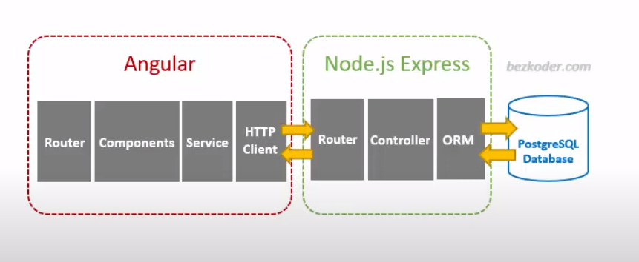
Succeed communication postgresql , CURD transaction
(view and delete only) (update and insert need to fetch data gets issue)

Node.js, Express.js, and PostgreSQL: CRUD REST API example - LogRocket Blog<<<<<

Dec 30
Learn TensorFlow.js - Deep Learning and Neural Networks with JavaScript - YouTube
Learn Tensorflow.js -Depp learning and neural networks with java-script

Jan 5
AutoScheduler -- Warehouse and Dock Scheduling Software | Transportation | Warehouse Optimization

Jan 6
Jetbrains.com --- Intellij

khinthidasan Kau.88khin

project branching folder >> C:\Users\khin thida san\Documents\ecs-nodejs

Using Branch
Using branches | Backlog

In command prompt, install npm
npm i
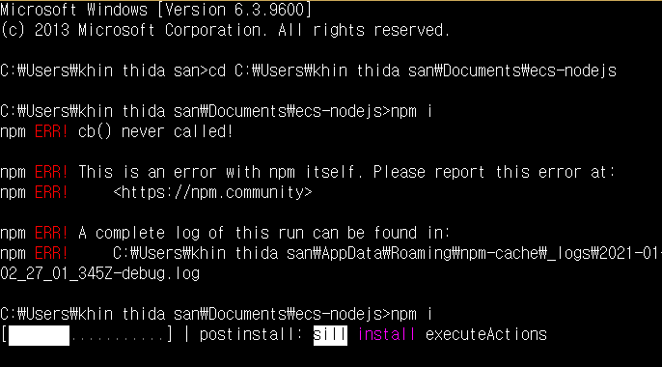

Node_modules is installed , check physical folder in the project

In sourcetree
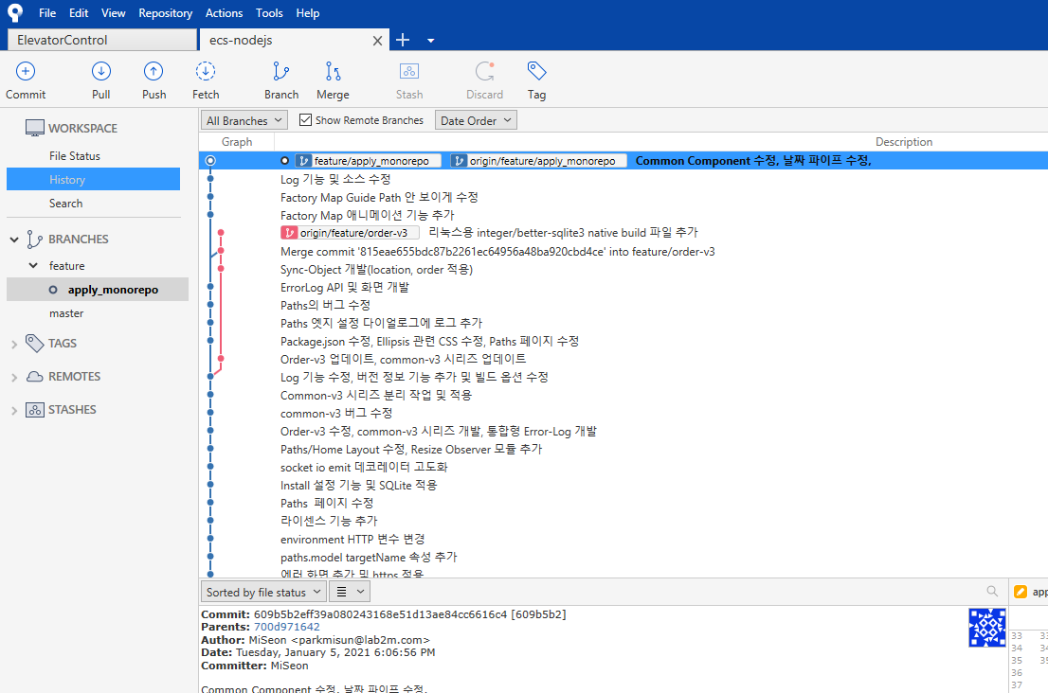
Install NVM
Install under C:/Users/default/nvm
Install node 12.13.0

nvm use down not work while user home directory have space · Issue #161 · coreybutler/nvm-windows (github.com)

Association Rule Mining via Apriori Algorithm in Python (stackabuse.com)

Good Morning Professor
I am analyzing the excels file of daily order from the 쿠캣
- Which products are assigned to which station need to be decide among various order and its related products, and therefore, association rule mining via apriori algorithm can be applied in this case.

Jan 13 2021
RegExp - JavaScript | MDN (mozilla.org)

Jan 14
Full-stack Tutorial: Angular 5 and ASP.NET Core | Toptal

Jan 21
How to Build Web APIs with NestJS, Postgres, and Sequelize - A Beginner's Guide (freecodecamp.org)
NestJs basic

Jan 26
Getting Started with NestJS | DigitalOcean

