Our Reference : 100-UiTMKKT (FSKM.14/3/4)
Date : 17 August 2026
Unilever (Malaysia) Holdings Sdn Bhd,
Suite 2-1, Level 2 & Suite 3-1, Level 3,
Vertical Corporate Tower B,
Avenue 10, The Vertical,
Bangsar South City,
No. 8 Jalan Kerinchi,
59200 Kuala Lumpur, Malaysia.
Dear Sir/Madam
APPLICATION FOR INDUSTRIAL TRAINING PLACEMENT
We respectfully inform you that all students enrolled in Bachelor of Information Systems (Hons.) Business Computing program at the Faculty of Computer and Mathematical Sciences, Universiti Teknologi MARA, are required to undergo industrial training during their final semester as part of the curriculum requirements.
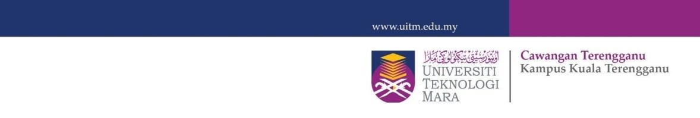
- In this regard, we kindly request your consideration to host our student for industrial training in a relevant field for a duration of 14 weeks, commencing from 14 September 2026 to 18 December 2026. Details of the student are provided below:
NO | STUDENT NAME | MATRIC NO
1 | AHMAD KHIR RASHDAN BIN MOHAMAD SHAMSUDIN | 2023217304
- Enclosed herewith are one (1) copy of the student resume and academic transcript, together with the objectives and scope of the industrial training program for your kind reference.
- We would be most grateful if your organization could provide a response by completing and returning the attached Reply Form (BLI02) the applicant within TWO weeks or we will consider this application to be unsuccessful.
Your cooperation in this matter is highly appreciated, and we extend our sincere thanks in advance.
Yours Truthfully,
NIK MARSYAHARIANI NIK DAUD
Internship Coordinator for Degree Program

